|  |  |  |
| --- | --- | --- |
| Cisco-logo-picture | Document Number | EDCS-XXXXXX |
| Based on Template | EDCS-189230 Rev 26 |
| Created By | Ankur Sao |

NSX-T policy API support in APIC

Software Functional Specification

Feature specification for NSX-T policy API support in APIC

*This document contains top level architecture, design and implementation details for feature policy api support in NSX-T integration with APIC.*

**<<ISO requirement>>**

**<<TL 9000: ADDITIONAL REQUIREMENT FOR TL 9000 COMPLIANCE>>**

Reviewers

*It is the responsibility of the project team to determine the document reviewers and approvers. Once you have completed this document, it will require appropriate review and approval prior to use. Recommend reviewing* [*EDCS -1161410*](http://wwwin-eng.cisco.com/protected-cgi-bin/edcs/edcs_attr_search.pl?doc_num=1161410) *for guidance on review and approval.*

|  |  |
| --- | --- |
| Department | Name/Title |
|  |  |
|  |  |
|  |  |
|  |  |

The departments and/or individuals listed above should be notified in advance and given a sufficient time period to review this document.

Modification History

*Modification history should be maintained for this document. EDCS maintains this history, the modification history table may be removed and the following note inserted where the table was. “For Modification History see EDCS.”*

|  |  |  |  |
| --- | --- | --- | --- |
| Revision | Date | Originator | Comments |
| 1 |  |  |  |
|  |  |  |  |

Table of Contents

1 Problem Definition 3

2 Software Architecture 3

3 Software Requirements 3

4 Memory and Performance Impact 4

5 Packaging Considerations 4

6 End User Interface/User Experience 4

7 Configuration and Restrictions 5

8 Testing Considerations 5

9 Initiative, Legal, & Regulatory 5

10 Requirements Traceability Considerations 6

11 References 6

12 Glossary 6

13 Attachments 6

13.1 Review Action Items 7

# Problem Definition

Support NSX-T policy API in ACI integration with NSX-T. NSX-T release 2.4 introduced a new policy api. It uses a declarative API model and can be used to create the entire intent in one go without caring about ordering or having to make multiple API calls.

From NSX-T 2.4 release, users interact with the NSX Manager using the Simplified UI. The traditional objects will be available under the Advanced UI.

The objects created in NSX-T 2.3 and before will be exposed in the Advanced UI section. There is a very clear separation of function that is defined between objects created with Policy APIs vs objects created using traditional MP APIs:

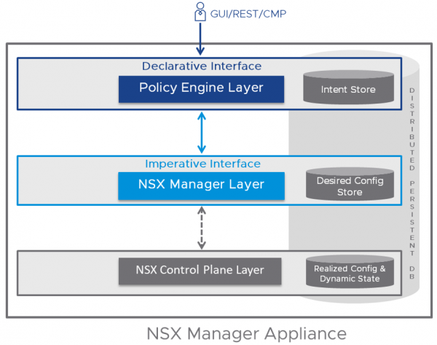

# 

Policy api URI has the prefix: /policy/api/v1/

Segment. :logical switch 1:1  
  
  
  
  
  
  
  
  
  
  
  
  
  
As of now, we have discovered that LS needs to be supported. We will add support for more objects if we find during the feature.

**Policy API introduces new names for following contructs:**

|  |  |  |
| --- | --- | --- |
| Management API | Policy API | ACI equivalent |
| Logical switch | segment | Port group |
| T1 logical router | Tier 1 Gateway | NA |
| T0 logical router | Tier 0 Gateway | NA |
| NSgroups, IP sets, MAC sets | Group | NA |
| Firewall section | Security policy | NA |
| Firewall rule | Rule | NA |
| Edge firewall | Gateway firewall | NA |

# Software Architecture

To support Logical switch in mgmt API, we need to support segment in policy api.

Following considerations are present to support this new object:

1. There will be knob at Epg to VmmDomain association level which identifies API mode (policy (new) or mgmt.(old))
2. Once user selects “policy” as api mode while creating **new epg**, policy api will be used to for all CRUD operations to NSX-T manager.
3. For **existing EPG,** user will need to use the promotion tool in NSX-T(3.2) to promote LS to segments and then turn on the knob in APIC.
4. Downgrade: if user downgrades APIC to unsupported version, retain the policies created with the new policy.
5. Upgrade: Existing EPG have to follow a workflow(mentioned in next page) to switch to policy API.
6. User cannot switch back and forth. (Switching to mgmt api from policy api is blocked.)

**Model/Code Changes:** <type name="NsxtApiMode"

base="scalar:Bitmask16">

<const name="mgmt" value="0" label="mgmt-api">

<const name="policy" value="1" label="policy-api">

</type>  
  
A new property is added to Hvs:ExtPol to contains id of corresponding segment if present.

<property name="segmentId"

type="comp:Oid"

owner="management"

mod="implicit"

/>

Existing relation from AEPg to vmm:DomP will contain a new property ‘apiMode’. This property will be also added in Vmm:EpPD and comp:EpPD.   
  
<rel-def name="domAtt"

to="infra:DomP" …>

NSXController::addExtPolTask/ removeExtPol function will be updated to handle the case of apiMode==’policy’.

Any fault raised on comp:EpPD will be delegated to AEPg, will be user visible.

 From NSX-T UI, promotion tool is triggered to promote LS to segment.   
Following workflow to be followed to enable policyMode in existing EPGs:  
 1. NSX-T object promotion tool is triggered and verified that promotion is successful.  
 2. Knob on epg is turned on in APIC.   
 3. APIC starts using policy api.

# Software Requirements

APIC Version: 6.0(3)

NSX-T Version: >= 3.2

# Memory and Performance Impact

None.

# End User Interface/User Experience

Need UI team to add a knob to switch between Policy and Mgmt API mode. Knobs should be present while creating a new EPG and editing an existing EPG.

**For existing EPG:**

**

# Configuration and Restrictions

* User cannot switch back and forth between API mode. (Switching from Policy to Mgmt mode is allowed, Mgmt to policy is blocked.)
* Policy API is supported on APIC with NSX-T version >= 3.2
* For existing EPGs, APIC can’t manually promote corresponding LS to Segments.
* Default api mode will be ‘policy’ for new EPGs.

Following workflow would lead to an unmanageable LS:

1. Apic version doesn’t support policy api, and LS is promoted to segment in NSX-t.   
(Can't display anything to user)

Following errors from NSX-t will be displayed as fault on EPG:

Scenario 1:  
1. User upgrades ACI, creates epg, downgrades aci. NSX-T remains on policy api version.  
{

"httpStatus": "BAD_REQUEST",

"error_code": 289,

"module_name": "common-services",

"error_message": "Principal 'admin' with role '[enterprise_admin]' attempts to delete or modify an object of type nsx$LogicalSwitch it doesn't own. (createUser=nsx_policy, allowOverwrite=null)"

}

Can’t delete LS if it was created from a segment. We can only read it.

# Testing Considerations

# Initiative, Legal, & Regulatory

N/A

# Requirements Traceability Considerations

N/A

# References <https://blogs.vmware.com/networkvirtualization/2020/06/navigating-nsxt-policy-apis.html/#:~:text=Introduced%20in%20NSX%2DT%202.4,using%20an%20intent%2Dbased%20approach>.

# <https://docs.vmware.com/en/VMware-NSX-T-Data-Center/3.2/administration/GUID-3B619DC3-CB6B-4121-810E-B2DD46A49B0B.html>

# Glossary

The following list describes acronyms and definitions for terms used throughout this document:

* **Term 1 <in bold>**: **<**definition in plain text**>**
* **Term 2 <in bold>**: **<**definition in plain text**>**

# Attachments

As appropriate, attach log sheets, diagrams, schematics, usability research, examples of forms, or other pieces of information used in or generated in the production of the document.

## Review Action Items

Use this section to log meeting minutes from the review of this document and to track review action items to closure. Relevant data includes meeting attendees, issues, and action items. Action item data includes description and owner, status (Open or Closed), and closure date.

In lieu of keeping the action item log here, this section may reference external review records, which capture and track the action items to closure. Examples of these external review records include Review Minutes checked into EDCS and review data captured via Peer Review Request Queue Tool:   
<http://wwwin-tools.cisco.com/prrq/welcome.do>

**<<ISO requirement>>**

<Body>

For guidelines about creating documents using this template, see the [Template Instructions](http://wwwin-eng.cisco.com/cgi-bin/edcs/edcs_info?EDCS-700169). For template comments, contact the [[cpdm-input](mailto:cpdm-input@cisco.com)](mailto:cpdm-input@cisco.com) alias.

End of Document