|  |  |
| --- | --- |
|  |  |
| Lab-Final |  |
|  |  |
|  | January, 11Compiler Construction |
|  | Muhammad Ansar JavaidFA19-BCS-011 |

### Q1:



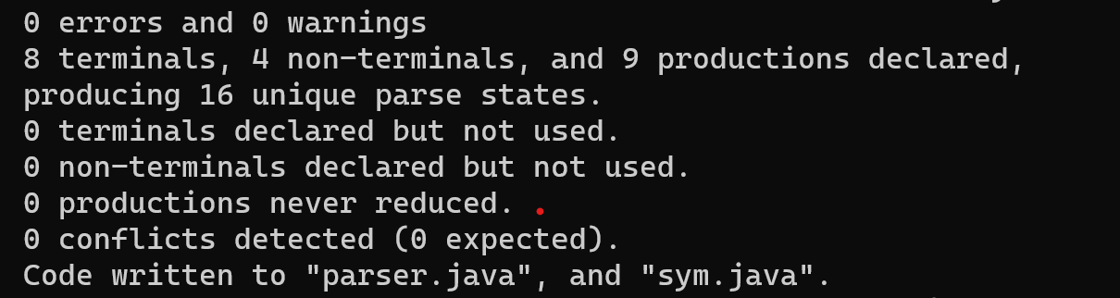

### Q3:

