Title
“Joint Audio-Phonetic Embeddings Explained”
Introduction:
Why does your phone sometimes confuse the word ‘will’ with ‘well’? Speech recognition systems do not just read words they try to understand how words sound which is much harder task. Many words sound similar but they are spelled differently like “will” and “well” which creates confusion for machines(computers). This project focuses on giving solution for this problem by teaching machines to identify sound similarity instead of just relying on text. The figure below shows human perception vs understanding of conventional ASR systems.

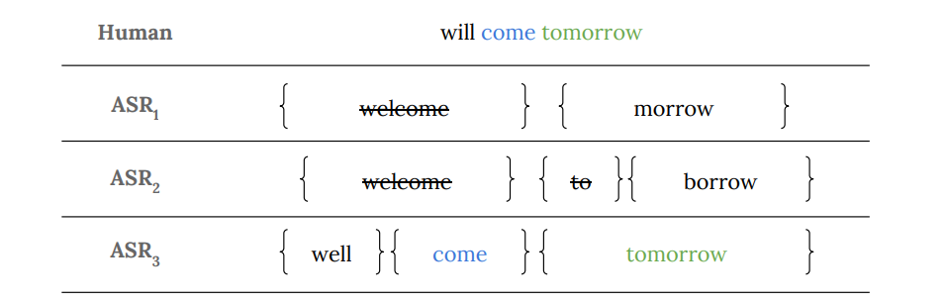
Figure 1: Human Auditory Understanding vs Conventional Automatic Speech Recognition (ASR) Systems

What is the core idea?
The concept is to represent words in a way that captures how they sound. Instead treating words as simple text, the system converts them into numerical representations(vectors). These vectors are arranged in a space where words having similar sound are placed close to each other, and words that sound different are placed distant from each other.
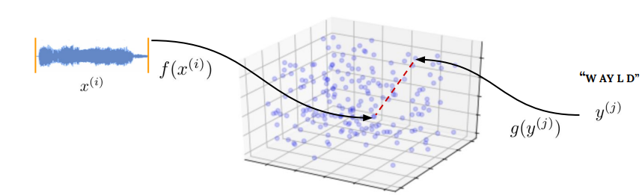
Figure 2: Joint Latent Embedding Space for Audio and Phonetic Representations

Preprocessing Pipeline
Before training, several preprocessing steps were applied to convert raw speech recordings into structured audio representations suitable for learning audio-phonetic embeddings.

Forced Alignment
To make our dataset useful, we needed timestamps for every single word. We used a tool called the Montreal Aligner (MFA). We give it the our audio file + the transcript to figure out: "The word 'hello' starts at 1.2 seconds and ends at 1.5 seconds".
We also used some pre-made Praat TextGrid files to help it stay accurate. Those are the files that tell the aligner where to look.
During this process, we cleaned up the data by cutting out silences, "ums" and any broken or jerk sounds.
So, we got a list of showing each word with its exact start and end time. This makes the dataset way more powerful for training speech models.
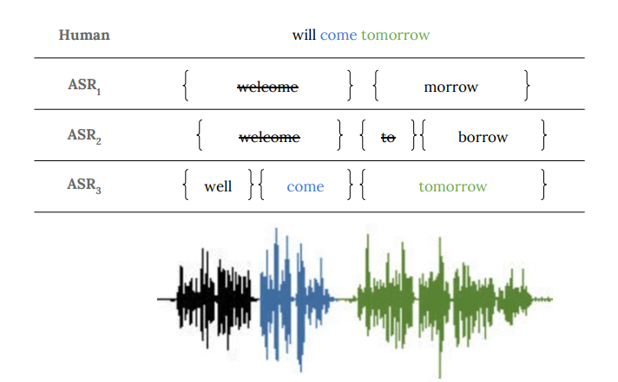
Figure 3: Forced Alignment Example Showing Word-Level Temporal Segmentation and Hard Negative Pair Formation

Audio Loading and Segmentation
Speech recordings from the LibriSpeech train-clean-100 dataset were loaded and standardized to a sampling rate of 16kHz. Using the alignment timestamps, individual word-level audio segments were extracted from each utterance.
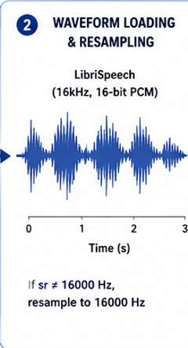
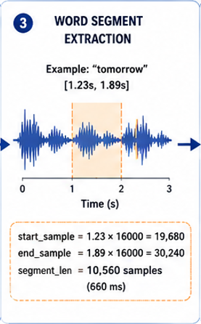
Figure 4: Audio Standardization to a 16 kHz Sampling Rate for Speech Processing
Figure 5: Word-Level Audio Segmentation Using Alignment Timestamps

Quality Filtering
To improve training quality, multiple filtering stages were applied:
Very short segments below 50ms were removed. Non-alphabetic tokens were discarded. Out-of-vocabulary words do not present in the CMU Pronouncing Dictionary were excluded. These steps ensured that only reliable and phonetically valid speech segments were retained.

Mel Spectrogram Generation
Each word segment was converted into a 40-channel Mel spectrogram using STFT-based feature extraction. The following parameters were used during feature computation:
Parameter | Value | Description
SAMPLE_RATE | 16,000 Hz | Standard speech sampling frequency
N_MELS | 40 | Number of Mel filterbank channels
WIN_LENGTH | 400 samples | 25ms analysis window
HOP_LENGTH | 160 samples | 10ms frame shift
MAX_FRAMES | 100 | Fixed spectrogram length
MIN_WORD_DUR | 0.05s | Minimum valid word duration
MAX_WORDS | 50,000 | Maximum processed word segments
Mel spectrograms provide a compact time-frequency representation that closely resembles human auditory perception.

Mel Spectrogram Generation
Each extracted word segment was transformed into a Mel spectrogram using Short-Time Fourier Transform (STFT)-based feature extraction. The audio was processed at a sampling rate of 16kHz with a 25ms analysis window (WINLENGTH = 400) and a 10ms frame shift (HOP_LENGTH = 160). A total of 40 Mel filter bank channels (NMELS = 40) were used to capture perceptually relevant speech frequencies. The generated Mel spectrograms provide a compact time-frequency representation that closely resembles human auditory perception and are widely used in speech recognition systems. To maintain consistent input dimensions for Siamese BiLSTM training, each spectrogram was normalized to a fixed length of 100 frames (MAXFRAMES = 100) using zero-padding or truncation techniques.
Formula used for MEL Scale conversion:
Mel = 2595 log₁₀ (1 + f/700)

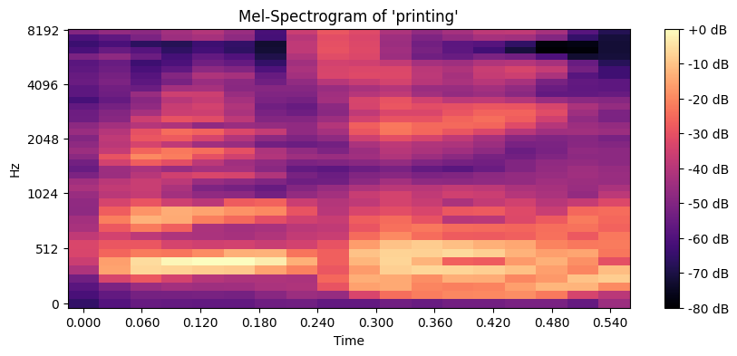
Figure 6: Mel Spectrogram Generation from Speech Signals Using STFT-Based Feature Extraction
Log Compression
Amplitude values were transformed into the logarithmic decibel (dB) scale to reduce dynamic range variations and improve neural network stability during training.
Amplitude ⇔ Decibel
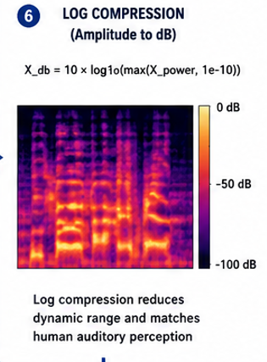
Figure 7: Logarithmic Decibel Compression for Dynamic Range Normalization

Fixed-Length Normalization
Since spoken words vary in duration, all spectrograms were normalized to a fixed size of (40 × 100) using zero-padding or truncation. This produced consistent input dimensions required for Siamese BiLSTM training.
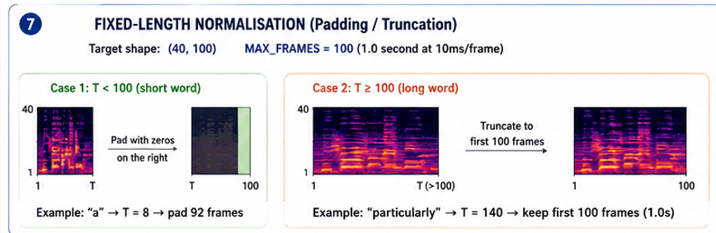
Figure 8: Fixed-Length Spectrogram Normalization Using Padding and Truncation

Word Bank Construction
Finally, the processed spectrogram tensors were organized into a word-level feature bank where each word maps to multiple Mel spectrogram instances. A total of 50,000 word segments were collected for downstream similarity learning and pair generation.

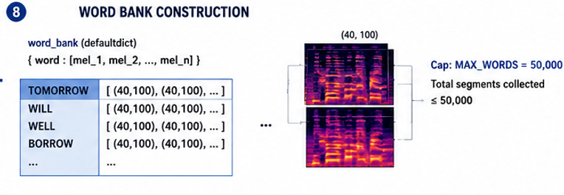
Figure 9: Construction of the Word-Level Mel Spectrogram Feature Bank

Further Methodology
Technology Used: Siamese Neural Networks
The main technology behind this concept is Siamese Neural Networks. It consists of two identical neural networks that takes two inputs (audio and phonetic) at the same time.
Each input is passed through a network to generate a respective vector. These vectors are then compared to find how similar the words sound. The network learns to adjust these vectors so that similar words are placed together, and different words are placed farther apart.
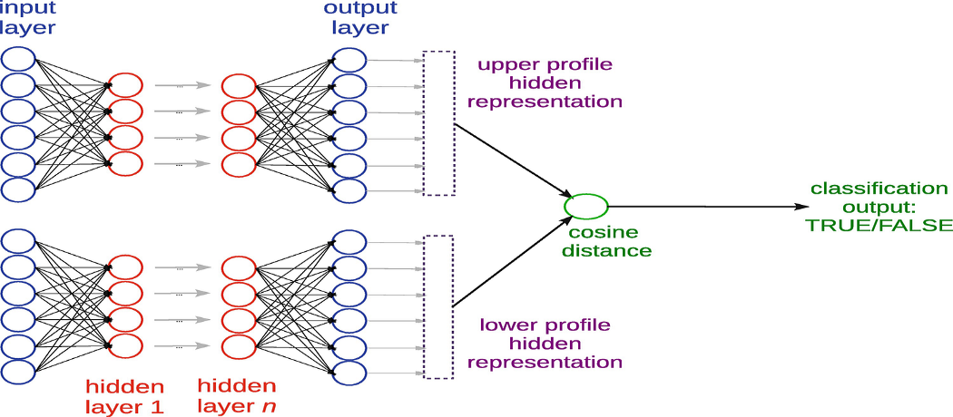
Figure 10: Architecture of the Siamese Neural Network for Audio–Phonetic Similarity Learning
How the Model Learns
The model learns by comparing pairs of examples:
Positive pairs: Words that sound the same are pushed closer together Example: The audio for “cardiac” and the phonetic text ‘K AA R D IY AE K’.
Hard negative pairs: Words that sound almost the same but are not, used as challenge cases Example: “will” vs “well” Easy negative pairs: Words that sound completely different are pushed far apart Example: “cardiac” vs “banana”.
During training both audio and phonetic text are mapped into the same vector space. If two inputs sound similar, their vectors end up close together.
Example of Positive Pairs:
Audio ("cardiac") → [0.21, -0.77, 1.09, ...]
Phonetic ("K AA R D IY AE K") → [0.20, -0.78, 1.10, ...]
Because the vectors are nearly identical, the model knows they represent the same sound.
The system uses a similarity measure (cosine distance) to compare vectors. During training, it faces both clean and noisy data which allows it to perform well even when real world input is not clean.
Cosine Distance = cos(θ) = A.B / ||A|| ||B||
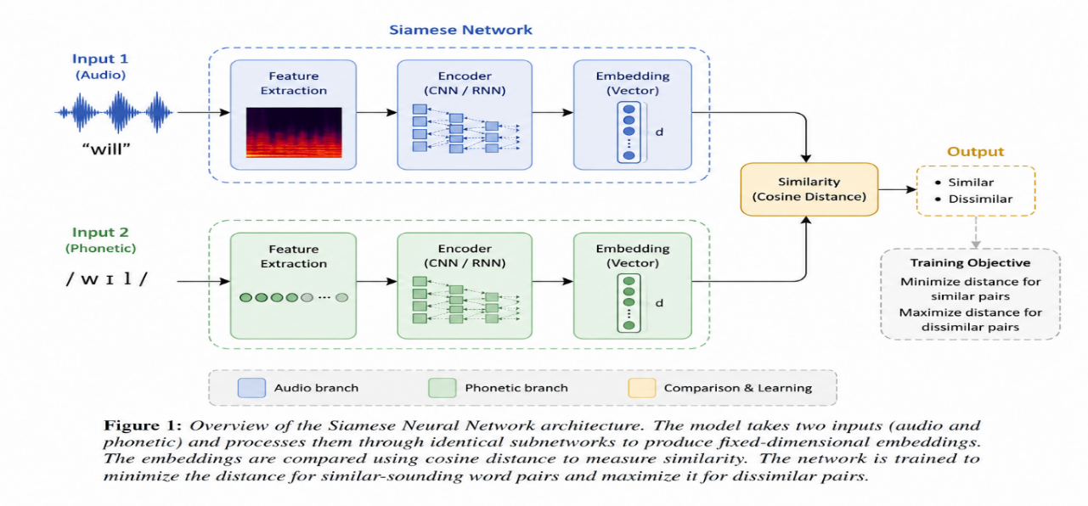
Figure 11: Joint Audio–Phonetic Embedding Framework Using Siamese Neural Networks and Cosine Similarity

Why This Matters?

Real-World Application: Intelligent Emergency Call Detection
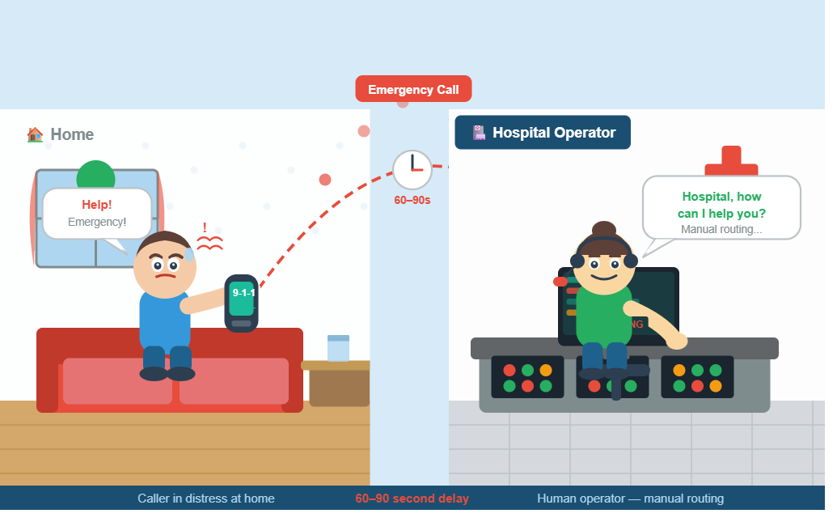
Figure 12: "One panicked call. One tired operator. 60 seconds lost."
- One important application of this technology is in hospital emergency response systems. In many hospitals, emergency calls are still manually handled by human operators, which can introduce delays during critical situations like cardiac arrest, respiratory failure or other emergencies.
- Traditional speech recognition systems often struggle in noisy environments, especially when callers speak with stress, panic or regional accents. Since the proposed system focuses on pronunciation-based similarity learning rather than exact word matching, it becomes more robust in real-world hospital conditions.
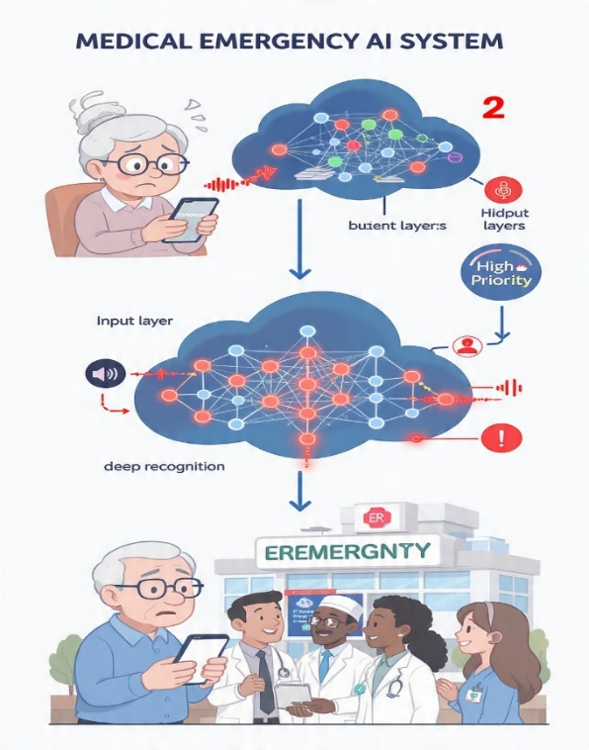
Figure 13: Real-Time Emergency Keyword Detection in Hospital Response Systems
- By learning joint phonetic embeddings, the system can detect emergency related keywords even when pronunciation varies or audio quality is poor. For example, words such as “help,” “emergency,” “cardiac,” or oxygen can still be identified despite background noise or accent differences.
- The proposed model can be deployed on edge devices such as Raspberry Pi to perform real-time emergency keyword detection without relying on cloud infrastructure. Once an emergency phrase is detected, the system can automatically trigger alerts to the relevant hospital department, reducing response time and improving patient safety.
Conclusion:
In high-stakes environments such as hospitals, even small improvements in speech understanding can save valuable response time. By learning pronunciation-aware representations instead of relying only on exact words, audio-phonetic embedding systems offer a more robust and human-like approach to speech understanding in noisy real-world conditions.
Literature Review
- The research paper "SCRAPS: Speech Contrastive Representations of Acoustic and Phonetic Spaces
Vallas -Perez et al. in 2023 gave an end-to-end CLIP (Contrastive Language-Image Pre-training) based architecture built to learn a shared latent space in between phonetic sequences and acoustic mel spectrograms. He used a proprietary data set of 60k hours of speech in English. The model employs dual encoders which consist of 3-layered Transformer backbone and a shared LSTM integrator used to produce 1024-unit resulting embeddings. Evaluations demonstrate high sensitivity to phonetic accuracy of 91.06% score drop when 20% of phonemes are randomly substituted along with maintaining robust performance against acoustic interference with a 10% drop in the presence of 75% Gaussian Noise. Further it utilizing the model’s pre-trained phonetic embeddings in downstream TTS tasks significantly boosted convergence, having initial errors drops 250000 training steps earlier than baseline models.

(2)
CLAP (Contrastive Language-Audio Pretraining)
Yusong Wu proposes CLAP (Contractive Language-Audio Pretraining) which is a multimodel deep learning framework that learns joint representations of audio and text using contrastive learning. It utilizes a shared 512-dimensional latent embedding space for contrastive learning. The authors introduced LAION-Audio-630k which is the largest public audio-text dataset which contains 633526 audio-caption pairs and 4325.39 hours of audio data. The system utilizes two audio encoders. One is PANN(CNN-based, 2048 dimensional output) and HTSAT(Transformer based, 768-dimensional output) along with transformer-based text encoders including BERT, RoBERTa, and CLIP transformer where RoBERTa achieved the best performance. Audio signals are converted into Mel spectrograms using 48kHz sampling rate, 1024 window size, 480 hop size and 64 Mel bins before feature extraction. The architecture uses 2-layered MLP projection layers with ReLU activation to align audio and text embeddings. Model training is performed using a contrastive loss function with a learnable temperature parameter τ which maximizes similarity between correct audio-text pairs while minimizing incorrect matches. To handle variable length audio, the paper introduces Attentional Feature Fusion which combines global and local audio representations through fusion equation. For audio clips longer than 10 seconds, the model extracts three local 10 second segments from different temporal regions and fuses them with globally downsampled features. The authors also proposed Keyword to caption(K2C) augmentation using the T5 language model to generate natural language captions from labels which improves semantic richness and training efficiency. Using the adam optimizer, learning rate 10⁻⁴ with 45 epochs and batch size upto 4608. The proposed model achieved state of the art results including 91.0% zero shot accuracy on ESC-50 and strong text to audio retrieval performance.
Major Difference:
Unlike SCRAPS: Speech Contrastive Representations of Acoustic and Phonetic Spaces, which learns shared representations between acoustic speech and phonetic sequences, and CLAP: Contrastive Language-Audio Pretraining, which focuses on aligning general audio inputs with natural language text captions, the proposed approach specifically uses speech audio and phonetic word representations as input modalities to perform pronunciation-based similarity learning at the word level. The proposed system employs Siamese Neural Networks along with hard negative mining techniques to better distinguish confusing similar-sounding words for improved speech discrimination.
Bullets:
- SCRAPS: uses acoustic speech signals and phonetic sequences as input modalities to learn shared multimodal speech representations through contrastive learning.
- CLAP: uses general audio inputs and natural language text captions as input modalities to learn semantic relationships between audio and language representations.
- The proposed approach uses speech audio and phonetic word representations as input modalities to specifically learn pronunciation-based similarity at the word level.
- Unlike SCRAPS and CLAP, which mainly focus on large-scale multimodal representation learning, the proposed system emphasizes direct comparison of similar-sounding words using Siamese Neural Networks.
- The proposed approach also incorporates hard negative mining techniques to better distinguish confusing word pairs such as “will” and “well” for improved speech discrimination.

