|  |
| --- |
|  |
| Assessment |
| Retail store discount |
|  |
|  |
|  |

|  |
| --- |
|  |

1.Download project from GitHub

2.Go to the root directory of the project **spring-boot-rest-example-master**

* RUN mvn clean package
* RUN mvn spring-boot:run

3. Once server started , open Chrome browser ,

<http://localhost:8090/swagger-ui.html#!/discount/getDiscountUsingGET>

You will see the Swagger screen for testing the application.You need to enter

1. TotalAmount [ Total Bill Amount]
2. GroceryAmount [In the Total bill ,what is the grocery amount]
3. CustomerID [Enter the customer id]

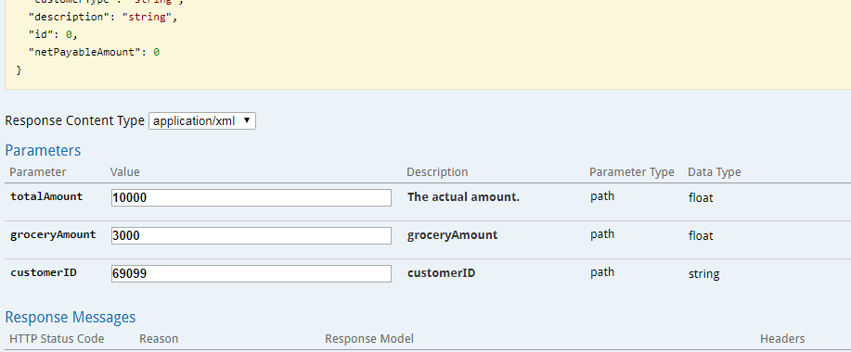

You will get back below response in the **Swagger screen ,** it shows the net payable amount

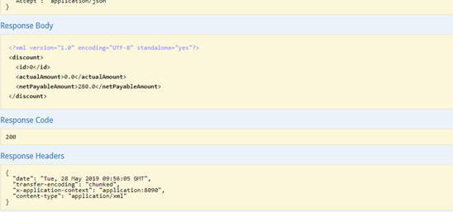

The REST Services Code from Eclipse is attached for your quick understanding

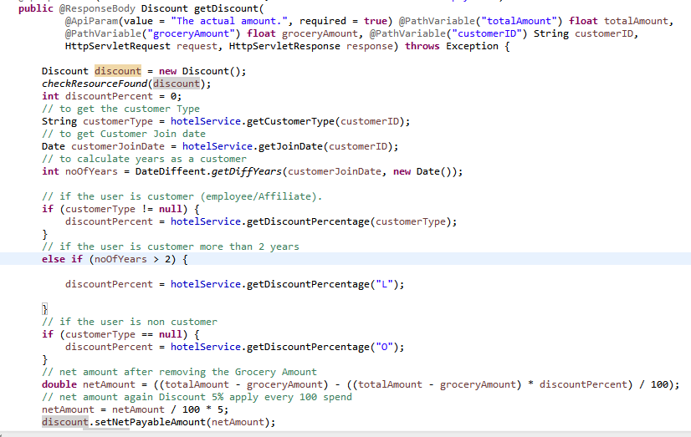

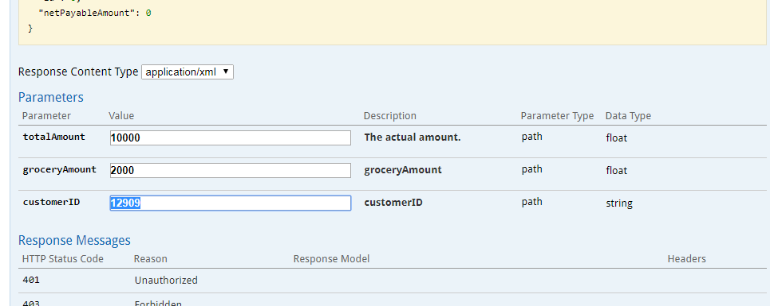

UNIT TESTING CODE /TEST CASE

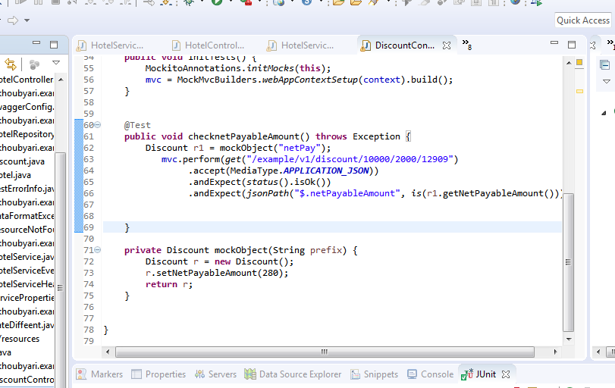

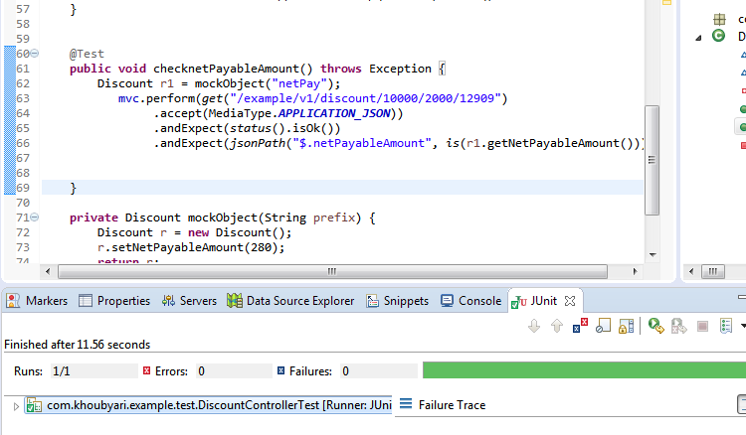

UML DIAGRAMS

