**Course Title**:Telecommunication Engineering **Assignment Name:** Controller REST API **Assignment No:03**

# Name:MD. Ansar Ali ID:IT-17041

**Theory:-**

**OpenFlow**: **Reactive versus Proactive**

OpenFlow is still the only one wire protocol that has a reasonably good chance at becoming the de-facto open SDN southbound messaging standard. When using OpenFlow to populate tables in switches there are essentially three modes of operation:

**Reactive Flow Instantiation**: When a new flow comes into the switch, the OpenFlow agent software on the switch does a lookup in the flow tables. If no match for the flow is found, the switch creates an OFP packet-in packet and sends it off to the controller for instructions.

**Proactive Flow Instantiation**: Rather than reacting to a packet, an OpenFlow controller

could populate the flow tables ahead of time for all traffic matches that could come into the switch. By pre-defining all of the flows and actions ahead of time in the switches flow tables, the packet-in event never occurs. The result is all packets are forwarded at line

rate.

**Hybrid flow instantiation**: A combination of both would allow for flexibility of reactive for particular sets a granular traffic control that while still preserving low-latency forwarding for the rest of the traffic.

# Controller: REST API

**Application program interface (API**) is an interface presented by software (such as a network operating system) that provides the capability to collect information from or

make a change to an underlying set of resources.

**APIs in the context of SDN:** In an open SDN model, a common interface discussed is the northbound interface (NBI). The NBI is the interface between software applications, such as operational support systems, and a centralized SDN controller.

**Datapath Identifier of Openflow Switch:** Each OpenFlow instance on a switch is identified by a Datapath Identifier. This is a 64 bit number determined as follows according to the OpenFlow specification: “The datapath_id fleld uniquely identifies a datapath.

5. Questions

# 1. Explain the advantages of REST API of the Controller.

**Ans:**

One of the most popular types of [API](https://www.mulesoft.com/platform/api) is REST or, as they’re sometimes known, RESTful APIs. REST or RESTful APIs were designed to take advantage of existing protocols. While REST - or Representational State

Transfer - can be used over nearly any protocol, when used for web APIs it typically takes advantage of HTTP. This means that developers have no need to install additional software or libraries when creating a REST API.

There are 6 key constraints to think about when considering whether a RESTful API is the right [type of API](https://www.mulesoft.com/resources/api/types-of-apis) for your needs:

**Client-Server**: This constraint operates on the concept that the client and the server should be separate from each other and allowed to evolve individually.

**Stateless**: REST APIs are stateless, meaning that calls can be made independently of one another, and each call contains all of the data necessary to complete itself successfully.

**Cache**: Because a stateless API can increase request overhead by handling large loads of incoming and outbound calls, a REST API should be designed to encourage the storage of cacheable data.

**Uniform Interface**: The key to the decoupling client from server is having a uniform interface that allows independent evolution of the application without having the application’s services, or models and actions, tightly coupled to the API layer itself.

**Layered System:** REST APIs have different layers of their architecture working together to build a hierarchy that helps create a more scalable and modular application.

**Code on Demand**: Code on Demand allows for code or applets to be transmitted via the API for use within the application.

Unlike SOAP, REST is not constrained to XML, but instead can return XML, JSON, YAML or any other format depending on what the client requests. And unlike RPC, users aren’t required to know procedure names or specific parameters in a specific order.One of the disadvantages of RESTful APIs is that you can lose the ability to maintain state in REST, such as within sessions.

# Question 2: What is the difference between sdn and openflow? Ans:-

Software defined networking architecture separates control plane (controller) and data plane (switches). The most fundamental rule of SDN architecture is:- Data plane is directly programmable by controller and centrally managed. Controller provide central view of the network and also allows switches to be directly controllable via network application written on top of Controller.

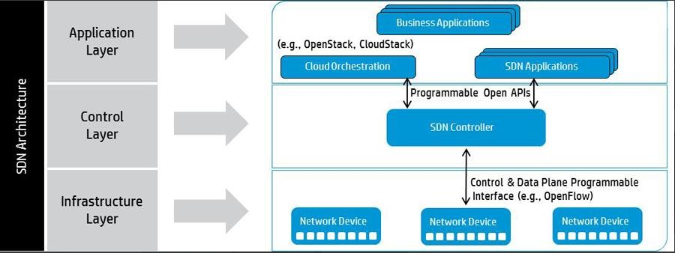

Now lets come to Openflow.

Openflow is a forwarding protocol, which is being used for the interaction between data plane and control plane. Any network is said to be openflow network only if the switches and controller in the network supports openflow.

SDN and OpenFlow are prone to be confused and misunderstood. Take a look at SDN vs. OpenFlow, the two are indeed interconnected.

**Conclusion**

Even though REpresentational State Transfer, also known as REST, is often referred to as a protocol, it’s an architectural style. It defines how applications communicate over the Hypertext Transfer Protocol (HTTP). Applications that use REST are loosely-coupled and transfer information quickly and efficiently.This interface overcomes the disadvantages **SOAP** exhibited, such as the need for clients to know the operation semantics as a pre-requisite for its use, or the need for ports for different types

of notifications. In addition, with a few operations, **REST** can handle many resources, while **SOAP** needs many operations to accomplish that.