**Lab Report No:** 04

**Lab Report on:** Introduction to Mininet.

**Name:** MD Ansar Ali

**ID:** IT-17041

**Objective:**

In this lab we will learn about installation process of Mininet in Linux. After completion of installation,we will apply some mininet command to experiment the process.

1. Installation process:

$ sudo apt-get install git

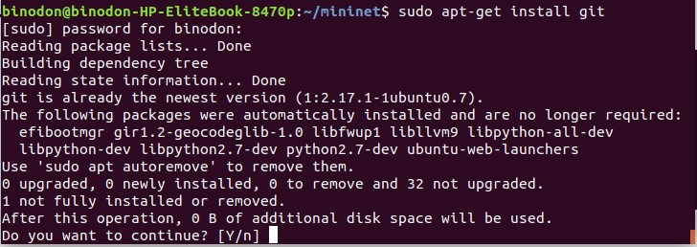

1. $ sudo mn

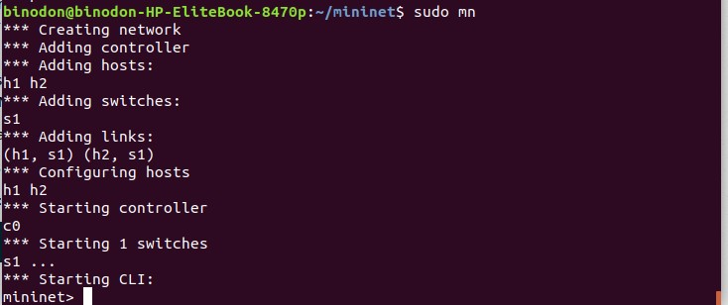

3. mininet> help

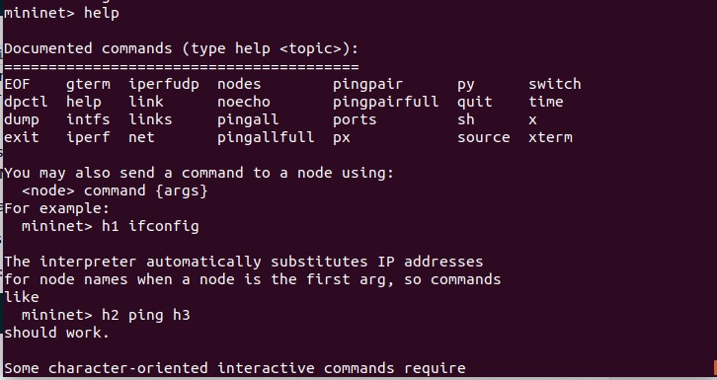

1. mininet> nodes



1. mininet> net

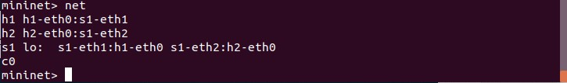

1. mininet> net



1. mininet> h1 ifconfig -a

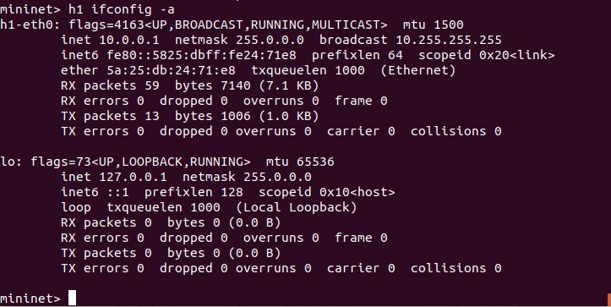

1. mininet> s1 ifconfig -a

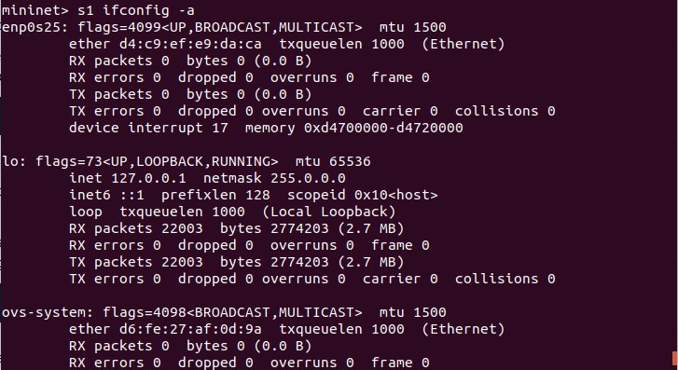

1. mininet> h1 ps -a

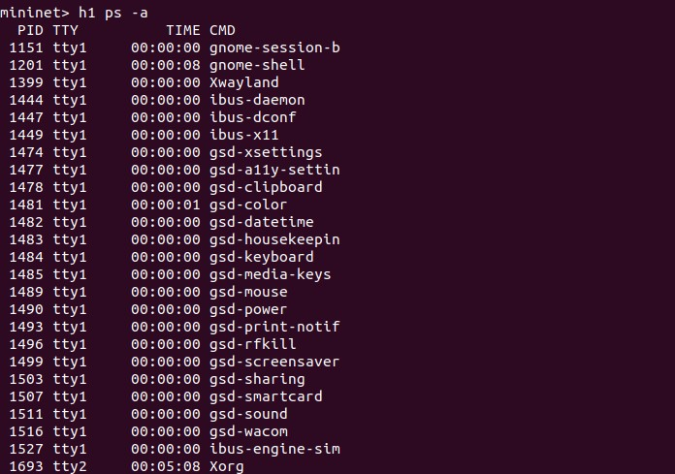

1. mininet> s1 ps -a

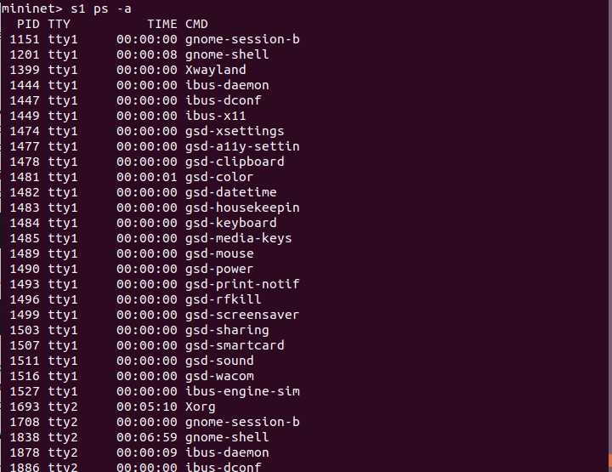

1. mininet> h1 ping -c 1 h2

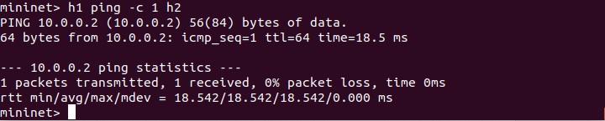

1. mininet> pingall

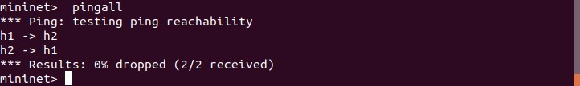

1. mininet> h1 python -m SimpleHTTPServer 80 &

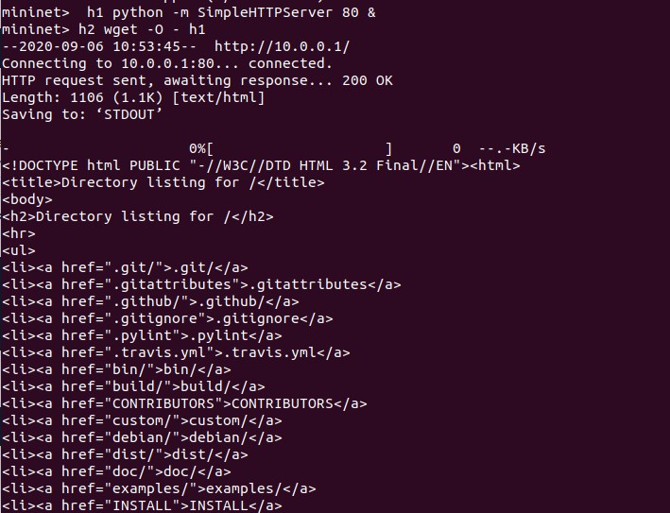

1. mininet> h1 kill %python

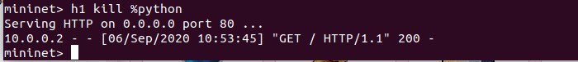

1. mininet> exit

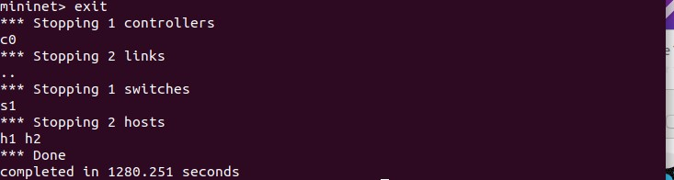

1. $ sudo mn -c

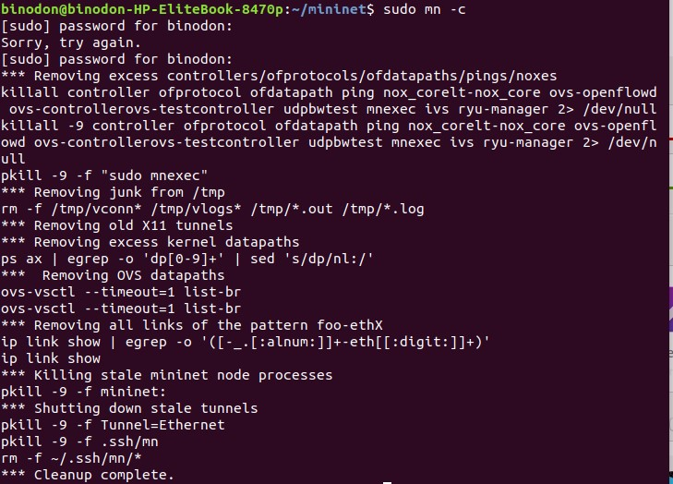

1. $ sudo mn --test pingpair

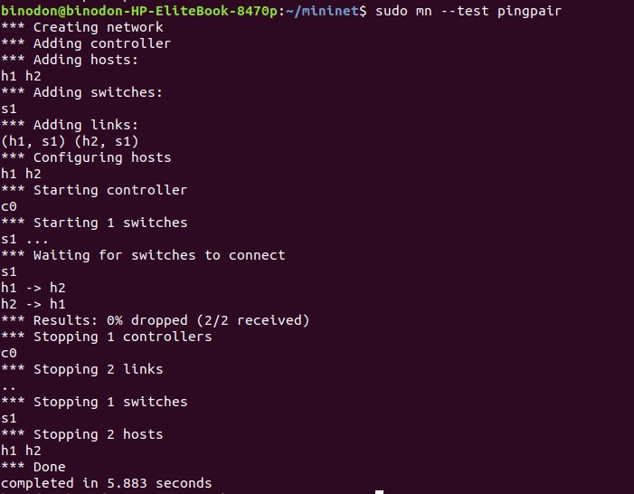

1. $ sudo mn --test iperf

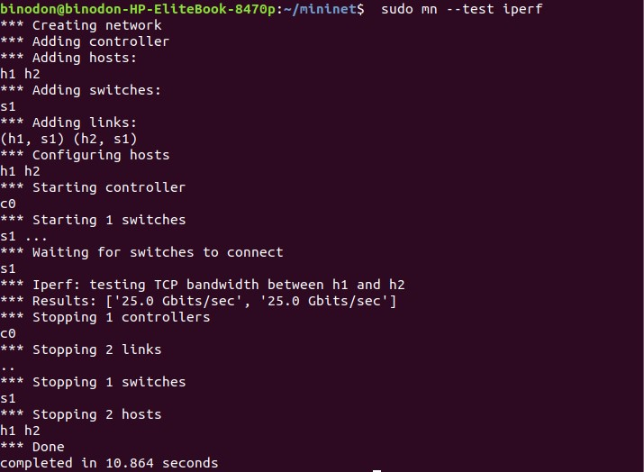

1. $ sudo mn --test pingall --topo single,3

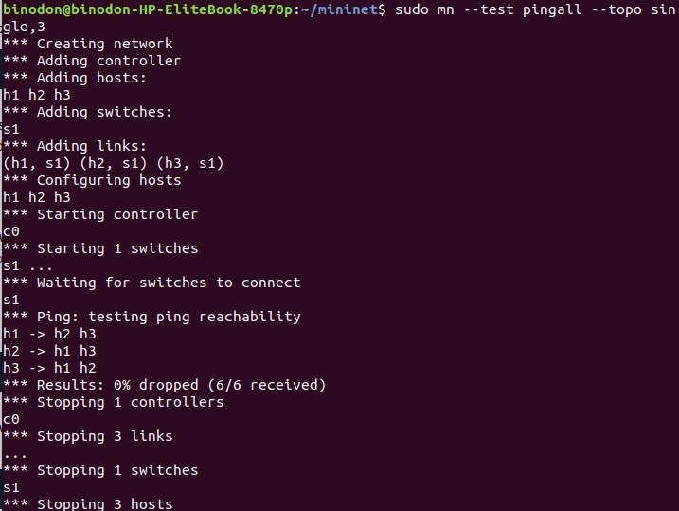

1. $ sudo mn --test pingall --topo linear,

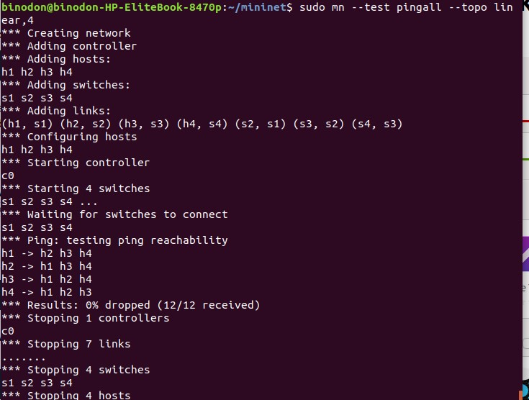

1. $ sudo mn --link tc,bw=10,delay=10ms

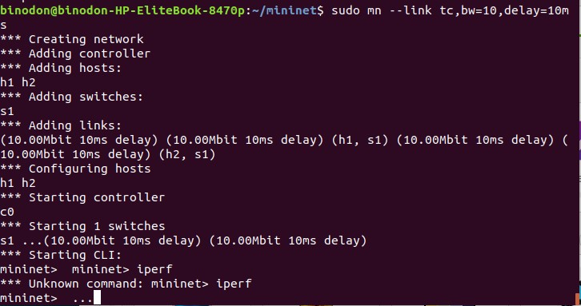

1. $ sudo mn -v debug

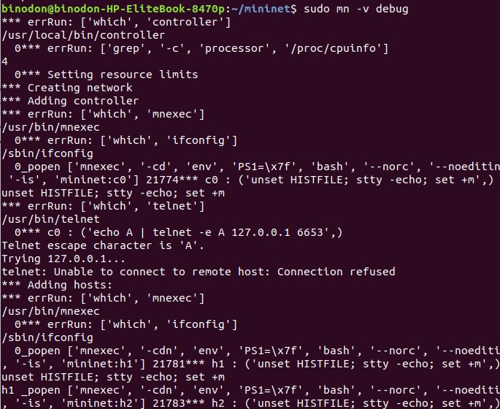

1. mininet> exit

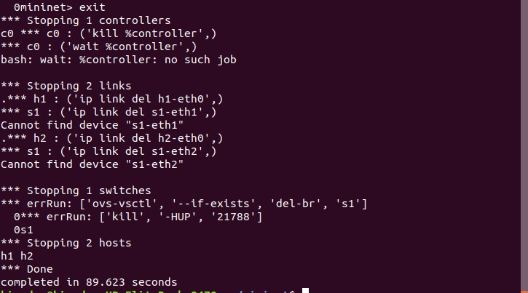

1. $sudo mn --custom ~/mininet/custom/topo-2sw-2host.py --topo mytopo --test pingall

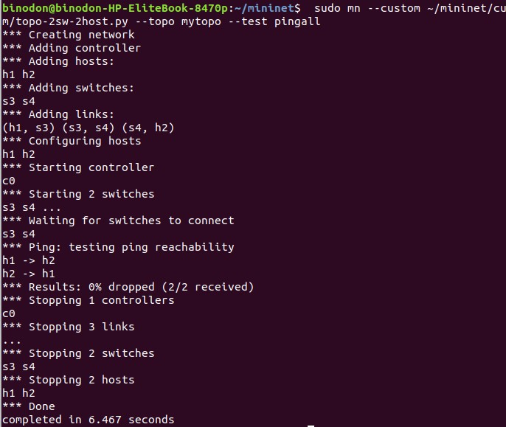

**Conclusion:**

In this lab we learn about installation process of Mininet in Linux. We face some problem in installation process but successfully did it. It will help to acsess with Wireshark and interact with Hosts and Switches.