**Lab Report No:** 07

**Lab Report on:** Software Defined Network ( SDN Mininet with Ryu Controller)

**Name:** MD Ansar Ali

**ID:** IT-17041

**Objective:** In this lab we will learn about installation process of Software Defined Network (Mininet with Ryu Controller).First we will install python pip3.Using pip3 we install ryu controller.After thet we install Mininet .We will apply some command to experiment about this process.

# Installation process:

$ sudo apt install python3-pip



2.Now we may install Ryu Controller by following instruction

$ sudo pip3 install ryu



3.After Completing installation Now We can check the version:

$ ryu-manager --version



**Install Mininet:**

1.$ git clone git://github.com/mininet/mininet





Mininet Already exists in my system

2.$ git tag



3.$ git checkout -b 2.2.2 2.2.2

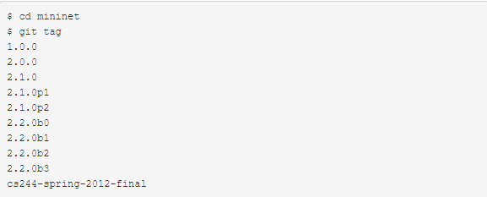

**Application:**

mininet> pingall



**Conclusion:**

In this lab we learn how to install SDN and give command through it.It provides admins with granular control over the way switches handle data, giving them the ability to automatically prioritize or block certain types of packets. Using various installation process we also test some command through it.