**Soble edge detection algorithm:**

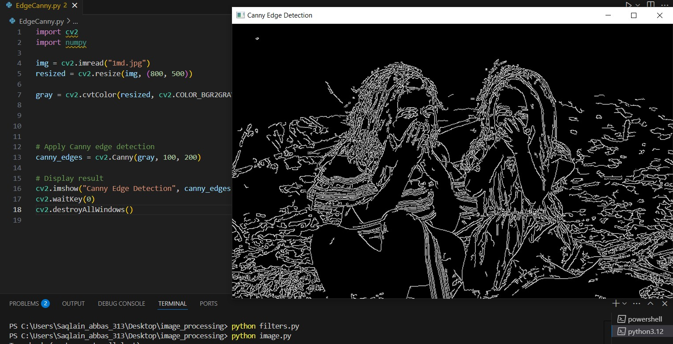

**Canny edge detection:**

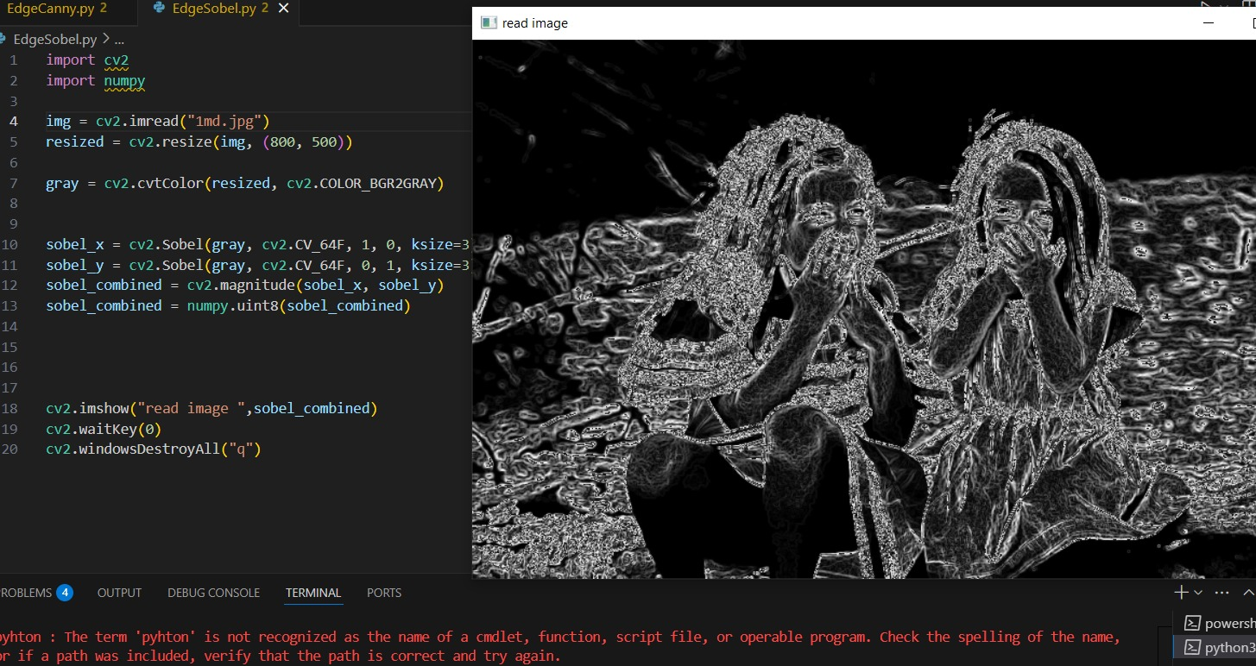

**Difference:**  
**Sobel edge detection** is a simple method that detects edges by checking changes in pixel intensity. It examines both horizontal and vertical directions to highlight where edges occur. This technique tends to produce thick and soft edges and is more sensitive to noise, which can affect the clarity of the results. It's generally good for quick, rough edge maps and is easy to implement, making it suitable for basic applications.

**Canny edge detection**, in contrast, is a more advanced and accurate method. It follows a multi-step process that includes image smoothing, gradient calculation, thresholding, and edge tracking. This approach not only reduces noise before detecting edges but also focuses on preserving strong, meaningful edges while removing weak or irrelevant ones. The result is sharp, clean, and well-defined edges. While it is more complex and computationally heavier than Sobel, Canny is ideal for high-accuracy edge detection, such as in object recognition tasks.