**Comsats University Islamabad Abbottabad Campus**

**Software Requirements Specification**

(SRS Document)

Tours and Travelling Site

Arsalan Saleem SP23-BSE-070

Yawar Hussain SP23-BSE-122

Supervisor

MZ

**Bachelor of Software Engineering (Non-Engineering)**

Contents

1. Introduction 2

2. Overall Description 2

3. Specific Requirements 4

# Introduction

* 1. **Purpose:**

The purpose of this tour and travelling website is to provide a digital platform where tourists can easily search, plan, and book their travel experiences. It connects tourists with hotels, travel agencies, and tour guides to streamline the travel planning process. The website aims to offer convenience, real-time information, and secure booking services to enhance the overall tourism experience.

* 1. **Scope**

This website will serve as a one-stop platform for:

* Browsing destinations, hotels, and travel packages.
* Booking hotel rooms and tour services.
* Viewing reviews, ratings, and travel tips.
* Managing user profiles and booking history.
* Supporting multi-language and multi-currency features (optional for future upgrade).
* Providing admin control to manage hotels, tours, users, and bookings.

This system will be accessible through web browsers on both desktop and mobile devices. It is designed for use by:

* **Tourists**: To explore destinations, book hotels, and plan tours.
* **Hotels and Travel Agencies**: To list their services and manage bookings.
* **Admins**: To manage and monitor platform content and users.
  1. **Definitions**
* **Tourist**: A user who visits the website to explore destinations, book travel packages, or reserve hotel accommodations.
* **Tour Package**: A pre-designed travel plan that includes destinations, hotel stays, and possibly guided tours and transport services.
* **Hotel**: A service provider that offers lodging and accommodation facilities to tourists and can register/list on the website.
* **Booking**: The process of reserving a hotel room or a tour package through the website.
* **Admin Panel**: A secured backend dashboard for website administrators to manage users, hotels, tour packages, and site content.
* **Travel Agency**: A company or individual offering tour services, including transportation, guides, or full travel packages, listed on the platform.
* **User Profile**: A personal account for tourists to manage their bookings, preferences, and reviews.
* **Blog:** A tourists can watch the blog and apply for customize booking for own budget range

# Overall Description

* 1. **Product Perspective:**

This tour and travelling website is a standalone web-based application designed to simplify the process of planning and booking tours and hotel stays. It integrates various services such as hotel listings, tour packages, reviews, and user account management. The product will interact with:

* Hotel management systems (to update room availability).
* Third-party payment gateways (for secure online transactions).
* Email or SMS services (for sending confirmations and updates).

This system does not rely on any existing software but may optionally integrate APIs (e.g., Google Maps API for location tracking).

* 1. **Product Functions:**

The main functions of the product include:

* **User Registration/Login**: Tourists, hotels, and admins can create and access accounts.
* **Search and Filter**: Users can search destinations, hotels, or tours using filters like date, price, rating, or location.
* **Booking System**: Tourists can book hotel rooms or tour packages.
* **Hotel/Tour Listing Management**: Hotels and travel agencies can add, update, or remove their listings.
* **Review and Rating System**: Tourists can leave feedback on hotels or tours.
* **Admin Dashboard**: Admins can manage users, listings, and system data.
* **Payment Integration**: Users can make secure payments for bookings.
* **Notifications**: Users receive email/SMS updates about bookings and offers.
* **Blog:** Tourists can watch and read the blog to explore the places
* **Customize Booking**: Tourists can customize own trip plan
  1. **User Classes:**

The system will serve three main types of users:

1. **Tourists (End Users):**
   * Search and book hotels or tour packages.
   * View and post reviews.
   * Manage profile and booking history.
2. **Service Providers (Hotels & Tour Agencies):**
   * Register and list their services (rooms, packages).
   * Manage availability and pricing.
   * View and manage customer bookings.
3. **Admin:**
   * Oversee all platform activities.
   * Approve/reject listings.
   * Monitor transactions and user activities.
   * Handle user issues and reports.
   1. **Assumption & Dependencies:**

**Assumptions**:

* Users have stable internet access.
* Hotels and travel agencies will regularly update their listings and availability.
* Users will provide valid contact and payment information.
* The platform will comply with local laws and tourism regulations.

**Dependencies**:

* Payment gateway services (e.g., Stripe, PayPal).
* Email/SMS service for notification.
* External APIs (e.g., Google Maps, Weather).
* Reliable hosting/server infrastructure.
* Modern web browser for accessing the platform.

# Specific Requirements

* 1. **Functional Requirements**
* These are the core features the system must perform:
* User Registration and Login
  + - * Users (Tourists, Hotels, Admin) can register and log in.
      * System validates email and password.
* Search Functionality
  + - * Tourists can search for destinations, hotels, and tour packages.
      * Filters include price, location, dates, rating, etc.
* Booking System
  + - * Tourists can select and book hotels or tour packages.
      * Bookings are saved under the user's account.
      * Confirmation is sent via email/SMS.
* Listing Management (Hotels & Tours)
  + - * Service providers can add, update, and delete hotel rooms or tour packages.
      * Admin reviews and approves listings.
* Review and Rating
  + - * Tourists can write reviews and give ratings after completing bookings.
      * Reviews are shown on listings.
* Admin Panel
  + - * Admin can manage users, bookings, listings, and site content.
      * Admin can suspend or delete accounts.
* Payment System
  + - * Integration with secure payment gateways.
      * Invoices and receipts generated automatically.
* Notification System
  + - * Users get booking confirmations, reminders, and promotional emails.

Blog System

* + - * Tourists can watch the blog and customize own trip plan

Explore the places

Tourists

* 1. **Non-Functional Requirements (Performance, Security, Usability)**

**Performance**

* Website should respond within 2–3 seconds for normal actions (search, view).
* Should handle up to 10,000 concurrent users.

**Security**

* Passwords stored securely (e.g., using hashing).
* All payments processed via secure HTTPS.
* User roles strictly separated (Tourist, Hotel, Admin).
* User data protection compliant with data privacy laws.

**Usability**

* Simple and clean interface, mobile-friendly design.
* Easy navigation with clear categories and filters.
* Language support (English by default; others optional in future).
* Help section or chatbot for user support.
  1. **External Interface Requirements (UI, Hardware, Software)**

**User Interface (UI)**

* Responsive web design (HTML5, CSS3, JavaScript/React).
* User dashboards for tourists, hotels, and admin.
* Forms for search, booking, listing, and feedback.
* Booking calendar, maps integration.

**Hardware Interface**

* No special hardware required.
* Compatible with desktop, laptops, tablets, and smartphones.

**Software Interface**

* Web browsers: Chrome, Firefox, Safari, Edge.
* Server: Apache/Nginx with PHP, Node.js, or Django (based on your choice).
* Database: MySQL, PostgreSQL, or MongoDB.
* APIs: Payment Gateway API, Google Maps API, Email/SMS services.

**Fully Address UseCase**

#### ****1. Customer Use Cases****

| ****Section**** | ****UC-T1: Register Account**** |
| --- | --- |
| ****Actor**** | Customer |
| ****Description**** | Tourist creates an account with email, password, and personal details. |
| ****Preconditions**** | User is not logged in. |
| ****Postconditions**** | Account is created; confirmation email sent. |
| ****Main Flow**** | 1. User selects "Register" 2. Enters email, password, name, phone 3. Submits form 4. System validates data 5. Sends confirmation email |
| ****Alternative Flow**** | A1. Email exists: - System shows "Email already registered" - Returns to step 2 |
| ****Exception Flow**** | E1. Server error: - Displays "Try again later" - Logs error |
| ****Actual Result**** | Account record created in UserDB; email queue triggered. |

| ****Section**** | ****UC-T4: Book Hotel**** |
| --- | --- |
| ****Actor**** | Customer |
| ****Description**** | Tourist reserves a hotel room and completes payment. |
| ****Preconditions**** | Hotel is available for booking; user is logged in. |
| ****Postconditions**** | Booking confirmed; invoice generated. |
| ****Main Flow**** | 1. Select dates/room. 2. Enter guest details. 3. Choose payment method. 4. Process payment. 5. Receive confirmation. |
| ****Alternative Flow**** | A1. Payment failed: - Retry payment - Select alternate card |
| ****Exception Flow**** | E1. Room no longer available: - Show "Unavailable" - Suggest alternatives |
| ****Actual Result**** | Booking record created; room inventory updated; payment logged. |

#### ****2. Hotel/Travel Agency Use Cases****

| ****Section**** | ****UC-H2: Add Hotel Room**** |
| --- | --- |
| ****Actor**** | Hotel Manager |
| ****Description**** | Hotel adds a new room type with pricing and availability. |
| ****Preconditions**** | Hotel account is active. |
| ****Postconditions**** | Room is listed for booking. |
| ****Main Flow**** | 1. Login to dashboard 2. Select "Add Room" 3. Upload photos, set price/amenities 4. Submit for admin approval |
| ****Alternative Flow**** | A1. Missing required fields: - System highlights errors - Block submission |
| ****Exception Flow**** | E1. Storage limit exceeded: - Compress images automatically |
| ****Actual Result**** | Room added to InventoryDB with "Pending Approval" status. |

| ****Section**** | ****UC-H6: Manage Tour Package**** |
| --- | --- |
| ****Actor**** | Travel Agency |
| ****Description**** | Agency adds/updates/removes a tour package. |
| ****Preconditions**** | Agency account is active. |
| ****Postconditions**** | Package is updated in listings. |
| ****Main Flow**** | 1. Login → Tour Manager 2. Create/edit package 3. Set destinations/dates 4. Publish changes |
| ****Alternative Flow**** | A1. Invalid location: - Show Google Maps validation error |
| ****Exception Flow**** | E1. Concurrent edit conflict: - Lock record for editing |
| ****Actual Result**** | TourPackage record updated; notifications sent to subscribers. |

#### ****3. Admin Use Cases****

| ****Section**** | ****UC-A1: Approve Hotel Listing**** |
| --- | --- |
| ****Actor**** | Admin |
| ****Description**** | Admin verifies and approves new hotel registrations. |
| ****Preconditions**** | Hotel submits registration request. |
| ****Postconditions**** | Hotel listing goes live. |
| ****Main Flow**** | 1. Review documents 2. Verify license 3. Approve/reject 4. Notify hotel |
| ****Alternative Flow**** | A1. Rejected: - Specify reasons - Allow resubmission |
| ****Exception Flow**** | E1. Fraud detected: - Permanently blacklist |
| ****Actual Result**** | Hotel status changed to "Active"; added to search results. |

| ****Section**** | ****UC-A5: Monitor Transactions**** |
| --- | --- |
| ****Actor**** | Admin |
| ****Description**** | Admin tracks bookings, payments, and refunds. |
| ****Preconditions**** | Transactions exist in the system. |
| ****Postconditions**** | Financial reports generated. |
| ****Main Flow**** | 1. Select date range 2. Filter by type (hotel/tour) 3. Export CSV/PDF |
| ****Alternative Flow**** | A1. Dispute detected: - Flag for investigation |
| ****Exception Flow**** | E1. Data corruption: - Restore from backup |
| ****Actual Result**** | Report generated with totals, commissions, and trends. |

### ****4. Hotel Manager Use Cases****

| ****Use Case ID**** | ****Use Case Name**** | ****Actor**** | ****Main Flow**** | ****Alternative Flows**** | ****Exceptions**** | ****Postconditions**** |
| --- | --- | --- | --- | --- | --- | --- |
| ****UC-HM1**** | Add Room Type | Hotel Manager | 1. Login to vendor portal 2. Navigate to "Room Management" 3. Enter room details (type, price, capacity) 4. Upload photos 5. Submit for admin approval | A1. Missing required fields: System highlights errors and blocks submission | E1. Image upload fails: Auto-retry with reduced resolution | New room appears in "Pending Approval" section |
| ****UC-HM2**** | Update Pricing | Hotel Manager | 1. Select room from dashboard 2. Edit price/seasonal rates 3. Specify effective dates 4. Confirm changes | A1. Invalid price range: Shows industry benchmarks | E1. Concurrent edit: Locks record during update | Prices updated across all booking channels |
| ****UC-HM3**** | Handle Check-ins | Hotel Manager | 1. Scan booking QR code 2. Verify ID 3. Assign room key 4. Update system status | A1. Early check-in: Charges extra fee if available | E1. Overbooking: Triggers compensation workflow | Room marked as "Occupied" in system |

### ****5. Travel Agency Use Cases****

| ****Use Case ID**** | ****Use Case Name**** | ****Actor**** | ****Main Flow**** | ****Alternative Flows**** | ****Exceptions**** | ****Postconditions**** |
| --- | --- | --- | --- | --- | --- | --- |
| ****UC-TA1**** | Create Tour Package | Travel Agency | 1. Login to agency portal 2. Select "New Package" 3. Add destinations/itinerary 4. Set pricing tiers 5. Publish after admin approval | A1. Duplicate package: Recommends merging options | E1. Location API failure: Manual coordinates entry | Package appears in search results |
| ****UC-TA2**** | Manage Bookings | Travel Agency | 1. View booking calendar 2. Confirm guide availability 3. Send pre-trip instructions 4. Update attendance list | A1. Last-minute changes: Notify all participants | E1. Guide cancellation: Auto-reassign from pool | Booking status changes to "Confirmed" |
| ****UC-TA3**** | Process Refunds | Travel Agency | 1. Locate booking in system 2. Verify cancellation policy 3. Initiate partial/full refund 4. Notify customer | A1. Dispute: Escalate to admin | E1. Payment gateway timeout: Logs for manual retry | Refund appears in transaction history |

### ****6. System Admin Use Cases****

| ****Use Case ID**** | ****Use Case Name**** | ****Actor**** | ****Main Flow**** | ****Alternative Flows**** | ****Exceptions**** | ****Postconditions**** |
| --- | --- | --- | --- | --- | --- | --- |
| ****UC-SA1**** | Approve New Listings | System Admin | 1. Review pending submissions 2. Verify licenses/documents 3. Approve/reject with comments 4. Notify vendor | A1. Additional docs required: Puts in "Draft" status | E1. Fraud detected: Blacklists IP/email | Listing goes live or returns to vendor |
| ****UC-SA2**** | Resolve Disputes | System Admin | 1. Access dispute ticket 2. Review chat logs/evidence 3. Issue refund/penalty 4. Update both parties | A1. Mediation required: Schedule video call | E1. Data corruption: Restore from backup | Case marked "Resolved" with audit trail |
| ****UC-SA3**** | Backup System | System Admin | 1. Initiate manual backup 2. Select databases (UserDB, BookingDB) 3. Verify encryption 4. Transfer to cloud storage | A1. Low storage: Auto-purges old backups | E1. Network failure: Switches to local backup | Backup log updated with checksum |

**Communication Diagarm**

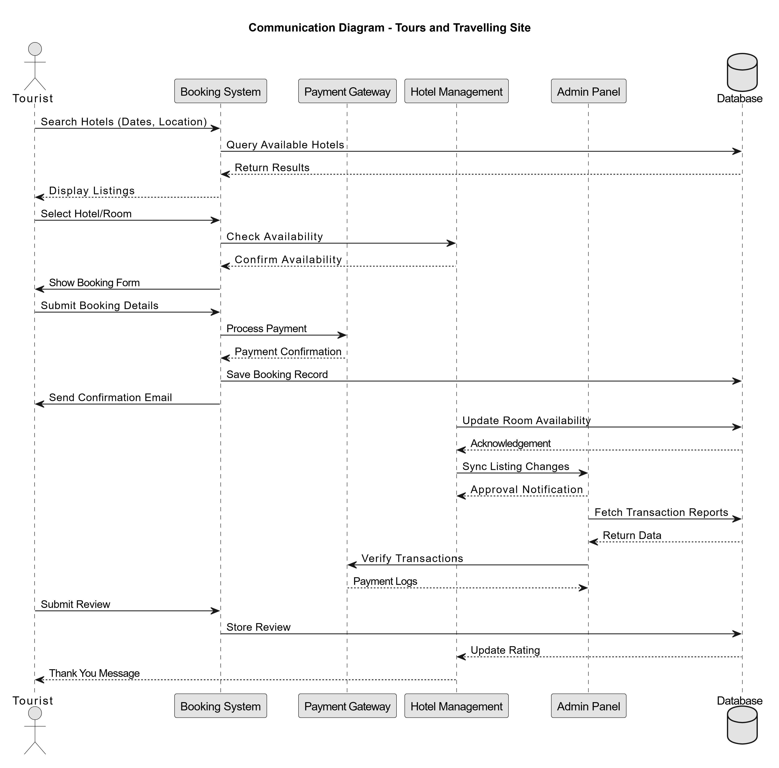

**Hotel Admin**

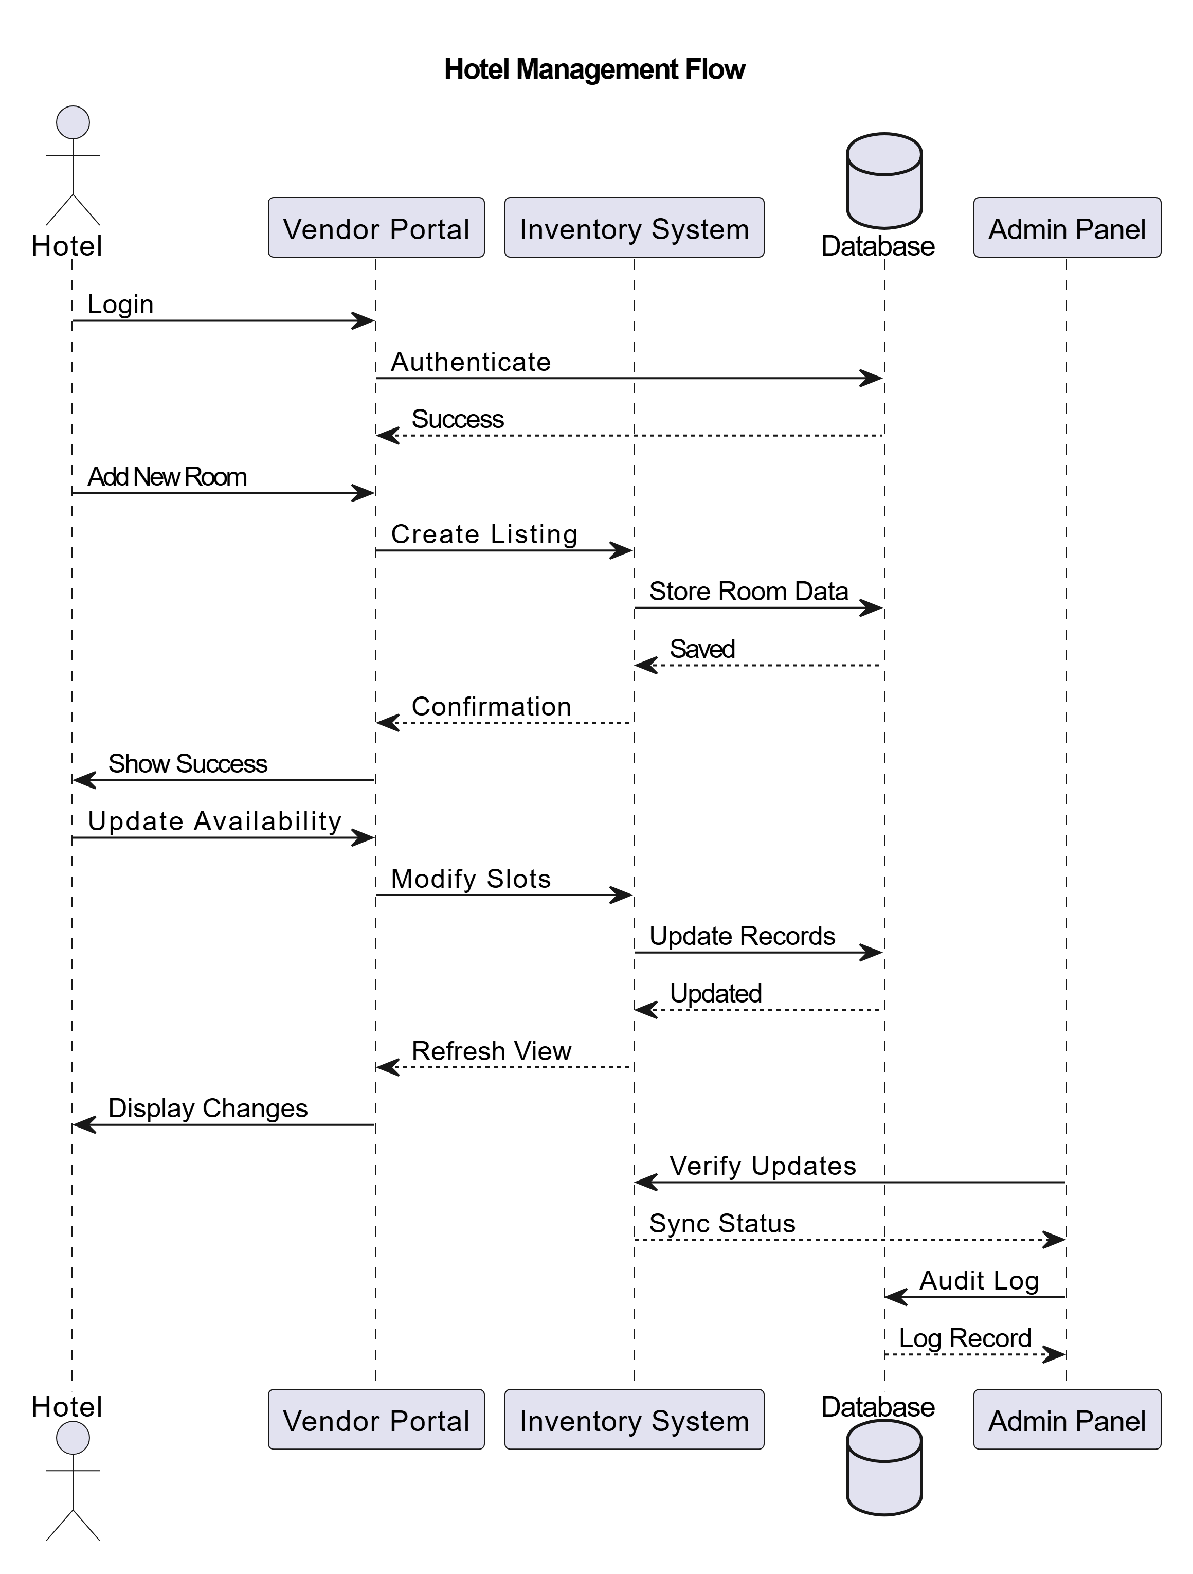

**Tour Admin**

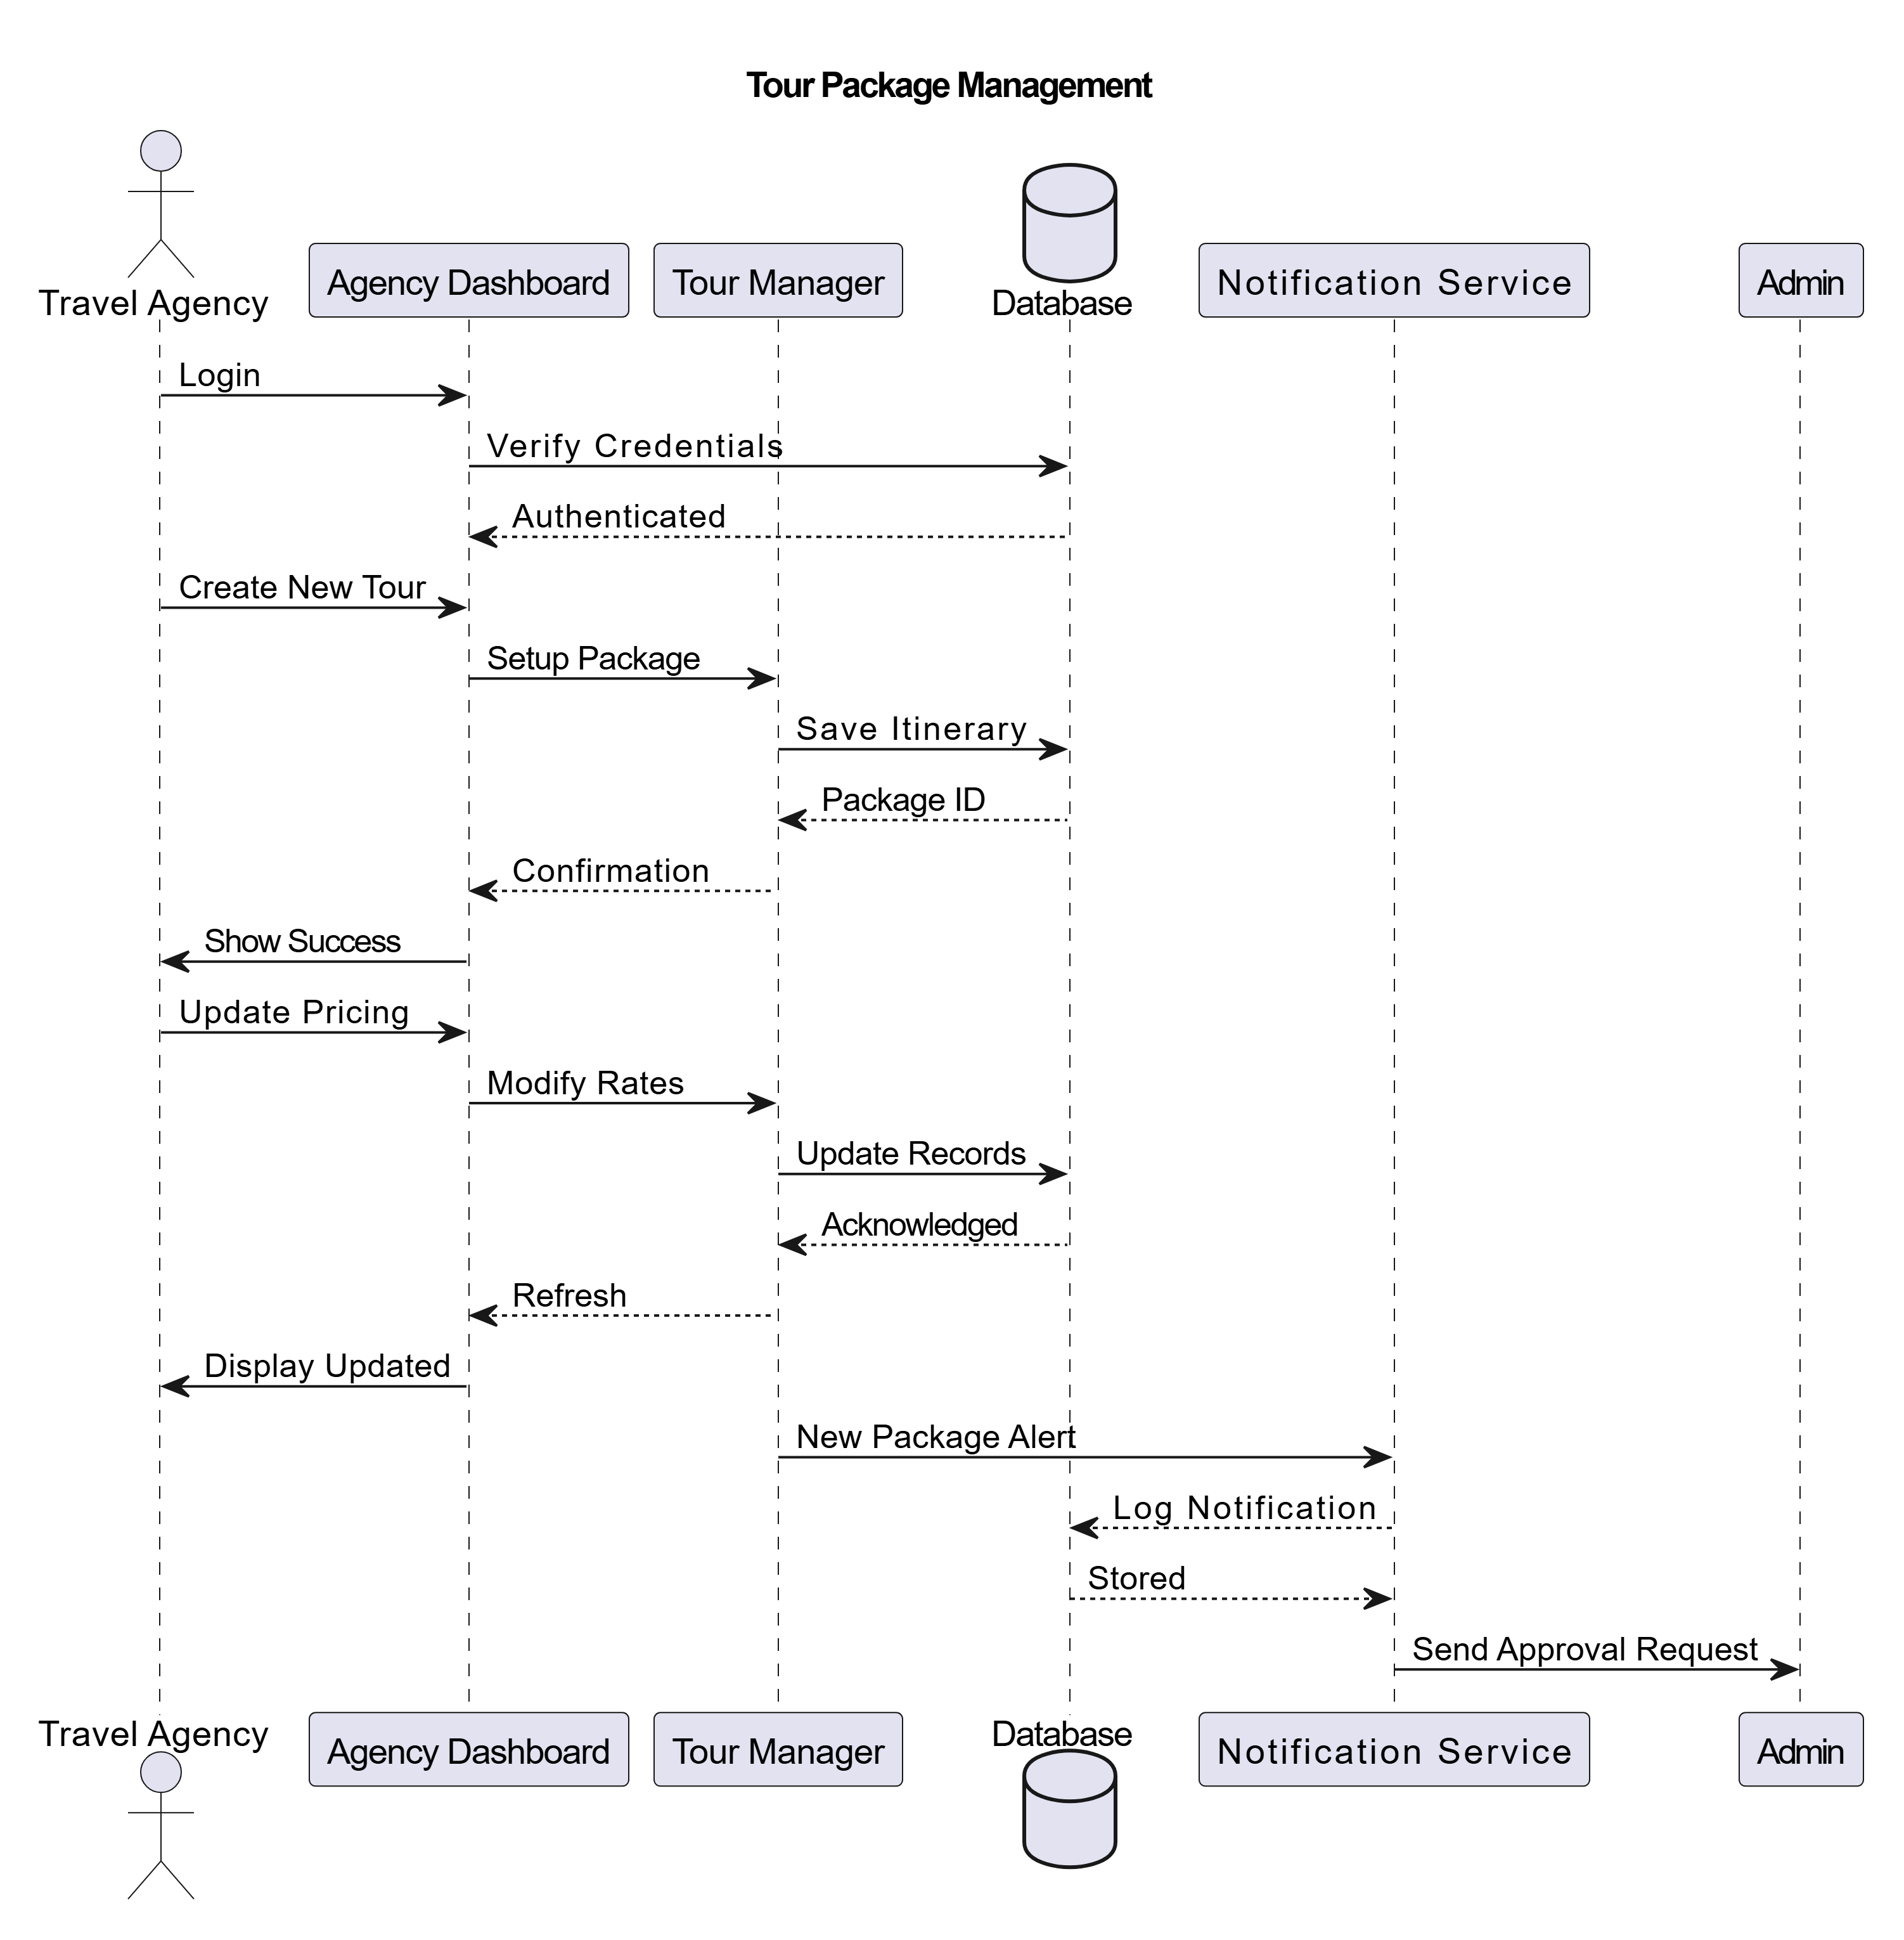

**SSD :**

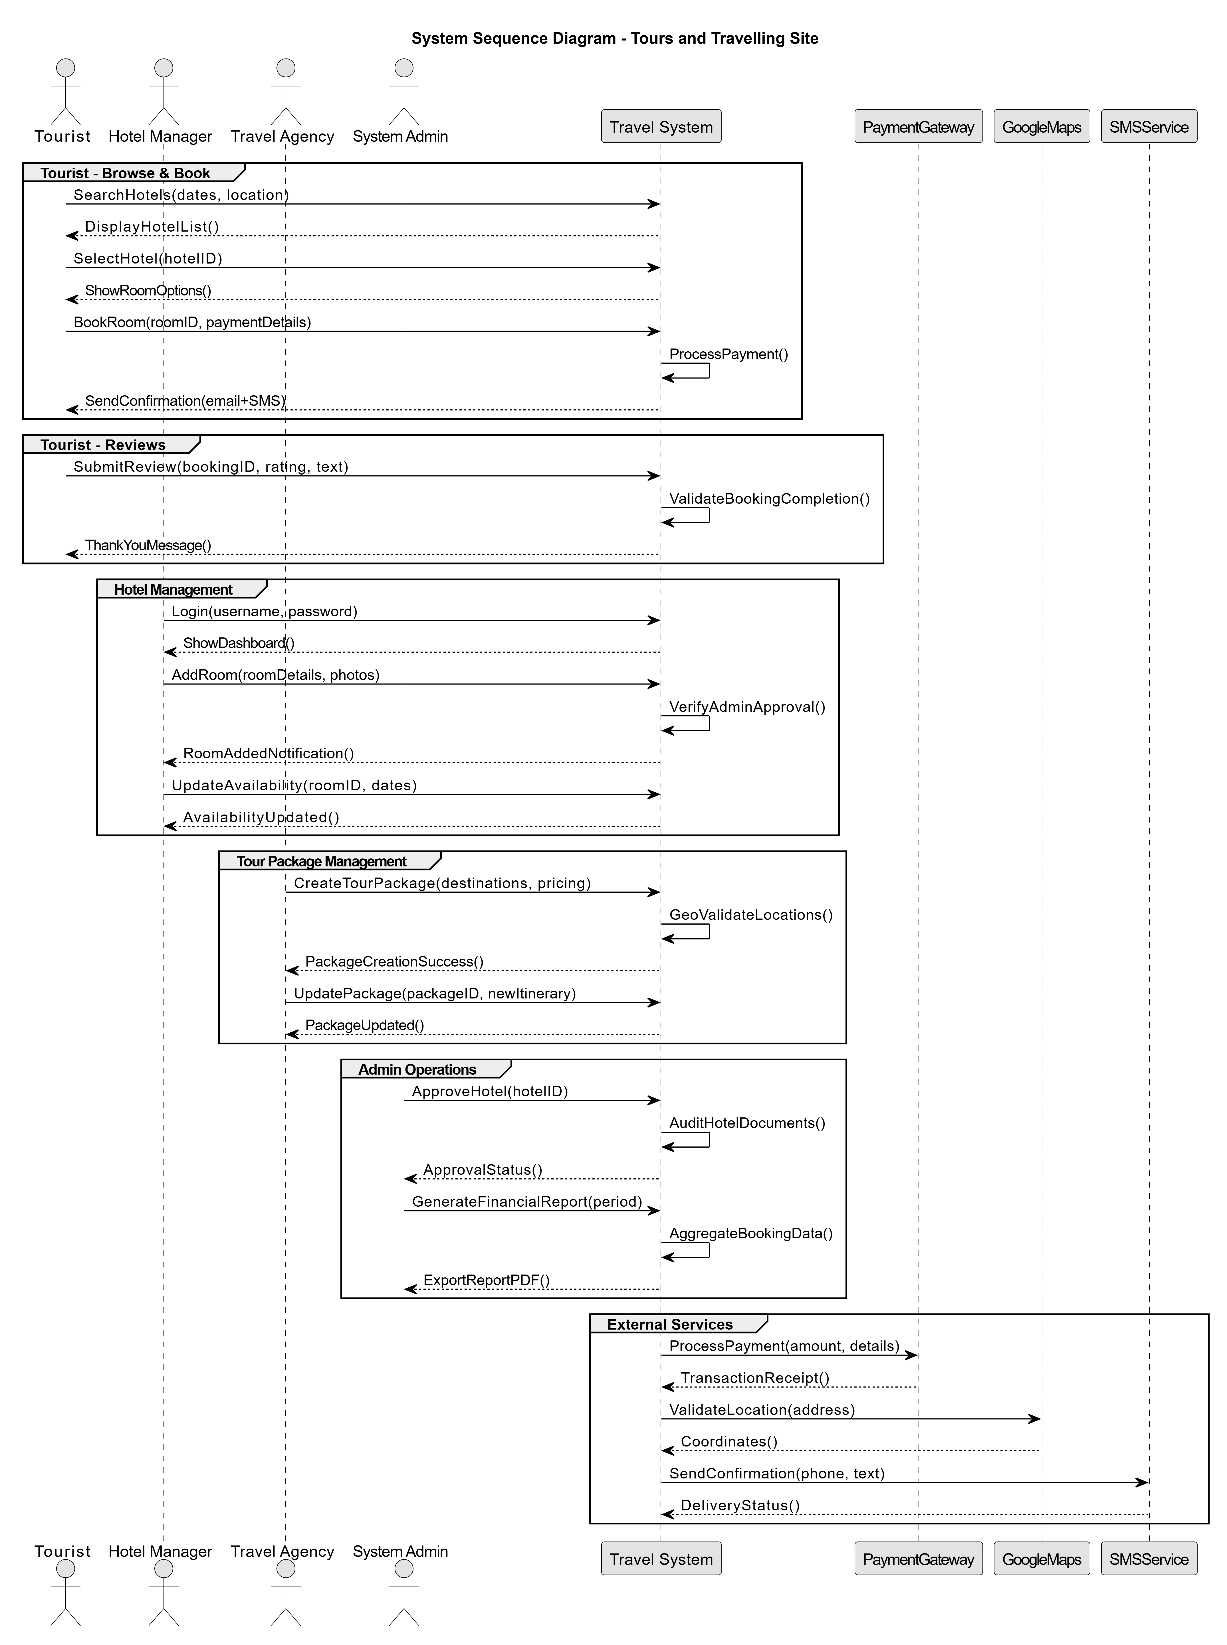

**Class Diagram**

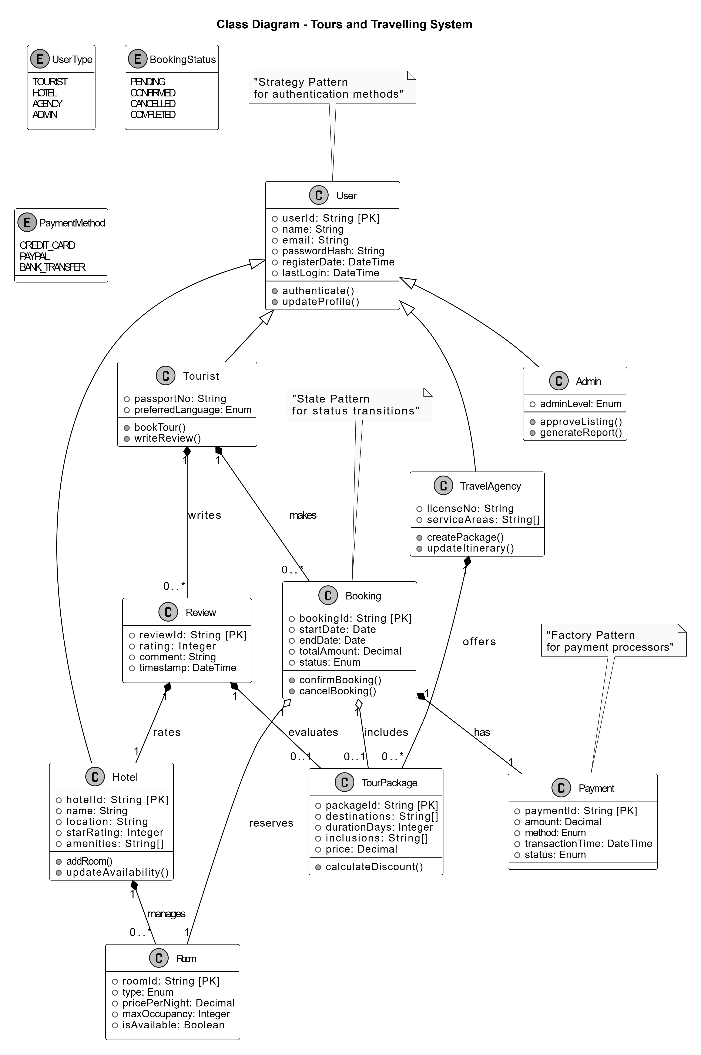

**PACKAGE DIAGRAM**

