**Simple Steps to fast-Api CRUD setup in Win10**

**Download Python Form Office Site**

**https://www.python.org/ftp/python/3.13.2/python-3.13.2-amd64.exe**

**Install File & Restart OS Windows**

1. Make sure you have **pip install fastapi[all] sqlalchemy sqlite** Framework installed,
2. then install pip install fastapi uvicorn sqlalchemy databases

Cereate main.py (under Main APP)

from fastapi import FastAPI, Depends, HTTPException

from sqlalchemy import Column, Integer, String, create_engine

from sqlalchemy.ext.declarative import declarative_base

from sqlalchemy.orm import sessionmaker, Session

DATABASE_URL = "sqlite:///./test.db"

engine = create_engine(DATABASE_URL, connect_args={"check_same_thread": False})

SessionLocal = sessionmaker(bind=engine, autoflush=False, autocommit=False)

Base = declarative_base()

app = FastAPI()

# Database Model

class User(Base):

__tablename__ = "users"

id = Column(Integer, primary_key=True, index=True)

name = Column(String, index=True)

email = Column(String, unique=True, index=True)

# Create Database Tables

Base.metadata.create_all(bind=engine)

# Dependency to get the database session

def get_db():

db = SessionLocal()

try:

yield db

finally:

db.close()

# Create User

@app.post("/users/", response_model=dict)

def create_user(name: str, email: str, db: Session = Depends(get_db)):

db_user = User(name=name, email=email)

db.add(db_user)

db.commit()

db.refresh(db_user)

return {"id": db_user.id, "name": db_user.name, "email": db_user.email}

# Read Users

@app.get("/users/", response_model=list)

def get_users(db: Session = Depends(get_db)):

return db.query(User).all()

# Read Single User

@app.get("/users/{user_id}", response_model=dict)

def get_user(user_id: int, db: Session = Depends(get_db)):

user = db.query(User).filter(User.id == user_id).first()

if user is None:

raise HTTPException(status_code=404, detail="User not found")

return {"id": user.id, "name": user.name, "email": user.email}

# Update User

@app.put("/users/{user_id}", response_model=dict)

def update_user(user_id: int, name: str, email: str, db: Session = Depends(get_db)):

user = db.query(User).filter(User.id == user_id).first()

if user is None:

raise HTTPException(status_code=404, detail="User not found")

user.name = name

user.email = email

db.commit()

db.refresh(user)

return {"id": user.id, "name": user.name, "email": user.email}

# Delete User

@app.delete("/users/{user_id}", response_model=dict)

def delete_user(user_id: int, db: Session = Depends(get_db)):

user = db.query(User).filter(User.id == user_id).first()

if user is None:

raise HTTPException(status_code=404, detail="User not found")

db.delete(user)

db.commit()

return {"message": "User deleted successfully"}

**Save & Exit;**

**Run own server : uvicorn main:app –reload**

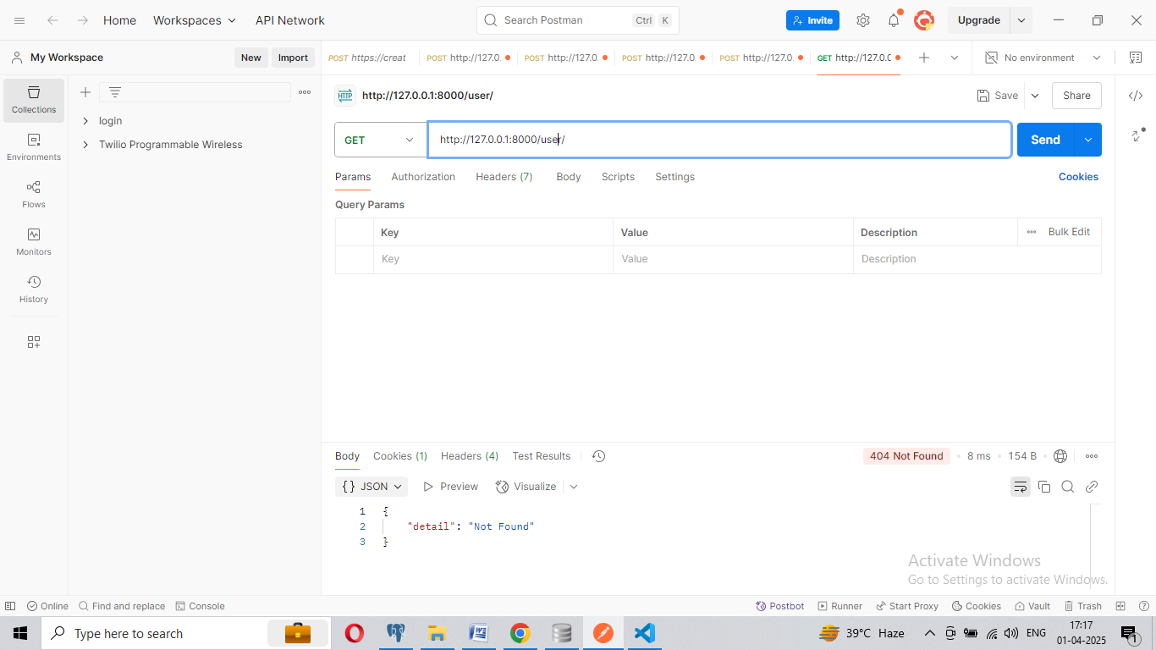

**API Endpoints**

| **Method** | **Endpoint** | **Description** |
| --- | --- | --- |
| POST | /users/ | Create a new user |
| GET | /users/ | Get all users |
| GET | /users/{id} | Get a user by ID |
| PUT | /users/{id} | Update user details |
| DELETE | /users/{id} | Delete a user |

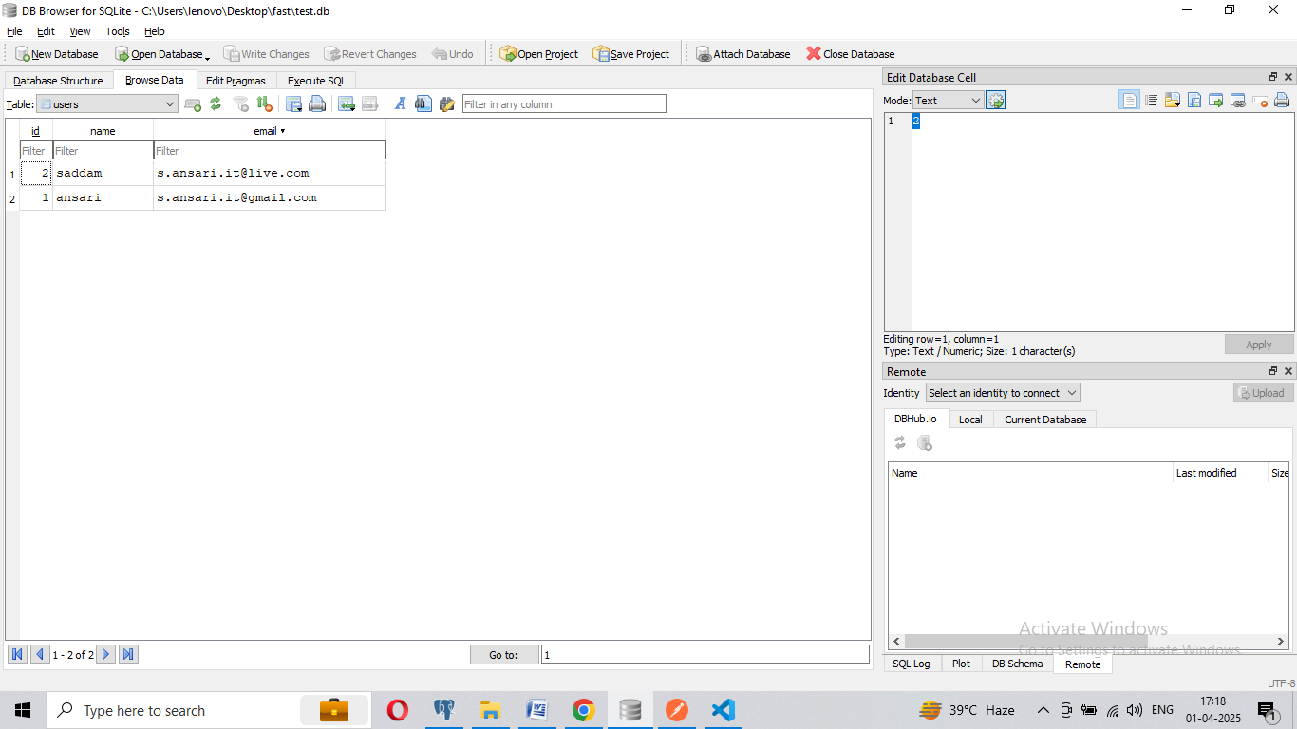

**Database login**

In your project, open <http://127.0.0.1:8000/docs> 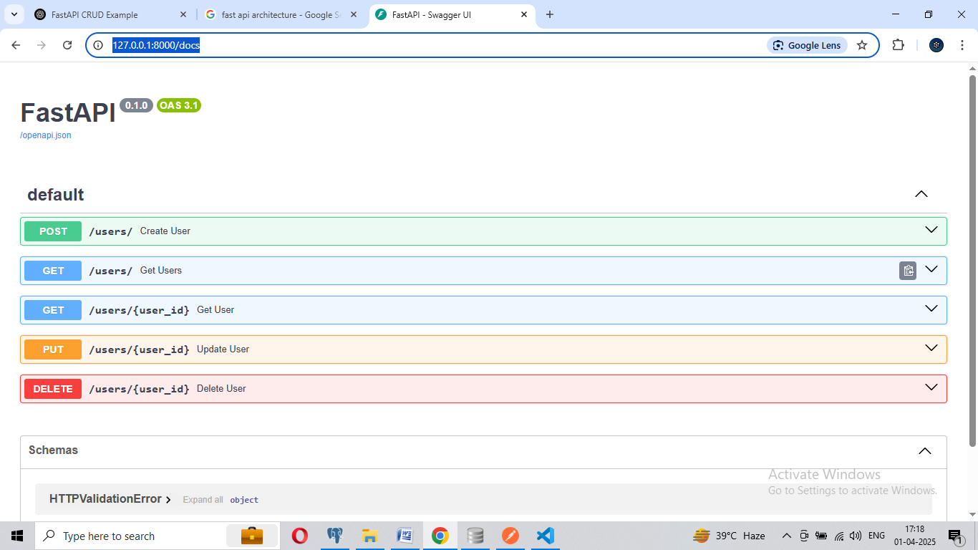

Swagger UI: its free install