Handwritten Digit Predictor

# Introduction

This Python program demonstrates a Handwritten Digit Predictor using TensorFlow and the MNIST dataset. It features a GUI built using Tkinter, where users can draw a digit on a canvas and get the model's predicted digit upon clicking the 'predict digit' button. The canvas can be cleared for repeated predictions.

# Requirements

This application requires the following libraries and dependencies to be installed:  
1. TensorFlow (for the digit recognition model)  
2. Numpy (for array manipulations)  
3. Pickle (for loading the pre-trained model)  
4. PIL (Python Imaging Library, for image manipulations)  
5. Tkinter (for GUI creation)

# Code Overview

The following sections describe the components of the code in detail.

## 1. Loading the Model

The pre-trained model is loaded using the pickle library from a file called 'hand_written_digit_recognizer.pkl'. This model is used to make predictions on the user-drawn digit.

## 2. The predict_digit Function

The function 'predict_digit' takes the drawn image from the canvas, preprocesses it to a 28x28 grayscale image, and inverts the pixel values before feeding it to the model for prediction. The predicted digit is then returned.

## 3. Tkinter GUI and Class Structure

The class `DigitPredictor` handles the GUI creation, button actions, and canvas drawing functionality. The GUI consists of a canvas where users can draw digits, a 'predict digit' button to predict the drawn digit, a 'clear screen' button to reset the canvas, and a label to display the predicted result.

Key methods of the `DigitPredictor` class:  
1. `paint`: This method captures the user's drawing on the canvas and renders it as an oval shape.  
2. `clear_canvas`: Clears the canvas to allow the user to draw a new digit.

3. `predict`: This method passes the current image from the canvas to the `predict_digit` function and displays the result.

## 4. Output

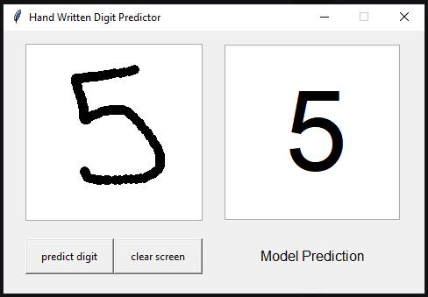

# Conclusion

This application showcases a simple yet effective way to create an interactive handwritten digit predictor. By integrating machine learning with a GUI, users can experience real-time predictions in a fun and engaging way.