Mawad Mart

Backend:->

Membership Content :->

https://promaticstechnologies.xyz/mawad_mart/admin/membership/membershipContent

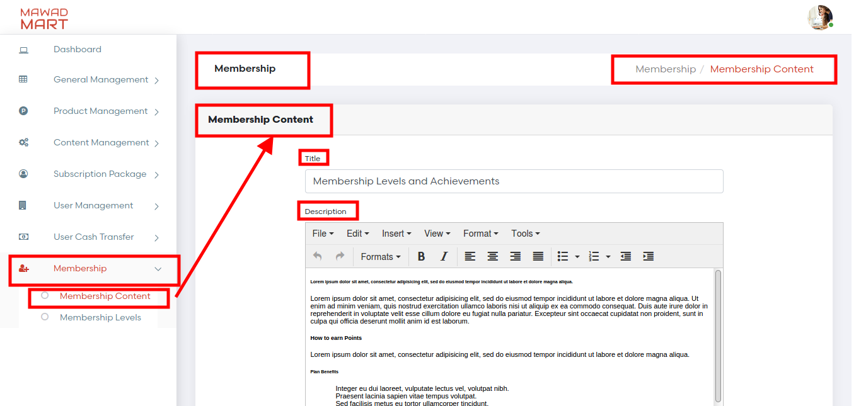

Membership Level List

https://promaticstechnologies.xyz/mawad_mart/admin/membership/list

Admin can manage membership levels from backend,if admin turn status off of any title(level) than that particular level is not visible on the frontend

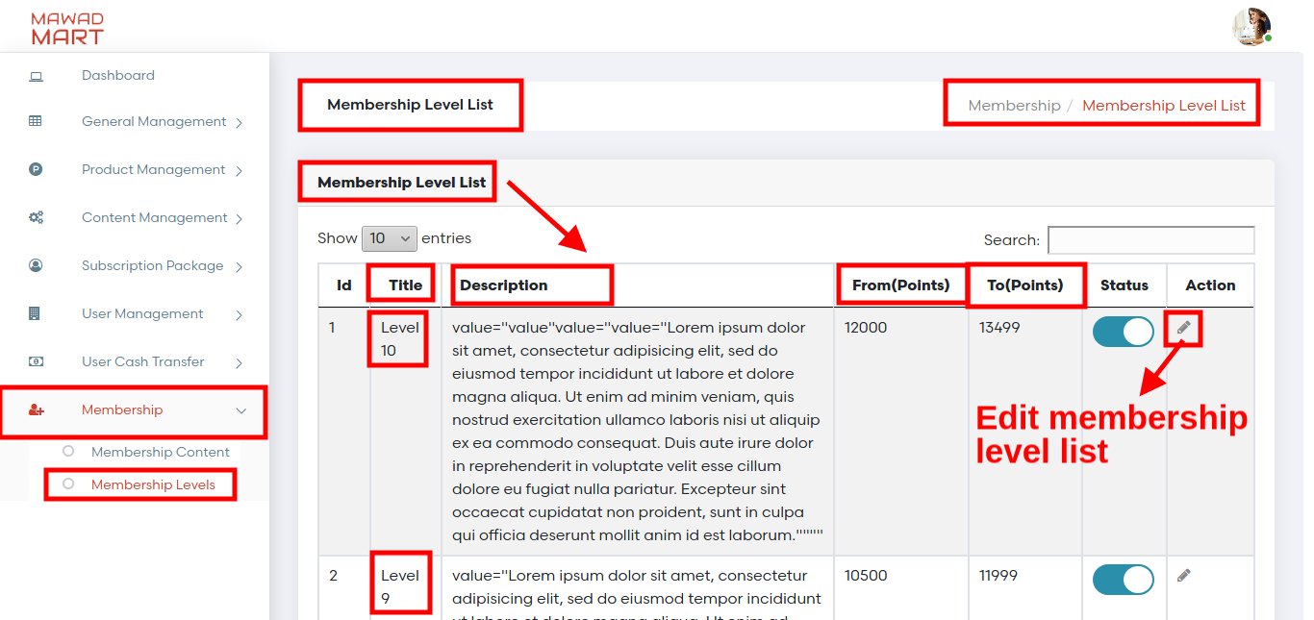

Edit Membership Level :->
https://promaticstechnologies.xyz/mawad_mart/admin/membership/edit/MTE=

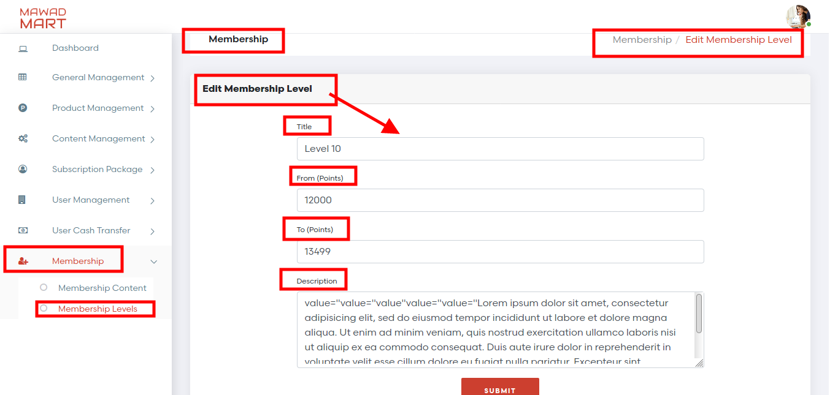

Frontend:->

User name :->provider@mailinator .com
Password :->123456

Membership:->
https://promaticstechnologies.xyz/mawad_mart/provider/myMembership/page

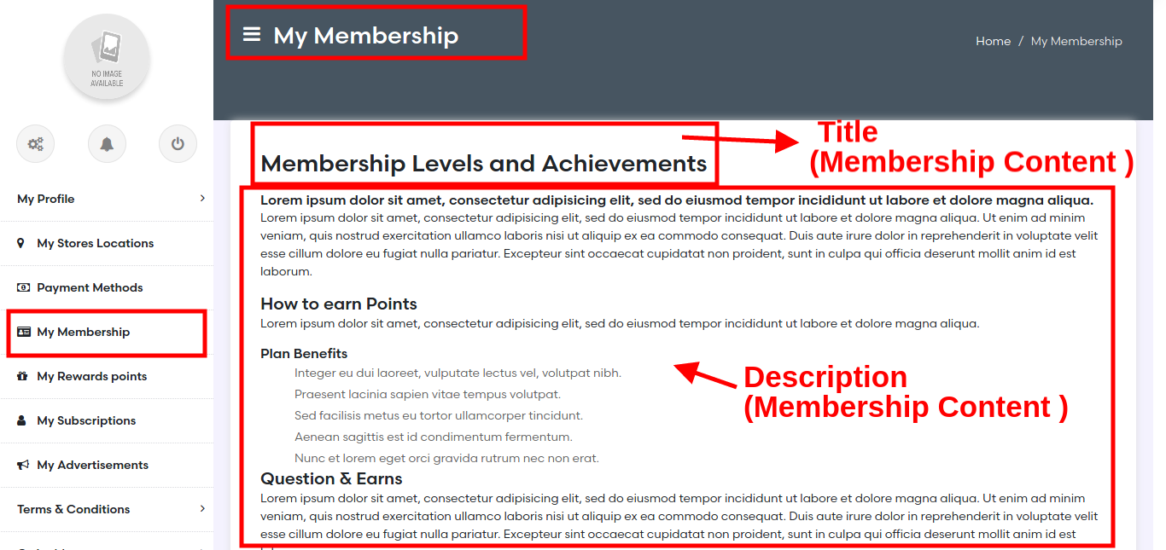

Membership:->

https://promaticstechnologies.xyz/mawad_mart/provider/myMembership/page

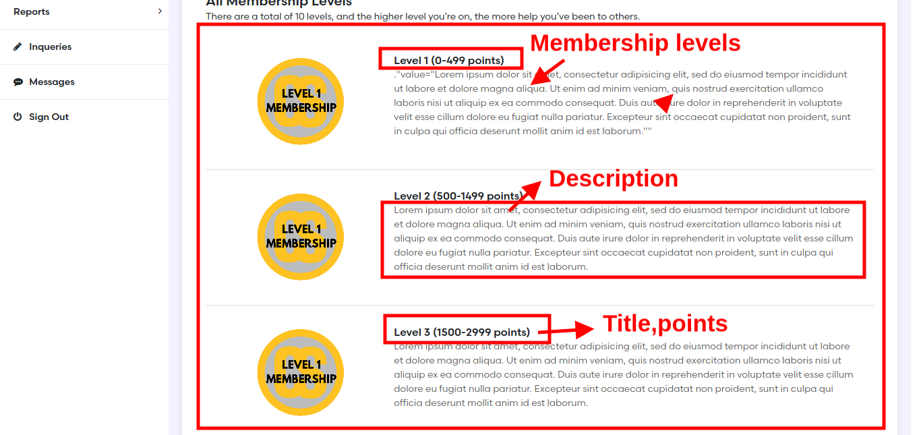

Thanks

