**(Mawad Mart Update)**

**(Website)**

**# My Store Locations -> My Locations :-**

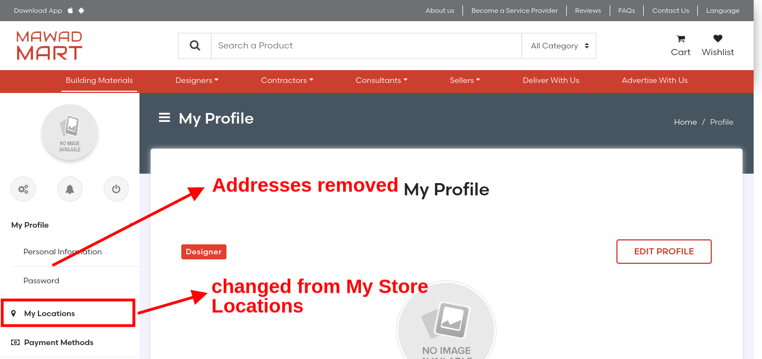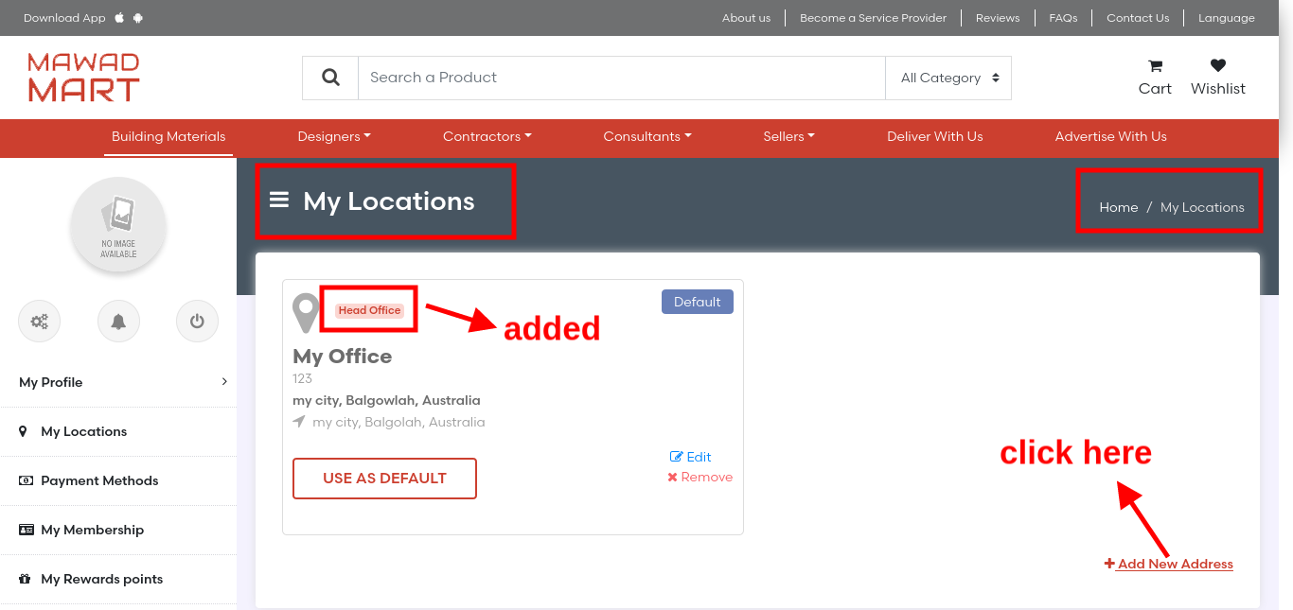

**# My Locations -> Add New Address :-**

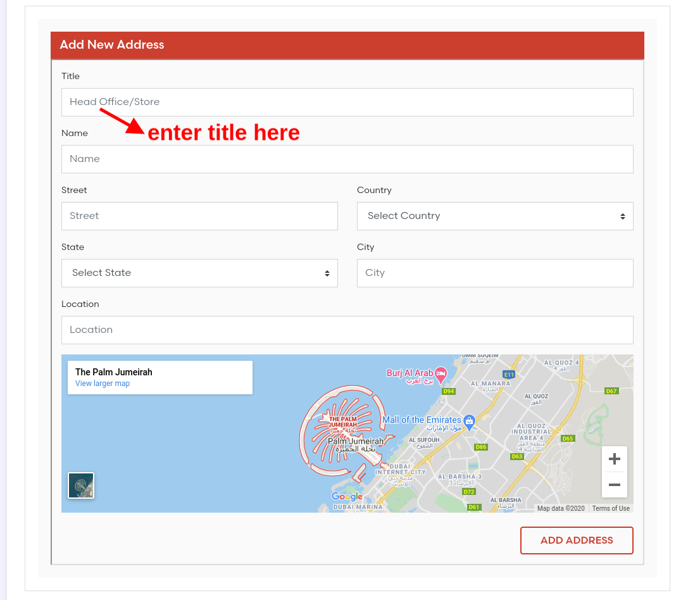

**(Thank You)**