Abdullah Ismail Ansari

April 19, 2022

**Learner’s Academy**

# Intent and Purpose

The intent and purpose is design and develop a backend administrative portal for the Learner’s Academy using Java EE technologies. The goal of this project is to apply servlet, JSP and JDBC concepts.

# Method

* Creating the flow of the application
  + Create database and tables.
  + Connect the database to the project.
  + Create models classes.
  + Create admin classes.
  + Create JSP files for all pages of the project.
  + Create a servlet to get requests and send responses to the JSP files.
* Creating specification document.
* Initializing git repository to track changes as development progresses.
* Pushing code to GitHub.

**Flow Chart**

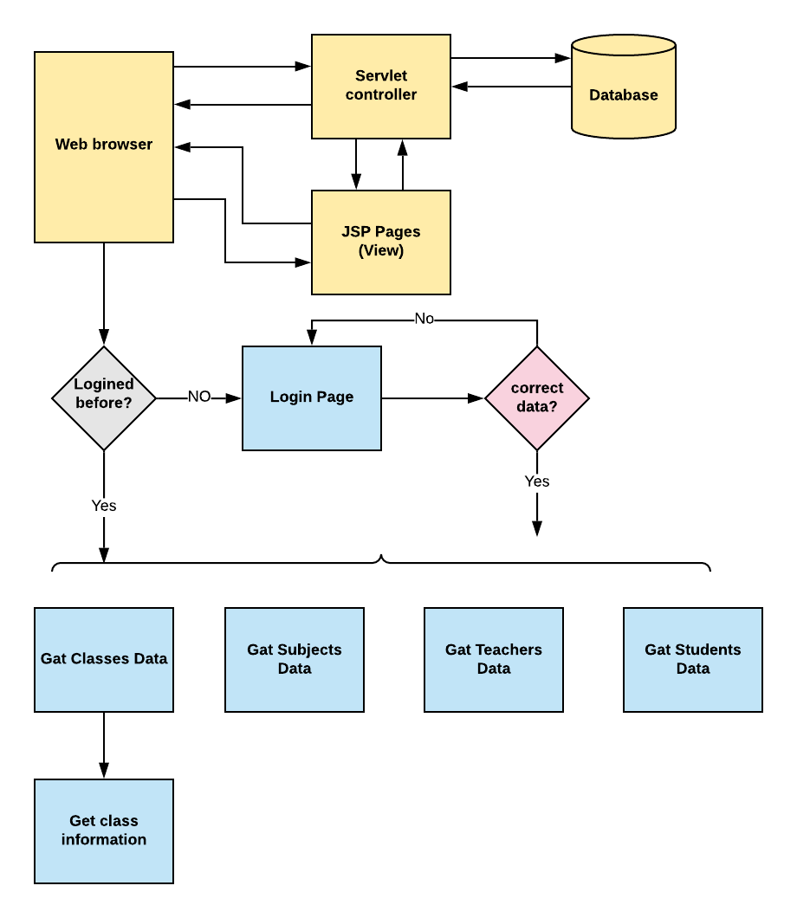

# Result

The output presented by the code shows the desired answer.

# Conclusion

Further enhancements to the application can be made which may include:

* Adding search and filter options.
* Registration and management of newly admitted students and teachers.
* Adding time table.