# **Code Output**

## **Admin authorization fails for invalid credentials**

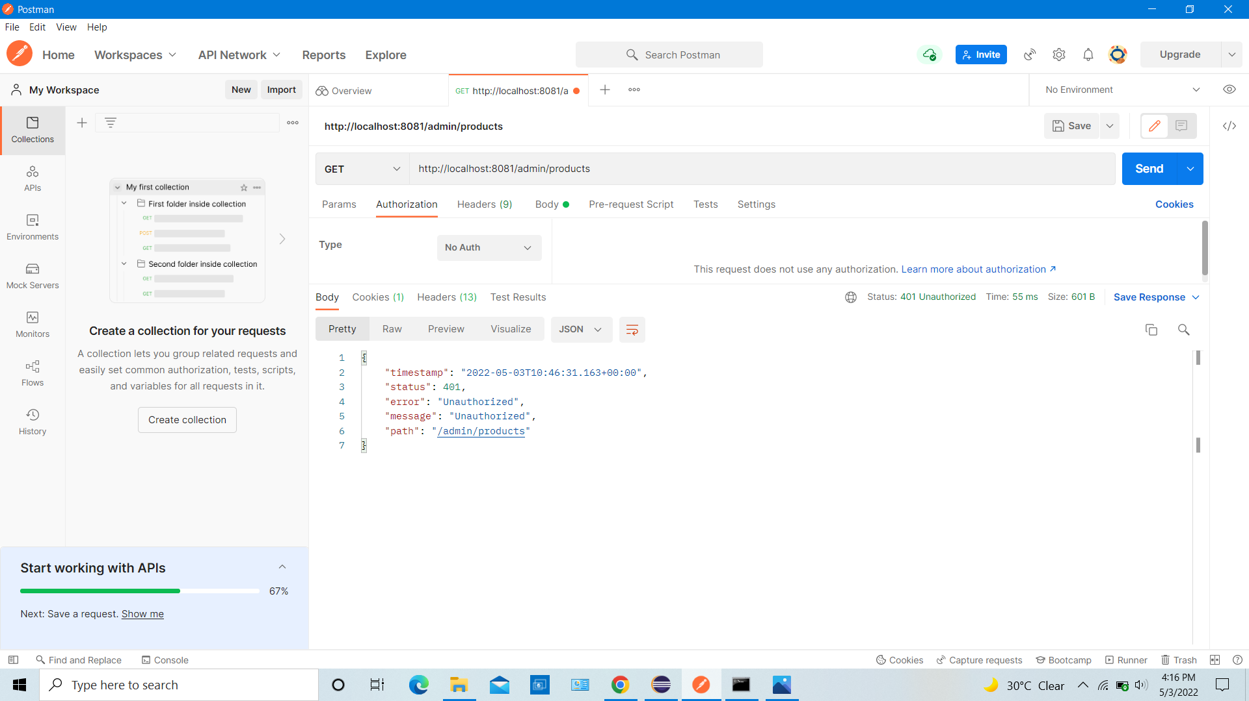

## **Admin login successful with valid credentials**

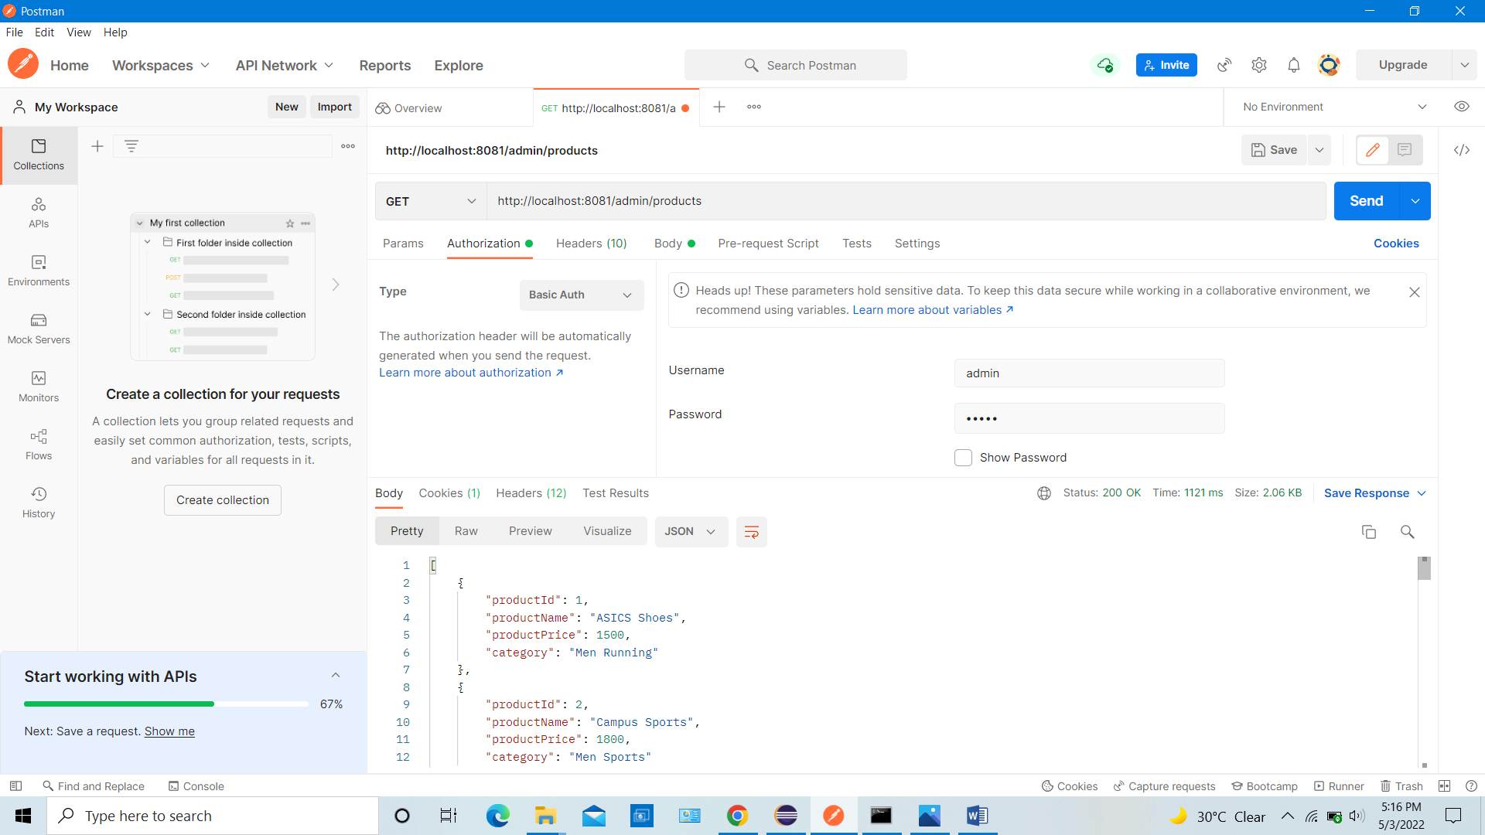

## **Admin can add new product to the database**

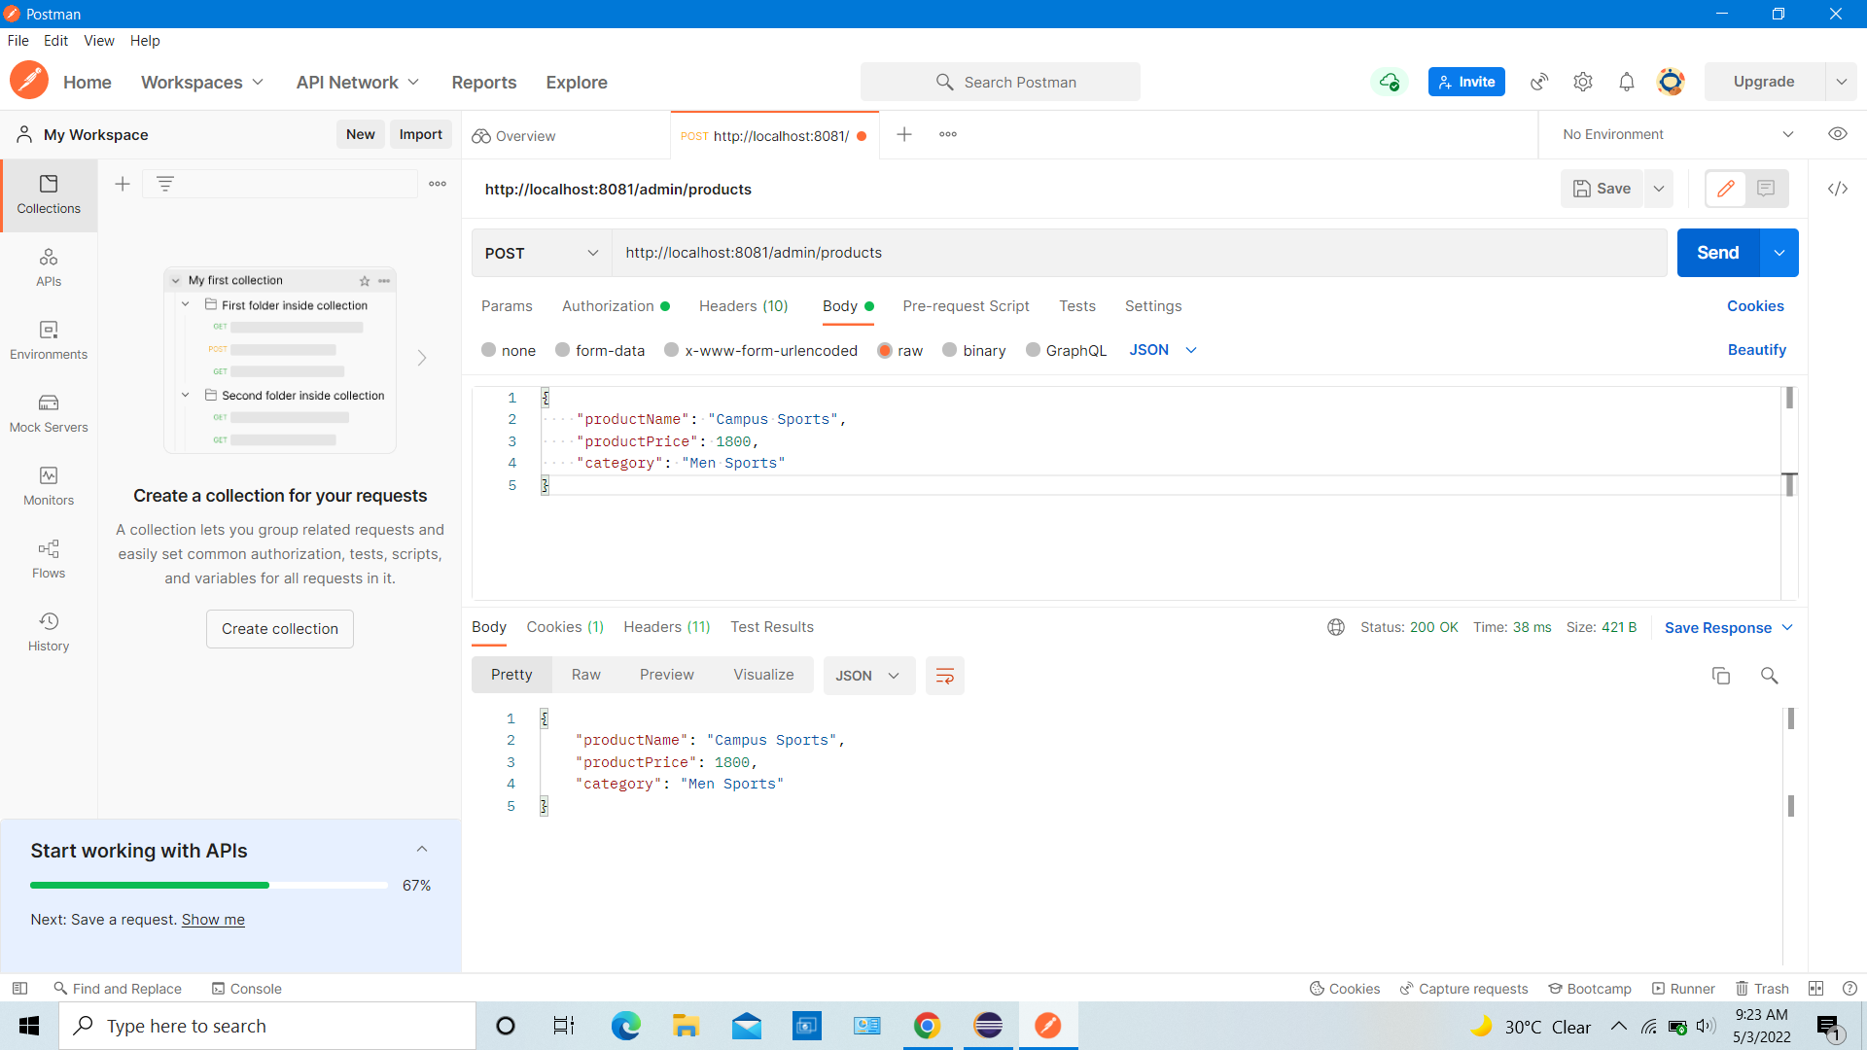

## **Admin can retrieve all product details**

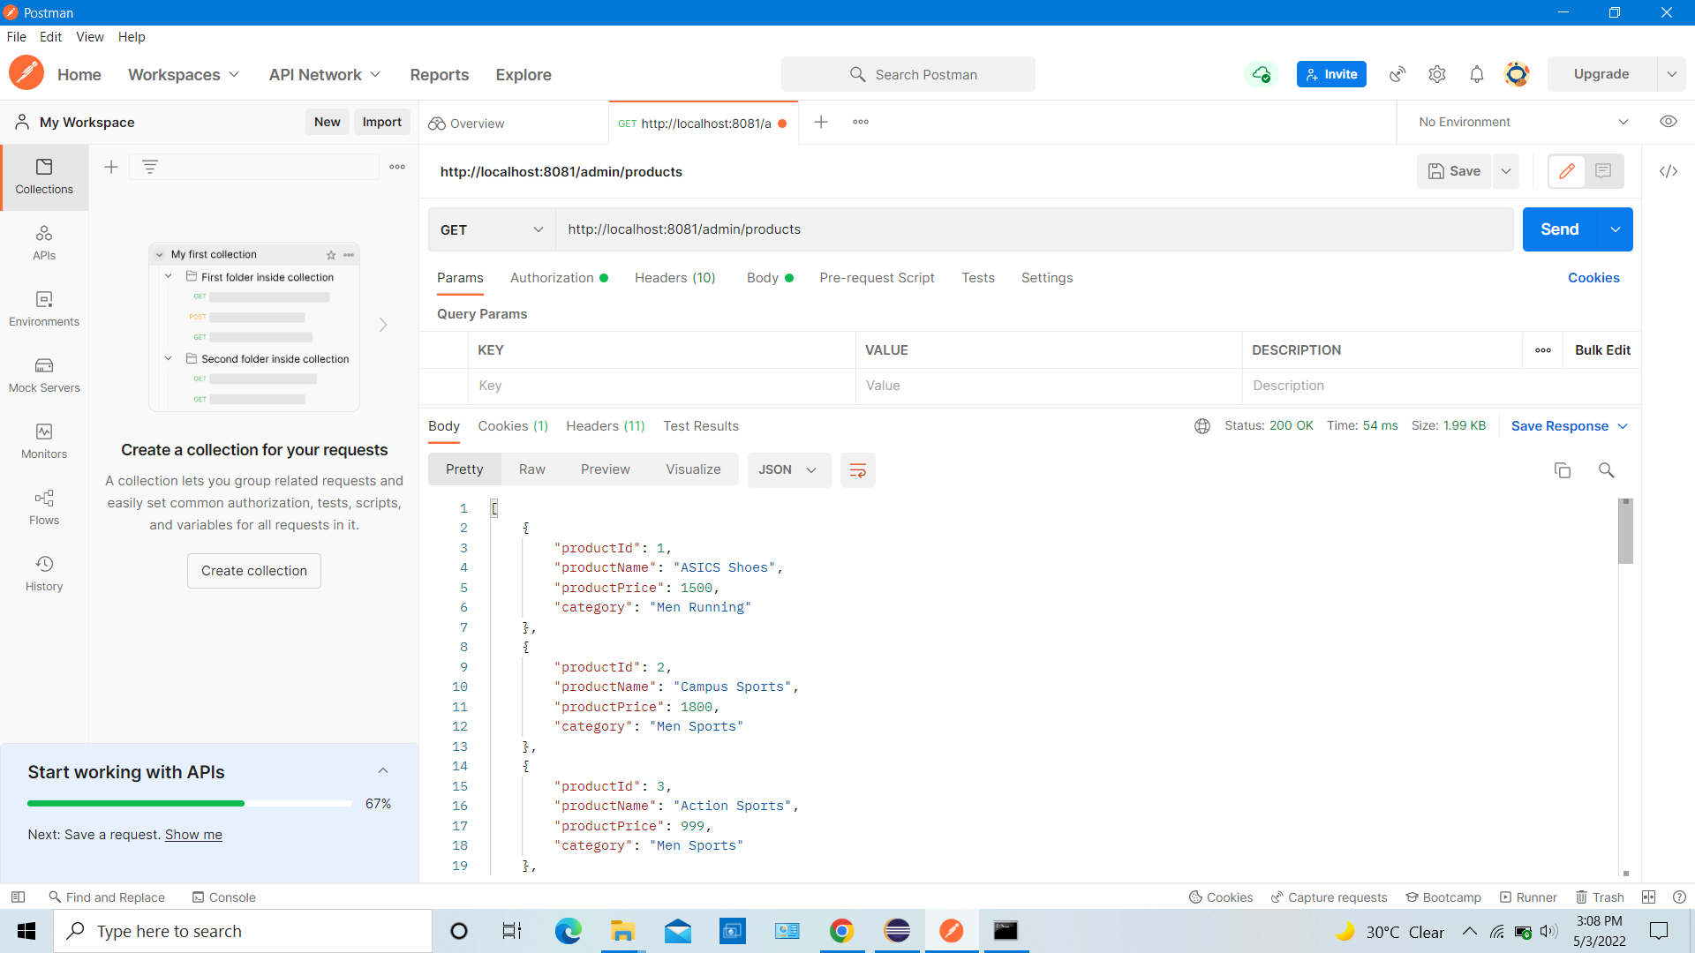

## **Admin can search product by category**

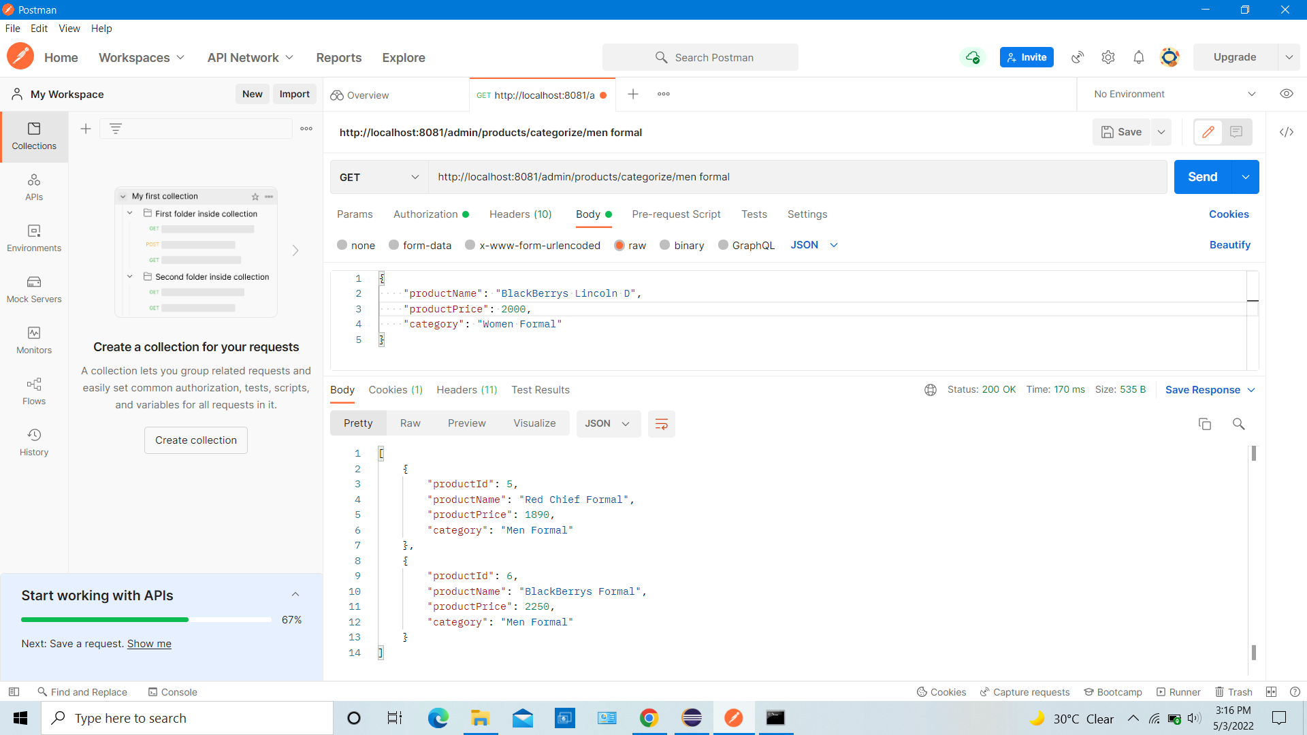

## **Admin can search product by id**

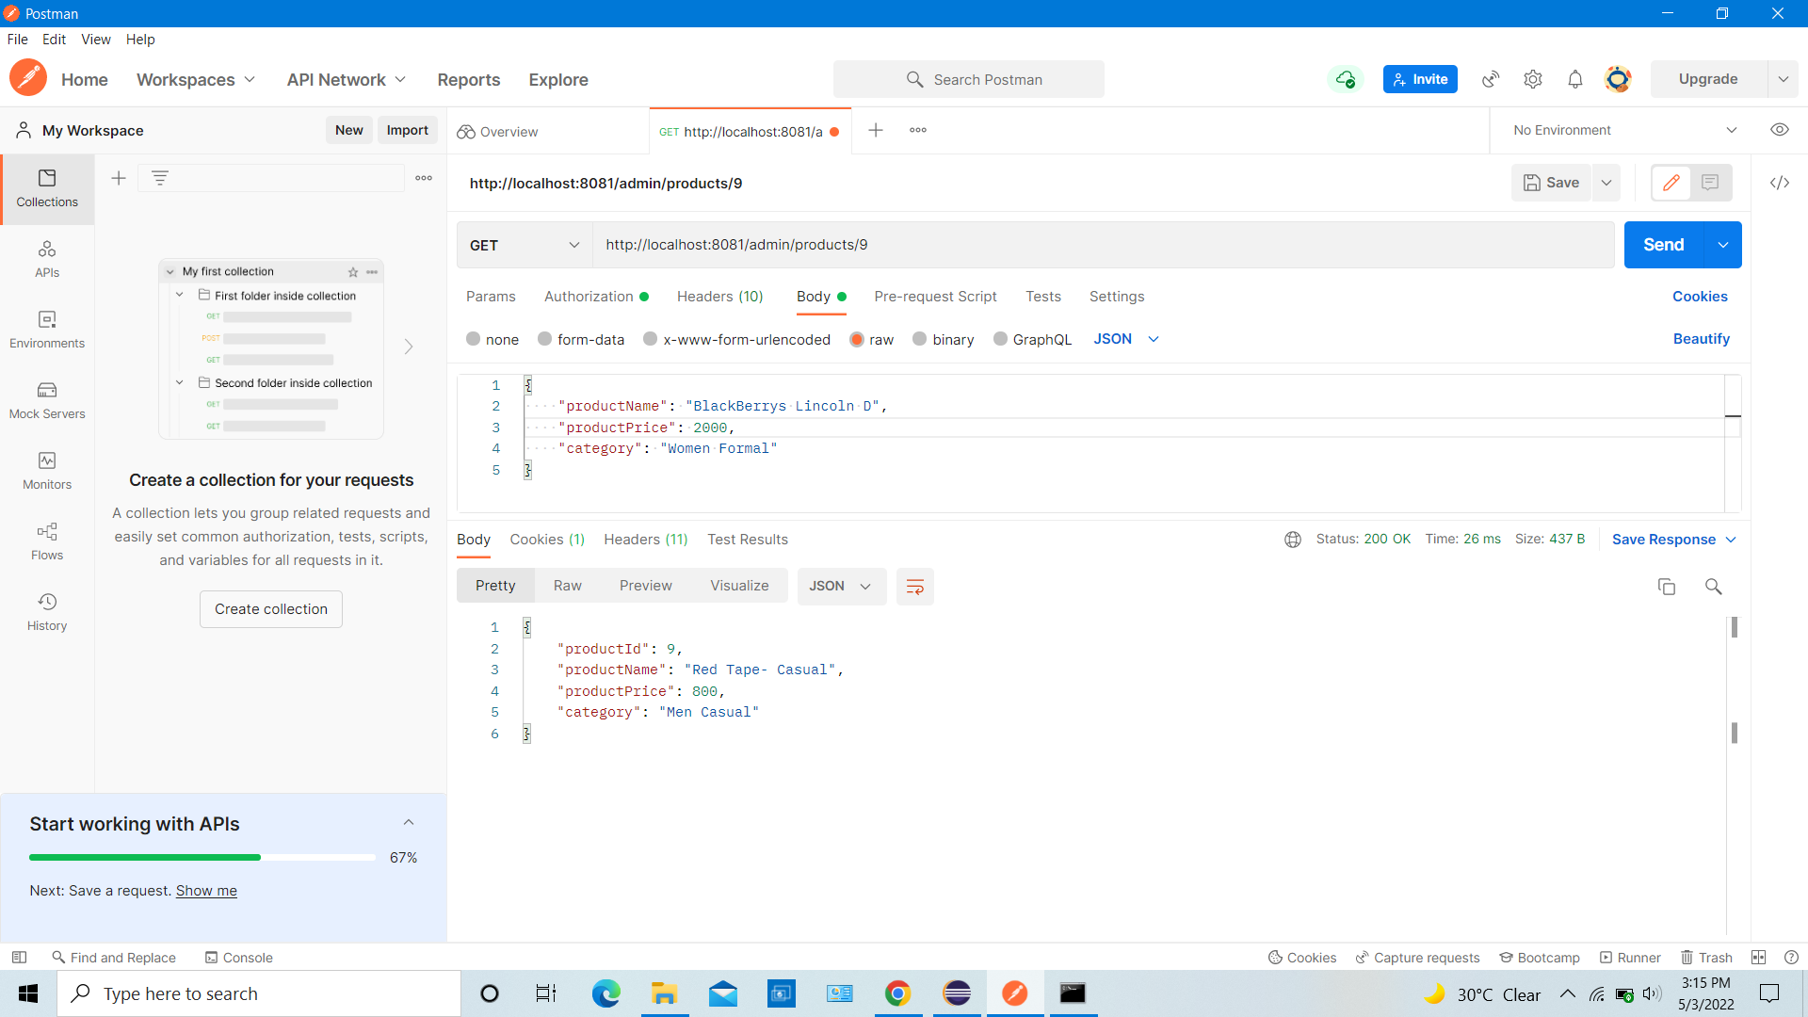

## **Admin can delete product by id**

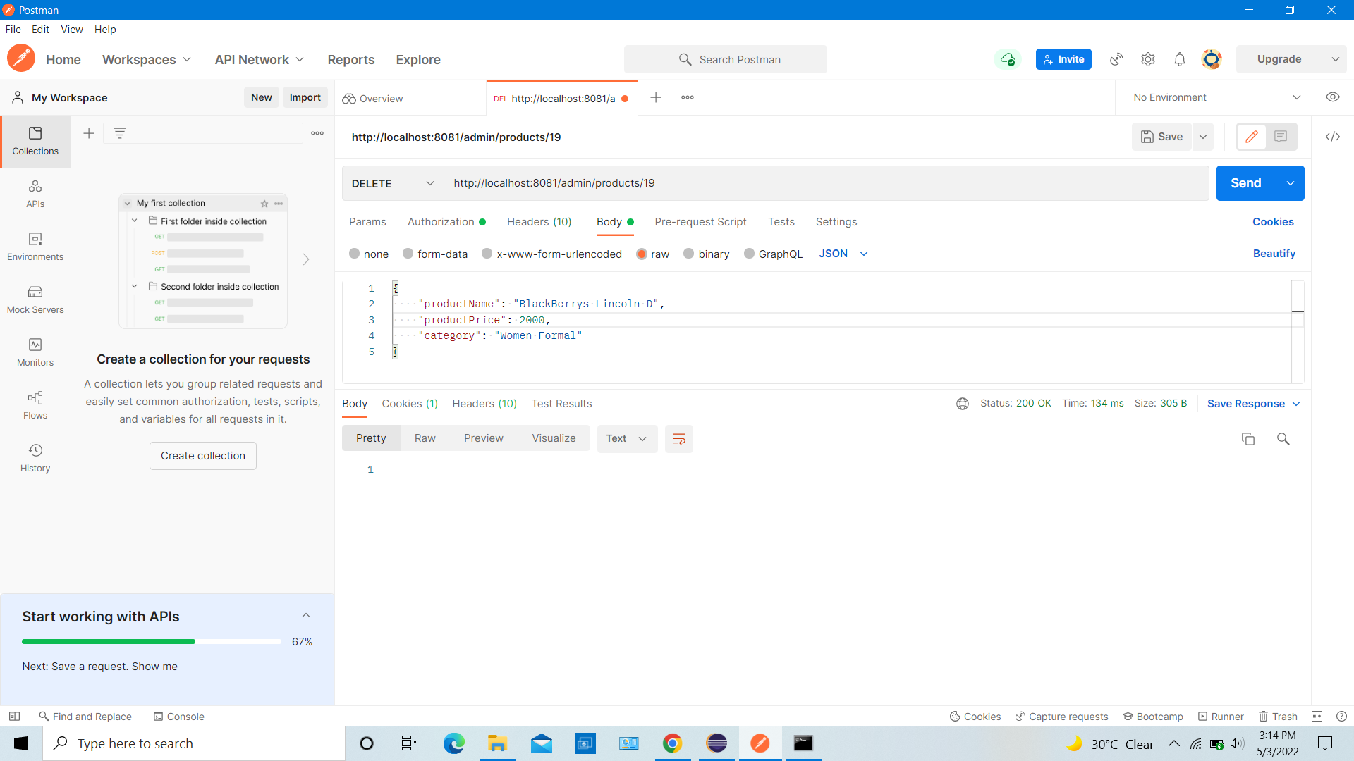

## **Admin can search for specific user**

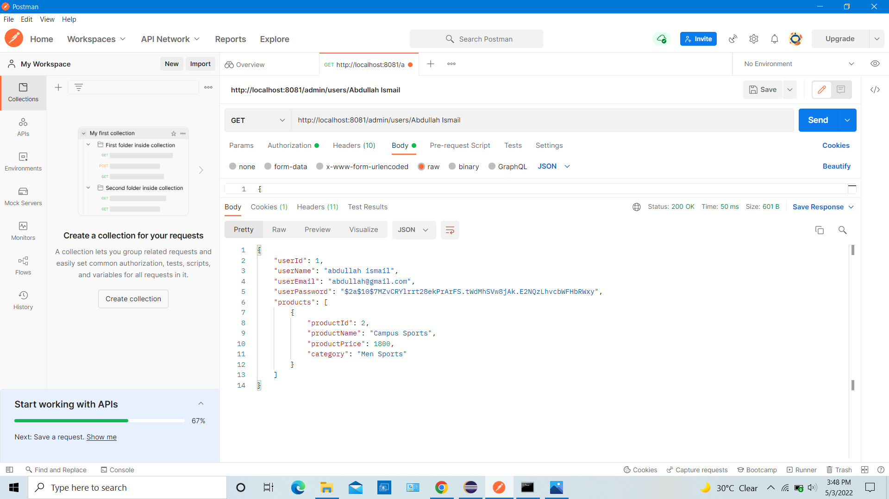

## **Admin can see all signed up users and their purchase details**

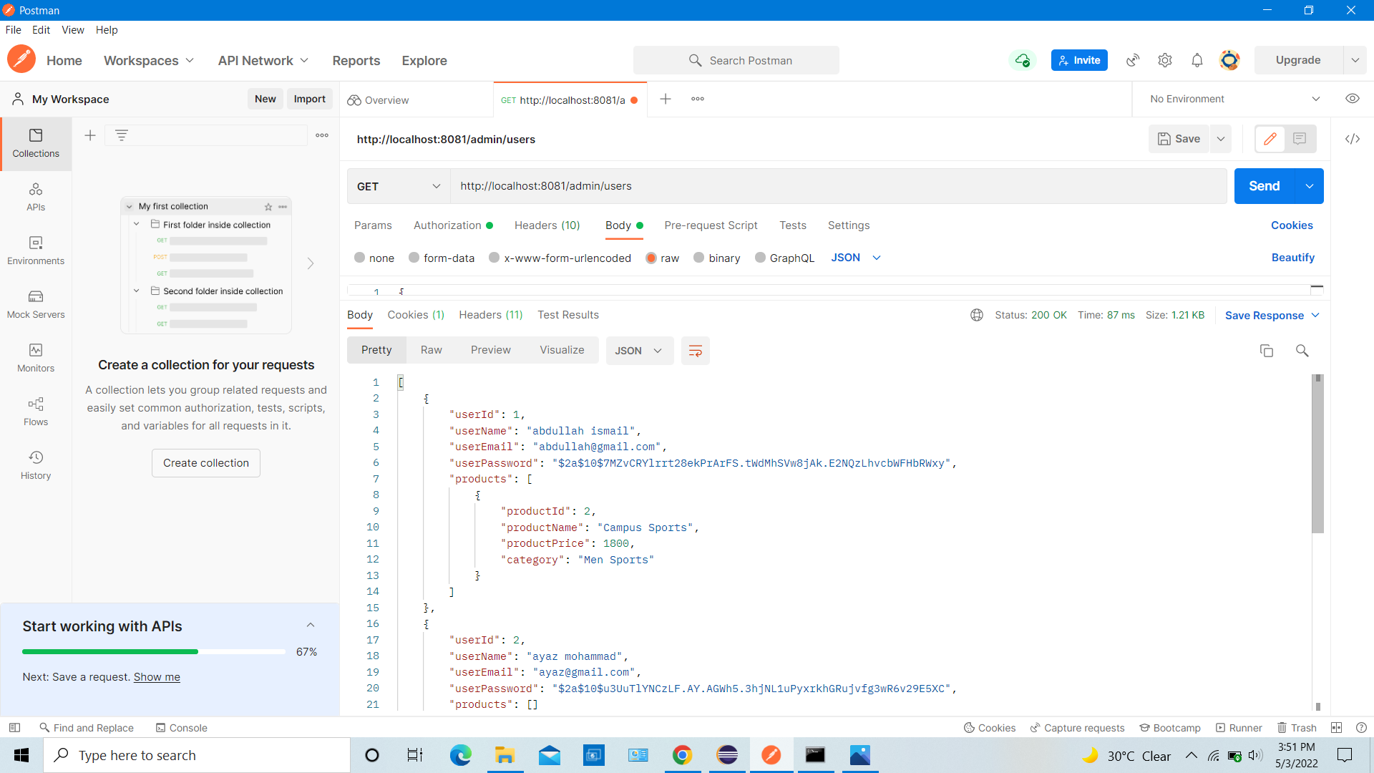

## **Admin can see entire purchase report**

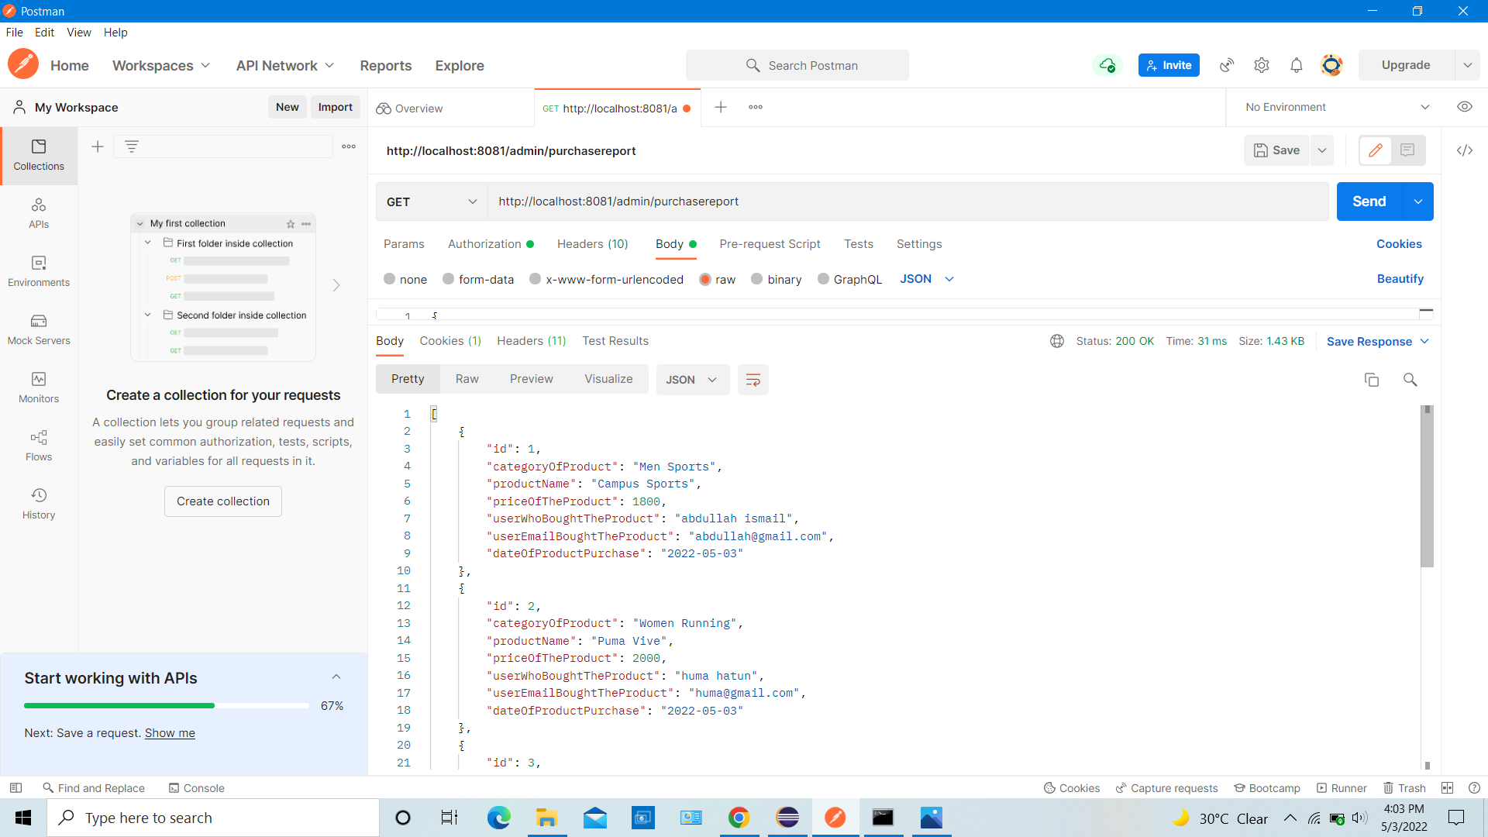

## **Admin can see entire purchase report by category**

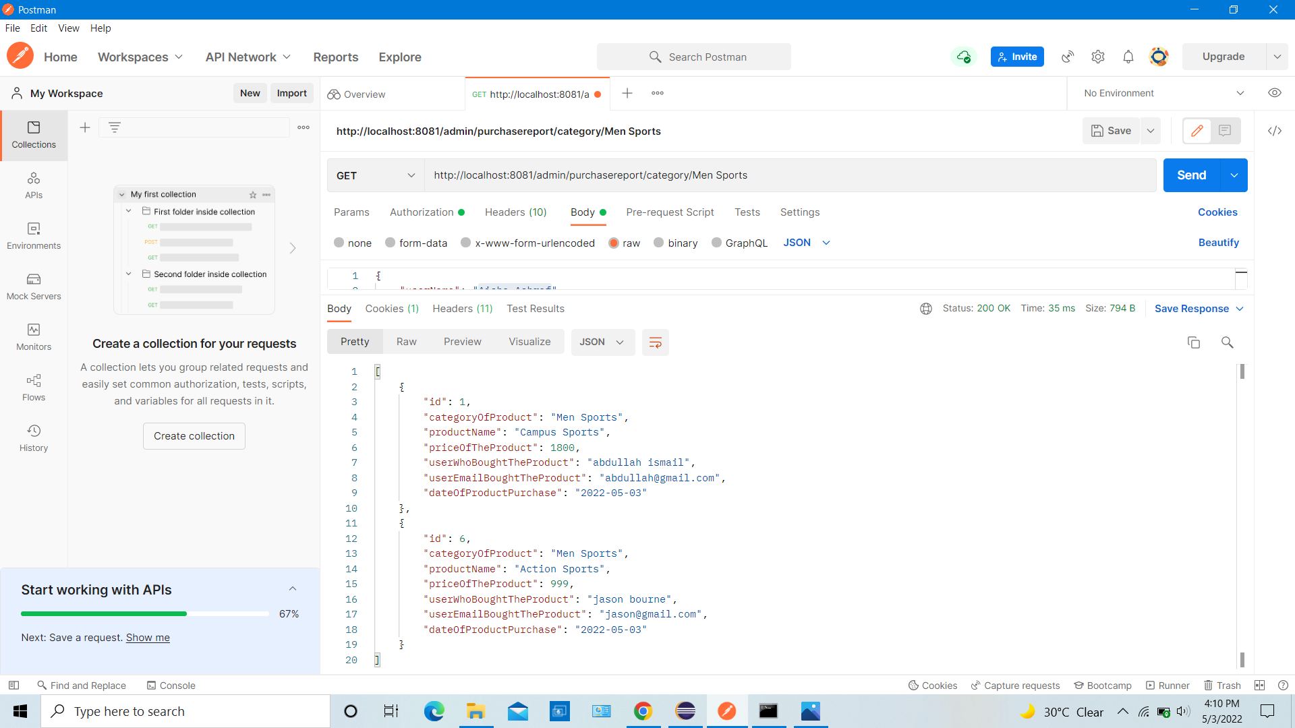

## **Admin can see entire purchase report by date**

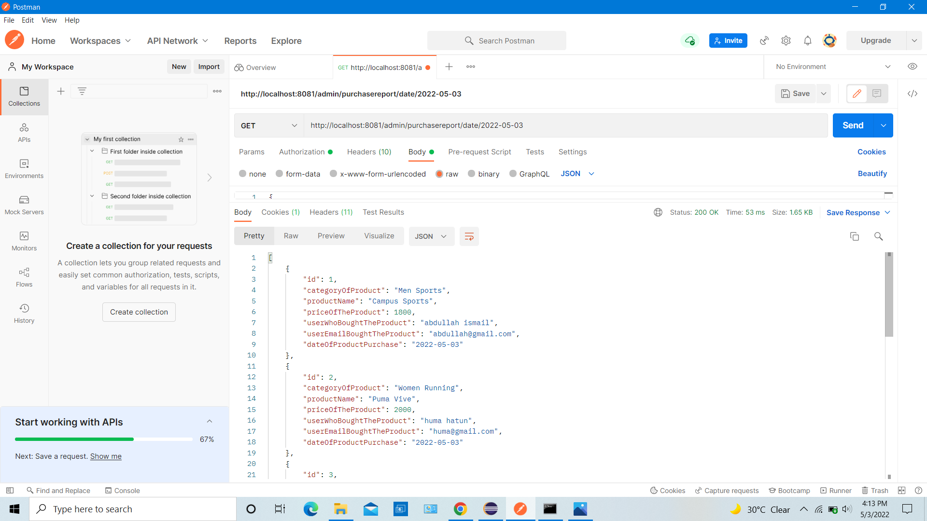

## **User sign up or register**

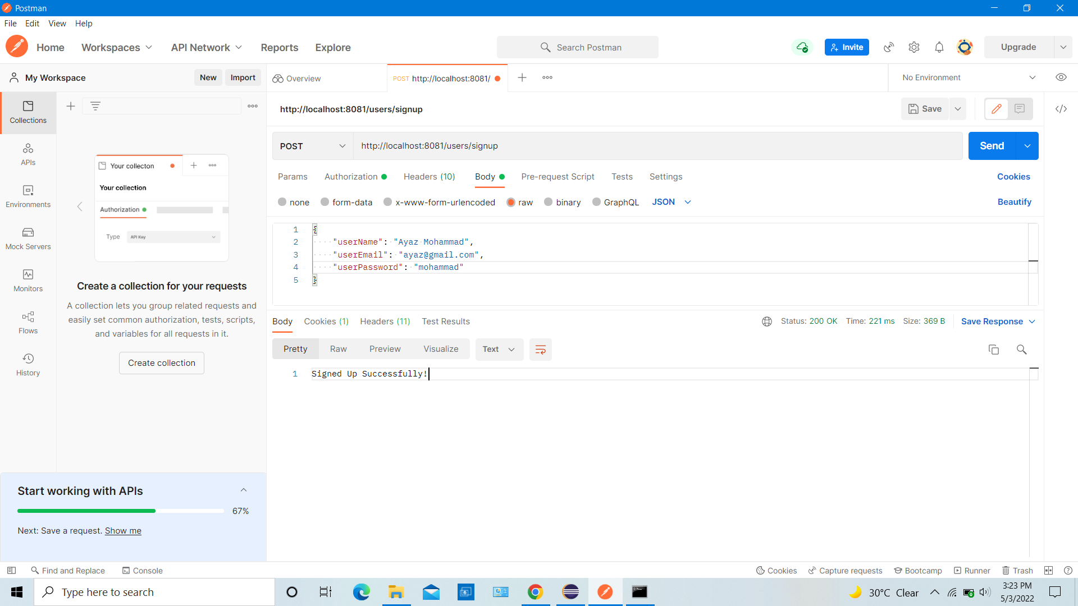

## **User can purchase shoes**

