# **Code Output**

## **Initial Screen**

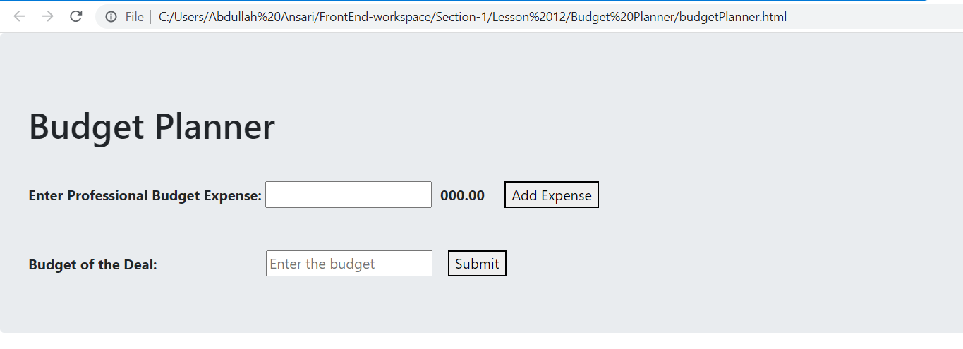

## **Setting Budget of the Deal**

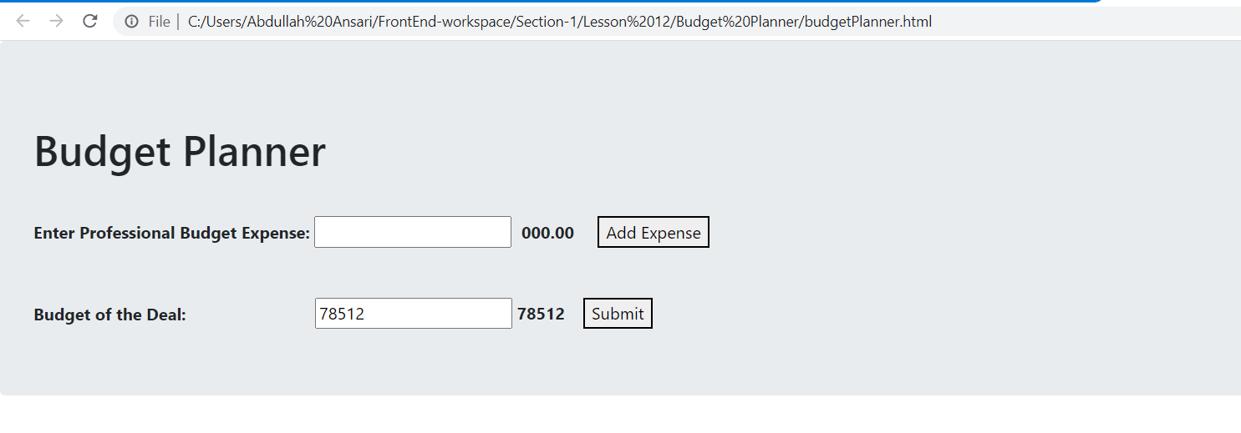

## **Adding Professional Budget Expense**

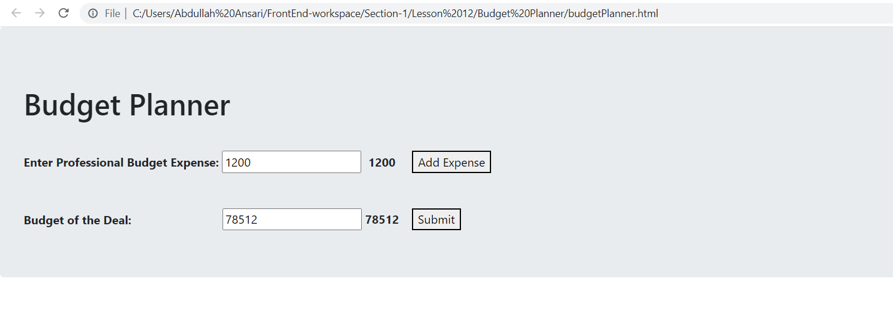

## **Adding More Expense**

