Assignment #HW2

CSSE490: Bio-Inspired Artificial Intelligence

Prepared and submitted by:

________________________

Collaboration and resources:

I worked (alone / with other student(s) including _________)

Resources I used to complete this assignment (websites, textbook, friends, etc.):

________________________

________________________

________________________

When complete, please remember to commit a PDF to your repo!

(File-> Save As->PDF)

Sample Experiment

1. **An explanation of the experiment (including parameters used)**

|  |  |
| --- | --- |
| *population size:* | *1000* |
| *mutation rate:* | *1/N* |
| *crossover:* | *FALSE* |
| *elitism rate:* | *0* |
| *selection method:* | *TRUNCATION* |
| *max generations:* | *1000* |
| *target expression* | *5 * x * x + 7 * x + 19* |
| *node terminal values* | *[-20,20]* |
| *node functions* | *+, -, \** |
| *testing values* | *[-50,50]* |

*The plot below is single example of a result of an implementation for experiment 3.*

1. **A hypothesis (might just be a guess)**

*Educated guess here*

1. **A plot of fitness over time and the best final expression and any observations**

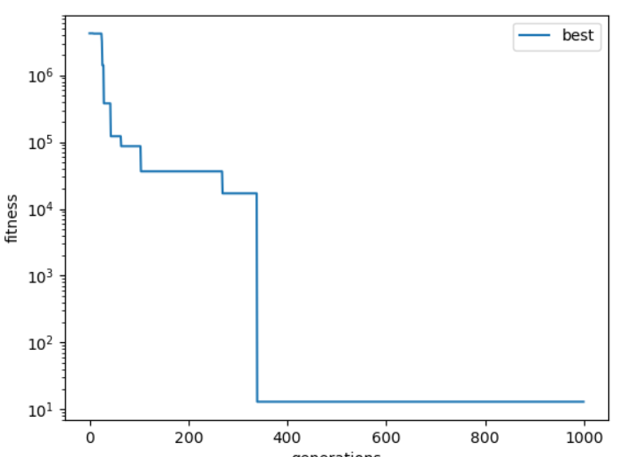

Best final expression: ((19 - x) + ((((x * -5) - 8) * -1) * x))

*Observations from results go here (i.e. this expression simplifies to the target expression)*

1. **What if anything you can conclude and anything you learned or affirmed by doing so?**

*Conclusions and anything you learned here*