INDUSTRIAL TRAINING REPORT
on
“Java-Based Banking Transaction System: A Conceptual Study”
by
Mohd Najeeb [Roll No.: ____________________]

Submitted in partial fulfillment of the requirements for the award of the degree
of
BACHELOR OF TECHNOLOGY
in
COMPUTER SCIENCE & ENGINEERING

from
EWB EDUTECH PRIVATE LIMITED

Submitted to
DEPARTMENT OF COMPUTER SCIENCE AND ENGINEERING
FACULTY OF ENGINEERING & TECHNOLOGY
UNIVERSITY OF LUCKNOW, LUCKNOW
[Month, Year]

DECLARATION
I, Mohd Najeeb, declare that this report titled “Java-Based Banking Transaction System: A Conceptual Study” is presented for the B.Tech Computer Science and Engineering summer internship requirement.
This report is a conceptual academic study. Its diagrams, sample records and transaction calculations are illustrative; they do not describe a deployed banking application or actual customer accounts. Sources consulted are listed in the references.
The report is submitted for academic purposes. No confidential information is intentionally included, and sources consulted are acknowledged in the references.

Student name: Mohd Najeeb
Roll number: __________________________
Signature: ____________________________
Date: _________________________________
Place: ________________________________

TRAINING / INTERNSHIP CERTIFICATE
Colour copy of the certificate supplied by the student:
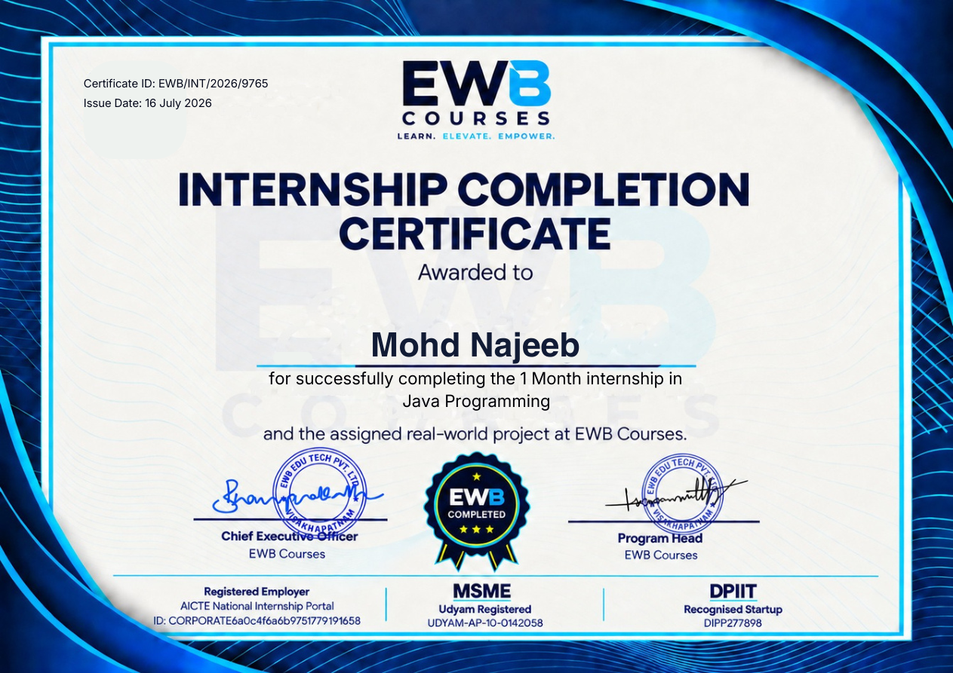
The supplied certificate states successful completion of a one-month internship in Java Programming and was issued on 16 July 2026.

ABSTRACT
This report presents a conceptual study of a Java-based banking transaction system. Its purpose is to connect introductory Java programming concepts with a familiar real-world problem: maintaining a bank account balance and recording deposits, withdrawals and transfers. The report describes an intended design, rather than a built or deployed application.
The study explains Java fundamentals, object-oriented programming, data validation, exception handling and the use of appropriate numeric types for money. It proposes simple customer, account and transaction concepts, then illustrates how a transaction can be checked and recorded. Flowcharts, tables and fictional examples make the proposed logic easier to understand.
The example transactions are hypothetical and are not bank records, benchmark results or screenshots from a running program. The study also outlines security, testing and reliability considerations that a production system would require, without claiming to implement them. The result is an accessible design that can be used as a starting point for future development.
The case study includes proposed requirements, illustrative entity descriptions, sample transaction calculations, validation rules and suggested test cases. Its purpose is to demonstrate the practical application of Java ideas at a conceptual level while keeping the explanation accessible to a beginner.

ACKNOWLEDGEMENT
I would like to express my gratitude to the Department of Computer Science and Engineering, Faculty of Engineering & Technology, University of Lucknow, for providing the opportunity to prepare this summer internship report.
I thank EWB EDUTECH PRIVATE LIMITED for the Java Programming internship opportunity. I also thank my teachers and well-wishers for their guidance and encouragement during my learning and report preparation.
I am grateful to everyone whose educational resources helped me understand the basic concepts of Java and banking transactions. Any mistakes or omissions in this report remain my responsibility.
Mohd Najeeb
I also acknowledge the authors of the Java documentation and educational resources referenced in this report. Their materials provide background for the language concepts and general security principles discussed in the study.

TABLE OF CONTENTS
Declaration . . . . . . . . . . . . . . . . . . . . . . . i
Training / Internship Certificate . . . . . . . . . . . . ii
Abstract . . . . . . . . . . . . . . . . . . . . . . . . iii
Acknowledgement . . . . . . . . . . . . . . . . . . . . . iv
Table of Contents . . . . . . . . . . . . . . . . . . . . v
List of Tables . . . . . . . . . . . . . . . . . . . . . vi
List of Figures . . . . . . . . . . . . . . . . . . . . . vii
Chapter 1: Introduction . . . . . . . . . . . . . . . . . 1
Chapter 2: Objectives . . . . . . . . . . . . . . . . . . 4
Chapter 3: Overview of the Training Organization . . . . 6
Chapter 4: Overview of Technology . . . . . . . . . . . . 8
Chapter 5: Problem Statement and Requirements . . . . . . 16
Chapter 6: Detailed Description of the Proposed System . . 19
Chapter 7: Conclusion and Future Scope . . . . . . . . . 35
References . . . . . . . . . . . . . . . . . . . . . . . 37

LIST OF TABLES
Table 2.1: Objectives and expected outcomes ........................ 5
Table 4.1: Java concepts used in the study ........................... 13
Table 5.1: Functional requirements ........................................ 17
Table 6.1: Suggested data fields ............................................. 21
Table 6.2: Illustrative transaction history ................................ 25
Table 6.3: Illustrative test cases ............................................... 30
Supplementary Table S1: Data representation ................................ 10
Supplementary Table S2: Example decisions ..................................... 11
Supplementary Table S3: Data organization options ........................... 12
Supplementary Table S4: Example error categories ............................. 14
Supplementary Table S5: Assumptions and boundaries ...................... 16
Supplementary Table S6: Entity responsibilities ................................ 20
Supplementary Table S7: Deposit calculation ...................................... 22
Supplementary Table S8: Transfer before and after ............................ 24
Supplementary Table S9: Invalid requests .......................................... 27
Supplementary Table S10: Security goals .......................................... 31

LIST OF FIGURES
Figure 1.1: Scope of the conceptual study ................................ 3
Figure 4.1: Java source-to-execution flow ................................... 15
Figure 6.1: Proposed system layers ........................................... 19
Figure 6.2: Conceptual withdrawal flow ................................... 23
Figure 6.3: Simplified conceptual relationships ........................... 29
Figure 6.4: Proposed transfer sequence .................................... 32
All figures are original conceptual illustrations prepared for this report. They are not screenshots of a running application.
Chart A: Illustrative balance after each transaction step ................... 26
Chart B: Comparison of illustrative transaction amounts .................. 34

CHAPTER 1: INTRODUCTION

1.1 Background
Banking transactions are activities that change or report the state of an account. Common examples include depositing money, withdrawing money, transferring money and checking a balance. Even simple transactions need clear rules so that the amount is valid and the account balance remains consistent.
Java is a general-purpose programming language that can be used to express such rules in a structured manner. Its classes, methods, conditions and exception-handling features make it suitable for explaining a small transaction system to beginners.
This report uses a simplified banking scenario as a learning exercise. It focuses on what a system could do and how its logic could be organized. It does not claim to be a completed application, a real bank product or an implementation created during the internship.
A real bank must satisfy additional regulatory, security and operational requirements. The examples here are intentionally small and do not cover all such requirements.

Banking terminology
A balance is the amount shown for an account at a particular point in time. A credit increases the balance in the simple model, while a debit decreases it. A transaction is a record of an action and its outcome. These terms help distinguish the money itself from the record describing how the balance changed.
The example follows a straightforward sequence: receive a request, check its validity, calculate a result and communicate the outcome. Thinking about the sequence first helps identify mistakes before any programming work begins.
Each operation can be viewed as a request with an input and an outcome. A deposit request contains an amount to add; a withdrawal request contains an amount to subtract. Before a result is accepted, the system must check that the requested action is allowed. Recording the result helps explain the path from an opening balance to a later balance.

1.2 Need for the Study

Why use a banking example?
A banking example combines several programming ideas in one understandable setting. It requires information to be stored, rules to be checked and a clear result to be communicated. These requirements provide a practical context for learning Java without needing to build a working model.
A poorly defined transaction may produce an incorrect balance or an unclear record. For example, allowing a withdrawal that exceeds the available balance could lead to inconsistent results. A conceptual design identifies such issues before implementation starts.
The study illustrates how input validation, arithmetic, classes and transaction records fit together. Each idea is described in simple terms, followed by examples or diagrams where appropriate.
The design is not a substitute for real banking software. It leaves out many production features, including integration with financial networks, legal compliance checks and actual user authentication.

Why design before implementation?
Writing down the rules before coding makes assumptions visible. For example, the designer must decide whether zero is a valid deposit, whether an account may have a negative balance and how a failed request is reported. In this report, zero and negative amounts are rejected and overdrafts are not allowed.
A reviewer can use the diagrams and tables to check whether the same rules are applied consistently. If a rule changes later, the related calculation, messages and proposed tests should also be reviewed. This approach keeps the learning exercise manageable without suggesting that a production system has been completed.
A design also improves communication. A reader can inspect a table of requirements and ask whether a rule is missing, while a flowchart can reveal a decision that was overlooked. For example, the withdrawal path needs both an amount check and a balance check. Reviewing these decisions early is easier than finding an unexpected result after a large program has been written.

1.3 Scope and Limitations

Scope
The proposed system covers a limited set of operations: viewing a balance, making a deposit, making a withdrawal, transferring funds between two illustrative accounts and viewing a simple transaction history.
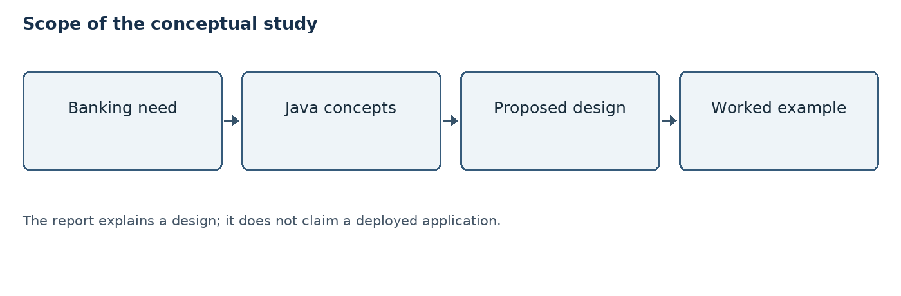
Figure 1.1: Scope of the conceptual study
The report provides descriptions, sample records and conceptual diagrams. No user interface, database, mobile application or payment gateway has been built or tested as part of this document.
All account identifiers, names, balances and amounts are fictional. The design does not handle interest, loans, fees, multiple currencies or banking regulations in detail.

Boundary of the example
The study begins with a fictional account whose opening balance is already known. It ends when a valid operation has a proposed result or an invalid operation is rejected. It does not explain how cash is physically collected or how banks settle transfers between institutions.
Simple assumptions keep the arithmetic transparent: all values are in Indian rupees, amounts are displayed to two decimal places and there are no fees. The figures in the later charts are derived from the worked example rather than collected from users.
Within this boundary, the report follows a single sequence of example transactions. That makes it possible to verify each value independently and compare the table with the chart. More complex matters, such as account recovery, fraud detection and integration with other banks, are identified as outside scope rather than silently assumed to work.

CHAPTER 2: OBJECTIVES

2.1 Project Objectives
The overall objective is to explain how introductory Java concepts can be applied to a simplified banking transaction problem. The work is presented as a study and design exercise rather than an implementation.
• Understand the purpose of deposits, withdrawals, transfers and balance enquiries.
• Identify suitable classes and data fields for customers, accounts and transactions.
• Describe validation rules for amounts and available balances.
• Use flowcharts and worked examples to show the proposed transaction flow.
• Discuss basic error handling, security, testing and possible future improvements.
The objectives are deliberately limited. A diagram or example in this report shows an intended solution; it is not evidence of a working system or production-ready banking service.

Questions addressed by the study
The report asks four basic questions: what information is needed for an account, what checks should be performed before a transaction, how should a new balance be calculated, and what information should be recorded afterwards? These questions guide the class descriptions, diagrams and examples.
A separate objective is to distinguish a conceptual proposal from an actual result. The document describes what a future system should do; it does not present performance data, execution results or evidence of a working application.
The objectives can be grouped into understanding, design and review. Understanding covers Java and the meaning of transactions. Design covers the proposed entities and rules. Review covers arithmetic, validation scenarios and limitations. Organizing the work this way helps the reader see how each chapter contributes to the overall case study.

2.2 Expected Outcomes

Learning outcomes
The expected outcome is an understandable design that relates basic Java language features to a familiar financial example. A reader should be able to trace how an input amount affects a fictional balance and explain why invalid input must be rejected.
Table 2.1: Objectives and expected outcomes
Objective | Expected outcome
Understand banking operations | Explain deposit, withdrawal and transfer
Apply Java concepts | Identify suitable classes and methods
Describe validation | State conditions for accepting an amount
Evaluate the design | Suggest tests and note limitations

These outcomes are educational goals, not measured performance results. The report does not claim that any code, interface or test was executed.

How the outcomes can be reviewed
Each outcome can be checked by reading the related section and tracing an example. For instance, the withdrawal flow can be compared with the stated validation rules, while the transaction history can be checked using ordinary arithmetic.
An account balance should change only when an allowed operation succeeds. If a reader finds a contradiction between a rule, diagram and table, the design should be corrected before any implementation is attempted. This review is conceptual and does not replace program testing.
A useful check is to follow a transaction from its initial state to its final state. The reader can write the starting balance, apply the amount and compare the result with the history table. A second check is to try an invalid value and confirm that the proposed rules do not permit any balance change.

CHAPTER 3: OVERVIEW OF THE TRAINING ORGANIZATION

3.1 Organization Profile
The supplied offer letter identifies EWB EDUTECH PRIVATE LIMITED as the organization offering a Java Programming internship. It describes the opportunity as virtual, unpaid and one month in duration. The accompanying certificate records successful completion of a one-month internship in Java Programming and was issued on 16 July 2026.
The offer letter refers to beginner-oriented Java learning, scheduled sessions, assessments and a final mini project. These are stated participation requirements in the letter; they are not independent evidence that any particular activity or project in this report was completed.
This report uses a hypothetical banking system to explain Java concepts. No confidential organization data or real financial records are included. Details beyond those supported by the supplied documents should be verified by the student before final submission.

Relationship to this report
The offer letter describes an educational internship for beginners. The attached certificate states the area of training as Java Programming. This report therefore uses Java terminology to discuss a small banking-related case study.
The organizational information is limited to the documents supplied. The proposed system is an independent explanatory example; the report does not attribute its design, diagrams or hypothetical banking data to a client or claim that EWB deployed such a system.
The certificate is reproduced in colour in the preliminary pages. It identifies the student and the training area. It is included as supporting documentation for the internship, whereas the banking discussion in the main chapters is a separate illustrative example based on common programming concepts.

3.2 Training Context

Learning context and verification
The certificate identifies the training area as Java Programming. Accordingly, the following chapters explain language basics and show how those basics could support a simple transaction design.
The exact session content, tools used, training dates and mentor details were not supplied for this report. They should be added only after the student verifies them. The report does not assume that the conceptual banking system was assigned or implemented by the training organization.
The internship certificate records a one-month duration but does not specify the exact start and end dates. The certificate is included in the preliminary pages of this report.
The banking scenario in this report is a learning case study. It uses fictional examples to connect introductory programming concepts to a practical problem.

Using a learning case study
Technology-based training can be documented by explaining the relevant concepts, then showing how those concepts apply to a chosen problem. Here, an account and its transaction history provide the context for methods, conditions and data structures.
The worked calculations and suggested pseudocode are illustrative applications of the concepts. They should be read alongside the original certificate and any verified training details supplied by the student. They do not reveal confidential company information or represent an actual bank dataset.
A case study gives abstract ideas a setting in which their purpose becomes visible. A condition is not merely a language feature: it can express a rule that an amount must be positive. An object can represent an account, and a collection can group its records. These connections are the educational focus of the following chapters.

CHAPTER 4: OVERVIEW OF TECHNOLOGY

4.1 What is Java?
Java is a programming language used to build many types of software, including desktop applications, web services and enterprise systems. A Java program is commonly written in a source file and compiled into bytecode. A compatible Java Virtual Machine (JVM) can execute that bytecode.
Java supports object-oriented programming, which organizes a program around objects with data and behaviour. Its standard library provides useful facilities for collections, text processing, dates and numeric calculations.
For this conceptual banking study, Java is useful because accounts and transactions can be represented as classes, while operations can be described as methods. Conditional statements can express rules such as accepting only a positive transaction amount.
The report describes these concepts for learning purposes. It does not depend on a particular Java version or claim that any Java program was run.

Java in the proposed design
A program written in Java is usually divided into classes. Each class can group related information and operations, helping a designer describe the different responsibilities of a banking example. An account object could have its own identifier and balance, while methods describe what operations are permitted.
Java also provides mechanisms to express decisions, repeat work and handle exceptional conditions. These capabilities are useful for the proposed problem, but using Java alone does not guarantee correctness or security; those qualities depend on the complete design and its implementation.
Java source code uses a defined syntax. Statements and expressions express the actions to be performed, and a method groups instructions that have a particular responsibility. Types help describe the kind of information being handled. In a future banking program these mechanisms could be used to organize checks and calculations in a clear way.

4.2 Java Development Tools

JDK, JRE and JVM
The Java Development Kit (JDK) contains tools for developing Java programs, including the compiler. The Java Virtual Machine (JVM) executes Java bytecode. A Java runtime environment provides the components needed to run Java applications; its packaging varies by Java distribution.
A programmer may write Java source code in a text editor or an integrated development environment (IDE). Common IDE features include syntax highlighting, navigation and debugging. A command-line terminal can also be used to compile and run a program.
In a future implementation, a development environment could help organize source files and examine errors. No specific IDE, tool version or executed command is claimed in this report.
Understanding the distinction is useful: the compiler translates source code into bytecode, while the JVM executes the resulting bytecode.

Illustrative development workflow
If a future developer chose to implement the design, a possible workflow would be to install a suitable JDK, create a project, write source files, compile the code and review any compiler messages. The developer could then run a small set of tests and improve the design based on the results.
A compiler checks Java syntax and types, but an accepted program can still contain incorrect banking logic. For example, adding rather than subtracting a withdrawal could be syntactically valid. Business rules must therefore be checked separately.
An editor or IDE can make source text easier to navigate, but the underlying business decisions must still be made by the developer. Likewise, a debugger can help inspect values during a run, but it cannot decide the correct overdraft policy. Tools support the work; the requirements determine what behaviour is expected.

4.3 Variables and Data Types

Representing account information
A variable is a named storage location for a value. Java requires a variable to have a declared type. For example, an account number may be represented as text, while a count of transactions may be represented as an integer.
An account number is better treated as an identifier than as a value to calculate with. Text representation can preserve leading zeroes. A customer name is also stored as text.
Amounts of money should be represented carefully. Binary floating-point values can introduce rounding surprises, so a real implementation can use BigDecimal with explicit scale and rounding rules, or integer values in the smallest currency unit when appropriate.
The conceptual examples in this report use rupee amounts with two decimal places. They assume no fees or interest. They are illustrative arithmetic, not real account balances.
Supplementary Table S1: Examples of data representation
Item | Possible representation | Reason
Account identifier | String | Preserves leading zeroes
Number of records | int | Stores a whole-number count
Money amount | BigDecimal | Supports decimal calculations

An identifier should not be treated as money, even if it contains only digits. Similarly, the program should use an agreed scale and rounding policy for amounts. These are design choices for a possible implementation, not a description of existing stored data.
For money, the input and the stored value must follow a consistent convention. The design should specify the currency, allowed number of decimal places and handling of rounding. For example, ₹100.00 and ₹100.50 are distinct values, while an input with extra decimal places needs a defined response rather than an undocumented assumption.

4.4 Operators and Decision Making

Applying rules
Arithmetic operators perform calculations such as adding a deposit or subtracting a withdrawal. Comparison operators compare values, for example to check whether a transaction amount is positive.
An if statement can select an action based on a condition. For a simple withdrawal, the proposed rules are: accept the amount only if it is greater than zero and no greater than the available balance; otherwise reject the request.
Logical operators can combine checks. Careful ordering is important: invalid or missing input should be handled before arithmetic is performed. A failed validation must not change the account balance.
For example, if a fictional account has ₹5,000.00, a request to withdraw ₹1,000.00 passes the balance check. The resulting balance is ₹4,000.00, assuming all other checks succeed.
Supplementary Table S2: Example decisions
Condition | Proposed action
Amount is positive | Continue to account checks
Amount is zero or negative | Reject the request
Withdrawal exceeds balance | Reject; keep balance unchanged

The order of checks should be predictable. A request should not reach a calculation until its input has been validated. In a future implementation, decimal comparisons should use the appropriate BigDecimal comparison methods rather than converting values to binary floating point.
Consider a balance of ₹5,000.00. A withdrawal of ₹5,000.00 satisfies the simple rule because it is not greater than the available balance, and it would leave ₹0.00. A withdrawal of ₹5,000.01 fails the same rule. An implementation would also need to consider other policies, such as transaction limits, if they were specified.

4.5 Loops, Arrays and Collections

Organizing repeated data
A loop repeats an operation while a condition holds or for each item in a group. For example, a future program could display each transaction in a history list by visiting records one at a time.
An array holds a fixed number of values of the same type. A collection such as an ArrayList can hold a variable number of objects. A list of Transaction objects is a natural conceptual choice for a small in-memory history.
A list kept only in memory disappears when the program ends. Persistent storage would be required if records must survive a restart. This report describes persistence as a future possibility rather than an implemented feature.
Displaying history should not modify it. A transaction record should identify its type, amount, result and date or time when those details are available.
Supplementary Table S3: Data organization options
Structure | Possible role
Array | Fixed set of menu labels
List | Collection of transaction records
Map | Look up an account by identifier

The appropriate structure depends on the problem. A list can preserve the order of transactions for display, while a map can help locate an account by a unique key. Neither choice by itself provides durable storage or protection against unauthorized access.
Order can matter when displaying a history. If a later record is shown before an earlier one, the sequence of balances can be confusing unless the display clearly states its ordering. A future design should decide whether to show oldest or newest records first and use a consistent timestamp or sequence identifier.

4.6 Object-Oriented Programming

Classes and objects
A class describes the data and behaviour associated with a concept. An object is an instance of a class. In this study, an Account class could hold an identifier and balance, while its methods could define deposit and withdrawal behaviour.
Encapsulation means restricting direct access to internal state and providing controlled operations. For example, a balance should not be changed arbitrarily by any part of a program; the account should apply validation when processing an operation.
Table 4.1: Java concepts used in the study
Java concept | Conceptual use
Class and object | Represent an account
Method | Describe a banking action
Condition | Check amount and balance
Collection | Organize transaction records

Inheritance and polymorphism are useful in larger designs, but they are not required for the basic example in this report.

Encapsulation example
Suppose an account starts with ₹5,000.00. Rather than allowing unrelated code to set its balance to any value, a future Account object could accept a deposit request through a method. That method would validate the amount and only then calculate the new balance.
The same idea can be applied to withdrawals. Keeping validation near the operation makes the rule easier to find and review. This is a proposed class design, not a statement that such a class has already been written.
Encapsulation is not the same as hiding every detail from the user. The user may still see a balance and receive an explanation of a rejected request. The key idea is that changes to internal state go through controlled operations, rather than allowing arbitrary direct modification from any part of the program.

4.7 Exception Handling

Handling unexpected situations
Exception handling is a way to respond to exceptional conditions without allowing the program to fail without explanation. A Java program can use try, catch and finally blocks when appropriate. The exact approach depends on the type of error and the design.
For example, text entered where a number is expected may fail to parse. A future program should report that the amount is invalid and ask for a correct value rather than silently using an incorrect amount.
Business rule failures, such as insufficient funds, should also be communicated clearly. They need not all be represented as Java exceptions; a result object or another explicit mechanism may be suitable.
Error messages should avoid exposing passwords, personal data or internal system details. No actual error logs or executed exceptions are presented in this conceptual study.
Supplementary Table S4: Example error categories
Situation | Suggested response
Amount cannot be read | Request a valid numeric amount
Insufficient funds | Decline without changing balance
Unexpected storage failure | Report failure and protect consistency

A clear distinction between invalid input, a business-rule rejection and an unexpected technical failure can make a future system easier to understand. Details exposed to a user should be limited, while authorized support personnel may need suitable diagnostic information.
A future design should decide which failures are expected and how each is reported. A malformed number is different from a storage outage: the first may be corrected by the user, while the second may require retry or investigation. In either situation, the system must avoid presenting a transaction as successful when it was not completed.

4.8 Compilation and Execution

Java execution process
In a typical workflow, Java source code is saved in a file with a .java extension. The compiler checks the source and produces bytecode in a .class file. The JVM then executes that bytecode in a suitable runtime environment.
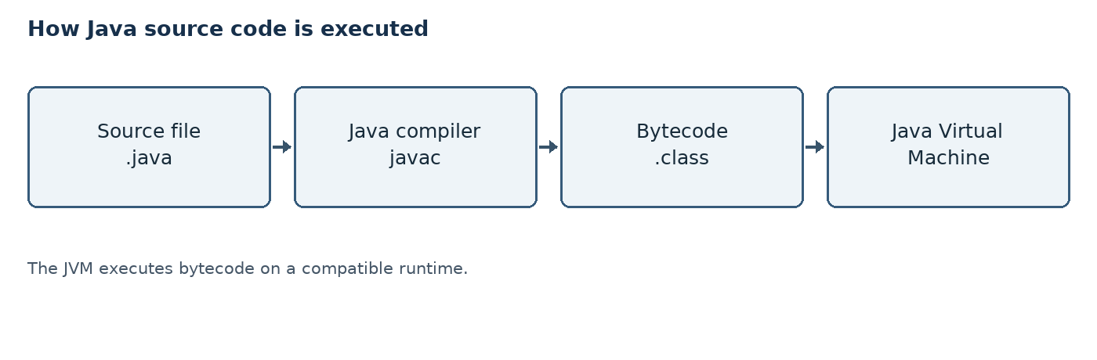
Figure 4.1: Java source-to-execution flow
The diagram shows a general language workflow, not a process performed for this report. Compilation can detect certain language errors, but it cannot prove that banking rules are correct.
If the design were implemented later, it would still require careful testing, secure storage and independent review before any real banking use.

Checks at each stage
During source creation, the developer selects names and expresses the intended logic. During compilation, Java checks rules such as valid syntax and compatible types. During execution, the program follows its instructions and may encounter input or runtime errors.
A banking rule such as “do not withdraw more than the balance” must be explicitly designed and checked. Neither compilation nor the JVM automatically supplies this rule. The flow shown above is therefore only one part of a complete development process.
The standard workflow can be repeated after changes: edit the source, compile it and run relevant checks again. A previously successful compilation does not validate a later edit. If an implementation is developed, its compiler version, environment and test outcomes should be recorded accurately rather than inferred from the diagram.

CHAPTER 5: PROBLEM STATEMENT AND REQUIREMENTS

5.1 Problem Statement
Consider a simplified situation in which a customer wants to view an account balance and perform basic transactions. A manual or poorly organized record can be difficult to update consistently. The conceptual problem is to describe a system that can apply clear transaction rules and maintain an understandable record.
The proposed design should accept valid deposits and withdrawals, reject invalid amounts and prevent withdrawal beyond the available balance. It should also describe a transfer between two accounts and record the outcome of an operation.
The aim is not to reproduce the infrastructure of a bank. Instead, the study uses a small and clearly defined model to explain how Java concepts may support transaction logic.
Success in this report means a coherent explanation of the design and its examples, not a claim that software was built, tested or deployed.
Supplementary Table S5: Assumptions and boundaries
Assumption | Effect on example
One currency | No exchange-rate calculation
No overdraft | Balance cannot go below zero
No charges | Only the stated amount changes balance

The model assumes an account exists before the examples begin and that the figures are available for calculation. These assumptions are used only to simplify the study and must not be mistaken for actual bank policy.
The problem includes both information and behaviour. Information includes the balance and identifying details; behaviour includes the rules for changing or displaying the balance. Treating these separately makes it easier to identify what must be stored and which operations are allowed to modify it.

5.2 Functional Requirements

What the proposed system should do
Functional requirements describe the actions a proposed system should support. The following requirements are intentionally limited to a beginner-friendly example.
Table 5.1: Functional requirements
ID | Proposed requirement
FR1 | Display the current account balance
FR2 | Accept a valid positive deposit
FR3 | Reject an invalid or excessive withdrawal
FR4 | Describe a transfer between accounts
FR5 | Show an illustrative transaction history

Each operation should return a clear success or failure result. The design assumes that an authorized user has already been identified; authentication is discussed separately as a production consideration.

Relationship between requirements
The operations share common checks. Deposit, withdrawal and transfer each need a valid account and a positive amount; withdrawal and transfer additionally require adequate funds in the source account. Balance enquiry should return information without changing the balance.
Transaction history makes the sequence easier to inspect. For a real implementation, requirements should define whether unsuccessful attempts are recorded, who can view them and how long they must be retained. Those details are beyond this simplified design.
Requirements should be stated so that a reviewer can determine what a successful operation means. For a deposit, that means an allowed amount is added once. For an invalid withdrawal, it means the request is declined and the previous balance remains unchanged. These examples make the requirements more precise than a general instruction to manage accounts.

5.3 Non-Functional Requirements

Quality considerations
• Correctness: a successful transaction should apply the intended rule and produce an accurate balance.
• Reliability: an incomplete operation should not leave account data in an inconsistent state.
• Security: access to financial data should be restricted and sensitive information protected.
• Usability: prompts, confirmations and error messages should be clear to the user.
• Maintainability: responsibilities should be separated so that rules can be understood and changed.
• Traceability: records should make it possible to understand the outcome of an operation.
These are design goals, not measured properties of an actual system. A production service would need formal performance targets, threat analysis, legal review and testing beyond the scope of this study.

How quality could be assessed
Correctness could be assessed by checking a set of expected balances against actual outputs if an application were built. Usability could be reviewed by asking whether prompts and error messages are understandable. Reliability could be investigated using failure and recovery scenarios.
None of these assessments has been performed for this report. A non-functional requirement should eventually be stated in measurable terms, such as an agreed response time or availability target, but inventing measurements would not be appropriate here.
Quality attributes can interact. For instance, additional authorization checks improve protection but may also affect how a user completes an operation. The design should aim for clear messages while maintaining appropriate security. Requirements and measurements for these qualities would need to be agreed before evaluating a production system.

CHAPTER 6: DETAILED DESCRIPTION OF THE PROPOSED SYSTEM

6.1 Proposed Architecture
The conceptual design separates interaction, banking rules and account data. A user interface would collect a request and display its result. Banking logic would validate the request and decide whether the account can be updated. The data layer would represent balances and transaction records.
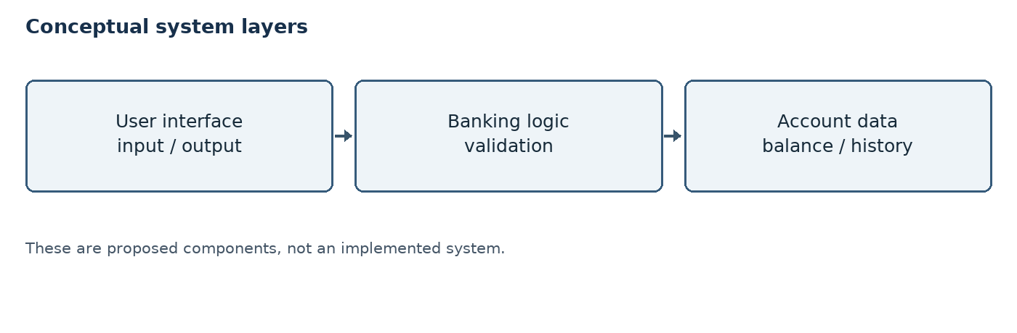
Figure 6.1: Proposed system layers
This separation helps a reader see where each responsibility belongs. It also makes future changes easier to reason about: the same business rules could be used with different interfaces.
The diagram is conceptual. It does not imply that these components, a database or a user interface were implemented.

Responsibilities across layers
The interface should pass a request to the logic layer instead of changing account data directly. The logic layer checks the rules and requests an appropriate update. A data layer would be responsible for reading and saving the information needed by the operation.
If a database were added, a storage operation could fail even after input validation succeeds. The design would need a clear failure result and a way to prevent partial updates. The proposed layers only describe responsibilities; they are not a deployed architecture.
The boundaries between layers also support testing. Banking rules could be reviewed independently of the wording of the interface, and a storage component could be examined separately from the validation logic. In a future program, these boundaries would need carefully defined inputs, outputs and error handling.

6.2 Main Entities

Customer, account and transaction
Customer: represents a person who owns or uses an account. In the simple model, a customer has a name and an identifier. Real banking systems need much more information and must protect it carefully.
Account: represents a place where a balance is maintained. An account has an account identifier and a balance. Its operations should enforce rules before the balance changes.
Transaction: represents an attempted banking action. A record can include the operation type, amount, status and relevant time. The design may also record the resulting balance, depending on its requirements.
For simplicity, the examples use one customer and one primary account, with a second account introduced for a transfer. These entities are proposed concepts; no real persons or account details are used.
Supplementary Table S6: Conceptual entity responsibilities
Entity | Information | Main responsibility
Customer | Name and ID | Identify the account holder
Account | ID and balance | Apply balance rules
Transaction | Type and status | Describe an operation

The distinction between the entities prevents a transaction record from being confused with the account itself. An account has a current balance; transaction records describe events that may explain changes over time.
In the simplest example, a customer can be associated with one account and an account can have many transaction records. This is a teaching assumption, not a universal banking rule. A more detailed system might permit joint accounts, multiple owners, account types and additional relationships.

6.3 Data Fields

Illustrative data model
The table below lists suggested fields for a simple design. It is not a database schema and contains no real customer information.
Table 6.1: Suggested data fields
Entity | Field | Purpose
Customer | customerId | Identify a customer
Account | accountId | Identify an account
Account | balance | Store available amount
Transaction | type, amount | Describe the action
Transaction | status, time | Record outcome and time

A real implementation would need additional identifiers, access rules, currency information and record-retention policies. Money should be stored with a suitable decimal representation and a documented rounding policy.

Field design considerations
Identifiers should be unique within their intended scope and should not expose unnecessary personal details. A transaction status might distinguish success from rejection, while a timestamp can help order events. The format and time zone should be documented if timestamps are used.
The table is deliberately small. A production design would also require decisions about currency, account ownership, auditing, storage constraints and access permissions. Adding a field to the conceptual table does not create a database or prove that data exists.
A field should have a clear meaning so that two developers do not interpret it differently. For example, a balance field should specify whether it represents available funds or another accounting value. A transaction amount should be associated with a currency and an operation type so that a reader can understand its effect.

6.4 Deposit Operation

Adding money to an account
A deposit increases an account balance by a valid positive amount. The proposed process begins when the user provides an account identifier and an amount. The system checks whether the account is valid and whether the amount is greater than zero.
If validation succeeds, the new balance is calculated as: new balance = old balance + deposit amount. A successful result and a transaction record should then be produced. If validation fails, the system should explain the problem and leave the balance unchanged.
Illustrative example: starting balance ₹5,000.00; deposit ₹1,500.00; resulting balance ₹6,500.00. These numbers are fictional and ignore fees and other real-world rules.
In a real system, the update and its record must be handled reliably together. This report does not implement that behaviour.
Supplementary Table S7: Deposit calculation
Item | Illustrative value
Opening balance | ₹5,000.00
Deposit | ₹1,500.00
Closing balance | ₹6,500.00

The amount is added only after the deposit request passes the stated checks. A rejected deposit, such as ₹0.00, leaves the opening balance unchanged. The values are hypothetical and are used consistently in the later transaction history.
The transaction result should be communicated in terms that make the operation clear. A future design could display the amount accepted and the resulting balance after a successful deposit. It should not display a success message when validation or storage fails, because that would mislead the user about the account state.

6.5 Withdrawal Operation

Checking available funds
A withdrawal reduces the account balance. Before updating the balance, the proposed logic checks that the amount is positive and does not exceed the available balance.
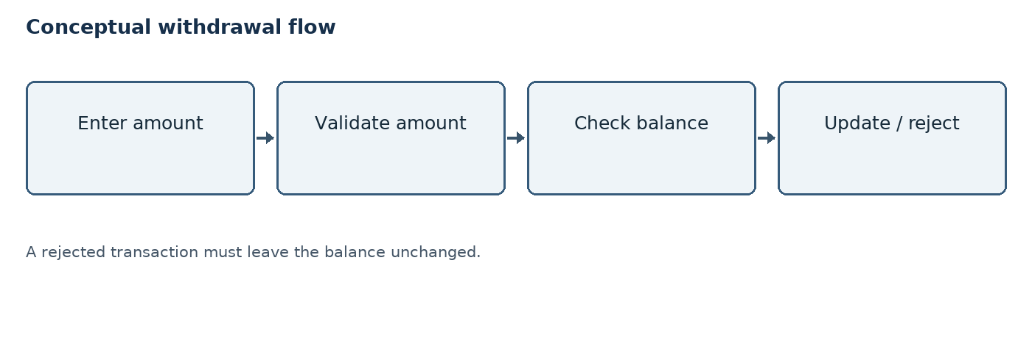
Figure 6.2: Conceptual withdrawal flow
Example: from ₹6,500.00, a withdrawal of ₹2,000.00 gives ₹4,500.00. A request to withdraw ₹7,000.00 from the same ₹6,500.00 balance is rejected; the balance remains ₹6,500.00.
The example assumes no overdraft, fee, daily limit or pending transaction. Actual banking rules may be more complex.

Decision points
The first decision is whether the requested amount is a valid positive value. The second is whether enough money is available. If either decision fails, the proposed system returns a rejection rather than performing subtraction.
If both conditions hold, the balance changes once and the operation can be recorded. In an actual system, the check and update would need proper coordination so that concurrent requests do not both spend the same available balance.
The order of operations matters. Subtracting first and checking later could temporarily create an invalid balance or make recovery harder. The conceptual design therefore places the amount and funds checks before the update. The flow also assumes that the requester has permission to use the account.

6.6 Transfer Operation

Moving funds between accounts
A transfer moves an amount from a source account to a different destination account. The proposed process validates both account identifiers, confirms that the amount is positive and checks that the source has sufficient funds.
If all checks pass, the source is debited and the destination is credited by the same amount. A record should identify the operation and its result without exposing unnecessary sensitive information.
Illustrative example: source balance ₹4,500.00; destination balance ₹2,000.00; transfer ₹500.00. The resulting balances are ₹4,000.00 and ₹2,500.00 respectively. The combined balance remains ₹6,500.00.
A real implementation must make the debit and credit atomic: both succeed together or neither takes effect. It must also handle concurrent requests and failures, which are not implemented in this study.
Supplementary Table S8: Transfer before and after
Account | Before | After
Source | ₹4,500.00 | ₹4,000.00
Destination | ₹2,000.00 | ₹2,500.00
Combined | ₹6,500.00 | ₹6,500.00

The combined balance stays the same because the model assumes no fees and both accounts use the same currency. This equality is a useful check for this example; it is not a complete test of a real transfer system.
The source and destination are different accounts. Before any change, the proposed process checks that both can be identified and that the source has sufficient funds. The displayed values show only the arithmetic; a real transfer would need additional checks and a reliable record of the outcome.

6.7 Illustrative Transaction History

Sample records
The table traces a fictional primary account. It uses the same deposit, withdrawal and transfer amounts as the preceding examples. All operations shown are assumed to succeed.
Table 6.2: Illustrative transaction history
Step | Operation | Amount (₹) | Balance (₹)
1 | Opening balance | — | 5,000.00
2 | Deposit | 1,500.00 | 6,500.00
3 | Withdrawal | 2,000.00 | 4,500.00
4 | Outgoing transfer | 500.00 | 4,000.00

A real history would normally include identifiers, timestamps and statuses, and access to it would be controlled. This sample is invented to demonstrate the calculations; it is not a screenshot or actual transaction log.

Reading the example
Step 2 adds ₹1,500.00 to the opening balance. Step 3 subtracts ₹2,000.00 from the updated balance. Step 4 subtracts the outgoing transfer of ₹500.00 from the primary account. Each row uses the result of the previous successful step.
The table does not include dates because none were supplied for these fictional events. A real application would need appropriately generated timestamps and identifiers. Failed operations could also be recorded separately according to the system’s policy.
The closing balance can be verified directly: ₹5,000.00 + ₹1,500.00 − ₹2,000.00 − ₹500.00 = ₹4,000.00. The outgoing transfer changes the primary account shown in this table, while the corresponding increase in the destination account is shown separately in Table S8.

6.8 Balance Enquiry

Viewing the current balance
A balance enquiry returns the current balance without changing it. The conceptual sequence is to identify the requested account, check that the requester is allowed to view it, retrieve the balance and display it clearly.
For the fictional primary account in Table 6.2, a balance enquiry after the outgoing transfer would display ₹4,000.00. No deposit or withdrawal is performed by the enquiry itself.
A real system may distinguish available balance from ledger balance and account for pending transactions. This simplified report treats the displayed figure as the available balance and assumes no pending transactions.
A future interface should avoid showing more personal information than necessary. The design does not specify an actual authentication method or a running interface.
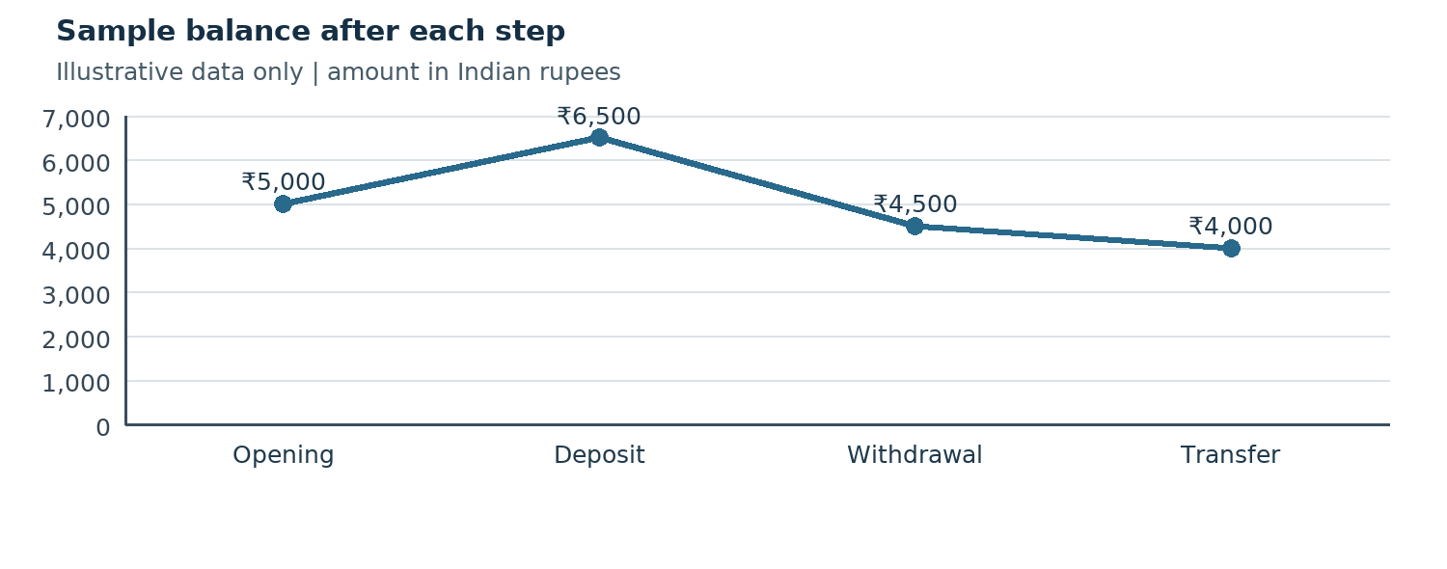
Chart A: Illustrative balance after each transaction step
The chart visualizes the same fictional sequence in Table 6.2. It is a graph of sample balances, not a measurement of a deployed application or actual bank account.
The first point is the opening balance. The second reflects the deposit, the third reflects the withdrawal, and the fourth reflects the outgoing transfer. The horizontal axis represents the order of the example rather than calendar dates.

6.9 Input Validation

Rules before processing
Validation checks whether an input is acceptable before it is used. In the proposed design, an amount must be present, numeric, positive and within any allowed precision or limit. Account identifiers must refer to valid accounts.
A withdrawal also requires sufficient available funds. A transfer requires a valid destination and should reject a transfer from an account to itself if that is a business rule. Different banking products may apply different limits.
Examples of invalid input include a blank amount, letters instead of a number, zero, a negative amount and a withdrawal larger than the available balance. In every rejected case, the existing balance should remain unchanged.
Validation messages should be understandable but should not reveal unnecessary account or security details. These rules are proposals rather than verified software behaviour.
Supplementary Table S9: Illustrative invalid requests
Request | Reason for rejection
Deposit ₹0.00 | Amount is not positive
Withdraw ₹7,000.00 from ₹6,500.00 | Insufficient funds
Transfer to an unknown account | Destination cannot be verified

A validation rule should be applied consistently wherever the corresponding input is accepted. A future system should also check authorization and avoid assuming that a correctly formatted identifier necessarily refers to a real account.
A check may depend on more than the amount. A correctly formatted account identifier can still be unknown, and a valid account can still be inaccessible to a particular user. A future system should distinguish these concerns internally while choosing messages that do not reveal sensitive account information.

6.10 Suggested Algorithm

Withdrawal pseudocode
The following is a language-independent outline of the proposed logic. It is not executable Java code.
• Receive the account identifier and requested amount.
• If the account is unavailable or the requester is not authorized, reject the request.
• If the amount is not a valid positive monetary value, reject the request.
• If the amount is greater than the available balance, reject the request.
• Otherwise, subtract the amount, record the successful operation and return the updated balance.
For every rejection, report a suitable reason and do not change the balance. In a production system, checking the balance and updating it must be coordinated to prevent simultaneous requests from causing inconsistent results.
This pseudocode is intended to explain the sequence, not to demonstrate a completed implementation.

Manual trace
Assume the account has ₹5,000.00 and the requested withdrawal is ₹1,000.00. The amount is positive and is less than the available balance, so the conceptual outcome is acceptance and a new balance of ₹4,000.00.
Now assume the requested amount is ₹6,000.00. The amount is positive, but it exceeds the available balance. The logic stops at the balance check, returns a rejection and leaves ₹5,000.00 unchanged. These are manual traces rather than executed tests.
A manual trace is useful because it exposes the state before and after each decision. It can be repeated with a boundary value, such as withdrawing exactly the available balance. Under the assumptions in this report, that request would be accepted and the remaining balance would be zero.

6.11 Conceptual Class Relationships

Object-oriented view
The diagram below shows a simplified relationship among the main concepts. A customer is associated with an account, and an account is associated with transaction records. A real application may support many accounts per customer and more complex relationships.
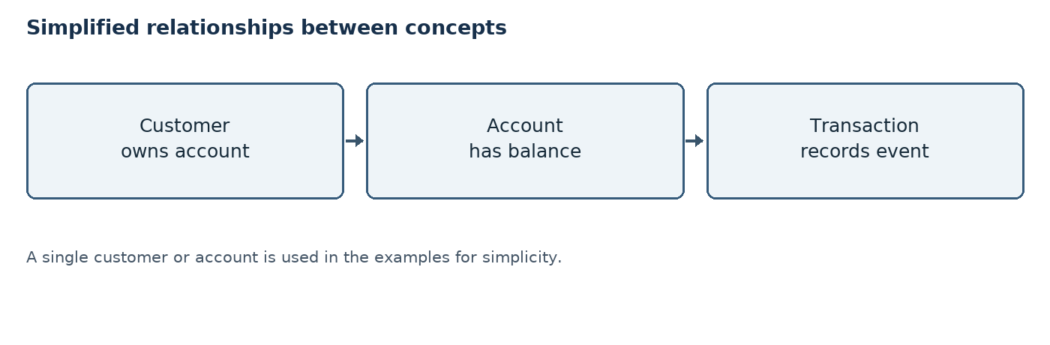
Figure 6.3: Simplified conceptual relationships
An Account concept could expose methods such as deposit, withdraw and getBalance. A Transaction concept could describe the type, amount and status of an operation. Names are illustrative and do not represent implemented code.
Separating these responsibilities makes the design easier to understand and provides a basis for future refinement.

Method responsibilities
A deposit method would check an amount and propose an increase. A withdrawal method would check both the amount and the balance before proposing a decrease. A balance enquiry would return the current amount without changing it.
The transaction concept records what happened, while the account concept holds the current state. A real design might use a separate service to coordinate transfers between accounts. The diagram intentionally omits implementation-specific details to keep the relationships easy to follow.
A relationship in a diagram communicates association, not a complete programming interface. Before implementation, the designer would still need to decide how objects are created, how identifiers are checked, where history is stored and how changes to two accounts are coordinated during a transfer.

6.12 Conceptual Testing

Example test cases
The cases below describe expected outcomes. They are proposed tests, not results from an executed program.
Table 6.3: Illustrative test cases
Case | Input / condition | Expected outcome
Deposit | ₹500.00, valid account | Balance increases by ₹500.00
Withdrawal | ₹300.00, sufficient funds | Balance decreases by ₹300.00
Withdrawal | More than balance | Reject; balance unchanged
Amount | Zero or negative | Reject; balance unchanged
Transfer | Invalid destination | Reject; no balance changes

A future implementation should test additional cases such as decimal precision, concurrent updates, storage failures and repeated requests. Real test results should only be added after execution.

Reviewing test results
For each future test, the starting balance, input, expected result and observed result should be recorded. A test passes only when the observed result matches the expected result and any relevant state remains consistent.
For example, a rejected withdrawal should be checked twice: the system should show an appropriate rejection and the balance should remain unchanged. The cases in the table are plans only; no pass or fail results have been fabricated.
Boundary cases are important because errors often appear at the edge of an allowed range. Suggested examples include an amount of zero, an amount equal to the balance, an amount slightly above the balance and an amount with more decimal places than permitted. Each case requires an agreed expected outcome.

6.13 Security Considerations

Protecting accounts and data
Banking information is sensitive. A production system needs strong authentication, authorization, secure communication and protection of stored data. Users should only be able to access accounts and actions for which they have permission.
Passwords must not be stored as plain text. A real system should use established authentication practices, appropriate password hashing and secure session management. It should also protect against unauthorized access and carefully handle sensitive information in logs.
The system should use trustworthy libraries, apply updates and undergo security reviews. These points are general design considerations, not a claim that this report implements security controls.
No real customer information, credentials, account numbers or confidential company materials have been used in the examples.
Supplementary Table S10: Security goals
Goal | Example control to consider
Confidentiality | Restrict access and protect data
Integrity | Validate and authorize changes
Accountability | Keep appropriate audit records

Security controls must work together. For example, encryption does not replace authorization, and an audit record does not prevent an unauthorized action by itself. The controls listed here are considerations for future development, not features of an implemented system.
Access decisions should be made for every sensitive operation, not only when the user first opens a screen. A production service should also define how to recover access safely and how to respond to suspicious activity. The specific controls depend on risk, regulations and the environment in which the service operates.

6.14 Transaction Reliability

Atomicity and consistency
A transfer involves two related updates: the source balance decreases and the destination balance increases. If only one update succeeds, the records become inconsistent. A reliable implementation must ensure that both updates are committed together or neither is applied.
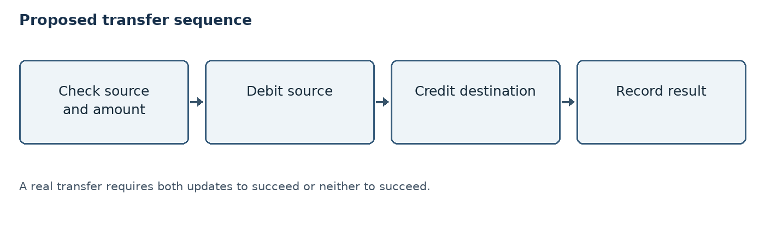
Figure 6.4: Proposed transfer sequence
A real database transaction can help provide atomicity, but correct design must also address concurrent operations, failures, duplicate requests and durable records. The details depend on the storage technology and system requirements.
The diagram describes the desired sequence; no database transaction has been executed for this report.

Example of a partial failure
Suppose ₹500.00 is debited from the source but an error occurs before it is credited to the destination. A correct transaction mechanism must prevent the final state from retaining only the debit. Both balances should remain as they were before the transfer if the operation cannot be completed.
A reliable design should also consider a repeated request after a timeout. An operation identifier and an appropriate duplicate-handling policy can help prevent the same request from being applied twice, but those controls are not implemented here.
Concurrency creates another risk: two withdrawal requests might read the same starting balance before either has completed. A real implementation needs a transaction or locking strategy appropriate to its database so that the final state follows the agreed rules. The simple example assumes operations occur one after another.

6.15 Advantages and Limitations

Evaluation of the design
The main advantage of the conceptual approach is simplicity. The banking example links Java data types, methods, conditions and objects to operations that are easy to follow. Tables and diagrams allow the logic to be reviewed before any implementation.
The design also makes important rules visible: valid amounts, sufficient funds and unchanged balances after rejection. The fictional transaction history provides a small arithmetic example that can be checked by hand.
The limitations are significant. There is no working program, database, user interface, performance measurement or executed test suite. The study does not model all regulatory, security, reconciliation or operational requirements of an actual bank.
Therefore the proposed design should be viewed only as an educational starting point, not as banking software ready for use.

Suitability for learning
The limited scope makes it possible to review the proposed rules without setting up infrastructure. A student can follow a transaction by hand, identify the relevant Java concepts and discuss the consequences of invalid input.
However, the absence of code means the document cannot demonstrate that a program compiles or that its implementation satisfies the rules. Any later implementation would need its own verified outputs, genuine screenshots and actual test evidence rather than relying on these illustrations.
The case study is useful for discussing the difference between a requirement and evidence. “The system should reject a negative amount” is a design requirement. A genuine test result would require an implementation, a specific input, an observed outcome and a record of the test environment.

6.16 Suggested Interface and Outputs

Illustrative screen content
If implemented in the future, a simple text-based menu could offer the choices below. This is a mock-up of proposed content, not a screenshot of a running application.
• 1. View balance
• 2. Deposit money
• 3. Withdraw money
• 4. Transfer money
• 5. View transaction history
• 6. Exit
A successful deposit might display: “Deposit accepted. Updated balance: ₹6,500.00.” A rejected withdrawal might display: “Transaction declined: insufficient funds.” Both messages are illustrative.
A future interface should provide clear labels and avoid displaying sensitive information unnecessarily. The sample messages are conceptual illustrations rather than output produced by an application.
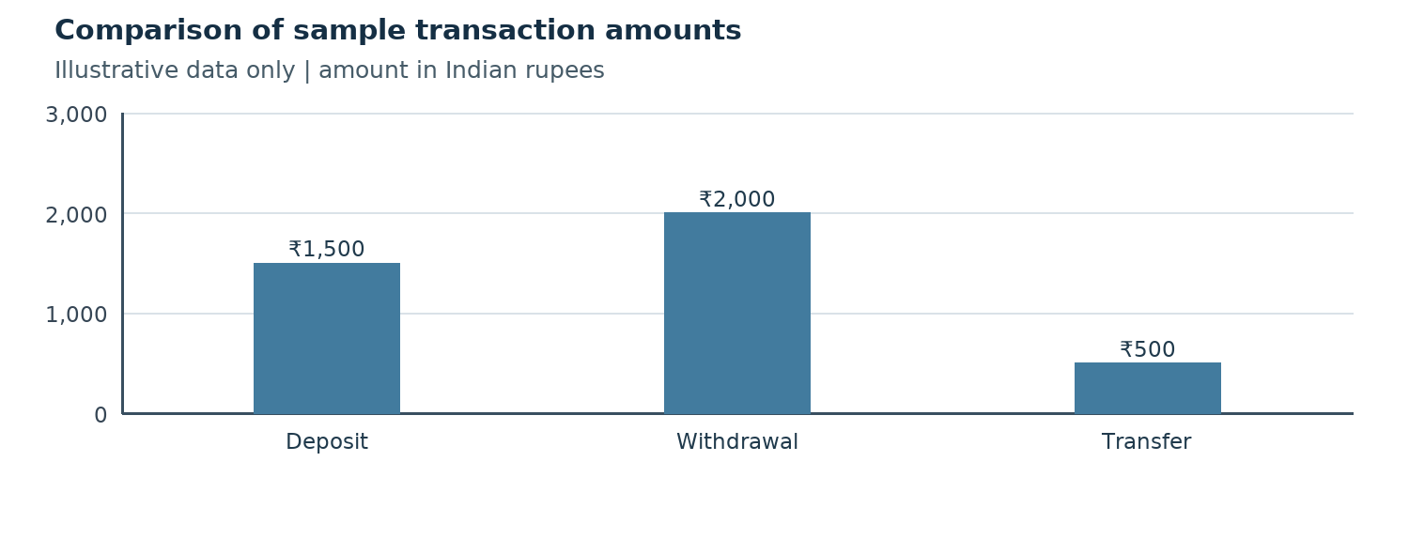
Chart B: Comparison of illustrative transaction amounts
The bar chart compares the fictional transaction amounts used in the example. The bars show amounts, not the frequency or success rate of real transactions.
In the chosen example, the withdrawal amount is the largest of the three transaction amounts, followed by the deposit and the transfer. Comparing these figures does not imply any pattern in customer behaviour because the values were selected only for illustration.

CHAPTER 7: CONCLUSION AND FUTURE SCOPE

7.1 Conclusion
This report studied a simple Java-based banking transaction system as a conceptual example. It explained how classes, methods, data types, conditions, collections and error handling can be connected to deposits, withdrawals, transfers and balance enquiries.
The proposed design emphasizes validation before a balance is changed. Worked examples show how balances are calculated and why a rejected request must leave the balance unchanged. The transfer discussion highlights the importance of completing both sides of a transaction together.
The diagrams, tables and test cases are educational illustrations. They do not demonstrate a working application or an actual bank transaction. The report therefore meets its aim as an introductory study while recognizing the broader demands of production financial software.

Summary of the example
The worked scenario begins at ₹5,000.00, adds a ₹1,500.00 deposit, subtracts a ₹2,000.00 withdrawal and then subtracts a ₹500.00 outgoing transfer. The resulting illustrative balance is ₹4,000.00. Each step follows the simplified rules explained in the report.
Together, the figures and tables show that design includes more than arithmetic: it also involves describing inputs, responsibilities, possible errors and the limitations of the proposed solution.
The proposed system is intentionally small enough to explain without a running model. Its value lies in the connection between programming concepts and a concrete sequence of decisions. The report also identifies important work that would be necessary before the design could be used for actual financial transactions.

7.2 Future Scope

Possible extensions
A future project could turn the conceptual design into a small learning application, starting with an account class and a menu-driven interface. The developer could then add automated tests for valid and invalid transaction scenarios.
A later version could use a persistent database, transaction management and controlled user access. Other possible features include transaction search, statements, multiple account types and notification messages.
Any move toward real financial use would require much more than these features. It would need professional security review, compliance assessment, reliable operations, protection of personal data and thorough testing under realistic conditions.
These suggestions are future possibilities only. None is claimed to have been implemented during the preparation of this conceptual report.

A possible development sequence
The first stage could define precise requirements and create an account model. The next stage could implement and test one operation at a time, beginning with deposit and withdrawal. A later stage could introduce a second account and carefully designed transfer logic.
Only after the basic behaviour is verified should additional storage, access controls and interface features be considered. Each addition creates new risks and tests. Such a sequence is a recommendation for possible future work, not a record of work already carried out.
Future work should also define a clear test plan, including normal cases, boundary values, failure recovery and concurrent requests. Any results should be reported as observations from real tests. Security and compliance should be considered from the beginning rather than treated as an optional final feature.

REFERENCES

Sources and supplied documents
[1] Oracle, “The Java Tutorials.” https://docs.oracle.com/javase/tutorial/ (accessed for general Java concepts; tutorials may refer to earlier Java versions).
[2] Oracle, “Java Platform, Standard Edition Documentation.” https://docs.oracle.com/en/java/javase/ (Java language and platform reference).
[3] Oracle, “Class BigDecimal.” https://docs.oracle.com/en/java/javase/21/docs/api/java.base/java/math/BigDecimal.html (decimal arithmetic).
[4] OWASP Foundation, “OWASP Top Ten.” https://owasp.org/www-project-top-ten/ (general application security awareness).
[5] EWB EDUTECH PRIVATE LIMITED, Java Programming Internship Offer Letter, dated 15 June 2026, supplied by the student.
[6] EWB Courses, Java Programming Internship Certificate for Mohd Najeeb, issued 16 July 2026, supplied by the student.
[7] Department of Computer Science and Engineering, University of Lucknow, Industrial Training Report cover-page format, supplied by the student.
[8] Oracle, “The Collections Framework.” https://docs.oracle.com/javase/tutorial/collections/ (overview of lists and other collections).
[9] Oracle, “Exceptions.” https://docs.oracle.com/javase/tutorial/essential/exceptions/ (introductory exception-handling concepts).
[10] Oracle, “Transactions,” JDBC Basics. https://docs.oracle.com/javase/tutorial/jdbc/basics/transactions.html (background on database transaction concepts).
The illustrative diagrams, tables, charts and calculations in this report were prepared for this conceptual case study; they are not drawn from real banking records.

