SUMMER INTERNSHIP REPORT
on
“SwachhAI Lite – A Simple Household Waste Segregation Guide”
by
Mohammad Ramish Ansari [Roll No.: ____________]
Submitted in partial fulfilment of the requirements for the award of the degree of
BACHELOR OF TECHNOLOGY
in
COMPUTER SCIENCE & ENGINEERING
from
1M1B (One Million for One Billion)
(AI for Sustainability Virtual Internship, in collaboration with AICTE and IBM SkillsBuild)

Submitted to
Dr. Sakshi Srivastava
DEPARTMENT OF COMPUTER SCIENCE AND ENGINEERING
FACULTY OF ENGINEERING & TECHNOLOGY
UNIVERSITY OF LUCKNOW, LUCKNOW
Academic Session: 2026–2027
November 2026

DECLARATION
I, Mohammad Ramish Ansari, student of B.Tech. (Computer Science and Engineering), Semester V, Department of Computer Science and Engineering, University of Lucknow, hereby declare that this summer internship report entitled “SwachhAI Lite – A Simple Household Waste Segregation Guide” is my own work, prepared for submission to the Department of Computer Science and Engineering, University of Lucknow, in the academic session 2026–2027.
The report is based on the AI for Sustainability Virtual Internship organised by 1M1B (One Million for One Billion), supported by AICTE and conducted in collaboration with IBM SkillsBuild. All facts about the internship have been taken from the official offer letter, the completion certificates and the internship project document, copies of which are included in this report.
I further declare that the project presented here is a simplified, rule-based academic concept inspired by the waste-management theme of my internship material. It is not a trained Artificial Intelligence or Machine Learning system, and no claim of software implementation, testing, user study or measured impact is made. Wherever information was not available, editable placeholders have been used instead of invented details.
This report has not been submitted elsewhere for the award of any other degree or diploma.

Place: Lucknow  Date: ____________ | (Signature of the Student)  Mohammad Ramish Ansari  Roll No.: ____________

INTERNSHIP COMPLETION CERTIFICATE
The official Certificate of Completion issued by 1M1B, supported by AICTE, in collaboration with IBM SkillsBuild, is reproduced below in colour. The certificate records the programme period as July 2026 to September 2026 and was issued on 22nd September 2026.
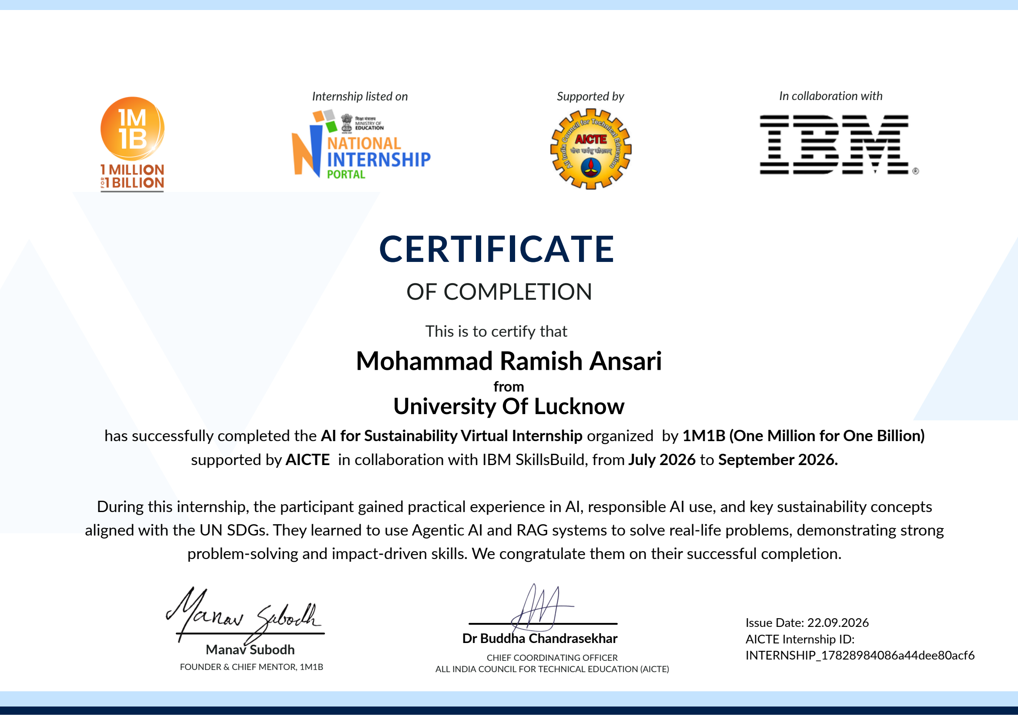
Official Internship Completion Certificate (Issue date: 22.09.2026)
Note: The offer letter records the offered internship period as six weeks, from 28th July 2026 to 28th August 2026. The certificate above records the programme period as July 2026 to September 2026. Each date is presented exactly as stated in its own source document.

ABSTRACT
This report presents the summer internship completed by Mohammad Ramish Ansari, student of B.Tech. Computer Science and Engineering (Semester V), Department of Computer Science and Engineering, University of Lucknow, in the academic session 2026–2027. The internship, titled “AI for Sustainability Virtual Internship”, was organised by 1M1B (One Million for One Billion), supported by the All India Council for Technical Education (AICTE), and conducted in collaboration with IBM SkillsBuild. The offer letter records a six-week period from 28th July 2026 to 28th August 2026; the official completion certificate, issued on 22nd September 2026, records the programme period as July 2026 to September 2026. Both references are presented exactly as stated in their respective sources.
The programme combined guided e-learning on the IBM SkillsBuild platform with scheduled learning topics including prompt engineering, AI and emerging technologies, quantum computing fundamentals, IBM Granite, agentic AI, retrieval-augmented generation, AI project design thinking, IBM labs and tools, and patenting ideas. The student completed two IBM SkillsBuild learning plans and the internship project deliverable.
The project presented in this report is “SwachhAI Lite – A Simple Household Waste Segregation Guide”, a beginner-friendly conceptual project inspired by the waste-management theme of the original SwachhAI internship material. It proposes a rule-based educational decision-support system that classifies common household waste items into Wet Waste, Dry Waste and Hazardous Waste and provides short disposal guidance. The concept is deliberately simple: it uses a predefined, human-reviewed rule list and an honest fallback for unknown items. It is not a trained AI or machine learning model, and no software implementation, testing, user study or measured impact is claimed.
The report documents the organisations and structure of the internship, the learning outcomes, the problem of household waste segregation, the design and working of the proposed concept, and its alignment with Sustainable Development Goals 11, 12 and 13. It closes with responsible-technology considerations, future scope, references and appendices, including a viva-preparation question bank.
Keywords: waste segregation; rule-based system; Artificial Intelligence; sustainability; SwachhAI Lite; Sustainable Development Goals; 1M1B; IBM SkillsBuild.

ACKNOWLEDGEMENT
I express my sincere gratitude to Dr. Sakshi Srivastava, Department of Computer Science and Engineering, University of Lucknow, to whom this report is submitted, for the guidance and encouragement extended to me during the preparation of this internship report.
I am thankful to the Department of Computer Science and Engineering and the Faculty of Engineering & Technology, University of Lucknow, for including the summer internship in the curriculum and for providing the academic environment in which practical learning is valued.
I gratefully acknowledge 1M1B (One Million for One Billion) for organising the AI for Sustainability Virtual Internship, the All India Council for Technical Education (AICTE) for supporting the programme through the National Internship Portal, and IBM SkillsBuild for the learning platform and the guided learning plans. I thank the mentors and the organising teams for the structured learning path and the project guidance.
I also thank my teachers, my family and my friends for their constant support and patience during the internship and during the writing of this report. Their encouragement helped me complete this work with honesty and care.

Mohammad Ramish Ansari
B.Tech. CSE, Semester V
University of Lucknow

TABLE OF CONTENTS

Declaration i
Internship Completion Certificate ii
Abstract iii
Acknowledgement iv
Table of Contents v
List of Tables viii
List of Figures ix
Chapter 1 – Introduction 1
1.1 Introduction to Summer Internship 1
1.2 Importance of Internship in Engineering Education 1
1.3 Role of Practical Learning in Computer Science 1
1.4 Introduction to Artificial Intelligence 2
1.5 Relationship Between Technology and Sustainability 2
1.6 Introduction to the 1M1B Internship 2
1.7 Introduction to the Selected Project 2
1.8 Scope of the Report 3
Chapter 2 – Organisation And Internship Overview 4
2.1 Introduction to 1M1B 4
2.2 Organisational Overview 4
2.3 Role of AICTE 4
2.4 Role of IBM SkillsBuild 5
2.5 Introduction to AI for Sustainability Virtual Internship 5
2.6 Internship Objectives 5
2.7 Internship Structure and Duration 6
2.8 Internship Learning Schedule 6
2.9 Technical Sessions 7
2.10 Overall Programme Overview 7
Chapter 3 – Objectives And Learning Outcomes 9
3.1 Internship Objectives 9
3.2 Technical Learning Objectives 9
3.3 Understanding Artificial Intelligence 9
3.4 Introduction to Generative AI 9
3.5 Introduction to Large Language Models 9
3.6 Learning About IBM Granite 10
3.7 Introduction to Prompt Engineering 10
3.8 Introduction to RAG 10
3.9 Introduction to Agentic AI 10
3.10 Responsible AI 11
3.11 Overall Learning Outcomes 11
Chapter 4 – Technology Overview 12
4.1 Introduction to Artificial Intelligence 12
4.2 Basic Machine Learning Concepts 12
4.3 Introduction to Generative AI 12
4.4 Introduction to Large Language Models 13
4.5 Overview of IBM Granite 13
4.6 Introduction to Prompt Engineering 13
4.7 Introduction to Retrieval-Augmented Generation 14
4.8 Introduction to Agentic AI 14
4.9 Rule-Based Systems 14
4.10 Basic Waste Classification 14
4.11 Applications of AI in Sustainability 15
Chapter 5 – Problem Statement And Analysis 16
5.1 Introduction to Waste Management 16
5.2 Household Waste Management Problems 16
5.3 Importance of Waste Segregation 16
5.4 Wet Waste 16
5.5 Dry Waste 17
5.6 Hazardous Waste 17
5.7 Problems Caused by Mixing Different Waste Types 17
5.8 Need for a Simple Waste Segregation Guide 17
5.9 Problem Statement 18
5.10 Project Scope 18
Chapter 6 – Project Overview And System Design 19
6.1 Introduction to SwachhAI Lite 19
6.2 Project Background 19
6.3 Project Objectives 19
6.4 Proposed Approach 19
6.5 Intended Users 20
6.6 Project Scope 20
6.7 Basic System Architecture 20
6.8 Waste Category Design 21
6.9 Predefined Classification Rules 21
6.10 Input and Output 22
6.11 System Requirements at a Conceptual Level 22
6.12 Advantages and Limitations 22
Chapter 7 – Detailed Project Description 23
7.1 Overall Project Working 23
7.2 User Input 23
7.3 Waste Identification 23
7.4 Rule-Based Classification 23
7.5 Wet Waste Classification 24
7.6 Dry Waste Classification 24
7.7 Hazardous Waste Classification 24
7.8 Disposal Guidance 24
7.9 Complete Project Workflow 25
7.10 Practical Examples 26
7.11 Illustrative Case Study 26
7.12 Expected Benefits 26
Chapter 8 – Responsible Technology And Sustainability 28
8.1 Introduction to Responsible Technology 28
8.2 Importance of Accurate Information 28
8.3 Environmental Awareness 28
8.4 Safe Disposal Practices 28
8.5 Limitations of Rule-Based Classification 28
8.6 Human Verification 28
8.7 Sustainable Development Goals 29
8.8 SDG 11 – Sustainable Cities and Communities 29
8.9 SDG 12 – Responsible Consumption and Production 29
8.10 SDG 13 – Climate Action 29
8.11 Environmental and Social Benefits 29
Chapter 9 – Future Scope And Learning Outcomes 31
9.1 Technical Knowledge Gained 31
9.2 Understanding of Artificial Intelligence 31
9.3 Understanding of Waste Classification 31
9.4 Skills Developed During Internship 31
9.5 Challenges and Limitations 31
9.6 Future Scope of the Project 31
9.7 Possible Improvements 32
Chapter 10 – Conclusion 33
10.1 Internship Summary 33
10.2 Project Summary 33
10.3 Technical Learning Summary 33
10.4 Overall Conclusion 33
References and Bibliography 34
Appendix A – Additional Internship Certificates 36
Appendix B – Internship Schedule 38
Appendix C – Relevant Project Supporting Material 39
Appendix D – Viva-Voce Preparation 41

LIST OF TABLES
Table 2.2 Roles of the organisations in the internship 4
Table 2.1 Key internship details as recorded in the official documents 6
Table 2.3 Scheduled learning topics of the internship (July 2026 schedule) 6
Table 3.1 Objectives and achieved learning outcomes 11
Table 4.1 Internship learning topics versus technologies used in SwachhAI Lite 15
Table 5.1 Summary of the three waste categories 18
Table 6.1 Core predefined classification rules 21
Table 6.2 Conceptual system requirements 22
Table 7.1 Disposal guidance for the core waste items 24
Table 7.2 Illustrative household case study (fictional example, not field data) 26
Table 9.1 Proposed future improvements (not implemented) 31
Table B.1 Chronological summary of documented internship dates 38
Table C.1 Extended predefined rule list for the SwachhAI Lite concept 39

LIST OF FIGURES
Figure 2.1 Structure of the AI for Sustainability Virtual Internship 8
Figure 5.1 The three household waste categories used in the project 18
Figure 6.1 Basic block diagram of the SwachhAI Lite concept 20
Figure 6.2 Conceptual system architecture of SwachhAI Lite 21
Figure 7.1 Complete workflow of the SwachhAI Lite concept, including the fallback path 25
Figure 8.1 Alignment of the project with SDG 11, SDG 12 and SDG 13 29

CHAPTER 1 – INTRODUCTION

1.1 Introduction to Summer Internship
A summer internship is a short period of structured learning and practice that a student completes outside the regular classroom, usually during the summer vacation. Its purpose is to give the student a first look at how the knowledge studied in college is used in real working environments. An internship may be carried out in a company, a research laboratory, a government body or, as in the present case, in a virtual mode organised by a national-level organisation.
This report presents the summer internship completed by the author, Mohammad Ramish Ansari, a student of B.Tech. Computer Science and Engineering (Semester V) at the University of Lucknow. The internship, titled “AI for Sustainability Virtual Internship”, was organised by 1M1B (One Million for One Billion), supported by the All India Council for Technical Education (AICTE), and conducted in collaboration with IBM SkillsBuild. The offer letter records the internship period as six weeks, from 28th July 2026 to 28th August 2026, while the official completion certificate records the programme period as July 2026 to September 2026. Both references are reproduced in this report exactly as stated in their respective source documents.

1.2 Importance of Internship in Engineering Education
Engineering education is not complete with theory alone. A student may understand a definition from a textbook, but the ability to use that definition to solve a real problem develops only through practice. An internship connects these two sides of learning. It shows the student how professionals approach a problem, how they divide a large task into smaller steps, and how they present their work to others.
For an engineering student, an internship builds three kinds of abilities. The first is technical ability, such as understanding tools and technologies beyond the syllabus. The second is professional ability, such as communicating clearly, meeting deadlines and working with mentors. The third is personal ability, such as discipline, self-learning and confidence. The virtual internship described in this report contributed to all three, because it combined guided learning modules, scheduled technical topics and a final project deliverable.

1.3 Role of Practical Learning in Computer Science
Computer Science is a subject in which ideas become useful only when they are applied. A concept such as classification, for example, is easy to define but becomes truly clear when the student uses it to sort real items into groups. Practical learning forces the student to answer simple but important questions: What is the input? What is the output? What happens when the input is unexpected?
In this internship, practical learning took the form of guided e-learning modules on the IBM SkillsBuild platform, scheduled learning topics on emerging technologies, and a project deliverable on the theme of AI for sustainability. The project work encouraged the student to think about a real social problem, namely household waste, and to design a simple, honest solution around it. This habit of starting from a real problem, rather than from a technology, is one of the most valuable lessons of practical learning in Computer Science.

1.4 Introduction to Artificial Intelligence
Artificial Intelligence, commonly written as AI, is the branch of Computer Science that studies how computers can perform tasks that normally need human intelligence. Such tasks include recognising objects, understanding language, answering questions and making decisions. A music application that suggests songs, a keyboard that predicts the next word, and an email filter that separates spam are all everyday examples of AI at work.
It is important for a beginner to understand that AI is a wide family of techniques, not a single magic tool. Some AI systems learn patterns from large amounts of data. Others simply follow clear rules written by human designers. The simplified project presented in this report belongs to the second family: it is a rule-based educational concept, and it does not use a trained machine learning model. Chapter 4 explains this distinction in detail.

1.5 Relationship Between Technology and Sustainability
Sustainability means meeting the needs of the present without damaging the ability of future generations to meet their own needs. In simple words, it means using resources carefully so that they last. Technology and sustainability are closely connected. Technology can help society measure pollution, save energy, reduce waste and spread awareness. At the same time, technology itself must be used responsibly, because every tool has a cost as well as a benefit.
The theme of the internship was exactly this connection: how can AI support sustainable development? The programme explored applications such as climate action, clean energy, waste reduction, biodiversity and sustainable cities. The project chosen for this report follows the same theme at a small, household level. It shows how even a very simple decision-support idea can encourage better waste habits, which is a small but real contribution to sustainability.

1.6 Introduction to the 1M1B Internship
The AI for Sustainability Virtual Internship was offered by 1M1B in collaboration with AICTE through the National Internship Portal, and co-certified by IBM SkillsBuild. The internship was selected by the student through the AICTE internship process and carried the Internship ID INTERNSHIP_17828984086a44dee80acf6. It was a virtual, unpaid internship focused on building industry-relevant AI skills and exploring the intersection of AI and sustainable development.
According to the offer letter, the programme included hands-on learning with AI and machine learning concepts, large language models, IBM Granite models, retrieval-augmented generation and agentic AI systems with IBM Labs. It also offered access to the IBM SkillsBuild e-learning platform, guided project work on sustainability challenges, and interaction with AI professionals from IBM and 1M1B. The main completion certificate confirms that the student successfully completed the internship and gained practical experience in AI, responsible AI use and key sustainability concepts aligned with the United Nations Sustainable Development Goals.

1.7 Introduction to the Selected Project
The project presented in this report is titled “SwachhAI Lite – A Simple Household Waste Segregation Guide”. It is a beginner-friendly, conceptual project that explains how common household waste items can be identified and divided into three simple categories: Wet Waste, Dry Waste and Hazardous Waste. The project proposes a basic rule-based approach in which an item is checked against a predefined list and a short disposal recommendation is provided.
The project is inspired by the waste-management theme of the original SwachhAI project material prepared during the internship. However, it is deliberately simplified. It is not a claim of having developed the full original SwachhAI prototype, and it is not a trained AI or machine learning model. It is presented honestly as a proposed, rule-based educational decision-support system that a third-year student can fully understand and explain.

1.8 Scope of the Report
This report documents the internship and the simplified project in ten chapters. Chapter 2 describes the organisations and the internship structure. Chapter 3 presents the objectives and learning outcomes. Chapter 4 gives a beginner-level overview of the technologies covered during the internship and clearly separates them from the simple approach used in the project. Chapter 5 analyses the waste-management problem. Chapters 6 and 7 describe the project design and working in detail. Chapter 8 discusses responsible technology use and sustainability. Chapter 9 presents the learning outcomes and future scope, and Chapter 10 concludes the report.
The report does not claim software development, model training, deployment, testing results, user surveys or field research. All statements about the internship are based on the official offer letter, the completion certificates and the internship project document. The project chapters describe a proposed educational concept, and all future features are clearly marked as proposals.

CHAPTER 2 – ORGANISATION AND INTERNSHIP OVERVIEW

2.1 Introduction to 1M1B
1M1B, which stands for “One Million for One Billion”, is the organisation that designed and conducted the AI for Sustainability Virtual Internship. The name expresses a simple idea: one million motivated people working to improve the lives of one billion people. The organisation works at the intersection of emerging technology, entrepreneurship and social impact, and it engages students with real-world challenges connected to sustainable development.
In this internship, 1M1B acted as the organising body. The offer letter was issued by the 1M1B Academia Team, and the main completion certificate was signed by Mr. Manav Subodh, Founder and Chief Mentor of 1M1B. The organisation coordinated the programme structure, the mentor sessions and the final project submission process.

2.2 Organisational Overview
The internship was a collaborative effort of three bodies, each with a distinct role. 1M1B was the organising organisation responsible for the programme design and delivery. AICTE was the supporting organisation, and the internship was listed on the National Internship Portal. IBM SkillsBuild was the collaborating partner, providing the e-learning platform and co-certifying the programme. This three-part structure is stated in both the offer letter and the main completion certificate.
Table 2.2: Roles of the organisations in the internship
Organisation | Role in the internship | Contribution
1M1B (One Million for One Billion) | Organising organisation | Programme design, mentor sessions, project guidance and certification
AICTE | Supporting organisation | Listing on the National Internship Portal; national-level academic support
IBM SkillsBuild | Collaborating partner | E-learning platform, guided learning plans and co-certification

For a student, this structure means that the internship combined the social-impact orientation of 1M1B, the academic recognition of AICTE and the technology-learning resources of IBM. Such a combination is difficult to obtain from a single organisation, and it is one of the strengths of this programme.

2.3 Role of AICTE
The All India Council for Technical Education (AICTE) is the national statutory body that regulates and supports technical education in India. One of its initiatives is the National Internship Portal, which lists internship opportunities for students of technical institutions. The offer letter states that the internship was offered in collaboration with AICTE through this portal, and the completion certificate displays the AICTE Internship ID INTERNSHIP_17828984086a44dee80acf6.
The main completion certificate was also signed by Dr. Buddha Chandrasekhar, Chief Coordinating Officer, AICTE. The involvement of AICTE gives the internship national academic recognition and connects it to the wider effort to make internships a regular part of technical education in India.

2.4 Role of IBM SkillsBuild
IBM SkillsBuild is the free learning platform of IBM that offers courses on technical and professional skills. The offer letter notes that the platform provides access to more than 80,000 curated courses. In this internship, IBM SkillsBuild served as the e-learning environment in which the guided learning plans were completed, and it co-certified the programme.
The student completed two learning plans on the platform. The first, titled “1M1B | AI for Sustainability Virtual Internship” (PLAN-56138075980A), was completed on 1st August 2026. The second, titled “1M1B | AI for Sustainability” (PLAN-F60F1D7DADA9), was completed on 5th August 2026. Both completion certificates, issued through the Your Learning Builder – Plans system of record, are reproduced in Appendix A of this report.

2.5 Introduction to AI for Sustainability Virtual Internship
The AI for Sustainability Virtual Internship was designed to develop industry-relevant AI skills while exploring how AI can support sustainable development. The offer letter describes the programme as an opportunity to work on real-world climate and sustainability challenges using emerging technologies. Its highlights included hands-on learning with AI and machine learning concepts, large language models, IBM Granite models, retrieval-augmented generation (RAG) frameworks and agentic AI systems with IBM Labs.
The programme also explored how AI can support climate action, clean energy, waste reduction, biodiversity and sustainable cities. Students were expected to attend scheduled live sessions, complete guided learning modules and digital badge requirements on IBM SkillsBuild, and submit a final project including a concept note, video and code repository. A laptop or desktop with stable internet connectivity was required for all sessions.

2.6 Internship Objectives
Based on the offer letter and the programme structure, the objectives of the internship can be summarised as follows:
• To build foundational, industry-relevant skills in Artificial Intelligence and emerging technologies.
• To understand the intersection of AI and sustainable development.
• To explore real-world climate and sustainability challenges, including waste reduction and sustainable cities.
• To complete guided learning modules and digital badges on the IBM SkillsBuild platform.
• To design and present an AI-themed sustainability project guided by expert mentors.
• To practise responsible and ethical use of AI tools.
These objectives guided the selection of the project presented in this report. The waste-segregation theme was chosen because it directly matches the waste-reduction and sustainable-cities focus of the programme, while remaining simple enough to be explained honestly at the student’s current level of study.

2.7 Internship Structure and Duration
The internship was conducted in virtual mode and was unpaid in nature, as stated in the terms and conditions of the offer letter. The offer letter records a six-week internship from 28th July 2026 to 28th August 2026. The student signed the declaration of acceptance on 27th July 2026. The main completion certificate, issued on 22nd September 2026, records the programme period as July 2026 to September 2026. These two duration references come from different official documents and are presented here separately, exactly as each source states them; they have not been merged into a single invented period.
Table 2.1: Key internship details as recorded in the official documents
Item | Details | Source
Internship title | 1M1B | AI for Sustainability Virtual Internship | Offer letter; certificate
Internship ID | INTERNSHIP_17828984086a44dee80acf6 | Offer letter; certificate
Offer period | 6 weeks: 28 July 2026 to 28 August 2026 | Offer letter
Declaration signed | 27 July 2026 | Offer letter, page 2
Certificate period | July 2026 to September 2026 | Main completion certificate
Certificate issue date | 22 September 2026 | Main completion certificate
Mode and nature | Virtual; unpaid | Offer letter
SkillsBuild plan 1 | Completed 01 Aug 2026 (PLAN-56138075980A) | IBM SkillsBuild certificate
SkillsBuild plan 2 | Completed 05 Aug 2026 (PLAN-F60F1D7DADA9) | IBM SkillsBuild certificate

2.8 Internship Learning Schedule
The learning schedule of the programme, circulated for July 2026, listed a series of scheduled learning topics covering both foundational and emerging areas of AI. The topics are listed in Table 2.3 in the order in which they appear in the schedule. They are described here as scheduled learning topics of the programme; this report does not claim attendance at any specific session beyond the completion recorded in the official certificates.
Table 2.3: Scheduled learning topics of the internship (July 2026 schedule)
S. No. | Scheduled learning topic | Brief focus of the topic
1 | Prompt Engineering | Writing clear instructions for AI language models
2 | AI and Emerging Technologies | Overview of current and upcoming AI technologies
3 | Quantum Computing Fundamentals | Basic ideas of quantum computing as an emerging field
4 | IBM Granite | Introduction to the IBM Granite family of AI models
5 | Agentic AI | AI systems that plan and carry out tasks step by step
6 | Retrieval-Augmented Generation (RAG) | Answering questions using retrieved reference documents
7 | AI Project Design Thinking | Structuring an AI project around a real user problem
8 | IBM Labs and Tools | Guided exposure to IBM learning labs and tools
9 | Patenting Ideas | Basic awareness of protecting original ideas

Note: The topic list above follows the internship learning schedule provided for July 2026. Exact session dates were governed by the organiser’s schedule. The documented programme window, as per the offer letter, was 28 July 2026 to 28 August 2026.

2.9 Technical Sessions
The technical content of the programme was delivered through a combination of scheduled live sessions, guided e-learning modules on IBM SkillsBuild and self-learning labs. The offer letter expected interns to attend the scheduled live sessions, participate actively in workshops, and complete the weekly tasks and milestones defined by the organisers. Certification required participation in weekly mentor sessions, completion of the SkillsBuild learning plan and submission of the final project presentation.
The technical topics ranged from practical skills such as prompt engineering to awareness-level topics such as quantum computing fundamentals and patenting ideas. This spread was useful for a third-year student: some topics built directly usable skills, while others created awareness of where the technology field is heading. Chapter 3 and Chapter 4 of this report explain these topics at a beginner level.

2.10 Overall Programme Overview
Figure 2.1 summarises the structure of the programme. The three organisations contributed their respective strengths, and the student completed the guided learning plans and the final project deliverable. The original project material prepared for the internship submission was titled “SwachhAI – AI-guided waste segregation and circularity assistant for India’s households”, submitted on 14th September 2026. That document forms the background inspiration for the simplified project presented in this report, and the relationship between the two is explained honestly in Chapter 6.
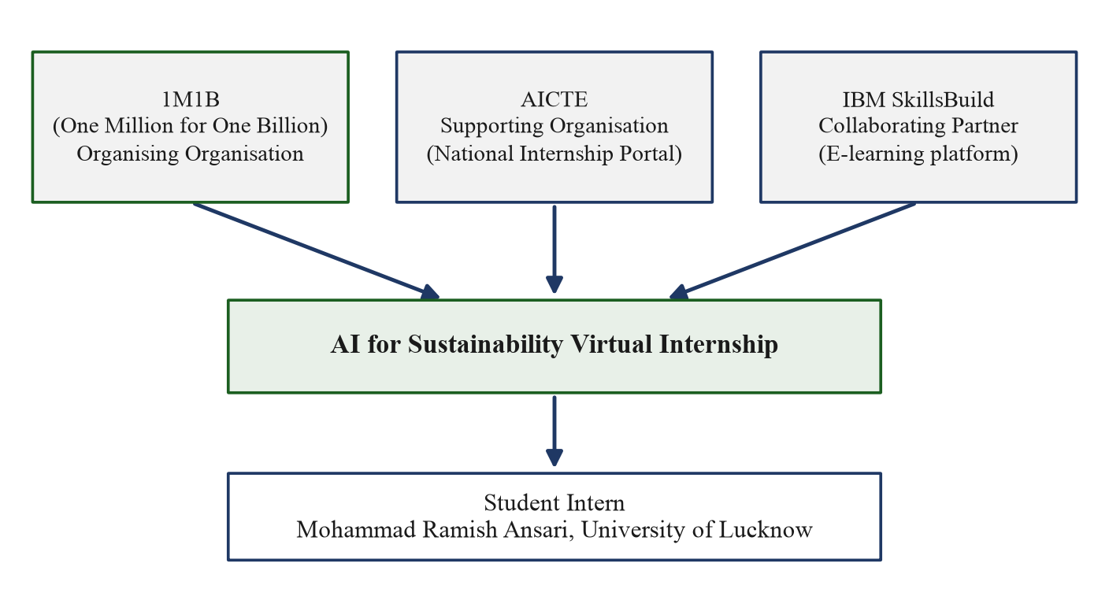
Figure 2.1: Structure of the AI for Sustainability Virtual Internship
Overall, the programme gave the student a structured first exposure to AI for social good: a recognised platform, a defined learning path, mentor guidance and a project theme connected to a real national problem.

CHAPTER 3 – OBJECTIVES AND LEARNING OUTCOMES

3.1 Internship Objectives
The personal objectives of the student at the start of the internship were simple and realistic. The first objective was to understand what Artificial Intelligence actually means beyond the popular image of robots and chatbots. The second was to learn how AI is being applied to sustainability problems such as waste, energy and climate. The third was to complete a small project that could be explained with full honesty in a university viva. These objectives matched the programme objectives described in Chapter 2.
A fourth objective was to develop the discipline of online learning: completing modules on time, following a schedule and documenting the work properly. This report itself is part of that documentation discipline.

3.2 Technical Learning Objectives
The technical learning objectives were set at a beginner level. They included understanding the basic vocabulary of AI, such as model, training, prompt and classification; becoming familiar with the names and purposes of tools such as IBM Granite; and understanding, at a conceptual level, how techniques such as retrieval-augmented generation and agentic AI are described in industry. The objective was understanding, not mastery. No objective was set to train or deploy a machine learning model, and no such claim is made anywhere in this report.

3.3 Understanding Artificial Intelligence
The internship helped the student form a clear beginner’s picture of AI. Artificial Intelligence is the field of making computers perform tasks that usually need human intelligence, such as understanding language or recognising images. Some AI systems learn from data; others follow rules written by people. A useful everyday example is the difference between a music app that learns a listener’s taste (learning-based) and a simple kitchen timer that follows fixed instructions (rule-based).
The most important learning was that AI is not a single technology and that not every useful system needs advanced AI. This understanding directly shaped the project: a rule-based guide was chosen because it honestly matches the student’s current ability and the educational goal of the project.

3.4 Introduction to Generative AI
Generative AI is the part of AI that creates new content, such as text, images or code, instead of only choosing between existing options. A chatbot that writes a paragraph, or a tool that drafts an email, is using generative AI. During the internship, generative AI was introduced as one of the most visible current applications of the field.
The student learned that generative AI produces content based on patterns learned from large collections of data, and that its output must always be checked by a human before being trusted. This lesson of verification is carried into the responsible-technology discussion in Chapter 8. Generative AI is a learning topic of the internship; it is not used in the simplified project.

3.5 Introduction to Large Language Models
A Large Language Model, or LLM, is a type of AI model trained on very large amounts of text so that it can understand and generate human language. The word “large” refers both to the amount of training data and to the size of the model itself. LLMs are the technology behind most modern chat assistants.
At a beginner level, the student understood an LLM as a very advanced prediction system: given some text, it predicts what text should come next, and this simple-sounding ability produces surprisingly useful behaviour. The student also learned that LLMs can produce confident but wrong answers, which is why techniques such as retrieval-augmented generation exist. LLMs were studied as a learning topic and are not implemented in the project.

3.6 Learning About IBM Granite
IBM Granite is the family of AI models developed by IBM for enterprise and developer use. The internship introduced Granite as an example of a real, industry-grade model family that can be used for language tasks and other applications. The scheduled topic on IBM Granite, together with the IBM Labs sessions, gave the student awareness of how such models are positioned and used in practice.
The learning outcome here is awareness, not implementation. The student can explain what IBM Granite is and why organisations use ready model families instead of building models from scratch. The simplified project of this report does not use IBM Granite or any other language model.

3.7 Introduction to Prompt Engineering
Prompt engineering is the skill of writing clear, well-structured instructions for an AI language model so that it produces a useful answer. A prompt is simply the input text given to the model. A vague prompt gives a vague answer; a specific prompt with context, constraints and examples gives a better answer. An everyday analogy is asking a shopkeeper for “something to eat” versus “a vegetarian sandwich without onion”.
This was one of the most practically useful topics of the internship, because it teaches precise thinking and clear communication even apart from AI. The student practised writing structured instructions during the learning modules. The project of this report does not call any language model, so prompt engineering is not part of its implementation.

3.8 Introduction to RAG
Retrieval-Augmented Generation, written as RAG, is a technique in which an AI system first retrieves relevant passages from a trusted collection of documents and then generates an answer based on those passages. In simple words, the system is made to “look up the book before answering”. This reduces the chance of invented answers and allows the answer to cite its sources.
The original SwachhAI internship material described a RAG-based assistant that answered municipal waste questions from a document collection. The student understood this design at a conceptual level. RAG is an internship learning topic; the simplified project does not implement retrieval or generation of any kind.

3.9 Introduction to Agentic AI
Agentic AI refers to AI systems that do not merely answer a single question but plan and carry out a sequence of steps towards a goal, checking their progress as they go. Such a system is often described as a loop: perceive the situation, decide the next step, act, and learn from the result. A simple everyday analogy is a travel agent who does not just suggest a destination but plans the whole journey step by step.
The internship introduced this idea through the scheduled topic and through the agent-loop design described in the original SwachhAI material. The student can explain the concept and its appeal, while recognising that building a reliable agent is an advanced engineering task. Agentic AI is not implemented in the simplified project.

3.10 Responsible AI
Responsible AI means designing and using AI systems in a way that is fair, transparent, safe and respectful of people. The internship treated this as a core theme, and the main completion certificate specifically records that the participant gained practical experience in responsible AI use. Key ideas included: being honest about what a system can and cannot do; showing sources where possible; protecting user privacy; and never allowing a system to give unsafe advice.
These ideas influenced the simplified project directly. The project states its limitations openly, refuses to guess when an item is not in its rule list, and always advises human verification for hazardous waste. In this way, a small project can still practise responsible design.

3.11 Overall Learning Outcomes
At the end of the internship, the student achieved the beginner-level outcomes that were set out at the start. Table 3.1 maps the main objectives to the outcomes actually achieved. The outcomes are stated modestly and honestly: they describe understanding and awareness, not professional mastery.
Table 3.1: Objectives and achieved learning outcomes
Objective | Learning outcome achieved
Understand AI basics | Can explain AI, classification and rule-based decision-making in simple words
Explore AI for sustainability | Can describe how AI themes connect to waste, climate and cities
Complete guided learning | Two IBM SkillsBuild learning plans completed (certificates in Appendix A)
Learn emerging-topic vocabulary | Can define LLM, prompt, RAG, agentic AI and IBM Granite at a beginner level
Design a simple project | Prepared the SwachhAI Lite concept with honest scope and clear rules
Practise responsible AI | Applied honesty, verification and safety principles in the project design

CHAPTER 4 – TECHNOLOGY OVERVIEW

4.1 Introduction to Artificial Intelligence
Artificial Intelligence (AI) is the branch of Computer Science that aims to make computers perform tasks which normally require human intelligence. These tasks include understanding language, recognising pictures, recommending options and making decisions. AI systems are already part of daily life: a search engine ranking results, a phone unlocking by face, and a navigation app choosing a route are all familiar examples.
For a beginner, it is useful to divide AI into two broad styles. The first style is learning-based AI, in which the system studies many examples and finds patterns on its own. The second style is rule-based AI, in which human designers write explicit conditions and the system simply follows them. Both styles are legitimate members of the AI family, and the choice between them depends on the problem. When the problem is small, well understood and safety-sensitive, a rule-based design is often the better engineering choice because every decision can be traced to a written rule.
In this internship, AI was studied as a learning subject in its full breadth. In the project, only the simplest rule-based style is proposed. This chapter therefore serves two purposes: it explains the technologies covered during the internship, and it clearly marks which of them are actually used in the simplified project. Table 4.1 at the end of the chapter makes this separation explicit.

4.2 Basic Machine Learning Concepts
Machine Learning (ML) is the part of AI in which a computer learns patterns from data instead of being programmed with fixed rules. The basic vocabulary is small and easy. A dataset is a collection of examples. Training is the process of showing these examples to an algorithm so that it adjusts itself. A model is the result of training: a compact representation of the learned patterns. Prediction is the use of the trained model on new, unseen input.
A simple everyday example is learning to identify ripe fruit. A child who has seen many ripe and unripe mangoes slowly learns the colour, smell and feel of a ripe one. The child was not given a written rulebook; the examples did the teaching. Machine learning works in a similar way. Classification, the ML task most relevant to this report, means assigning an input to one of a fixed set of categories, such as deciding whether an email is spam or not spam.
Deep Learning is a sub-field of ML that uses large layered structures called neural networks. It powers image recognition and modern language models, but it needs large datasets and careful engineering. Machine learning and deep learning were covered as internship learning topics. The project in this report does not train or use any machine learning model; its “classification” is a simple lookup in a predefined list, which is deliberately much simpler than ML classification.

4.3 Introduction to Generative AI
Generative AI is the family of AI systems that create new content rather than only analysing existing content. The content may be text, images, audio, video or computer code. A chat assistant that drafts a letter, a tool that turns a sentence into a picture, and an assistant that writes program code are all examples of generative AI.
The key idea is that the system has learned the patterns of its training material so well that it can produce new material in the same style. This power comes with a well-known weakness: a generative system can produce fluent, confident output that is factually wrong. Such output is sometimes called a hallucination. For this reason, generative AI must be supervised by humans, and important answers should be grounded in trusted sources.
Generative AI was an important learning topic of the internship, and the original SwachhAI material described language-model-based components. The simplified project of this report generates nothing: its guidance sentences are fixed text written in advance by the student. This keeps the project honest, predictable and easy to explain.

4.4 Introduction to Large Language Models
A Large Language Model (LLM) is a very large AI model trained on enormous collections of text to understand and generate human language. The model learns statistical relationships between words and phrases. When given an input, called a prompt, it produces a continuation, called a completion. Repeated application of this simple mechanism allows an LLM to answer questions, summarise documents, translate languages and hold conversations.
Two practical ideas about LLMs are worth remembering at a beginner level. First, an LLM does not “know” facts the way a database does; it reproduces patterns, so its factual claims need verification. Second, the quality of an LLM’s output depends strongly on the quality of the prompt, which is why prompt engineering became a scheduled topic of the internship. LLMs are studied here as a learning topic only; no LLM is called, hosted or implemented in the project.

4.5 Overview of IBM Granite
IBM Granite is IBM’s family of AI models designed for business and developer use. The family includes language models of different sizes, intended for tasks such as text generation, summarisation, classification and code-related work. The idea behind offering a model family is practical: organisations can start from a ready, supported model instead of building one from scratch, in the same way that a builder starts from standard bricks rather than making every brick by hand.
The internship introduced IBM Granite through a scheduled learning topic and through IBM Labs exposure, and the original SwachhAI material described Granite-style model usage in its prototype design. For this report, the learning outcome is the ability to explain what Granite is and where it fits. The simplified project does not use IBM Granite, any other LLM, or any cloud AI service.

4.6 Introduction to Prompt Engineering
Prompt engineering is the practice of designing the input given to a language model so that the output is accurate, relevant and safe. A well-engineered prompt usually contains four elements: a clear role or context, a specific task, constraints such as length or format, and one or more examples of the desired output. The original SwachhAI material included detailed prompt workflows as part of its prototype documentation, which gave the student a concrete picture of what careful prompting looks like.
The general lesson of prompt engineering is valuable even without AI: precise instructions produce better results from any system, including people. In the simplified project, this lesson appears in a small way: the disposal guidance sentences are written as short, clear, action-oriented instructions. No prompts are sent to any model, because the project uses no model.

4.7 Introduction to Retrieval-Augmented Generation
Retrieval-Augmented Generation (RAG) combines two steps. In the retrieval step, the system searches a trusted collection of documents and selects the passages most relevant to the user’s question. In the generation step, a language model writes an answer using only those passages, usually with citations. If the documents do not contain the answer, a well-designed RAG system refuses to answer instead of inventing one.
An everyday analogy is an open-book examination: the student answers from the textbook in front of them rather than from memory alone, and can point to the page that supports each answer. RAG gives AI systems the same discipline. The original SwachhAI material described a RAG assistant grounded in public documents such as the Solid Waste Management Rules, 2016. The simplified project borrows only the spirit of this idea — answers should come from a fixed, checkable source — but implements it as a plain predefined list, with no retrieval engine and no generation.

4.8 Introduction to Agentic AI
Agentic AI describes systems that pursue a goal through a sequence of steps rather than a single response. A common description is the perceive–decide–act–learn loop: the system observes the situation, chooses the next action, performs it, and records the outcome to improve the next cycle. The original SwachhAI material presented its prototype as such a loop, with a human-oversight gate on changes to its knowledge base.
The appeal of agentic AI is that many real tasks are multi-step: planning a trip, managing a workflow or guiding a user through a process. The difficulty is reliability: every step can fail, so careful engineering and human oversight are essential. The student learned to describe this concept and its trade-offs. The simplified project is not an agent; it is a single-pass guide that performs one lookup and shows one guidance message.

4.9 Rule-Based Systems
A rule-based system is a program that makes decisions using explicit conditions written by human designers, usually in the form “IF condition THEN action”. The collection of rules is called the rule base. The component that checks the input against the rules is called the inference engine, although in a simple system it is nothing more than a matching procedure. Rule-based systems are one of the oldest and most transparent forms of AI.
Everyday examples are easy to find. A traffic signal follows timing rules. A bank’s eligibility checker applies rules about age and income. A school grading sheet assigns grades by fixed mark ranges. The strength of this approach is transparency: every output can be explained by pointing to the rule that produced it. The weakness is coverage: the system knows only what its rules cover, and it cannot handle situations outside the rule base unless a safe fallback is designed.
This is the only decision-making approach proposed in SwachhAI Lite. The rule base is a short, fixed list of common household items mapped to three categories, and the fallback for unknown items is an honest “not recognised” message. Because the rule base is small and human-written, every answer can be verified by inspection, which is exactly what an educational project needs.

4.10 Basic Waste Classification
Waste classification means assigning a waste item to a category so that it can be handled correctly. In the Indian context, the Solid Waste Management Rules, 2016 require waste generators to segregate waste at source into broad streams, commonly described as wet (biodegradable) waste, dry (recyclable and non-recyclable dry) waste, and domestic hazardous waste. This three-way division is the basis of the category design in this project.
Classification can be done by a person, by a rule-based program or by a trained machine learning model. The three approaches differ in cost and complexity, not in purpose. For an educational guide aimed at common household items, a fixed rule list is sufficient and safest, because the category of every listed item can be checked against public guidance before the list is finalised. Chapter 5 explains the three categories in everyday language, and Chapter 6 presents the rule design.

4.11 Applications of AI in Sustainability
AI is being applied to sustainability in many ways. In energy, it helps predict demand and balance grids. In agriculture, it helps monitor crops and reduce water use. In transport, it improves routing and reduces fuel use. In waste management, it supports sorting, route planning for collection vehicles, and answering citizen questions about local rules. The internship explored these application areas to show that AI is a tool for many domains, not only for chatbots.
The common thread is that AI is useful where decisions must be made quickly from information that people cannot process fast enough. At the same time, the internship emphasised that the simplest adequate solution is often the best one. SwachhAI Lite follows this principle: the household segregation problem, at the educational level, is adequately served by a transparent rule list, and advanced AI is left as a clearly labelled future possibility.
Table 4.1: Internship learning topics versus technologies used in SwachhAI Lite
Topic / technology | Covered in internship learning | Used in the simplified project
Basic AI concepts | Yes | Yes, as conceptual background
Rule-based decision-making | Yes | Yes — the core of the project
Waste classification (three streams) | Yes | Yes — the application domain
Machine learning / deep learning | Yes | No
Generative AI and LLMs | Yes | No
IBM Granite | Yes | No
Prompt engineering | Yes | No (no model is called)
Retrieval-Augmented Generation | Yes | No
Agentic AI | Yes | No
Quantum computing fundamentals | Yes (awareness) | No
Cloud services, APIs, databases | Referenced in programme | No

CHAPTER 5 – PROBLEM STATEMENT AND ANALYSIS

5.1 Introduction to Waste Management
Waste management is the complete process of handling the material that people discard: collecting it, transporting it, treating it, recycling what can be recycled, and safely disposing of the rest. It is one of the basic services that keep a city liveable. When it works, streets stay clean and disease stays low; when it fails, drains choke, landfills grow and pollution rises.
The scale of the problem is large. The World Bank’s What a Waste 2.0 report estimates that the world generated 2.01 billion tonnes of municipal solid waste in 2016 and projects this to reach 3.40 billion tonnes by 2050, with at least one-third of today’s waste mismanaged through open dumping or burning [1]. For India, Central Pollution Control Board estimates commonly reported in the literature place municipal solid waste generation at roughly 62 million tonnes per year [2]. These verified figures show why even small improvements in household behaviour matter.

5.2 Household Waste Management Problems
Most waste problems begin at the household, not at the landfill. A typical home produces a mixed stream: kitchen leftovers, packaging, paper, glass, old batteries and occasional chemical containers. When all of this goes into one bag, three difficulties appear. First, the useful material becomes dirty and loses its recycling value. Second, dangerous items become invisible inside the mixed bag. Third, the collection system receives a stream that is expensive and unpleasant to process.
The everyday cause is rarely carelessness alone. Many residents are simply unsure which bin an item belongs to. A milk pouch, a chips packet or a tube light creates a moment of hesitation at the bin, and the easiest choice is the mixed bag. This observation, described in the original internship project material, motivated the idea of a simple per-item guide.

5.3 Importance of Waste Segregation
Segregation means separating waste into categories at the point where it is generated, before it is collected. It is the single most important step in the whole waste chain, because once different wastes are mixed, separating them again is difficult and costly. Clean, separated streams can be composted or recycled efficiently; mixed streams usually end up dumped or burned.
The Solid Waste Management Rules, 2016 make source segregation a duty of every waste generator in India [3]. Segregation also protects the people who handle waste: sanitation workers face injuries and infection when sharps, chemicals or broken glass are hidden in mixed bags. In short, segregation is good for the environment, for the economy of recycling, and for human safety at the same time.

5.4 Wet Waste
Wet waste is the biodegradable part of household waste: material that comes from living sources and rots naturally. Common examples are banana peels, vegetable leftovers, food scraps, tea leaves and garden leaves. Because it decays, wet waste is best handled quickly, ideally by composting at home or in the community, or through the municipal wet-waste collection stream, commonly associated with a green bin.
When wet waste is composted, it becomes a useful soil conditioner instead of a pollutant. When it is trapped in a mixed bag inside a landfill, the same material rots without air and produces methane, a strong greenhouse gas. The same item can therefore be a resource or a problem depending only on how it is separated. The global importance of this stream is underlined by the UNEP Food Waste Index Report 2024, which estimates that 1.05 billion tonnes of food were wasted in 2022, nearly one-fifth of all food available to consumers, with households responsible for the largest share [5].

5.5 Dry Waste
Dry waste is the non-biodegradable part of household waste that stays dry and clean: paper, cardboard, plastics, glass and metals. Common examples are newspaper, cardboard boxes, clean plastic bottles and glass jars. Dry waste is the recyclable stream, commonly associated with a blue bin, and much of it can also be sold or handed to local recycling collectors.
The value of dry waste depends on its cleanliness. A newspaper soaked with food waste can no longer be recycled. This is why the guidance in this project repeatedly says “keep it clean and dry”: the condition of the item matters as much as its material.

5.6 Hazardous Waste
Domestic hazardous waste is the small but dangerous part of household waste: items that can harm health or the environment if they are mixed, crushed or burned. Common examples are used batteries, CFL bulbs, expired medicines, paint and chemical containers. These items must never enter the wet or dry streams. They need separate storage and disposal through authorised collection arrangements, such as take-back points or municipal hazardous-waste facilities.
The quantity of hazardous waste in a home is small, but its risk is high: a single leaking battery or broken mercury-containing bulb can contaminate a whole collection load and injure a worker. For this reason, the project treats the hazardous category with extra caution and always recommends human verification and authorised disposal channels.

5.7 Problems Caused by Mixing Different Waste Types
Mixing waste types creates a chain of problems. Wet waste contaminates dry recyclables, so material that had market value becomes rejection. Hazardous items hidden in mixed bags injure workers and contaminate compost. Mixed organic waste in landfills generates methane and leachate, polluting air and groundwater. Collection and treatment costs rise at every stage, and the city loses the economic benefit of recycling.
There is also a hidden social cost. Sanitation workers and informal recyclers handle the mixed stream with their hands; every unmarked sharp or chemical container is a direct risk to a person. Better segregation at home is therefore also a matter of dignity and safety for the people who manage the city’s waste.

5.8 Need for a Simple Waste Segregation Guide
The analysis above shows that the decisive moment is small: a resident stands at the bin with one item and a few seconds to decide. What is missing at that moment is not motivation but clear, per-item information. A short, trustworthy guide that answers “which category is this item, and what should I do with it?” addresses exactly that gap.
The guide must be simple enough to be trusted and checked. A long, complicated system would be harder to verify and harder to explain. A short rule list of common items, three clear categories and one-line guidance sentences is sufficient for an educational first version, and it can be reviewed item by item against public municipal guidance.

5.9 Problem Statement
The problem addressed by this project can be stated in one paragraph: Households often mix wet, dry and hazardous waste because residents lack simple, item-level guidance at the moment of disposal. This mixing reduces recycling value, increases pollution and creates safety risks for waste handlers. There is a need for a simple, transparent, educational decision-support concept that classifies common household waste items into the three standard categories and provides short, safe disposal guidance, while clearly stating its own limitations.

5.10 Project Scope
The scope of the project is deliberately narrow. It covers a fixed list of common household items, three waste categories, and short disposal guidance written in advance. It is an educational concept, not a municipal compliance tool. It does not cover industrial, biomedical or construction waste; it does not replace local municipal rules, which always take precedence; and it does not claim any software implementation, testing or measured impact. Figure 5.1 and Table 5.1 summarise the three categories that form the boundary of the project.
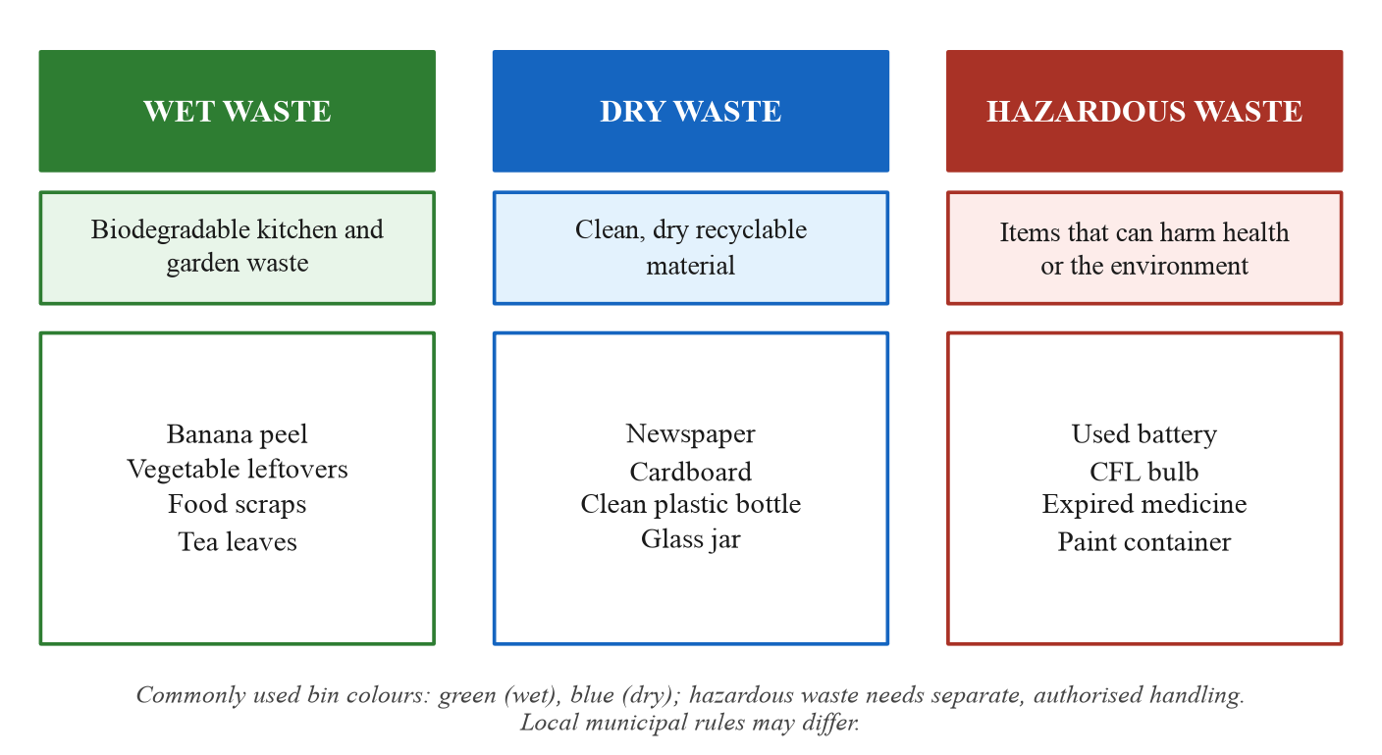
Figure 5.1: The three household waste categories used in the project
Table 5.1: Summary of the three waste categories
Category | Nature | Typical examples | General handling
Wet Waste | Biodegradable | Banana peel, food scraps, tea leaves | Compost or municipal wet stream (commonly green bin)
Dry Waste | Non-biodegradable, recyclable | Newspaper, cardboard, clean bottles | Keep clean and dry; recycle (commonly blue bin)
Hazardous Waste | Harmful to health / environment | Batteries, CFL bulbs, expired medicine | Separate storage; authorised disposal only

CHAPTER 6 – PROJECT OVERVIEW AND SYSTEM DESIGN

6.1 Introduction to SwachhAI Lite
SwachhAI Lite is a beginner-friendly conceptual project that explains how common household waste can be identified and divided into three simple categories: Wet Waste, Dry Waste and Hazardous Waste. The word “Lite” is used honestly: the project is a light, educational version of the waste-management theme explored during the internship. It is a proposed rule-based decision-support guide, not a trained AI system and not a developed software product.
The project’s purpose is awareness. It shows, through a small and fully checkable design, how a computer can support a household decision using predefined rules. Every part of the design can be explained by a third-year student in a viva without referring to advanced technology.

6.2 Project Background
The background of the project is the internship’s waste-management theme. The original internship project document, titled “SwachhAI – AI-guided waste segregation and circularity assistant for India’s households”, described an ambitious multi-module prototype with a language-model classifier, a retrieval-grounded rules assistant and an impact forecaster. That document was prepared as the internship’s final project deliverable and is part of the uploaded material.
For this university report, the theme is deliberately simplified into SwachhAI Lite. The advanced modules of the original material are not claimed as implemented work in this report. What is carried forward is only the core educational idea: help a household decide the correct category of a waste item at the moment of disposal. This simplification keeps the report honest and matches the student’s stated priority of a project that can be confidently explained.

6.3 Project Objectives
The objectives of SwachhAI Lite are:
1. To explain the importance of waste segregation in simple language.
2. To identify common household waste categories.
3. To provide basic disposal guidance for listed items.
4. To encourage responsible waste management habits.
5. To promote environmental awareness at the household level.
6. To demonstrate a simple decision-making approach using predefined rules.

6.4 Proposed Approach
The proposed approach is a four-step, rule-based flow. Step 1, Item Identification: the user identifies a common household waste item, for example a banana peel. Step 2, Rule Checking: the item is compared with a predefined list of waste items and their categories. Step 3, Category Identification: the item is assigned to one of the three categories, for example banana peel → Wet Waste. Step 4, Disposal Guidance: the system conceptually provides a short recommendation on how the item should be segregated and disposed of. Figure 6.1 shows these four steps as a basic block diagram.
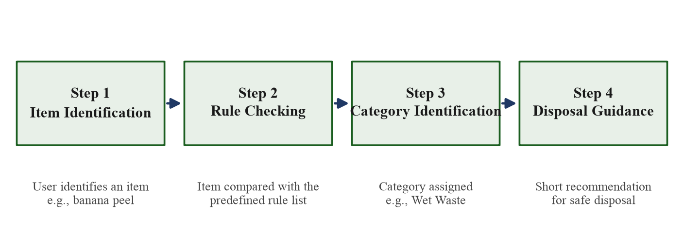
Figure 6.1: Basic block diagram of the SwachhAI Lite concept
No step involves learning, prediction or external services. The entire behaviour of the concept is determined by the predefined list, which is written and reviewed by the student designer before use.

6.5 Intended Users
The concept is aimed at ordinary households, not at specialists. The intended users are:
• Family members who handle daily kitchen and household waste and want a quick category answer.
• Students living in hostels or shared rooms, where mixed waste is common and space for separate bins is limited.
• Teachers and community volunteers who want a simple teaching aid for waste-awareness activities.
The design assumes no technical knowledge from the user: the user only needs to name an item, and the guide returns a category and one short instruction.

6.6 Project Scope
The scope is limited to the items in the predefined list and the three categories. The guidance is general educational advice; local municipal rules may differ and always take precedence. Hazardous materials require suitable authorised disposal arrangements, and the guide says so explicitly. The project does not include image recognition, voice input, databases, internet services or any trained model. It does not claim to measure environmental impact; it only aims to support better decisions.

6.7 Basic System Architecture
The conceptual architecture has three simple parts, shown in Figure 6.2. The input part receives the name of a waste item from the user. The processing part matches that name against the predefined rule base and reads the mapped category. The output part presents the category together with the guidance sentence stored for it. The rule base itself is a fixed table of items, categories and guidance text, prepared in advance.
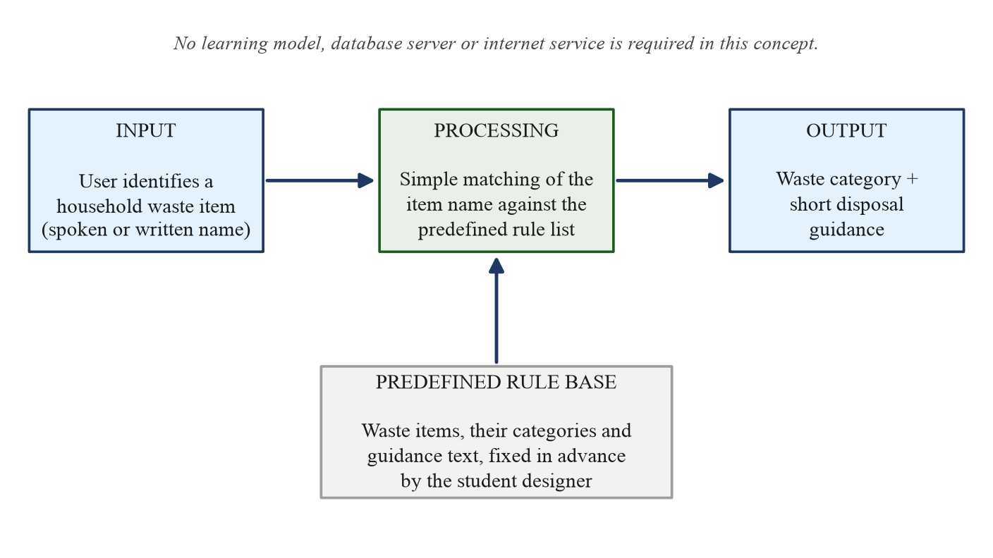
Figure 6.2: Conceptual system architecture of SwachhAI Lite
This architecture is intentionally minimal. There is no server, no database management system and no network dependency in the concept; the rule base could be kept as a simple table in any basic program or even on paper. The architecture is presented to explain the flow of information, not to describe a built product.

6.8 Waste Category Design
The three categories follow the broad stream division of the Solid Waste Management Rules, 2016, expressed in everyday language. Wet Waste covers biodegradable kitchen and garden material. Dry Waste covers clean, dry recyclable material such as paper, plastic, glass and metal. Hazardous Waste covers the small domestic items that can harm health or the environment. Each category has one fixed guidance template, so the user always receives a consistent message.
Three categories were chosen deliberately. They are the standard public division, they are easy to remember, and they keep the rule list small enough to be fully checked. Finer divisions, such as separate e-waste or sanitary streams, are noted as possible future refinements in Chapter 9, not as part of the present design.

6.9 Predefined Classification Rules
The heart of the concept is the predefined rule list. Each rule is a simple mapping: item name → category. Table 6.1 shows the core list used in this report. An extended list, prepared in the same style, is given in Appendix C. Every entry can be verified against public segregation guidance, and any item not present in the list produces the honest fallback message rather than a guess.
Table 6.1: Core predefined classification rules
Waste item | Category
Banana peel | Wet Waste
Vegetable leftovers | Wet Waste
Food scraps | Wet Waste
Newspaper | Dry Waste
Clean plastic bottle | Dry Waste
Cardboard | Dry Waste
Used battery | Hazardous Waste
CFL bulb | Hazardous Waste

6.10 Input and Output
The input of the concept is the name of one household waste item, spoken or written in simple words, for example “banana peel”. The output has two parts: the category label (Wet, Dry or Hazardous) and one short guidance sentence, for example “Wet Waste: place in the wet/compost stream; do not mix with dry recyclables.” If the item is not in the list, the output is the fallback message: “Item not recognised. Please check your local municipal guidance.”
Keeping the input and output this small is a design decision. It makes the concept easy to understand, easy to check and safe to use, because there is no open-ended conversation in which wrong advice could appear.

6.11 System Requirements at a Conceptual Level
Because the project is a concept, its requirements are stated at a conceptual level only. Table 6.2 lists what would be needed if the concept were later realised as a basic teaching program. No such implementation is claimed in this report.
Table 6.2: Conceptual system requirements
Requirement | Conceptual description
Rule base | A fixed, human-reviewed table of items, categories and guidance text
Matching logic | Simple comparison of the entered item name with the rule list
User interface | Any basic means of entering an item name and reading the result
Fallback behaviour | A clear "not recognised" message for items outside the list
Review process | Periodic human checking of the list against municipal guidance

6.12 Advantages and Limitations
The main advantages of the design are transparency, simplicity and safety. Every answer can be traced to a written rule; the whole system can be explained in one page; and the fallback prevents guessing. The design is also inexpensive as a concept, because it needs no data collection, training or infrastructure.
The limitations are equally clear. The concept knows only the items in its list; it cannot understand photographs, voice or free-form questions; it cannot adapt to local rules automatically; and it has not been implemented or tested. These limitations are not hidden — they are part of the honest description of the project, and they define the future scope discussed in Chapter 9.

CHAPTER 7 – DETAILED PROJECT DESCRIPTION

7.1 Overall Project Working
This chapter explains the working of SwachhAI Lite step by step, using everyday examples. The complete working can be stated in one line: the user names an item, the item is checked against a predefined list, the mapped category is read, and the stored guidance sentence is shown. Nothing is learned, predicted or generated at run time; all knowledge is fixed in advance by the student designer.
This single-pass design is intentional. It means that for any listed item, the answer is always the same, and anyone can verify the answer by looking at the list. For an educational project, this predictability is a strength, not a weakness.

7.2 User Input
The user provides the name of one common household waste item in simple words. Examples of valid inputs are “banana peel”, “newspaper”, “clean plastic bottle” and “used battery”. The concept expects the item to be named as it appears in the rule list; it does not attempt to interpret sentences, photographs or voice. If a user types a name that is not in the list, the fallback message is shown.
In a future implementation, small conveniences such as ignoring capital letters or extra spaces could be added without changing the rule-based nature of the system. Such conveniences are listed as possible improvements in Chapter 9 and are not part of the present concept.

7.3 Waste Identification
Waste identification in this concept means finding the entered item name in the predefined list. The list is organised as a simple table with one row per item. Identification is therefore an exact, checkable operation: either the item has a row, or it does not. There is no confidence score and no probability, because no model is involved.
Consider the example of a banana peel. The user names the item; the list contains the row “Banana peel → Wet Waste”; identification succeeds. Consider instead an unusual item such as a ceramic statue: the list has no row for it, identification fails, and the honest fallback message advises the user to check local municipal guidance. Both outcomes are correct behaviour for the design.

7.4 Rule-Based Classification
Once the item is identified, classification simply reads the category stored in its row. The rule base uses the plain form “IF the item is X THEN the category is Y”. Because the categories were assigned by the designer after checking public segregation guidance, the classification step adds no new judgement; it only reports a decision that was already reviewed by a human.
This is the essential difference between the project and a machine learning classifier. A learning-based classifier would compute a category from patterns and could be wrong in unpredictable ways. The rule-based guide can only be wrong if the list itself is wrong, and the list is short enough to be checked line by line. That property is what makes the concept suitable for education and for safety-sensitive guidance.

7.5 Wet Waste Classification
Items classified as Wet Waste are biodegradable kitchen and garden materials. In the core list these are banana peel, vegetable leftovers and food scraps; the extended list in Appendix C adds items such as tea leaves, fruit peels and garden leaves. The guidance template for this category is: “Wet Waste: place in the wet/compost stream (commonly the green bin). Do not mix with dry recyclables.”
The everyday reasoning is simple: these items rot, so they should go where rotting is useful — composting — rather than where it is harmful, such as inside a mixed landfill bag. Where home composting is possible, the guidance encourages it as the best use of wet waste.

7.6 Dry Waste Classification
Items classified as Dry Waste are clean, dry, non-biodegradable materials. In the core list these are newspaper, clean plastic bottle and cardboard; the extended list adds items such as glass jars, metal cans and clean paper bags. The guidance template is: “Dry Waste: keep clean and dry; place in the dry/recycling stream (commonly the blue bin) or hand to a local recycler.”
The word “clean” is part of the rule itself. A plastic bottle with food residue is not ready for the dry stream; the guidance for such cases is to rinse and dry it first. This small instruction carries a large part of the practical value of segregation, because cleanliness is what preserves recycling value.

7.7 Hazardous Waste Classification
Items classified as Hazardous Waste are the small domestic items that can harm health or the environment. In the core list these are used battery and CFL bulb; the extended list adds expired medicine and paint containers. The guidance template is: “Hazardous Waste: do not mix with wet or dry waste. Store separately and use an authorised collection or take-back arrangement. Verify with your local municipal body.”
This category receives the strongest wording in the whole design. The guidance never suggests putting a hazardous item into any ordinary bin, and it always ends with human verification. This follows the responsible-technology principle that safety advice must be conservative: when in doubt, the system says less and refers the user to an authority, rather than saying more and risking harm.

7.8 Disposal Guidance
The disposal guidance is a fixed, one-line sentence stored with each category. It is written in plain, action-oriented language so that a user can follow it immediately at the bin. Table 7.1 shows the guidance for the eight core items. The sentences are educational suggestions; local municipal rules may differ, and hazardous materials require suitable authorised disposal arrangements.
Table 7.1: Disposal guidance for the core waste items
Waste item | Category | Guidance shown to the user
Banana peel | Wet | Use the wet/compost stream; do not mix with dry waste.
Vegetable leftovers | Wet | Use the wet/compost stream; compost at home if possible.
Food scraps | Wet | Use the wet/compost stream; keep out of the dry bin.
Newspaper | Dry | Keep clean and dry; use the dry/recycling stream.
Clean plastic bottle | Dry | Empty, rinse and dry; use the dry/recycling stream.
Cardboard | Dry | Flatten and keep dry; use the dry/recycling stream.
Used battery | Hazardous | Never bin it; store separately; use authorised take-back.
CFL bulb | Hazardous | Handle carefully; never bin it; use authorised collection.

7.9 Complete Project Workflow
Figure 7.1 shows the complete workflow, including the fallback path. The user names an item; the concept checks whether the item is present in the predefined rule list. If it is present, the mapped category is read and the guidance sentence is displayed. If it is not present, the concept shows the “item not recognised” message and advises checking local municipal guidance. The workflow then ends. There are no loops, no learning and no external calls.
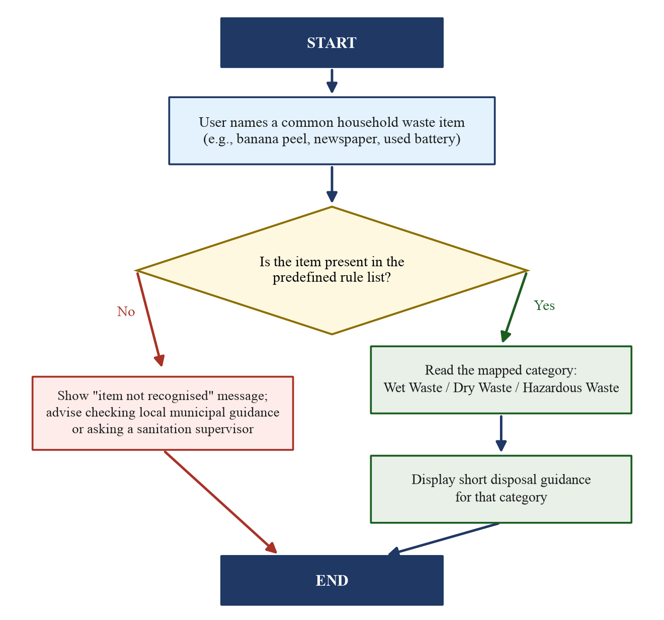
Figure 7.1: Complete workflow of the SwachhAI Lite concept, including the fallback path

7.10 Practical Examples
Three short examples illustrate the complete flow. Example 1: the user names “banana peel”; the item is found; the category Wet Waste is read; the guidance “Use the wet/compost stream” is shown. Example 2: the user names “newspaper”; the item is found; the category Dry Waste is read; the guidance “Keep clean and dry; use the dry/recycling stream” is shown. Example 3: the user names “used battery”; the item is found; the category Hazardous Waste is read; the guidance “Never bin it; use authorised take-back” is shown.
A fourth example shows the fallback: the user names “ceramic statue”; the item is not found; the message “Item not recognised. Please check your local municipal guidance” is shown. These four examples together cover every behaviour the concept can produce.

7.11 Illustrative Case Study
The following case study is a fictional, illustrative example. It is not field research, not a user trial and not a measured result. It is included only to show how a household could use the concept in daily life. Imagine a family of four finishing a day’s activities and collecting six items: banana peels from breakfast, vegetable leftovers from cooking, food scraps from dinner, yesterday’s newspaper, a clean plastic water bottle, and a used battery from a wall clock.
Using the concept, the family names each item and receives its category and guidance. The three kitchen items go to the wet/compost stream. The newspaper and the rinsed, dried bottle go to the dry/recycling stream. The battery is stored separately in a small box until it can be handed to an authorised take-back point. Table 7.2 summarises the illustrative sorting. The example shows the intended habit: one quick check per item, three clean streams, and no hazardous item hidden in a mixed bag.
Table 7.2: Illustrative household case study (fictional example, not field data)
Item collected | Category shown | Illustrative action taken
Banana peels | Wet Waste | Placed in the kitchen wet/compost container
Vegetable leftovers | Wet Waste | Placed in the kitchen wet/compost container
Food scraps | Wet Waste | Placed in the kitchen wet/compost container
Newspaper | Dry Waste | Kept dry and stacked for the dry stream
Clean plastic bottle | Dry Waste | Rinsed, dried and added to the dry stream
Used battery | Hazardous Waste | Stored separately for authorised take-back

7.12 Expected Benefits
The expected benefits of the concept are educational and behavioural, not measured environmental quantities. If used as a teaching aid, the guide can make the three-category habit familiar, reduce hesitation at the bin, keep recyclables cleaner, and keep hazardous items out of mixed bags. It can also serve as a conversation starter in classrooms and community awareness activities.
No numerical impact is claimed. Any real environmental benefit would depend on actual adoption and correct behaviour, which would have to be studied separately before any claim could be made. Stating this clearly is itself part of the responsible design of the project.

CHAPTER 8 – RESPONSIBLE TECHNOLOGY AND SUSTAINABILITY

8.1 Introduction to Responsible Technology
Responsible technology means designing and using technical systems so that they help people without misleading them or putting them at risk. It includes honesty about what a system can do, transparency about how it decides, care for safety and privacy, and respect for the people affected by its advice. The internship treated responsible AI as a core theme, and this project applies the same principles at its own small scale.

8.2 Importance of Accurate Information
A waste guide is trusted by its users, so wrong information can cause real harm: a mislabelled hazardous item can injure a worker, and a wrong recycling instruction can spoil a whole batch of material. For this reason, every rule in the project is checked against public segregation guidance before being included, and the guidance sentences are kept short and conservative. Accuracy is treated as a design requirement, not as an afterthought.

8.3 Environmental Awareness
The deeper purpose of the project is awareness. Each guidance sentence quietly teaches a reason: wet waste belongs to compost because it rots; dry waste must stay clean because cleanliness preserves recycling value; hazardous waste must stay separate because it can harm people and nature. A user who follows the guide for a few weeks learns the logic of segregation, not just a list of answers. That learning is the real environmental contribution of the concept.

8.4 Safe Disposal Practices
For hazardous items, the project repeats three safe practices: never mix hazardous waste with ordinary waste; store it separately and safely until disposal; and use authorised collection or take-back arrangements, verifying with the local municipal body. For broken glass or sharps, general public guidance recommends wrapping and marking the material so that handlers are protected. The project states these practices as educational advice and always defers to local authority instructions.

8.5 Limitations of Rule-Based Classification
The rule-based approach has honest limits. It covers only listed items; it cannot interpret new or ambiguous descriptions; it cannot see a photograph; and it cannot update itself when municipal rules change. A fixed list also reflects the knowledge of its designer at the time of writing. These limits are stated openly in the project description so that users never expect more than the design can deliver.

8.6 Human Verification
Human verification is built into the design at two points. First, the rule list itself is reviewed by a human against public guidance before use. Second, the hazardous-waste guidance always ends with a recommendation to verify with the local municipal body. The fallback message for unknown items is also a form of verification: instead of guessing, the system hands the decision back to a human authority. This keeps the human in charge, which is the central principle of responsible decision support.

8.7 Sustainable Development Goals
The United Nations Sustainable Development Goals (SDGs) are seventeen global goals adopted in 2015 to guide development towards a fairer and healthier planet [4]. The internship aligned its sustainability themes with the SDGs, and the original project material identified Goals 11, 12 and 13 as the relevant ones. SwachhAI Lite keeps the same alignment at an educational level, as shown in Figure 8.1.
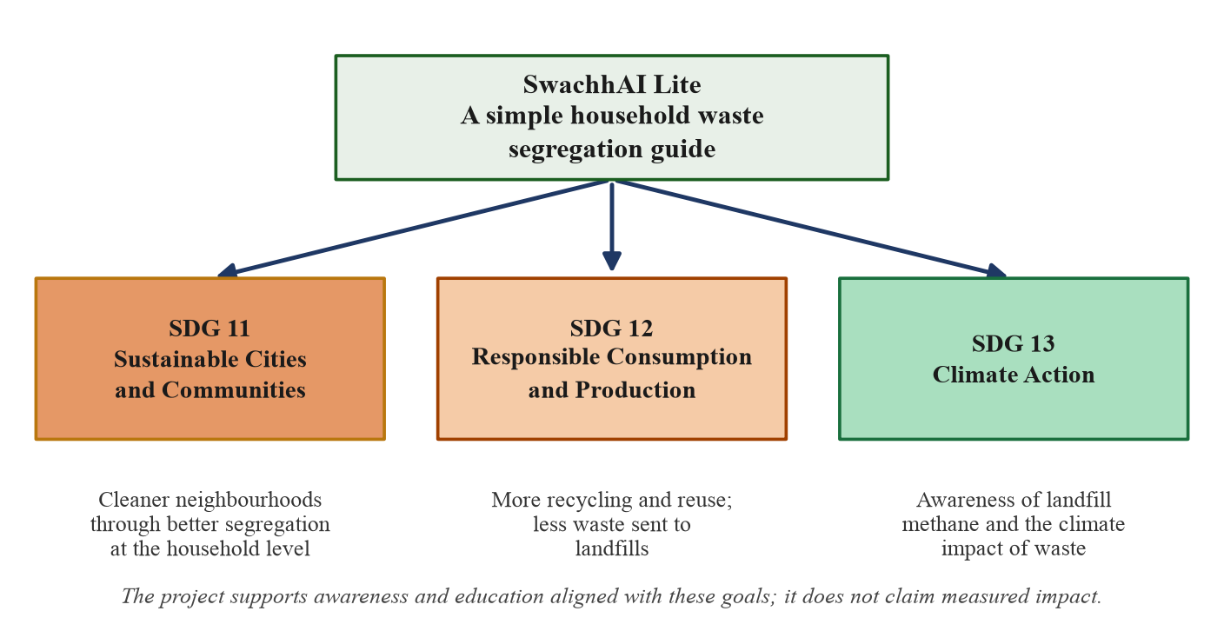
Figure 8.1: Alignment of the project with SDG 11, SDG 12 and SDG 13

8.8 SDG 11 – Sustainable Cities and Communities
SDG 11 aims to make cities inclusive, safe, resilient and sustainable. One of its targets concerns reducing the adverse environmental impact of cities, including through attention to municipal waste management [4]. Household segregation supports this target directly: cleaner streams mean cleaner neighbourhoods, less dumping and less burning. The project contributes by teaching the household habit on which city-level cleanliness depends.

8.9 SDG 12 – Responsible Consumption and Production
SDG 12 aims to ensure sustainable consumption and production patterns. Its target 12.5 calls for substantially reducing waste generation through prevention, reduction, recycling and reuse [4]. Segregation is the practical first step of recycling and reuse: material can only be recycled if it arrives clean and separated. The project therefore supports SDG 12 as its primary goal, exactly as the original internship material did.

8.10 SDG 13 – Climate Action
SDG 13 calls for urgent action to combat climate change and its impacts, including improving education and awareness [4]. Wet waste in landfills produces methane, a powerful greenhouse gas; composting the same waste avoids that emission. By explaining this connection in simple words, the project supports the awareness dimension of SDG 13. It claims awareness support only, not measured climate impact.

8.11 Environmental and Social Benefits
The expected environmental benefits of better household segregation are cleaner recyclable streams, more composting, less mixed dumping and reduced risk of pollution. The social benefits are equally important: safer working conditions for sanitation workers, more dignified handling of waste, and a shared household habit that children learn early. The project presents these as expected, qualitative benefits of the behaviour it teaches; it does not present them as measured outcomes of a deployed system.

CHAPTER 9 – FUTURE SCOPE AND LEARNING OUTCOMES

9.1 Technical Knowledge Gained
The internship gave the student a structured beginner’s map of modern AI. The student can now define the basic terms — model, training, prompt, classification, LLM, RAG and agent — and can explain where each fits. The student also learned to read a technical project document and separate its claims from its demonstrated parts, which is a useful skill for any engineer. This knowledge is stated as understanding, not as professional implementation experience.

9.2 Understanding of Artificial Intelligence
The most valuable understanding gained is that AI is a spectrum of techniques, and that the simplest adequate technique is often the best engineering choice. A rule list, a learned classifier and a language model can all answer “which category is this item?”, but they differ in cost, transparency and risk. Choosing the rule list for a small educational problem is therefore not a compromise; it is a reasoned design decision that the student can defend in a viva.

9.3 Understanding of Waste Classification
The student gained a clear practical understanding of the three household waste streams, their examples and their handling logic, grounded in the Solid Waste Management Rules, 2016. Equally important, the student learned why segregation matters at each later stage of the waste chain: recycling value, worker safety, compost quality and landfill emissions. This domain understanding is what makes the project meaningful rather than merely technical.

9.4 Skills Developed During Internship
Beyond technical vocabulary, the internship developed working skills: completing a guided online learning plan on schedule, following a structured project submission pattern, writing clear documentation, and presenting a project honestly with its limitations stated. The preparation of this report itself exercised these skills, because every claim had to be checked against the official documents and every simplification had to be declared.

9.5 Challenges and Limitations
The main challenge was resisting the temptation to overstate the project. The internship material described advanced modules, and it would have been easy to copy their language into this report. The discipline adopted was to claim only what the documents support and to present the simplified project as a concept. The limitations of the work are therefore honest ones: no implementation, no testing, no field data, and a rule list that covers only common items.

9.6 Future Scope of the Project
The concept has a clear and modest growth path. Table 9.1 lists the possible improvements, all of which are proposals for future work and none of which is implemented or claimed in this report. Any practical implementation would first require review of the rule list against current municipal guidance and evaluation with real users under proper supervision.
Table 9.1: Proposed future improvements (not implemented)
Proposed improvement | Purpose
More waste categories | Finer streams such as e-waste or sanitary waste, if locally relevant
Regional language support | Item names and guidance in Hindi and other local languages
Optional image-based identification | A future, separately studied addition; not part of this concept
Updated municipal disposal information | City-specific guidance reviewed with local authorities
Evaluation before practical use | User studies and expert review before any real deployment

9.7 Possible Improvements
Small, low-risk improvements could also be made to the basic concept without changing its nature: ignoring capitalisation and extra spaces in item names, adding common synonyms to the rule list, and printing the rule table as a one-page household chart. These improvements keep the system rule-based and checkable while making it friendlier. They are listed as possibilities, consistent with the honest scope of this report.

CHAPTER 10 – CONCLUSION

10.1 Internship Summary
The AI for Sustainability Virtual Internship, organised by 1M1B, supported by AICTE and conducted in collaboration with IBM SkillsBuild, gave the student a structured introduction to Artificial Intelligence and its application to sustainable development. The official completion certificate records the programme period as July 2026 to September 2026, while the offer letter records the offered six-week period as 28 July 2026 to 28 August 2026. The student completed two IBM SkillsBuild learning plans and the internship’s project deliverable, and the completion is documented by the certificates reproduced in this report.

10.2 Project Summary
SwachhAI Lite presented a simple, honest educational concept: a rule-based household waste segregation guide with three categories and short disposal guidance. The project demonstrated that a small, transparent design can address a real everyday problem — hesitation at the bin — without advanced technology. Its scope, limitations and future possibilities were stated openly throughout the report.

10.3 Technical Learning Summary
The internship built beginner-level understanding of AI, machine learning, generative AI, LLMs, IBM Granite, prompt engineering, RAG and agentic AI, together with a practical understanding of waste classification and responsible technology. The student can explain each of these at a conceptual level and can clearly distinguish what was learned from what was actually used in the project.

10.4 Overall Conclusion
The overall lesson of the internship is that technology earns its value by serving people and the planet honestly. A large model is not always the right tool; sometimes the right tool is a short, checked list that helps a family separate its waste correctly. Applying even simple computing ideas to environmental problems, with full honesty about what has and has not been done, is a worthy first step for a student of Computer Science. This report, and the simple project it describes, represent that first step.

REFERENCES AND BIBLIOGRAPHY
The following sources were used in the preparation of this report. Items [1]–[13] are public references; items [14]–[18] are the uploaded primary documents of the internship. Web addresses were accessed in November 2026.
[1] World Bank. What a Waste 2.0: A Global Snapshot of Solid Waste Management to 2050. Washington, DC: World Bank, 2018. Available: https://datatopics.worldbank.org/what-a-waste/
[2] Central Pollution Control Board (CPCB), Ministry of Environment, Forest and Climate Change, Government of India. Municipal solid waste management data and annual reports. (The estimate of approximately 62 million tonnes of municipal solid waste per year for India is a widely reported CPCB-based figure.) Available: https://cpcb.nic.in/
[3] Ministry of Environment, Forest and Climate Change (MoEFCC), Government of India. Solid Waste Management Rules, 2016. Gazette of India, 2016. Available: https://cpcb.nic.in/uploads/MSW/SWM_2016.pdf
[4] United Nations. Sustainable Development Goals — Goals 11, 12 and 13. Department of Economic and Social Affairs, 2015. Available: https://sdgs.un.org/goals
[5] United Nations Environment Programme (UNEP). Food Waste Index Report 2024. Nairobi: UNEP, 2024. Available: https://www.unep.org/resources/publication/food-waste-index-report-2024
[6] Ministry of Environment, Forest and Climate Change (MoEFCC), Government of India. Battery Waste Management Rules, 2022. Gazette of India, 2022. Available: https://cpcb.nic.in/
[7] Ministry of Environment, Forest and Climate Change (MoEFCC), Government of India. E-Waste (Management) Rules, 2022. Gazette of India, 2022. Available: https://cpcb.nic.in/
[8] Ministry of Housing and Urban Affairs (MoHUA), Government of India. Swachh Bharat Mission – Urban: citizen guidance on source segregation. Available: https://sbmurban.org/
[9] All India Council for Technical Education (AICTE). National Internship Portal. Available: https://internship.aicte-india.org/
[10] 1M1B — One Million for One Billion. Organisation and programmes. Available: https://1m1b.org/
[11] IBM SkillsBuild. Free learning platform for technical and professional skills. Available: https://skillsbuild.org/
[12] IBM. IBM Granite — family of AI models for enterprise and developers. Available: https://www.ibm.com/granite
[13] Russell, S. and Norvig, P. Artificial Intelligence: A Modern Approach. Pearson. (Standard textbook reference for the conceptual background of AI and rule-based systems.)
[14] 1M1B. AICTE Internship Offer Letter — AI for Sustainability Virtual Internship, issued July 2026 (Internship ID INTERNSHIP_17828984086a44dee80acf6). Uploaded primary document.
[15] 1M1B, AICTE and IBM SkillsBuild. Certificate of Completion — AI for Sustainability Virtual Internship, issued 22 September 2026. Uploaded primary document.
[16] IBM SkillsBuild. Completion Certificates for learning plans PLAN-56138075980A (01 Aug 2026) and PLAN-F60F1D7DADA9 (05 Aug 2026). Uploaded primary documents.
[17] Ansari, M. R. SwachhAI — AI for Sustainable Waste Management. Final project deliverable, 1M1B AI for Sustainability Virtual Internship, submitted 14 September 2026. Uploaded primary document.
[18] University of Lucknow. Prescribed report format reference, Department of Computer Science and Engineering. Uploaded reference document.

APPENDIX A – ADDITIONAL INTERNSHIP CERTIFICATES
This appendix reproduces the two IBM SkillsBuild learning-plan completion certificates earned during the internship. The main internship completion certificate is already included in the preliminary pages and is not duplicated here.

A.1 IBM SkillsBuild Completion Certificate – Learning Plan 1
Certificate for the learning plan “1M1B | AI for Sustainability Virtual Internship” (PLAN-56138075980A), completed on 1st August 2026 (GMT), according to the Your Learning Builder – Plans system of record.
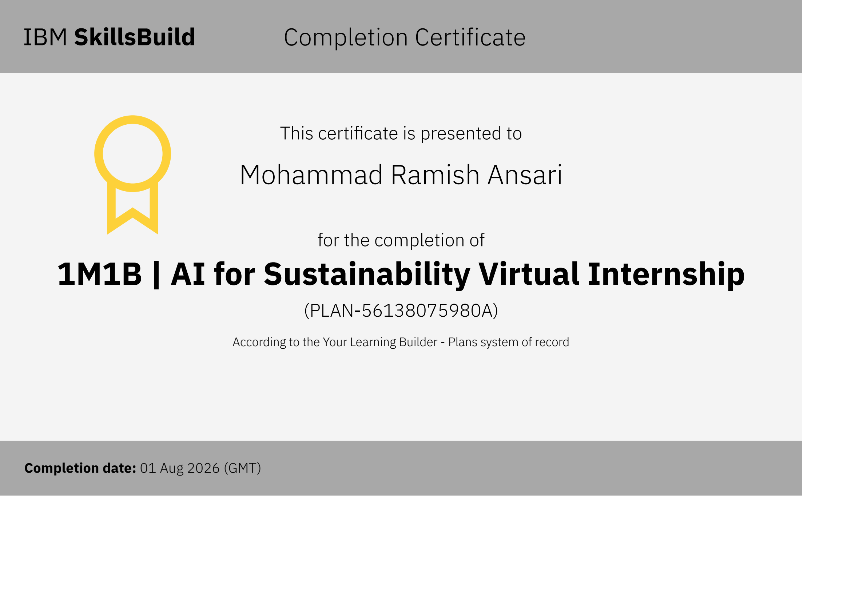
IBM SkillsBuild Completion Certificate – PLAN-56138075980A (01 Aug 2026)

A.2 IBM SkillsBuild Completion Certificate – Learning Plan 2
Certificate for the learning plan “1M1B | AI for Sustainability” (PLAN-F60F1D7DADA9), completed on 5th August 2026 (GMT), according to the Your Learning Builder – Plans system of record.
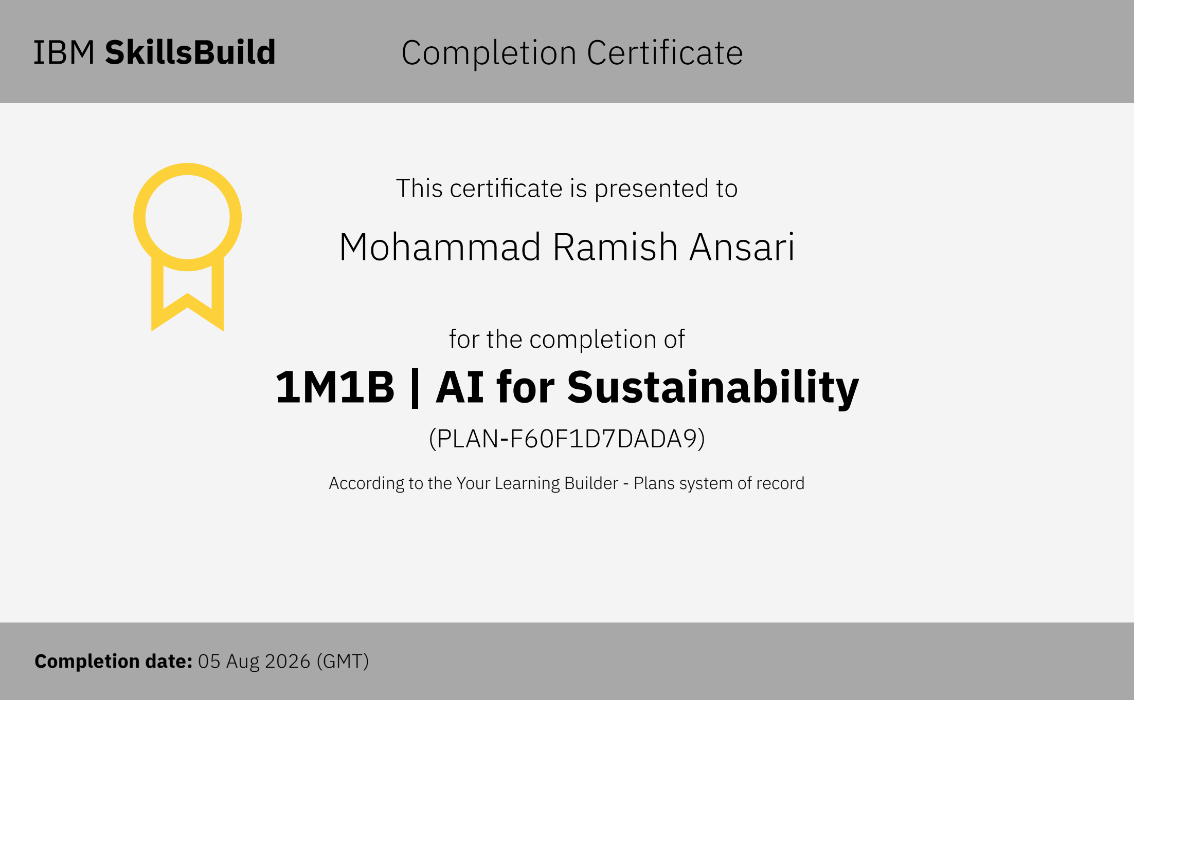
IBM SkillsBuild Completion Certificate – PLAN-F60F1D7DADA9 (05 Aug 2026)
These certificates document the completion of the guided SkillsBuild learning plans. They are distinct from the main internship completion certificate issued on 22nd September 2026.

APPENDIX B – INTERNSHIP SCHEDULE
This appendix summarises the documented schedule of the internship. Table B.1 lists the key dates exactly as recorded in the official documents. The scheduled learning topics of the July 2026 learning schedule are listed in Table 2.3 of Chapter 2 and are not repeated here.
Table B.1: Chronological summary of documented internship dates
Date (as documented) | Event | Source document
27 July 2026 | Student declaration of acceptance signed | Offer letter, page 2
28 July – 28 August 2026 | Six-week internship period stated in the offer | Offer letter, page 1
01 August 2026 | SkillsBuild plan PLAN-56138075980A completed | IBM SkillsBuild certificate 1
05 August 2026 | SkillsBuild plan PLAN-F60F1D7DADA9 completed | IBM SkillsBuild certificate 2
14 September 2026 | Original SwachhAI project deliverable submitted | SwachhAI project document
22 September 2026 | Main completion certificate issued | Main completion certificate
July – September 2026 | Programme period stated on the certificate | Main completion certificate

The offer letter records the offered internship period as six weeks, from 28th July 2026 to 28th August 2026. The main completion certificate records the programme period as July 2026 to September 2026. These two references come from different official documents and are presented separately, exactly as each source states them.
Note on session dates: the learning topics in Table 2.3 follow the internship learning schedule circulated for July 2026. Exact dates of individual live sessions were governed by the organiser’s schedule; this report lists the topics as scheduled learning topics and does not claim attendance at specific sessions beyond the completion recorded in the official certificates.

APPENDIX C – RELEVANT PROJECT SUPPORTING MATERIAL

C.1 Extended Predefined Rule List
Table C.1 extends the core rule list of Table 6.1 in the same simple style. Every entry is a fixed mapping prepared by the student designer and intended to be checked against public municipal segregation guidance before any practical use. Local municipal rules may differ and always take precedence.
Table C.1: Extended predefined rule list for the SwachhAI Lite concept
Waste item | Category | Note for the designer
Banana peel | Wet | Biodegradable kitchen waste
Vegetable leftovers | Wet | Biodegradable kitchen waste
Food scraps | Wet | Biodegradable kitchen waste
Tea leaves / tea bags | Wet | Remove staple if present
Fruit peels | Wet | Biodegradable kitchen waste
Garden leaves | Wet | Biodegradable garden waste
Eggshells | Wet | Biodegradable; crush for compost
Coffee grounds | Wet | Biodegradable kitchen waste
Newspaper | Dry | Keep clean and dry
Cardboard | Dry | Flatten; keep dry
Clean plastic bottle | Dry | Empty, rinse, dry
Glass jar | Dry | Empty and rinse; handle carefully
Metal can | Dry | Empty and rinse
Clean paper bag | Dry | Keep clean and dry
Old notebook | Dry | Remove plastic cover if any
Milk pouch (rinsed) | Dry | Cut, rinse and dry before disposal
Used battery | Hazardous | Authorised take-back only
CFL bulb | Hazardous | Contains mercury; handle carefully
Expired medicine | Hazardous | Use authorised medicine take-back
Paint container | Hazardous | Chemical residue; authorised disposal
Cleaning chemical container | Hazardous | Chemical residue; authorised disposal
Aerosol can | Hazardous | Pressurised; follow local guidance
Nail polish remover | Hazardous | Chemical; authorised disposal
Broken glass (wrapped) | Hazardous | Wrap and mark; protect handlers; follow local guidance

C.2 Guidance Templates
The concept stores one fixed guidance sentence per category, plus one fallback message. These templates are educational suggestions, not municipal instructions.
Wet Waste: Wet Waste: place in the wet/compost stream (commonly the green bin). Do not mix with dry recyclables. Compost at home if possible.
Dry Waste: Dry Waste: keep clean and dry; place in the dry/recycling stream (commonly the blue bin) or hand to a local recycler.
Hazardous Waste: Hazardous Waste: do not mix with wet or dry waste. Store separately and use an authorised collection or take-back arrangement. Verify with your local municipal body.
Fallback (item not in list): Item not recognised. Please check your local municipal guidance or ask your sanitation supervisor.

C.3 Glossary of Key Terms
Artificial Intelligence (AI): The field of making computers perform tasks that normally need human intelligence.
Classification: Assigning an input to one of a fixed set of categories.
Rule-based system: A system that decides using explicit IF–THEN conditions written by human designers.
Prompt: The input text given to an AI language model.
Large Language Model (LLM): A very large AI model trained on text to understand and generate language.
RAG: Retrieval-Augmented Generation: answering from retrieved, trusted documents.
Agentic AI: AI that plans and carries out a sequence of steps towards a goal.
Segregation: Separating waste into categories at the point where it is generated.
Composting: Controlled natural decay of wet waste into a useful soil conditioner.
Methane: A strong greenhouse gas produced when wet waste rots without air in landfills.
SDG: Sustainable Development Goal: one of the seventeen United Nations global goals.
Decision-support system: A system that helps a human make a decision; the human remains in charge.

APPENDIX D – VIVA-VOCE PREPARATION
This appendix contains twenty-five basic questions with short answers to help the student prepare for the viva-voce examination. The answers restate the honest scope of the project: RAG, IBM Granite and Agentic AI are internship learning topics, not implementations claimed in this project.
Q1. What is your project?
Ans. My project is SwachhAI Lite, a simple household waste segregation guide. It is a proposed, rule-based educational concept that classifies common household waste items into Wet, Dry and Hazardous categories and gives short disposal guidance. It is not a trained AI model or a developed software product.
Q2. What is the objective of your project?
Ans. The objective is to make household waste segregation easier to understand. The project explains the three waste categories, provides basic disposal guidance and demonstrates simple decision-making using predefined rules. It also promotes environmental awareness.
Q3. Why did you select this topic?
Ans. The topic matches the waste-reduction and sustainable-cities theme of my 1M1B AI for Sustainability internship. Household waste is a real, everyday problem that I can observe around me. It also allowed me to build a simple project that I can explain honestly.
Q4. What is waste segregation?
Ans. Waste segregation means separating waste into categories at the place where it is generated, before collection. In India it commonly means separating wet, dry and domestic hazardous waste. It is important because mixed waste is difficult and costly to process later.
Q5. What is wet waste?
Ans. Wet waste is biodegradable waste that rots naturally, such as banana peels, vegetable leftovers and food scraps. It is best composted or sent through the municipal wet-waste stream, commonly the green bin. When it rots without air in a landfill, it produces methane.
Q6. What is dry waste?
Ans. Dry waste is clean, non-biodegradable material such as newspaper, cardboard, clean plastic bottles and glass jars. It is the recyclable stream, commonly the blue bin. It must be kept clean and dry, because food contamination destroys its recycling value.
Q7. What is hazardous waste?
Ans. Domestic hazardous waste is the small but dangerous part of household waste, such as used batteries, CFL bulbs and expired medicines. It must never be mixed with ordinary waste. It needs separate storage and authorised disposal arrangements.
Q8. What is Artificial Intelligence?
Ans. AI is the branch of Computer Science that makes computers perform tasks that normally need human intelligence, such as understanding language or making decisions. Some AI systems learn from data, while others follow rules written by people. My project belongs to the rule-based family.
Q9. What is classification?
Ans. Classification means assigning an input to one of a fixed set of categories. An everyday example is sorting letters into departments. In my project, classification means assigning a waste item to Wet, Dry or Hazardous Waste.
Q10. What is a rule-based system?
Ans. A rule-based system makes decisions using explicit IF–THEN conditions written by human designers. For example, IF the item is a banana peel THEN the category is Wet Waste. Its advantage is transparency: every answer can be traced to a written rule.
Q11. How does your proposed system work?
Ans. It works in four steps. The user names an item; the item is checked against a predefined list; the mapped category is read; and a short disposal guidance sentence is shown. If the item is not in the list, the system honestly says it is not recognised.
Q12. Is your project a machine learning model?
Ans. No. It is a rule-based educational concept, not a trained machine learning model. There is no training, no dataset and no prediction. I chose this deliberately so that every decision is transparent and checkable.
Q13. What is the input and output of your system?
Ans. The input is the name of one common household waste item, such as “banana peel”. The output is the category label plus one short guidance sentence. For unknown items, the output is a fallback message advising local verification.
Q14. What happens if an item is not in your list?
Ans. The system shows an “item not recognised” message and advises the user to check local municipal guidance. It never guesses. This fallback is a safety feature of the design.
Q15. What are the advantages of your project?
Ans. It is simple, transparent and safe. Every answer can be verified by looking at the rule list, and the whole design can be explained in one page. It needs no data collection, training, internet or infrastructure.
Q16. What are the limitations of your project?
Ans. It covers only the items in its list and cannot understand photographs, voice or free-form questions. It cannot update itself when municipal rules change. It is a concept only: it has not been implemented, tested or evaluated with users.
Q17. Why did you not use machine learning or image recognition?
Ans. Because the educational goal does not need them, and they would add cost and risk without adding clarity. A short, checked rule list answers the common cases safely. Image-based identification is listed only as a possible future improvement.
Q18. What are the future improvements of your project?
Ans. Possible improvements include more waste categories, regional language support, optional image-based identification, updated municipal disposal information, and proper evaluation before any practical use. All of these are proposals, not implemented features.
Q19. What did you learn during the internship?
Ans. I gained beginner-level understanding of AI, machine learning, generative AI, LLMs, prompt engineering, RAG and agentic AI, and of responsible AI use. I also learned how AI connects to sustainability themes such as waste and climate. I completed two IBM SkillsBuild learning plans.
Q20. What is sustainability?
Ans. Sustainability means meeting present needs without damaging the ability of future generations to meet theirs. In simple words, it means using resources carefully so that they last. Better waste handling is one practical part of sustainability.
Q21. Which SDGs are relevant to your project?
Ans. SDG 11 (Sustainable Cities and Communities), SDG 12 (Responsible Consumption and Production) and SDG 13 (Climate Action). Segregation supports cleaner cities, enables recycling, and reduces landfill methane. My project supports awareness of these goals; it does not claim measured impact.
Q22. What is IBM Granite?
Ans. IBM Granite is IBM’s family of AI models for business and developer use, including language models. It was a learning topic in my internship. It is not used in my simplified project.
Q23. What is RAG?
Ans. RAG, or Retrieval-Augmented Generation, is a technique where an AI system first retrieves relevant passages from trusted documents and then answers based on them, usually with citations. It was an internship learning topic. My project does not implement RAG.
Q24. What is Agentic AI?
Ans. Agentic AI refers to systems that plan and carry out a sequence of steps towards a goal, often described as a perceive–decide–act–learn loop. It was an internship learning topic. My project is a single-pass guide, not an agent.
Q25. How is your project responsible technology?
Ans. It states its limitations openly, never guesses for unknown items, and always recommends human verification for hazardous waste. Its guidance is checked against public segregation advice. The human user remains in charge of every decision.

