INDUSTRIAL TRAINING REPORT
on
“SwachhAI: AI for Sustainable Waste Management”
by
Mohammad Ramish Ansari [Roll No.: __________________]
Submitted in Partial Fulfilment of the Requirements for the Award of the Degree
of
BACHELOR OF TECHNOLOGY
in
COMPUTER SCIENCE & ENGINEERING
from
1M1B (One Million for One Billion)

Submitted to
DEPARTMENT OF COMPUTER SCIENCE AND ENGINEERING
FACULTY OF ENGINEERING & TECHNOLOGY
UNIVERSITY OF LUCKNOW, LUCKNOW
November 2026

DECLARATION
I, Mohammad Ramish Ansari, declare that this report, “SwachhAI: AI for Sustainable Waste Management,” is prepared for submission to the Department of Computer Science and Engineering, University of Lucknow, in partial fulfilment of the requirements for the award of the degree of Bachelor of Technology.
This report describes my learning from the AI for Sustainability Virtual Internship and presents SwachhAI as a conceptual case study based on the supplied project document. The illustrations and examples are explanatory; this report does not claim a working model or measured results. Sources used are acknowledged in the references.
I have taken care not to include confidential training materials or restricted company data. I understand that this declaration should be signed only after I have reviewed the report and verified its contents.

Signature: ______________________________
Name: Mohammad Ramish Ansari
Roll No.: ______________________________
Date: __________________________________
Place: Lucknow

TRAINING / INTERNSHIP CERTIFICATE
Colour reproduction of the supplied certificate of completion.
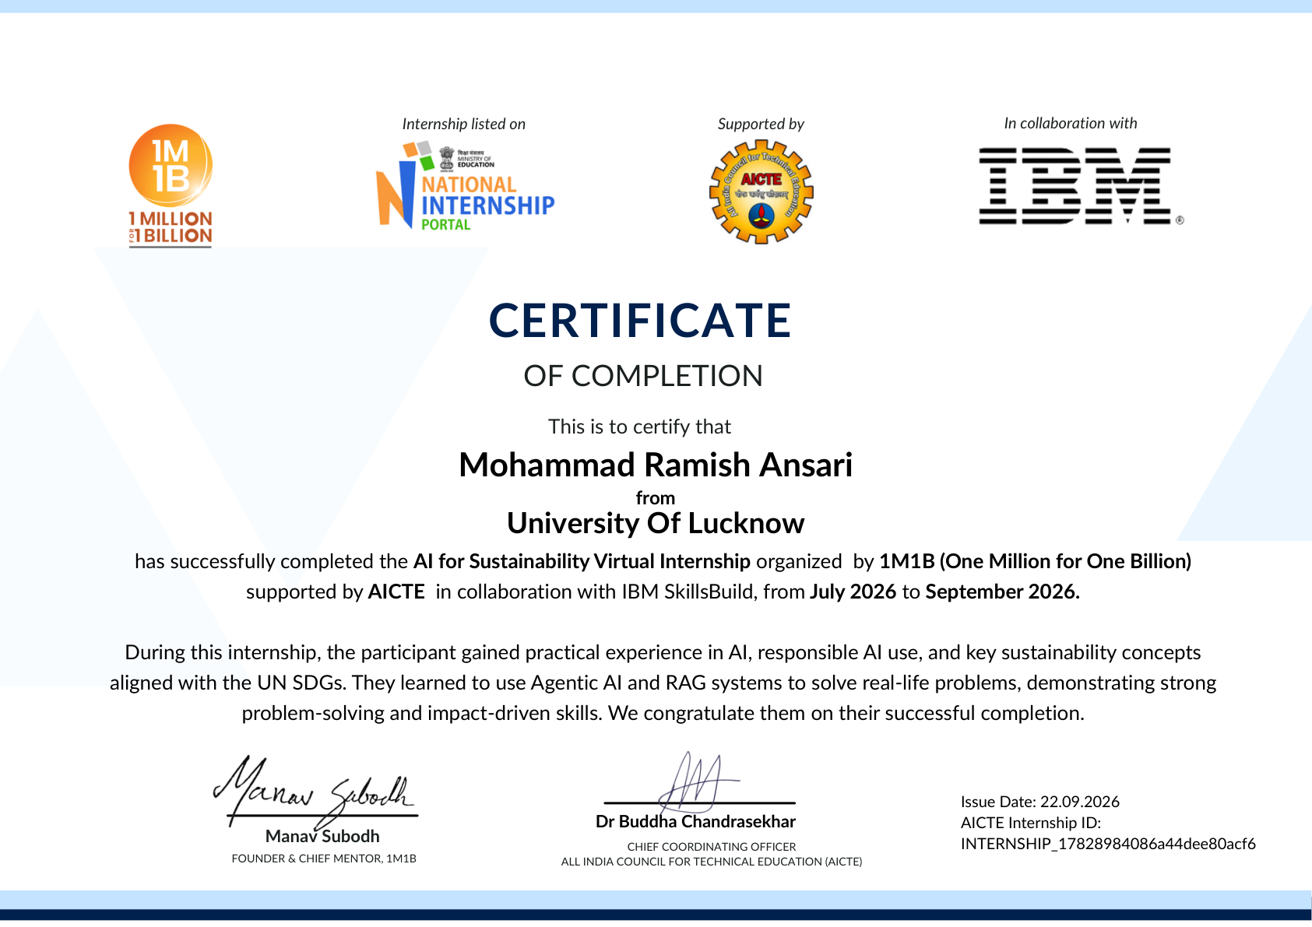
The certificate records July 2026 to September 2026. Confirm the exact training duration with the issuing organisation before final submission.

ABSTRACT
This report presents a simple conceptual study of SwachhAI, an AI-guided assistant for sustainable waste management. It draws on learning from the 1M1B AI for Sustainability Virtual Internship, supported by AICTE in collaboration with IBM SkillsBuild. The case study addresses the difficulty people may face when deciding how to handle common household waste.
The report explains artificial intelligence, machine learning, large language models, retrieval-augmented generation and agentic AI in straightforward terms. It proposes a workflow in which a user describes an item, relevant guidance is consulted and a clear response is prepared with appropriate safety and local-rule cautions. An old battery is used as an illustrative example.
The illustrations and responses are conceptual. No working model, deployment, performance measurement or environmental impact is claimed. The report emphasises trustworthy sources, privacy, human oversight and the need to verify current local disposal arrangements.
Keywords
Artificial intelligence; sustainability; waste segregation; retrieval-augmented generation; responsible AI.

ACKNOWLEDGEMENT
I express my gratitude to 1M1B for organising the AI for Sustainability Virtual Internship, and to AICTE and IBM SkillsBuild for supporting and collaborating on the programme. The learning experience helped me explore how AI concepts can be connected to sustainability challenges.
I am thankful to the Department of Computer Science and Engineering, Faculty of Engineering & Technology, University of Lucknow, for the opportunity to present this report. I also thank the trainers and mentors associated with the internship for their guidance and learning resources.
Finally, I thank everyone who encouraged me during the preparation of this report.

Mohammad Ramish Ansari

TABLE OF CONTENTS
Declaration .............................................................. i
Training / Internship Certificate ..................................... ii
Abstract .................................................................. iii
Acknowledgement ..................................................... iv
Table of Contents ....................................................... v
List of Tables ........................................................... vi
List of Figures ......................................................... vii
1. Introduction ........................................................... 1
2. Objectives of the Project .......................................... 2
3. Overview of the Organisation and Internship ................ 3
4. Overview of Technology .......................................... 4
5. Tools and Responsible Technology ............................. 5
6. Problem Statement ................................................. 6
7. Detailed Description of the Project ............................... 7
8. Conclusion .......................................................... 11
9. References .......................................................... 12

LIST OF TABLES
Table 1: Technology concepts and their possible roles ........................ 4
Table 2: Example questions and checks ............................................. 9
Table 3: Risks and suggested safeguards .......................................... 10

LIST OF FIGURES
Figure 1: Conceptual SwachhAI workflow ............................................. 7
Figure 2: Illustrative retrieval sequence for a battery question ............... 8
Both figures are conceptual illustrations, not screenshots of a working system.

1. INTRODUCTION
Artificial intelligence (AI) can help people understand everyday sustainability problems by turning information into simple, useful guidance. During the AI for Sustainability Virtual Internship, the training connected AI concepts with environmental challenges and responsible use of technology [1].
This report presents SwachhAI, a conceptual waste-management assistant inspired by the submitted project document [2]. It focuses on a familiar question: how should a household handle an item when its disposal category is unclear? The proposed response combines item identification, relevant guidance and a reminder to check local collection rules.
Scope of this report
This is a technology-learning report and case study. The workflow, examples and illustrations explain how a solution could be designed; they are not evidence of a working application, a deployed model or real-world results. No software, code or live demonstration is required to understand this report.
Connection to sustainability
The case study supports the ideas behind SDG 12 (responsible consumption and production), SDG 11 (sustainable cities and communities) and SDG 13 (climate action) [6]. Sorting waste at the point of disposal can support reuse and recycling, while safer handling of hazardous items can help protect waste workers.
Think about it: What happens to a recyclable item when it is mixed with food waste?

2. OBJECTIVES OF THE PROJECT
The overall objective is to study how AI concepts could support clear, responsible waste-segregation guidance for households.
Specific objectives
• Understand the basic role of AI, machine learning and large language models in interpreting a user’s question.
• Study retrieval-augmented generation (RAG) as a way to connect answers to relevant source material.
• Describe a simple workflow for identifying a waste item and suggesting a suitable next step.
• Explore a practical example involving an old battery without building or claiming a working model.
• Recognise the importance of privacy, human review, uncertainty and current local disposal rules.
Intended audience
The proposed guidance is intended for household members and students who need a simple starting point. Municipal authorities, collection agencies and authorised recyclers remain the appropriate sources for local, operational or safety-critical instructions.
Expected learning outcome
The report demonstrates an understanding of the relationship between a problem, a proposed AI-assisted workflow, its information sources and its limitations. It does not claim measured environmental impact.

3. OVERVIEW OF THE ORGANISATION AND INTERNSHIP
3.1 Training organisation
1M1B (One Million for One Billion) organised the AI for Sustainability Virtual Internship, supported by AICTE and conducted in collaboration with IBM SkillsBuild, as stated on the completion certificate [1]. The programme connects AI learning with sustainability and real-life problem solving.
3.2 Internship context
The completion certificate records the internship period as July 2026 to September 2026 and its issue date as 22 September 2026. The internship was undertaken in virtual mode. The exact duration should be confirmed against the organisation’s records before submission, as the certificate gives a month range rather than the number of weeks.
The certificate describes learning in AI, responsible AI, sustainability, agentic AI and RAG systems. This report discusses these topics in general terms and applies them to a public-interest example.
3.3 Project overview
SwachhAI is an AI-guided waste segregation and circularity assistant described in the supplied project document [2]. For this report it is treated as a conceptual design: a user asks about an item, the proposed system consults relevant information, and the user receives understandable guidance with appropriate caution.
Note: The name SwachhAI refers to the case-study concept, not a verified deployed service.

4. OVERVIEW OF TECHNOLOGY
4.1 Artificial intelligence and machine learning
AI refers to techniques that enable computers to perform tasks associated with human intelligence, such as recognising patterns or interpreting language. Machine learning (ML) is a branch of AI in which a system learns patterns from data. In waste management, a classifier could be trained or configured to associate an item with a broad category, but its answer would still need review.
4.2 Large language models
A large language model (LLM) processes and generates text. It can interpret natural-language questions and produce readable explanations. An LLM can also produce incorrect or outdated statements, so its output should not be treated as an authority on disposal rules.
4.3 Retrieval-augmented generation
RAG combines information retrieval with text generation. A question is used to locate relevant passages in a selected collection of documents; the model then uses those passages to prepare an answer [3]. Providing source names helps the reader check the response. Retrieval quality, document freshness and the relevance of sources all affect the final answer.
4.4 Technology summary
Concept | Possible role in the case study
ML / classification | Identify the likely type of waste item.
LLM | Interpret a question and explain an answer.
RAG | Find supporting guidance before composing a response.
Human review | Check uncertain or safety-sensitive guidance.
Table 1: Technology concepts and their possible roles

5. TOOLS AND RESPONSIBLE TECHNOLOGY
5.1 IBM SkillsBuild and IBM Granite
IBM SkillsBuild is a learning platform associated with the internship [1, 4]. IBM Granite is a family of AI models relevant to understanding language-model applications [5]. These are discussed as learning context; this report does not claim that a Granite model was trained, connected or deployed for SwachhAI.
5.2 Agentic AI
An AI agent can be understood as a system that observes an input, chooses actions using available instructions or tools, and produces an outcome. For this case study, an illustrative sequence is: receive a question, identify an item, consult guidance and respond. Human oversight remains important, especially when an item may be hazardous.
5.3 Responsible AI principles
• Transparency: explain that advice is informational and identify the source where possible.
• Reliability: use current, trustworthy information and avoid guessing when it is unavailable.
• Fairness and accessibility: make language clear and consider users with different levels of digital literacy.
• Privacy: request only the information needed to answer; avoid unnecessary personal details or location data.
• Safety: direct users to local authorities or authorised collection channels for hazardous items.
Reflection: If the source document is old, can an accurate summary still be misleading?

6. PROBLEM STATEMENT
6.1 The problem
Households handle food scraps, packaging, batteries, broken objects and many other materials every day. People may be uncertain about which items can be composted, recycled, reused or sent for special collection. Local systems and accepted materials can differ, making a single universal instruction unreliable.
6.2 Why it matters
Mixing different types of waste can make recovery more difficult. Poorly handled sharp or hazardous items may also create risks for people who collect and sort waste. Clear guidance at the time of disposal can help users make more informed decisions, while recognising that collection rules are local.
6.3 Problem statement
How can a simple, responsible AI-assisted approach help a household understand a waste item and find relevant disposal guidance, without presenting uncertain information as fact?
6.4 Constraints
• Guidance must be checked against current rules and available services in the user’s locality.
• A general AI response is not a substitute for municipal or expert advice.
• The study is conceptual; it does not establish technical performance, user adoption or environmental impact.
Example: A battery may need a separate authorised collection route, but the exact drop-off option depends on local arrangements.

7. DETAILED DESCRIPTION OF THE PROJECT
7.1 Proposed solution
SwachhAI is conceived as an easy-to-understand decision-support assistant. A resident describes an item or asks a waste-related question. The proposed workflow identifies the subject, looks for relevant guidance and produces a short answer. If the available information is insufficient, the safer response is to say so and suggest checking an authoritative source.
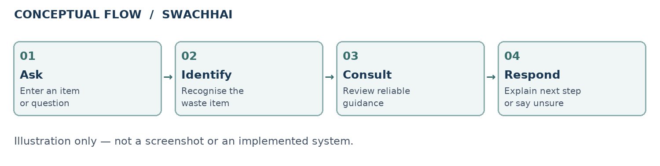
Figure 1: Conceptual SwachhAI workflow (author’s illustration)
7.2 Main components
• Input: a short description, such as “old battery” or “food scraps”.
• Interpretation: identify the item and any important clues, such as whether it is damaged.
• Information: locate relevant guidance in reliable, current documents.
• Response: present a clear next step, a source and any safety or local-rule caveat.
The original project document discusses additional ideas such as impact forecasting [2]. Those ideas are outside the scope of this simple conceptual report; no forecasting system or measured benefit is claimed here.

7. DETAILED DESCRIPTION OF THE PROJECT (CONTINUED)
7.3 How the proposed workflow would work
Step 1 — Receive a question. The user describes an item in ordinary language. The system should ask for clarification if the material or condition is unclear.
Step 2 — Interpret the request. A language model or a simple rule-based classifier could identify the item. The category is a hypothesis, not a guaranteed decision.
Step 3 — Retrieve information. A RAG component could search a curated collection of current public guidance, including official rules and local instructions where available.
Step 4 — Prepare a response. The answer would combine the relevant guidance with a plain-language explanation and a reference. It should clearly say when information is missing or uncertain.
Step 5 — Apply human judgement. The user checks local collection arrangements. Unclear, damaged or potentially dangerous items should be handled according to official safety instructions.
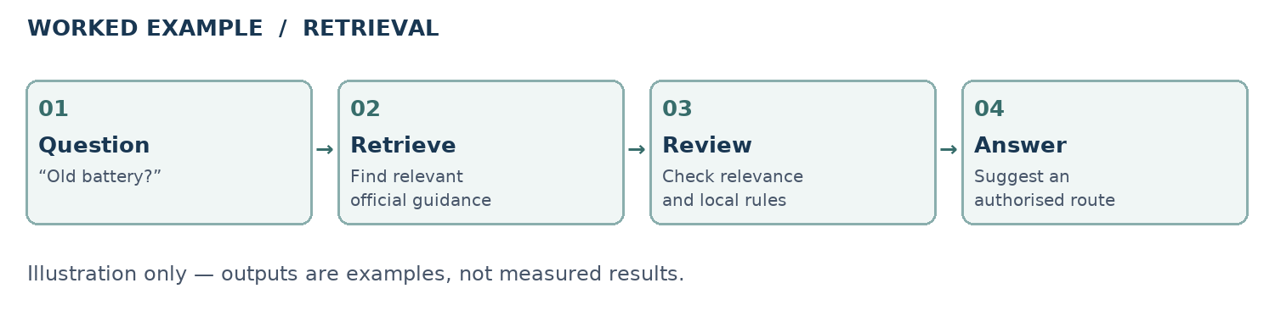
Figure 2: Illustrative retrieval sequence for a battery question
Figures 1 and 2 are conceptual illustrations, not screenshots of a working application. They are included to make the process easy to follow.

7. DETAILED DESCRIPTION OF THE PROJECT (CONTINUED)
7.4 Worked example: an old household battery
Suppose a student asks, “Where should I dispose of an old battery?” A conceptual assistant could identify the item as a battery, search official battery-waste guidance and check for local collection information. An example response might be:
“Keep the battery separate from ordinary household waste and check with your local authority, retailer or an authorised collection channel for the appropriate return option. Follow local safety guidance, especially if the battery is damaged.”
This is an illustrative response, not a generated result or a substitute for current official advice. The Battery Waste Management Rules, 2022 are a relevant starting point [7]; local collection arrangements should also be verified.
7.5 Try the reasoning
User question | What the concept should consider
“Can food scraps be composted?” | Check local composting guidance and what the facility accepts.
“Where does a broken bulb go?” | Consider breakage and possible hazardous contents; seek local guidance.
“Is this packet recyclable?” | Identify the material and check local collection acceptance.
Table 2: Example questions and checks
For each question, the key interaction is not just providing a category: it is helping the user understand what to verify before acting.

7. DETAILED DESCRIPTION OF THE PROJECT (CONTINUED)
7.6 Limitations and safeguards
Risk or limitation | Suggested safeguard
Incorrect identification | Ask a follow-up question instead of guessing.
Outdated or irrelevant source | Review documents regularly and cite the relevant source.
Different local rules | Refer users to the local authority and authorised collectors.
Hazardous or damaged items | Prioritise safety and defer to official guidance.
Unnecessary personal information | Collect the minimum information needed.
Table 3: Risks and suggested safeguards
7.7 What could be evaluated in future
If a system is developed later, its answers could be reviewed against a set of common questions and official sources. Reviewers could check whether citations are relevant, whether the response admits uncertainty, and whether people find the wording understandable. Any environmental or safety impact would require a separate, carefully designed field study.
7.8 What this report does not claim
No application is presented for operation or testing. No accuracy, adoption, emissions reduction or other outcome has been measured for this report. The examples demonstrate the intended reasoning only.

8. CONCLUSION
The internship introduced the connection between AI and sustainability, including responsible AI, agentic approaches and retrieval-augmented generation. The SwachhAI case study shows how these concepts could be organised around a practical question: how to give people clearer waste-disposal guidance.
The proposed flow emphasises simple language, relevant information, uncertainty and human oversight. It also recognises that waste collection differs by locality and that an AI-generated answer must not replace official guidance.
The central learning is that a useful AI solution is not only about generating an answer. It also requires reliable sources, careful scope, responsible handling of uncertainty and consideration of the people affected by the advice.
Key takeaway: Identify the item → consult reliable guidance → explain the next step → verify local rules.

9. REFERENCES
[1] 1M1B. Certificate of Completion, “AI for Sustainability Virtual Internship,” issued 22 September 2026. Supplied by the student; reproduced in the preliminary pages.
[2] Mohammad Ramish Ansari. “SwachhAI — AI for Sustainable Waste Management,” internship project document, supplied by the student. Used as the basis for the conceptual case study.
[3] IBM. “What is retrieval-augmented generation (RAG)?” https://www.ibm.com/think/topics/retrieval-augmented-generation
[4] IBM SkillsBuild. Learning platform. https://skillsbuild.org/
[5] IBM. Granite models. https://www.ibm.com/granite
[6] United Nations. Sustainable Development Goals, Goals 11, 12 and 13. https://sdgs.un.org/goals
[7] Ministry of Environment, Forest and Climate Change, Government of India. Battery Waste Management Rules, 2022. Official rules and updates: https://moef.gov.in/
[8] Ministry of Environment, Forest and Climate Change, Government of India. Solid Waste Management Rules, 2016. Official rules and updates: https://moef.gov.in/
For practical disposal decisions, consult the latest applicable rules and the relevant local authority. Web addresses are provided as starting points; availability and current requirements should be checked before use.

