INDUSTRIAL TRAINING REPORT
on
“Print Hello World in Python”
by
Mayank Kumar [ROLL NUMBER TO FILL]
Submitted in partial fulfillment of the requirements for the award of the degree
of
BACHELOR OF TECHNOLOGY
in
COMPUTER SCIENCE & ENGINEERING
from
EWB EDUTECH PRIVATE LIMITED (EWB Courses)

Submitted to
DEPARTMENT OF COMPUTER SCIENCE AND ENGINEERING
FACULTY OF ENGINEERING & TECHNOLOGY
UNIVERSITY OF LUCKNOW, LUCKNOW
November 2026

DECLARATION
I, Mayank Kumar, declare that this report titled “Print Hello World in Python” is a theory-based academic case study for the B.Tech CSE summer training submission. The syntax examples, manually derived counts, diagrams and predicted behaviours explain a beginner concept; no software product, deployment, executed test or empirical result is claimed.
The attached student-supplied certificate documents completion of a one-month Python Programming internship. It does not identify Hello World as an assigned internship project. This topic is a separate academic learning study and should be described as actual internship work only if independently supported.
All illustrative statements and character counts are based on public Python concepts or manually checkable reasoning. No restricted organisation information is included. The supplied documents and general reference sources are listed at the end of this report.
Signature: ________________________
Name: Mayank Kumar
Roll No.: [TO FILL]
Section: [TO FILL]
Date: [TO FILL]

TRAINING / INTERNSHIP CERTIFICATE
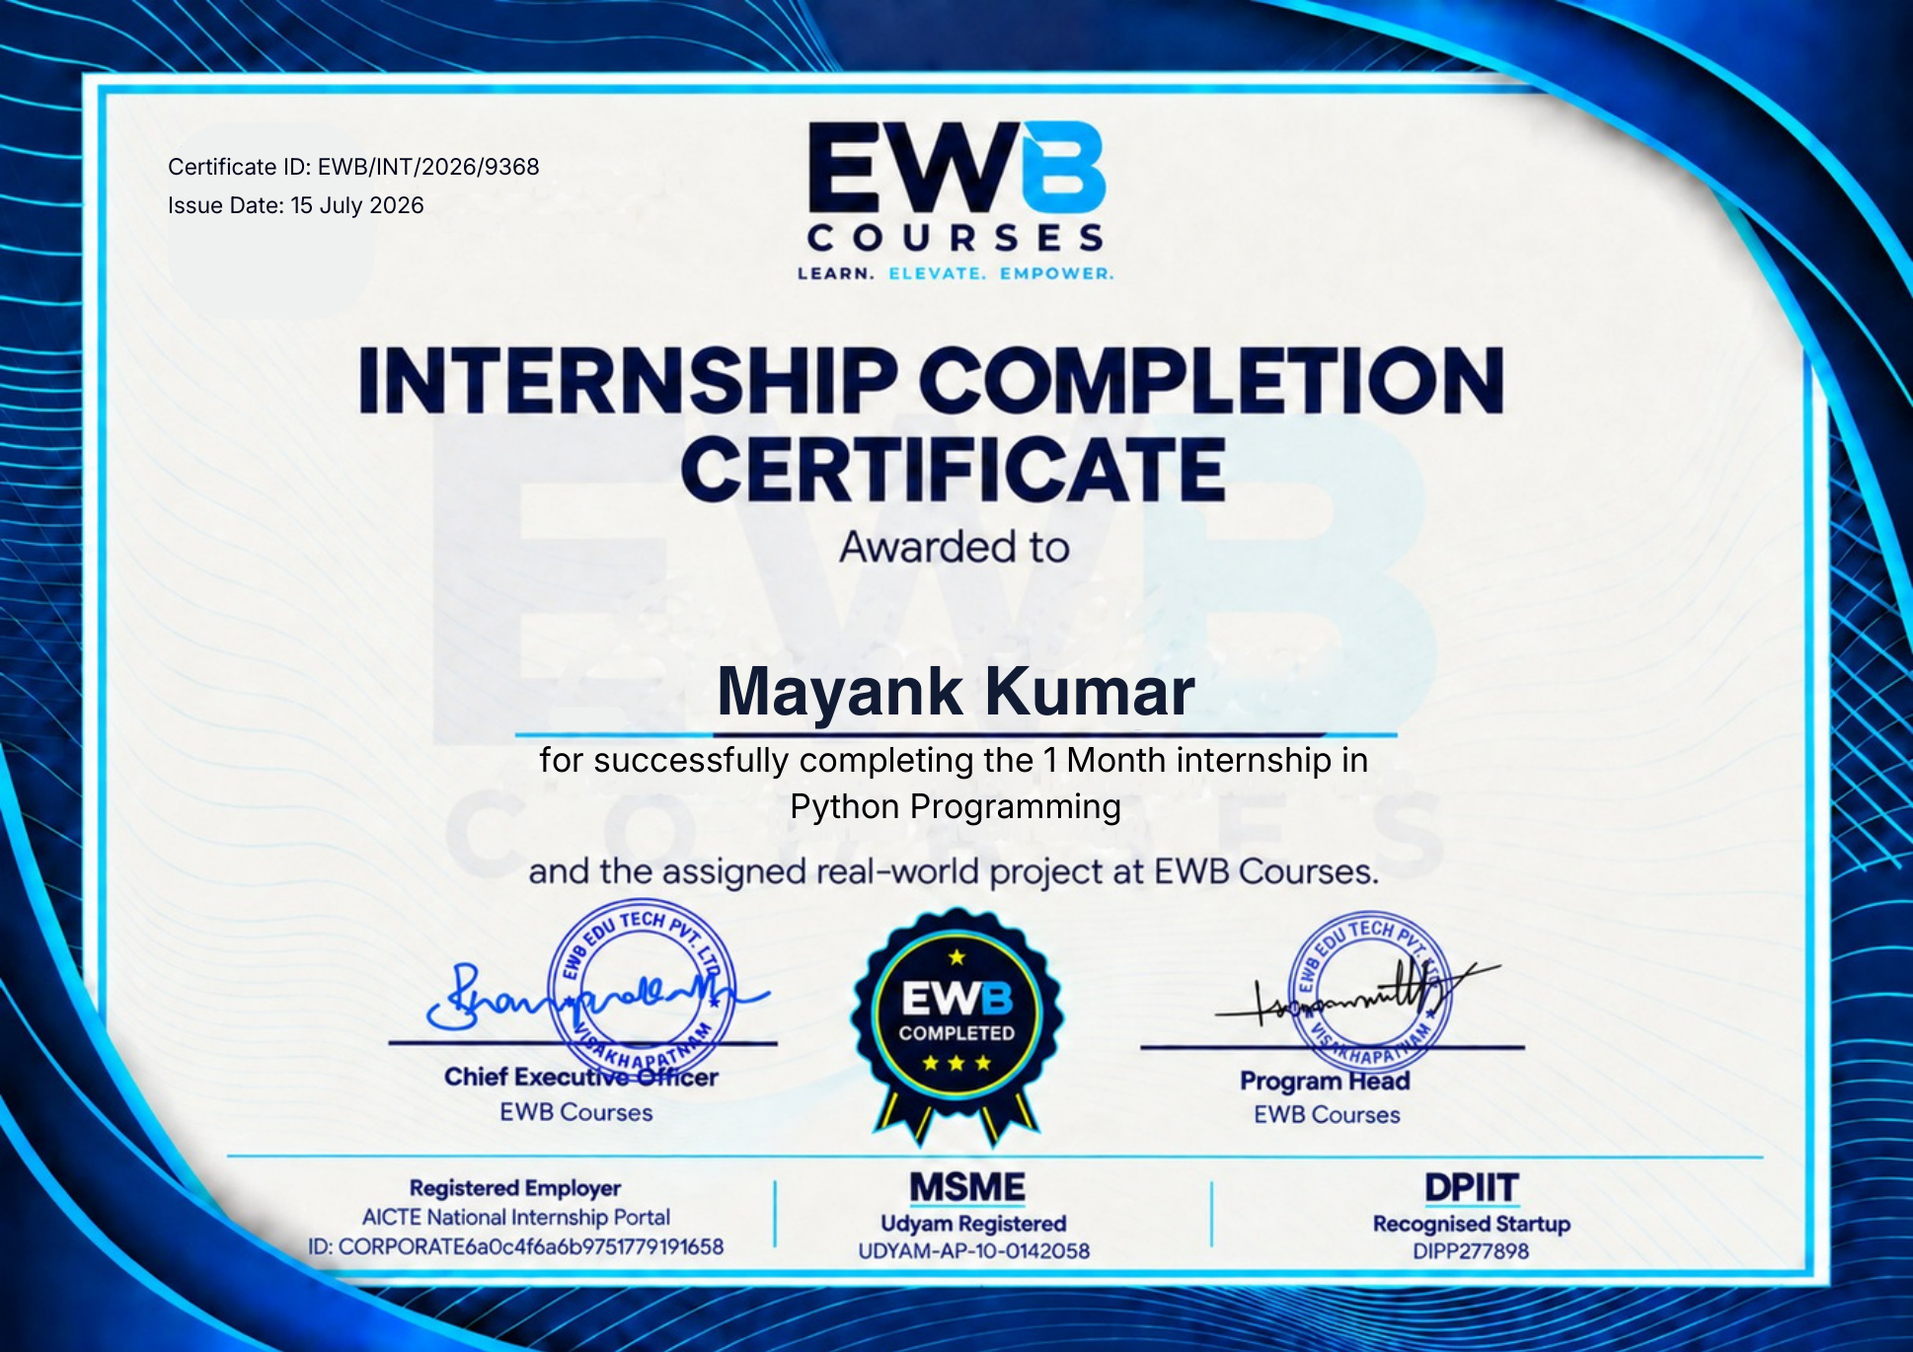
Colour reproduction of the student-provided original certificate. Issued 15 July 2026; it states a one-month Python Programming internship.

ABSTRACT
This report presents a theory-only study of the introductory Python 3 example print("Hello, World!"). The small example is used to explain source text, function calls, arguments, string literals, standard output and the normal line ending. It is not a claim that a working model or company deliverable was produced.
The report breaks the greeting into manually counted character categories and discusses exact-output comparison, variants, common syntax mistakes, conceptual execution flow and a proposed verification plan. A bar chart represents ten letters, two punctuation marks and one space in the thirteen-character visible greeting. It is a manually derived illustration, not an experiment or performance result.
The supplied certificate confirms a one-month Python Programming internship for Mayank Kumar but does not identify this topic as the assigned internship project. Accordingly, this report is a separate academic application of beginner Python concepts.
Keywords: Python 3, Hello World, print, string literal, standard output, conceptual study.

ACKNOWLEDGEMENT
I thank the Department of Computer Science and Engineering, Faculty of Engineering & Technology, University of Lucknow, for the prescribed report format and the opportunity to develop a careful account of a basic Python concept.
I acknowledge EWB EDUTECH PRIVATE LIMITED / EWB Courses for the Python Programming internship documented by the attached completion certificate. This particular Hello World study is presented as a separate academic explanation, not as a verified company-assigned project.
I thank the faculty reviewing this report for any guidance on its clarity and presentation. The explanatory interpretations and any errors remain my responsibility.
Before submitting, the student should amend this acknowledgement to reflect the support actually received.

TABLE OF CONTENTS
Declaration .......... i
Training / Internship Certificate .......... ii
Abstract .......... iii
Acknowledgement .......... iv
Table of Contents .......... v
List of Tables .......... vi
List of Figures .......... vii
1. Introduction to the Study .......... 1
2. Why a First Output Example Matters .......... 2
3. Training Evidence and Attribution .......... 3
4. Objectives .......... 4
5. Scope and Exclusions .......... 5
6. Overview of the Training Organisation .......... 6
7. Technology Overview: Python 3 .......... 7
8. A First View of the Statement .......... 8
9. What a Program Instruction Is .......... 9
10. Function Calls and Arguments .......... 10
11. String Literals .......... 11
12. Capitalisation and Punctuation .......... 12
13. What the Quotes Do Not Print .......... 13
14. Standard Output .......... 14
15. The Default Newline .......... 15
16. Character Composition .......... 16
17. A Conceptual Output Pipeline .......... 17
18. Preparing a Python Environment .......... 18
19. Interactive Mode Versus a File .......... 19
20. Reading Error Messages .......... 20
21. Unmatched Quote Marks .......... 21
22. Unmatched Parentheses .......... 22
23. Spelling the Function Name .......... 23
24. Spaces and Exact Output .......... 24
25. Single and Multiple Arguments .......... 25
26. The sep Argument .......... 26
27. The end Argument .......... 27
28. Newline Escape Sequence .......... 28
29. Variables as a Later Variation .......... 29
30. Unicode and the Greeting .......... 30
31. Case Sensitivity and String Values .......... 31
32. Distinguishing Output from Return Value .......... 32
33. Manual Trace of the Basic Example .......... 33
34. Expected Output and Its Limits .......... 34
35. Character-Category Chart .......... 35
36. Alternative Greeting Variants .......... 36
37. Proposed Verification Checklist .......... 37
38. Planned Test Cases .......... 38
39. Error Diagnosis Decision Path .......... 39
40. Common Misinterpretations .......... 40
41. Practical Application as a Learning Example .......... 41
42. Limits of the Study .......... 42
43. Future Learning Path .......... 43
44. Conclusion .......... 44
References .......... 45
Appendix A: Glossary .......... 46
Appendix B: Submission Checklist .......... 47

LIST OF TABLES
Table 1. Source evidence and its limitations. .......... 3
Table 2. Scope boundary for a theory-only report. .......... 5
Table 3. Basic terminology used throughout the report. .......... 7
Table 4. Parts of the illustrative Python statement. .......... 8
Table 5. Common call forms, not executed results. .......... 10
Table 6. Illustrative string values and their visible text. .......... 11
Table 7. Source syntax versus displayed data. .......... 13
Table 8. Visible text versus line ending. .......... 15
Table 9. Manually counted characters in the greeting. .......... 16
Table 10. Environment checks for a future practical exercise. .......... 18
Table 11. Ways to encounter the same output idea. .......... 19
Table 12. Beginner mistake categories without fabricated tracebacks. .......... 20
Table 13. Function spelling examples. .......... 23
Table 14. Character-by-character comparison examples. .......... 24
Table 15. Two conceptual ways to form the same visible line. .......... 25
Table 16. Manually predicted separator effects. .......... 26
Table 17. Two different sources of line breaks. .......... 28
Table 18. Text representation concepts for beginners. .......... 30
Table 19. Effects of case and content changes. .......... 31
Table 20. Three different ways information can be presented. .......... 32
Table 21. Evidence levels for program output claims. .......... 34
Table 22. Manual comparison of illustrative greeting variants. .......... 36
Table 23. Planned verification cases, not executed tests. .......... 38
Table 24. Common misunderstandings and corrections. .......... 40

LIST OF FIGURES
Figure 1. What the reader can trace (conceptual or manually derived). .......... 1
Figure 2. Conceptual journey of a first output example. .......... 2
Figure 3. What the documents establish (conceptual or manually derived). .......... 3
Figure 4. From objective to proposed check (conceptual or manually derived). .......... 4
Figure 5. Scope of organisational claims (conceptual or manually derived). .......... 6
Figure 6. Source notation versus text value (conceptual or manually derived). .......... 8
Figure 7. Conceptual separation between source and result. .......... 9
Figure 8. One argument, one display path (conceptual or manually derived). .......... 10
Figure 9. Validity is not the same as exactness (conceptual or manually derived). .......... 12
Figure 10. Delimiters compared with data (conceptual or manually derived). .......... 13
Figure 11. Default output destination in a simplified environment. .......... 14
Figure 12. Default output route (conceptual or manually derived). .......... 14
Figure 13. Letter occurrences in Hello, World! (conceptual or manually derived). .......... 16
Figure 14. Teaching model of the greeting output path. .......... 17
Figure 15. Preparation before a later run (conceptual or manually derived). .......... 18
Figure 16. Diagnosis order (conceptual or manually derived). .......... 20
Figure 17. Quote-pair comparison (conceptual or manually derived). .......... 21
Figure 18. Manual inspection order for a simple call. .......... 22
Figure 19. Two distinct mistakes (conceptual or manually derived). .......... 22
Figure 20. Inside versus outside the string (conceptual or manually derived). .......... 24
Figure 21. Where the joining space comes from (conceptual or manually derived). .......... 25
Figure 22. Position of the default line ending. .......... 27
Figure 23. Where does a line break originate? (conceptual or manually derived). .......... 27
Figure 24. Conceptual variable-based variation. .......... 29
Figure 25. Literal versus variable (conceptual or manually derived). .......... 29
Figure 26. Manually counted character classes (conceptual or manually derived). .......... 31
Figure 27. Reasoned trace, not an execution log. .......... 33
Figure 28. Prediction and observation are different (conceptual or manually derived). .......... 33
Figure 29. Manually derived character composition of “Hello, World!”. .......... 35
Figure 30. Visible length of greeting variants (conceptual or manually derived). .......... 36
Figure 31. Beginner-focused diagnosis questions. .......... 39
Figure 32. Planned fault isolation (conceptual or manually derived). .......... 39
Figure 33. Proposed learning cycle; not an executed activity. .......... 41
Figure 34. Proposed learning cycle (conceptual or manually derived). .......... 41
Figure 35. What this report can and cannot show (conceptual or manually derived). .......... 42
Figure 36. Possible future sequence beyond the present scope. .......... 43
Figure 37. Summary of core distinctions (conceptual or manually derived). .......... 44

1. Introduction to the Study
A program can be understood by following the path from a written instruction to the effect a user observes. The familiar introductory instruction to display “Hello, World!” offers a small but complete example of this path. It contains a function call, a text value, a standard output destination and a visible line of text.
This report is a theory-based academic study of printing a greeting in Python 3. It does not describe a built software product, deployed application or completed test run. Instead, the simple example becomes a lens for studying syntax, data representation, execution, output, verification and typical beginner mistakes.
The supplied certificate documents a one-month Python Programming internship. It does not identify this particular topic as an assigned internship project. The topic is therefore a separate learning case study, not an assertion about work delivered to the training organisation.
The greeting has a deliberately narrow input and output contract. Its input is a fixed text value chosen by the author; its output is the same visible text followed by the normal line ending. There is no user-supplied name, file path, database state or network connection to consider. Keeping the contract small lets a reader trace every stage without hiding a dependency behind the word 'simple'.
A useful reading exercise is to underline the characters in the source that define structure and circle those that belong to the message. The structure consists of the function name, brackets and quotation delimiters; the message consists of the thirteen characters of the greeting. This distinction guides the later diagrams and prevents source notation from being mistaken for output.
• Core example: print("Hello, World!") in Python 3.
• Method: explanation, manual calculations, tables and conceptual diagrams.
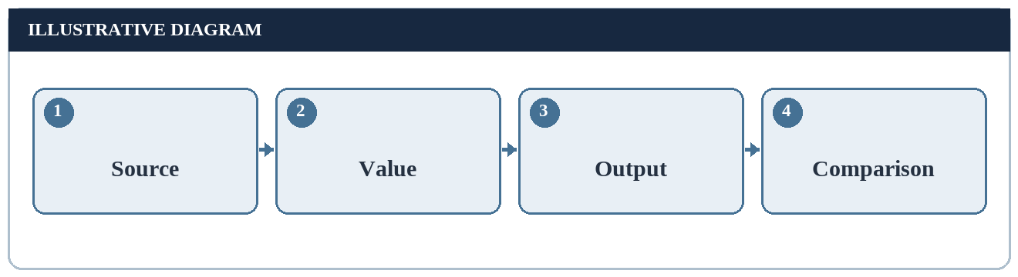
Figure 1. What the reader can trace (conceptual or manually derived).

2. Why a First Output Example Matters
A first output example gives a new programmer fast feedback that instructions have a predictable effect. The result is short enough to compare visually with the intended message. That simplicity is valuable because the learner can isolate the ideas of source text, interpreter, function, argument and output without first learning storage or networking.
The example is educational rather than operational. It does not solve a library or company workflow and makes no claim of economic impact. Its main value is establishing vocabulary that supports more advanced exercises later.
A complete explanation should also clarify what the example does not show: a printed message does not prove that data was stored, that a user interface was built or that a program was tested under many conditions.
For a first exercise, success is not defined by visual excitement but by an exact, predictable relationship between instruction and result. If the learner can explain why punctuation appears, why the source quotes do not appear and why the next prompt begins on another line, the example has done more than demonstrate typing skill. It has introduced a small specification that can be checked.
Conversely, a displayed greeting cannot tell us whether a source file was saved in the right place, whether other instructions are correct or whether a larger program is reliable. An educator should assess understanding through explanation and comparison of variants, not by assuming that one printed sentence proves competence in unrelated topics.
Worked learning check: imagine a reader is shown both the source-like expression and the predicted text. Ask which characters in the source do not appear in the latter. A defensible answer identifies the function name, parentheses and delimiter quotes, then explains their structural roles. A second question asks why there is still a comma and exclamation mark: both are inside the literal and therefore part of its value. This short oral check reveals whether the learner understands the instruction rather than merely recognising a familiar phrase. It is an assessment suggestion, not a record of a classroom exercise.
Source text → Interpreter → Output operation → Visible line
Figure 2. Conceptual journey of a first output example.

3. Training Evidence and Attribution
The student-supplied offer letter identifies EWB EDUTECH PRIVATE LIMITED, a virtual Python Programming Intern role and a one-month duration. It says the commencement date was “to be announced.” The student-supplied completion certificate for Mayank Kumar confirms a one-month Python Programming internship and is dated 15 July 2026.
The certificate refers to an assigned real-world project but does not say its topic was Hello World. The present report is accordingly labelled as a separate conceptual case study. It must not be represented as the provider’s assigned project without independent supporting evidence.
No confidential training materials, private company records or actual assessment results are included. The explanatory examples are general Python concepts and manually derived properties of a greeting string.
Evidence has different strengths. A certificate supports the statement that the named internship was completed. It does not identify every exercise performed during that internship. A report may use public Python documentation to explain general language behaviour, but it must not convert that explanation into a statement that an employer assigned or assessed this exact example.
The two student-provided documents also leave the exact internship start date unspecified. The offer's date is a document-issue date, not a verified commencement date. Accordingly, this study leaves the training dates as documented and asks the student to obtain confirmation if the department needs a four-to-six-week date range.
Document | Evidence supported
Offer letter | Role, organisation, virtual mode and one-month duration
Completion certificate | Name, Python Programming completion and issue date
This report | Independent conceptual study of a basic output example
Table 1. Source evidence and its limitations.
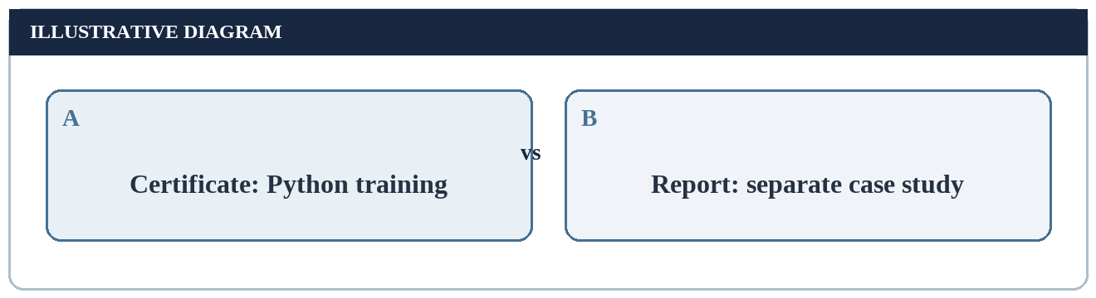
Figure 3. What the documents establish (conceptual or manually derived).

4. Objectives
The primary objective is to explain precisely how a Python 3 statement can send a short text message to standard output. The report deliberately starts from a minimal expression and develops the surrounding concepts rather than constructing a larger application.
A second objective is to identify what a learner must check when the expected line does not appear. This includes the file used, the interpreter invocation, the spelling of the function name, quote pairing, brackets, output destination and newline behaviour.
A third objective is to distinguish illustrative expected output from observed execution. The worked examples in this report are reasoned from Python documentation; they are not screenshots or logs of a running program.
The objectives can be made assessable by attaching a question to each one. For syntax, can the reader name every role in the illustrative call? For output, can the reader write the expected thirteen-character text? For diagnosis, can the reader separate a missing-file problem from an unmatched quote? For evidence, can the reader say which statements are predictions rather than observations?
These questions define the standard by which the study should be judged. They do not require a working prototype. A later practical exercise would add an observed transcript and would verify whether the predicted line matches a real run. Until then the present report stays at the level of reasoning and planning.
• Identify function, argument and string literal.
• Explain execution and output in a beginner-friendly way.
• Compare common display variants without inflating the task.
• Provide a proposed verification checklist for future practice.
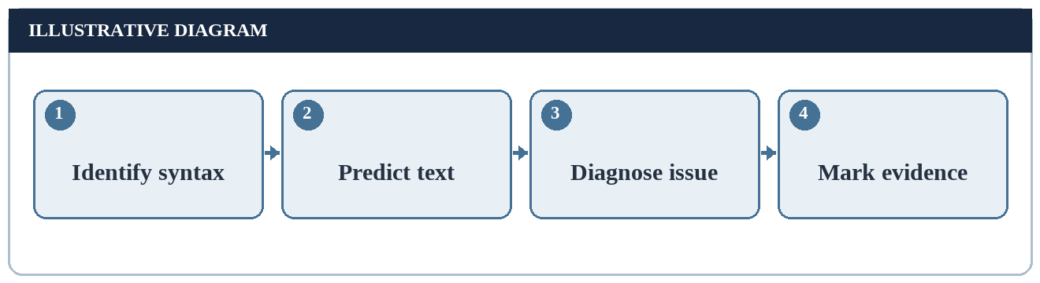
Figure 4. From objective to proposed check (conceptual or manually derived).

5. Scope and Exclusions
Within scope are Python 3 syntax for a print call, the “Hello, World!” string, the normal newline, basic standard output, common syntax mistakes and simple expected-output comparisons. Conceptual flowcharts and a character-count chart support the explanation.
Outside scope are a graphical application, chatbot, database, network service, industrial deployment, performance benchmark and any executed test report. This boundary matters because a one-line example should not be disguised as a complex software build to meet a page target.
The report uses several perspectives on the same example—language syntax, representation, environment and verification—without claiming each perspective is a separate implemented feature.
A boundary statement is useful because broad words such as 'project' can imply more work than the source warrants. In this report, project means a structured explanatory study, not a deliverable application. The scope includes language rules that directly affect the greeting and excludes claims about performance or business value that cannot be inferred from one output call.
Even within this boundary there are useful distinctions: a print call is not a return statement, a visible line is not a saved file and a string's character count is not an execution benchmark. These distinctions are treated as legitimate learning outcomes rather than as separate applications built during training.
Inside this study | Outside this study
Python 3 print syntax | Web or mobile interface
Short text and newline | Database or file persistence
Standard output concept | Measured runtime performance
Planned checks | Executed test evidence
Table 2. Scope boundary for a theory-only report.

6. Overview of the Training Organisation
The offer letter supplied with the report names EWB EDUTECH PRIVATE LIMITED as the training organisation, while the supplied completion certificate displays EWB Courses branding. These names are used here only as they appear in those student-provided documents.
The offer letter describes virtual participation and general expectations such as attending sessions and completing assigned activities. It does not document a Hello World deliverable or specify the content of individual sessions.
The report avoids inferring an internal teaching plan or company process. Its technical content is a general application of Python Programming concepts that can be discussed without exposing restricted information.
The overview of the organisation is deliberately source-limited. A public-facing brand in a certificate and a legal name in an offer may both appear in one training record; this report merely records those names as printed. It does not infer the organisation's internal technology stack, teaching schedule, employee roles or confidential datasets.
A suitable internship report should be specific about what evidence actually says and cautious about what it does not. That principle matters especially for a basic topic: there is no need to invent an employer problem statement or pretend that an introductory output example changed an organisational workflow.
Source: student-provided offer letter and completion certificate.
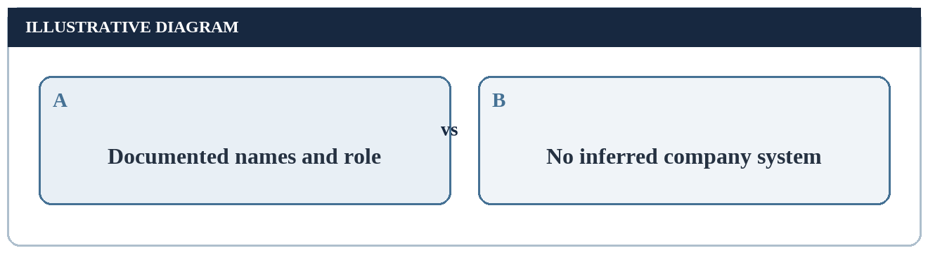
Figure 5. Scope of organisational claims (conceptual or manually derived).

7. Technology Overview: Python 3
Python 3 is a general-purpose programming language with a readable syntax. A beginner can express a basic output request as a function call with a string literal. Python 3 is specified here because Python 2 treated the print statement differently and is not an appropriate default for a new report.
The language processor reads source instructions and carries out their meaning. A one-line example does not require an external Python package; the built-in print function is available in a standard Python environment.
Although the report uses the term interpreter as a beginner-friendly model, implementation details may vary between Python implementations. The learning goal is to understand the observable relationship between the source instruction and output, not to claim a specific internal machine trace.
Python's built-in print function is part of the normal language environment and accepts values to display. It is different from the English instruction 'print on paper'. In programming discussion, print normally means write formatted text to a stream; a physical printer is not required. This terminological distinction helps beginners interpret the example without expecting a document to emerge from a printer.
Python 3 is the assumed language family throughout. Older descriptions sometimes show print without parentheses; copying that form into a Python 3 lesson may cause confusion. Naming the assumed version next to the example keeps the discussion internally consistent, while avoiding an unsupported assertion about which interpreter was used during the internship.
Term | Simple meaning
Python 3 | Language version assumed in this study
Built-in | Available without importing an added package
Function | Callable operation that accepts arguments
Interpreter | Environment that processes Python source
Table 3. Basic terminology used throughout the report.

8. A First View of the Statement
The conceptual example is print("Hello, World!"). It asks Python to send the text inside the quotes to its default output destination. The exact capitalisation and punctuation of the text are intentional: the H and W are uppercase, a comma follows “Hello,” and an exclamation mark ends the greeting.
The letters p-r-i-n-t name a Python built-in function. The round brackets enclose the argument supplied to it. The double quotes delimit a string literal; the quote marks themselves are not part of the displayed greeting.
The example is shown as syntax for study, not as evidence that a file was written or executed during this report. The expected text is derived from the language rules explained below.
Read the source left to right. The identifier print chooses an operation. The opening parenthesis starts the call's argument list. The opening quote begins a string literal, and the closing quote ends it. Finally the closing parenthesis finishes the call. The thirteen internal characters form the argument's text value.
This order is also a manual correction technique. If an intended greeting is absent, check the paired delimiters before changing the message. If the program is valid but the visible line differs, inspect the characters inside the quotes instead. Separating structural checks from content checks makes the diagnosis shorter and more precise.
Component | Role
print | Name of built-in output function
( and ) | Delimit the argument list
"Hello, World!" | String literal supplied as argument
Table 4. Parts of the illustrative Python statement.
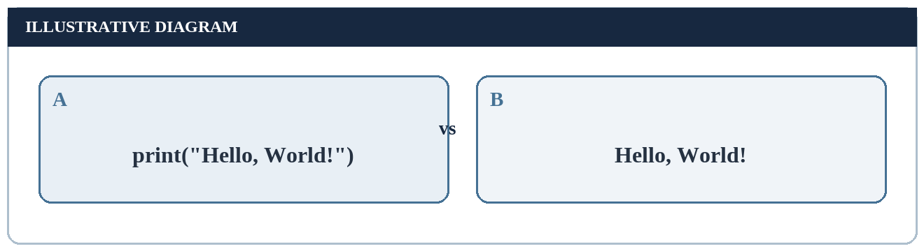
Figure 6. Source notation versus text value (conceptual or manually derived).

9. What a Program Instruction Is
Source code is a written description of operations to be performed under a language’s rules. A Python source file normally contains text, and the interpreter processes its statements in order. A single print call is enough to describe an output action.
A source statement should not be confused with the result shown on a terminal. The source contains punctuation that defines the instruction: function name, parentheses and quote marks. The output contains the text value, normally followed by a line ending.
Separating instruction from result helps beginners diagnose mistakes. If the source itself appears in a document, it should be labelled “illustrative statement”; the expected screen line should be labelled “expected text,” not “captured output.”
The same physical line can contain both human-readable words and characters with a formal syntactic role. The Python processor does not guess a programmer's intentions from the phrase 'Hello, World!'; it follows a grammar that recognises a call and a literal. A document that teaches the example should preserve both levels of meaning.
A beginner may copy a line from a formatted document containing curly quotation marks rather than ordinary Python quote delimiters. In this report, decorative quotation marks in prose are typography; the source-like expression uses straight quotation marks. This is one reason to review the actual source text carefully in a future practical exercise.
A useful three-column annotation would label each source portion as notation, value or output convention. The literal contains the value; print and parentheses supply the operation; the default ending is a convention of the function call. These categories must not be collapsed. For example, adding a comma inside the literal changes the value, while adding another argument changes the call structure. Neither change is equivalent to changing the working directory from which a script is launched. Each belongs to a different stage of explanation.
Written instruction → Meaning of string → Output request → Expected text
Figure 7. Conceptual separation between source and result.

10. Function Calls and Arguments
A function call uses a name followed by parentheses. The values placed inside the parentheses are arguments. In the minimal example the argument is one string containing the complete greeting. Python passes that value to the print function.
A call with an empty argument list is a different case: print() normally produces a blank line. A call with several arguments can insert a separator between their displayed forms. These variants are useful for understanding the function, but the report’s principal case uses just one argument.
This distinction matters when manually predicting output. A single string with a space already inside it does not depend on the separator between multiple arguments.
Functions can accept zero, one or several arguments depending on their definition. For print, zero positional values still allow an output operation that ends a line; one string displays its text; several values introduce the separator rule. These three cases show why the argument list matters even when the function name stays unchanged.
For this report, the single-string form is the reference. It puts the comma and space inside one value and removes the need to reason about inter-argument spacing. The multiple-argument variant is discussed to show a contrast, not because it is required for the simplest output task.
Conceptual form | Expected effect
print("Hello, World!") | Greeting and normal line ending
print() | Blank line
print("Hello", "World!") | Two arguments separated by default space
Table 5. Common call forms, not executed results.
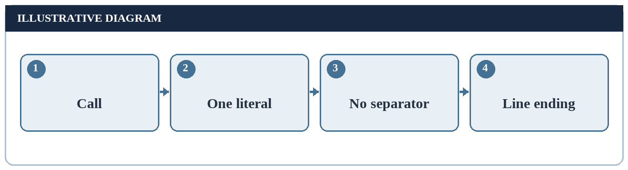
Figure 8. One argument, one display path (conceptual or manually derived).

11. String Literals
A string represents text as a sequence of characters. Surrounding the greeting with matching single or double quote marks tells Python that the words are text rather than names of variables. In the simple example, the quote marks delimit a value but are not printed.
Python permits both matching single and matching double quotes for a short string. If a learner starts with one kind and ends with the other without a valid escape strategy, the source is not a valid string literal.
A beginner should first write the exact text to display, then enclose it with matching quotes, and finally pass it to print. This ordering makes it easier to check punctuation and spacing.
A literal is a way to write a value directly in source. The choice of surrounding single or double quotes need not change the value, provided each form is written correctly. But an apostrophe inside a single-quoted literal, or an unmatched delimiter of either kind, introduces a different parsing question that the basic greeting avoids.
Text inside the literal should be treated as data, not as a Python command. If the word World is misspelled, Python will not repair it; a valid source line can still display the wrong greeting. Correct syntax and correct intended content are two independent checks.
A minimal counterexample illustrates why matching delimiters matter. A phrase beginning with a double quote and ending with a single quote is not the same literal form as one bounded by two double quotes. The source cannot be interpreted as the intended simple string without additional syntax. By contrast, using two single quotes around the full greeting represents the same text value. This comparison isolates the property being tested: the outer marks establish the boundary; the internal characters establish the message. It is a paper exercise, not a copied traceback.
Literal form | Value represented
"Hello, World!" | Hello, World!
'Hello, World!' | Hello, World!
"Hello World" | Hello World (different punctuation)
Table 6. Illustrative string values and their visible text.

12. Capitalisation and Punctuation
The message “Hello, World!” contains uppercase H and W, a comma immediately after “Hello,” one separating space and a final exclamation mark. These details affect an exact-output comparison even though a person may understand a differently punctuated greeting.
Python preserves the characters in the string unless the program explicitly transforms them. The language does not automatically capitalise “world” or insert missing punctuation in an arbitrary literal.
When preparing an expected-output check, the chosen reference spelling should be written down once. The check then compares the actual text with that reference, rather than with a vague description such as “shows a greeting.”
The punctuation in the reference greeting is part of the value. Removing the comma shortens the visible text by one character, while replacing the exclamation mark changes one character without changing the length. Thus checking length alone is insufficient to confirm exact output.
A careful specification may compare both length and content. For instance, two candidate strings can each contain thirteen characters yet disagree at one position. This is why an exact-output exercise should name the expected sequence rather than merely say 'print a sentence'.
• Reference text: Hello, World!
• Uppercase letters: H and W.
• Punctuation: comma and exclamation mark.
• One ordinary space separates the two words.
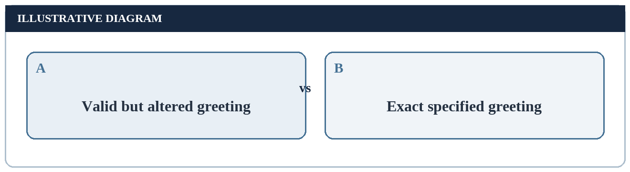
Figure 9. Validity is not the same as exactness (conceptual or manually derived).

13. What the Quotes Do Not Print
In print("Hello, World!"), the surrounding double quotes are part of source syntax. They are not characters in the string value. Thus the expected display does not begin or end with a double-quote character.
If quotation marks are intended to appear in output, they must instead become part of the string value through an appropriate literal form or escaping. That is a different task from the basic greeting. The distinction between delimiters and data applies to many programming languages.
The same principle explains why the parentheses are not displayed. Parentheses organise the function call in source; the text value is the material passed to the output operation.
Consider a pair of quotation marks around a phrase in an essay. Those marks may be displayed because they are part of the essay's text. In the source example, by contrast, the outer marks are a notation for constructing a string and are consumed as delimiters. A reader must first determine whether marks are syntax or data.
The reasoning is not restricted to quotation marks. Parentheses and the function identifier likewise belong to the instruction, not to the greeting value. A diagram showing the two layers makes it harder to mistake a source line for the text that would appear on standard output.
Element in source | Displayed in basic greeting?
Function name print | No
Parentheses | No
Delimiting quote marks | No
Characters inside quote marks | Yes
Table 7. Source syntax versus displayed data.
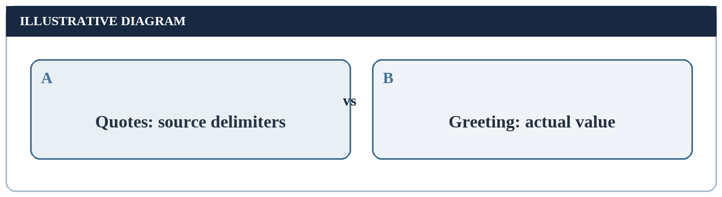
Figure 10. Delimiters compared with data (conceptual or manually derived).

14. Standard Output
By default, print writes to standard output, often abbreviated stdout. A terminal usually shows that stream, but other environments may capture or redirect it. It is therefore more precise to say “writes to standard output” than to promise a particular application window.
Standard output is a channel, not a storage guarantee. Seeing a line on screen does not mean that a permanent file was created. An editor or notebook may display captured output in a pane while the same underlying idea remains: a textual output request has been made.
This report does not redirect the greeting to a file or show a live terminal capture. The distinction is explained so the reader can identify what a later practical exercise would observe.
A standard stream is a conventional channel through which a process communicates with its environment. Standard output can be shown in a terminal, captured by an integrated development environment or redirected by another process. The simple example is about this channel rather than about one particular window style.
If a later learner sees no line in the expected pane, the cause might be a hidden or redirected output stream rather than a faulty string literal. That possibility should be investigated only after confirming that the correct source was run. This report itself has no observed stream capture to diagnose.
print call → Standard output stream → Terminal or capturing environment
Figure 11. Default output destination in a simplified environment.
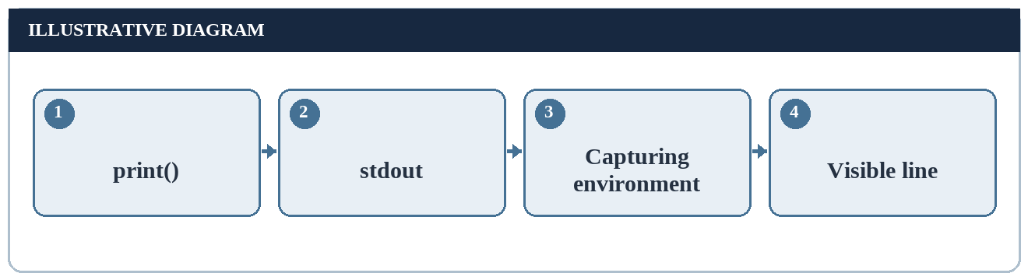
Figure 12. Default output route (conceptual or manually derived).

15. The Default Newline
A normal print call adds a line ending after its arguments. Consequently, the conceptual output occupies one displayed line and the next output would usually begin on a following line. The line-ending characters are not always visible as a glyph on screen.
The output text “Hello, World!” has thirteen visible characters. The normal line ending is additional to those visible characters. On different systems, its low-level byte representation may differ; that variation does not change the visual greeting.
The optional end argument can change this behaviour, but the basic example uses the default. This makes it useful for teaching the distinction between visible text and control characters.
The normal end of a print call is often described as a newline. On a displayed page, that is usually represented by moving subsequent text to the next line. The visible greeting still has thirteen characters; the line boundary is a separate feature of the output operation.
A learner can predict a two-call example without executing it: two default print calls should normally produce two lines in order. Replacing the first call's end value would alter this prediction. The point is not to implement such a variant here but to isolate where line layout comes from.
Consider a later pair of print calls, the first containing Hello and the second containing World. With the ordinary ending on each call, the two words would appear on separate lines rather than as the one-line greeting in the reference example. One could change the first ending, but doing so introduces a separate formatting choice. The reference form avoids that choice by placing the entire message in one literal. This is an illustration of how the same visible words can be organised differently as source.
Item | Meaning
Visible greeting | 13 displayed characters
Normal end behaviour | Line ends after the greeting
Line ending glyph | Normally not visibly shown
File bytes | May depend on encoding and newline handling
Table 8. Visible text versus line ending.

16. Character Composition
The greeting “Hello, World!” can be analysed by category without running a program. “Hello” contributes five letters and “World” contributes five more. The comma and exclamation mark contribute two punctuation marks, and there is one separating space.
The total is therefore 10 letters + 2 punctuation marks + 1 space = 13 visible characters. The two uppercase letters are H and W, while eight letters are lowercase. The string delimiter quotes are not included in this count.
This manually derived breakdown provides simple, transparent data for a chart. It is not a statistical result from an internship dataset or a benchmark of Python output performance.
Manual counting should be reproducible. Index the visible message from one to thirteen: H, e, l, l, o, comma, space, W, o, r, l, d, exclamation mark. The sequence makes it possible to verify the total independently of a chart. The l appears three times; o appears twice; each other letter appears once.
This count treats characters as displayed textual elements, not as raw file bytes. The delimiting quote marks and the implicit line ending are excluded. A figure can then display either category totals or individual-character frequencies without inventing an external dataset.
Category | Count | Example
Letters | 10 | HelloWorld
Punctuation | 2 | , and !
Space | 1 | Between the words
Total | 13 | Visible greeting only
Table 9. Manually counted characters in the greeting.
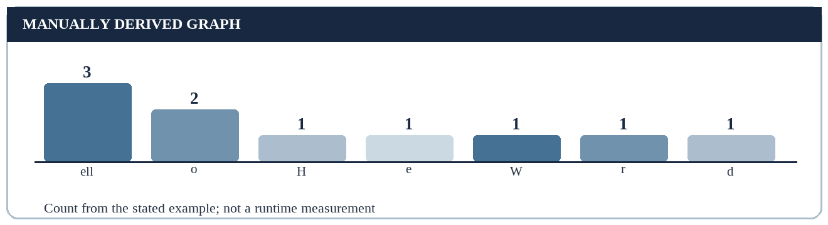
Figure 13. Letter occurrences in Hello, World! (conceptual or manually derived).

17. A Conceptual Output Pipeline
To explain the result at a high level, the learner writes valid Python 3 source; the environment interprets the function call; the function formats the string value for output; standard output carries the text; and an attached display may show the resulting line.
This pipeline is a teaching model. It omits implementation-specific parser internals, buffering and operating-system details that are unnecessary for the first example. Those details may matter in advanced programs but do not change the minimal expected greeting.
A process diagram is useful because it separates the stages at which different mistakes can occur. A syntax mistake stops before normal output, while an output capture issue may occur after a valid instruction has been processed.
The source-to-output diagram is deliberately an abstraction. A Python implementation can have internal stages beyond the boxes shown, including parsing and the runtime's stream handling. Drawing fewer boxes does not assert that the internal process is identical on every computer; it shows only the relationships needed to explain this example.
The distinction between a source-level error and a display-location issue follows from the pipeline. A malformed call may stop before an output request exists. A correct output request may instead be routed into a captured stream. Knowing where a problem could arise is more useful than memorising one error message.
The pipeline can also be read backward from the expected line. If there is a visible comma, it should be accounted for in the message value; if quote delimiters are absent in the visible line, that is consistent with their source-only role. This reverse check provides a way to spot an inaccurate diagram: a diagram that shows a database write or a web request would require an additional instruction absent from the one-line example. Each arrow should correspond to a justified relationship.
Source → Syntax check → Function call → stdout → Display
Figure 14. Teaching model of the greeting output path.

18. Preparing a Python Environment
A later practical exercise would require Python 3 to be available on a computer. The learner would check the environment’s documentation and select a Python 3 interpreter. The exact installation steps depend on the operating system and are not asserted as completed here.
A source file could be saved with a .py extension, or the illustrative statement could be entered in an interactive Python session. The first mode treats the text as a saved file; the second processes an entered statement. Both are ways to study the same language idea.
Before concluding that the statement is wrong, a learner should confirm that the intended file is being opened and the intended Python version is selected. Environment confusion is separate from a syntax error.
An environment check should begin with the least speculative questions. Which Python version is selected? Is the expression written in a Python source context rather than a command shell? If a file is involved, is it the intended file? Only after those questions should a learner conclude that a missing greeting comes from incorrect print syntax.
This is a proposed checklist, not a report of environment setup. Because the attached certificate does not specify an operating system or editor, no installation screenshot or institution-specific command is fabricated for this study.
Preparation question | Why it matters
Is Python 3 selected? | Avoids version confusion
Is the intended file open? | Avoids inspecting an older file
Is output visible? | Avoids mistaking hidden output for no output
Table 10. Environment checks for a future practical exercise.
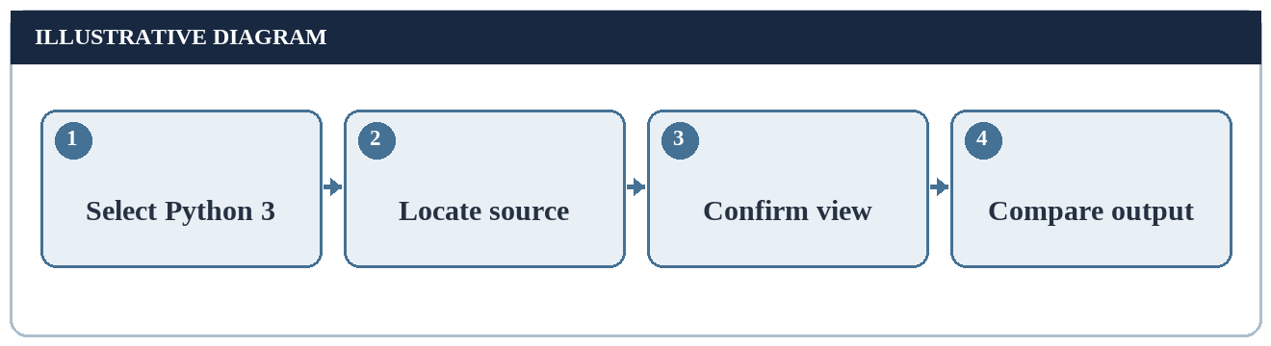
Figure 15. Preparation before a later run (conceptual or manually derived).

19. Interactive Mode Versus a File
An interactive Python session accepts a statement and can show a response immediately. A saved script is source text stored under a file name and processed when invoked. The print call has the same basic meaning in both contexts.
The prompt shown by an interactive environment is not part of the program’s greeting. Likewise, an editor line number or a terminal command used to launch a file is not part of the text passed to print.
When documenting a future exercise, distinguish the input statement from a shell command, interpreter prompt and expected output. This report does not include a real screenshot from either mode.
An interactive prompt and a saved script offer different wrappers around the same instruction. In the interactive case the prompt shows readiness to receive input; the prompt characters are not part of the greeting. In the file case a command or editor action starts processing; that launcher is not part of the string value.
When comparing two examples, remove the wrappers and examine the instruction and its expected result. This keeps the conceptual lesson stable even if one learner uses a terminal and another uses a notebook. It does not imply that either mode was used by the student during training.
When writing a practical report later, a useful evidence table would distinguish the entered instruction, the command or prompt used to submit it and the resulting output. The prompt is context, not message content. In a notebook the output area is context as well. The same expected message should be describable without relying on the colour, font or shape of that context. This report avoids drawing a fake terminal screenshot because no actual environment for the case study has been documented.
Context | Learner sees
Interactive session | Prompt, entered statement, displayed line
Saved script | Source file and later program output
This report | Conceptual example and predicted result
Table 11. Ways to encounter the same output idea.

20. Reading Error Messages
If a statement is malformed, Python normally reports an error instead of producing the intended greeting. The kind of problem matters: an unclosed quote is different from a misspelled function name or an incorrectly located file.
The first useful step is to find where the message points and compare it with the source. A line number helps locate the area to inspect, but the actual cause may be a nearby missing bracket or quote. A learner should correct one issue and review the result again.
The examples below are predicted error categories, not collected traceback logs. Exact message wording can depend on Python version and surrounding source.
Error messages are evidence only when they come from a genuine run in a documented environment. In a theory report, it is better to classify what could go wrong than to invent an exact traceback. An unmatched quote affects lexical interpretation; a mistyped function name affects name resolution; a changed space affects content but not validity.
These categories suggest a correction order: first make the source valid, then ensure the requested operation exists, and finally compare the resulting message with the specification. That sequence avoids treating every unexpected screen as the same kind of failure.
Illustrative mistake | Likely category
Unclosed string quote | Syntax problem
prnt instead of print | Unknown name
Wrong file location | Environment/file lookup problem
Extra space in greeting | Valid program; unexpected text
Table 12. Beginner mistake categories without fabricated tracebacks.
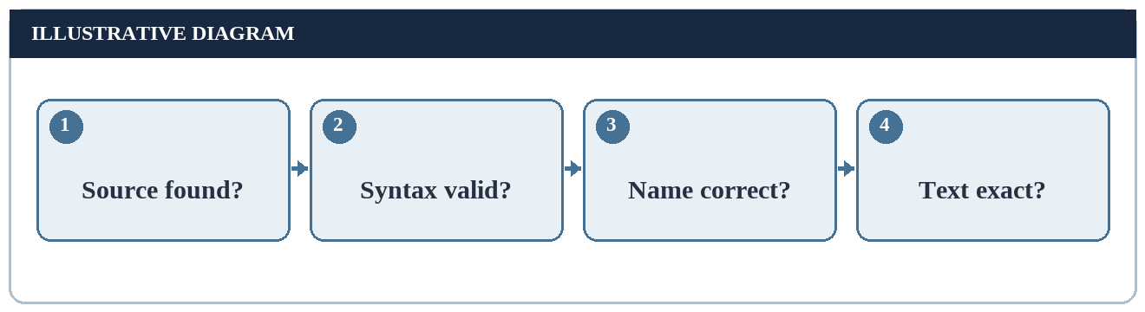
Figure 16. Diagnosis order (conceptual or manually derived).

21. Unmatched Quote Marks
A string literal must have matching delimiters in a form Python understands. If the opening quote is present and the closing quote is omitted, the source cannot define the intended text value. The interpreter therefore cannot complete the ordinary print call.
A common beginner correction is to visually pair the opening and closing quote before checking the surrounding parentheses. In an editor that highlights pairs, colour can help, but the underlying rule does not depend on an editor feature.
The absence of output caused by invalid syntax must not be confused with a program that successfully printed an empty string. In the first case the instruction was not valid; in the second case a valid operation emitted little or no visible text.
A quotation delimiter determines where a literal begins and ends. If the opening mark has no suitable close, Python cannot obtain the intended string from the source. The correct response is to inspect the delimiters rather than to change the word Hello or add unrelated imports.
It is also possible to write a valid string that itself contains quote characters, but that is a separate representation exercise. The reference line avoids this complexity by displaying only letters, comma, space and exclamation mark. Keeping the reference unambiguous makes it easier to distinguish error types.
Manual quote check: read the intended source until the opening quote and mark it. Continue through the message without treating punctuation as syntax: the comma, space and exclamation point are ordinary characters in this literal. Mark the closing quote, then verify that the call closes with its parenthesis. If either delimiter is missing, do not predict the normal greeting as a successful result. A quoted value is not formed simply because the English words look recognisable; the structural boundary must be valid.
• Check that the two string delimiters match.
• Check whether a quote was meant to be part of the message.
• Do not report a successful output if syntax is invalid.
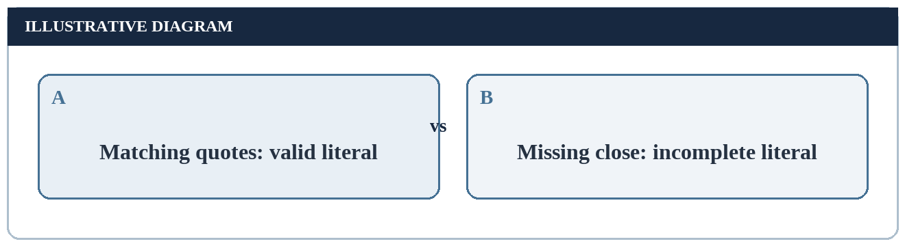
Figure 17. Quote-pair comparison (conceptual or manually derived).

22. Unmatched Parentheses
The print call encloses its argument list in round brackets. An opening bracket without the corresponding closing bracket leaves the call incomplete. A bracket typed in the wrong place can also change how the statement is read.
A useful manual technique is to examine the source from left to right: identify the function name, opening parenthesis, opening quote, text, closing quote and closing parenthesis. Each part has a distinct role.
This six-part inspection is not a substitute for an interpreter. It is a small reasoning procedure that can help a learner discover simple mistakes before a future practical run.
A bracket check can be done without tools by marking each opening parenthesis and its matching close. In the one-call example, the sole pair surrounds one string argument. If an opening bracket remains unmatched at the end, the intended call is incomplete.
This procedure should be applied to the source structure, not to arbitrary parentheses that might occur as characters inside a quoted message. The difference between syntax and data remains central: symbols inside a string can be displayed literally, whereas brackets around the argument list organise the call.
Function name → ( → Opening quote → Message → Closing quote → )
Figure 18. Manual inspection order for a simple call.
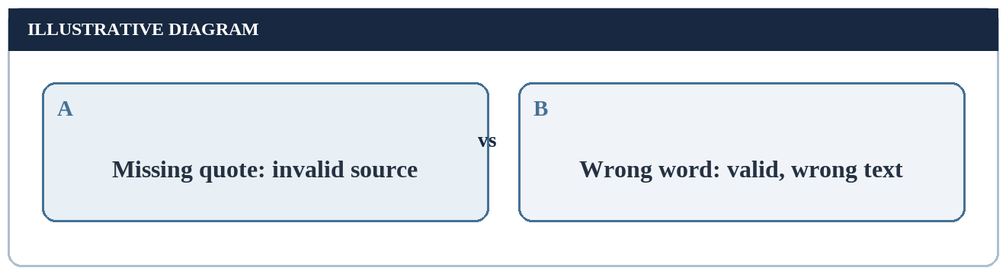
Figure 19. Two distinct mistakes (conceptual or manually derived).

23. Spelling the Function Name
The built-in function name is print in lowercase. The language treats names as case-sensitive, so writing Print would refer to a different name unless someone had explicitly defined it. A transposition such as prnit similarly does not refer to the built-in function.
A spelling mistake differs from a quote or bracket mistake: a misspelled identifier may still form syntactically understandable source but fail because the intended function cannot be found. The learner should inspect the name before changing the text of the greeting.
This report describes the expected category of behaviour. It does not claim to have captured a specific exception screen or tested all possible misspellings.
The visual similarity of print, Print and prnit makes them useful comparison cases. Python identifiers are case-sensitive, so a capital letter creates a different name. A transposed pair of letters likewise creates a different identifier. The report cannot guarantee one exact wording for every future error because the surrounding environment and Python version can differ.
A learner should check names against the language reference or a known-good source line before altering the desired output. Spelling the name correctly enables the function to be found; it does not automatically verify that the message argument itself is exact.
It is useful to test names mentally by considering a dictionary of exact identifiers. The entry print is not the same key as Print or prnit. Python may find one name and not another; the displayed message cannot fix the name lookup. Conversely, once the correct function is called, a wrongly capitalised word inside the literal is still just data and can still be displayed. This contrast explains why different errors call for different corrections even when both are described informally as typos.
Name written | Conceptual interpretation
print | Python built-in output function
Print | Different case-sensitive name
prnit | Different, misspelled name
Table 13. Function spelling examples.

24. Spaces and Exact Output
Spaces inside the string literal are data. The reference greeting has one space after the comma. Two spaces would produce a visibly wider gap and would not match an exact character-by-character check.
Spaces outside the literal serve a different purpose in source formatting. Depending on where they appear, they may be ignored or may affect source structure. This report focuses on the message characters inside the quotation marks.
Exactness matters most when the intended output is part of a learning exercise or a simple automated check. A human may consider several greetings equivalent in meaning, but the literal strings differ.
Whitespace deserves two questions. Is a space part of the message value, or is it outside the quotation delimiters? A space inside the literal can change displayed text, while source spacing between tokens may serve readability or other grammar roles. The reference message has exactly one space after the comma.
For a manual comparison, place two strings on separate lines and align positions rather than relying on overall appearance. Two neighbouring spaces can be hard to notice visually but make an exact equality check fail. The distinction matters even though the reader understands both sentences.
Message value | Same as reference?
Hello, World! | Yes
Hello, World! | No: extra space
Hello,World! | No: missing space
Hello World! | No: missing comma
Table 14. Character-by-character comparison examples.
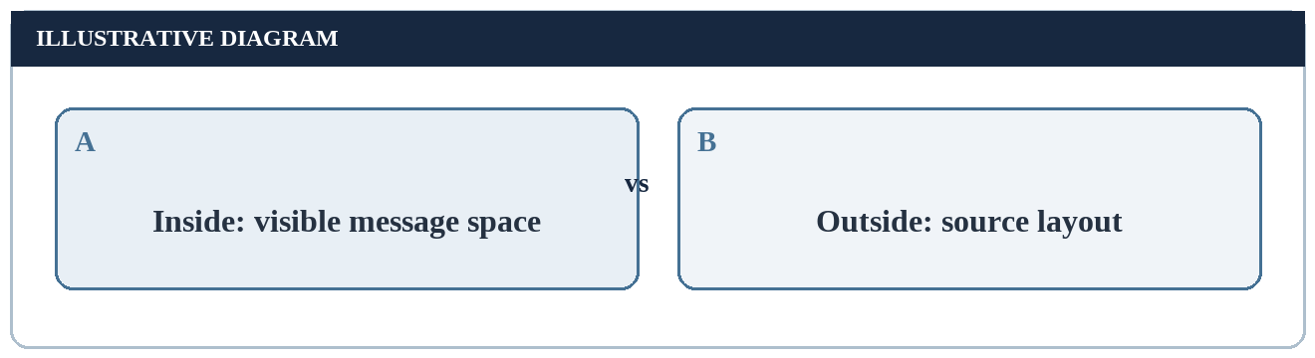
Figure 20. Inside versus outside the string (conceptual or manually derived).

25. Single and Multiple Arguments
The principal example passes one complete string. Another conceptual form passes “Hello,” and “World!” as two separate arguments. By default, print places a space between multiple arguments, so the visible greeting can be the same.
Equal visible output does not mean the source structure is identical. One form stores a space inside a single string; the other relies on the function’s separator. This is a useful first lesson in separating observable effect from source organisation.
For a beginner report, the one-string form is less ambiguous. It makes every visible character part of one literal and keeps the reasoning about expected output straightforward.
The one-string and two-string forms illustrate observational equivalence for a narrow purpose. With a default separator, both can display the same visible greeting. Yet they differ in how the space is produced. If the separator setting changes, only the multi-argument form is affected by that change.
This contrast helps the reader avoid an oversimplified rule such as 'a space is always added by print'. The default separator acts between values; it does not insert extra spaces inside a single literal. The topic stays small while introducing a useful idea about output formatting.
Conceptual form | Source of the space
One string: "Hello, World!" | Inside the string
Two strings: "Hello,", "World!" | Default print separator
Table 15. Two conceptual ways to form the same visible line.
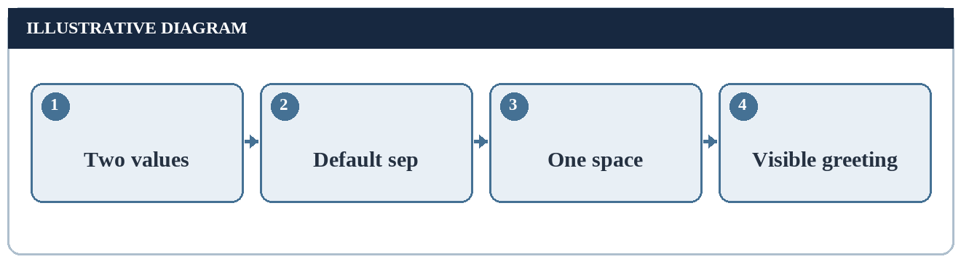
Figure 21. Where the joining space comes from (conceptual or manually derived).

26. The sep Argument
The optional sep parameter defines the text placed between multiple arguments in a print call. It has no visible effect when the basic greeting is supplied as one argument, because there is no boundary between two values to separate.
For a two-argument example, using a different separator could change the result. An empty separator would join the two arguments without the default space; a dash would place a dash between them. These are language features for explanation, not implemented project options.
The simplest practical lesson is to look at the number of arguments before predicting separators. A comma inside the literal is message punctuation; a comma between arguments is part of the call syntax.
The default separator is one space between arguments; it is not added before the first or after the last argument. If there is only one argument, changing the separator has no inter-argument boundary on which to act. With two arguments, an empty separator removes the join space and a dash makes the join visible.
The comparison table should be read as a prediction under explicitly stated values. Its rows are not different runs of a program. A student who later performs the exercise could capture actual output and compare it with these predictions.
For two values, the separator appears only at their boundary. In the imagined print call with Hello, as the first value and World! as the second, the ordinary separating space makes the same visible phrase as the single-literal reference. If the first value already ended with a space, the default separator would add another, producing two adjacent spaces. This thought experiment demonstrates why the exact content of each argument must be known before predicting the final text. No execution is claimed.
Arguments / separator | Expected visible text
"Hello,", "World!" / default | Hello, World!
"Hello,", "World!" / empty | Hello,World!
"Hello,", "World!" / dash | Hello,-World!
Table 16. Manually predicted separator effects.

27. The end Argument
The optional end parameter controls what print writes after the displayed argument text. Its normal value results in a line ending. With a different value, a future output operation might continue on the same displayed line.
The reference example uses no end parameter, so the ordinary line ending is expected. A screenshot of a terminal might show the next prompt on a later line, but a screenshot is not required to reason about the basic function behaviour.
Explaining end helps separate the thirteen visible characters of the greeting from the following line boundary. The present report does not claim to inspect raw output bytes.
The end parameter is independent of the separator parameter. Separator text occurs between multiple positional values; ending text follows the completed output. In the reference case there is one argument, no inter-argument separator appears and the default ending starts a new line.
This model helps answer a practical question: if the next prompt appears immediately after the greeting, which setting should be inspected? The ending behaviour is the relevant concept, not the spelling of World. The report does not claim a prompt was observed; it presents a diagnostic hypothesis.
Text value → print operation → Default end value → Next line
Figure 22. Position of the default line ending.
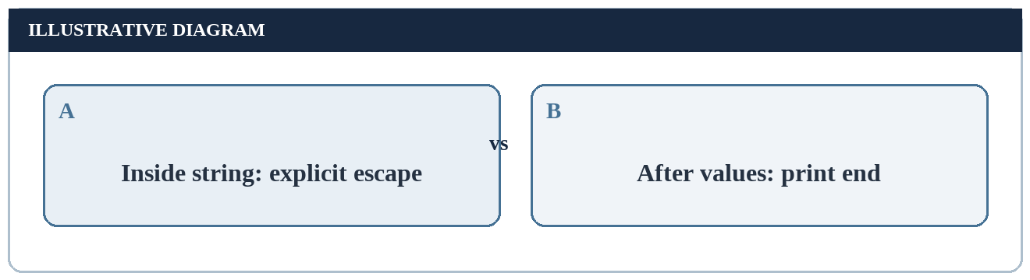
Figure 23. Where does a line break originate? (conceptual or manually derived).

28. Newline Escape Sequence
A string can contain an explicit newline escape sequence such as backslash followed by n. If used within the message, it represents an additional line break inside the argument text. That is different from the ordinary line ending that print appends after its arguments.
The basic “Hello, World!” literal does not contain an explicit newline. Introducing one would alter the displayed layout and would no longer be the same one-line greeting. A learner should identify whether a line break comes from the value or the output function.
This distinction is useful later when constructing multi-line text. It is explained here only to clarify the simple case, not to propose a multi-screen application.
An explicit newline inside a string is part of that string's value. The default ending of print is added after the argument has been displayed. Combining both would place more than one line boundary into the output scenario. The reference greeting uses only the normal ending and contains no explicit newline.
On paper, a backslash-n escape is written as two source characters but denotes a line break in the resulting string. This difference between source representation and value is another reason not to infer visible output by counting raw symbols in a source line.
A worked distinction uses a hypothetical literal containing a newline escape between two words. The internal break belongs to the value; the print ending follows after the second word. In contrast, the reference literal has no such internal break and therefore occupies one visible line before the normal ending. A reader can diagram the two positions separately on paper. This helps when future multi-line messages behave unexpectedly, while keeping the current project limited to one simple output.
Origin of a break | Location
Explicit \n in a literal | Inside the message value
Default print ending | After the printed value
Table 17. Two different sources of line breaks.

29. Variables as a Later Variation
The greeting can be stored in a variable before being displayed. In a conceptual sequence, a name refers to the text value and a later print call uses that name. The displayed text can remain the same even though the source has more than one instruction.
A variable is helpful when a value is reused or changed. For the one-time greeting, a direct string literal is sufficient. Adding a variable should be understood as a teaching variation, not as evidence of a larger application.
This variation also clarifies that print receives a value. Whether that value was written directly or obtained through a name, the output rule is based on the value supplied at the time of the call.
A variable can refer to a string value that was written earlier. The later print call uses that value; it does not display the variable's name unless the name itself is supplied as a literal. This gives a gentle transition from fixed messages to values that can be reused.
For a one-time greeting, however, adding a variable does not make the displayed result more correct. It is an educational variation useful for explaining assignment and lookup, not a requirement or evidence of implementation. A later practical task could compare both forms under the same expected-output rule.
Assign text to name → Use name as argument → Expected greeting
Figure 24. Conceptual variable-based variation.
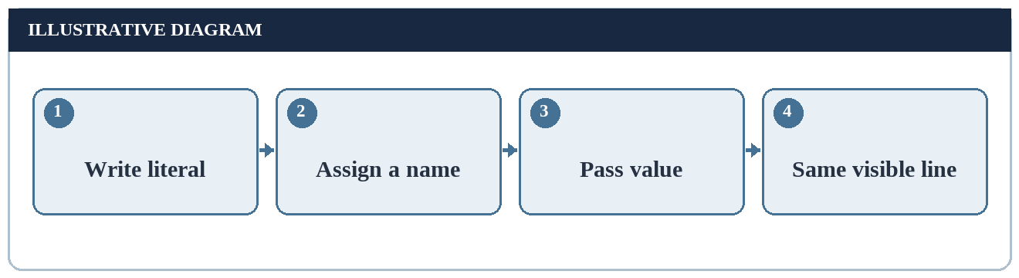
Figure 25. Literal versus variable (conceptual or manually derived).

30. Unicode and the Greeting
Python 3 strings are Unicode text. The particular reference greeting uses characters commonly represented in basic ASCII: English letters, comma, space and exclamation mark. A different greeting could include characters from other writing systems, but that would be a separate example.
The visible character count of thirteen should not automatically be treated as a byte count for every possible encoding or every possible string. Text characters and encoded bytes answer different questions.
For the basic greeting, focusing on text value rather than byte-level transport is appropriate. If the text is later saved or sent over a network, the selected encoding and receiving environment would matter.
The reference characters are all in the basic English-letter and punctuation set that common encodings represent straightforwardly. Python 3's text model is broader: strings can hold many writing systems and symbols. The choice of a basic greeting limits the representation questions a first lesson needs to answer.
A future international greeting might display correctly in one environment but require suitable fonts and encoding in another. That complexity does not alter the definition of print; it changes the conditions for representing and viewing a particular value. No internationalised output is claimed in this report.
The greeting is made from common Latin letters and familiar punctuation, which avoids many display complications. A later lesson could replace it with a message in another language and compare the character value with the chosen encoding and font support. Such a lesson would ask new questions about representation and rendering. It should not be reported as already completed here. The current character-count chart stays with the precisely stated basic greeting and makes no claim about all Unicode strings.
Term | Question answered
Character | What text element is being represented?
Encoding | How is text represented as bytes?
Display | How does an environment show the text?
Table 18. Text representation concepts for beginners.

31. Case Sensitivity and String Values
The function identifier print is case-sensitive, and the string value also preserves the case of its letters. These are two related but distinct facts: identifier spelling determines which callable is requested, while string spelling determines the displayed message.
Changing “World” to “world” does not make the source syntactically invalid. It simply changes the content of a valid string. Changing print to Print may instead make the intended function unavailable. Thus error diagnosis should first identify whether the problem is source interpretation or unexpected text.
The reference text is a chosen convention for this report; other greetings are legitimate programs but not exact matches for this one.
In source code, changing the function identifier can alter which operation is requested. In the literal, changing uppercase letters alters the data requested for display. A case-sensitive language treats these as different levels of meaning even though both changes may be described casually as 'capitalisation errors'.
A simple diagnosis asks which level changed. If the name is unknown, inspect the identifier; if the operation is valid but the greeting reads 'hello, world!', inspect the string value. This conceptual classification predicts the appropriate correction without inventing an actual error log.
Change | Likely effect
World to world | Valid call with different text
print to Print | Different identifier requested
Comma removed from literal | Valid call with different punctuation
Table 19. Effects of case and content changes.
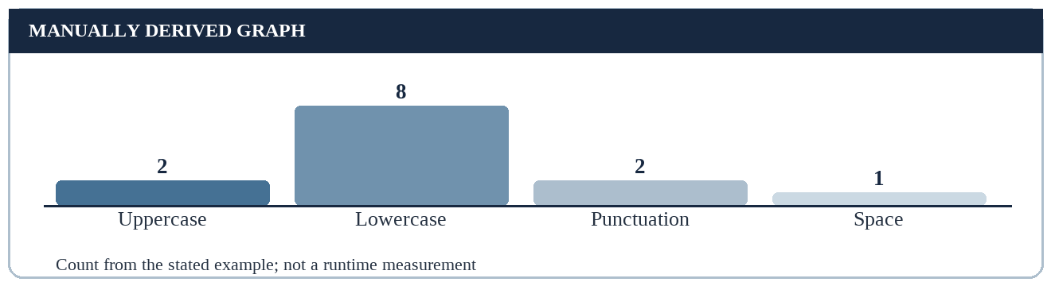
Figure 26. Manually counted character classes (conceptual or manually derived).

32. Distinguishing Output from Return Value
Printing a value is a side effect visible through an output stream. The return value of the print function is not the greeting text. This distinction prevents a common beginner misconception that displaying a value and returning a value are the same operation.
A function may compute and return data for further use, while another may primarily produce an external effect. In this introductory case, the learner’s goal is the effect on standard output. No later computation in this report depends on a returned greeting.
Keeping the distinction clear is useful when learners later write their own functions. A printed explanation may help a person, whereas a returned value can be used by another part of a program.
Printing a string and returning a string differ in where information goes. A print call causes text to be sent to a stream for a reader or a capturing tool; it does not hand the greeting back as a reusable return value. That is why showing the right words on screen is not the same as giving another function a text result to process.
An elementary thought experiment makes the distinction clearer. If another part of a hypothetical program needs the greeting as data, it should receive a value rather than scrape terminal output. This report neither constructs that program nor tests it; the contrast is included to prevent a frequent conceptual error about the meaning of output.
A hypothetical function that returns the greeting to its caller and a function that prints the greeting serve different purposes. One produces a value that another operation can use; the other requests an external text effect. A teaching exercise could ask whether a returned value would automatically appear in every program environment. The answer is no: an environment may display expressions, but that is separate from an explicit print operation. Keeping these ideas apart prevents a later program from relying on displayed output as if it were stored data.
Action | Recipient
Write to standard output | User or capturing environment
Return a value | Calling code
Show a report example | Reader of this document
Table 20. Three different ways information can be presented.

33. Manual Trace of the Basic Example
A manual trace predicts the basic example in a sequence of small reasoning steps. First, the function name is identified as print. Second, its argument is recognised as a string literal. Third, the value of that literal is identified as the thirteen-character greeting without quote marks.
Fourth, the print function sends the displayed form of the value to standard output. Fifth, the default end value produces a line ending. No file creation, database update or network request is implied by these steps.
This trace is a conceptual prediction from language rules. It is not a record of a debugger session or an actual executed trace.
One can state the first program's result as a five-step proof rather than as a screenshot. The argument is a literal with value Hello, World!. The built-in print operation accepts that value. With one argument there is no separator to insert. The text is written to standard output. The default ending terminates the line.
Each step has a condition that could change in a variant. More arguments make separator reasoning relevant; a changed literal makes the displayed text different; a changed ending changes layout. The manual trace is therefore reusable for several short exercises while remaining clearly distinct from an observed run.
Locate call → Read argument → Remove delimiters → Send text → End line
Figure 27. Reasoned trace, not an execution log.
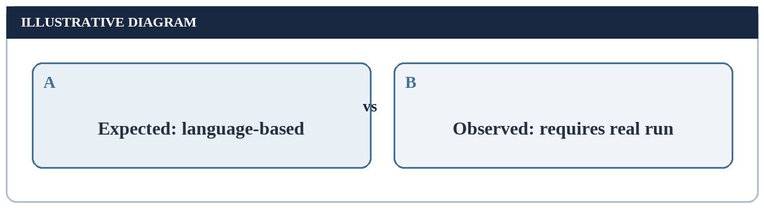
Figure 28. Prediction and observation are different (conceptual or manually derived).

34. Expected Output and Its Limits
For the reference statement, the expected visible line is “Hello, World!” with the exact punctuation and spacing previously described. The normal line ending follows it. An expected result is a specification that can guide a later check.
A real observed result would require an actual Python environment and a documented run. This report includes no such observation. It should therefore avoid a screenshot labelled “program output” or a test result marked “passed.”
This separation is especially important in an internship report. The certificate confirms training completion; it does not establish that this particular statement was executed as part of a company assignment.
A prediction should be precise enough to be falsifiable by a later exercise. 'A greeting appears' is too broad: it would not detect a missing comma, altered case or doubled space. 'The thirteen visible characters Hello, World! are written, followed by the default line ending' is more informative.
At the same time, a prediction should not promise an exact terminal theme, font or prompt character, because those belong to the viewing environment rather than to the text value. The report separates the logical expected line from how a particular tool might display it.
Exact-output reasoning benefits from two levels of comparison. First check the visible message characters in order: the initial H, comma after Hello, single space, uppercase W and final exclamation point. Next check layout: the default ending places subsequent output on another line. If the first level matches but the second does not, inspect ending behaviour rather than rewriting the literal. These are proposed comparison criteria; the report has no observed transcript against which to apply them.
Label | Appropriate claim
Expected text | Predicted from Python behaviour
Observed output | Requires a genuine recorded run
Pass/fail result | Requires an actual comparison
Table 21. Evidence levels for program output claims.

35. Character-Category Chart
The chart on this page uses the manually counted thirteen visible characters in “Hello, World!” Ten are letters, two are punctuation marks and one is a space. The chart shows a composition, not a performance measurement or survey result.
The fractions are 10/13, 2/13 and 1/13 respectively. A bar graph lets a reader compare the categories at a glance. The counts can be checked directly from the message without running code or consulting an external dataset.
The ordinary line ending and the source quote marks are excluded. The chart therefore describes the greeting value as displayed, not every character in a full source line or in a serialized file.
For the category chart, manually sum the bar heights: ten letter characters plus two punctuation characters plus one space makes thirteen. This arithmetic is an internal check on the figure. The chart does not show milliseconds, pass rates or a sample of students; those values would be ungrounded here.
A second valid view of the same string would count distinct letter frequencies: the letter ell occurs three times and o twice. Such a chart answers a different question from category composition. It should not be confused with a histogram of program executions or any measured runtime quantity.
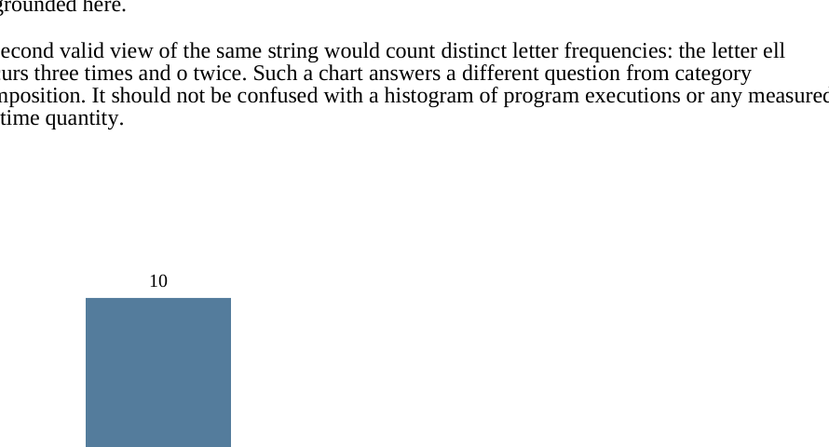
Figure 29. Manually derived character composition of “Hello, World!”.

36. Alternative Greeting Variants
Many first programs use “Hello World” without punctuation, while this report uses “Hello, World!” as a precise reference. Both are reasonable greetings, but they differ in length and in the characters a strict comparison would expect.
Changing the words, case or punctuation does not alter the basic mechanism: a string is supplied to a print call. The exercise is not about finding one universal sentence; it is about tracing the sentence selected and predicting its display accurately.
For assessment purposes, a teacher should specify the desired text explicitly. Otherwise a learner may complete the conceptual task yet fail a string equality check over stylistic differences.
A variant comparison needs a defined reference. This report chooses a comma, one space, title-style capitals and an exclamation mark. 'Hello World' and 'hello world' are understandable but are not exact matches. A much shorter 'Hi!' illustrates that length alone varies with content.
The comparison is pedagogical, not a competition between greeting phrases. An instructor could choose a different reference without changing the underlying print rule. What matters is being explicit about the target string and distinguishing a valid alternate message from incorrect syntax.
Greeting | Visible characters | Reference match?
Hello, World! | 13 | Yes
Hello World | 11 | No
hello world | 11 | No
Hi! | 3 | No
Table 22. Manual comparison of illustrative greeting variants.
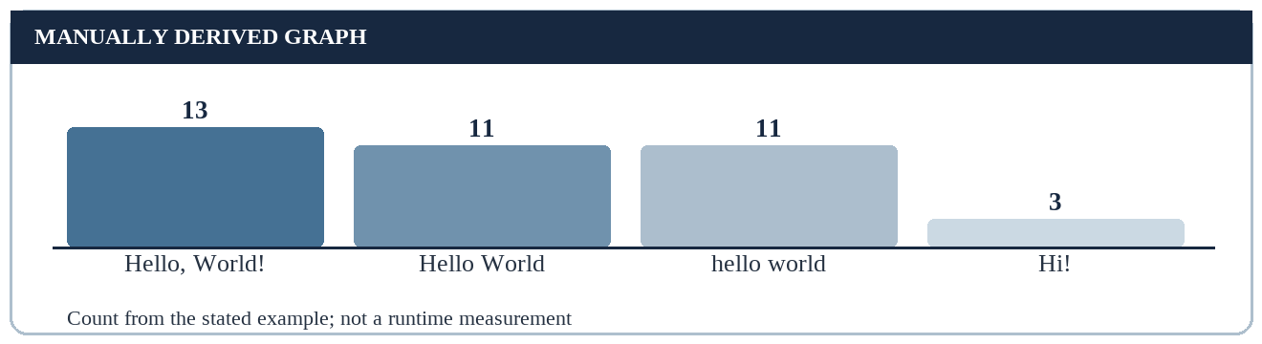
Figure 30. Visible length of greeting variants (conceptual or manually derived).

37. Proposed Verification Checklist
If a learner later performs the exercise, a small checklist can make the result auditable. First record the intended reference text. Then confirm Python 3 and the correct source location. Finally compare the visible text and, if important, the line ending separately.
The checks should include both a normal greeting and a few deliberately altered examples. A check that always accepts any output would not demonstrate that punctuation or spacing was understood.
The checklist below describes what should be verified, not what this report has verified. It is a plan for practical learning rather than a completed test log.
The verification checklist can be treated as a small protocol: write a prediction first, identify the environment that would be used, perform one operation later, capture the observed text and compare it with the prediction. The present report covers only the prediction and design stages.
A comparison that fails should record which property differs—spelling, case, spacing, punctuation or line layout—rather than simply call the whole program wrong. Such a record would be valuable in a practical follow-up, but no test log is manufactured for this theory-only submission.
A reproducible future verification should record the statement, Python version, environment type and the expected line before running anything. After a real run, the learner could copy the observed line and state whether each relevant property matched. Recording only “works” would hide useful discrepancies such as a missing comma or an extra space. In this report, those are recommendations for evidence collection, not entries in a completed test sheet. The distinction safeguards the honesty of the internship submission.
• Confirm intended Python 3 environment.
• Identify the source statement and expected string value.
• Compare visible text character by character.
• Distinguish a normal line ending from an extra blank line.
• Record actual observations only after running the example.

38. Planned Test Cases
A future practical exercise can use expected cases to check the learner’s understanding. The cases include the normal statement, a different capitalisation, an extra space, a blank print call and a malformed quote. Their expected behaviours are derived from syntax and print semantics.
A malformed source case is not expected to display the intended greeting. The precise error message should be recorded from the actual environment if the case is performed; it is not invented here.
No pass/fail results are stated because the cases have not been run for this conceptual report.
The planned cases cover both valid statements with different text and a malformed statement that cannot produce the intended line. These should not be collapsed into one 'failure' category. A valid alternate greeting tests exact comparison; an unmatched quote tests the ability to recognise invalid source.
To turn the plan into evidence, a learner would need to run each case in a named Python 3 environment and record actual observations. The current table deliberately reports predicted results only and does not include a column headed 'passed' or 'failed'.
A planned case should have an initial condition and an expected outcome. For the normal case, the condition is one valid print call with the reference literal and the expectation is the exact greeting plus a line ending. For the unclosed-quote case, the initial condition is malformed source and the expectation is that the intended ordinary output is not obtained. A future tester would still need to record what actually happened. The two expected outcomes are different kinds of claims and should not be summarised as a single pass rate.
Case | Illustrative change | Predicted result
V1 | Reference greeting | Hello, World! plus line ending
V2 | Lowercase world | Different visible string
V3 | Extra interior space | Different visible string
V4 | Empty argument list | Blank line
V5 | Missing closing quote | Invalid source; no intended greeting
Table 23. Planned verification cases, not executed tests.

39. Error Diagnosis Decision Path
A beginner can diagnose a missing greeting by asking where the process stopped. If the source file cannot be located, investigate the environment. If the source is found but malformed, inspect quotes and brackets. If the call is valid but the message differs, inspect the literal’s characters.
If valid output appears somewhere unexpected, inspect how the environment displays or captures standard output. This prevents rewriting a correct string to solve a terminal or notebook display issue.
The decision path is a conceptual aid. A real environment may require additional checks, and the report does not claim that every possible Python error fits this small chart.
A good diagnosis path asks questions in an order that narrows the cause. First confirm that the intended source was selected. Next determine whether the source can be interpreted. Then verify that the requested built-in name is correct. Finally inspect the exact message and the destination where output is shown.
This is not a claim that every Python problem fits five boxes. Rather, it shows how the simple greeting can teach fault isolation. The diagram is a checklist for future work, not a screenshot of a debugging session.
File found? → Syntax valid? → Function known? → Text exact? → Output visible?
Figure 31. Beginner-focused diagnosis questions.
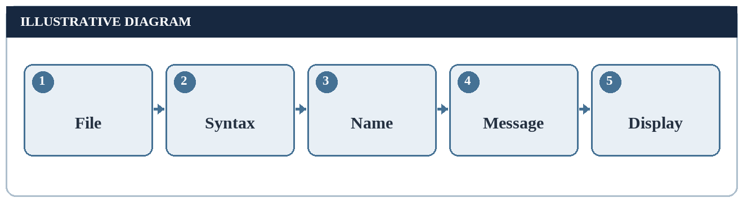
Figure 32. Planned fault isolation (conceptual or manually derived).

40. Common Misinterpretations
Several misconceptions can arise from a tiny example. Some learners think the quote marks must appear in output; others think print saves the text to a file. Still others treat a displayed message as proof that a full project has been implemented.
The corrective idea is to name the role of each component. Quote marks define the string literal, print writes to standard output, and the terminal is only one possible way of viewing that output. The message itself is the value between the delimiters.
In an academic report, the strongest correction is honest labelling. A diagram is a diagram, a predicted line is predicted, and a genuine program run would need separate evidence.
A common mistake is to mistake visible output for the return value of the print function. Another is to treat quotation marks in source as characters displayed. A third is to assume that standard output must be a permanent file. Each misconception comes from collapsing two different roles into one.
A short oral explanation can expose the difference: ask the learner what text is supplied, what operation receives it, where that operation sends it and what evidence would be needed to say it ran. Answering those questions is more informative than memorising the source line alone.
A compact self-questioning exercise is to ask “What belongs to source syntax? What belongs to the text value? What is an output-stream convention? What is only a viewing tool?” In this example, parentheses answer the first question, the comma inside the quotes answers the second, the ordinary ending answers the third, and the terminal prompt answers the fourth. Misplacing an element in one of those categories explains several beginner mistakes at once. This is a conceptual classification, not a surveyed result.
Misinterpretation | Correction
Quote marks always display | They delimit the literal in the basic case
Print means save to disk | Default destination is standard output
Expected text proves testing | Testing requires an actual run and record
Table 24. Common misunderstandings and corrections.

41. Practical Application as a Learning Example
The immediate practical application of a Hello World study is instructional: a learner can use the greeting as the first step before studying input, variables, conditionals and functions. It establishes the habit of predicting what an instruction should display.
A classroom could ask learners to explain why quotes do not appear in output, why the next line begins below the greeting and why a change of case in the literal alters the visible text. These questions test understanding beyond memorising a one-line example.
This is not a business solution or deployed tool. The “application” in the present report is a proposed teaching sequence that an instructor could adopt with permission.
The learning application here is intentionally modest. A teacher could ask students to predict the reference line, explain why quotes disappear, compare two variants, and identify one source mistake from a supplied snippet. Those tasks measure conceptual understanding without requiring a fake industrial problem statement.
The study can also serve as a baseline for later lessons. Once a learner understands literal output, replacing the literal with a variable or user input creates a genuine new topic. Nothing in this report asserts that such follow-up exercises were completed during the internship.
Predict text → Explain syntax → Check later in practice → Reflect on mismatch
Figure 33. Proposed learning cycle; not an executed activity.
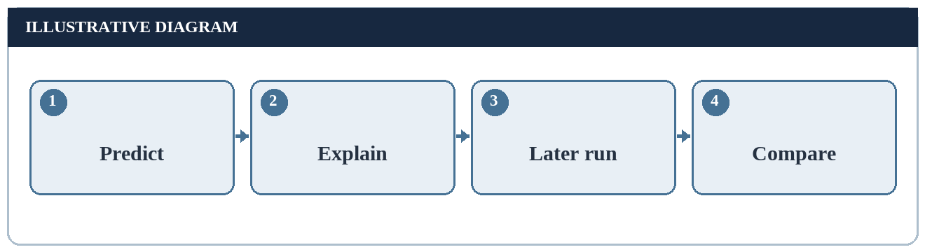
Figure 34. Proposed learning cycle (conceptual or manually derived).

42. Limits of the Study
The report has no runtime capture, source repository for a new application, performance analysis or user evaluation. The supplied training certificate confirms Python Programming completion but does not prove that this specific instructional topic was submitted during the internship.
A greeting printed to standard output is too small to demonstrate software design quality, long-term maintainability or organisational impact. The length of this academic report reflects multiple explanations of foundational ideas, not the size of an implemented project.
The character chart is deterministic and manually derived. Other diagrams are conceptual. A future practical submission should use real screenshots only if the student actually executes the statement and the department permits them.
The design's limits should be visible to the reader rather than hidden at the end. There is no tested command, execution screenshot, captured standard output or measured performance in this document. Illustrations are derived from language rules or manual counting and are explicitly named as such.
There is also an academic proportionality question: a greeting is only one line of source, while a fifty-five-page report is large. The extra pages explain surrounding fundamentals; they do not turn the greeting into a complex project. A supervisor should confirm that this subject is acceptable for the required internship submission.
Honest boundary: conceptual report, not a working model.
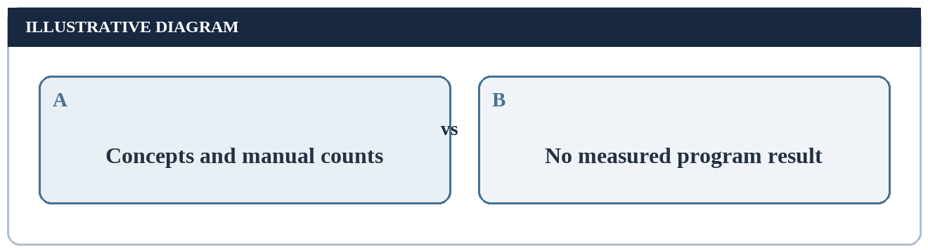
Figure 35. What this report can and cannot show (conceptual or manually derived).

43. Future Learning Path
A natural next lesson is to assign the greeting to a variable and print the variable, which separates storage of a value from its display. A later lesson could request a name from a user, form a greeting and then compare expected and observed output in an actual environment.
After those fundamentals, the learner might study control flow, functions, file handling and tests. Each new topic introduces a distinct question rather than pretending the original one-line statement already performs those tasks.
A future practical report should document the environment, the exact source, genuine run evidence and test observations. None of those additions are claimed as part of this theory-only study.
A responsible future path separates stages. First practise the literal example. Next practise a variable-based form. Then accept a value from a user, define a function and record genuine test outcomes. Each stage adds new requirements that should be independently specified and checked.
It would be misleading to label those stages as already completed merely because a diagram lists them. The diagram is a learning roadmap. If the department requests proof of actual practical work, the student should provide authentic source, screenshots and observations from work personally carried out.
The suggested learning path can be used to formulate genuinely new exercises rather than stretching one exercise without purpose. A variable adds assignment and lookup; user input adds a changing value; a function adds a reusable abstraction; genuine tests add recorded evidence. Each addition requires a different expected result and may require new validation. The present report stops before those stages. An honest next report should identify which stage was actually carried out and provide matching source and observations rather than copying the current diagram as proof.
Literal output → Variable → User input → Functions → Actual tests
Figure 36. Possible future sequence beyond the present scope.

44. Conclusion
Printing “Hello, World!” in Python 3 is a compact way to study how a source instruction can produce visible text. The expression introduces a built-in function, argument parentheses, a string literal, standard output and the normal line ending.
The worked comparisons distinguish source punctuation from output characters, valid but different greetings from malformed source, and predicted results from observed tests. The thirteen-character greeting was counted manually and displayed in a plainly labelled chart.
This report is a theoretical academic application of Python Programming ideas. It does not claim that Hello World was an assigned EWB Courses internship project or that a working model was built. Its value lies in a careful explanation of a beginner concept and an honest account of the evidence available.
The main result of the study is a set of distinctions: instruction versus displayed text, delimiting quotes versus string characters, an output stream versus a saved file, a predicted line versus an observed run, and an exact match versus a merely understandable greeting.
These distinctions are transferable to later Python study. At the same time, the report remains honest about its scale. It documents a beginner topic using reasoned examples, diagrams and manually checkable charts rather than claiming that an application was implemented or that an employer assigned this exact exercise.
End of the main theory-only study.
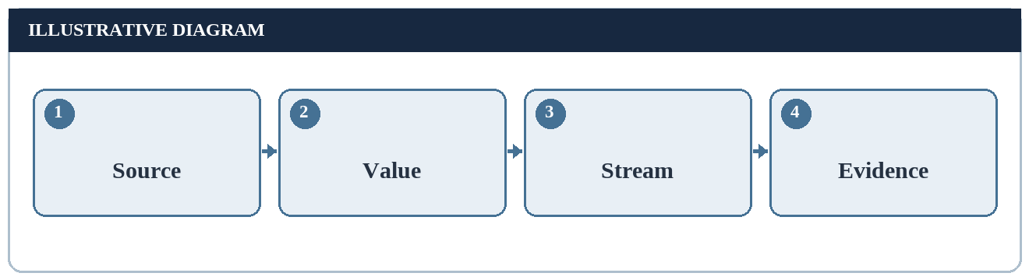
Figure 37. Summary of core distinctions (conceptual or manually derived).

REFERENCES
1. Python Software Foundation. “The Python Tutorial.” https://docs.python.org/3/tutorial/ (student should add actual access date).
2. Python Software Foundation. “Built-in Functions: print.” https://docs.python.org/3/library/functions.html#print (student should add actual access date).
3. Python Software Foundation. “Lexical Analysis: String and Bytes Literals.” https://docs.python.org/3/reference/lexical_analysis.html#string-and-bytes-literals (student should add actual access date).
4. Python Software Foundation. “Input and Output.” https://docs.python.org/3/tutorial/inputoutput.html (student should add actual access date).
5. University of Lucknow, Department of Computer Science and Engineering. Student-supplied industrial training report cover-page format.
6. EWB EDUTECH PRIVATE LIMITED. Student-supplied Internship Offer Letter to Mayank Kumar, dated 14 June 2026.
7. EWB Courses. Student-supplied Internship Completion Certificate to Mayank Kumar, issued 15 July 2026.

APPENDIX A: GLOSSARY
Source statement: Written Python instruction, distinct from its effect.
Function call: Request to apply a named callable to arguments.
Argument: Value supplied to a function in a call.
String literal: Source notation for a text value.
Standard output: Default channel used by print for text.
Line ending: Control character or sequence marking a new line.
Expected output: Reasoned prediction, not a recorded observation.
Conceptual diagram: Teaching representation rather than an application screenshot.

APPENDIX B: SUBMISSION CHECKLIST
[ ] Fill roll number, section, date and signature.
[ ] Check acceptance of one-month certificate for four-to-six-week requirement; exact dates are not shown.
[ ] Confirm that a separate academic case study is acceptable.
[ ] Do not present predicted output, proposed checks or diagrams as actual execution evidence.
[ ] Print single-sided, certificate in colour, and spiral-bind.
[ ] Submit by 16 November 2026 to the faculty member designated for your section.

