UNIVERSITY OF LUCKNOW
LUCKNOW — 226 021, UTTAR PRADESH
DEPARTMENT OF COMPUTER SCIENCE AND ENGINEERING
A REPORT ON SUMMER INTERNSHIP
(Session 2025–26)
SwachhAI
AI-Guided Waste Segregation and Circularity Assistant
for India’s Households
Submitted in partial fulfilment of the requirements for the award of the degree of
BACHELOR OF TECHNOLOGY
in
COMPUTER SCIENCE AND ENGINEERING
SUBMITTED BY
MOHAMMAD RAMISH ANSARI
B.Tech. Computer Science and Engineering
Third Year, Semester V
University Roll No.: ____________________
UNDER THE SUPERVISION OF
____________________ (Faculty Supervisor)
Department of Computer Science and Engineering
INTERNSHIP COMPLETED AT
1M1B (One Million for One Billion)
AI for Sustainability Virtual Internship · supported by AICTE · in collaboration with IBM SkillsBuild
Certified completion period: July 2026 – September 2026 · Certificate issued 22 September 2026
SESSION 2025–26
Spiral bound · single-sided printing · submitted for university evaluation

DECLARATION

I, Mohammad Ramish Ansari, a student of the third year (Semester V) of the Bachelor of Technology programme in Computer Science and Engineering at the University of Lucknow, Lucknow, hereby declare that the Summer Internship Report titled “SwachhAI: AI-Guided Waste Segregation and Circularity Assistant for India’s Households” is a record of work carried out by me during the 1M1B AI for Sustainability Virtual Internship, offered by 1M1B (One Million for One Billion), supported by the All India Council for Technical Education (AICTE) and delivered in collaboration with IBM SkillsBuild, during July to September 2026.
I further declare that the technical explanations, module descriptions and conceptual designs presented in this report are my own work, prepared from the public documents listed in the References and from the guidance provided during the internship. The report does not reproduce confidential course material, private meeting links or any restricted content shared by the organising bodies, and it does not present the proposed design as a tested or deployed product. No part of this report has been submitted for the award of any other degree or diploma.
Where the report draws on published rules, standards or studies, the source is cited. Where an estimate is modelled rather than measured, it is described as modelled. The coloured certificate reproduced in this report is a copy of the certificate issued to me on 22 September 2026.

Place: Lucknow
Date: ______________

Mohammad Ramish Ansari
B.Tech. Computer Science and Engineering
Semester V, University of Lucknow, Lucknow

CERTIFICATE

A colour copy of the internship completion certificate issued by 1M1B, supported by AICTE and in collaboration with IBM SkillsBuild, follows on the next page. It is reproduced here exactly as issued, and it is the primary evidence for the completion of the internship described in this report.
The certificate records that the internship was carried out from July 2026 to September 2026, that it was issued on 22 September 2026, and that it carries the AICTE Internship ID INTERNSHIP_17828984086a44dee80acf6. Supporting certificates from IBM SkillsBuild, together with the AICTE offer letter, are reproduced in the appendices.

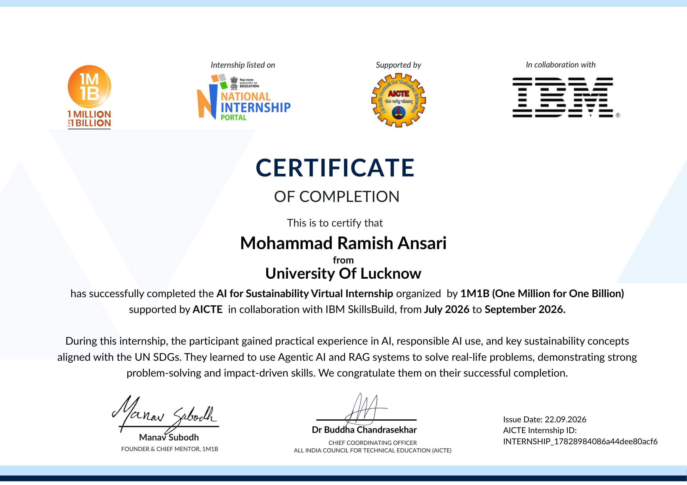
Internship completion certificate issued by 1M1B, supported by AICTE, in collaboration with IBM SkillsBuild (issued 22 September 2026)

ABSTRACT

This report documents a six-week virtual summer internship carried out under the 1M1B AI for Sustainability Virtual Internship, an AICTE-listed programme delivered in collaboration with IBM SkillsBuild. The internship combined guided learning on artificial intelligence with a project requirement: identify a real sustainability problem and design an AI-assisted response to it. The work described here was carried out between July and September 2026 and was certified on 22 September 2026.
The project developed during the internship is SwachhAI, a decision-support concept for household waste segregation in Indian cities. Its starting observation is simple: most Indian households do not sort their waste, not because they are indifferent, but because the correct answer for a specific item is rarely available at the moment it is thrown away. SwachhAI addresses that gap with three cooperating modules — a classifier that maps an item to one of eight waste streams with a stated confidence, a retrieval-augmented rule assistant that answers questions about municipal waste rules only from cited public documents, and an impact forecaster that converts a household’s habits into a transparent estimate of waste diverted and carbon dioxide equivalent avoided.
The report explains the technologies involved in plain technical language: machine learning, large language models, the IBM Granite family, prompt engineering, retrieval-augmented generation, agentic AI and responsible AI. It describes the problem, the users, the conceptual architecture and the three modules through block diagrams, workflow diagrams, tables and illustrative examples. It states clearly what the project claims and what it does not, and it distinguishes modelled estimates from measured results.
No working model was built for this report. The report is an academic document, not a software deliverable: it explains a design, its reasoning and its limits. The most important learning recorded is that the hard part of applied AI in the public interest is not the model. It is deciding when the model should decline to answer, what evidence an answer must be built from, and who remains accountable when the answer reaches a person standing at a dustbin with five seconds to spare.

Keywords: artificial intelligence, large language models, IBM Granite, retrieval-augmented generation, prompt engineering, agentic AI, responsible AI, solid waste management, source segregation, circular economy, Sustainable Development Goals 11, 12 and 13.

ACKNOWLEDGEMENT

An internship that begins with a form and a deadline is completed by people. I am grateful to several of them.
I thank 1M1B (One Million for One Billion) for designing a programme that treated a college student as capable of working on a real problem, and for the mentors who reviewed progress week after week. I thank the All India Council for Technical Education (AICTE) for listing and supporting the internship, and the AICTE National Internship Portal for the infrastructure that made the placement possible. I thank IBM SkillsBuild for the guided learning plan, the digital badges, and the grounding in Granite, retrieval-augmented generation and responsible AI that made the project technically possible.
At the University of Lucknow, Lucknow, I thank the faculty and staff of the Department of Computer Science and Engineering for the academic grounding in data structures, databases, operating systems and programming that this work leaned on, and for the guidance on this report’s prescribed format.
I thank my family for tolerating a summer of early calls and late drafts, and my classmates for arguing with me about the design until it improved.
Any error that remains is mine. The interpretations, diagrams and judgement calls in this report are my own work, prepared within the University’s academic honesty requirements and the internship’s ethical-use expectations.

Mohammad Ramish Ansari
B.Tech. Computer Science and Engineering, Semester V
University of Lucknow, Lucknow

TABLE OF CONTENTS

Right-click and choose “Update Field” to build the table of contents.

The table of contents is a live Word field: all entries are clickable and page numbers follow the pagination of this document. It is configured to update automatically when the file is opened; if it does not, select the field and press F9.

LIST OF TABLES

Table 1: Internship objectives and what each one required in practice
Table 2: Structure of the internship, reconstructed from its official documents
Table 3: Proposed internship window and certified completion period
Table 4: Technology introduced during the internship and where it appears in SwachhAI
Table 5: Learning outcomes recorded, with the evidence for each
Table 6: Limits of a large language model, and how the project responds to each
Table 7: Indian rules and standards relevant to household waste
Table 8: Target users and what each one needs from the system
Table 9: Contribution of SwachhAI to individual Sustainable Development Goal targets
Table 10: The eight waste streams, with the handling each one needs
Table 11: Module 1: inputs, outputs and technologies
Table 12: Module 2: inputs, outputs and technologies
Table 13: Module 3: inputs, outputs and technologies
Table 14: Impact coefficients used by the forecaster, and what they represent
Table 15: Worked example: one household adopting all three practices for a year
Table 16: Personal data the system does and does not touch
Table 17: Known limitations of the proposed approach
Table 18: Skills developed, and the level honestly claimed for each
Table 19: Future scope, grouped by the phase in which it would be justified
Table 20: How each kind of claim in this report is supported
Table 21: Student and internship particulars, as recorded in the documents

LIST OF FIGURES

Figure 1: The organisations involved in the internship and the role each one played
Figure 2: Dates as they appear in the official documents
Figure 3: Where the internship sat inside the wider family of AI technologies
Figure 4: How a large language model turns a prompt into a response, one token at a time
Figure 5: The two halves of retrieval-augmented generation: building the index, then answering from it
Figure 6: The perceive-decide-act-learn loop of an agentic assistant
Figure 7: The five responsible-AI behaviours the project commits to
Figure 8: From observed symptom to addressable cause in household waste segregation
Figure 9: What one badly sorted bag costs, downstream
Figure 10: System context: what SwachhAI talks to, and what it deliberately does not
Figure 11: How SwachhAI maps to Sustainable Development Goals 11, 12 and 13
Figure 12: The eight waste streams used as the project’s knowledge graph
Figure 13: Module 1: how one item travels through the classifier
Figure 14: Module 2: the retrieval-grounded rule assistant
Figure 15: Module 3: from household inputs to a transparent estimate
Figure 16: Conceptual system architecture of SwachhAI
Figure 17: End-to-end workflow of a single household interaction
Figure 18: Illustrative mock-up of the classification screen (not a working application)
Figure 19: Illustrative mock-up of the impact forecaster screen (a modelled example, not measurements)
Figure 20: A staged path from a campus pilot to city-level analytics

CHAPTER 1

INTRODUCTION

1.1 What a summer internship is for
A summer internship is the part of an engineering degree in which a student stops studying technology and starts using it on somebody else’s problem. Until that point, almost every exercise a student completes has three convenient properties: the question is already framed, the data is already clean, and the answer is already known to the person who will mark it. Industry does not work that way. A real requirement arrives incomplete, the data has gaps, several solutions are defensible, and someone has to decide which one is worth building.
The All India Council for Technical Education (AICTE) treats this gap as a structural part of technical education rather than an optional extra, and maintains an internship portal through which students are placed with companies, research organisations and government programmes. AICTE’s model curriculum and its internship guidelines treat practical exposure as part of the assessment of a degree programme, and universities usually require a written report so that the learning can be reviewed by a faculty member rather than taken on trust. This report is that document.
For a Computer Science and Engineering student, the internship has a second purpose. Coursework teaches a subject in isolation: a database course teaches normalisation, a machine learning course teaches gradient descent. An internship teaches the interaction between subjects — that a model which is 92 per cent accurate can still be useless if the interface does not show its confidence, that a service which is technically correct can still fail if the person using it has four seconds and one hand free. That interaction is what an employer is actually buying, and it is difficult to teach in a lecture hall.

1.2 Why internships matter for engineering students
There are four things an internship supplies that a classroom cannot supply on its own, and all four appear in the work described in this report.
• Contact with a real constraint. The problem chosen for this internship was not invented for assessment. Household waste segregation in India is a live public problem with published rules, published shortfalls and an actual person at the end of every decision. Working on it meant accepting constraints that no assignment imposes.
• Exposure to professional tools and vocabulary. The internship introduced IBM Granite models, retrieval-augmented generation, prompt engineering, agentic design patterns and responsible-AI review. These are not exotic research topics; they are the current working vocabulary of applied AI, and meeting them early changes what a student reads and what a student builds.
• Practice at written and visual communication. A technical decision that nobody else can follow is not yet an engineering decision. The internship required a concept note, a project document and a presentation, each addressed to a different reader. The diagrams and tables in this report are a direct result of that requirement.
• Practice at judging one’s own claim. The most useful professional habit gained was the discipline of separating what a system is designed to do from what it has been shown to do. That distinction appears repeatedly in later chapters, and it is the reason this report contains no invented test results.

There is also a plain, practical reason. Internship experience is the first evidence a student can offer that the degree has been used for something. For a third-year student preparing for placements, a documented project with a stated problem, a stated design and a stated set of limits is more persuasive than a list of technologies studied, because it demonstrates a sequence of decisions rather than a sequence of topics.

1.3 Artificial intelligence and sustainability
Artificial intelligence and sustainability are usually discussed in two separate conversations, and the internship was designed to put them in one. The first conversation is about what AI can do: recognise an image, answer a question in natural language, forecast a quantity, generate a document. The second is about what the planet can afford: how much waste is generated, how much of it is recovered, how much methane escapes from a landfill, and how quickly cities can change behaviour at the household level.
The connection between them is not automatic. AI systems consume electricity and water during training and inference, and an AI application that solves a trivial problem is a net cost. The useful framing, and the one the internship adopted, is narrower: AI is worth deploying where a problem is linguistic, visual or contextual — where a fixed set of rules cannot cover the variety of real inputs, but a learned or retrieved answer can. Waste segregation is exactly that kind of problem. A printed poster cannot tell a resident whether a particular milk pouch, with a particular residue inside it, belongs in the dry bin; a system that understands an item description and can quote the applicable rule can.
The same reasoning explains why the internship placed responsible AI beside the technical content rather than after it. A system that tells households what to do with their waste is making claims about public rules. If it invents a rule, it does not merely produce a wrong answer; it sends a battery into a bin where a sanitation worker will reach for it. The design constraint that follows — answer only from cited documents, and refuse when the documents do not cover the question — is a technical decision with an ethical origin, and it is developed in Chapter 6 and Chapter 8.

1.4 The internship in brief
The internship was the 1M1B AI for Sustainability Virtual Internship, offered by 1M1B (One Million for One Billion), supported by AICTE and delivered in collaboration with IBM SkillsBuild. It was a virtual, six-week programme built around guided learning, weekly mentor interaction and a final project that applied AI to a sustainability problem. The project submitted at the end of the internship was SwachhAI — AI-Guided Waste Segregation and Circularity Assistant for India’s Households.
The programme’s own documents describe its purpose as developing industry-relevant AI skills in the context of sustainable development: working with AI and machine learning concepts, large language models, IBM Granite models, retrieval-augmented generation frameworks and agentic AI systems, and applying them to climate action, clean energy, waste reduction, biodiversity and sustainable cities. The structure of the internship, its partners and its schedule are described in Chapter 2.
This report is deliberately written as documentation rather than as a software submission. It explains the problem, the technology, the design and the limits of the proposed concept. It contains no source code, no deployment instructions and no performance claims, because the deliverable required by the University is an academic report and because the honest description of an untested design is a design document, not a product announcement.

1.5 How this report is organised
The report follows the sequence in which the work actually happened. Chapter 2 describes the organisations, the internship’s objectives and its certified duration. Chapter 3 states what the internship set out to achieve and what was actually gained. Chapter 4 explains the technologies at the level a third-year student should be able to defend in a viva. Chapter 5 establishes why the project was worth doing. Chapter 6 introduces the concept and the users. Chapter 7 is the technical core: three modules, an architecture and a workflow. Chapter 8 examines what could go wrong and what the design does about it. Chapter 9 records what was learned and what would come next, and Chapter 10 closes the report. References and appendices follow.
Two conventions are used throughout. First, every figure and table is numbered and referred to by number in the text, and every reference to a chapter in this document is a working link in the digital edition. Second, any number that is an estimate is labelled as an estimate at the point where it appears; the report does not repeat a modelled figure often enough for it to start looking like a measurement.

CHAPTER 2

ORGANIZATION AND INTERNSHIP OVERVIEW

2.1 Introduction to 1M1B
1M1B stands for One Million for One Billion. It is the organising body of the internship: the organisation that designed the programme, ran the sessions, assigned mentors and assessed the final project. Its self-description, as it appears on the programme’s material, is a mission to mobilise a million young people in India to create impact at the scale of a billion — a formulation that explains the name. In practice, its work with students takes the form of structured programmes that combine awareness of the Sustainable Development Goals with practical technology skills, delivered in partnership with industry and with government bodies.
What matters for this report is the shape of the programme rather than the organisation’s history. The internship was virtual, which meant that participation did not depend on being in a particular city; it was cohort-based, which meant that interns progressed through the same milestones at roughly the same time; and it was project-based, which meant that the certificate depended on producing a piece of work rather than on attendance alone. The programme’s terms state that certification requires participation in weekly mentor sessions, completion of the weekly tasks and milestones, completion of the SkillsBuild learning plan, and submission of the final project presentation.
The programme was explicitly unpaid: the offer letter states that no stipend or financial remuneration is provided. This is normal for a learning-oriented, government-supported programme, and it is recorded because a report should state the terms under which the work was done.

2.2 The role of AICTE
The All India Council for Technical Education is the statutory body responsible for the planning and coordinated development of technical education in India. Its involvement in this internship took three concrete forms, each visible in the documents reproduced in the appendices.
1. Listing and support. The internship was listed on the AICTE National Internship Portal, which is AICTE’s mechanism for connecting students with internship opportunities and for recording that the opportunity has been recognised. The offer letter names the portal explicitly, describing the programme as offered by 1M1B “in collaboration with AICTE (National Internship Portal)”.
2. Co-signature on the completion certificate. The certificate reproduced in this report carries the signatures of the Founder and Chief Mentor of 1M1B and of the Chief Coordinating Officer of AICTE. The AICTE signature is not decorative; it is the reason the certificate is usable as evidence for a university requirement.
3. An internship identity. The certificate records an AICTE Internship ID, INTERNSHIP_17828984086a44dee80acf6, which is the same identifier that appears in the offer letter and in the project document. That continuity is what makes the three documents traceable to one another.

For a student, the practical consequence is that the internship is not an informal arrangement between an individual and a company. It is a recognised activity, recorded in a national system, with a certificate that a university can accept.

2.3 The role of IBM SkillsBuild
IBM SkillsBuild is IBM’s free digital learning platform. In this internship it supplied the technical curriculum and the credentialing. The offer letter describes access to the SkillsBuild platform with more than eighty thousand curated courses, and lists the technical scope of the programme as AI and machine learning concepts, large language models, IBM Granite models, retrieval-augmented generation frameworks and agentic AI systems.
The platform’s role is visible in the certificate structure. Two of the documents reproduced in this report are IBM SkillsBuild completion certificates, issued on 1 August 2026 and 5 August 2026 for the completion of two learning plans associated with the internship. They are Completion Certificates of the SkillsBuild learning system, and they are distinct from the internship completion certificate issued by 1M1B on 22 September 2026. The distinction matters and is stated in Section 2.5: a learning-plan certificate records that a module was completed, while the internship certificate records that the whole programme, including the project, was completed.
The technology named in the internship’s own material — IBM Granite — is IBM’s family of enterprise foundation models. The internship did not require training a model; it required understanding what such a model can and cannot be trusted to do, and how to constrain it with prompts, retrieval and review. That understanding is the subject of Chapter 4.
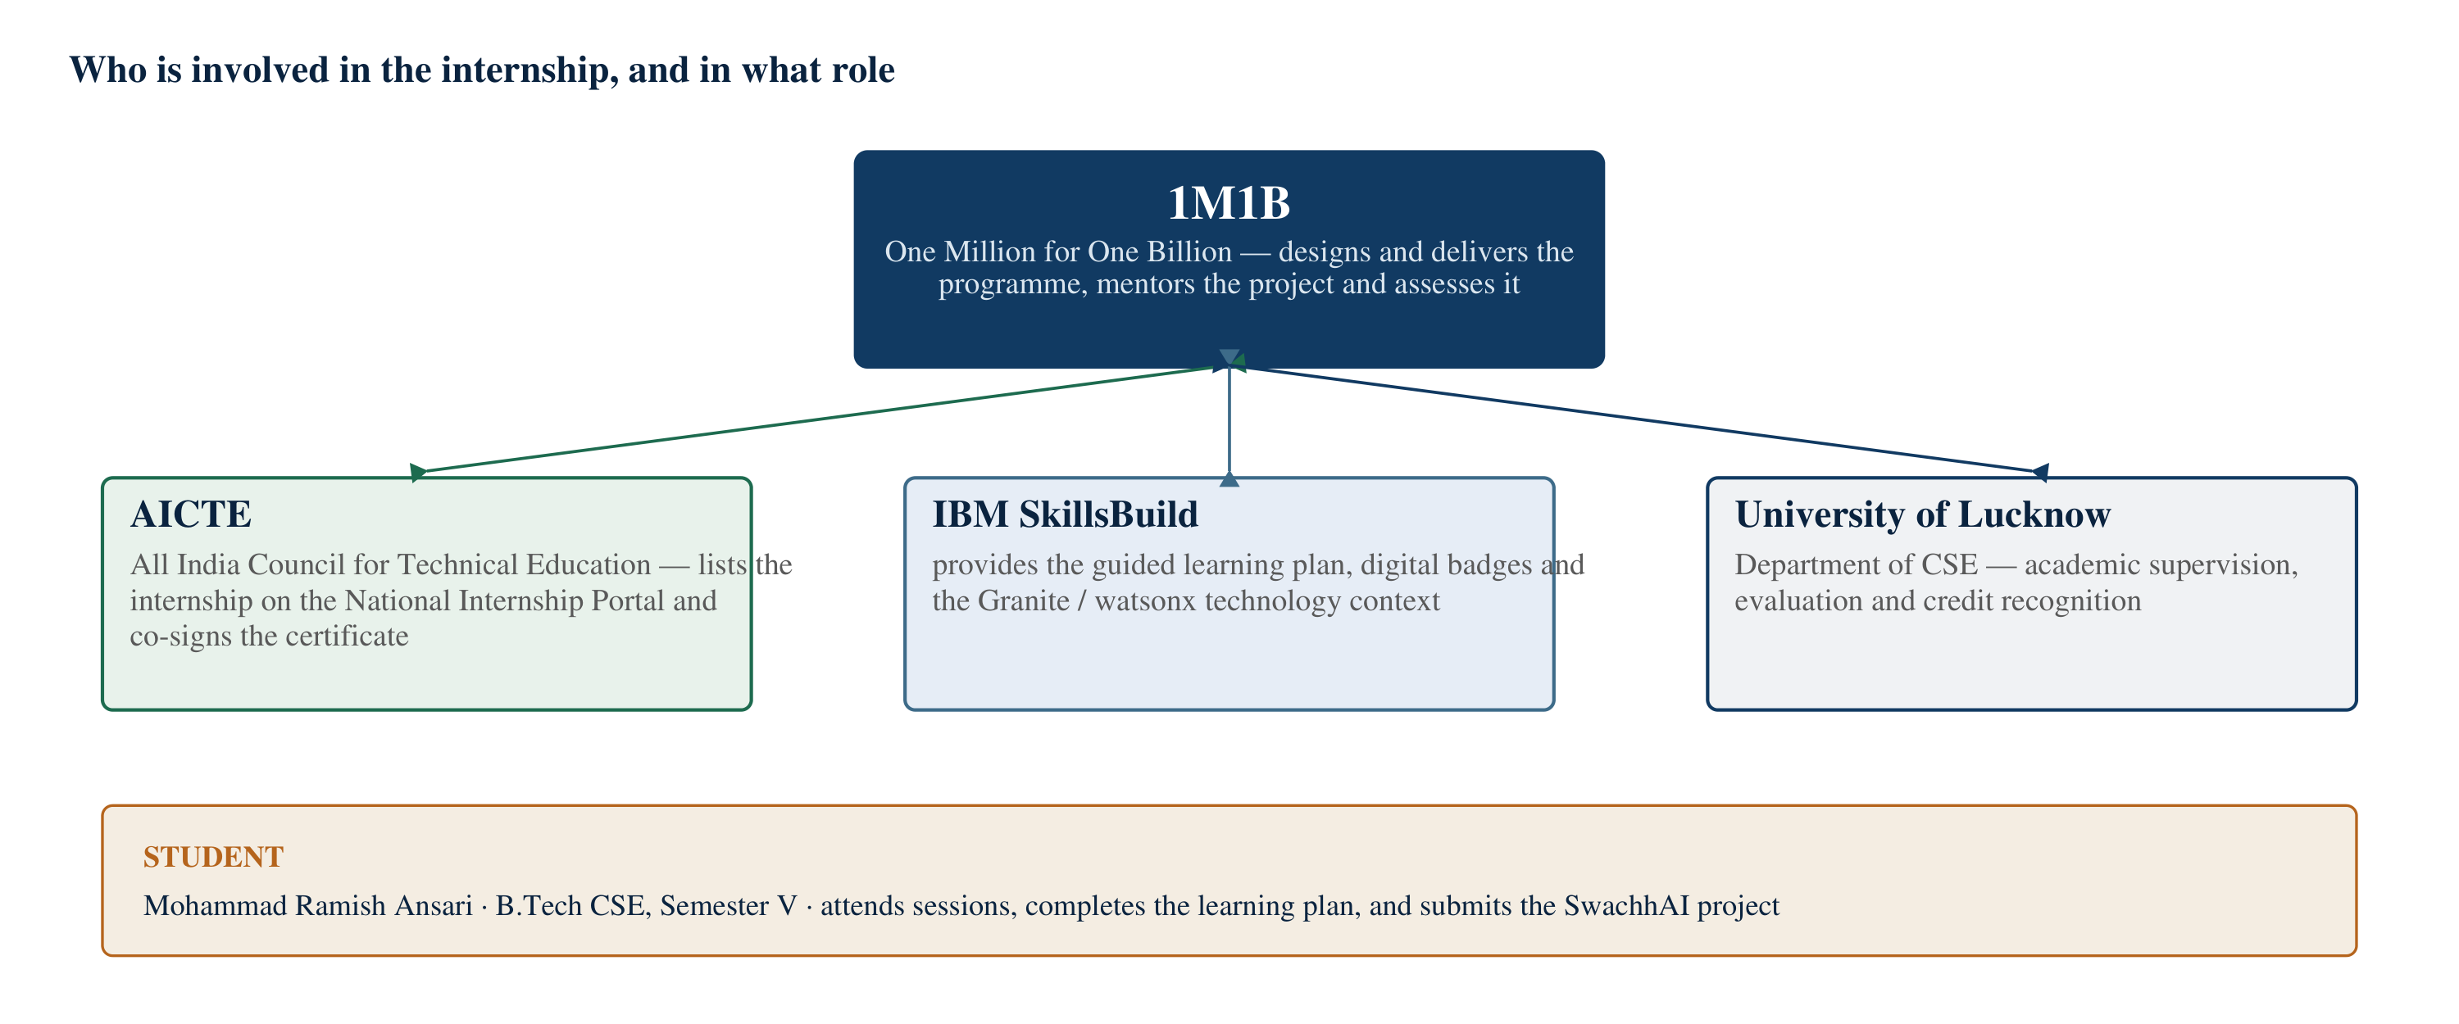
Figure 1: The organisations involved in the internship and the role each one played
The figure above shows the five parties involved and what each one contributed. The student appears at the bottom because that is the honest hierarchy: the programme supplied structure and access, the technology partners supplied tools and curriculum, the University supplied the academic frame, and the work itself was done by the intern.

2.4 Internship objectives and structure
The internship’s objectives can be taken directly from its own documents rather than reconstructed. The offer letter lists its highlights and its expectations; the programme structure described below follows that list, grouped into five objectives for clarity.
Table 1: Internship objectives and what each one required in practice
No. | Objective stated for the internship | What it required in practice
1 | Develop industry-relevant AI skills in the context of sustainable development | Working through the SkillsBuild guided learning plan on AI, machine learning, large language models and IBM Granite, and applying the concepts to a live problem rather than to a textbook exercise
2 | Explore the intersection of AI and climate action, clean energy, waste reduction, biodiversity and sustainable cities | Choosing a specific sustainability problem, researching its published policy and science context, and justifying why an AI approach is appropriate to it
3 | Design and prototype an AI-powered sustainability solution with expert mentors | Preparing a concept note, developing the modules on paper, presenting them for mentor feedback, and revising the design in response
4 | Learn directly from AI and emerging-technology professionals | Attending the scheduled live sessions and workshops, and using the mentor sessions to test design decisions against practitioner judgement
5 | Complete the guided learning modules, self-learning labs, digital badges and the final project | Meeting the weekly milestones, completing the two SkillsBuild learning plans, and submitting the final project document, video and repository as required
Source: AICTE Internship Offer Letter for the 1M1B AI for Sustainability Virtual Internship (internship ID INTERNSHIP_17828984086a44dee80acf6).
Structurally, the programme ran as a repeating weekly cycle rather than as a single course. Each week combined self-paced learning on IBM SkillsBuild, one or more live sessions with mentors, a task or milestone to be completed, and feedback. The final weeks were given to the project: framing the problem, designing the response, documenting it and presenting it.
Table 2: Structure of the internship, reconstructed from its official documents
Stage | Focus | What the intern did
Orientation | Programme briefing, expectations and terms | Reviewed the offer letter and its terms, confirmed participation, and returned the signed declaration dated 27 July 2026
Weeks 1–2 | Foundations of AI, machine learning and responsible AI | Completed the opening modules of the SkillsBuild learning plan; attended the scheduled live sessions; began researching sustainability problems
Weeks 3–4 | Large language models, IBM Granite, prompt engineering, retrieval-augmented generation, agentic AI | Worked through the technical modules; completed the first SkillsBuild learning plan (certificate dated 1 August 2026); shortlisted the waste-segregation problem
Weeks 5–6 | Solution design and project development | Framed the problem statement, defined users, designed the three modules and the architecture, and prepared the project document; completed the second SkillsBuild learning plan (certificate dated 5 August 2026)
Final phase | Project submission and presentation | Submitted the final project document on 14 September 2026 and presented the work; the internship completion certificate was issued on 22 September 2026
Reconstructed from the internship offer letter, the two IBM SkillsBuild completion certificates, the SwachhAI project document and the internship completion certificate. The ordering reflects the programme’s stated requirements; it does not claim to reproduce the content of any confidential session.
The sessions themselves are covered by the confidentiality clause of the offer letter, which prohibits disclosure of course material, session content and project-related discussions without written approval. This report therefore describes the structure of the programme and the learning outcomes it produced, and does not reproduce slides, recordings, internal documents or meeting links.

2.5 Internship duration and the dates that govern this report
Three different documents give three different date ranges, and a report that mixes them carelessly becomes inaccurate. The three are set out below exactly as they appear, followed by the reading this report adopts.
Table 3: Proposed internship window and certified completion period
Document | Date or period stated | What it establishes
AICTE Internship Offer Letter (declaration signed 27 July 2026) | “A period of 6 weeks, from 28th July 2026 to 28th August 2026” | The proposed internship window at the time of selection
IBM SkillsBuild completion certificate 1 (PLAN-56138075980A) | Completion date 01 August 2026 (GMT) | Completion of one learning plan within the internship
IBM SkillsBuild completion certificate 2 (PLAN-F60F1D7DADA9) | Completion date 05 August 2026 (GMT) | Completion of the second learning plan within the internship
SwachhAI final project document | Submission date 14 September 2026 | The date on which the project deliverable was submitted
Internship completion certificate (the governing document) | “from July 2026 to September 2026”; issue date 22.09.2026 | The actual certified period of the internship
Where this report states a duration, it follows the completion certificate, because that is the document which certifies successful completion. The offer letter’s six-week window is referred to only as the proposed window.
Reading the dates. The offer letter proposed a six-week internship beginning on 28 July 2026. The completion certificate, issued on 22 September 2026, records that the internship ran from July 2026 to September 2026. Both statements are accurate about their own moment: the first is a plan, the second is a record. This report describes the internship as a six-week programme that ran from July to September 2026, and dates individual events — the declaration, the two learning-plan certificates, the project submission and the final certificate — exactly as the documents state them.
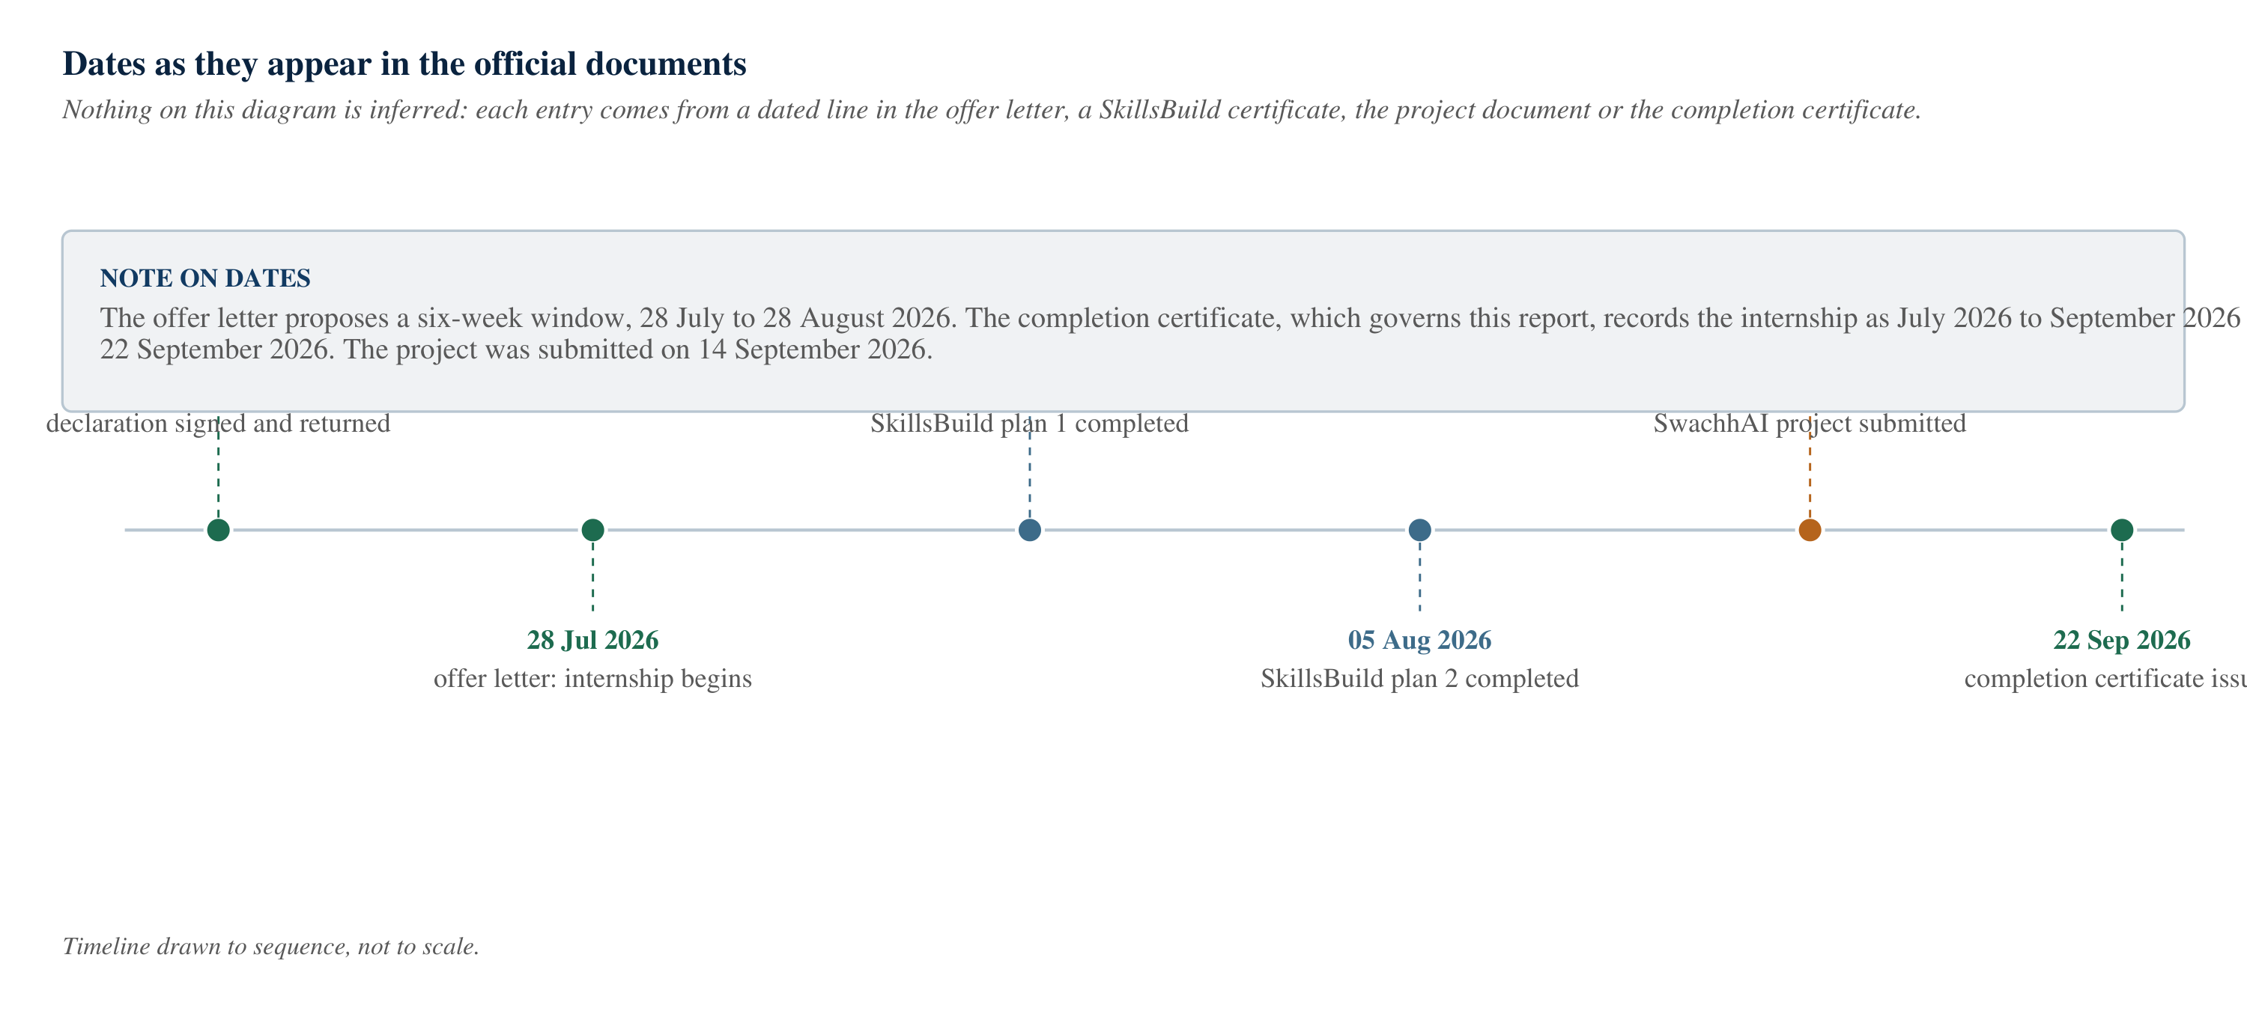
Figure 2: Dates as they appear in the official documents

2.6 Learning sessions and activities
Without reproducing restricted material, the activities that shaped this report can be described at the level of what they asked of the intern. Four kinds of activity recurred.
• Guided learning. Self-paced modules on the IBM SkillsBuild platform, organised as learning plans with checkpoints, covering AI and machine learning fundamentals, generative AI and large language models, prompt engineering, retrieval-augmented generation, agentic systems and responsible AI. Two plan completions are evidenced by the SkillsBuild certificates of 1 and 5 August 2026.
• Live mentor sessions. Scheduled online sessions with practitioners from 1M1B and IBM. Their value was less in new facts than in pressure-testing decisions: whether a problem was narrow enough to be solved, whether a proposed use of a language model was justified, and whether a claimed benefit could be measured.
• Milestone tasks. Weekly deliverables that converted learning into an artefact — a problem shortlist, a concept note, a design description, a presentation. The project document submitted on 14 September 2026 is the final accumulation of these.
• The final project. A complete proposal for an AI-assisted sustainability solution, submitted with a concept note, a short video and a code repository. The project described in this report is that submission.

Two aspects of the programme deserve specific mention because they shaped the project’s character. First, the internship’s material returned repeatedly to responsible AI — fairness, transparency, privacy and human oversight were presented as design requirements rather than as concluding remarks. Second, the programme asked for a solution to a field problem rather than a demonstration of a technique. The project could not be “a chatbot”; it had to be a response to something specific that was failing in the world. That requirement is what produced the problem statement in Chapter 5.

CHAPTER 3

OBJECTIVES AND LEARNING OUTCOMES

3.1 Introduction
This chapter separates two things that are often merged in internship reports: what the internship set out to achieve, and what the intern actually gained. The first is a statement of intent and can be listed from the programme documents. The second is a claim about the student and has to be supportable — which is why each learning outcome below is tied to something that appears in this report or in an appended document, rather than to an adjective.

3.2 Technical objectives
The technical objectives were stated in the internship’s own material and are reproduced with their practical meaning.
1. Understand the AI and machine learning pipeline well enough to reason about it. Not to implement a neural network from scratch, but to understand what a model learns, what it does not learn, what data it requires and where it fails. This objective is addressed in Section 4.1.
2. Understand large language models and the IBM Granite family. How a language model generates text, why it can produce confident errors, and what an enterprise-oriented, open model family such as Granite is designed for. See Section 4.2 and Section 4.3.
3. Learn prompt engineering as a design discipline. Writing instructions that constrain the output format, set a refusal rule and fix the tone, and then testing whether the model obeys them. See Section 4.4.
4. Understand retrieval-augmented generation. Why an answer assembled from retrieved public documents is more trustworthy than an answer drawn from a model’s memory, and what the retrieval pipeline actually looks like. See Section 4.5.
5. Understand agentic AI. The difference between a single question-and-answer exchange and a loop that perceives, decides, acts and learns. See Section 4.6.
6. Apply all of the above to one sustainability problem. Not five problems. One, described well enough to be criticised. That application is Chapter 6 and Chapter 7.

A seventh objective emerged during the work and was not in the original list: to produce technical documentation that a non-specialist could follow. Explaining a retrieval pipeline to a reader who has not met one is a different skill from building it, and it is the skill this report exists to demonstrate.

3.3 Professional learning objectives
The programme’s terms set out professional expectations alongside technical ones: consistent participation, professional conduct, timely deliverables, confidentiality, ethical compliance and academic integrity. These are not abstract virtues in a virtual internship; each corresponds to a specific behaviour.
• Working to a schedule without a supervisor in the room. A virtual internship has no corridor conversations. Milestones either arrive or they do not, and the intern is responsible for the difference.
• Receiving and using criticism. Mentor feedback on an early concept note was the reason the project shifted from a general “AI for waste” idea to a specific household decision moment. Accepting that redirection quickly was more valuable than defending the first idea.
• Respecting confidentiality. The offer letter prohibits disclosure of course material, session content and project discussions. This report deliberately describes structure and outcomes rather than content, and it does not reproduce meeting links, internal documents or restricted material.
• Using AI tools honestly. The internship explicitly required responsible use of AI tools. In practice that meant using such tools for drafting and for checking wording, while keeping the problem framing, the design decisions and the technical claims the intern’s own.
• Documenting work as it happens. A project document written from memory at the end is a reconstruction. Keeping notes during the design phase is what made the module descriptions in Chapter 7 possible.

3.4 Exposure to AI and emerging technology
For a third-year student, the internship’s most valuable contribution was vocabulary with meaning attached. The table below records the technologies the internship introduced, and where each one surfaces in the project. The mapping is the reason the project is coherent rather than a list of buzzwords.
Table 4: Technology introduced during the internship and where it appears in SwachhAI
Technology | What it means, briefly | Where it appears in SwachhAI
Artificial intelligence and machine learning | Programmes that perform tasks associated with intelligence, usually by learning patterns from examples | The classification of an item description into a waste stream
Generative AI and large language models | Models that produce new text by predicting likely continuations, conditioned on a prompt | Understanding free-form item descriptions and composing guidance in plain language
IBM Granite | IBM’s family of open, enterprise-oriented foundation models, designed to be fine-tuned and prompted for business tasks | The model class the classifier and the assistant are designed around
Prompt engineering | Designing the instruction, examples, output format and refusal rules given to a model | The classifier prompt, which fixes a JSON output shape and a confidence threshold
Retrieval-augmented generation | Retrieving relevant passages from a document collection and requiring the model to answer only from them | The rule assistant, which answers waste-rule questions with citations
Agentic AI | A loop in which a system perceives, decides, acts and learns, using tools, rather than answering one question at a time | The overall interaction model, including the pattern log that feeds taxonomy review
Responsible AI | Design practices for fairness, transparency, privacy, safety and human oversight | Confidence display, honest refusal, client-side processing and human review gates

Two things are worth noting. None of the seven is exotic — all are in current industrial use, which is why the internship covered them. And they are layered rather than parallel: prompting and retrieval are techniques for using a language model, agentic design is a pattern for organising those uses, and responsible AI is a set of constraints on all of it. The next chapter explains each layer in turn.

3.5 Skills and knowledge gained
The table below states each outcome with the evidence that supports it. It is deliberately conservative: where an outcome is a change in understanding rather than a demonstrable artefact, the evidence is the explanation given in this report, not a certificate.
Table 5: Learning outcomes recorded, with the evidence for each
Outcome | What was actually gained | Where it is evidenced
Technical literacy in applied AI | The ability to explain, in plain terms, what a language model does, why it hallucinates, and what retrieval and prompting change about that | Chapter 4 of this report
Design under constraint | Practice at reducing a broad problem to a specific intervention, and at rejecting features that could not be justified | Chapters 5 to 7
Responsible-AI reasoning | The habit of asking, for each capability, what happens when it is wrong, and who is harmed | Chapter 8; the system disclosure table
Policy and standards research | Locating and reading primary sources — the Solid Waste Management Rules, 2016, the E-Waste and Battery Waste Rules, 2022 — instead of relying on summaries | Chapter 5 and the References
Quantitative reasoning about impact | Converting behaviour change into a defensible estimate, and stating its uncertainty instead of hiding it | Section 7.3 and Table 16
Technical writing and diagramming | Explaining an architecture to a reader who did not design it, using block diagrams, workflows and tables | Every figure and table in this report
Professional discipline | Meeting milestones without supervision, and separating what was done from what was intended | Sections 2.5 and 2.6; the appendices

What was not gained. It would be easy to overstate this section. The internship did not make the intern a machine learning engineer: no model was trained, no dataset was curated and no benchmark was reproduced. What it did produce is a working understanding of how these systems are assembled, constrained and supervised — which is the appropriate outcome for a six-week programme, and the honest one to record.

CHAPTER 4

TECHNOLOGY OVERVIEW

4.1 Artificial Intelligence and Machine Learning
Artificial intelligence is the name for the project of getting computers to do things that would require intelligence if a person did them: recognising a face, understanding a sentence, choosing a route, recommending a film. Machine learning is the dominant approach to that project today. Instead of writing rules that describe how to perform the task, a machine learning system is given examples and adjusts internal numbers until its outputs match the examples. The rules are discovered, not written.
The distinction matters for the SwachhAI project. A rule-based waste application would consist of a long list of item names and their bins. It would work for the items on the list and fail for everything else — and household waste is precisely the domain where “everything else” dominates. A resident types “doodh ka packet”, then “milk pouch”, then “plastic milk cover”, then “bananna peel” with a typo. A learned model generalises across these variations in a way that a list cannot.
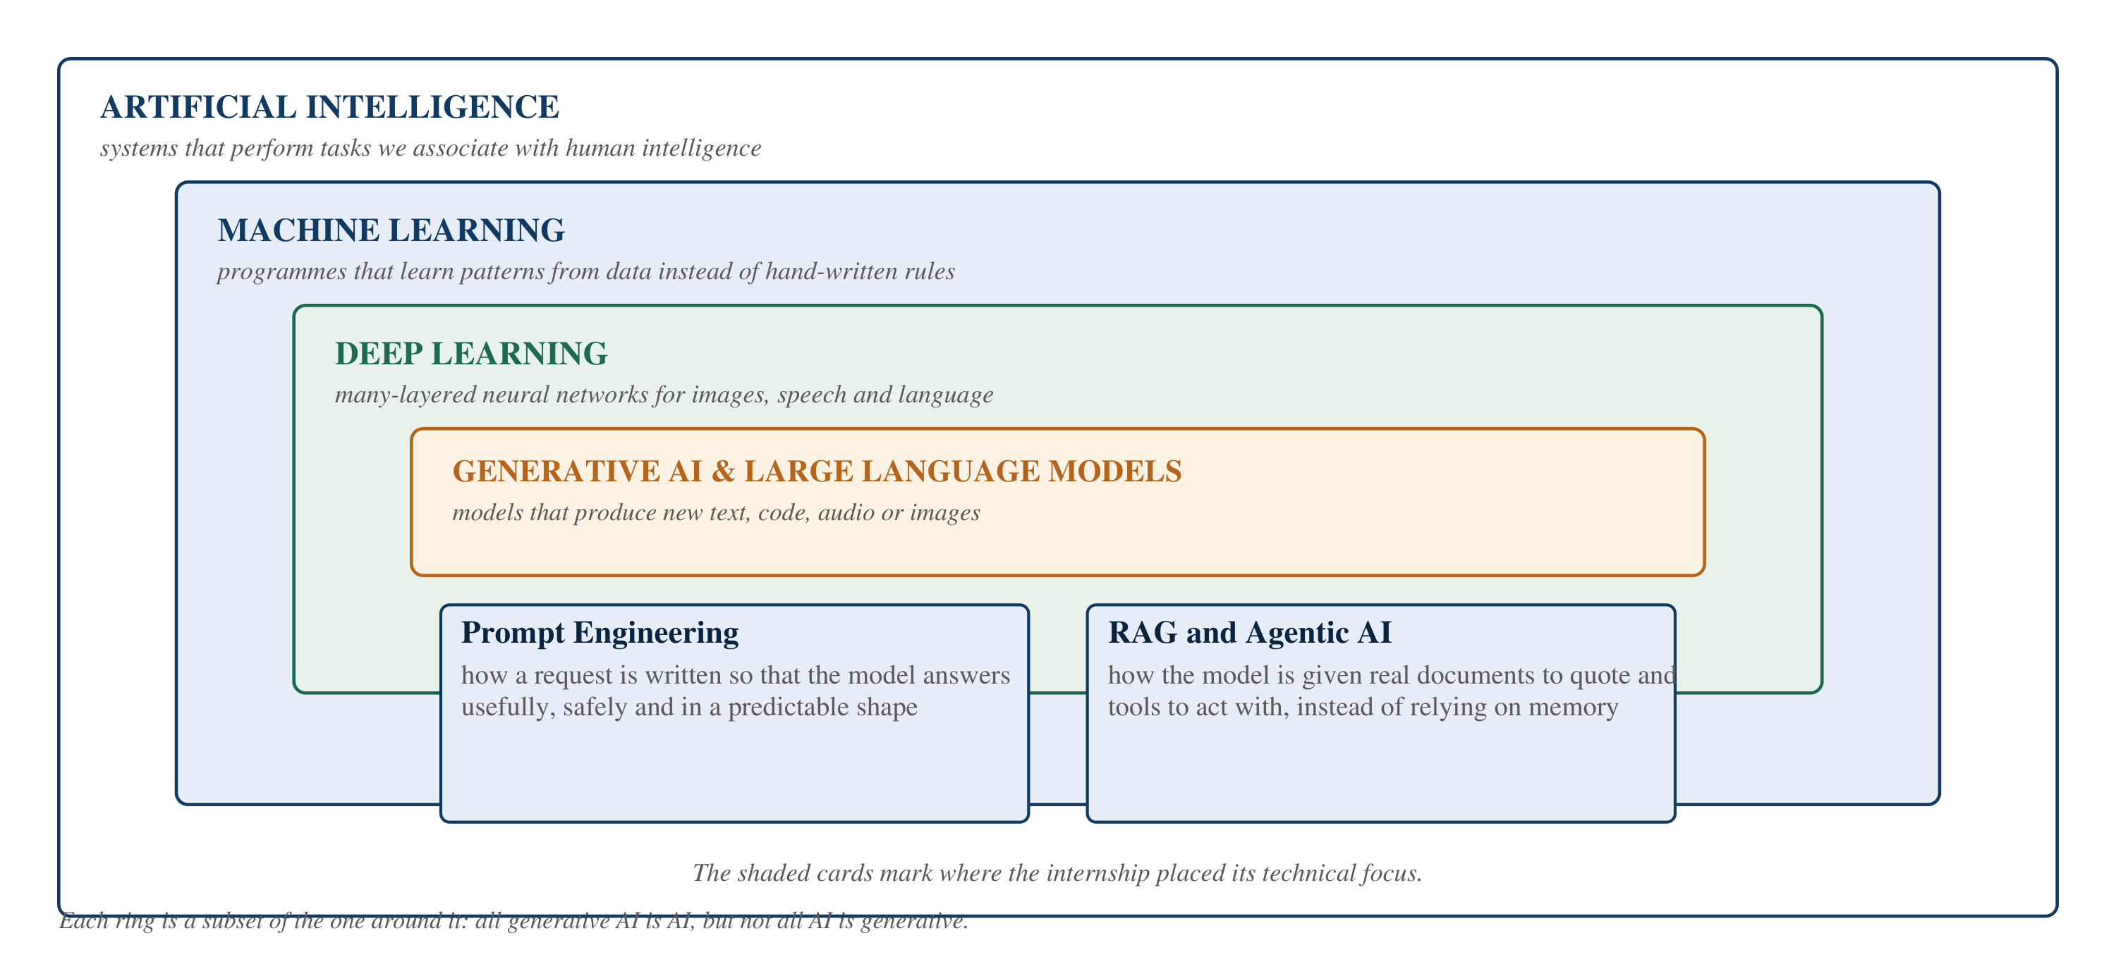
Figure 3: Where the internship sat inside the wider family of AI technologies
Three families of machine learning are worth distinguishing, because they correspond to three different jobs. Supervised learning learns from labelled examples: here are ten thousand photographs of waste, each already labelled with its stream, learn to label new ones. Unsupervised learning looks for structure without labels: here are a city’s collection records, find the neighbourhoods that behave differently. Reinforcement learning learns from reward: take this action, receive this score, improve. The project’s classifier is conceptually a supervised classification task; the impact forecaster is deliberately not a learned model at all, for reasons given in Chapter 6.
Every learned model carries three properties that a user should know about. It has a training distribution — the kind of data it has seen — and it degrades outside it; a classifier trained on urban Indian household waste should not be trusted on hospital waste. It has an error rate, and errors are not uniformly distributed: a model may be excellent at plastics and poor at composite items. And it has a confidence that is useful only if it is calibrated, meaning that when the model says 80 per cent, it is right about eighty times in a hundred. The project’s decision to display confidence on every classification, and to treat anything below 75 as “unknown”, follows directly from this third property.

4.2 Large Language Models
A large language model is a machine learning model trained to predict the next token in a sequence of text. A token is a fragment of a word — often a whole short word, sometimes part of a longer one. Training exposes the model to an enormous quantity of text and adjusts its parameters so that, given any preceding text, it assigns high probability to continuations that resemble real writing.
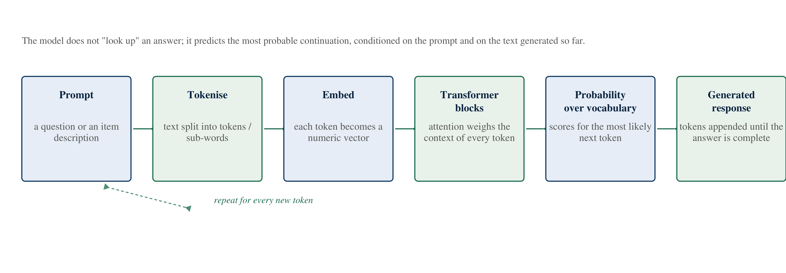
Figure 4: How a large language model turns a prompt into a response, one token at a time
Two consequences of this design matter for the project. First, the model has no database to consult. When it produces a statement about the Battery Waste Management Rules, 2022, it is producing a plausible continuation, not retrieving a record. It may be right because such statements appeared in its training data; it may be wrong in a way that reads exactly the same. This failure mode is usually called hallucination, and it is the single most important limitation to design around in an application that gives advice about public rules.
Second, the model’s behaviour is steerable through the text it is given. That steering is what prompt engineering does, and it is also what makes retrieval-augmented generation possible: if the relevant rule text is placed in front of the model and the model is instructed to answer only from that text, the probability of a fabricated rule drops sharply — though, as described in Section 4.5, it does not fall to zero.
Table 6: Limits of a large language model, and how the project responds to each
Property | What it means | How the project responds
Probabilistic output | The same prompt can produce different wording on different runs | The classifier prompt fixes a strict JSON output shape, so the interface always receives the same fields
No guaranteed factual grounding | Statements about rules may be invented and are hard to distinguish from true ones | The rule assistant may answer only from retrieved passages, and must cite them
Context window limits | Only a bounded amount of text can be supplied with a question | Retrieval selects a small number of passages rather than pasting whole documents
Sensitivity to phrasing | Small changes in the prompt can change the output materially | Prompts are treated as versioned design artefacts and reviewed like code
Language bias | Performance is usually weaker in low-resource languages and in transliterated text | The prompt explicitly accepts Hinglish, romanisation and misspellings, and falls back to a deterministic matcher

4.3 IBM Granite
IBM Granite is IBM’s family of foundation models. The family is described by IBM as open, enterprise-oriented and available under permissive licensing, and it includes instruction-tuned language models of a few billion parameters, mixture-of-experts variants, and specialised models for tasks such as code, time series and guardrails. The models are designed to be adapted by organisations — prompted, fine-tuned or grounded in their own data — rather than used only as a general chatbot.
For a student, three features of this family are more instructive than parameter counts. First, open weights: the model can be downloaded and run locally, which makes it possible to study and to build without a permanent connection to a vendor service. Second, instruction tuning: the models are trained to follow directions in a structured chat format, which is what makes prompt engineering a meaningful activity rather than a hopeful one. Third, governance models: the family includes companion models intended to detect harmful or off-policy content, which reflects the industrial assumption that a language model is deployed inside a system of checks, not on its own.
The internship used the Granite family as the reference model class for the project. This distinction is important for accuracy: SwachhAI is designed around a Granite-style small instruction-tuned model, and the project document describes the model layer as “Granite-style”. The project does not claim to have trained, fine-tuned or benchmarked a Granite model, and this report does not make that claim either.
Why a small, instruction-tuned model suits this problem is a design argument rather than a preference. The task is narrow: extract an item and its material clues, choose one of eight streams, produce a confidence and write four short steps. A very large general model is unnecessary and expensive per query; a small model that follows a fixed instruction reliably is sufficient, cheaper, and easier to keep private because it can run locally.

4.4 Prompt Engineering
Prompt engineering is the practice of designing the text a model receives so that it produces a useful, predictable and safe output. It is not a trick for circumventing a model; it is the interface specification of an AI feature. A well-engineered prompt for a production feature typically specifies five things.
1. Role and scope. What the model is, and what it is not. In the project: “You are SwachhAI, a municipal solid-waste assistant for Indian households.”
2. Input description. What the model will receive, including its imperfections. In the project: an item description in any language or romanisation, possibly with typos or a photo caption stub.
3. Task decomposition. The steps to perform, in order. In the project: extract the item and material clues, map to exactly one of eight streams, calibrate confidence, produce up to four steps and one fact.
4. Output contract. The exact shape of the response. In the project: a strict JSON object with fixed keys, so that the interface can render a card without guessing.
5. Rules and refusal conditions. What the model must never do, and when it must decline. In the project: never guess when unsure; below a confidence of 75 the stream becomes “unknown”; never shame the user; hazardous instructions must mention wrap, mark and separate.

Two engineering habits turn prompting from an anecdote into a practice. The first is few-shot examples: including two or three worked input-output pairs in the prompt so that the model can imitate the shape and tone of the answer, which is considerably more reliable than describing the shape in prose. The second is deterministic post-processing: never trusting the model alone. In the project, the returned stream is checked against the taxonomy, a confidence below the threshold is overridden, and a fallback matcher handles the case where the model’s output cannot be parsed at all. The prompt is the first line of defence; the code around it is the second.
An example of the discipline. A weak prompt says: “Tell the user which bin to use.” A production prompt says: which streams exist, that exactly one must be chosen, that confidence below 75 becomes “unknown”, that the safety step comes first, that the output must be JSON with five named keys, and that the assistant must never shame the user. The second version is longer, and it is the version that can be tested.

4.5 Retrieval-Augmented Generation
Retrieval-augmented generation, usually shortened to RAG, is a pattern for making a language model answer from a specified body of documents rather than from its parameters. It has two halves. Offline, the documents are split into passages, each passage is converted into a numeric vector that represents its meaning, and the vectors are stored in an index. Online, a user’s question is converted into a vector in the same space, the nearest passages are retrieved, and the model is asked to compose an answer using only those passages.
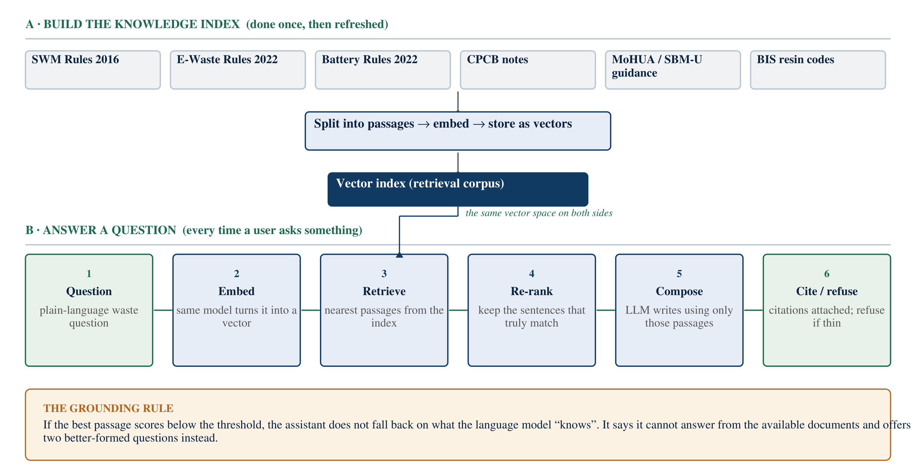
Figure 5: The two halves of retrieval-augmented generation: building the index, then answering from it
Three details separate a working RAG system from a demonstration. The first is chunking: passages must be small enough to be specific and large enough to be meaningful, and they must carry their source title so that a citation can be produced. The second is re-ranking: vector similarity returns passages that are topically close, which is not the same as passages that contain the answer, so a second pass scores individual sentences against the question. The third, and the most important for this project, is the refusal path: if the best passage scores too low, the system must say that it cannot answer from the available documents. Without that path, RAG becomes a machine for attaching citations to guesses.
The appeal of RAG in a public-information context is that it makes an answer auditable. A resident who reads “batteries must not go into household bins” can be shown which document says so, and can check it. It also makes the system maintainable: when a rule is amended, the corpus is updated and the answers change, whereas a model’s memorised knowledge cannot be edited in the same way. The cost is that RAG is only as good as its corpus, which is why the project states its corpus — twenty public documents — openly, and states its absence of municipal-specific bylaws as a known limit.

4.6 Agentic AI
An agentic system does not merely answer a question; it pursues a goal through a loop. The loop is usually described in four stages: perceive the situation, decide what to do, act using available tools, and learn from the result so that the next iteration is better. The word “agent” is used because the system takes initiative within its scope rather than waiting to be asked each individual step.
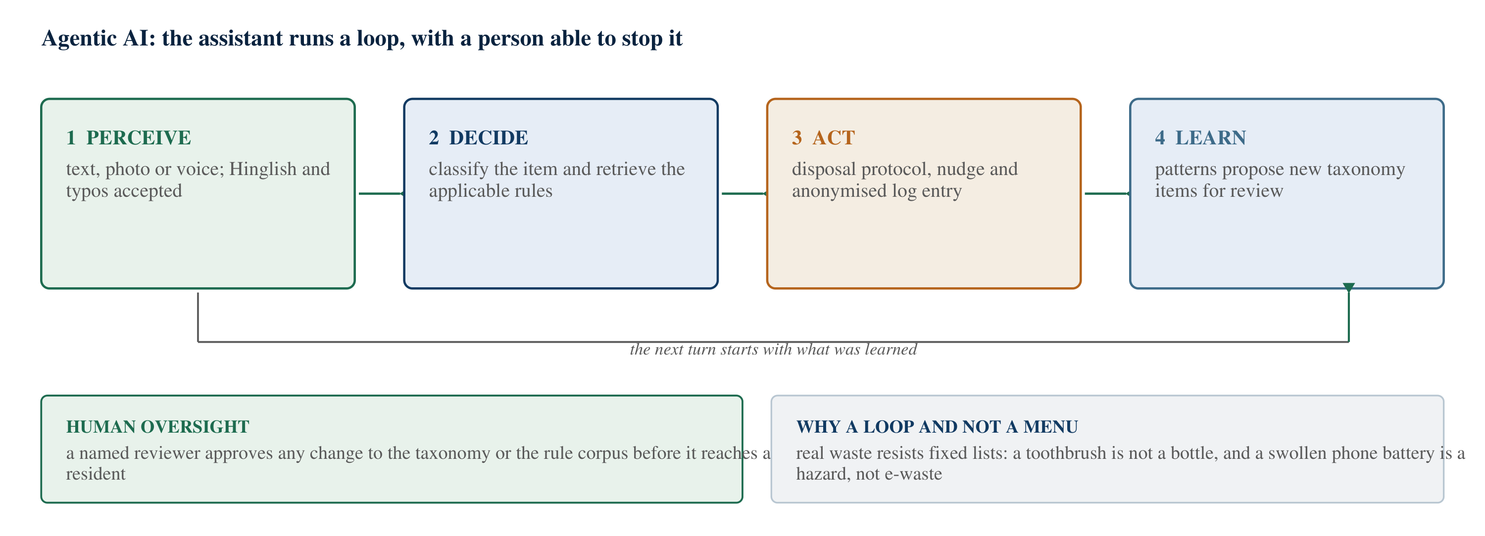
Figure 6: The perceive-decide-act-learn loop of an agentic assistant
Agentic design is powerful, and it is also where AI systems become difficult to supervise, because a loop can amplify a small error. The project keeps the autonomy narrow and places a person at the only point where the loop could cause wider harm. The system may classify an item, retrieve a rule, compose guidance and log an anonymised pattern without asking anyone; it may not change its own taxonomy, admit a new document or act on behalf of a household. Those changes require human review, which is shown in the figure as the oversight gate.
This is a defensible pattern for public-interest AI: automate the repetitive, interactive part of the task, and keep the consequential part under human control. It also happens to be what the internship’s responsible-AI material argues for, and it is revisited in Chapter 8.

4.7 Responsible AI
Responsible AI is the set of design practices that keep an AI system fair, transparent, private, safe and accountable. It is often written as a list of principles, which makes it easy to agree with and hard to implement. The internship’s material treated it as a set of testable behaviours, and the project followed that treatment.
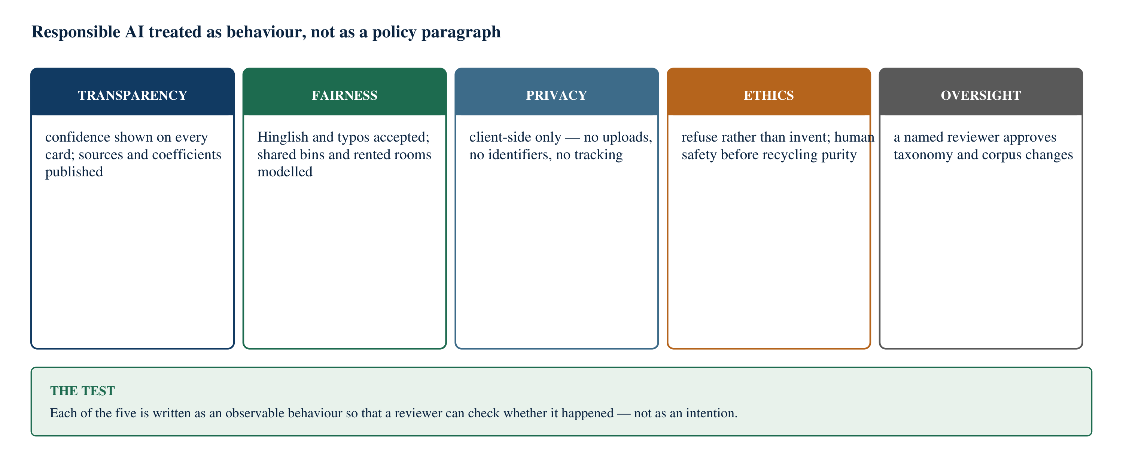
Figure 7: The five responsible-AI behaviours the project commits to
Five behaviours are treated as requirements in the project. Transparency: every classification shows its confidence, and every coefficient used in an estimate is published in plain sight. Fairness: the system accepts Hinglish, transliteration and misspellings, so that a resident who is more comfortable in Hindi is not excluded from correct disposal; and it models shared bins and rented rooms rather than assuming a nuclear household with a garden. Privacy: the design processes input on the device, uploads no photographs and asks only for quantities, never names or addresses. Ethics: the system refuses rather than invents, and human safety outranks recycling purity — a mercury lamp is a hazard before it is a recycling opportunity. Oversight: changes to the taxonomy or the corpus pass through human review.
The feature of this list that a student should notice is that none of the five is achieved by adding a disclaimer. Each one changes the system’s design: the confidence threshold exists because of transparency, the client-side architecture exists because of privacy, and the refusal path exists because of honesty. That is the difference between responsible AI as a value and responsible AI as an engineering constraint.
Why this belongs in the technology chapter. It is tempting to treat responsible AI as a concluding section about ethics. In practice it is a design input that constrains the architecture as much as performance does, and the project would be a different system — easier to build, less defensible — without it.

CHAPTER 5

PROBLEM STATEMENT

5.1 Waste management in India at a glance
India’s municipal solid waste problem is usually described with two numbers and one phrase. The numbers are the quantity of waste generated and the fraction of it that is processed; the phrase is “segregation at source”, which appears in every policy document on the subject. The Central Pollution Control Board’s annual report on the implementation of the Solid Waste Management Rules, 2016 for 2020–21 records municipal areas generating about 1,60,039 tonnes per day of solid waste, of which about 1,52,750 tonnes per day was collected [1]. Of what was collected, roughly half was treated and a substantial remainder went to landfill, with a further quantity accounted for as unprocessed.
These figures should be read with care, and three cautions belong beside them. First, they are a national aggregate over a reporting year and conceal enormous variation between states and between cities within a state. Second, the categories in the reporting — generated, collected, treated, landfilled — are not a clean partition, and different summaries of the same report quote different subsets. Third, they describe municipal solid waste, which is the stream a household influences directly, and they do not include construction and demolition debris, e-waste, battery waste or hazardous industrial waste, each of which has its own rules and its own reporting.
The statutory frame for household waste is the Solid Waste Management Rules, 2016, notified by the Ministry of Environment, Forest and Climate Change on 8 April 2016 [2]. The rules, among other things, make source segregation a duty of the waste generator, require local bodies to establish door-to-door collection and separate streams, address sanitary waste, and require user fees and spot fines for littering and non-segregation as specified by local bodies. They also sit within a wider set of instruments: the Plastic Waste Management Rules as amended in 2021, the E-Waste (Management) Rules, 2022, the Battery Waste Management Rules, 2022, and the Construction and Demolition Waste Management Rules, 2016.
Table 7: Indian rules and standards relevant to household waste
Instrument | Notified | What it means for a household
Solid Waste Management Rules, 2016 | 8 April 2016 (MoEFCC) [2] | Source segregation is a duty; the generator is expected to hand over segregated wet, dry and domestic hazardous waste, and to pay user fees and fines as notified by the local body
Plastic Waste Management Rules, 2016 as amended (2021) | 2016; amendment 2021 [4] | Thickness and labelling requirements for plastic carry bags; a list of banned single-use plastic items from 1 July 2022; recycled content conforming to BIS standards
E-Waste (Management) Rules, 2022 | 2 November 2022, in force 1 April 2023 [5] | Electronic waste must travel through authorised collection and recycling routes; extended producer responsibility places obligations on producers
Battery Waste Management Rules, 2022 | 24 August 2022 [3] | Waste batteries must be collected, not landfilled or incinerated; producers carry extended producer responsibility; retail take-back is part of the intended route
Construction and Demolition Waste Management Rules, 2016 | 29 March 2016 [6] | Debris is a separate stream with its own handling; it should not enter municipal bins
Publication details verified against the Gazette notifications and the corresponding ministry or CPCB releases; see the References for full entries.
Finally, the policy ambition is not merely to collect waste but to stop treating it as waste. Swachh Bharat Mission–Urban 2.0, launched on 1 October 2021 for the period to 1 October 2026, sets the vision of “Garbage Free Cities” and gives substantial weight to door-to-door collection, source segregation, waste processing and dumpsite remediation [7]. Source segregation is therefore not a private lifestyle preference; it is the first step on which the rest of the municipal system depends.

5.2 The household segregation problem
Why, then, does segregation at source remain uneven? The explanation most often offered is indifference: people do not care, or will not change. That explanation is convenient because it locates the problem in other people. The project document records a different reading, arrived at through observation and interviews, and it is the reading this report adopts. Residents, by and large, are willing. What they lack is an answer at the moment they need it.
Consider the actual situation. A resident is standing at a bin with an object in one hand and perhaps four or five seconds available. The object may be a milk pouch with residue in it, a CFL tube, a chips packet with a foil lining, a used battery, a battery-operated toy, a broken ceramic mug, a torn school shirt. For each of these the correct answer is genuinely uncertain to a non-specialist, and the answers are not obvious even to an interested person:
• The milk pouch is plastic, so “plastic” suggests recycling — but a pouch with milk residue inside will contaminate the batch it is bundled with unless it is cut open, rinsed and dried.
• The CFL tube contains a small amount of mercury, so it is domestic hazardous waste, not general dry waste — a distinction that matters to the person who handles it next.
• The chips packet is a multi-layer laminate, which is largely non-recyclable in practice; it belongs in the reject stream, not with clean plastics.
• The battery looks like a small harmless object and is, by the rules, domestic hazardous waste with a dedicated take-back route [3].

A poster at the bin cannot resolve these cases, because the poster must generalise and these cases are specific. A municipal website can explain the rules, but it explains them in formal language, in English, at the length of a regulation. What is missing is not information; it is an interface between the resident and the information, available in the seconds available, in the language the resident actually uses.
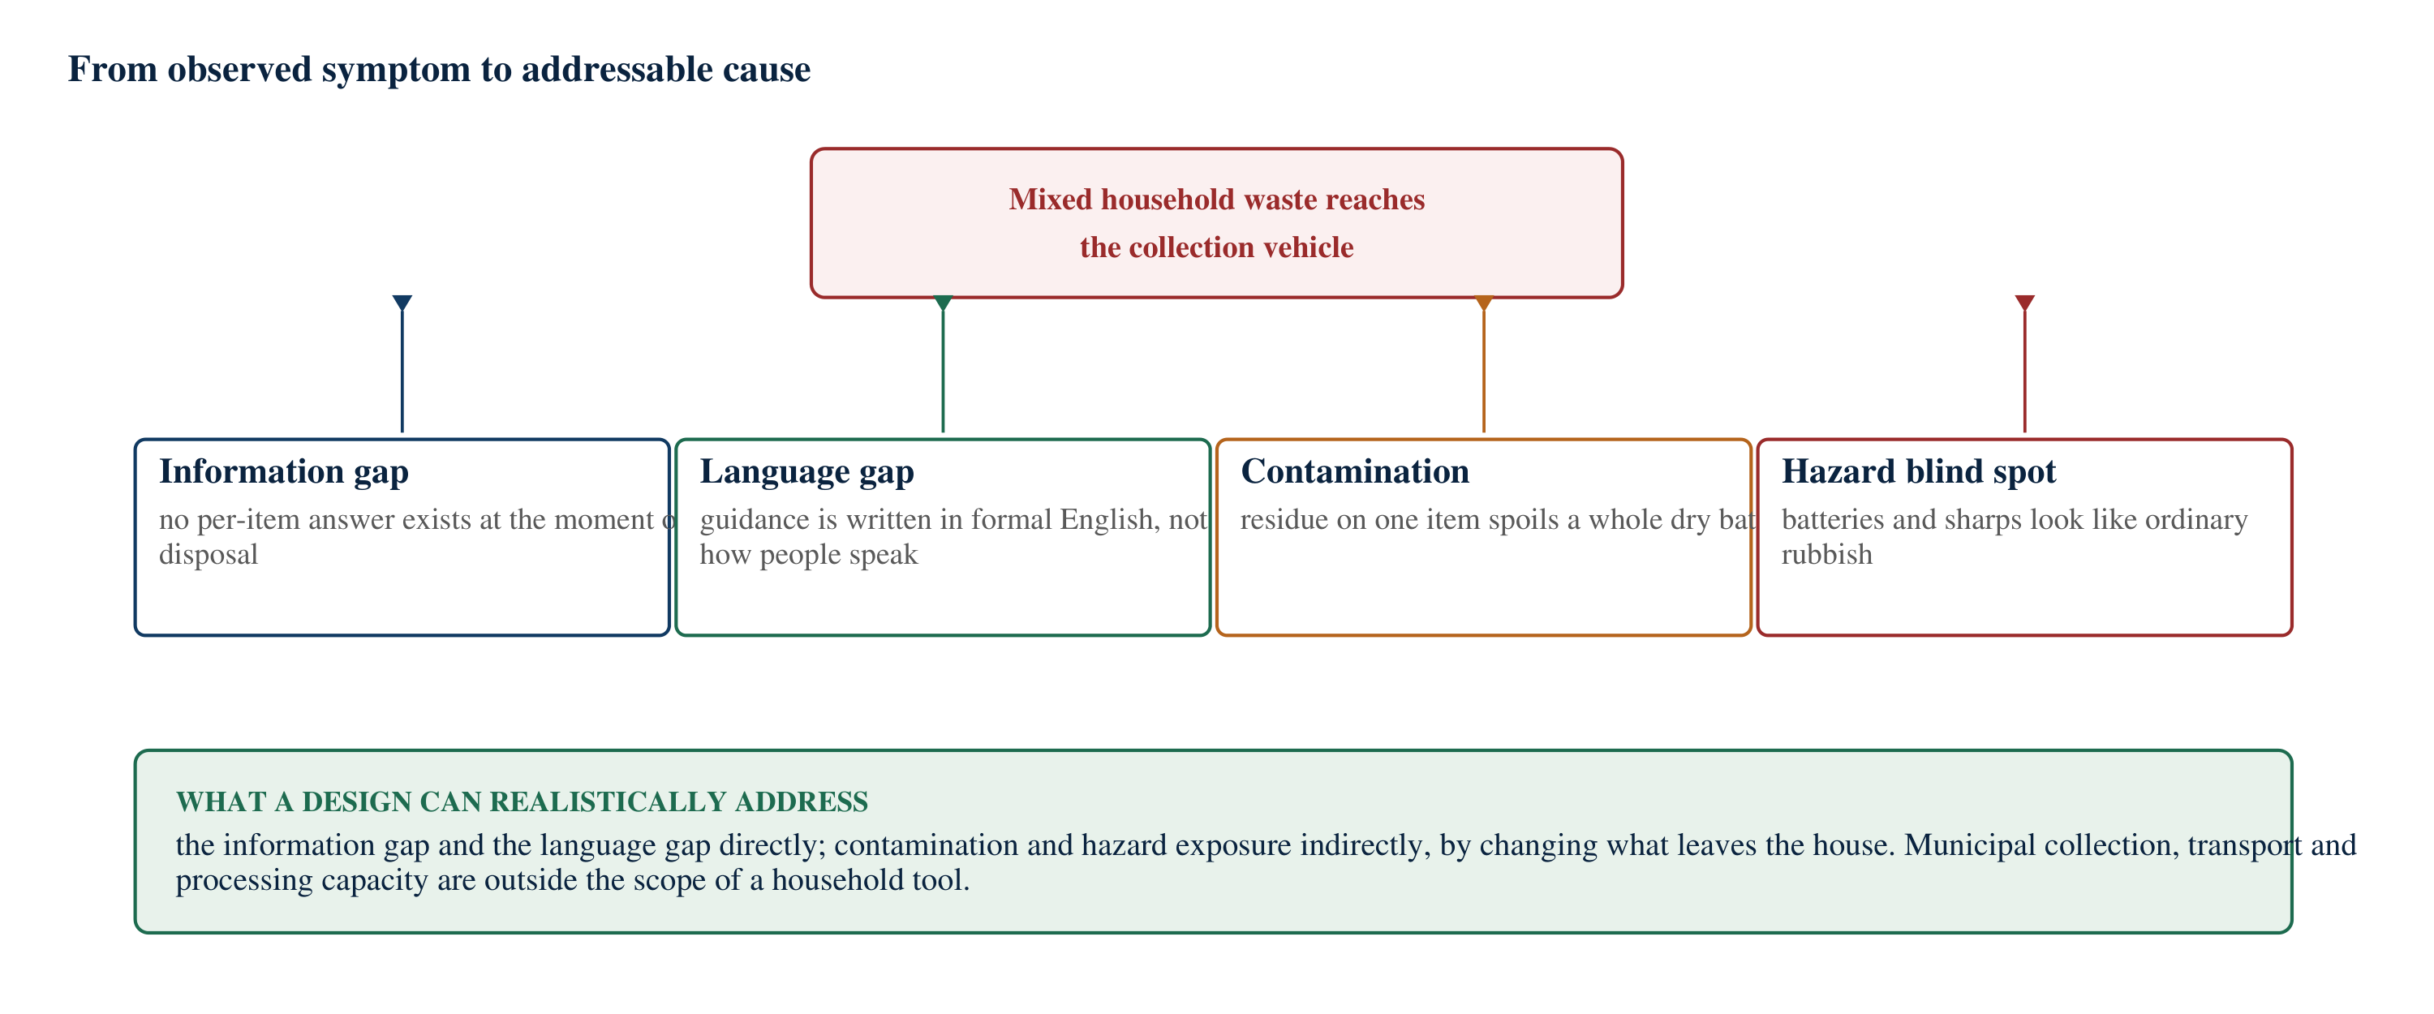
Figure 8: From observed symptom to addressable cause in household waste segregation
The figure above separates four causes that are often conflated. The information gap is the absence of a per-item answer at the decision moment. The language gap is that official guidance is written in formal English while the resident may think in Hinglish. Contamination is a physical consequence of the first two: residue on one item spoils a batch. The hazard blind spot is the special case where a mis-sorted item endangers a person rather than a process. A household tool can address the first two directly, and influence the second two indirectly. It cannot address collection capacity, transport, or processing infrastructure, and the project does not pretend otherwise.

5.3 Recycling and contamination
Contamination is the least visible and most expensive part of the problem. Recycling is a manufacturing process, and it requires input of predictable quality. When wet waste, food residue or mixed-material items enter a dry recyclables stream, three things happen. The contaminated material itself loses value, because a buyer of recycled fibre or film will not accept material soaked in organic matter. The materials around it lose value too, because bales are graded as a unit and one wet sack of paper degrades a bale. And the cost of the loss is not borne by the resident who caused it; it is borne by the material recovery facility, by the recycler, and eventually by the municipal budget.
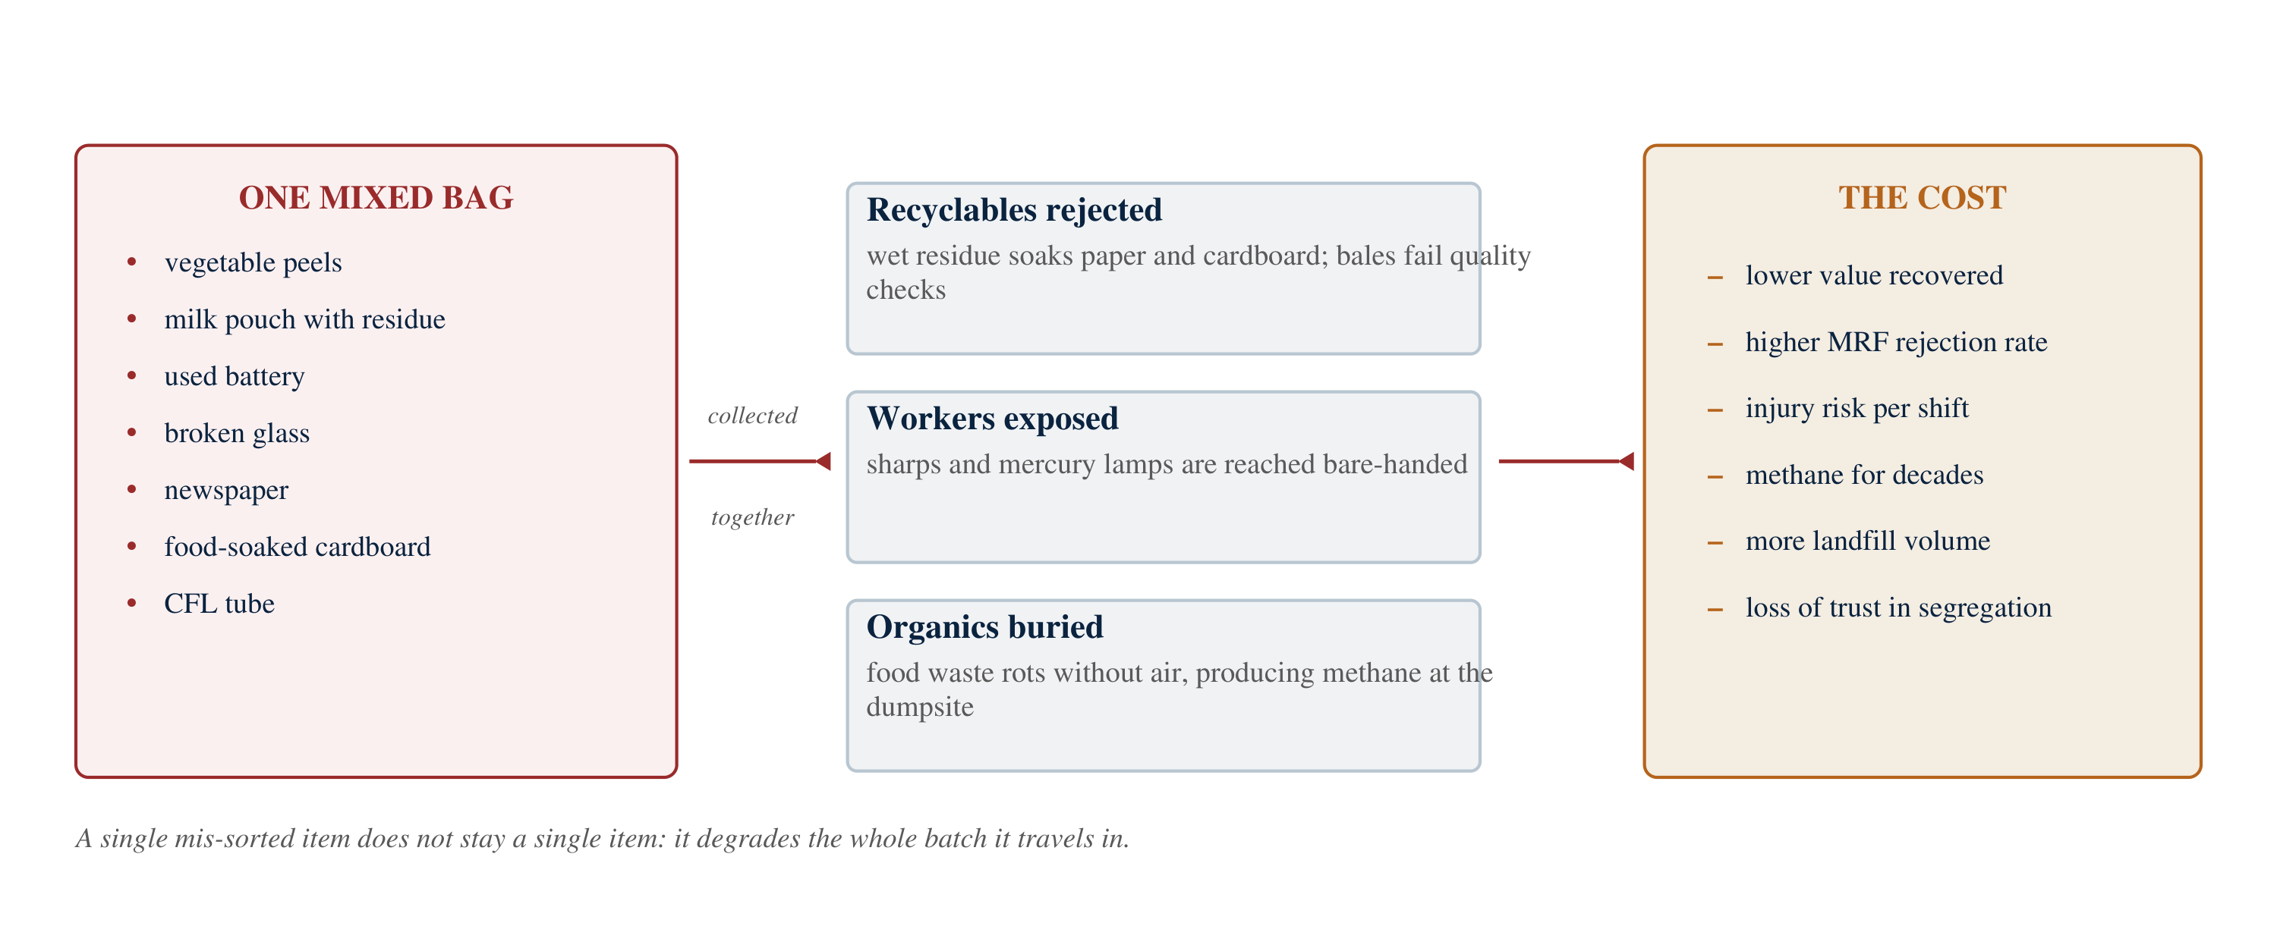
Figure 9: What one badly sorted bag costs, downstream
The economic consequence is a familiar trap. If inbound dry waste is contaminated, the recovered material sells for less; if it sells for less, the facility struggles; if the facility struggles, there is less capacity to accept material; and the material that cannot be accepted goes to landfill. Better segregation upstream is, in most Indian cities, a cheaper intervention than new processing capacity downstream, because it improves the productivity of capacity that already exists. The project makes this argument as a design motivation, not as a claim of measured effect: no facility data was collected during the internship.

5.4 Sanitation worker safety
The most serious consequence of mixed waste is not economic. Waste that arrives mixed arrives unmarked, and unmarked waste is handled by people. Batteries, broken glass, discarded needles and blades, and mercury-bearing lamps travel inside mixed bags to collection workers, to waste pickers and to facility staff. The project document records worker interviews in which needle injuries were described as routine, and it treats that description as the strongest single argument for resident-side guidance.
This reframes the purpose of a household application. The resident is not the only user who benefits. A guidance card that tells a household to wrap a broken bulb in paper, label it, and hand it over separately is written for the generator but it protects the handler. It is therefore a design principle of the project that the safety step comes first in every hazardous-waste protocol, before any instruction about recycling or material value. Human safety outranks material recovery, every time.
The same framing disciplines how the project talks about sanitation workers. They are beneficiaries to be protected, not a population to be monitored, scored or policed. That is why the design includes no performance ranking of workers, no photograph-based monitoring and no household-level surveillance, and why the later-phase analytics described in Section 9.4 are aggregate-only.

5.5 Environmental and sustainability concerns
A large fraction of Indian household waste is organic — the project document uses a 55/25/20 working split of organic, dry recyclable and reject material. When organic waste is segregated and composted, the carbon in it returns to soil and the process is aerobic. When the same waste is buried in a mixed landfill, it decomposes without oxygen and produces methane, a greenhouse gas with a far higher warming effect per kilogram than carbon dioxide over a hundred-year horizon. The Sixth Assessment Report of the Intergovernmental Panel on Climate Change gives a hundred-year global warming potential for non-fossil methane of about 27 and for fossil methane of about 29.8, relative to carbon dioxide [8]. That is the climate arithmetic behind a household bin.
Three further environmental consequences follow from mixed waste. Leachate — the liquid that drains from decomposing waste — can carry organic load and heavy metals into soil and water. Open burning of waste, including at dumpsites, releases particulate matter and dioxins, and is a recurring public-health complaint near legacy sites. And the loss of recyclable material forces the production of virgin material, which for metals and plastics carries a substantial energy penalty compared with recycling.
The global picture is consistent with the local one. The United Nations Environment Programme’s Food Waste Index Report 2024 estimated that about 1.05 billion tonnes of food was wasted in 2022 across households, food service and retail, with households the largest contributor [9]. In a country where a large share of household waste is food waste, keeping organics out of landfill is simultaneously a waste problem, an emissions problem and a soil problem.
Scope note. None of the statistics in this chapter were generated by the project. They are published figures used to establish that the problem is real and that the design is aimed at a genuine gap. Where the project itself produces a number — for example, an estimate of carbon dioxide equivalent avoided — that number is explicitly labelled as modelled, and the arithmetic behind it is published in Chapter 6.

CHAPTER 6

PROJECT OVERVIEW: SWACHHAI

6.1 Introducing the project
SwachhAI is a proposed decision-support assistant that helps an Indian household put any item into the right waste stream, answers questions about municipal waste rules from cited public documents, and converts a household’s habits into a visible estimate of the waste and emissions it avoids. It is not a bin-sorting robot, not a municipal fleet management system and not a replacement for a collection service. It is an interface between a confused resident and the rules that already exist.
The name joins swachh, clean, with AI. The project’s one-line statement of purpose, as recorded in the project document, is to make the right bin the easy bin. That phrase is the whole design brief: not to educate in the abstract, not to lecture, but to make the correct action the one that requires the least effort at the moment of decision.
The scope is deliberately modest. The concept does not change how waste is collected or processed; it assumes the municipal rules are broadly correct and that collection exists in some form, and it addresses the step that fails before either of those matters: the resident’s decision about what goes where.
This chapter introduces the objectives, the problem, the users, the proposed solution and the sustainable development goals the project contributes to. The technical description of the three modules follows in Chapter 7. As stated in the Abstract, the project is presented here as a documented design; no working application was built for this report and none is required for it.

6.2 Project objectives
The project pursued six objectives. Each is written so that it could, in principle, be shown to have failed — which is what distinguishes an objective from a hope.
1. Remove the guess at the bin. Given an item described in ordinary language — including Hinglish, transliteration and misspellings — return exactly one waste stream, a stated confidence, and a short disposal protocol.
2. Make the answer truthful. Where the system is not confident, it must say so rather than guess; where it answers a policy question, it must answer from cited public documents and must decline when those documents do not cover the question.
3. Protect the person who handles the waste. Every protocol for hazardous or sharp items must lead with a wrap-mark-separate instruction written for the generator, so that the item never arrives unmarked in a worker’s hands.
4. Make the benefit visible. Convert a household’s stated habits into an estimate of kilograms diverted and carbon dioxide equivalent avoided, using published coefficients that the user can inspect, and label the output as an estimate.
5. Respect language and circumstance. Accept the way people actually write and speak, and model shared bins, rented rooms and small homes as normal cases rather than as edge cases.
6. Stay inside the household’s privacy. Process input without uploading photographs, without requiring an account, and without collecting names, addresses or identifiers.

Two further requirements shaped the design as much as the objectives. The first was explainability: a resident must be able to see why the system said what it said, which is why the classifier displays confidence and the forecaster uses a published multiplication rather than a trained model. The second was honesty about scope: the system must not imply that it can settle a compliance question. It offers decision support for a household, and defers to the local body on any question of law.

6.3 The problem addressed
Chapter 5 established the problem in detail. In one paragraph: Indian households are expected by the Solid Waste Management Rules, 2016 to segregate waste at source, but the correct stream for a specific item is often genuinely unclear, the available guidance is written for regulators rather than residents, and the cost of a wrong decision is paid downstream — by a recycler whose bale is rejected, by a sanitation worker who reaches into a bag containing a broken bulb, and by the atmosphere in the form of methane from landfilled organics.
SwachhAI addresses the point of decision rather than the point of consequence. The design bet is that a sufficiently low-effort answer, delivered in the resident’s own vocabulary at the moment of disposal, changes what leaves the house — and that everything downstream improves as a result. That bet is stated as a hypothesis, not as a result; testing it would require the field pilot described in Section 9.4.
What the project does not address matters equally. It provides no collection, transport or processing capacity, enforces no rule, and deliberately contains no mechanism for shaming or ranking a household. It does not resolve conflicts between municipal bylaws; it defers to the local body. And it does not claim that household segregation alone solves India’s waste problem — only that it is a necessary input that is currently weak.

6.4 Target users
The project defines four user groups. Two are direct users of the assistant, and two benefit from it without necessarily operating it. Defining all four mattered, because a design that serves only the first would be a consumer app; a design that serves all four has to make different choices.
Table 8: Target users and what each one needs from the system
User | Situation and need | What the design gives them
Urban household head or homemaker | Manages daily kitchen and household disposal; has no time at the bin and no reliable memory of which item belongs where | A per-item answer in seconds, in ordinary language; a short protocol rather than a rule; a monthly card showing what changed
Student or hosteller | Shares a room and a bin, has almost no space to store segregated waste, and deals with a specific set of items (food cups, chargers, notebooks, packaging) | Quick-pick entries for hostel items; compact protocols that fit a shared room; guidance on where to take e-waste on or near campus
Sanitation worker (formal and informal) | Handles unmarked sharps, broken glass, acids and mercury-bearing lamps, often with minimal protective equipment | Resident-side protocols that require wrapping, marking and separate handover before the item ever reaches a collection round
Urban local body and ward waste operations | Receives contaminated loads that make recycling financially difficult, and holds almost no stream-level data about its own wards | Cleaner inbound streams; in a later phase, anonymised aggregate stream data for routing, facility planning and tariff design
Personas as defined in the SwachhAI project document; the fourth is a later-phase user and is not served by the first version of the concept.
One design consequence is worth drawing out. The sanitation worker is listed as a user even though that worker will never open the application. This is not a rhetorical gesture: it changes the content of the output. A protocol written only for the household might say “batteries go to a take-back point”. A protocol written with the handler in mind says “tape the terminals, keep the cells in a leak-proof container, and hand them over separately — never in the mixed bag”. The second sentence is longer and it is the one that prevents an injury.

6.5 The proposed solution
SwachhAI is described in the project document as three cooperating modules sharing one pipeline, rather than as a single model or a single screen. The three modules are introduced here and described in technical detail in Chapter 7.
• Module 1 — AI-based waste classification. The resident describes an item in words (or, in the designed extension, supplies a photograph). The system extracts the item and its material clues, maps it to exactly one of eight waste streams defined with reference to the Solid Waste Management Rules, 2016, attaches a calibrated confidence, and returns a short disposal protocol with a safety step first. Below a confidence of 75 it returns “unknown” instead of guessing.
• Module 2 — RAG-based waste management assistant. The resident asks a question in natural language — “where should I throw old batteries?”, “is a CFL bulb e-waste or hazardous?” The system retrieves passages from a curated corpus of public documents, composes an answer only from those passages, and attaches numbered citations. If the best passage scores too low, it declines to answer.
• Module 3 — environmental impact forecaster. The resident sets a few quantities — household size, kilograms per week, the fraction currently segregated and composted — and switches on the practices they intend to adopt. The system projects twelve months of diversion and carbon dioxide equivalent avoided using published coefficients, and expresses the result in familiar equivalents.

The three modules are not independent features bolted together. They share one input pipeline, one taxonomy and one privacy contract, and they are designed so that a failure in one degrades gracefully into another: a low-confidence classification hands the resident to the rule assistant, and the quantities logged during classification feed the forecaster. That shared structure is the subject of Chapter 7.
AI is not decorative in this design. The problem is linguistic and contextual: the same item is named differently by different people, rules differ by city, and a rigid list cannot absorb “doodh ka packet”, a photograph, or a question about one’s own municipality. Language understanding, retrieval and prediction are the capabilities that make the interface possible. A static FAQ page cannot do this job, which is why the project’s justification for AI is functional rather than fashionable.
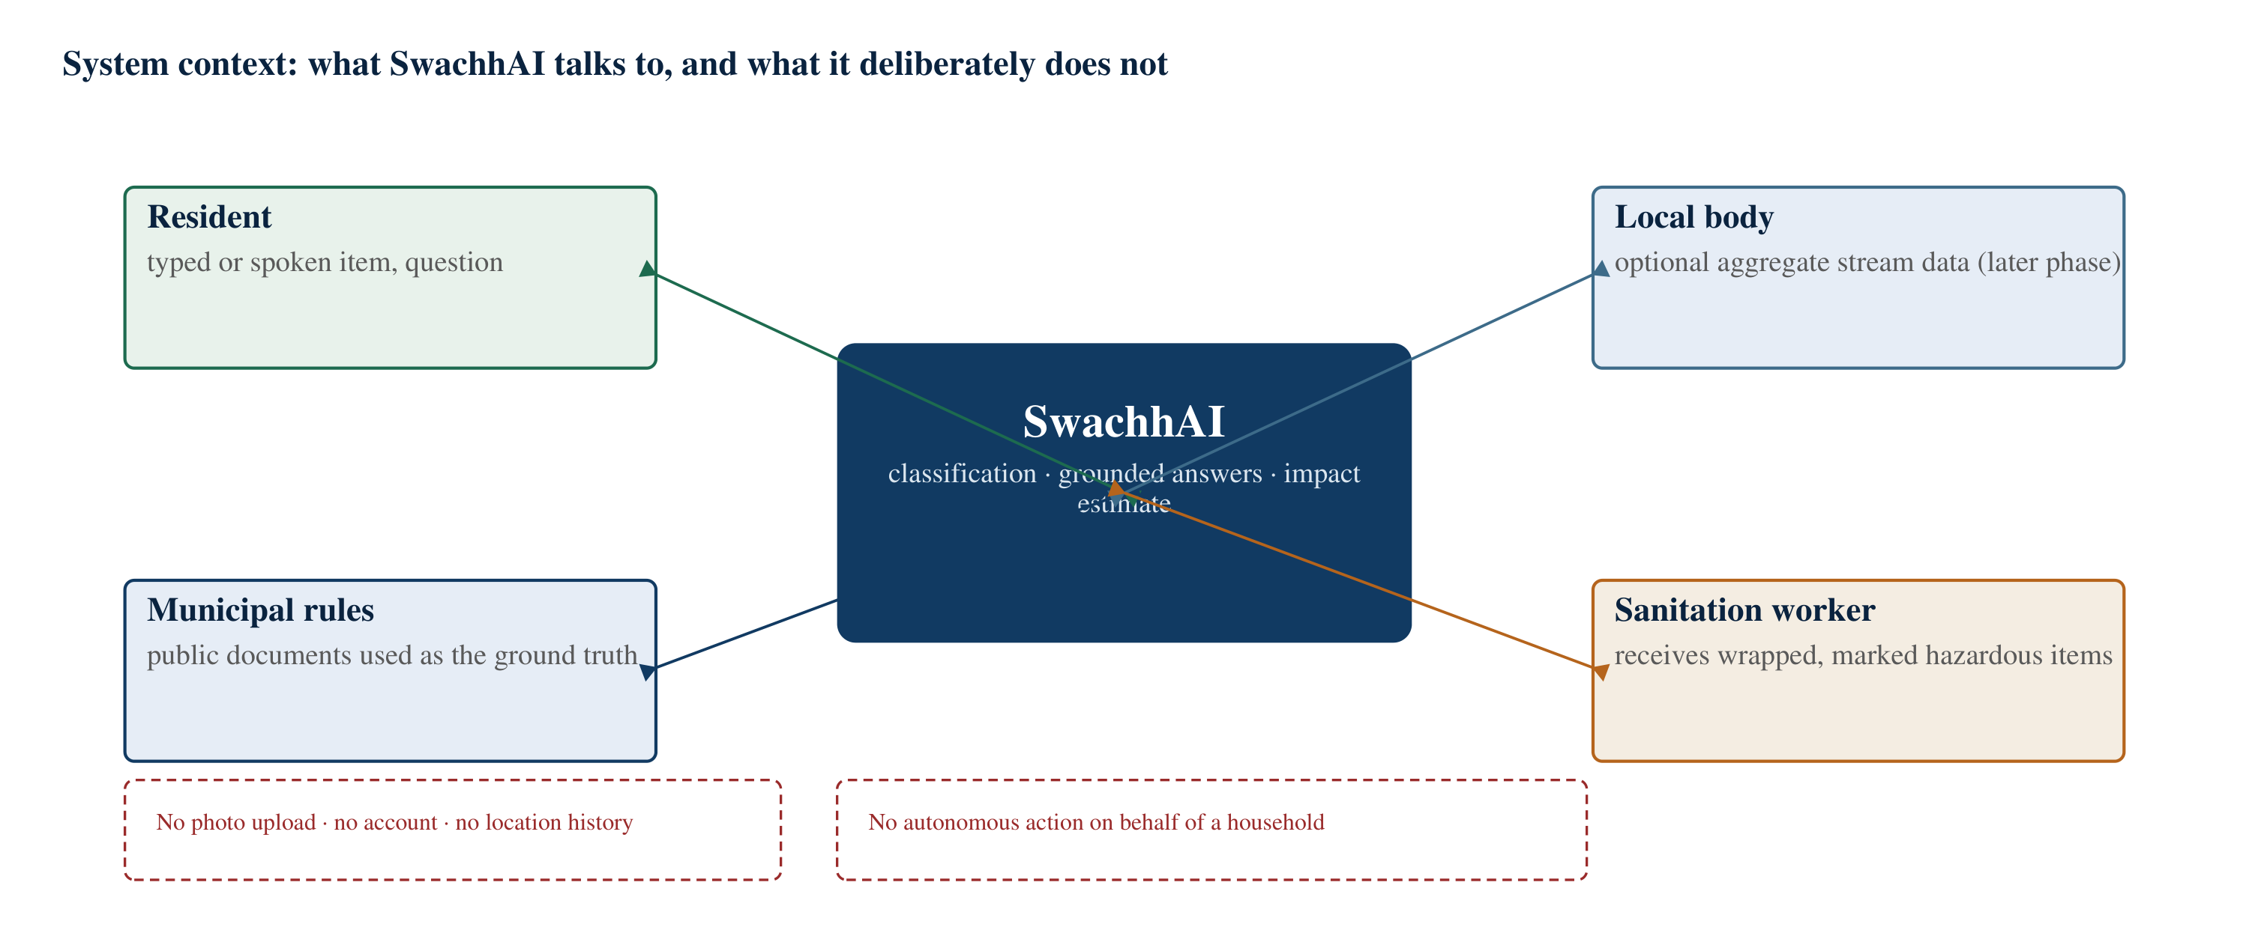
Figure 10: System context: what SwachhAI talks to, and what it deliberately does not

6.6 Relevance to SDG 11, SDG 12 and SDG 13
The project document aligns SwachhAI with three Sustainable Development Goals and identifies one as primary. The alignment is stated at the level of specific targets rather than at the level of goal titles, because a goal title can be claimed by almost any project while a target can be argued about.
Table 9: Contribution of SwachhAI to individual Sustainable Development Goal targets
Goal and target | Relation to the project | How the project contributes
SDG 12 — Responsible Consumption and Production; Target 12.5 (substantially reduce waste generation through prevention, reduction, recycling and reuse by 2030) | Primary | The classifier, the rule assistant and the composting and rinsing protocols all raise prevention, recycling and reuse behaviour at the point where the waste is generated
SDG 11 — Sustainable Cities and Communities; Target 11.6 (reduce the adverse per capita environmental impact of cities, with attention to air quality and waste management) | Secondary | Cleaner separated streams, and in a later phase ward-level stream analytics, support municipal waste management and reduce dumpsite and burning pollution
SDG 13 — Climate Action; Target 13.3 (improve education, awareness and human capacity on climate mitigation and adaptation) | Secondary | The forecaster explains landfill methane in plain language and converts a household’s behaviour into a visible carbon dioxide equivalent figure
Target statements paraphrased from the United Nations Sustainable Development Goals; see the References.
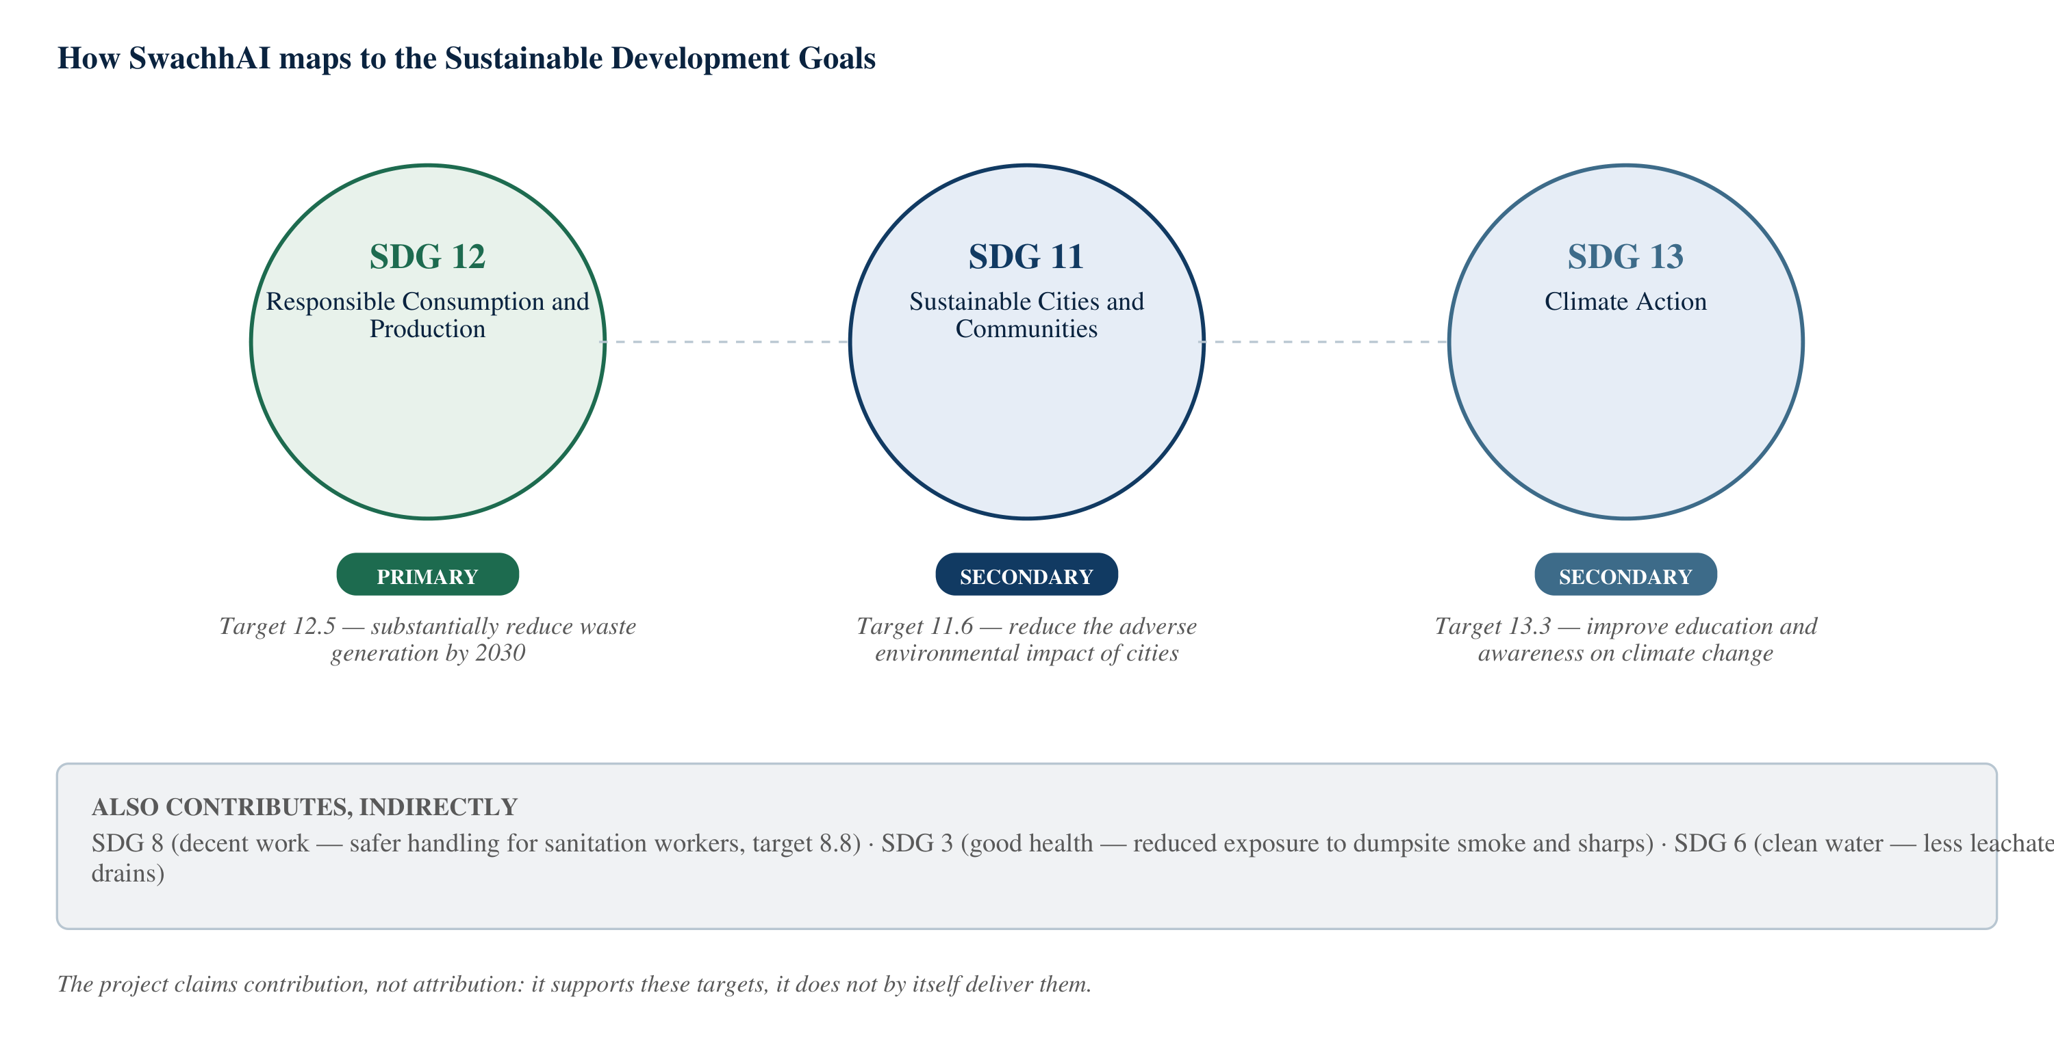
Figure 11: How SwachhAI maps to Sustainable Development Goals 11, 12 and 13
Two further goals are touched indirectly and are recorded in the project document for completeness: SDG 8, through safer working conditions for sanitation workers, and SDG 3, through reduced exposure to dumpsite smoke and sharps. The report states its claim precisely: the project contributes to these targets. It does not deliver them, and a household tool should not be described as if it did.

CHAPTER 7

DETAILED PROJECT DESCRIPTION

7.1 The eight waste streams
Every part of SwachhAI depends on one decision made early: the taxonomy. Before a classifier can classify, and before a corpus can be retrieved, the project has to decide how many categories exist and what they are called. Too few categories and the guidance is useless — “dry waste” does not tell anyone what to do with a battery. Too many and the system becomes a rulebook that nobody can use at a bin, and the classifier’s accuracy per category collapses.
The project settled on eight streams, defined with reference to the Solid Waste Management Rules, 2016 and the separate rules that govern specific material types: wet, dry, e-waste, hazard, sanitary, textile, debris and reject. Each of the approximately ninety-five items in the project’s knowledge base maps to exactly one of these eight, and the mapping is deliberate rather than incidental: the eight correspond to the ways in which waste is actually collected and handed over at the household gate, not to a materials-science classification.
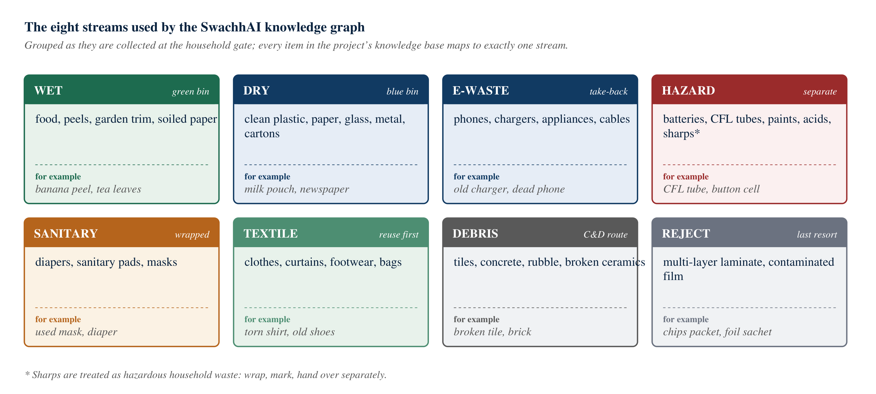
Figure 12: The eight waste streams used as the project’s knowledge graph
Table 10: The eight waste streams, with the handling each one needs
Stream | What belongs here | Why the distinction matters
Wet | Food waste, vegetable and fruit peels, cooked food residues, garden trimmings, soiled paper | Compostable; if mixed with dry waste it soaks and contaminates recyclables
Dry | Clean plastics and films, paper and cardboard, glass, metals, cartons | Has market value only while clean and dry; the project insists on rinsing and drying before handover
E-waste | Phones, chargers, cables, small appliances, batteries inside devices, lamps other than CFLs | Governed by the E-Waste (Management) Rules, 2022; must travel through authorised routes
Hazard | Batteries, CFL tubes, paints and solvents, acids, sharps, expired medicines | Domestic hazardous waste; the safety step for the handler comes first in every protocol
Sanitary | Diapers, sanitary pads, masks, contaminated dressings | Must be wrapped before handover; treated separately from wet and dry streams
Textile | Clothing, curtains, footwear, bags, bedding | Reuse comes before recycling; donation or repair is preferred to the dry bin
Debris | Tiles, concrete, rubble, broken ceramics, mirrors | Covered by the C&D Waste Management Rules, 2016; should not enter municipal bins
Reject | Multi-layer laminate packets, foil-lined sachets, heavily contaminated film, composite items that cannot be separated | The honest last resort; keeping these out of the dry stream protects the value of the rest

Two aspects of this taxonomy are worth defending. First, textile and debris are separate streams even though both could be folded into “dry”. They are separated because the correct action differs: a wearable shirt should be donated, not binned, and a broken tile must not be put in a municipal bin at all. Second, reject exists as a stream. A taxonomy that pretends every item is recyclable produces worse behaviour than one that admits a residual category, because it pushes laminate packets into the dry stream where they reduce bale quality.
The number ninety-five deserves a note as well. It is the size of the demo knowledge base, not a claim about the size of the problem; the project’s own roadmap proposes extending the taxonomy to about 250 items using real user queries from a campus pilot. The report repeats that number as a description of the design, not as a measure of coverage.

7.2 Module 1: AI-Based Waste Classification

7.2.1 Purpose
To answer the resident’s question — where does this go? — with a single stream, a stated confidence, and a short sequence of steps that a person can follow while holding the object. The module exists because the uncertainty in household segregation is item-specific, and the answer must therefore be item-specific too.

7.2.2 Working concept
The input is an item description in natural language: “doodh ka packet”, “tube light”, “bananna peel”, “old charger”. The system first normalises the text — lower-casing, splitting into words, and expanding common aliases so that “doodh ka packet”, “milk pouch” and “milk packet” converge on the same item. It then extracts the item name and the material clues around it: “packet” suggests film, “tube” suggests glass and mercury, “peel” suggests organic.
The extracted description is then matched against the taxonomy. The project uses a Granite-style small language model, prompted with a small number of worked examples, to perform the match and to explain it. The prompt requires exactly one stream from the eight, a confidence between 0 and 100, up to four imperative steps, and one factual note about the material. A deterministic fallback matcher handles the case where the model output cannot be parsed, and a threshold rule overrides the model when confidence is below 75: the stream becomes “unknown” and the resident is handed to the rule assistant instead of being given a guess.
The output is a card, not a sentence. It carries the stream, a colour, the confidence, the reason, the steps, and an optional impact note. The choice of a structured card over free text is a deliberate interface decision: it allows the same information to be rendered on a phone, read aloud, or printed onto a bin label.
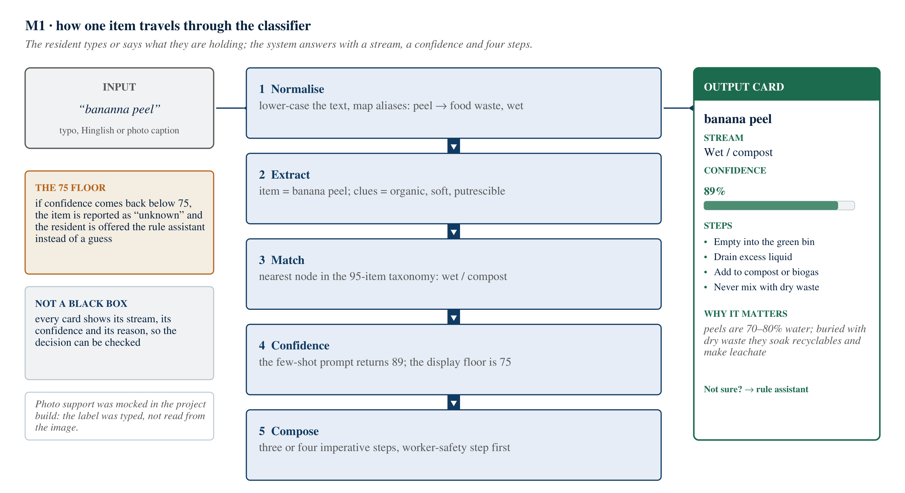
Figure 13: Module 1: how one item travels through the classifier

7.2.3 Technologies involved
• A small instruction-tuned language model of the IBM Granite class, used in a few-shot prompting configuration
• Prompt engineering with a strict JSON output contract, a refusal rule and a tone rule
• Alias and normalisation logic (deterministic text processing) in front of the model
• A curated taxonomy of approximately ninety-five items across eight streams, with material clues attached to each
• Confidence calibration and a threshold policy applied after the model, not by the model

7.2.4 Input and expected output
Table 11: Module 1: inputs, outputs and technologies
Element | Description
Input (text) | An item description in ordinary language, in English, Hindi transliteration or a mixture; typos tolerated
Input (image, designed extension) | A photograph of the item or of its label. In the project build this layer was mocked: the label was typed rather than read from the image, and the report describes it as a designed, untested capability
Processed fields | Item name, material clues, candidate stream, confidence, steps, impact note
Expected output | A single stream from the eight; a confidence between 0 and 100, or the explicit value “unknown” below the threshold; up to four imperative steps with the safety step first; one factual note
Failure behaviour | “Unknown” plus an offer of the rule assistant; a hazard case always appends a reminder to verify with the local municipal body

7.2.5 A practical example
Example — a typo, a pouch and a tube.<br/><br/>Input: “bananna peel” (misspelt).<br/>Extraction: item = banana peel; clues = organic, soft, putrescible.<br/>Result: stream = wet, confidence 89 per cent.<br/>Steps shown: empty it into the green bin; drain excess liquid; add it to the compost bin, a community pit or a biogas feed; never mix it with dry recyclables.<br/>Impact note: peels are mostly water; buried with dry waste they soak recyclables and generate leachate.<br/><br/>Input: “doodh ka packet” (Hinglish).<br/>Extraction: item = milk pouch; clues = LDPE film, single layer, liquid contact.<br/>Result: stream = dry, confidence 92 per cent.<br/>Steps shown: cut the pouch open fully and rinse it; sun-dry it to prevent odour and mould; bundle pouches so that sorters do not miss them; hand them over with dry waste or to a kabadiwala.<br/><br/>Input: “tube light”.<br/>Result: stream = hazard, confidence 94 per cent. The first step is a safety step: do not break the tube; wrap it, mark it, and hand it over separately. The card notes that it contains mercury and that it must never enter a mixed bag.
These three examples are from the project document, which records them as traced outputs of the demo build. They are reproduced here as illustrations of the intended behaviour. This report does not present them as independently verified results, and the confidence values are properties of that build, not of a general model.

7.3 Module 2: RAG-Based Waste Management Assistant

7.3.1 Purpose
The classifier answers “which bin”. Many real questions are different: “Is a CFL bulb e-waste or hazardous?”, “where do old batteries go?”, “does my municipality collect e-waste separately?”, “what do I do with expired medicines?” These are questions about rules, and a classifier that guesses at a rule is worse than no classifier at all. The second module exists to answer them from documents, with citations, and to decline when the documents do not cover the question.

7.3.2 Working concept
The module has an offline half and an online half. Offline, a corpus of twenty public documents is split into passages, each passage is converted into a numeric vector, and the vectors are indexed. The corpus is deliberately small, public and checkable: the Solid Waste Management Rules, 2016 and its schedule guidance; the E-Waste (Management) Rules, 2022 and the Battery Waste Management Rules, 2022; the Construction and Demolition Waste Management Rules, 2016; the Plastic Waste Management Rules as amended; CPCB disposal practice notes and landfill advisories; MoHUA and Swachh Bharat Mission guidance; BIS plastic resin identification codes; and summaries from UNEP and the IPCC.
Online, a question is converted into a vector in the same space, the nearest passages are retrieved, and a sentence-level re-ranking step keeps the sentences that actually address the question. The language model is then given those passages and asked to compose an answer only from them, numbering each claim against the passage it came from. A guard stage compares the best retrieval score against a threshold; below it, the system produces a refusal — an explicit statement that it cannot answer from the available documents, together with two better-formed questions drawn from the corpus.
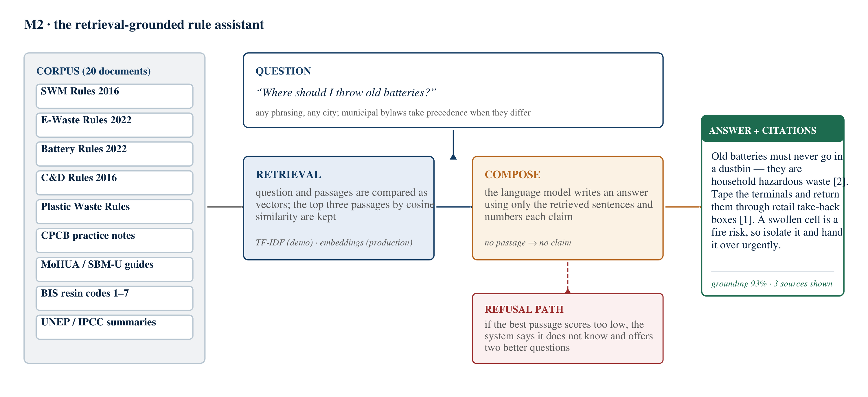
Figure 14: Module 2: the retrieval-grounded rule assistant
The refusal path is the most important part of the design and the easiest to omit. A system that always answers will sometimes answer wrongly, and a wrong answer about hazardous waste is not a harmless one. The project treats a refusal as a successful outcome, because it preserves the resident’s ability to trust the answers that are given.

7.3.3 Technologies involved
• Retrieval-augmented generation, with retrieval, re-ranking and constrained composition as separate stages
• Vector representations of passages and questions; in the demo build a term-frequency weighting scheme (TF-IDF) was used, and in a production design dense embeddings with a vector store would replace it — the same pattern, a different similarity function
• A language model of the Granite class, instructed to answer only from the supplied passages and to cite them
• A curated twenty-document corpus of public Indian waste rules and scientific summaries
• A grounding threshold that converts an uncertain retrieval into an explicit refusal

7.3.4 Input and expected output
Table 12: Module 2: inputs, outputs and technologies
Element | Description
Input | A natural-language question about waste rules or disposal practice, in any phrasing
Retrieved evidence | The top-ranked passages, each with a source title and a relevance score
Expected output | A short answer, in at most four points, in which every claim carries a numbered citation to a retrieved passage, followed by the source list
Refusal output | An explicit statement that the available documents do not answer the question, plus two better-formed questions
Failure behaviour | No citation means no claim; hazardous-waste answers always advise verifying with the local body, because municipal bylaws vary and take precedence

7.3.5 A practical example
Example — old batteries.<br/><br/>Question: “Where should I throw old batteries?”<br/>Retrieved: a passage from the Battery Waste Management Rules, 2022 (highest relevance), a passage from the Solid Waste Management Rules, 2016 listing batteries as domestic hazardous waste, and a related passage from the E-Waste Rules, 2022.<br/>Answer, as designed: old batteries must never go into a household bin, because they are domestic hazardous waste [2]. Tape the terminals of lithium cells, keep them in a leak-proof container, and return them through retail take-back boxes or an authorised collection point under the Battery Waste Management Rules, 2022 [1]. Swollen or damaged cells can cause fires in collection vehicles and facilities, so isolate them and hand them over urgently [1].<br/><br/>Contrast — the refusal: to the question “what are the best pizza toppings?”, the system does not attempt an answer. It reports that the question is outside the documents it holds and offers two questions it can answer.<br/><br/>Reproduced from the project document as an illustration of the intended behaviour; the citation numbers refer to the retrieved passage list shown to the user, not to this report’s reference list.

7.4 Module 3: Environmental Impact Forecaster

7.4.1 Purpose
Correct behaviour is invisible. A household that segregates properly has no way of knowing whether it diverted ten kilograms or a hundred over a year, or what any of it was worth in climate terms. The third module exists to make the benefit visible, on the theory — stated as a hypothesis — that a household which can see its own progress maintains the habit longer than one which is merely told that segregation is good.

7.4.2 Working concept
The resident supplies a small number of quantities: the number of people in the household, kilograms of waste per week, the percentage currently segregated, the percentage currently composted, and whether a recycling collection point and composting space are available. They then switch on the practices they intend to adopt.
The model applies a composition prior — the project uses a working split of about 55 per cent organic, 25 per cent dry recyclable and 20 per cent reject — and two published coefficients: approximately 0.47 kg CO₂e avoided per kilogram of organics composted instead of landfilled, and approximately 1.1 kg CO₂e avoided per kilogram of dry material recycled. The result is expressed in kilograms diverted and kilograms of carbon dioxide equivalent avoided over twelve months, and then translated into familiar equivalents: the annual absorption of a mature tree (about 21 kg CO₂ per year) and kilometres driven in a petrol car (about 0.192 kg CO₂ per kilometre).
Critically, this module is not a trained machine learning model, and that is a design decision rather than a limitation. A household needs to be able to understand and challenge its own number. A published multiplication can be inspected, argued with and corrected; a neural network’s output cannot. Explainability was prioritised over marginal accuracy, and the coefficients are printed on screen and reproduced in this report so that the arithmetic can be checked by hand.
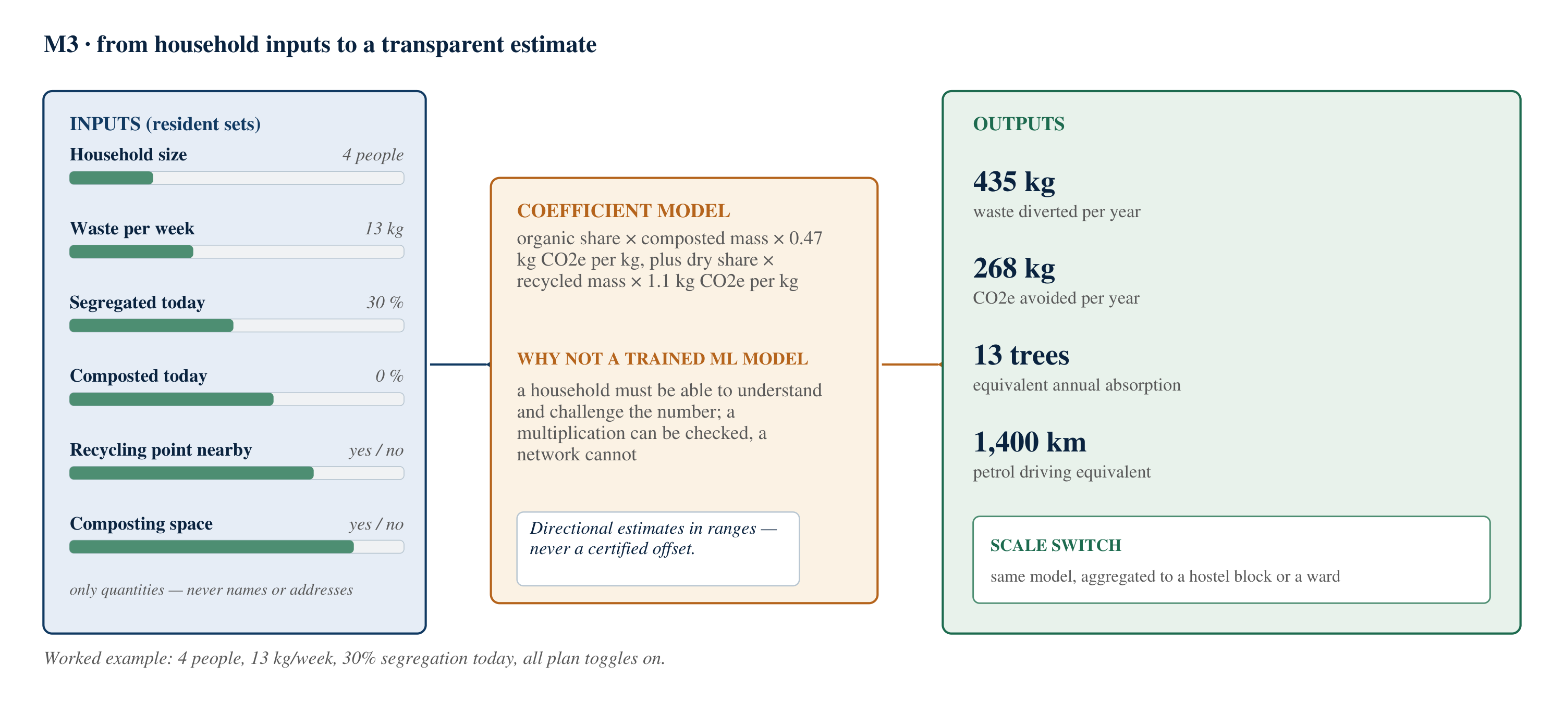
Figure 15: Module 3: from household inputs to a transparent estimate
Table 14: Impact coefficients used by the forecaster, and what they represent
Quantity | Value used | What it represents
CO₂e avoided per kg of organics composted rather than landfilled | 0.47 kg CO₂e/kg | Avoided methane formation when organic waste decomposes aerobically instead of anaerobically in a landfill
CO₂e avoided per kg of dry material recycled | 1.1 kg CO₂e/kg | Avoided emissions from producing material from virgin feedstock
Carbon absorbed by a mature tree in a year | 21 kg CO₂/tree/year | Used only to express the result in a familiar unit
CO₂ emitted by a petrol car per kilometre | 0.192 kg CO₂/km | Used only to express the result in a familiar unit
Working composition of household waste | 55% organic, 25% dry, 20% reject | A prior used to split the stated weekly quantity; municipal composition varies
These are the project’s working coefficients, taken from the SwachhAI project document. They are order-of-magnitude factors drawn from published life-cycle and inventory literature; they are not measurements made by this project, and the outputs they produce are directional estimates, not verified offsets.

7.4.3 Technologies involved
• A transparent coefficient model — arithmetic over published factors, chosen over a learned model for explainability
• A composition prior for splitting household waste into organic, dry and reject fractions
• Unit-conversion logic that expresses results as trees and driving kilometres
• Aggregation logic that allows the same model to be applied to a hostel block or a ward rather than to a single household

7.4.4 Input and expected output
Table 13: Module 3: inputs, outputs and technologies
Element | Description
Inputs | Household size; kilograms of waste per week; percentage currently segregated; percentage currently composted; availability of a recycling point and of composting space; plan toggles for practices to be adopted
Derived quantities | Organic, dry and reject mass per week after applying the composition prior; the additional mass diverted under the selected practices
Expected output | Kilograms diverted per year; kilograms of CO₂e avoided per year; equivalent number of trees; equivalent kilometres of petrol driving
Scale switch | The same model aggregated to a hostel block or a ward, using an assumed adoption rate
Failure behaviour | Outputs are labelled as modelled estimates in ranges; the system never presents them as certified offsets

7.4.5 A practical example
The worked example used throughout the project is a family of four generating about thirteen kilograms of household waste per week, currently segregating about 30 per cent and composting nothing, who adopt all three proposed practices: home composting, daily separation of dry waste, and using the nearest take-back point. The arithmetic below follows the published coefficients and is reproducible with a calculator.
Table 15: Worked example: one household adopting all three practices for a year
Step | Result | How it is obtained
Waste generated per year | 676 kg | 13 kg per week × 52 weeks
Organic fraction of that waste | ≈ 372 kg | 55 per cent of 676 kg, using the composition prior
Dry recyclable fraction | ≈ 169 kg | 25 per cent of 676 kg
Additional organic mass composted under full adoption | ≈ 372 kg | the organic fraction currently landfilled; assumes composting space is available
Additional dry mass recycled | ≈ 63 kg | the currently unsegregated share of the dry fraction
Total newly diverted per year | ≈ 435 kg | composted organics plus newly recycled dry material
Emissions avoided from organics | ≈ 175 kg CO₂e | 372 kg × 0.47 kg CO₂e per kg
Emissions avoided from dry recycling | ≈ 69 kg CO₂e | 63 kg × 1.1 kg CO₂e per kg
Emissions avoided in total | ≈ 245 kg CO₂e | sum of the two components; the project document quotes approximately 268 kg for a slightly different set of assumptions, and states the result as a range
Expressed as tree-years | ≈ 12 tree-years | 245 ÷ 21 kg CO₂ per tree per year
Expressed as driving | ≈ 1,275 km | 245 ÷ 0.192 kg CO₂ per km
Modelled estimate only. The arithmetic is shown in full so that the assumptions can be inspected; the inputs are the household’s own stated quantities and the coefficients are the project’s published factors. No measurement of any household’s actual diversion was made, and none is claimed.
The example is deliberately kept reproducible. A resident who does not believe the figure can check the multiplication; a reviewer who doubts the coefficient can ask about it. That is the standard the project sets for its own claims, and it is the reason the forecaster was not built as a black box. The same arithmetic scales: applied to a ward of ten thousand homes with an assumed 36 per cent full adoption, the project document reports an order of magnitude of roughly 1,560 tonnes diverted per year, which it characterises as about a truckload a day. That figure is a scale illustration, not a forecast.

7.5 Conceptual system architecture
The architecture is organised into five layers, each with one responsibility. Reading it from the top, a resident interacts with the presentation layer; the orchestration layer turns the input into a routed request; the module layer performs the three functions described above; the knowledge and model layer supplies the taxonomy, the corpus, the model and the coefficients; and the data and governance layers state what is stored and who is accountable.
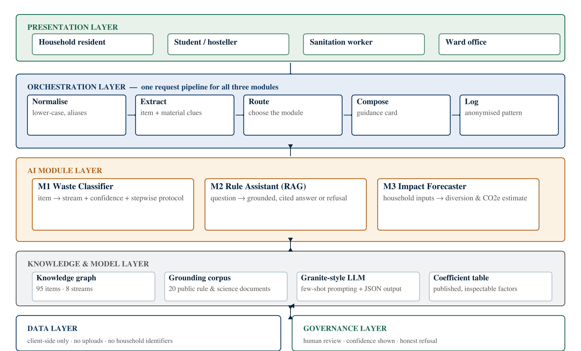
Figure 16: Conceptual system architecture of SwachhAI
Four architectural decisions are worth naming, because each represents a choice that could reasonably have gone the other way.
• One pipeline, three modules. The system does not contain three applications. It contains one input pipeline that routes a request to one of three functions, which is why normalisation, privacy handling and logging are written once rather than three times.
• Deterministic code around a probabilistic core. The language model sits in the middle of each path, and everything before and after it is ordinary deterministic code: alias expansion, taxonomy validation, threshold enforcement, JSON parsing, coefficient arithmetic. The model is never the last word.
• A separate knowledge layer. The taxonomy, the corpus and the coefficients are data, not code. They can be revised quarterly by a reviewer without releasing new software, which is what makes the human-oversight gate practical.
• Client-side by default. The design processes input on the device and stores nothing centrally, so the privacy position does not depend on a promise about how a server behaves.

The architecture is presented at the level of concept, as required for this report. It is a block diagram of responsibilities and data flow, not an implementation specification: it does not fix a hosting model, a database product or a model-serving stack, because those choices belong to a build phase that this project did not undertake.

7.6 Workflow of a single interaction
The workflow below shows what happens in one turn, from the resident opening the assistant to the guidance appearing on screen. It is the same pipeline regardless of whether the resident arrives with an item, a question or a monthly review.
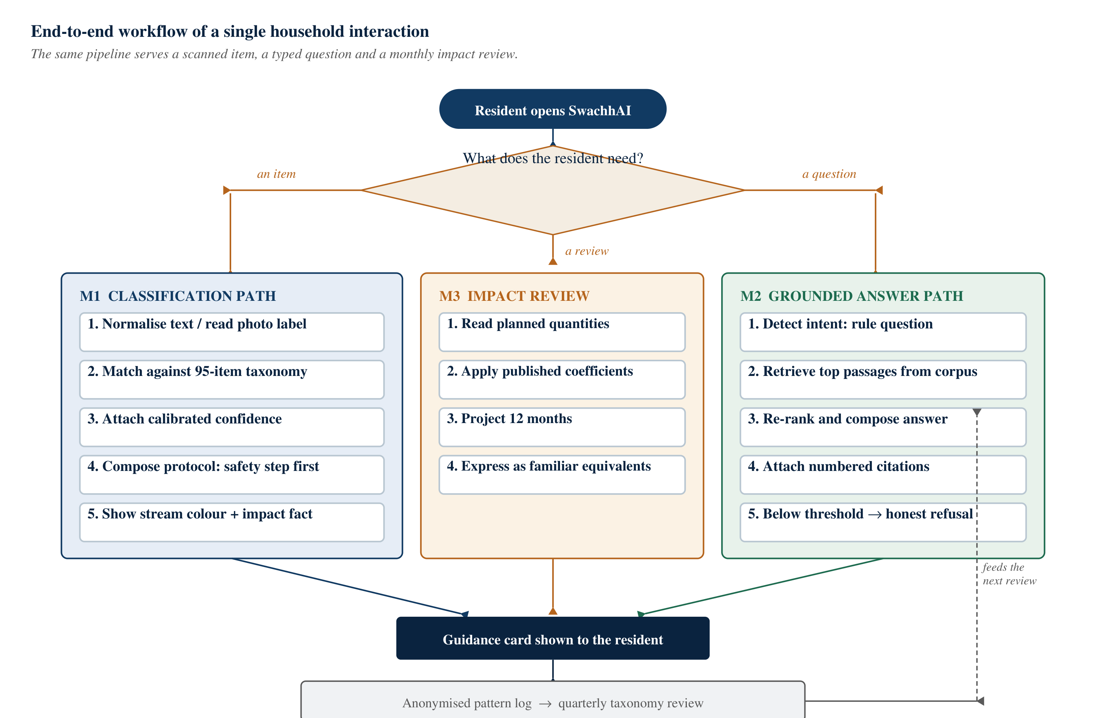
Figure 17: End-to-end workflow of a single household interaction
Reading the flow left to right, the resident’s intent is detected first; the request is normalised and, where necessary, the item is extracted; the request is routed to the classifier, the rule assistant or the forecaster; the selected module composes a response using the knowledge layer; the response is rendered as a card with its confidence and its sources; and an anonymised pattern is logged for the quarterly taxonomy review. Hazardous-waste requests take a variant of this path in which the safety step is mandatory and the system appends a reminder to verify with the local body.
Notice what the workflow does not contain: no step in which the system acts on the world. It classifies, retrieves, composes and logs. It does not order a collection, contact a recycler, notify a municipality about an individual household or penalise anyone. The scope of autonomy was set deliberately narrow, and Chapter 8 explains why.

7.7 Illustrative interface mock-ups
Two mock-ups are included to make the design concrete: the classification screen and the impact forecaster. Both are illustrations prepared for this report. They are not screenshots of a deployed product, they are not a demonstration of working software, and the numbers shown are the worked example from Chapter 7, not measurements. They are drawn in the report to communicate layout and information hierarchy, and they should be read in that spirit.
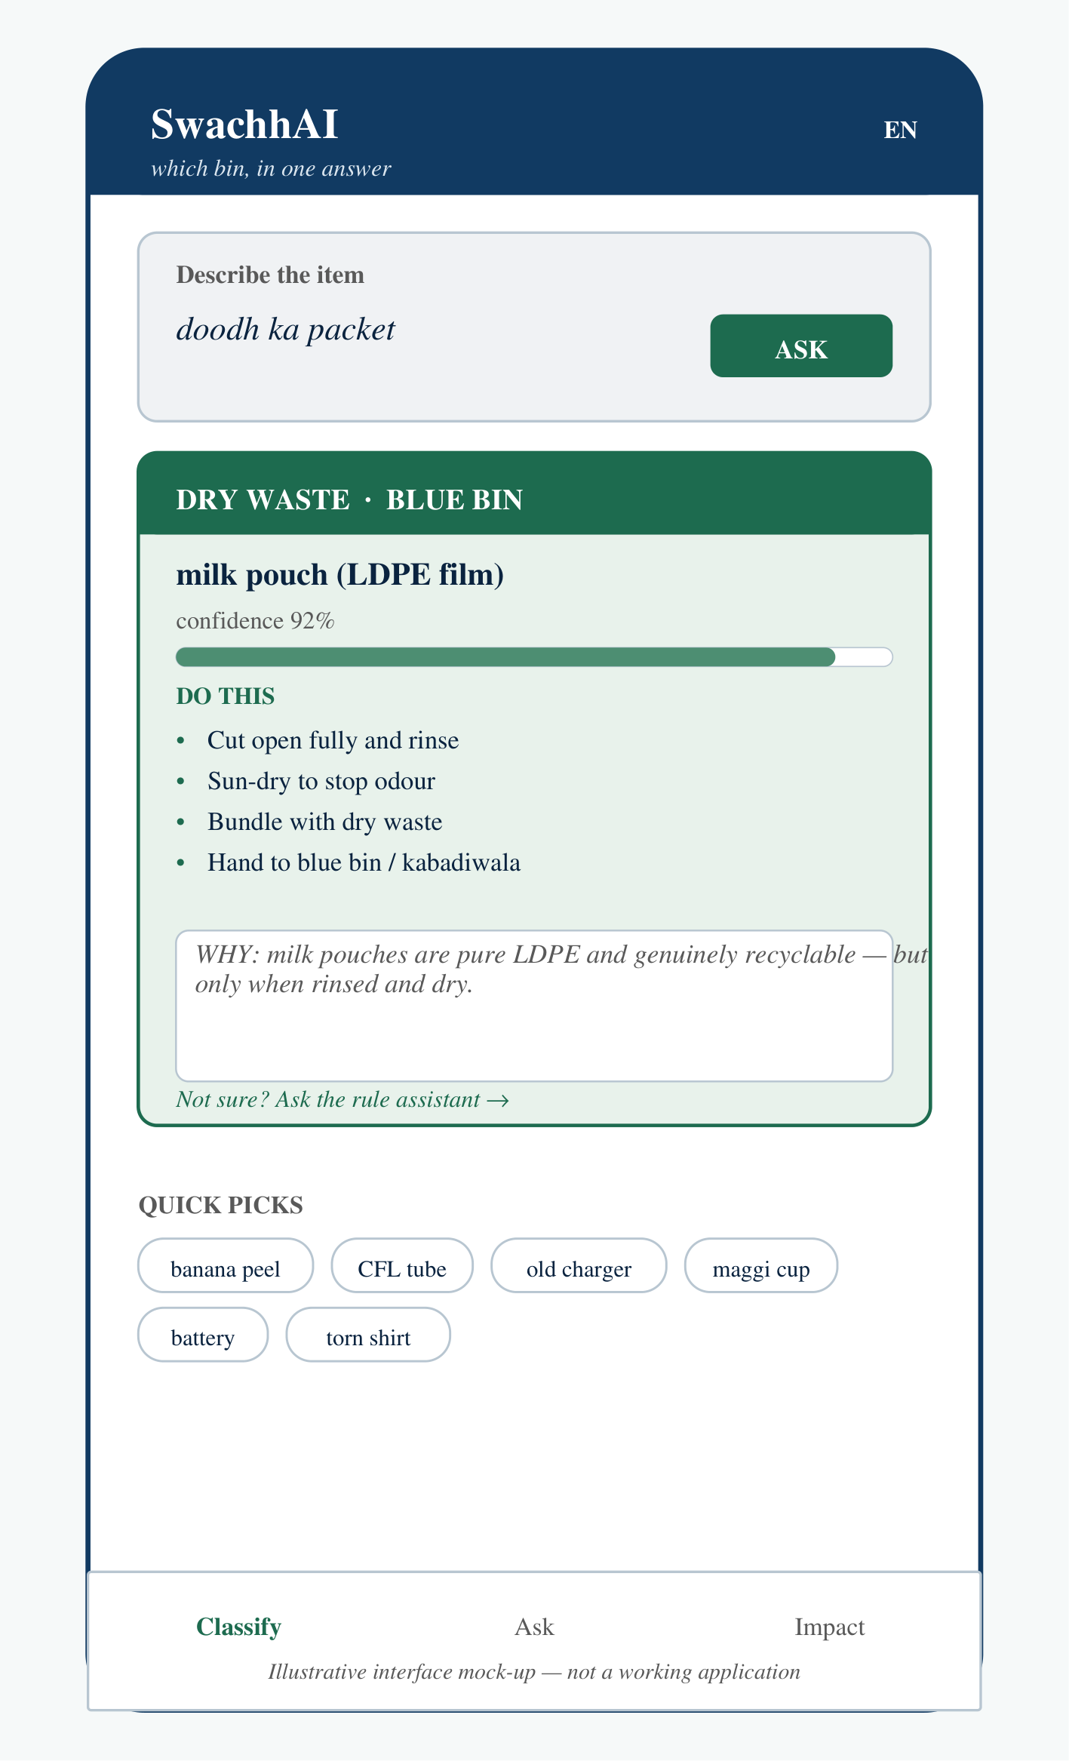
Figure 18: Illustrative mock-up of the classification screen (not a working application)
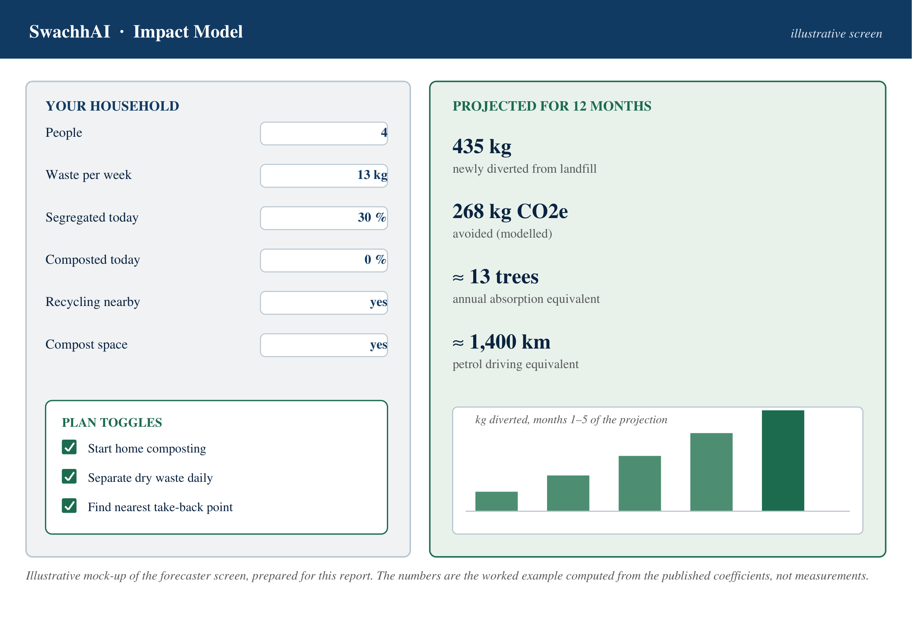
Figure 19: Illustrative mock-up of the impact forecaster screen (a modelled example, not measurements)
The classification mock-up shows the four elements that the design treats as non-negotiable: the stream, stated in words and as a colour; the confidence, stated as a number and a bar; the steps, with the safety step first; and the reason, in plain language. The forecaster mock-up shows the two elements it treats as non-negotiable: the inputs are quantities only, never identifying details, and the outputs are labelled as projections over twelve months rather than as achievements to date.

CHAPTER 8

RESPONSIBLE AI AND SUSTAINABILITY

8.1 Why this chapter is not an appendix
There is a comfortable way to write about responsible AI: state five principles, affirm that the project follows them, and move on. That approach produces a paragraph that no one can disagree with and no one can check. This chapter takes the harder route. It states each commitment as a behaviour that could be observed, describes what would happen if the commitment were absent, and then records the limits of what the design actually achieves.
The reason for the seriousness is the domain. A system that gives household advice about waste is giving advice about public rules, in a context where a wrong answer can put a sanitation worker in contact with a broken CFL tube or an unmarked needle. Responsible AI is not a reputational supplement to this project; it is the condition under which the project is worth building at all.

8.2 Transparency
Transparency in this design means that the user can see how a conclusion was reached. Four specific commitments implement it.
• Confidence is always shown. Every classification carries a percentage. A 72 per cent answer is visibly different from a 96 per cent answer, and below 75 the answer is not a stream at all but an admission of uncertainty.
• Sources are always listed. Every answer from the rule assistant lists the passages it retrieved, with the source document named, so that a resident can check the claim against the rule itself.
• Coefficients are published. The impact forecaster prints the factors it uses, and they are reproduced in this report (Table 16). A resident who disagrees with a coefficient can see exactly which one to argue with.
• Mocked layers are labelled. Where the project build simulated a capability — image understanding, for instance — the limitation is stated in the interface and in this report rather than hidden behind a plausible-looking screen.

Transparency of this kind costs something. It makes the system look less confident than a system that simply asserts an answer, and a product team under commercial pressure would be tempted to hide the confidence bar. The project’s position is that a user who is told the system is unsure can compensate; a user who is misled cannot.

8.3 Fairness
An AI system is unfair when it works better for some people than for others in ways that are not justified by the task. In a waste assistant, the most consequential unfairness would be linguistic: a system that understands polished English and fails on Hinglish would serve exactly the households who least need help, and abandon the ones who do.
The design responds with four commitments. It accepts Hinglish, transliteration and misspellings as first-class inputs, and treats a failure to understand ordinary spoken language as a defect rather than a user error. It makes no income-coded assumptions: shared bins, rented rooms, single-room homes and informal settlements are modelled as normal circumstances, not as exceptions requiring a special flow. It keeps the knowledge base balanced across all eight streams, so that a question about an affluent household’s e-waste and a question about reusing cloth receive comparable depth of guidance. And it frames sanitation workers as people to protect rather than as people to monitor, which rules out any feature that scores, ranks or photographs them.
There is an honest limit here. A language model’s competence in a language depends on its training data, and Hindi, Marathi or Bengali inputs may be handled less reliably than English ones regardless of what the prompt requests. The project’s fallback matcher exists partly for this reason, and the roadmap’s second phase explicitly includes multilingual voice input. The report does not claim that fairness in language has been achieved; it claims that it has been designed for.

8.4 Privacy
The privacy position of the project is unusually strong for an AI application, and it is architectural rather than declarative. The demo build was designed to execute entirely on the client side: no uploads, no storage, no cookies, no tracking. Photographs, in the designed extension, would never leave the device. The forecaster asks for quantities and percentages only — household size, kilograms per week, segregation share — and never for a name, an address, a phone number or an identifier.
Table 16: Personal data the system does and does not touch
Data element | Handled how | Why it is treated this way
Item description typed by the resident | Processed on the device; not stored centrally | It is the minimum input needed to answer the question
Photograph of an item | Designed to be processed on the device; not uploaded | A photograph can reveal a home, a document or a person; upload is unnecessary for the task
Household quantities (size, kg per week, percentages) | Used only to compute an estimate; no identifier attached | Sufficient for the arithmetic; useless for identifying a household on its own
Name, address, phone number, location history | Not collected at all | Not required by any function of the system
Anonymised usage pattern (for example, an unrecognised item name) | Logged without identifiers, for quarterly taxonomy review | The only way the system improves, without knowing who asked
Ward-level aggregate (later phase) | Aggregate only, with a minimum cohort size | Supports municipal planning without household-level surveillance

One distinction deserves emphasis: anonymised is not the same as unlinkable. A pattern log that records a sequence of unusual item queries could, in principle, be re-identified if combined with other data. The design mitigates this by logging the pattern rather than the query, by keeping no account, and by keeping the logs local wherever possible. It does not claim that the risk is zero, and a production deployment would need a formal privacy review before any server-side logging was introduced.

8.5 Ethical use of AI
Three ethical commitments shape the system’s behaviour more than any technical choice.
The honest-refusal contract. Below the grounding threshold, the system says it does not know, and offers better questions, instead of fabricating a rule. This is the single most important behaviour in the design, because a fabricated rule about hazardous waste is not a minor inaccuracy. A system that refuses is less impressive in a demonstration and considerably safer in a kitchen.
Human safety outranks recycling purity. When the two conflict, the guidance resolves in favour of the person. A mercury-bearing lamp is a hazard before it is a recycling opportunity, and a swollen battery is a fire risk before it is a material recovery opportunity. Every hazardous protocol therefore leads with wrap, mark and hand over separately, rather than with material value.
No shame mechanics. The system contains no guilt score, no public ranking and no comparison with neighbours. Nudges are factual, kind and opt-in. The reason is both ethical and practical: a resident who feels judged by an application stops using it, and a waste tool that people stop using has no effect at all. Behaviour change that is sustained is voluntary.

8.6 Human supervision
The design keeps a person in the loop at precisely the point where an error would propagate. The system may answer questions, classify items and log anonymised patterns without human intervention. It may not change its own taxonomy, admit a new document into its corpus, or alter a coefficient without review. Each of those three is a change to the system’s beliefs about the world, and a system that can revise its own beliefs from user traffic alone can drift.
Supervision also has a scope limit that the report states explicitly: the system is advisory. It supports a household decision; it does not determine regulatory compliance, it does not replace a municipal instruction, and where a local body’s bylaws differ from the general rules, the local body takes precedence. Every hazardous answer therefore closes with a reminder to verify with the local municipal body.
The project document specifies the review cadence as quarterly for the taxonomy and the corpus, with bias and misuse regression checks at each release. Those are design intentions for a system in operation; no such reviews were conducted during the internship, because the system was not in operation.

8.7 Environmental and social benefits
The benefits the project is designed to produce fall into four groups, and it is worth separating them because they are of different kinds and are evidenced differently.
• Environmental. Organic waste composted instead of landfilled avoids methane formation; recycling displaces virgin production, which for aluminium saves the great majority of the energy required from ore; compost returns carbon and nutrients to soil. These are established mechanisms described in the published literature; the project’s contribution is behavioural, and its quantitative outputs are modelled.
• Social. Sanitation workers encounter marked, wrapped hazardous material instead of unmarked material; households gain a sense of agency over a problem that usually feels abstract; rules become readable in everyday language rather than only in legal English.
• Economic. Cleaner inbound streams raise the value of recovered material and give informal recyclers more predictable quality. These are argued mechanisms, not measured outcomes of this project.
• Educational. The forecaster turns landfill methane into a number attached to a household’s own kitchen, which is itself a form of climate education and aligns with Target 13.3 of SDG 13.

The report is careful here. None of these benefits has been demonstrated by this project. They are the mechanisms the design is built to activate, and the measurement plan that would test them is described in the project document: correct-sort rates from waste audits, dry-stream purity at the material recovery facility, worker injury and exposure incidents per thousand shifts, weekly active households, and modelled emissions avoidance derived from audited diversion. Until those measurements exist, the benefits remain claims with a stated basis, not results.

8.8 Limitations of the proposed approach
A design document that lists no limitations is a sales document. The table below records the limitations that the project itself acknowledges, together with what each one means for a reader of this report.
Table 17: Known limitations of the proposed approach
Limitation | Why it matters | How the project responds, and what remains open
Built for the Indian urban context | Rural practices, different collection systems and other countries are outside its design assumptions | The scope is stated openly; extension would require new taxonomy and corpus work, not just translation
Municipal bylaws vary by city and take precedence | A generally correct answer can be locally wrong | The corpus is designed to be swappable per city, and every answer defers to the local body; per-city corpora were not built
Demo taxonomy of about 95 items | Real household waste contains far more variety | The roadmap extends to about 250 items from real queries during a campus pilot; unrecognised items fall to the refusal path in the meantime
Image understanding was mocked in the project build | The designed visual capability is not evidence of a working vision system | Stated as a designed extension throughout this report; no accuracy claim is made for it
Estimates are modelled, not measured | A plausible number can be mistaken for a verified one | Outputs are labelled as directional, stated in ranges, and their arithmetic is published
Behaviour change may decay | A tool used for a month and abandoned changes nothing durable | Nudges and progress cards are designed to sustain use; this is untested
Language coverage depends on the model | Hindi, Marathi or Bengali input may be handled less reliably than English | Hinglish is explicitly supported and a fallback matcher exists; multilingual support is a phase-two goal
No field deployment or user testing | Every behavioural claim about residents is a hypothesis | The pilot and its measurement plan are specified but were outside the internship’s scope

The most important limitation is scope. SwachhAI addresses one step of a long municipal chain. Even a perfectly adopted household assistant would leave collection gaps, transport losses, facility capacity and legacy dumpsites untouched. The project is worth doing because that one step is currently weak and because it is the step a household actually controls — not because household behaviour is the whole problem.

CHAPTER 9

LEARNING OUTCOMES AND FUTURE SCOPE

9.1 Knowledge gained during the internship
The clearest way to describe what was learned is to describe what changed in how the intern now thinks about building software. Four shifts are worth recording, because each one is a durable change rather than a fact that could be looked up.
From accuracy to calibration. Before the internship, a model was good if it was right often. After it, a model is good if it knows when it is unsure. The classifier’s confidence display and its 75-point threshold are not cosmetic features; they are the mechanism by which a resident can decide whether to trust a particular answer. A system that is 85 per cent accurate and silent about which 15 per cent is wrong is less useful than one that is 80 per cent accurate and honest about its uncertainty.
From generating to grounding. The internship made the difference between a language model’s memory and a language model’s evidence concrete. Retrieval changes an AI feature from an assertion into a quotation, and a quotation can be checked. The design rule that emerged — no citation, no claim — is a small sentence with large architectural consequences.
From features to constraints. The most valuable design work on the project was subtractive. Four modules were considered and three were kept; several features were rejected because they could not be justified ethically or measured honestly. Learning to remove a feature that would have looked impressive in a demonstration, because it would have been unverifiable in practice, was the most professional thing the internship taught.
From code to documentation. The project’s value to an evaluator lies in its reasoning, which exists only if it is written down. Producing a document that a reader can follow — with diagrams, tables, examples and stated limits — turned out to be part of the engineering, not a report on it.

9.2 Technical skills developed
The skills below are stated at the level at which they can honestly be claimed after a six-week programme: working familiarity and applied practice, not mastery.
Table 18: Skills developed, and the level honestly claimed for each
Skill | How it was practised | Level honestly claimed
Prompt design | Writing and revising a classifier prompt with a role, a task decomposition, a JSON output contract, a refusal rule and a tone rule | Working familiarity; not benchmarked
Retrieval-augmented design | Specifying a corpus, chunking strategy, retrieval, re-ranking and a grounding threshold | Design-level understanding; the demo used a term-frequency retrieval approach
Responsible-AI review | Turning five principles into observable behaviours and reviewing the design against them | Applied practice on one system
Policy research | Reading primary instruments — SWM Rules 2016, E-Waste and Battery Rules 2022 — rather than summaries | Competent at locating and citing primary sources
Quantitative modelling | Building a transparent coefficient model and stating its uncertainty | Competent for order-of-magnitude estimates
Systems thinking | Separating a long municipal chain into one addressable step and stating what is out of scope | Applied, with supervision
Technical communication | Block diagrams, workflow diagrams, tables, worked examples and a structured report | Demonstrated by this document
Python and data handling | Data structures, basic scripting and tabular handling carried over from coursework and prior training | Coursework level

9.3 Practical understanding of emerging technologies
Three practical judgements about emerging technology emerged from the work, and they are more portable than any specific tool.
Justify the model, not the fashion. The classifier uses a language model because the input is language, variable and misspelt. The forecaster does not use a learned model, because a household needs arithmetic it can check. Both decisions are about the task; neither is about what is currently interesting. Being able to defend a decision not to use AI is as much a technical skill as being able to use it.
Assume the model will be wrong. Every path in the design has a defined failure behaviour: unknown instead of a guess, refusal instead of invention, a fallback matcher instead of a crash, a labelled estimate instead of a false precision. Designing the failure path first, and building the happy path around it, is the habit that separates a demonstration from a system.
Treat evaluation as part of the design. A claim without a measurement plan is an opinion. The project document specifies what would be measured — audit-based correct-sort rates, dry-stream purity, injury rates per thousand shifts, weekly active households — before claiming that anything works. That discipline is what allows this report to say “modelled” where it cannot say “measured”.

9.4 Future scope of SwachhAI
The project document sets out a phased path, and this report reproduces it as a plan rather than as a commitment. The organising principle is that each phase must earn the next one with field evidence: a taxonomy expanded from a campus pilot is more useful than one expanded from imagination, and a ward partnership is only worth entering once the tool has survived a smaller test.
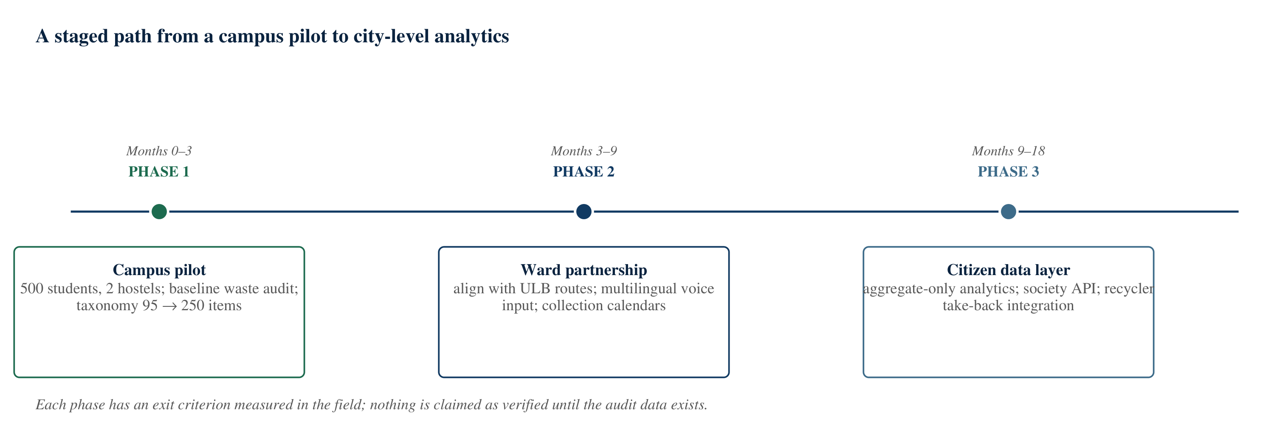
Figure 20: A staged path from a campus pilot to city-level analytics
Table 19: Future scope, grouped by the phase in which it would be justified
Phase | What would be built or done | What would have to be true to proceed
Phase 1 — campus pilot (months 0–3) | Deploy to about 500 students and two hostels; run a one-week baseline waste audit; expand the taxonomy from about 95 to about 250 items using real queries | At least 60 per cent weekly active use and a measurable cut in hostel mixed waste
Phase 2 — ward partnership (months 3–9) | Align the streams with the urban local body’s collection routes; add multilingual voice input and ward collection calendars; deploy the nudge agent | One ward onboarded, and the material recovery facility verifies improved dry-stream purity
Phase 3 — citizen data layer (months 9–18) | Aggregate-only stream analytics on city dashboards; an API for housing societies; integration with recycler take-back schemes | Verifiable tonnes diverted, published quarterly from audited data

Beyond the phased plan, four extensions are technically plausible and are recorded here as possibilities rather than promises. Vision-based classification, in which a photograph is read directly instead of a label being typed, would remove the typing burden but would need a properly labelled training set and an accuracy study before it could be trusted on hazardous items. Multilingual voice input would widen access substantially, and is the extension with the clearest equity case. Per-city corpora would address the limitation that municipal bylaws vary, and could be assembled with local bodies or student partners in each city. Recycler and kabadiwala integration would close the loop by telling a resident where to hand material over, rather than only which stream it belongs to.
One further extension is worth stating because it is often proposed and should be resisted in this form: a household league table or public ranking. It would probably increase short-term engagement and it would violate the project’s position on shame, privacy and dignity. The design keeps progress private to the household and treats aggregate data as a municipal planning input rather than as a social scoreboard.

9.5 What was not done, and why
Recording absences is as useful as recording achievements, particularly in a report that will be assessed. No model was trained or fine-tuned; no labelled image dataset was assembled; no field deployment or user testing was conducted; no municipal partnership was established; no measurement of diversion, contamination or injury was made; and no independent evaluation of accuracy was performed.
The reason is scope rather than omission. The internship’s deliverable was a designed and documented proposal, and the University’s requirement for this report is an academic record, not a deployed product. Claiming any of the above would have made the report longer and less true. What the work does provide is a design that states its assumptions, a set of published coefficients, a measurement plan and an honest list of limits — which is the correct starting position for the field work that would follow.

CHAPTER 10

CONCLUSION

10.1 What the internship was
This report has documented the 1M1B AI for Sustainability Virtual Internship, offered by 1M1B (One Million for One Billion), supported by the All India Council for Technical Education and delivered in collaboration with IBM SkillsBuild, and certified as completed over the period July to September 2026. The internship asked for two things that are usually kept apart: a working understanding of current artificial intelligence techniques, and a defensible application of them to a real sustainability problem.
The technical content covered machine learning, large language models, the IBM Granite family, prompt engineering, retrieval-augmented generation, agentic AI and responsible AI. The project requirement converted that syllabus into a problem: household waste segregation, where the rules exist, the obligation exists, and the interface between the two does not.

10.2 What the project proposed
SwachhAI is a decision-support concept with three cooperating modules. A classifier maps an item described in ordinary language to one of eight waste streams, with a stated confidence and a short protocol that leads with the safety step. A retrieval-augmented assistant answers questions about waste rules only from a curated corpus of public documents, with citations, and refuses when the documents do not cover the question. An impact forecaster converts a household’s stated habits into a transparent, checkable estimate of waste diverted and carbon dioxide equivalent avoided, using published coefficients rather than an opaque model.
The design is united by one argument: AI is justified in this domain because the problem is linguistic and contextual. Residents are not indifferent; they are unsure, at a moment when they have four seconds and no reliable memory of which item belongs where. A static poster cannot resolve an item-specific question in a resident’s own vocabulary. A system that understands language, retrieves rules and states its own uncertainty can.

10.3 What was learned
Three lessons will outlast the project. The first is that calibration matters more than raw accuracy in any system that advises a person: an answer that states its confidence can be acted on sensibly, while a confident answer that is sometimes wrong cannot. The second is that grounding converts an assertion into evidence, and evidence can be checked; the discipline of refusing to answer when the evidence is thin turned out to be a feature, not a shortfall. The third is that the ethical constraints were the design: the confidence threshold, the privacy architecture, the refusal path and the safety-first protocols all exist because someone asked what happens when the system is wrong, and who is harmed.
The professional lessons were less tidy. Working without supervision means that a milestone either exists or does not; mentor feedback is worth more than a first idea; documentation is part of the engineering; and a report is more credible when it states what it did not do.

10.4 Why the problem matters
India’s municipal waste problem is usually described in tonnes, and the tonnage is real: the Central Pollution Control Board’s reporting for 2020–21 places generation at roughly 1,60,000 tonnes per day [1]. But the tonnage is a consequence. The cause is a chain of small decisions, most of them made in kitchens, and the first of those decisions is which bin. When that decision goes wrong, the cost is paid three times: by a recycler whose bale is rejected, by a sanitation worker who reaches into a bag containing a broken tube, and by the atmosphere in the form of methane from organic waste that was buried instead of composted.
A household assistant does not fix a municipal system. It addresses one step — the step that a household controls — and it does so on the assumption that better inputs make every downstream stage easier. That assumption is testable, and the project document specifies how: audits, purity measurements, injury rates, active use. The honest status of the project is therefore not “solved” but “designed, with a plan to find out”.

10.5 Professional development
The internship changed the kind of engineer this student intends to be. It established an interest in the part of data and AI work that sits closest to a decision a person actually makes — the interface, the uncertainty, the failure path — and a working standard for claims: state the basis, show the arithmetic, label the estimate, and separate design from demonstrated behaviour.
Those habits connect directly to the career direction recorded in the accompanying résumé: data engineering and data systems. A pipeline that moves data reliably between systems has the same obligations as a classifier that moves an item into a stream — defined contracts, explicit failure behaviour, inspectable outputs and someone accountable for what happens when the data is wrong. The internship was about waste; the lesson was about trustworthiness.

10.6 Closing remark
The project was called SwachhAI because the aim was modest and specific: make the right bin the easy bin. It is a small ambition measured against a national problem, and a serious one measured against a household. If the design is ever built and tested, the question that will decide whether it was worth building is not whether the model was accurate. It is whether a resident, holding a milk pouch in one hand and a phone in the other, found the answer in time — and whether the person who collected the bag the next morning was a little safer for it.

REFERENCES AND BIBLIOGRAPHY
The list below contains only sources that were actually consulted and that support statements made in this report. Publication details and web addresses were verified before inclusion. Where a document has been amended since notification, the principal notification is cited and the amendment is named in the text.
Items [1] to [9] are the primary sources for the published statistics and rules used in Chapters 5 to 8. Items [10] to [16] support the technology and programme descriptions. Items [17] and [18] are the standard references for retrieval-augmented generation and the transformer architecture. Item [19] is the university guideline followed for formatting. Item [20] is the project document submitted during the internship; it is not publicly available and is cited for internal traceability only.
[1] Central Pollution Control Board, Annual Report 2020–21 on Implementation of Solid Waste Management Rules, 2016, Central Pollution Control Board, Ministry of Environment, Forest and Climate Change, Government of India.
https://cpcb.nic.in/uploads/MSW/MSW_AnnualReport_2020-21.pdf
[2] Ministry of Environment, Forest and Climate Change, Solid Waste Management Rules, 2016, Notification S.O. 1357(E) dated 8 April 2016, Gazette of India.
https://cpcb.nic.in/uploads/MSW/SWM_2016.pdf
[3] Ministry of Environment, Forest and Climate Change, Battery Waste Management Rules, 2022, notified 24 August 2022, Gazette of India; see also Press Information Bureau, “Government notifies Battery Waste Management Rules, 2022”, 25 August 2022.
https://www.pib.gov.in/PressReleasePage.aspx?PRID=1854433
[4] Ministry of Environment, Forest and Climate Change, Plastic Waste Management Rules, 2016, as amended by the Plastic Waste Management (Amendment) Rules, 2021 and subsequent amendments, Gazette of India.
https://cpcb.nic.in/displaypdf.php?id=cGxhc3RpY3dhc3RlL1BXTV9HYXpldHRlLnBkZg==
[5] Ministry of Environment, Forest and Climate Change, E-Waste (Management) Rules, 2022, Notification G.S.R. 801(E) dated 2 November 2022, in force from 1 April 2023, Gazette of India.
https://cpcb.nic.in/uploads/Projects/E-Waste/e-waste_rules_2022.pdf
[6] Ministry of Environment, Forest and Climate Change, Construction and Demolition Waste Management Rules, 2016, Gazette of India, 2016.
https://cpcb.nic.in/uploads/MSW/CD_Waste_Rules_English.pdf
[7] Ministry of Housing and Urban Affairs, Swachh Bharat Mission – Urban 2.0: Making Cities Garbage Free, operational guidelines, Government of India, 2021.
https://swachhbharaturban.gov.in/
[8] Intergovernmental Panel on Climate Change, “Chapter 7: The Earth’s Energy Budget, Climate Feedbacks and Climate Sensitivity”, in Climate Change 2021: The Physical Science Basis. Contribution of Working Group I to the Sixth Assessment Report, Cambridge University Press, 2021, Table 7.15.
https://www.ipcc.ch/report/ar6/wg1/chapter/chapter-7/
[9] United Nations Environment Programme, Food Waste Index Report 2024: Think Eat Save — Tracking Progress to Halve Global Food Waste, Nairobi, 2024.
https://www.unep.org/resources/publication/food-waste-index-report-2024
[10] IBM, “IBM Granite 3.0: open, state-of-the-art enterprise models”, IBM announcement, October 2024.
https://www.ibm.com/new/announcements/ibm-granite-3-0-open-state-of-the-art-enterprise-models
[11] IBM, granite-3.0-8b-instruct model card, IBM watsonx documentation.
https://www.ibm.com/docs/en/watsonx
[12] IBM SkillsBuild, digital learning platform, IBM.
https://skillsbuild.org/
[13] 1M1B (One Million for One Billion), programme information for the AI for Sustainability Virtual Internship.
https://www.1m1b.org/
[14] All India Council for Technical Education, National Internship Portal.
https://internship.aicte-india.org/
[15] Bureau of Indian Standards, IS 14534: Plastics — Guidelines for the Recovery and Recycling of Plastics, New Delhi.
https://www.bis.gov.in/
[16] United Nations, Transforming our World: The 2030 Agenda for Sustainable Development, A/RES/70/1, 2015, including Sustainable Development Goals 11, 12 and 13 and their targets.
https://sdgs.un.org/2030agenda
[17] Lewis, P., Perez, E., Piktus, A., et al., “Retrieval-Augmented Generation for Knowledge-Intensive NLP Tasks”, Advances in Neural Information Processing Systems 33, 2020.
https://arxiv.org/abs/2005.11401
[18] Vaswani, A., Shazeer, N., Parmar, N., et al., “Attention Is All You Need”, Advances in Neural Information Processing Systems 30, 2017.
https://arxiv.org/abs/1706.03762
[19] University of Lucknow, Guidelines for the Submission of Summer Internship Reports, Department of Computer Science and Engineering, Lucknow.
https://www.lkouniv.ac.in/
[20] Mohammad Ramish Ansari, SwachhAI — AI for Sustainable Waste Management: Final Project Deliverable, submitted for the 1M1B AI for Sustainability Virtual Internship, 14 September 2026.
A note on citation practice. Numerical citations in the text refer to this list and are clickable in the digital edition. Statistics are given with their reporting year, because several figures in this area change annually. No source has been cited that was not consulted, and no reference has been included to lengthen the list.

CHAPTER A

APPENDIX A: SUPPORTING DOCUMENTS

A.1 Purpose of this appendix
This appendix reproduces the supporting documents referred to in the report so that a reader can verify the particulars stated in Chapters 1 to 3 without taking them on trust. Three documents are reproduced: the AICTE internship completion certificate, already included in the preliminary pages and referenced here for completeness; the two IBM SkillsBuild completion certificates of 1 and 5 August 2026; and a summary of the AICTE internship offer letter.
The offer letter itself is not reproduced in full. It carries a confidentiality clause, which this report respects: the summary records only the particulars needed to establish the internship’s identity, duration and terms, and omits contact addresses, links, and all course and session content.

A.2 Internship completion certificate
Issued by 1M1B (One Million for One Billion), supported by AICTE, in collaboration with IBM SkillsBuild. Signed by the Founder and Chief Mentor of 1M1B and by the Chief Coordinating Officer of AICTE. Issue date 22 September 2026; AICTE Internship ID INTERNSHIP_17828984086a44dee80acf6. The certificate records the internship period as July 2026 to September 2026. A colour copy appears in the preliminary pages of this report; see also Table 2 for the date analysis.
Internship completion certificate (reproduced from the preliminary pages)

A.3 IBM SkillsBuild completion certificates
Two SkillsBuild completion certificates were issued during the internship, recording completion of two learning plans on 1 August 2026 and 5 August 2026. They are not internship certificates — that is the document in A.2 — but they evidence the guided learning component.
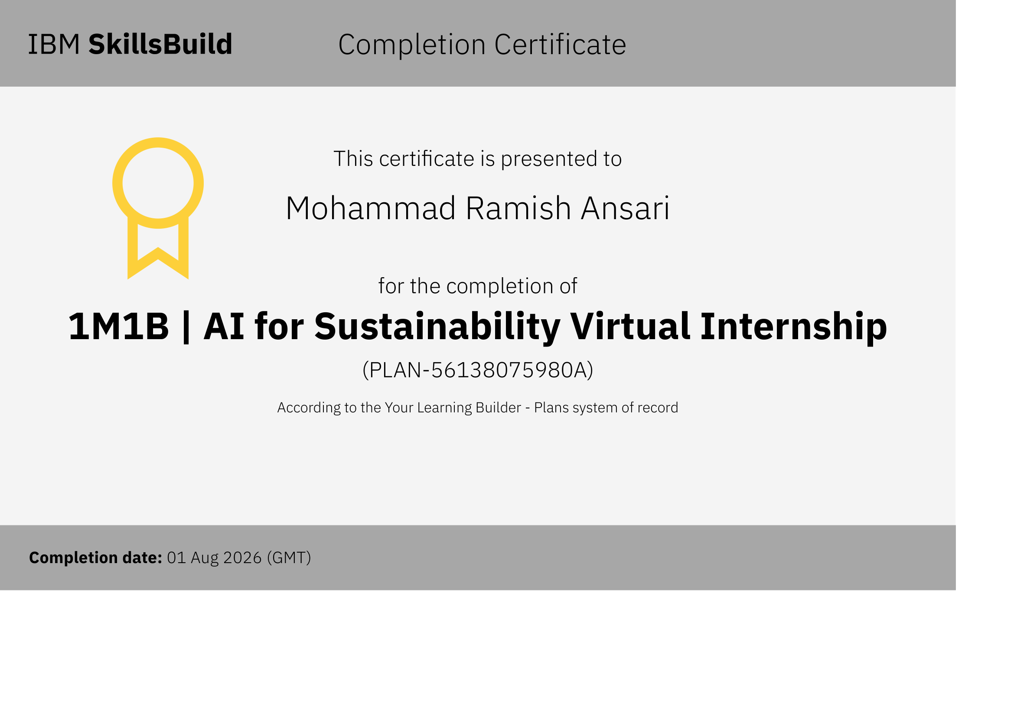
IBM SkillsBuild completion certificate, learning plan PLAN-56138075980A, 1 August 2026 (GMT)
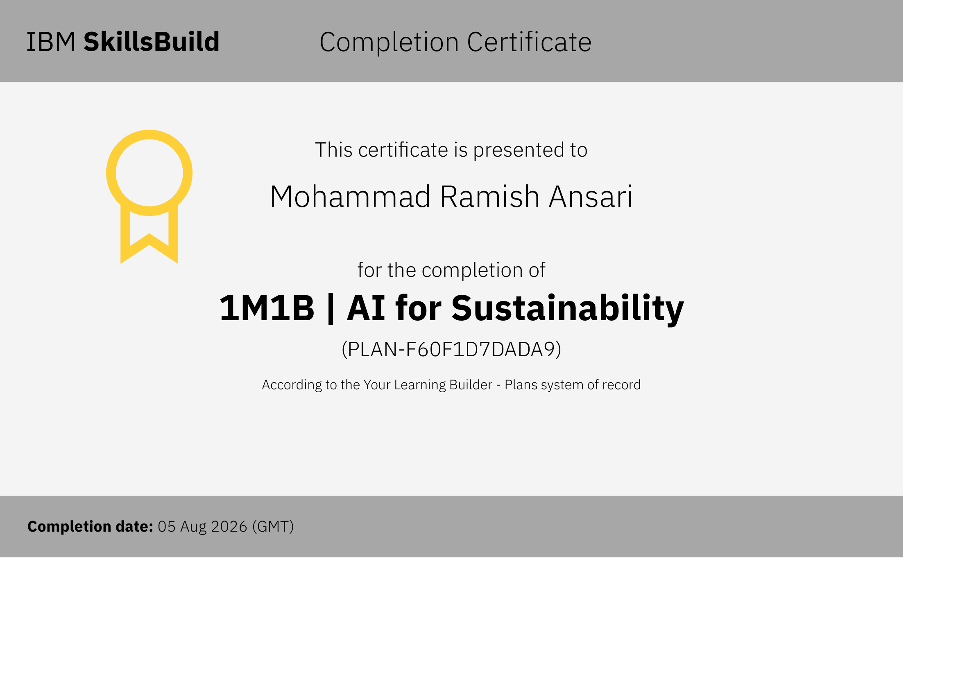
IBM SkillsBuild completion certificate, learning plan PLAN-F60F1D7DADA9, 5 August 2026 (GMT)

A.4 Summary of the AICTE internship offer letter
The offer letter confirms selection for the 1M1B AI for Sustainability Virtual Internship, offered by 1M1B in collaboration with AICTE (National Internship Portal) and co-certified by IBM SkillsBuild. The particulars relevant to this report are:
Table 21: Student and internship particulars, as recorded in the documents
Particular | Value as recorded in the documents
Student name | Mohammad Ramish Ansari
Programme and institution | B.Tech. Computer Science and Engineering, University of Lucknow, Lucknow — 226 021; third year, Semester V
University roll number and faculty supervisor | [To be entered — not stated in the uploaded documents]
Internship title | 1M1B | AI for Sustainability Virtual Internship
Organising body | 1M1B (One Million for One Billion), supported by AICTE (National Internship Portal) and co-certified in collaboration with IBM SkillsBuild
AICTE Internship ID | INTERNSHIP_17828984086a44dee80acf6
Duration | Proposed: six weeks, 28 July to 28 August 2026 (offer letter). Certified: July to September 2026 (completion certificate, issued 22 September 2026)
Project submitted | SwachhAI — final project deliverable, 14 September 2026
Remuneration | Unpaid internship; no stipend is provided
Square-bracketed items are placeholders: the documents do not state the university roll number or the faculty supervisor, and this report does not guess them.

A.5 How the claims in this report are supported
Because the report deliberately contains no invented results, it is worth stating what each kind of claim rests on. Student, internship and date particulars come from the offer letter, the completion certificate, the two SkillsBuild certificates and the project document, and are stated directly. National statistics come from the CPCB annual report for 2020–21 and are cited by number. Rule and standards content comes from the Gazette notifications, paraphrased rather than quoted. Greenhouse-gas and food-waste figures come from IPCC AR6 and the UNEP Food Waste Index Report 2024. Descriptions of the system’s behaviour describe the design in the project document, and are illustrated by its recorded examples. Quantities of waste diverted or emissions avoided are labelled as modelled estimates, with their arithmetic shown in Table 15. Expected benefits to households, workers and cities are argued mechanisms accompanied by a measurement plan. No performance, accuracy or testing result is claimed anywhere in this report, because none was measured.

A.6 Declaration of academic integrity
The report follows the University of Lucknow’s guidelines for the submission of summer internship reports: A4 paper, Times New Roman at 12 point for body text, single line spacing, justified paragraphs, consistent academic margins, Roman numerals for preliminary pages and Arabic numerals for the main report, and single-sided printing suitable for spiral binding.
The report contains no source code and describes no executable software product: it presents a conceptual design documented through descriptions, diagrams, tables and clearly labelled illustrations. Where the project’s own material describes a prototype, this report explains its intended design and does not claim to have tested or verified it. Both interface mock-ups are labelled as illustrations, and no confidential material or meeting link has been reproduced.

