______________________________________________
(Name of the University)
______________________________________________
(Name of the College)
Department of Computer Science & Engineering
WEB TECHNOLOGY LABORATORY FILE
(A practical report of the Web Technology Laboratory course)
Student Name : | ______________________________
Roll Number : | ______________________________
Enrollment Number : | ______________________________
Course : | B.Tech - Computer Science & Engineering
Semester : | ______________________________
Academic Session : | ______________________________

Submitted To
______________________________
(Faculty Name)
INDEX
S. No. | Name of Program | Date | Page No.
1 | HTML program to create resume preparation using tables. |  | 3
2 | HTML program for home page creation using frames. |  | 5
3 | HTML program for form creation. |  | 9
4 | Create a web page to embed an image map in a web page using HTML. |  | 12
5 | Create a web page to fix the hot spots and to show all the related information when the hot spots are clicked using HTML. |  | 15
6 | Create a web page to get the coordinates from an image using JavaScript. |  | 18
7 | Create a web page with all types of cascading style sheets. |  | 21
8 | Write HTML/JavaScript to display your CV in navigator, your institute website, Department website and tutorial website for specific subject. |  | 24
9 | Design HTML form for keeping student record and validate it using JavaScript. |  | 27
10 | Writing program in XML for creation of DTD, which specifies set of rules. |  | 32
11 | Create a style sheet in CSS/XSL and display the document in Internet Explorer. |  | 36
PRACTICAL No. 1
Program : HTML program to create resume preparation using tables.
Source Code :
resume.html
<!DOCTYPE html>
<!-- Practical 1 : HTML program to create a Resume using TABLES --> <html>
<head><title>Resume - Table Layout</title></head>
<body bgcolor="#FFFFFF">
<!-- Outer table of 8 rows; education and skills are nested tables -->
<table width="700" border="1" cellspacing="0"
cellpadding="8"
align="center"
bordercolor="#000000"><tr>
<td align="center" bgcolor="#D9E1F2" colspan="2">
<font face="Verdana" size="6"><b>YOUR NAME</b></font><br>
<font face="Verdana" size="2">123, Street Name, City, State - 226001<br>
Mobile : +91-98XXXXXXXX &nbsp;|&nbsp; Email : yourname@email.com</font></td>
</tr>
<tr><td width="160" bgcolor="#F2F2F2"><b>CAREER OBJECTIVE</b></td><td>To work
in a challenging environment where I can use my technical skills and knowledge
for the growth of the organisation, and to keep learning new web technologies.
</td></tr>
<tr><td bgcolor="#F2F2F2"><b>EDUCATIONAL<br>
QUALIFICATION</b></td><td>
<table width="100%" border="1" cellspacing="0" cellpadding="5">
<tr bgcolor="#D9E1F2"><th>Course / Degree</th><th>School / University</th>
<th>Year</th><th>Percentage</th></tr>
<tr><td>B.Tech (CSE)</td><td>Name of University</td><td>20XX</td><td>XX.X %
</td></tr>
<tr><td>Intermediate (12th)</td><td>Name of Board / College</td><td>20XX</td>
<td>XX.X %</td></tr>
<tr><td>High School (10th)</td><td>Name of Board / School</td><td>20XX</td>
<td>XX.X %</td></tr>
</table>
</td></tr>
<tr><td bgcolor="#F2F2F2"><b>TECHNICAL SKILLS</b></td><td>
<table width="100%" border="1" cellspacing="0" cellpadding="5"><tr>
<td width="180"><b>Languages</b></td><td>C, C++, Java, Python</td></tr>
<tr><td><b>Web Technologies</b></td><td>HTML, CSS, JavaScript, XML</td></tr>
<tr><td><b>Databases</b></td><td>MySQL, Oracle</td></tr>
<tr><td><b>Operating Systems</b></td><td>Windows, Linux (Ubuntu)</td></tr>
</table>
</td></tr>
<tr><td bgcolor="#F2F2F2"><b>PROJECTS</b></td><td><ol><li><b>Student Record
System</b> - HTML form with JavaScript validation.</li>
<li><b>College Home Page</b> - designed using HTML frames and CSS.</li>
</ol>
</td></tr>
<tr><td bgcolor="#F2F2F2"><b>PERSONAL DETAILS</b></td><td>
<table width="100%" border="0" cellspacing="0" cellpadding="3"><tr>
<td width="150"><b>Father's Name</b></td><td>: ____________________</td></tr>
<tr><td><b>Date of Birth</b></td><td>: ____________________</td></tr>
<tr><td><b>Languages Known</b></td><td>: English, Hindi</td></tr>
<tr><td><b>Hobbies </b></td><td>: Reading, Cricket, Music</td></tr>
</table>
</td></tr>
<tr><td bgcolor="#F2F2F2"><b>DECLARATION</b></td><td>I hereby declare that the
information given above is true to the best of my knowledge and belief.</td>
</tr>
<tr><td bgcolor="#F2F2F2"><b>PLACE / DATE</b></td><td align="right">Place :
____________<br>
<br>
Date&nbsp; : ____________<br>
<br>
<b>(YOUR NAME)</b></td></tr>
</table>
</body>
</html>

Output / Result :
The whole resume is one outer table with eight rows; the education and skill blocks are tables placed inside a table cell (nested tables). Open resume.html in any browser to get the output shown above.
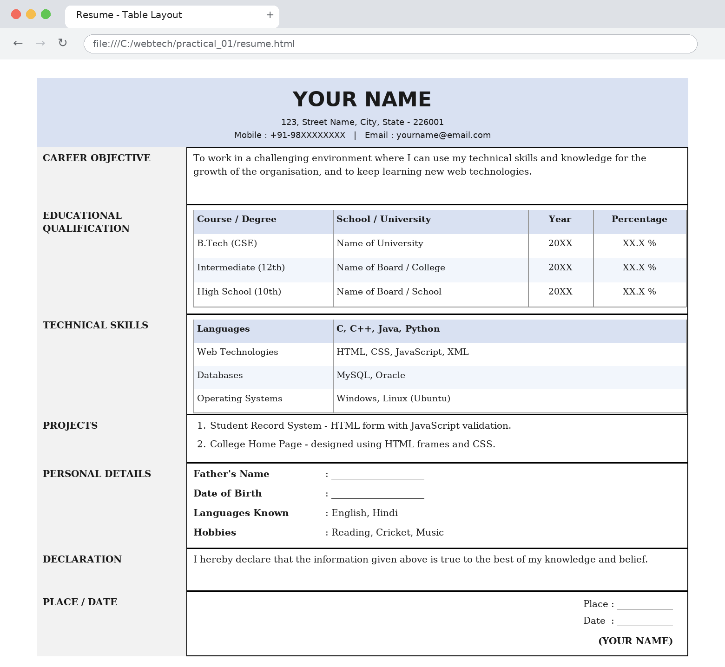
Fig. 1.1 : Resume displayed in the browser - the complete layout is built with nested HTML tables
PRACTICAL No. 2
Program : HTML program for home page creation using frames.
Source Code :
index.html
<!DOCTYPE html> <!-- Practical 2 : Home page creation using FRAMES -->
<!-- A frameset page has NO <body> tag; it only divides the window --> <html>
<head><title>College Home Page - Frames</title></head>
<!-- Outer frameset : banner row 15% + row for the inner frameset -->
<frameset rows="15%, 85%" border="2" frameborder="1">
<frame src="banner.html" name="top" scrolling="no" noresize>
<!-- Inner frameset : menu column 20% + content column 80% -->
<frameset cols="20%, 80%">
<frame src="menu.html" name="menu" scrolling="auto" noresize>
<frame src="home.html" name="main" scrolling="auto"></frameset>
<noframes> <body>Your browser does not support frames. Please open
<a href="home.html"> home.html</a> directly.</body>
</noframes></frameset>
</html>

banner.html
<!DOCTYPE html> <!-- banner.html : displayed in the TOP frame --> <html><head>
<title>Banner</title>
<style>
body { margin:0; background-color:#1F4E79; color:#FFFFFF; font-family:Verdana;
text-align:center; }
h1 { font-size:22px; margin:6px 0 2px 0; }
p { font-size:12px; margin:0 0 6px 0; }
</style>
</head>
<body><h1>NAME OF THE COLLEGE</h1>
<p>Department of Computer Science &amp; Engineering &nbsp;|&nbsp; Affiliated
to Name of University</p>
</body>
</html>

menu.html
<!DOCTYPE html>
<!--menu.html : LEFT frame. target="main" opens every link in
the
right
frame --> <html><head><title>Menu</title>
<style>
body { margin:0; background-color:#F2F2F2; font-family:Verdana; }
.head { background-color:#1F4E79; color:#FFFFFF; font-size:13px;
font-weight:bold;
padding:6px; text-align:center; }
a { display:block; padding:8px 10px; font-size:12px; color:#000000;
text-decoration:none; border-bottom:1px solid #CCCCCC; }
a:hover { background-color:#D9E1F2; color:#1F4E79; }
</style>
</head>
<body><div class="head">MAIN MENU</div>
<a href="home.html" target="main">Home</a> <a href="about.html" target="main">
About Us</a> <a href="courses.html" target="main">Courses</a>
<a href="contact.html" target="main">Contact Us</a></body>
</html>

home.html
<!DOCTYPE html>
<!-- home.html : default page of the RIGHT frame (name="main") --> <html>
<head><title>Home</title>
<style>
body { font-family:"Times New Roman"; margin:15px; }
h2 { color:#1F4E79; }
</style>
</head>
<body><h2>Welcome to the College Website</h2>
<p>This home page is created using HTML <b>frames</b>. The browser window is
divided into three parts:</p>
<ul><li><b>Top frame</b> &nbsp;- college banner (banner.html)</li>
<li><b>Left frame</b> - navigation menu (menu.html)</li>
<li><b>Right frame </b> - content pages, opened with target="main"</li>
</ul>
<p>Click any menu item on the left. Only this frame changes; the banner and
the menu stay fixed on the screen.</p>
</body>
</html>

about.html
<!DOCTYPE html> <!-- about.html : opened in the RIGHT frame --> <html><head>
<title>About Us</title>
<style>
body { font-family:"Times New Roman"; margin:15px; }
h2 { color:#1F4E79; }
</style>
</head>
<body><h2>About Us</h2>
<p>The Department of Computer Science &amp; Engineering was established to
provide quality technical education. The department has well equipped
laboratories, a library and experienced faculty members.</p>
<p><b>Vision :</b> To be a centre of excellence in computer science education.
</p>
<p><b>Mission :</b> To train students in modern technologies and to develop
their problem solving skills.</p>
</body>
</html>

courses.html
<!DOCTYPE html> <!-- courses.html : opened in the RIGHT frame --> <html><head>
<title>Courses</title>
<style>
body { font-family:"Times New Roman"; margin:15px; }
h2 { color:#1F4E79; }
table { border-collapse:collapse; width:80%; }
th,td { border:1px solid #000000; padding:6px; }
th { background-color:#D9E1F2; }
</style>
</head>
<body><h2>Courses Offered</h2>
<table><tr><th>Course</th><th>Duration</th><th>Seats</th></tr>
<tr><td>B.Tech (Computer Science &amp; Engineering)</td><td>4 Years</td><td>
120</td></tr>
<tr><td>B.Tech (Information Technology)</td><td>4 Years</td><td>60</td></tr>
<tr><td>M.Tech (Computer Science)</td><td>2 Years</td><td>30</td></tr>
</table>
</body>
</html>

contact.html
<!DOCTYPE html> <!-- contact.html : opened in the RIGHT frame --> <html><head>
<title>Contact Us</title>
<style>
body { font-family:"Times New Roman"; margin:15px; }
h2 { color:#1F4E79; }
</style>
</head>
<body><h2>Contact Us</h2>
<p>Department of Computer Science &amp; Engineering<br>
Name of the College, City, State - 2260XX</p>
<p>Phone : 0522-XXXXXXX<br>
Email : cse@college.ac.in<br>
Website : www.college.ac.in</p>
</body>
</html>

Output / Result :
Open index.html. The outer frameset divides the window into a 15% banner row and an 85% row; the inner frameset divides that row into a 20% menu column and an 80% content column. Every menu link uses target="main", so only the right frame is replaced. NOTE: frames are a traditional HTML feature (removed in HTML5); they run in Internet Explorer and in the legacy mode of modern browsers, which is what the syllabus asks for.
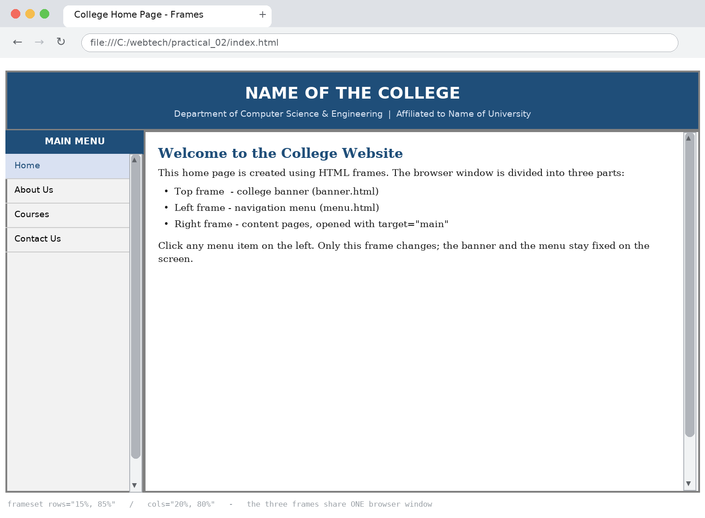
Fig. 2.1 : The three frames - banner (top), menu (left) and content (right) - share one browser window
PRACTICAL No. 3
Program : HTML program for form creation.
Source Code :
form.html
<!DOCTYPE html>
<!-- Practical 3 : HTML program for FORM creation (all common controls) -->
<html><head><title>Student Registration Form</title></head>
<body bgcolor="#FFFFFF"><h2 align="center">STUDENT REGISTRATION FORM</h2>
<form name="regForm"
action="submit.php"
method="post"
enctype="multipart/form-data"><fieldset>
<legend><b>Personal Details</b> </legend> <table cellpadding="6"><tr><td>
<label for="fname">Full Name : </label></td><td>
<input type="text" id="fname"
name="fname"
size="30"
maxlength="40"
placeholder="Enter your full name" required></td>
</tr>
<tr><td><label for="pwd">Password :</label></td><td>
<input type="password" id="pwd"
name="pwd" size="30" required></td></tr>
<tr><td>Gender :</td><td>
<input type="radio" name="gender" value="male" checked> Male
<input type="radio" name="gender" value="female"> Female
<input type="radio" name="gender" value="other"> Other</td></tr>
<tr><td><label for="dob">Date of Birth :</label></td><td>
<input type="date" id="dob" name="dob"></td></tr>
<tr><td><label for="email"> E-Mail :</label></td><td>
<input type="email"
id="email"
name="email"
size="30"
placeholder="name@email.com"></td></tr>
<tr><td><label for="mob">Mobile No. : </label></td><td>
<input type="tel" id="mob"
name="mob"
size="30"
pattern="[0-9]{10}"
placeholder="10 digit number"></td></tr>
</table>
</fieldset>
<br>
<fieldset><legend><b>Academic Details</b></legend> <table cellpadding="6"><tr>
<td><label for="course">Course :</label></td><td>
<select id="course" name="course"><option value="">-- Select Course --
</option> <option value="btech_cse" selected>B.Tech (CSE)</option>
<option value="btech_it">B.Tech (IT)</option> <option value="mca">MCA</option>
<option value="mtech">M.Tech</option></select>
</td></tr>
<tr><td><label for="sem">Semester :</label></td><td>
<select id="sem" name="sem" size="1"><option>I</option><option>II</option>
<option>III</option><option>IV</option> <option>V</option><option>VI</option>
<option>VII</option><option>VIII</option></select>
</td></tr>
<tr><td>Hobbies :</td><td><input type="checkbox" name="hobby" value="reading">
Reading <input type="checkbox" name="hobby" value="sports"> Sports
<input type="checkbox" name="hobby" value="music"> Music
<input type="checkbox" name="hobby" value="coding"> Coding</td></tr>
<tr><td><label for="addr">Address :</label></td><td>
<textarea id="addr" name="addr"
rows="4" cols="35" placeholder="Enter your complete address"></textarea>
</td></tr>
<tr><td><label for="photo">Upload Photo :</label></td><td>
<input type="file" id="photo"
name="photo" accept="image/*"></td></tr>
<tr><td><label for="marks">Marks Obtained :</label></td><td>
<input type="number"
id="marks" name="marks" min="0" max="100" step="1">
&nbsp;&nbsp; <label for="percent">Percentage :</label>
<input type="range" id="percent" name="percent"
min="0" max="100" value="60">
</td></tr>
<tr><td><label for="color">Favourite Colour :</label></td><td>
<input type="color"
id="color" name="color" value="#1F4E79"></td></tr>
</table>
</fieldset>
<br>
<input type="hidden" name="formid" value="REG2025"> <p align="center">
<input type="submit" value="Submit Form"> &nbsp;&nbsp;
<input type="reset" value="Reset Form"> &nbsp;&nbsp;
<input type="button" value="Cancel" onclick="window.close()"></p>
</form>
</body>
</html>

Output / Result :
The form uses two fieldset blocks and demonstrates text, password, radio, checkbox, select, textarea, file, date, number, range, colour and hidden controls together with submit, reset and button inputs.
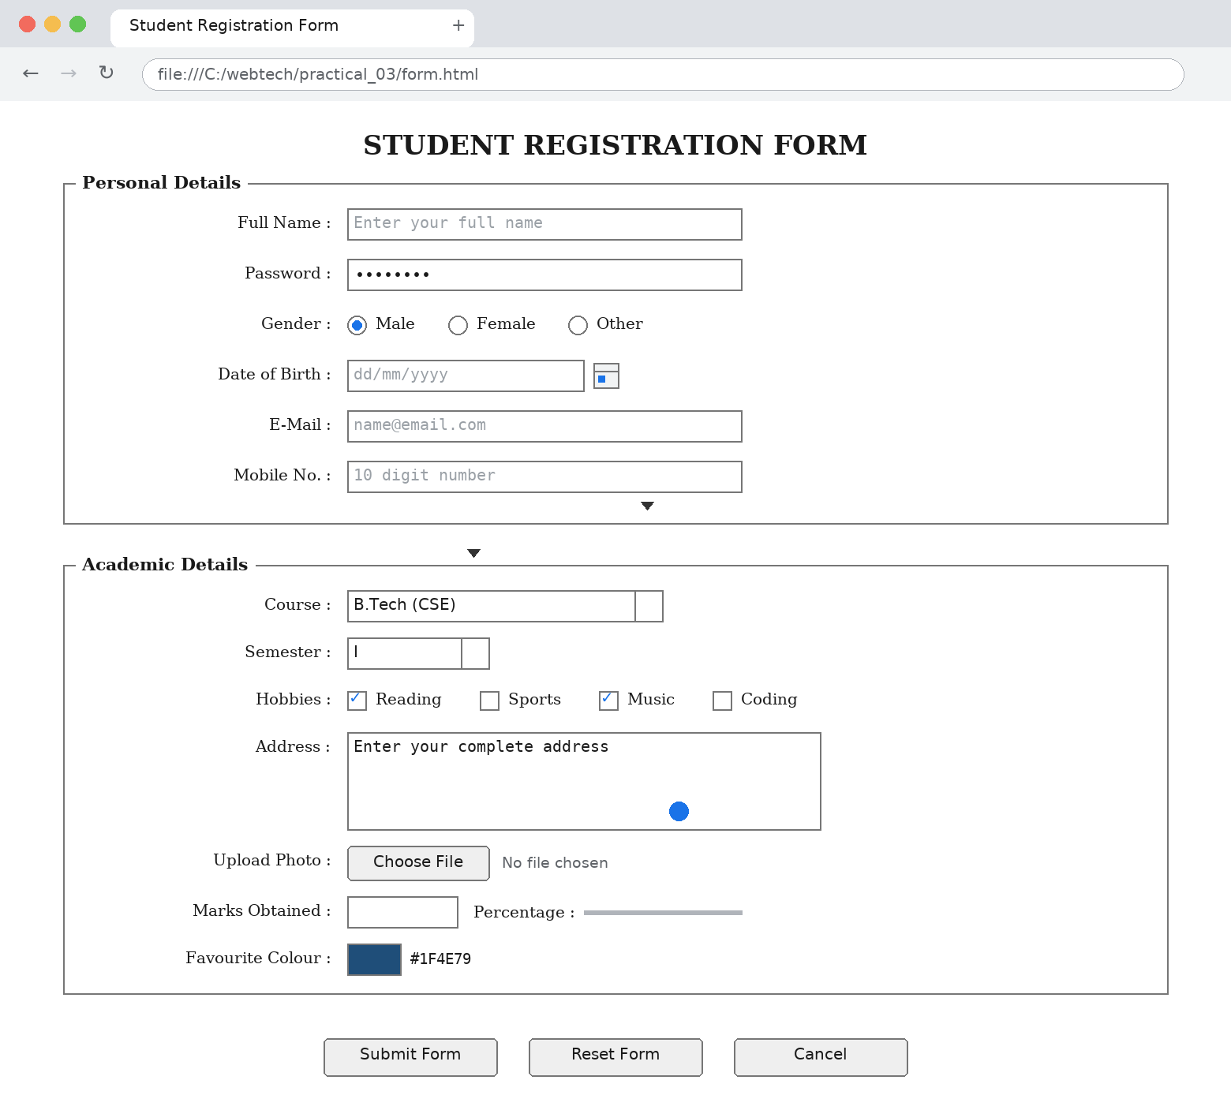
Fig. 3.1 : The registration form with all common input controls
PRACTICAL No. 4
Program : Create a web page to embed an image map in a web page using HTML.
Source Code :
image_map.html
<!DOCTYPE html> <!-- Practical 4 : Embed an IMAGE MAP in a web page -->
<!--<img usemap="#shapemap"> is linked to <map
name="shapemap">;
every
<area> is
one clickable region (rect / circle
/ poly). Keep
shapes.png
in this folder. --> <html><head><title>HTML Image Map
</title>
<style>
body { font-family:"Times New Roman"; text-align:center; margin:20px; }
h2 { color:#1F4E79; }
table { margin:10px auto; border-collapse:collapse; }
th,td { border:1px solid #000000; padding:5px 12px; font-size:14px; }
th { background-color:#D9E1F2; }
</style>
</head>
<body><h2>IMAGE MAP : Click on a Shape</h2>
<img src="shapes.png" width="520" height="320"
alt="Three shapes"
border="0"
usemap="#shapemap"> <map name="shapemap">
<area shape="rect"
coords="20,90,180,250"
href="rectangle.html"
alt="Rectangle"
title="Rectangle - 4 sides, all angles 90 degrees">
<area shape="circle"
coords="265,170,80"
href="circle.html"
alt="Circle"
title="Circle - all points at equal distance from centre">
<area shape="poly"
coords="430,90,510,250,350,250"
href="triangle.html"
alt="Triangle"
title="Triangle - 3 sides, 3 corners">
<area shape="default" nohref alt="No link"></map>
<h3>Coordinates used in this image map</h3>
<table><tr><th>Shape</th><th>shape attribute</th><th>coords attribute</th>
</tr>
<tr><td>Rectangle</td><td>rect</td><td>left,top,right,bottom = 20,90,180,250
</td></tr>
<tr><td>Circle</td><td>circle</td><td>centre-x,centre-y,radius = 265,170,80
</td></tr>
<tr><td>Triangle</td> <td>poly</td><td>x1,y1,x2,y2,x3,y3 =
430,90,510,250,350,250</td></tr>
</table>
</body>
</html>

rectangle.html
<!DOCTYPE html> <html><head><title>Rectangle</title></head>
<body style="font-family:'Times New Roman'; text-align:center;">
<h2 style="color:#1F4E79;">RECTANGLE</h2>
<p>A rectangle is a four sided closed figure whose every angle is 90 degrees.
</p>
<p><b>Area</b> = length x breadth &nbsp;&nbsp; <b>Perimeter</b> = 2 (l + b)
</p>
<a href="image_map.html">Back to Image Map</a></body>
</html>

circle.html
<!DOCTYPE html> <html><head><title>Circle</title></head>
<body style="font-family:'Times New Roman'; text-align:center;">
<h2 style="color:#1F4E79;">CIRCLE</h2>
<p>A circle is the set of all points which are at an equal distance (radius)
from a fixed point (centre).</p>
<p><b>Area</b> = pi x r<sup>2</sup> &nbsp;&nbsp; <b>Circumference</b> = 2 x pi
x r</p>
<a href="image_map.html">Back to Image Map</a></body>
</html>

triangle.html
<!DOCTYPE html> <html><head><title>Triangle</title></head>
<body style="font-family:'Times New Roman'; text-align:center;">
<h2 style="color:#1F4E79;">TRIANGLE</h2>
<p>A triangle is a three sided polygon. The sum of its three interior angles
is always 180 degrees.</p>
<p><b>Area</b> = (1/2) x base x height</p>
<a href="image_map.html">Back to Image Map</a></body>
</html>

Output / Result :
Keep shapes.png in the same folder as image_map.html. The usemap attribute of the image is connected to the map named shapemap, and each area defines one clickable region of shape rect, circle or poly. Clicking a shape opens its own page.
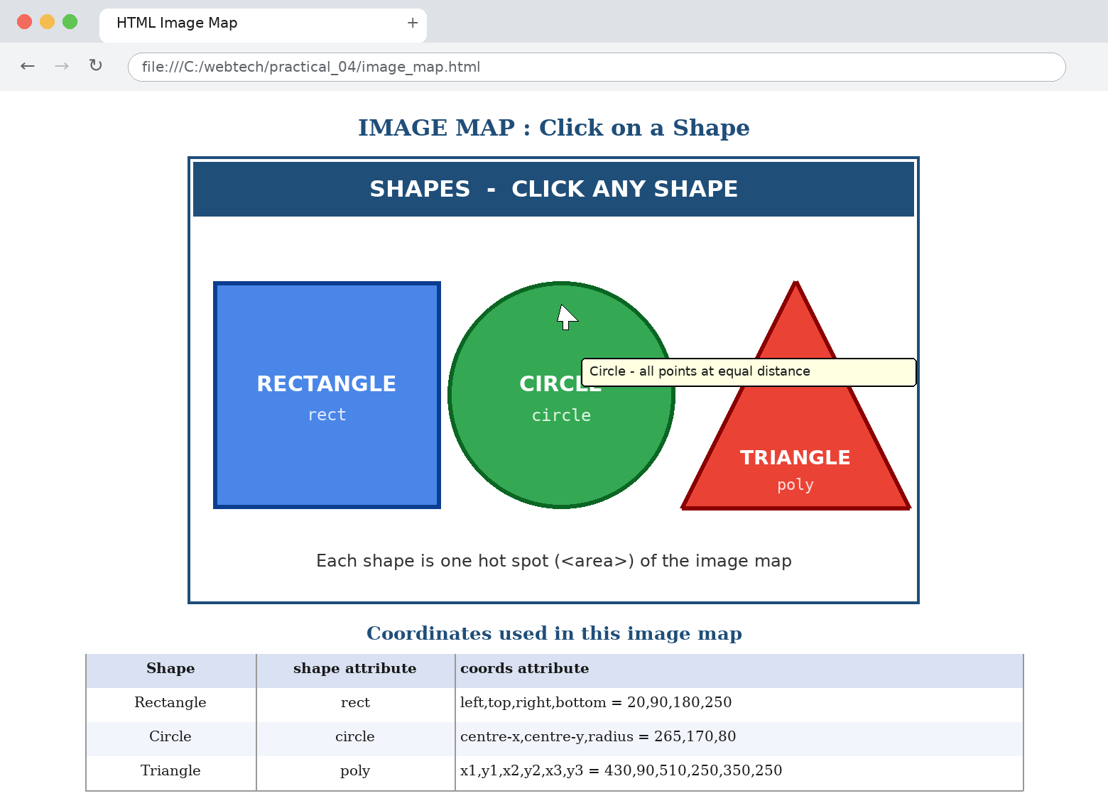
Fig. 4.1 : One image with three hot spots; the pointer is over the circle hot spot and its tooltip is shown
PRACTICAL No. 5
Program : Create a web page to fix the hot spots and to show all the related information when the hot spots are clicked using HTML.
Source Code :
hotspots.html
<!DOCTYPE html>
<!--Practical 5 : Fix HOT SPOTS on an image and show all
the
related
information
when a hot spot is clicked. showInfo() prints
it
in <div
id="info"> without
reloading the page. Keep hardware.png
in
the same
folder. --> <html><head><title>Image Hot Spots - Show Related
Information </title>
<style>
body { font-family:"Times New Roman"; margin:20px; background-color:#FFFFFF; }
h2 { color:#1F4E79; text-align:center; }
.wrap { text-align:center; }
#info { width:520px; margin:12px auto; padding:12px; text-align:left;
border:2px solid #1F4E79; background-color:#F7F9FC; min-height:96px; }
#info h3 { margin:0 0 6px 0; color:#1F4E79; }
table { border-collapse:collapse; width:100%; }
th,td { border:1px solid #999999; padding:4px 8px; font-size:14px; }
th { background-color:#D9E1F2; }
</style>
</head>
<body><h2>COMPUTER HARDWARE - CLICK A HOT SPOT</h2>
<div class="wrap">
<img src="hardware.png" width="520"
height="300"
border="0"
alt="Computer hardware" usemap="#hwmap">
<map name="hwmap">
<area
shape="rect"
coords="15,20,205,150"
href="javascript:void(0);"
onclick="showInfo('monitor')"
alt="Monitor"
title="Click for Monitor details">
<area
shape="rect"
coords="215,20,375,190"
href="javascript:void(0);"
onclick="showInfo('cpu')"
alt="CPU"
title="Click for CPU details">
<area
shape="poly"
coords="90,215,430,215,455,285,65,285"
href="javascript:void(0);"
onclick="showInfo('keyboard')"
alt="Keyboard"
title="Click for Keyboard details">
</map>
</div>
<div id="info"><h3>Information</h3>
<p>Click on the <b>Monitor</b>, <b>CPU</b> or <b>Keyboard</b> hot spot in the
image above to see its details here.</p>
</div>
<script>
/* All the related information is stored in one object; showInfo(part) prints
it */
var data = {
monitor: { name: "MONITOR (VDU)",
text: "The monitor is the output device of a computer. It displays text, " +
"images and video produced by the graphics card.",
rows: [["Type", "Output device"], ["Examples", "LCD, LED, CRT, OLED"],
["Measured in", "Inches (screen size), Pixels (resolution)"]] },
cpu: { name: "CPU (Central Processing Unit)",
text: "The CPU is called the brain of the computer. It performs all " +
"arithmetic and logical operations on the data.",
rows: [["Type", "Processing device"], ["Main parts", "ALU, Control Unit,
Memory Unit"],
["Examples", "Intel Core i5, AMD Ryzen 5"]] },
keyboard: { name: "KEYBOARD",
text: "The keyboard is the most common input device. It is used to type " +
"text, numbers and commands into the computer.",
rows: [["Type", "Input device"], ["Standard keys", "101 / 104 keys"],
["Groups", "Alphabet, Numeric, Function, Control keys"]] }
};
function showInfo(part) {
var d = data[part], html = "<h3>" + d.name + "</h3><p>" + d.text + "</p>";
html += "<table><tr><th>Property</th><th>Detail</th></tr>";
for (var i = 0; i < d.rows.length; i++) {
html += "<tr><td><b>" + d.rows[i][0] + "</b></td><td>" + d.rows[i][1] +
"</td></tr>";
}
html += "</table>";
document.getElementById("info").innerHTML = html;
}
</script>
</body>
</html>

Output / Result :
Keep hardware.png in the same folder. Three hot spots are fixed on the image with area elements; each one calls the JavaScript function showInfo() which prints the name, description and a property table of the clicked part inside the information box, without reloading the page.
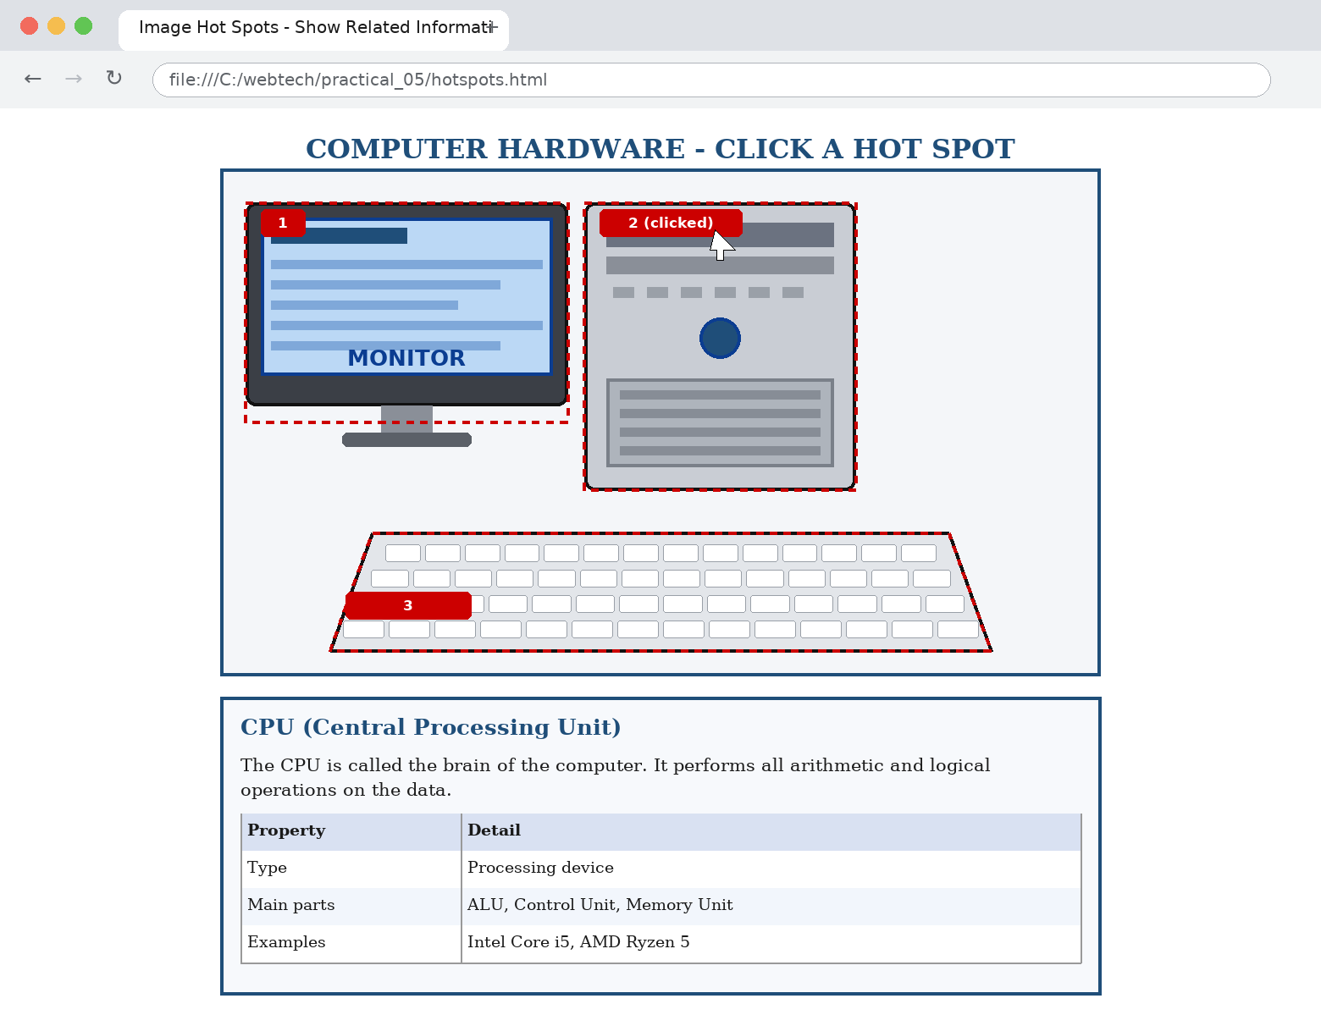
Fig. 5.1 : Hot spot 2 (CPU) clicked - its complete information appears in the box below the image
PRACTICAL No. 6
Program : Create a web page to get the coordinates from an image using JavaScript.
Source Code :
coordinates.html
<!DOCTYPE html>
<!--Practical 6 : Get the COORDINATES from an
image
using
JavaScript.
e.offsetX / e.offsetY -> position INSIDE
the
image;
e.clientX / e.clientY ->
inside the window; e.pageX /
e.pageY
->
inside the document. Keep grid.png here. --> <html><head><title>Get
Image Coordinates using JavaScript</title>
<style>
body { font-family:"Times New Roman"; margin:20px; }
h2 { color:#1F4E79; text-align:center; }
.box { text-align:center; }
img { border:2px solid #1F4E79; cursor:crosshair; }
table { margin:12px auto; border-collapse:collapse; }
th,td { border:1px solid #000000; padding:6px 14px; font-size:15px; }
th { background-color:#D9E1F2; }
input { font-family:"Courier New"; font-size:15px; text-align:center; }
#msg { text-align:center; font-size:16px; color:#990000; margin-top:8px; }
</style>
</head>
<body><h2>GET COORDINATES FROM AN IMAGE USING JAVASCRIPT</h2>
<p align="center">Move the mouse over the image or <b>click</b> anywhere on
it. The X and Y coordinates are shown below.</p>
<div class="box">
<img id="myImg" src="grid.png"
width="500"
height="300"
alt="Grid image"
onclick="getClick(event)"
onmousemove="getMove(event)">
</div>
<div id="msg">Coordinates will appear here...</div>
<table><tr><th>Event</th><th>X coordinate</th><th>Y coordinate</th></tr>
<tr><td><b>Mouse Move</b> (offset)</td><td>
<input type="text" id="mx" size="8"
value="0" readonly></td><td>
<input type="text" id="my" size="8" value="0" readonly></td></tr>
<tr><td><b> Mouse Click</b> (offset)</td><td>
<input type="text" id="cx" size="8"
value="0" readonly></td><td>
<input type="text" id="cy" size="8" value="0" readonly></td></tr>
<tr><td><b> Mouse Click</b> (client - window)</td><td>
<input type="text" id="clx"
size="8" value="0" readonly></td><td>
<input type="text" id="cly" size="8" value="0" readonly></td></tr>
<tr><td><b> Mouse Click</b> (page - document)</td><td>
<input type="text" id="pgx"
size="8" value="0" readonly></td><td>
<input type="text" id="pgy" size="8" value="0" readonly></td></tr>
</table>
<script>
/* coordinates while the mouse is MOVING */
function getMove(e) {
document.getElementById("mx").value = e.offsetX;
document.getElementById("my").value = e.offsetY;
document.getElementById("msg").innerHTML = "Mouse is at X = " + e.offsetX +
" , Y = " + e.offsetY;
}
/* coordinates when the mouse is CLICKED */
function getClick(e) {
var img = document.getElementById("myImg");
document.getElementById("cx").value = e.offsetX;
document.getElementById("cy").value = e.offsetY;
document.getElementById("clx").value = e.clientX;
document.getElementById("cly").value = e.clientY;
document.getElementById("pgx").value = e.pageX;
document.getElementById("pgy").value = e.pageY;
document.getElementById("msg").innerHTML = "CLICKED at X = " + e.offsetX +
" , Y = " + e.offsetY + " &nbsp;( image size = " + img.naturalWidth + " x " +
img.naturalHeight + " pixels )";
/* convert the shown coordinates into the ORIGINAL pixels of the image */
var scaleX = img.naturalWidth / img.width, scaleY = img.naturalHeight /
img.height;
var realX = Math.round(e.offsetX * scaleX), realY = Math.round(e.offsetY *
scaleY);
window.status = "Original image coordinates : " + realX + "," + realY;
}
</script>
</body>
</html>

Output / Result :
Keep grid.png in the same folder. The onmousemove event fills the move coordinates continuously and the onclick event fills the click coordinates. e.offsetX / e.offsetY give the position inside the image, e.clientX / e.clientY inside the window and e.pageX / e.pageY inside the document.
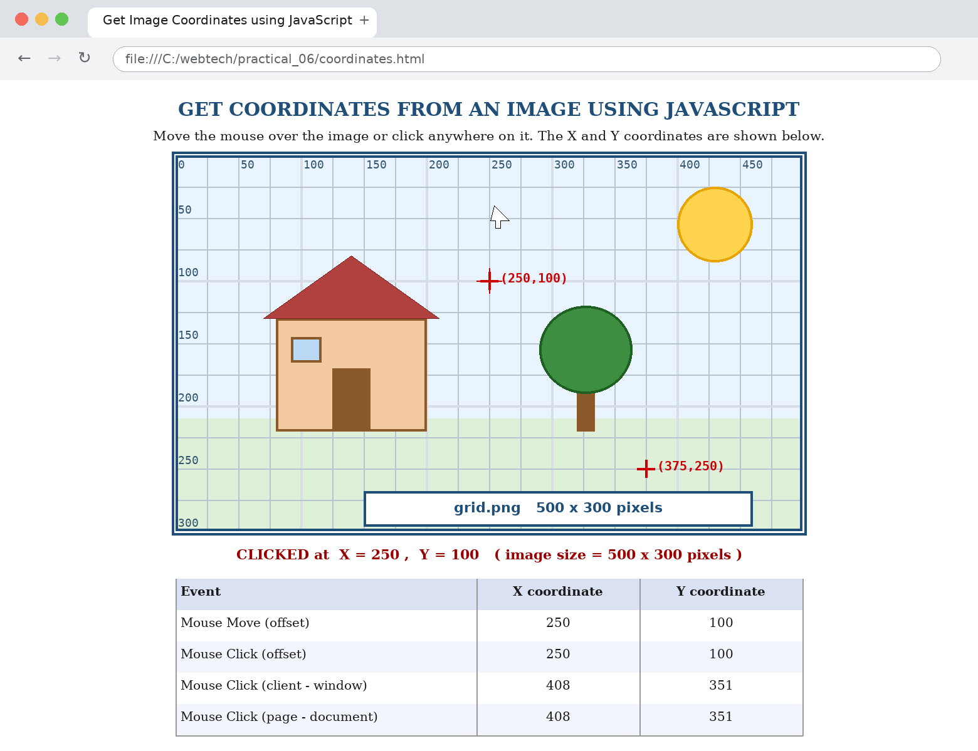
Fig. 6.1 : The image clicked at X = 250, Y = 100; all coordinate pairs are shown in the table
PRACTICAL No. 7
Program : Create a web page with all types of cascading style sheets.
Source Code :
css_all_types.html
<!DOCTYPE html>
<!-- Practical 7 : A page using ALL TYPES of CASCADING STYLE SHEETS.
1. INLINE - style="..." inside a tag; 2. INTERNAL - <style> block in <head>;
3. EXTERNAL - separate .css file added with <link>. Keep external_style.css
here. -->
<html>
<head>
<title>All Types of Cascading Style Sheets</title>
<!-- (3) EXTERNAL CSS : the file external_style.css -->
<link rel="stylesheet" type="text/css" href="external_style.css">
<!-- (2) INTERNAL (EMBEDDED) CSS -->
<style type="text/css">
body { background-color:#FFFDF5; font-family:"Times New Roman", serif;
margin:25px; }
h2.internal { color:#0B6623; background-color:#E8F5E9; border-left:8px solid
#0B6623;
padding:8px; font-variant:small-caps; }
p.internal { color:#333333; font-size:18px; line-height:1.6;
text-align:justify; }
table.internal { border-collapse:collapse; width:80%; }
table.internal th, table.internal td { border:1px solid #0B6623; padding:6px
10px; }
table.internal th { background-color:#C8E6C9; }
table.internal tr:nth-child(even) { background-color:#F1F8E9; }
</style>
</head>
<body><h1 class="page-title">THREE TYPES OF CASCADING STYLE SHEETS</h1>
<!-- (1) INLINE CSS : style written inside the tag -->
<h2
style="color:#FFFFFF; background-color:#990000;
padding:8px;
text-align:center;
font-family:Verdana;">1. INLINE STYLE SHEET
</h2>
<p style="color:#990000; font-size:18px; font-weight:bold;">This paragraph is
styled with the <i>style</i> attribute written directly inside the tag. Inline
CSS has the highest priority.</p>
<p
style="background-color:#FFEBEE; border:2px dashed
#990000;
padding:10px;
font-style:italic; letter-spacing:1px;">Inline CSS is
used to style only ONE single element.</p>
<!-- (2) INTERNAL / EMBEDDED CSS : <style> in <head> --> <h2 class="internal">
2. INTERNAL (EMBEDDED) STYLE SHEET</h2>
<p class="internal">This paragraph and the heading above are styled by the
&lt;style&gt; block written inside the &lt;head&gt; section of this same page.
Internal CSS applies to the whole page.</p>
<table class="internal"><tr><th>Type of CSS</th><th>Where it is written</th>
<th>Applies to</th></tr>
<tr><td>Inline</td><td>style attribute of the tag</td><td>One element</td>
</tr>
<tr><td>Internal</td><td>&lt;style&gt; block in &lt;head&gt;</td><td>One page
</td></tr>
<tr><td>External</td><td>separate .css file + &lt;link&gt;</td><td>Many pages
</td></tr>
</table>
<!-- (3) EXTERNAL CSS : external_style.css --> <h2 class="external">3.
EXTERNAL STYLE SHEET</h2>
<p class="external">This heading and paragraph are styled by the separate file
<b>external_style.css</b>, which is attached to this page with the
&lt;link&gt; tag. The same file can be attached to any number of pages of a
website, so the design stays common everywhere.</p>
<div class="box">This DIV also uses the external style sheet (class = "box").
</div>
</body>
</html>

external_style.css
/* Practical 7 : EXTERNAL STYLE SHEET (external_style.css)
Attached to the page with :
<link rel="stylesheet" type="text/css" href="external_style.css"> */
/* element selector */
body { background-color:#FFFDF5; }
/* class selectors */
.page-title { color:#1F4E79; font-family:Verdana, Arial, sans-serif;
text-align:center;
letter-spacing:2px; border-bottom:3px double #1F4E79; padding-bottom:8px; }
h2.external { color:#1F4E79; background-color:#D9E1F2; border:2px solid
#1F4E79;
padding:8px; text-align:center; font-family:Verdana, Arial, sans-serif; }
p.external { color:#191970; font-size:18px; font-style:italic;
text-align:justify;
text-indent:30px; line-height:1.6; }
.box { background-color:#EAF1FA; border:2px groove #1F4E79; border-radius:8px;
padding:12px; margin-top:15px; font-size:17px; color:#1F4E79;
text-align:center; }
/* id selector */
#footer { color:#666666; font-size:13px; text-align:center; }

Output / Result :
Keep external_style.css in the same folder. Section 1 uses the style attribute (inline), section 2 uses the style block in the head (internal) and section 3 uses the link tag to the external file, so all three types of cascading style sheets are visible on one page.
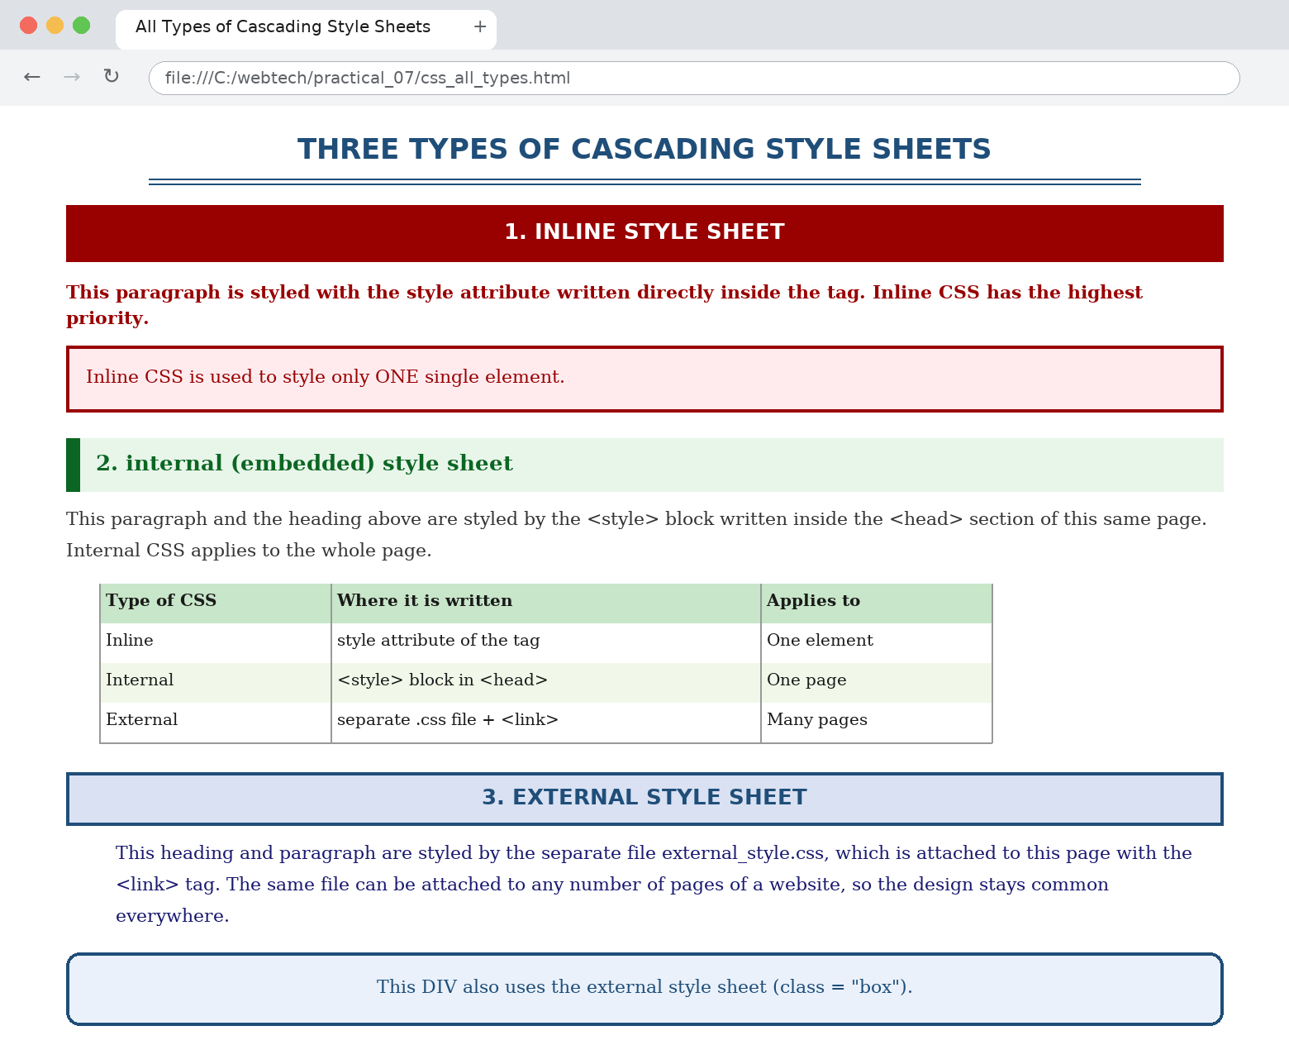
Fig. 7.1 : The same page styled by inline, internal and external CSS at the same time
PRACTICAL No. 8
Program : Write HTML/JavaScript to display your CV in navigator, your institute website, Department website and tutorial website for specific subject.
Source Code :
navigator.html
<!DOCTYPE html>
<!--Practical 8 : HTML / JavaScript to display your CV in
a
navigator,
your
institute website, department website and a
tutorial
website. The
drop-down list
works as a NAVIGATOR : JavaScript
opens
the selected
URL in the iframe "viewer".
Replace the three
sample URLs
with your
own institute addresses. --> <html><head><title>Web
Navigator - CV, Institute, Department, Tutorial</title>
<style>
body { font-family:"Times New Roman"; margin:0; }
.top { background-color:#1F4E79; color:#FFFFFF; padding:8px;
text-align:center;
font-size:20px; font-weight:bold; }
.bar { background-color:#D9E1F2; padding:8px; text-align:center; }
select, button { font-family:Verdana; font-size:13px; padding:3px; }
iframe { width:100%; height:520px; border:2px solid #1F4E79; }
#msg { text-align:center; font-size:14px; color:#990000; padding:4px; }
</style>
</head>
<body><div class="top">WEB NAVIGATOR</div>
<div class="bar"><select id="siteList"><option value="">-- Select a website --
</option> <option value="cv.html">My CV (Resume)</option>
<option value="https://www.youruniversity.ac.in">Institute Website</option>
<option value="https://www.yourcollege.ac.in/cse">Department Website (CSE)
</option> <option value="https://www.w3schools.com/html/">Tutorial Website -
Web Technology</option></select>
<button onclick="navigate()">GO</button>
<button onclick="openSite('cv.html')">My CV</button>
<button onclick="openSite('https://www.youruniversity.ac.in')">Institute
</button> <button onclick="openSite('https://www.yourcollege.ac.in/cse')">
Department</button>
<button onclick="openSite('https://www.w3schools.com/html/')">Tutorial
</button> <button onclick="openNewTab()">Open in NEW Tab</button>
<button onclick="goBack()">Back</button> <button onclick="goForward()">Forward
</button></div>
<div id="msg">Select a website from the list and press GO.</div>
<iframe name="viewer" id="viewer" src="cv.html"></iframe>
<script>
function navigate() {
var url = document.getElementById("siteList").value;
if (url === "") {
document.getElementById("msg").innerHTML = "Please select a website first.";
return;
}
window.open(url, "viewer");
document.getElementById("msg").innerHTML = "Now showing : " + url;
}
function openSite(url) {
window.open(url, "viewer");
document.getElementById("msg").innerHTML = "Now showing : " + url;
}
function openNewTab() {
var url = document.getElementById("siteList").value;
if (url !== "") { window.open(url, "_blank"); }
}
/* navigator buttons for the history of the iframe */
function goBack() { window.frames["viewer"].history.back(); }
function goForward() { window.frames["viewer"].history.forward(); }
</script>
</body>
</html>

cv.html
<!DOCTYPE html>
<!-- cv.html : the CV page displayed by the navigator (Practical 8) --> <html>
<head><title>My CV</title>
<style>
body { font-family:"Times New Roman"; margin:20px; background-color:#FFFFFF; }
h1 { text-align:center; color:#1F4E79; margin-bottom:0; }
.sub { text-align:center; font-size:14px; margin-top:2px; }
h3 { background-color:#D9E1F2; padding:4px 8px; border-left:6px solid #1F4E79;
}
table { border-collapse:collapse; width:100%; }
th,td { border:1px solid #666666; padding:5px; font-size:14px; }
th { background-color:#F2F2F2; }
</style>
</head>
<body><h1>CURRICULUM VITAE</h1>
<p class="sub"><b>YOUR NAME</b> &nbsp;|&nbsp; B.Tech (CSE) &nbsp;|&nbsp; Roll
No. ________ &nbsp;|&nbsp; yourname@email.com &nbsp;|&nbsp; +91-98XXXXXXXX</p>
<h3>Career Objective</h3>
<p>To obtain a position where I can apply my knowledge of web technologies and
grow along with the organisation.</p>
<h3>Educational Qualification</h3>
<table><tr><th>Course</th><th>Institute / Board</th><th>Year</th><th>%</th>
</tr>
<tr><td>B.Tech (CSE)</td><td>Name of College</td><td>20XX</td><td>XX.X</td>
</tr>
<tr><td>12th</td><td>Name of Board</td><td>20XX</td><td>XX.X</td></tr>
<tr><td>10th</td><td>Name of Board</td><td>20XX</td><td>XX.X</td></tr>
</table>
<h3>Technical Skills</h3>
<p>HTML, CSS, JavaScript, XML, C, C++, MySQL, Windows / Linux.</p>
<h3>Project</h3>
<p>Web Navigator - a JavaScript based page to display the CV, institute
website, department website and tutorial website in one window.</p>
<h3>Personal Details</h3>
<p>Date of Birth : __________ &nbsp;&nbsp; Languages : English, Hindi</p>
<h3>Declaration</h3>
<p>The information given above is true to the best of my knowledge.</p>
<p align="right"><b>(YOUR NAME)</b></p>
</body>
</html>

Output / Result :
The drop-down list and the four buttons work as a navigator: JavaScript reads the selected URL and opens it inside the iframe named viewer with window.open(url, "viewer"). Replace the three sample URLs in the code with the real addresses of your institute, your department and the tutorial website of your subject.
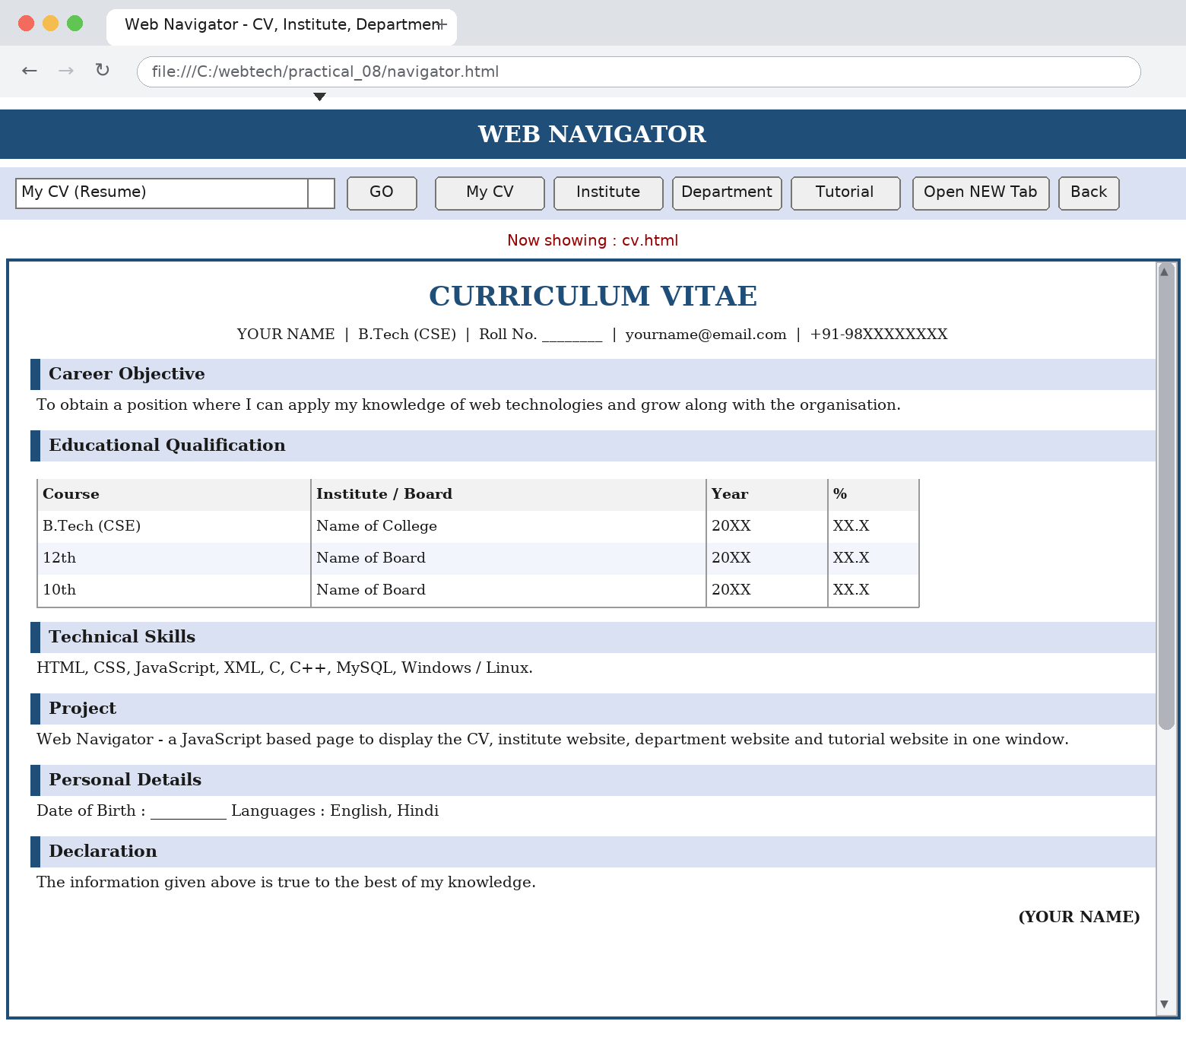
Fig. 8.1 : The navigator page with the CV loaded inside the viewer frame
PRACTICAL No. 9
Program : Design HTML form for keeping student record and validate it using JavaScript.
Source Code :
student_record.html
<!DOCTYPE html>
<!--Practical 9 : HTML form for keeping STUDENT RECORD and
VALIDATING
it
using
JavaScript. validateForm() runs on the onsubmit
event; if
any
check fails the
form is NOT submitted (return false) and
the error
is
shown next to the field. --> <html><head><title>Student Record -
JavaScript Validation</title>
<style>
body { font-family:"Times New Roman"; margin:20px; background-color:#FFFFFF; }
h2 { text-align:center; color:#1F4E79; }
form { width:600px; margin:auto; border:2px solid #1F4E79; padding:15px;
background-color:#F7F9FC; }
table { width:100%; }
td { padding:6px; font-size:16px; }
.lbl { width:200px; font-weight:bold; }
input[type=text], input[type=password], input[type=email], select, textarea {
font-family:"Times New Roman"; font-size:15px; padding:3px; }
.err { color:#CC0000; font-size:13px; font-weight:bold; }
.btn { text-align:center; padding-top:10px; }
button { font-size:15px; padding:5px 18px; }
</style>
</head>
<body><h2>STUDENT RECORD FORM (with JavaScript Validation)</h2>
<form name="studentForm" onsubmit="return validateForm()"><table><tr>
<td class="lbl">Student Name * :</td><td>
<input type="text" name="sname" id="sname"
size="28">
<span class="err" id="e_sname"></span></td></tr>
<tr><td class="lbl">Roll Number * :</td><td>
<input type="text" name="roll" id="roll"
size="28" placeholder="e.g. CSE2101">
<span class="err" id="e_roll"></span></td></tr>
<tr><td class="lbl">Enrollment Number * :</td><td>
<input type="text"
name="enroll"
id="enroll"
size="28"
placeholder="12 digits">
<span class="err" id="e_enroll"></span></td></tr>
<tr><td class="lbl">E-Mail * :</td><td>
<input type="text" name="email" id="email"
size="28">
<span class="err" id="e_email"></span></td></tr>
<tr><td class="lbl">Mobile Number * :</td><td>
<input type="text"
name="mobile"
id="mobile"
size="28"
placeholder="10 digits, starts with 6-9">
<span class="err" id="e_mobile"> </span></td></tr>
<tr><td class="lbl">Password * :</td><td>
<input type="password" name="pwd" id="pwd"
size="28">
<span class="err" id="e_pwd"></span></td></tr>
<tr><td class="lbl">Confirm Password * :</td><td>
<input type="password" name="cpwd"
id="cpwd" size="28">
<span class="err" id="e_cpwd"></span></td></tr>
<tr><td class="lbl">Date of Birth * :</td><td>
<input type="text" name="dob" id="dob"
size="28" placeholder="DD/MM/YYYY">
<span class="err" id="e_dob"></span></td></tr>
<tr><td class="lbl">Gender * :</td><td>
<input type="radio" name="gender" value="Male"> Male
<input type="radio" name="gender" value="Female"> Female
<span class="err" id="e_gender"></span></td></tr>
<tr><td class="lbl">Course * :</td><td><select name="course" id="course">
<option value="">-- Select --</option> <option value="B.Tech CSE">B.Tech (CSE)
</option> <option value="B.Tech IT">B.Tech (IT)</option> <option value="MCA">
MCA</option></select>
<span class="err" id="e_course"></span></td></tr>
<tr><td class="lbl">Semester * :</td><td><select name="sem" id="sem">
<option value="">-- Select --</option> <option>I</option><option>II</option>
<option>III</option><option>IV</option> <option>V</option><option>VI</option>
<option>VII</option><option>VIII</option></select>
<span class="err" id="e_sem"></span></td></tr>
<tr><td class="lbl">Address :</td><td>
<textarea name="addr" id="addr" rows="3"
cols="26"></textarea>
</td></tr>
<tr><td class="lbl">Hobbies :</td><td>
<input type="checkbox" name="hobby"
value="Reading"> Reading
<input type="checkbox" name="hobby" value="Sports"> Sports
<input type="checkbox" name="hobby" value="Music"> Music</td></tr>
<tr><td class="lbl">I accept the rules * :</td><td>
<input type="checkbox" name="agree"
id="agree" value="yes">
<span class="err" id="e_agree"></span></td></tr>
</table>
<div class="btn"><button type="submit">Save Record</button>
<button type="reset" onclick="clearErrors()">Reset</button></div>
</form>
<script>
/* helper : show / clear the error message of one field */
function setError(id, message) {
document.getElementById("e_" + id).innerHTML = message;
}
function clearErrors() {
var spans = document.getElementsByTagName("span");
for (var i = 0; i < spans.length; i++) { spans[i].innerHTML = ""; }
}
/* remove the spaces from both ends of a string */
function trim(s) { return s.replace(/^\s+|\s+$/g, ""); }
/* =============== MAIN VALIDATION FUNCTION =============== */
function validateForm() {
clearErrors();
var ok = true;
/* 1. name : required, letters and spaces only, minimum 3 characters */
var name = trim(document.getElementById("sname").value);
if (name === "") { setError("sname", "Name is required."); ok = false; }
else if (!/^[A-Za-z .]{3,30}$/.test(name)) {
setError("sname", "Only letters, min 3 characters."); ok = false;
}
/* 2. roll number : required, letters + digits, 4 to 12 characters */
var roll = trim(document.getElementById("roll").value);
if (roll === "") { setError("roll", "Roll number is required."); ok = false; }
else if (!/^[A-Za-z0-9]{4,12}$/.test(roll)) {
setError("roll", "4-12 letters/digits only."); ok = false;
}
/* 3. enrollment number : exactly 12 digits */
var enroll = trim(document.getElementById("enroll").value);
if (enroll === "") { setError("enroll", "Enrollment number is required."); ok
= false; }
else if (!/^[0-9]{12}$/.test(enroll)) {
setError("enroll", "Must be exactly 12 digits."); ok = false;
}
/* 4. e-mail : standard pattern */
var email = trim(document.getElementById("email").value);
var emailPattern = /^[A-Za-z0-9._%+-]+@[A-Za-z0-9.-]+\.[A-Za-z]{2,}$/;
if (email === "") { setError("email", "E-mail is required."); ok = false; }
else if (!emailPattern.test(email)) {
setError("email", "Invalid e-mail address."); ok = false;
}
/* 5. mobile : exactly 10 digits, first digit 6 to 9 */
var mobile = trim(document.getElementById("mobile").value);
if (mobile === "") { setError("mobile", "Mobile number is required."); ok =
false; }
else if (!/^[6-9][0-9]{9}$/.test(mobile)) {
setError("mobile", "10 digits, must start with 6-9."); ok = false;
}
/* 6. password : minimum 6 characters */
var pwd = document.getElementById("pwd").value;
if (pwd === "") { setError("pwd", "Password is required."); ok = false; }
else if (pwd.length < 6) { setError("pwd", "Minimum 6 characters."); ok =
false; }
/* 7. confirm password : must be the same */
var cpwd = document.getElementById("cpwd").value;
if (cpwd !== pwd) { setError("cpwd", "Passwords do not match."); ok = false; }
/* 8. date of birth : DD/MM/YYYY and a date that really exists */
var dob = trim(document.getElementById("dob").value);
if (dob === "") { setError("dob", "Date of birth is required."); ok = false; }
else if
(!/^(0[1-9]|[12][0-9]|3[01])\/(0[1-9]|1[0-2])\/(19|20)[0-9]{2}$/.test(dob)
) {
setError("dob", "Use the format DD/MM/YYYY."); ok = false;
} else {
var parts = dob.split("/"), day = parseInt(parts[0], 10),
mon = parseInt(parts[1], 10), yr = parseInt(parts[2], 10);
var daysInMonth = [31,28,31,30,31,30,31,31,30,31,30,31];
if ((yr % 4 === 0 && yr % 100 !== 0) || yr % 400 === 0) { daysInMonth[1] = 29;
}
if (day > daysInMonth[mon - 1]) {
setError("dob", "This date does not exist."); ok = false;
}
}
/* 9. gender : one of the radio buttons must be selected */
var gender = document.getElementsByName("gender"), gSelected = false;
for (var i = 0; i < gender.length; i++) {
if (gender[i].checked) { gSelected = true; }
}
if (!gSelected) { setError("gender", "Please select gender."); ok = false; }
/* 10. course and semester : the blank option is not allowed */
if (document.getElementById("course").value === "") {
setError("course", "Select a course."); ok = false;
}
if (document.getElementById("sem").value === "") {
setError("sem", "Select a semester."); ok = false;
}
/* 11. the rules check-box must be ticked */
if (!document.getElementById("agree").checked) {
setError("agree", "You must accept the rules."); ok = false;
}
/* ---------- result ---------- */
if (ok) {
alert("Record saved successfully!\n\nName : " + name + "\nRoll No. : " + roll
+
"\nE-Mail : " + email + "\nMobile : " + mobile);
return true; /* the form is submitted */
} else {
alert("Please correct the highlighted fields.");
return false; /* the form is NOT submitted */
}
}
</script>
</body>
</html>

Output / Result :
validateForm() is called by the onsubmit event. It checks the name, roll number, 12-digit enrollment number, e-mail pattern, 10-digit mobile number, password length, password match, a real DD/MM/YYYY date, gender, course, semester and the acceptance box. If any check fails the function returns false so the record is not submitted; otherwise an alert confirms that the record is saved.
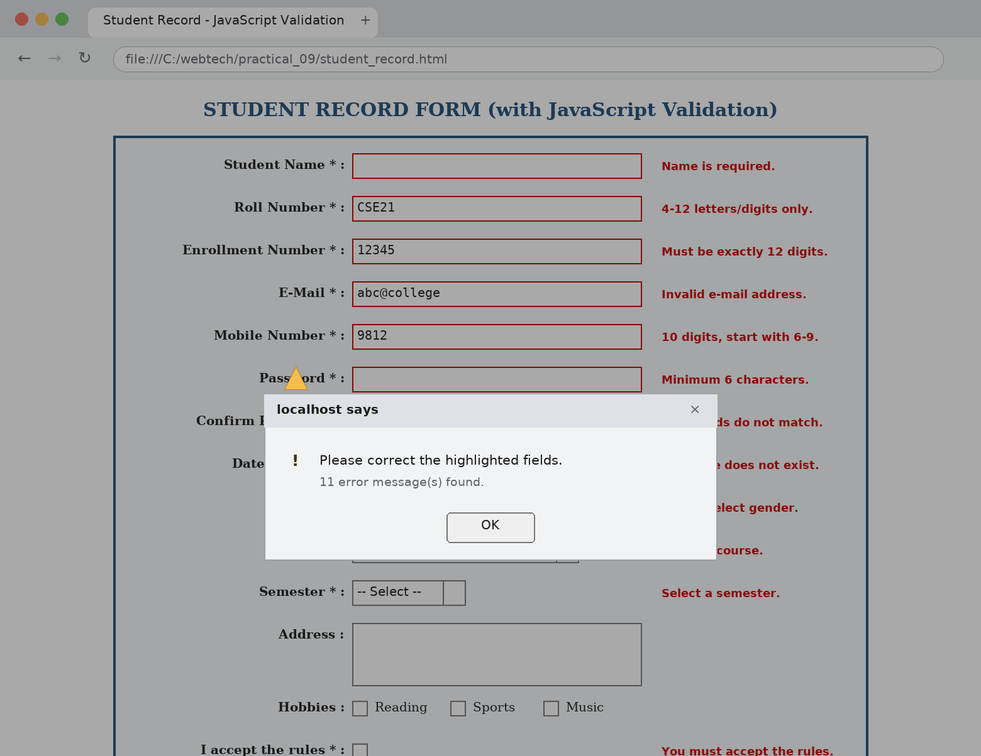
Fig. 9.1 : Invalid data entered - every failed check is marked in red and the alert box stops the submission
PRACTICAL No. 10
Program : Writing program in XML for creation of DTD, which specifies set of rules.
Source Code :
students.xml
<?xml version="1.0" encoding="UTF-8"?>
<!-- Practical 10 : XML program for the creation of a DTD which specifies a
set of
rules. The DTD is written INSIDE this file (internal DTD); every rule must be
followed, otherwise the document is reported as "not valid". -->
<!DOCTYPE students [
<!-- RULE 1 : the root <students> contains one or more <student> -->
<!ELEMENT students (student+)>
<!-- RULE 2 : children of <student> in THIS ORDER; address? and remarks?
optional -->
<!ELEMENT student (name, rollno, course, semester, email, address?, remarks?)>
<!-- RULE 3 : every <student> must have an id attribute (ID type, #REQUIRED)
-->
<!ATTLIST student id ID #REQUIRED type (regular | lateral) "regular"
active (yes | no) #IMPLIED>
<!-- RULE 4 : these elements contain only parsed text -->
<!ELEMENT name (#PCDATA)>
<!ELEMENT rollno (#PCDATA)>
<!ELEMENT course (#PCDATA)>
<!ELEMENT semester (#PCDATA)>
<!ELEMENT email (#PCDATA)>
<!-- RULE 5 : <address> is a container and its order is also fixed -->
<!ELEMENT address (city, state, pin)>
<!ELEMENT city (#PCDATA)>
<!ELEMENT state (#PCDATA)>
<!ELEMENT pin (#PCDATA)>
<!-- RULE 6 : <remarks> may contain unparsed character data (CDATA) -->
<!ELEMENT remarks (#PCDATA | note)*>
<!ELEMENT note (#PCDATA)>
<!-- RULE 7 : a text entity that can be reused anywhere in the document -->
<!ENTITY college "Name of the College">
]>
<students>
<student id="S01" type="regular" active="yes"><name>Student Name One</name>
<rollno>CSE2101</rollno><course>B.Tech (Computer Science &amp;
Engineering)</course>
<semester>V</semester><email>student1@college.ac.in</email>
<address><city>Lucknow</city><state>Uttar
Pradesh</state><pin>226001</pin></address>
</student>
<student id="S02" type="regular" active="yes"><name>Student Name Two</name>
<rollno>CSE2102</rollno><course>B.Tech (Computer Science &amp;
Engineering)</course>
<semester>V</semester><email>student2@college.ac.in</email>
<address><city>Kanpur</city><state>Uttar
Pradesh</state><pin>208001</pin></address>
</student>
<!-- address is optional, so it is not given for this student -->
<student id="S03" type="lateral"><name>Student Name Three</name>
<rollno>CSE2103</rollno><course>B.Tech (Information Technology)</course>
<semester>V</semester><email>student3@college.ac.in</email>
<remarks><![CDATA[ Lateral entry student. Marks & grades are pending.
]]></remarks>
</student>
</students>

rules.dtd
<!-- rules.dtd : EXTERNAL DTD FILE. Same rules as the internal DTD, but kept
in a
separate file so that many XML documents can share them. A .dtd file must NOT
start with an <?xml ... ?> declaration - only the rules are written here. -->
<!ELEMENT students (student+)>
<!ELEMENT student (name, rollno, course, semester, email, address?)>
<!ATTLIST student id ID #REQUIRED type (regular | lateral) "regular"
active (yes | no) #IMPLIED>
<!ELEMENT name (#PCDATA)>
<!ELEMENT rollno (#PCDATA)>
<!ELEMENT course (#PCDATA)>
<!ELEMENT semester (#PCDATA)>
<!ELEMENT email (#PCDATA)>
<!ELEMENT address (city, state, pin)>
<!ELEMENT city (#PCDATA)>
<!ELEMENT state (#PCDATA)>
<!ELEMENT pin (#PCDATA)>
<!ENTITY college "Name of the College">

students_external.xml
<?xml version="1.0" encoding="UTF-8"?>
<!-- This document uses the EXTERNAL DTD file "rules.dtd"; the SYSTEM keyword
tells the parser where the rule file is. -->
<!DOCTYPE students SYSTEM "rules.dtd">
<students>
<student id="S11" type="regular" active="yes"><name>Student Name Four</name>
<rollno>CSE2104</rollno><course>B.Tech (Computer Science &amp;
Engineering)</course>
<semester>V</semester><email>student4@college.ac.in</email>
<address><city>Delhi</city><state>Delhi</state><pin>110001</pin></address>
</student>
<student id="S12"><name>Student Name Five</name>
<rollno>CSE2105</rollno><course>B.Tech (Information Technology)</course>
<semester>V</semester><email>student5@college.ac.in</email>
</student>
</students>

invalid_example.xml
<?xml version="1.0" encoding="UTF-8"?>
<!-- This file is INTENTIONALLY WRONG : it breaks two rules of the DTD, so a
validating parser reports errors. (1) the REQUIRED attribute "id" is missing
and
(2) <email> is written before <course> (wrong order). -->
<!DOCTYPE students SYSTEM "rules.dtd">
<students>
<student><name>Wrong Student</name><rollno>CSE2999</rollno>
<email>wrong@college.ac.in</email><course>B.Tech (CSE)</course>
<semester>V</semester>
</student>
</students>

Output / Result :
students.xml carries the DTD inside itself (internal DTD) while students_external.xml takes the same rules from the separate file rules.dtd through the SYSTEM keyword. The DTD fixes the element order, the optional elements (address?, remarks?), the required id attribute and the allowed values of type and active. invalid_example.xml is deliberately wrong so that the enforcement of the rules can be demonstrated.
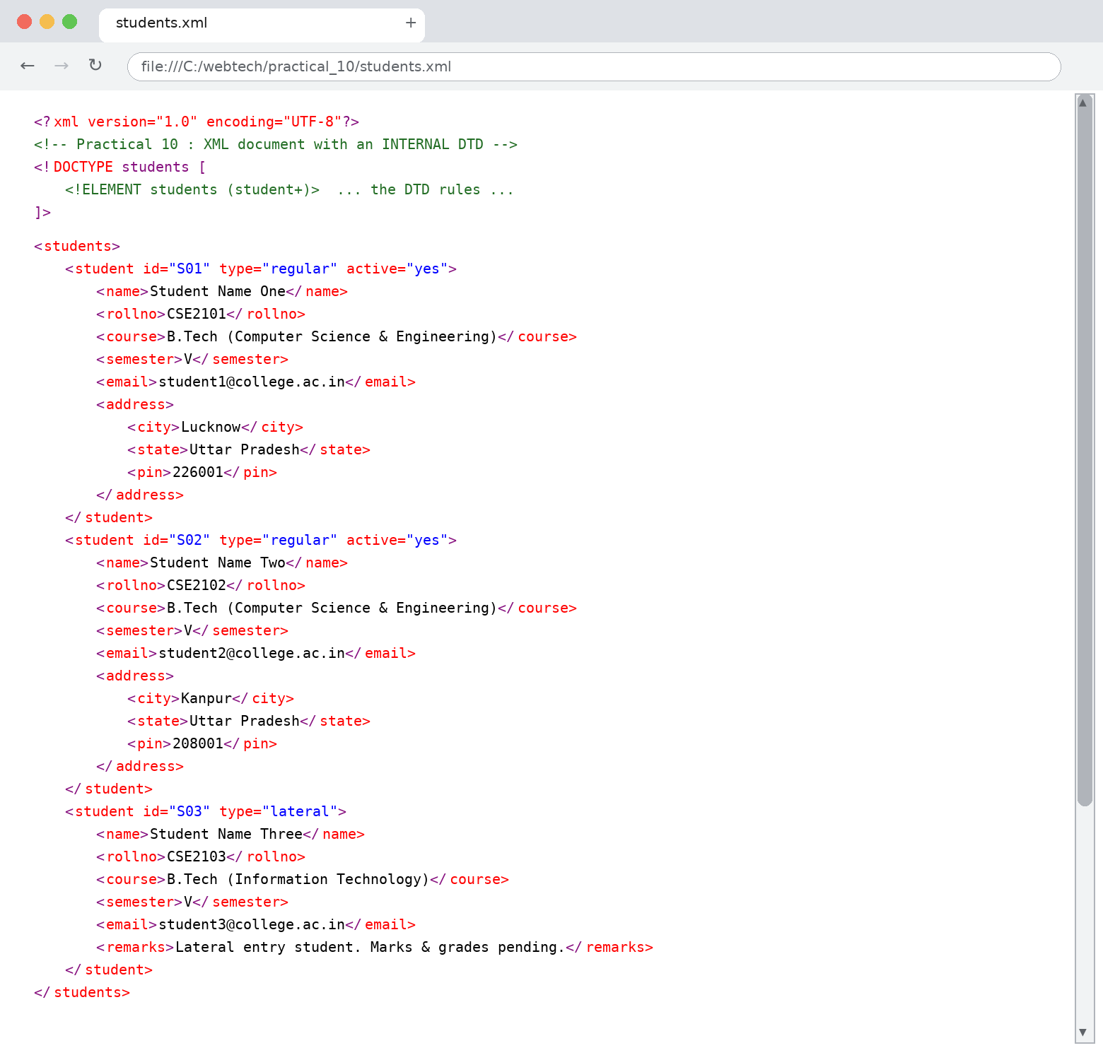
Fig. 10.1 : students.xml opened in a browser - the tree follows every rule of the internal DTD

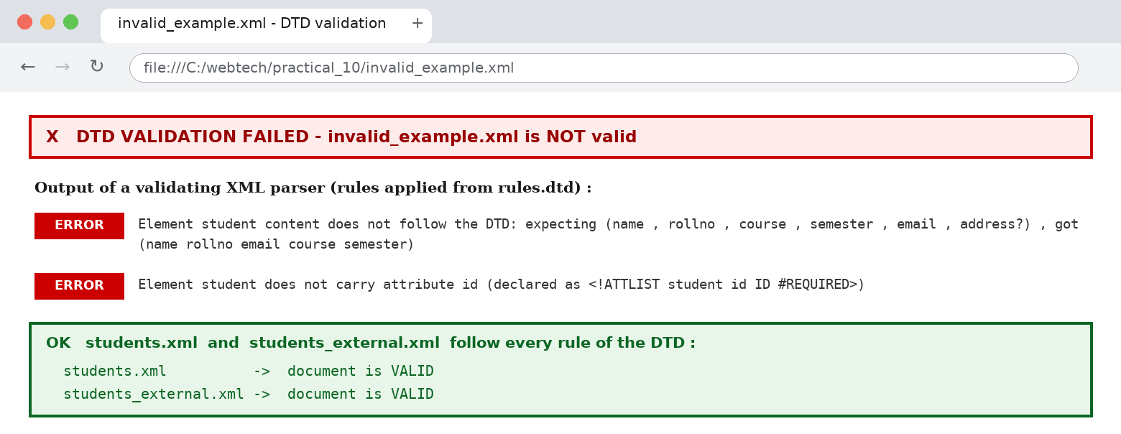
Fig. 10.2 : A validating parser rejects invalid_example.xml because it breaks two rules of the DTD
PRACTICAL No. 11
Program : Create a style sheet in CSS/XSL and display the document in Internet Explorer.
Source Code :
books.xml
<?xml version="1.0" encoding="UTF-8"?>
<!-- The xml-stylesheet instruction connects this XML file with the XSL style
sheet. Without this line the browser shows the raw XML tree. -->
<?xml-stylesheet type="text/xsl" href="books.xsl"?>
<catalogue>
<book category="Programming"><title lang="en">Web Technology</title>
<author>A. K. Sharma</author><year>2021</year><price>350</price></book>
<book category="Programming"><title lang="en">Learning XML</title>
<author>Erik Ray</author><year>2005</year><price>290</price></book>
<book category="Database"><title lang="en">SQL Complete Reference</title>
<author>R. K. Verma</author><year>2019</year><price>480</price></book>
<book category="Programming"><title lang="en">JavaScript for Beginners</title>
<author>S. Gupta</author><year>2022</year><price>199</price></book>
<book category="Network"><title lang="en">Computer Networks</title>
<author>P. Singh</author><year>2018</year><price>520</price></book>
</catalogue>

books.xsl
<?xml version="1.0" encoding="UTF-8"?>
<!-- books.xsl : XSL style sheet (XSLT 1.0). It transforms books.xml into a
normal
HTML page so that the XML data can be displayed in a browser. -->
<xsl:stylesheet version="1.0"
xmlns:xsl="http://www.w3.org/1999/XSL/Transform">
<xsl:output method="html" indent="yes" encoding="UTF-8"/>
<xsl:template match="/">
<html>
<head>
<title>Book Catalogue (XML + XSL)</title>
<style>
body { font-family:"Times New Roman"; margin:20px; background-color:#FFFFFF; }
h2 { color:#1F4E79; text-align:center; }
table { border-collapse:collapse; width:90%; margin:auto; }
th { background-color:#1F4E79; color:#FFFFFF; padding:7px; border:1px solid
#000000; }
td { padding:6px; border:1px solid #999999; text-align:center; }
tr:nth-child(even) { background-color:#EAF1FA; }
.low { color:#0B6623; font-weight:bold; }
.high { color:#990000; font-weight:bold; }
p.note { text-align:center; font-size:13px; color:#666666; }
</style>
</head>
<body>
<h2>BOOK CATALOGUE - DISPLAYED THROUGH XSL</h2>
<table>
<tr><th>S. No.</th><th>Title</th><th>Author</th><th>Category</th><th>Year</th>
<th>Price (Rs.)</th></tr>
<!-- repeat the row for every <book>, sorted by title -->
<xsl:for-each select="catalogue/book">
<xsl:sort select="title" order="ascending" data-type="text"/>
<tr>
<td><xsl:value-of select="position()"/></td>
<td style="text-align:left;"><xsl:value-of select="title"/></td>
<td><xsl:value-of select="author"/></td>
<td><xsl:value-of select="@category"/></td>
<td><xsl:value-of select="year"/></td>
<!-- conditional formatting of the price with xsl:choose -->
<td><xsl:choose>
<xsl:when test="price &lt; 300"><span class="low"><xsl:value-of
select="price"/></span></xsl:when>
<xsl:otherwise><span class="high"><xsl:value-of
select="price"/></span></xsl:otherwise>
</xsl:choose></td>
</tr>
</xsl:for-each>
</table>
<p class="note">Total books : <xsl:value-of select="count(catalogue/book)"/>
&#160;|&#160; Generated from books.xml by books.xsl</p>
</body>
</html>
</xsl:template>
</xsl:stylesheet>

books_css.xml
<?xml version="1.0" encoding="UTF-8"?>
<!-- Same data, but this time the style sheet is a CSS file. CSS can only
change
the LOOK of the XML tree - it cannot change the structure or the order of the
elements (XSL can). -->
<?xml-stylesheet type="text/css" href="books.css"?>
<catalogue>
<book category="Programming"><title>Web Technology</title>
<author>A. K. Sharma</author><year>2021</year><price>350</price></book>
<book category="Programming"><title>Learning XML</title>
<author>Erik Ray</author><year>2005</year><price>290</price></book>
<book category="Database"><title>SQL Complete Reference</title>
<author>R. K. Verma</author><year>2019</year><price>480</price></book>
<book category="Programming"><title>JavaScript for Beginners</title>
<author>S. Gupta</author><year>2022</year><price>199</price></book>
<book category="Network"><title>Computer Networks</title>
<author>P. Singh</author><year>2018</year><price>520</price></book>
</catalogue>

books.css
/* books.css : CSS style sheet applied directly to an XML file. Every element
is
styled with the "display" property, which makes the XML tree look like a page.
*/
catalogue { display:block; background-color:#FFFFFF;
font-family:"Times New Roman", serif; margin:20px; }
book { display:block; border:2px solid #1F4E79; border-radius:6px;
background-color:#F7F9FC; padding:8px; margin-bottom:12px; }
title { display:block; font-size:20px; font-weight:bold; color:#1F4E79; }
author, year, price { display:block; font-size:16px; color:#333333;
margin-left:15px; }
price:before { content:"Price (Rs.) : "; font-weight:bold; }
year:before { content:"Year : "; font-weight:bold; }
author:before { content:"Author : "; font-weight:bold; }

Output / Result :
books.xml points to books.xsl with the xml-stylesheet instruction; the XSL sheet converts the XML into an HTML table sorted by title. books_css.xml uses books.css instead, which only changes the look of the XML tree. Browser compatibility (brief): Internet Explorer supports XSLT 1.0 and the xml-stylesheet instruction natively, so opening books.xml in IE shows the formatted table; IE does not support XSLT 2.0 constructs. Firefox and Chrome also apply the XSL sheet when both files are well formed and are opened from the same folder. The CSS version works in IE, Firefox and Chrome, but CSS cannot reorder or restructure elements - only XSL can.
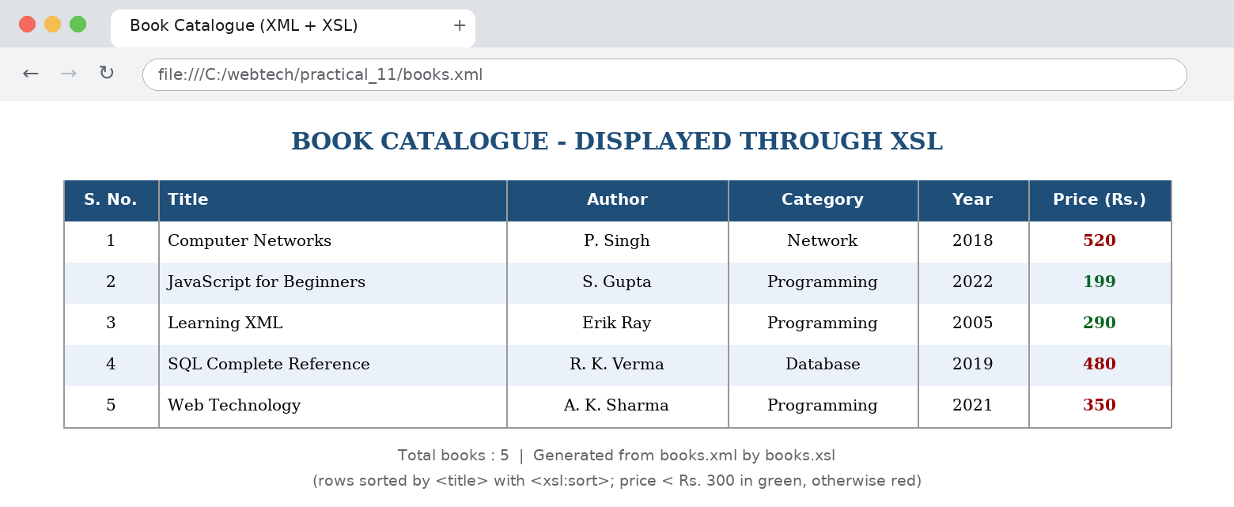
Fig. 11.1 : books.xml transformed by books.xsl into an HTML table

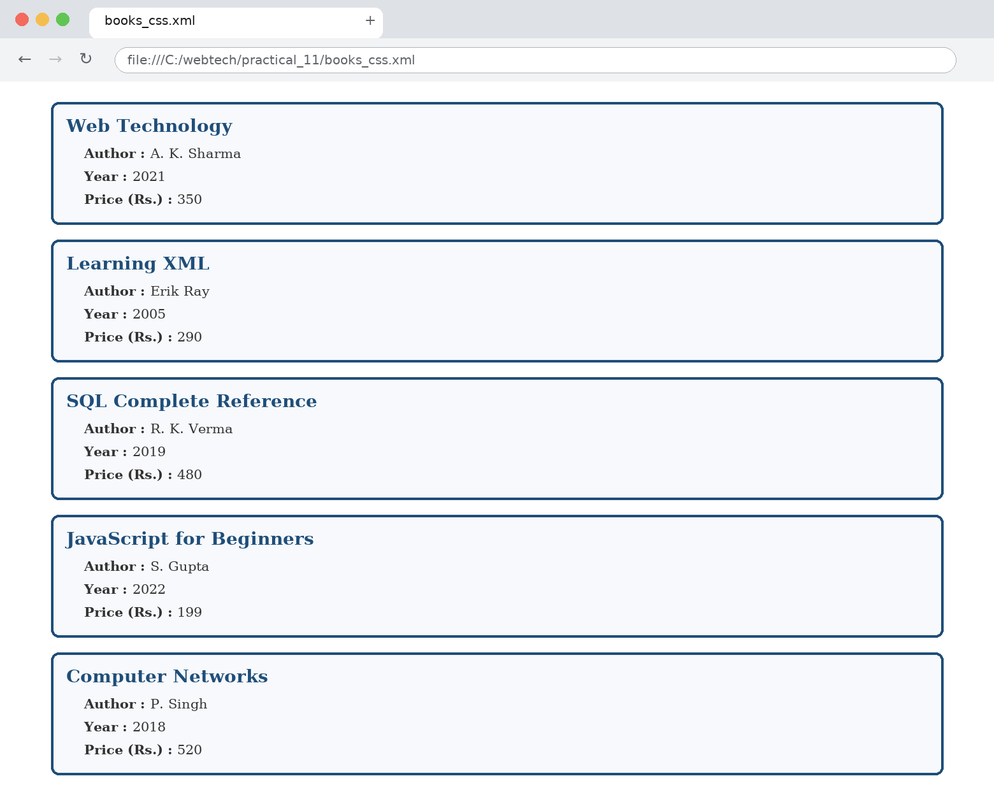
Fig. 11.2 : The same data displayed through the CSS style sheet books.css

