PROJECT FILE
WORKING WITH MONGO DB DOCUMENTS AND COLLECTIONS

SUBMITTED TO – _MR HARENDRA SINGH_ RAJPOOT
ROLL NO -1250258268 (26)
SUBMITTED BY – Mohammad Rehan Ansari
BCA – Data Science & Artificial Intelligence
SEMESTER – ODD (3rd)
UNIVERSITY / COLLEGE – BBD UNIVERSITY
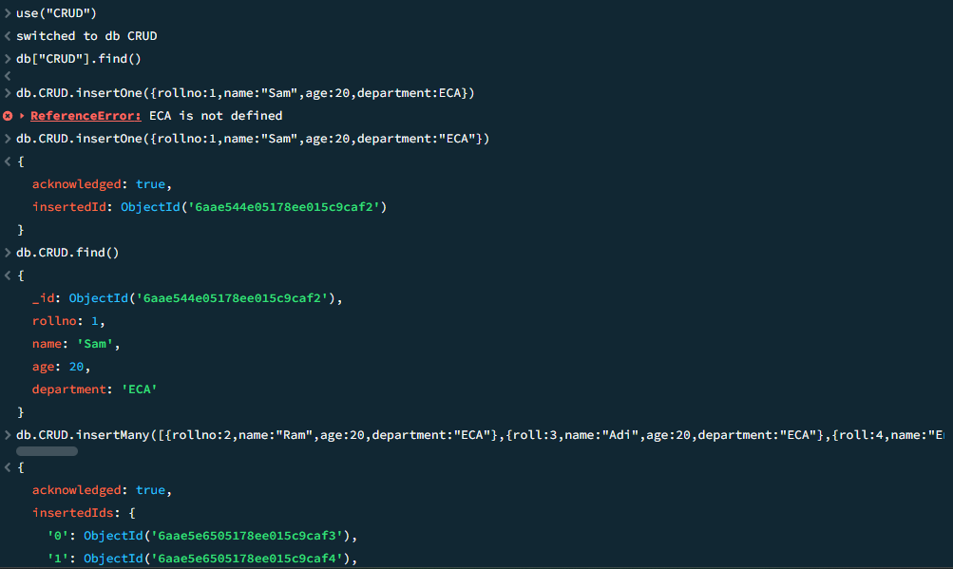
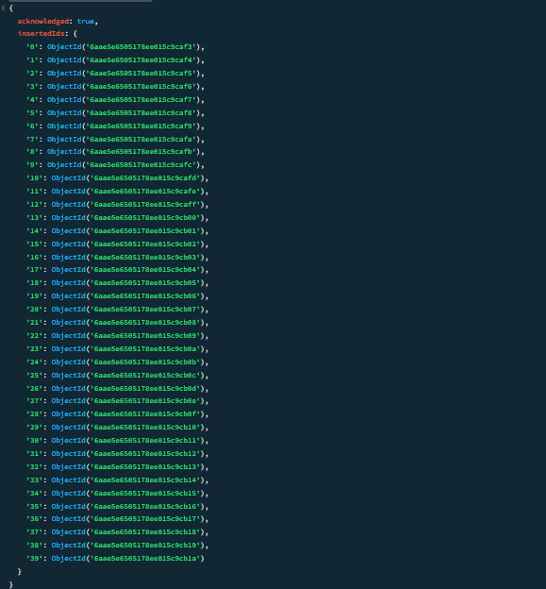
CREATE OPERATION- The Create operation is used to add new documents to a collection. MongoDB provides methods like insertOne() for single documents and insertMany() for multiple documents.
Read Operation- The Read operation retrieves documents from a collection. MongoDB uses methods like find() to fetch multiple documents and findOne() to retrieve a single document.

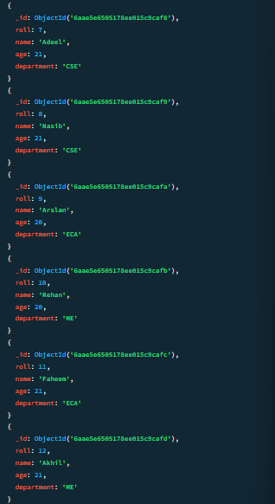
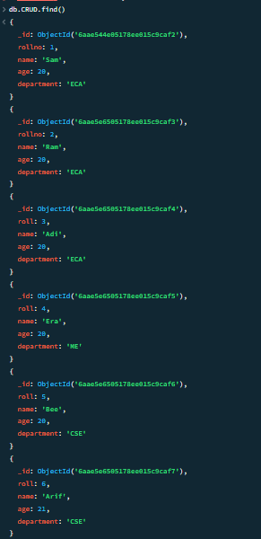

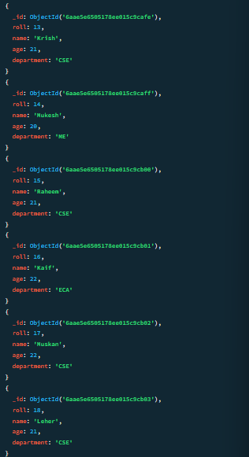
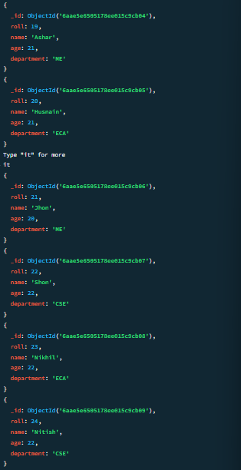

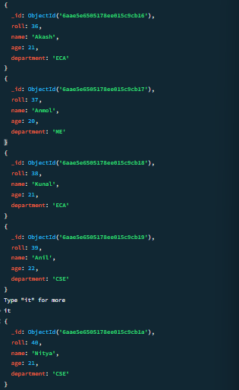
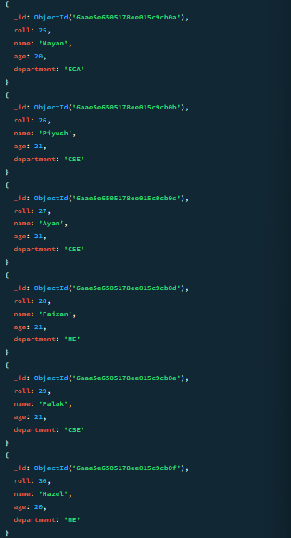

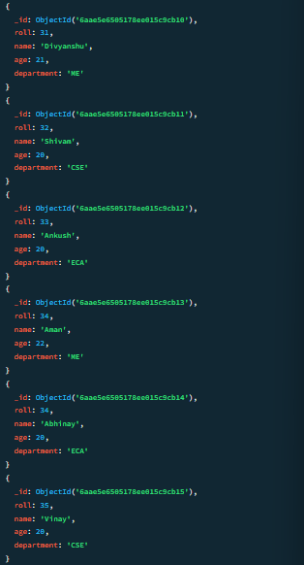


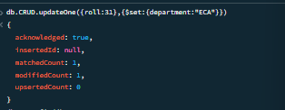
UPDATE OPERATION- The Update operation modifies existing documents. MongoDB provides methods like update One() to update a single document and update Many() to update multiple documents. The $set operator is commonly used to specify the fields to update.
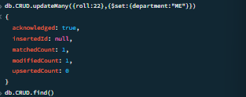

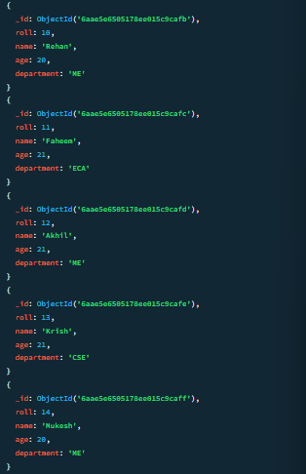

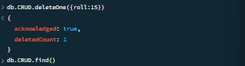
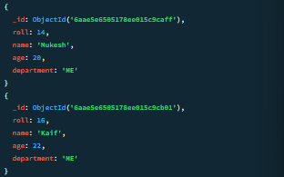
DELETE OPERATION- The Delete operation removes documents from a collection. MongoDB offers deleteOne() to delete a single document and deleteMany() to remove multiple documents based on a filter.

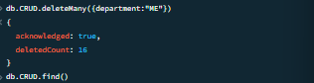
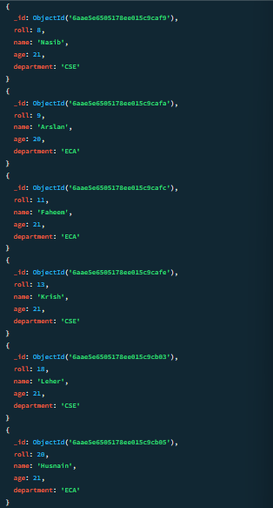

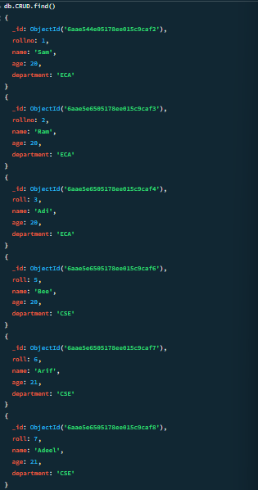

Using greater than in Mongo DB
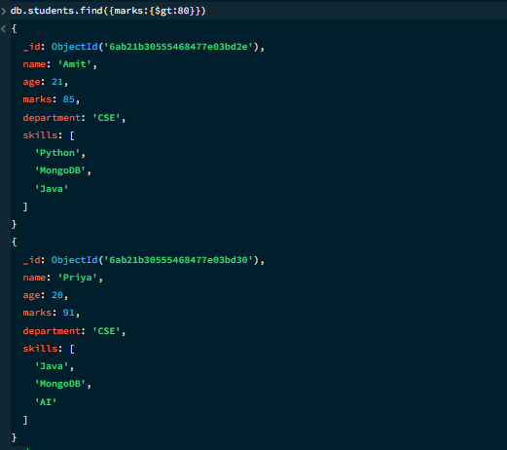

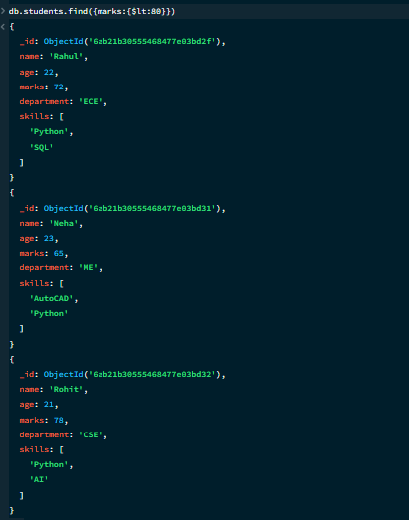
Using less than in Mongo DB

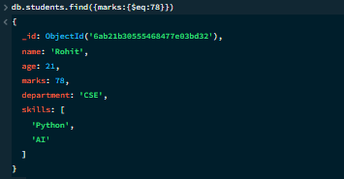
Using equal to in Mongo DB

Using not equal to in Mongo DB
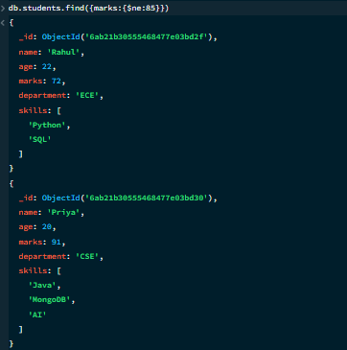

Using greater and equal to in Mongo DB
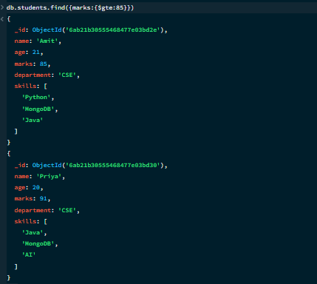

Using Conditional Operation in Mongo DB
AND Operation:-
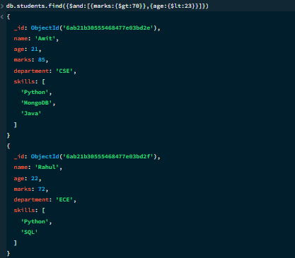

Using Conditional Operation in Mongo DB
OR Operation:-
