Course Code: CPL801 | Course Name: Cloud Computing Laboratory
Class :TECO | Batch :1
Roll no :15co12 | Name :Saeem Ansari

Experiment : 04

Aim : Study Platform as a Service and run application in Google App Engine

Theory:

Explain Platform as a Service.
Platform as a service (PaaS) is a cloud computing model in which a third-party provider delivers hardware and software tools -- usually those needed for application development -- to users over the internet. A PaaS provider hosts the hardware and software on its own infrastructure. As a result, PaaS frees users from having to install in-house hardware and software to develop or run a new application.

Explain the different Google Cloud Services.
Google Cloud Platform is a suite of public cloud computing services offered by Google. The platform includes a range of hosted services for compute, storage and application development that run on Google hardware.
different Google Cloud Services.
- Google Compute Engine
- Google App Engine
- Google Kubernetes Engine
- Google Cloud Bigtable

Explain the GCP Resources

GCP consists of a set of physical assets, such as computers and hard disk drives, and virtual resources, such as virtual machines (VMs), that are contained in Google's data centers around the globe. Each data center location is in a global region. Regions include Central US, Western Europe, and East Asia. Each region is a collection of zones, which are isolated from each other within the region. Each zone is identified by a name that combines a letter identifier with the name of the region. For example, zone a in the East Asia region is named asia-east1-a.
This distribution of resources provides several benefits, including redundancy in case of failure and reduced latency by locating resources closer to clients. This distribution also introduces some rules about how resources can be used together.

Explain the GCP Tools.

Development tools and environments

Cloud SDK
The Google Cloud SDK contains tools and libraries that enable you to easily create and manage resources on Cloud Platform, including App Engine, Compute Engine, Cloud Storage, Big-query, Cloud SQL, and Cloud DNS. It runs on Windows, macOS, and Linux, and requires Python 2.7.x.

Cloud Shell
Google Cloud Shell makes it easy for you to manage your GCP Console projects and resources without having to install the Cloud SDK and other tools on your system. Cloud Shell runs on a temporary Compute Engine instance, so you can run the gcloud command-line tool and other utilities in your web browser.

Android Studio
You can add Cloud Platform as a backend to your Android app directly from the Android Studio IDE. Android Studio ships with out-of- the- box integration for App Engine, Cloud Endpoints, and Google Cloud Messaging for Android (GCM).

IntelliJ IDEA
IntelliJ IDEA is the Java IDE from JetBrains. Cloud Tools for IntelliJ is a Google-sponsored plugin that adds support for the Google Cloud Platform to IDEA, both Community and Ultimate editions. Cloud Tools for IntelliJ enables you to debug production applications running on the Google Cloud Platform right inside of IntelliJ.

Cloud Tools for Visual Studio
Cloud Tools for Visual Studio enables ASP.NET development in Visual Studio on Google Cloud Platform. You can use Cloud Tools for Visual Studio to create and deploy an ASP.NET application on Google Cloud Platform.

Cloud Tools for PowerShell
Cloud Tools for PowerShell is a set of cmdlets for Windows PowerShell that lets you manage Google Cloud Platform resources. These cmdlets let you automate tasks by writing programs in PowerShell.

Cloud Tools for Eclipse
Cloud Tools for Eclipse helps you develop your Java application inside the Eclipse IDE and then deploy your project to App Engine. The plugin also provides tooling and API support for App Engine development with Java.

Cloud Source Repositories
Each project you create in the GCP Console has an associated, fully-featured Git repository that is hosted on Cloud Platform. You can use this repository for collaborative development of any application or service. If you are using Stackdriver Debugger, you can use Cloud Source Repositories and related tools in the GCP Console to view debugging information alongside your code during application runtime.

Debugging, tracing, and analysis
Stackdriver Debugger lets you inspect the state of your Java application running on App Engine or Compute Engine at any code location, without stopping the app or slowing it down. The debugger makes it easier to view the application state without adding logging statements. You can use Stackdriver Debugger with any deployment of your application, including test, development, and production.

Output:
Screen-shots of Hello World Tutorial

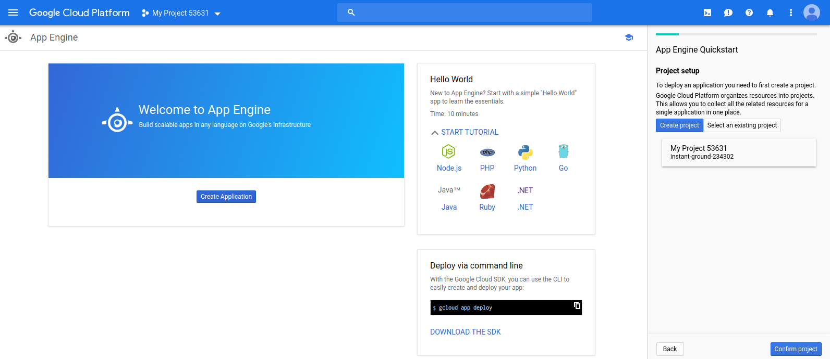

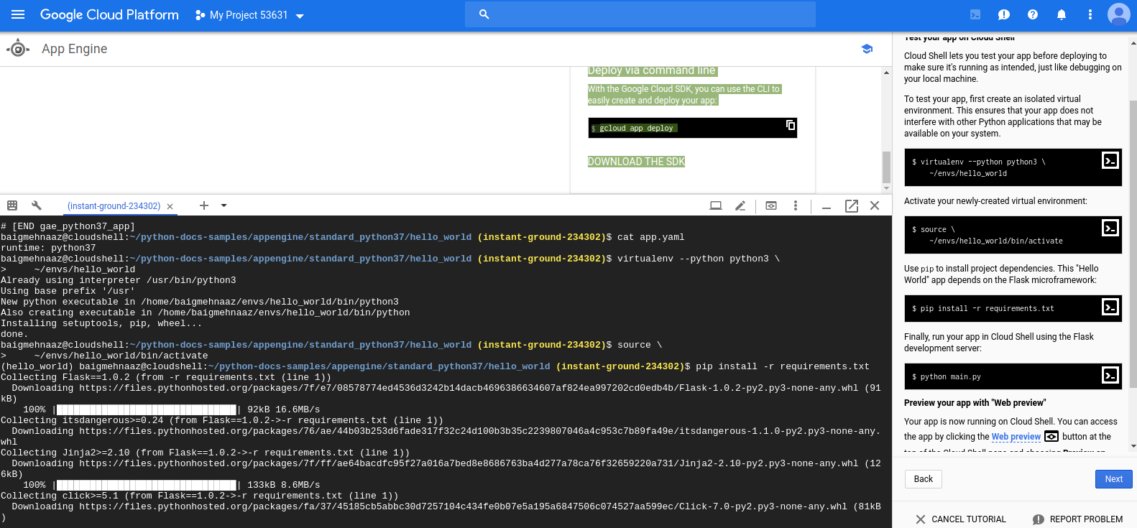

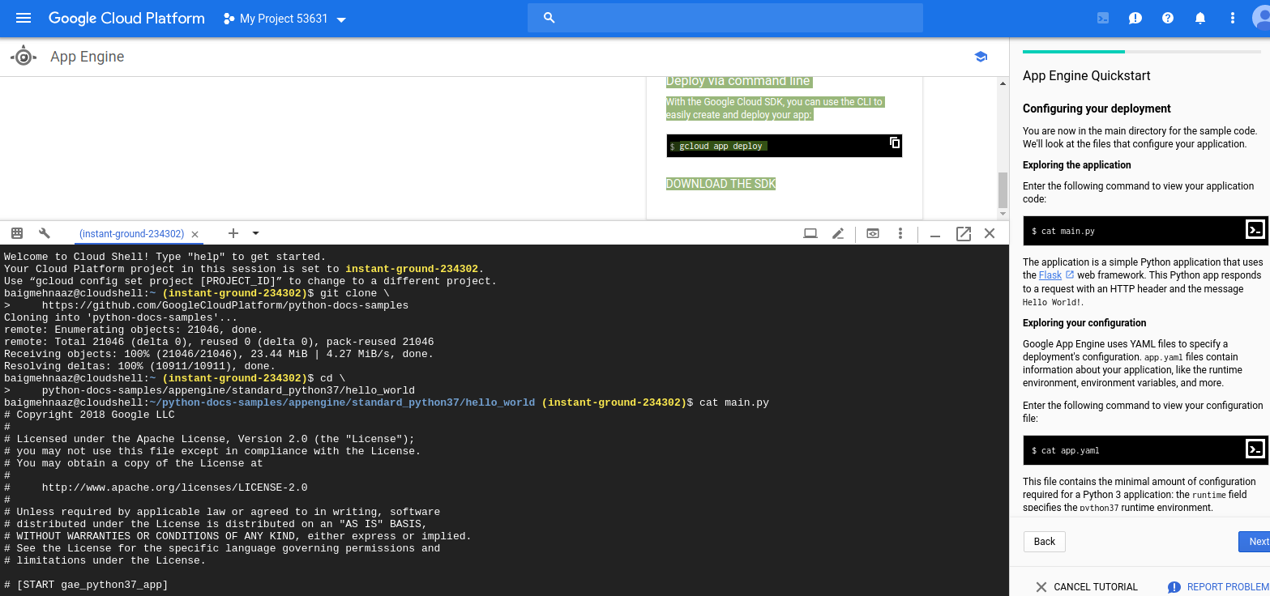

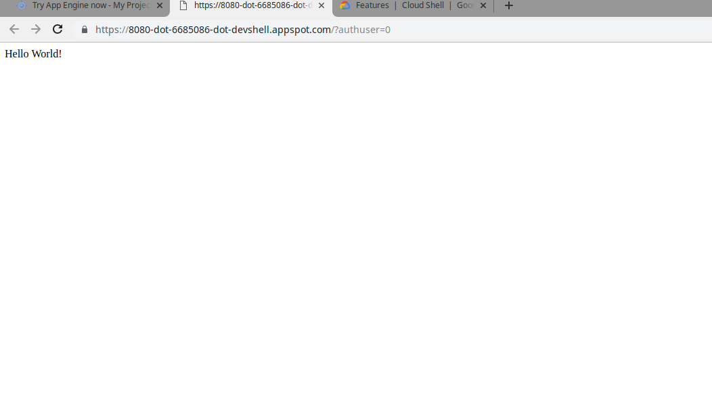
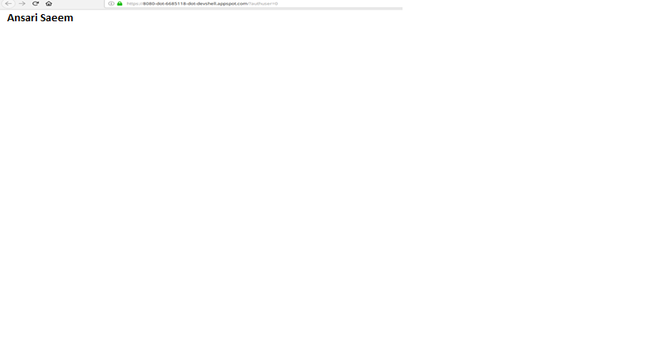

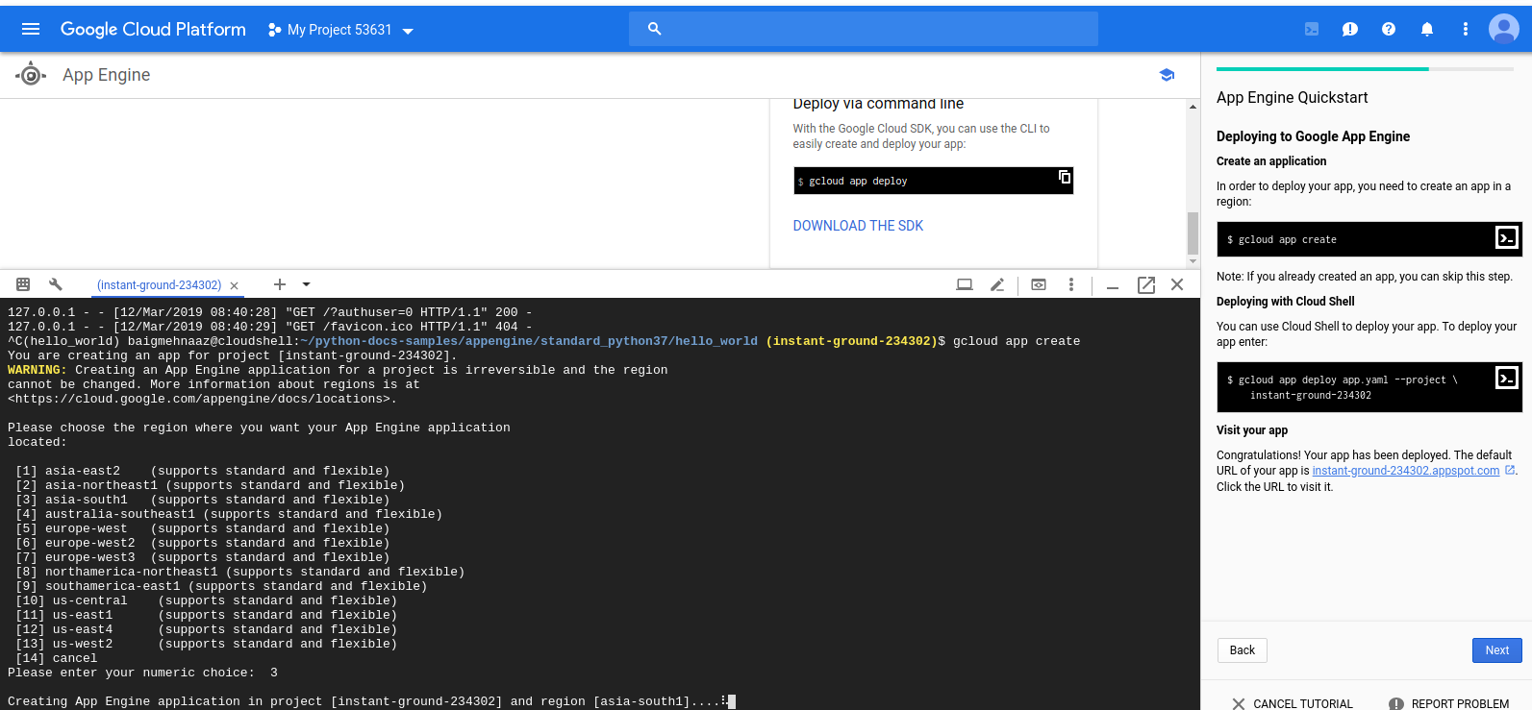

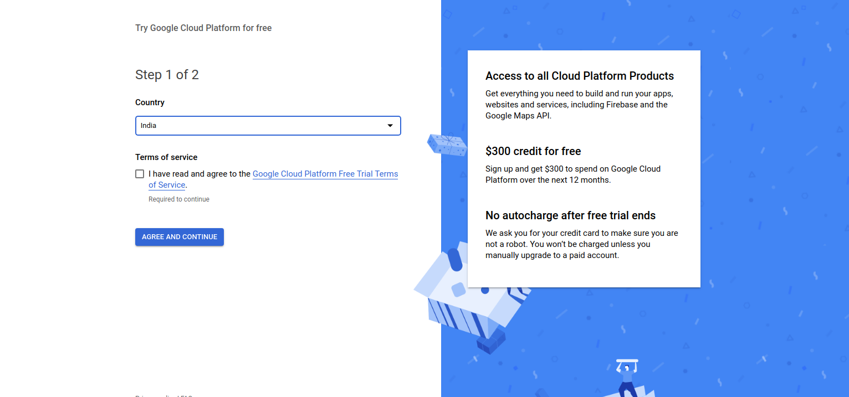

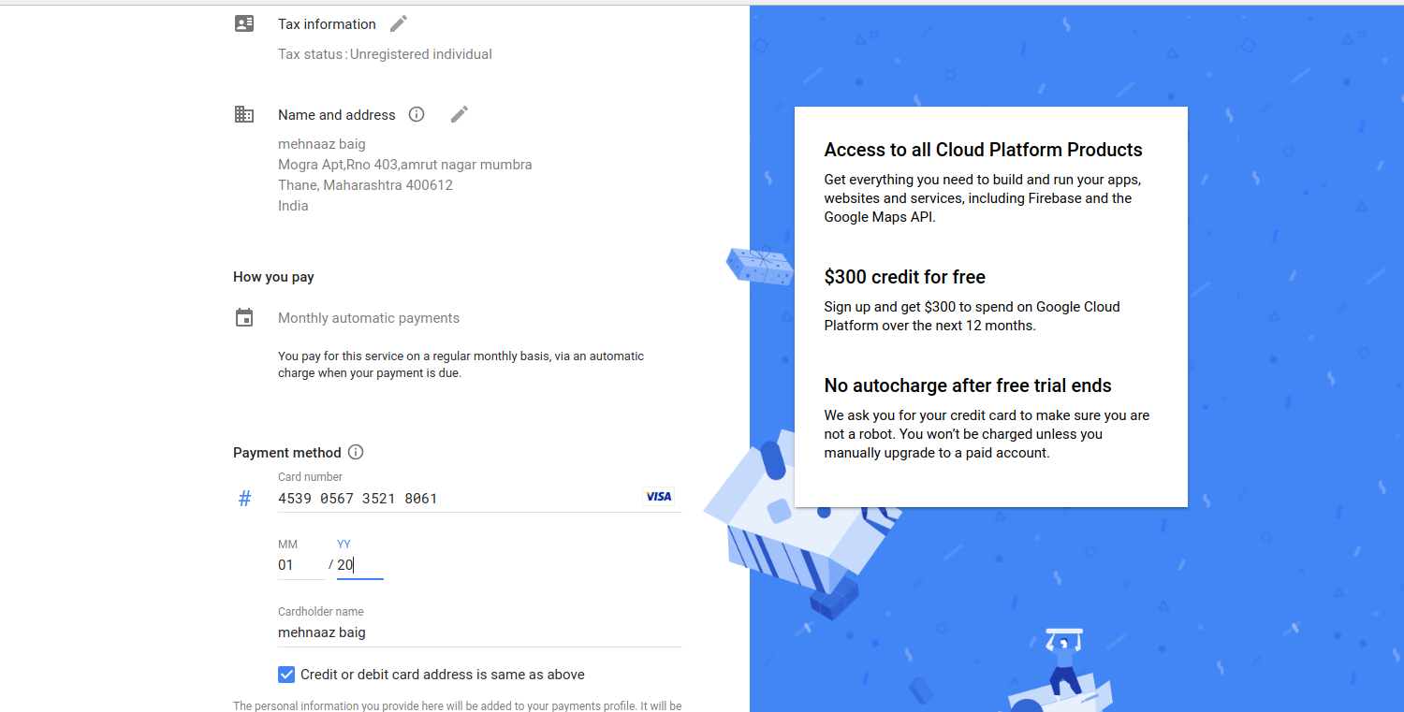

Conclusion:
In this experiment we learn how to use google API engine. Google App Engine (often referred to as GAE or simply App Engine) is a web framework and cloud computing platform for developing and hosting web applications in Google-managed data centers. Applications are sandboxes and run across multiple servers.

Reference:https://cloud.google.com/docs/overview/cloud-platform-services
https://cloud.google.com/sdk/docs/quickstart-linux
https://console.cloud.google.com/appengine
https://cloud.google.com/sdk/docs/how-to

