**Ajay Singh**

**UID 2019430012**

**Aim:** Write a program to implement & Analysis of Simplex algorithm.

**Objectives:**

1. To find the feasible set's adjacent vertices for a LP Problem.
2. Calculate the optimal solution to the linear programming problem.

**Definition:**

The **Simplex Method or Simplex Algorithm** is used for calculating the optimal solution to the linear programming problem. In other words, the simplex algorithm is an iterative procedure carried systematically to determine the optimal solution from the set of feasible solutions.

Firstly, to apply the simplex method, appropriate variables are introduced in the linear programming problem, and the primary or the decision variables are equated to zero. The iterative process begins by assigning values to these defined variables. The value of decision variables is taken as zero since the evaluation in terms of the graphical approach begins with the origin. Therefore, x1 and x2 is equal to zero. The decision maker will enter appropriate values of the variables in the problem and find out the variable value that contributes maximum to the objective function and removes those values which give undesirable results. Thus, the value of the objective function gets improved through this method. This procedure of substitution of variable value continues until any further improvement in the value of the objective function is possible.

**Following two conditions need to be met before applying the simplex method:**

1. The right-hand side of each constraint inequality should be non-negative. In case, any linear programming problem has a negative resource value, then it should be converted into positive value by multiplying both the sides of constraint inequality by “-1”.
2. The decision variables in the linear programming problem should be non-negative.

**Properties:**

1. The objective must be maximize or minimize the function.
2. All restrictions must be equal.
3. All variables are not negatives.
4. The independent terms are not negatives.

**Time Complexity:**

Best Case – Polynomial running time.

Worst Case – Exponential running time.

**Simplex Algorithm**

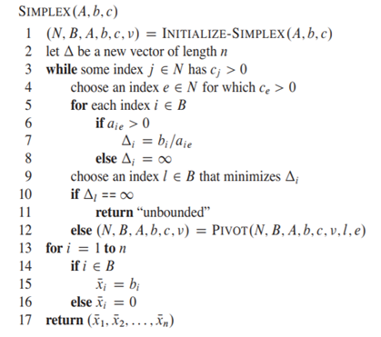

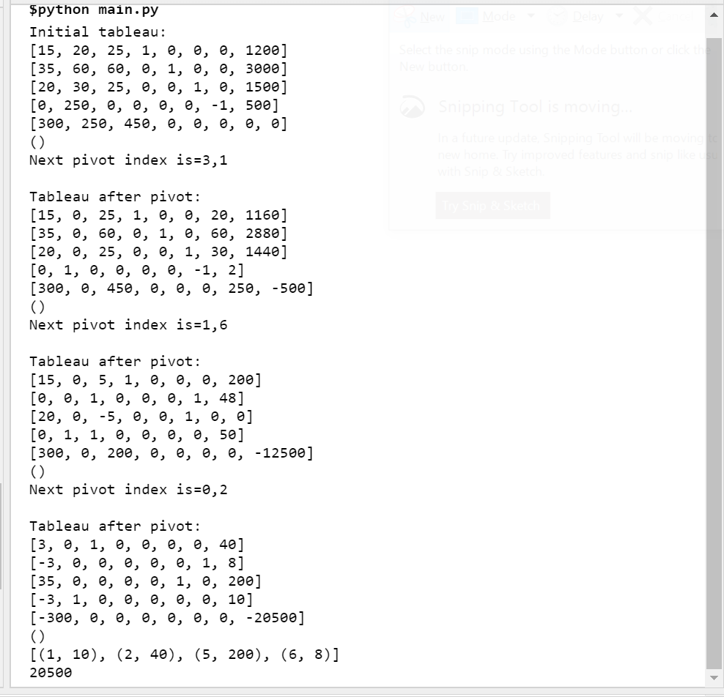**Implementation:**

**Conclusion:**

Here we can conclude that **Simplex method** is an approach for determining the optimal value of a linear program very fast and efficiently(in best case) . The **method** produces an optimal solution to satisfy the given constraints and produce a maximum zeta value.