ART networks follow both supervised and unsupervised algorithms.
- The unsupervised ART is to many iterative named as ART1, ART2 , ART3, . . and are similar clustering algorithms and "closer" are modified by introducing where the the terms "nearest" concept of "resonance". Resonance is just a matter of being within a certain threshold of a second similarity measure.
- The supervised ART algorithms that are named with the suffix "MAP",
as ARTMAP. Here the algorithms cluster both the inputs and targets and associate two sets of clusters.

• Comparison field : The comparison field takes an input vector(a one-dimensional array of values) and transfers it to its best match in the recognition field. Its best match is the single neuron whose set of weights (weight vector) most closely matches the input vector.
• Recognition field : Each recognition field neuron, outputs a negative signal proportional to
that neuron's quality of match to the input vector to each of the other recognition field neurons and inhibits their output accordingly. In this way the recognition field exhibits lateral inhibition, allowing each neuron in it to represent a category to which input vectors are classified.

- Vigilance parameter :After the input vector is classified, a reset module compares the strength of the recognition match to a vigilance parameter. The vigilance parameter has considerable influence on the system:
- Higher vigilance produces highly detailed memories
- Lower vigilance results in more general memories (fewer, more-
- general categories).

- Reset Module:The reset module compares the strength of the recognition match to the vigilance parameter.
  - If the vigilance threshold is met, then training commences.
  - Otherwise, if the match level does not meet he vigilance parameter, then network waits until a new input vector is applied;

The ART comes in several varieties. They belong to both unsupervised
and supervised form of learning.
Unsupervised ARTs are named as ART1, ART2 , ART3, . . and
are similar to many iterative clustering algorithms.
− ART1 model (1987) designed to cluster binary input patterns.
− ART2 model (1987) developed to cluster continuous input patterns.
− ART3 model (1990) is the refinement of these two models.
Supervised ARTs are named with the
suffix "MAP", as ARTMAP, that combines two slightly modified ART-1 or ART-2 units to form a supervised learning model where the first unit takes the input data and the second unit takes the correct output data. The algorithms cluste both the inputs and targets, and associate the two sets of clusters. Fuzzy ART and Fuzzy ARTMAP are generalization using fuzzy logic.
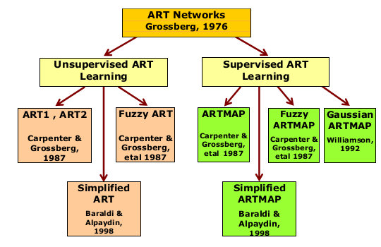
A taxonomy of important ART networks are shown below.

There are three groups of neurons to build ART as follows:
- Input processing neurons(F1 layers):
  - Input Portion F1(a) : processing based on received inputs
  - Interface Portion F1(b) :Combines the inputs from F1 and F2 layers for comaparing the similarities between input signals and weight vector for clustering unit
- Clustering Units (F2 layers):
- Control mechanism:

Real-World Text Clustering with Adaptive Resonance Theory Neural Networks

clustering has been an important research area in recent years.For real-world applications, on-line and incremental processing of highly dynamic data is required. Adaptive Resonance Theory (ART) neural networks possess several interesting properties that make them appealing as a potential solution to this problem.

An enormous quantity of human knowledge exists in the form of electronic text. The difficulty is to extract useful information one needs.

Positive – actually present and detected
false positive – not present but detected
false negative – present but not detected

Methodology :
- Feature selection and vocabulary growth :document collection is scanned and keywords extracted.
Issue that must be addressed is how to handle vocabulary growth.create data set TST which consists of terms of new vocabulary that extracted
- Determination of the vigilance parameter Value :
In practice, finding an optimal or at least an acceptable vigilance level may be difficult.
3.Stabilization:
4. Testing the level of quality achieved :

