Name : Ansari M.Saeem M.Saleem

Uid : 2019430001

Subject :BDA

Expt no :1

Aim : Case Study on Hadoop Ecosystem.

Hadoop Ecosystem

- Hadoop is a framework that enables processing of large data sets which reside in the form of clusters. Being a framework, Hadoop is made up of several modules that are supported by a large ecosystem of technologies. It is inspired by a technical document published by Google.

- Hadoop Ecosystem has an ecosystem that has evolved from its three core components processing, resource management, and storage.
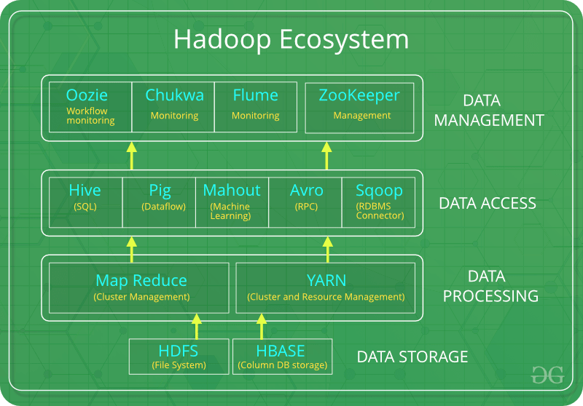

- Following are the components that collectively form a Hadoop ecosystem:
HDFS: Hadoop Distributed File System
HBase: NoSQL Database
YARN: Yet Another Resource Negotiator
MapReduce: Programming based Data Processing
Spark: In-Memory data processing
PIG, HIVE: Query based processing of data services
Mahout, Spark MLLib: Machine Learning algorithm libraries
SOLR, Lucene: Searching and Indexing
Sqoop: Connects to RDBMS
Avro: Avro, as a component, supports a rich set of primitive data types including: numeric, binary data and strings; and a number of complex types including arrays, maps, enumerations and records. A sort order can also be defined for the data.
Zookeeper: Managing cluster
Oozie: Job Scheduling

HDFS: Hadoop Distributed File System
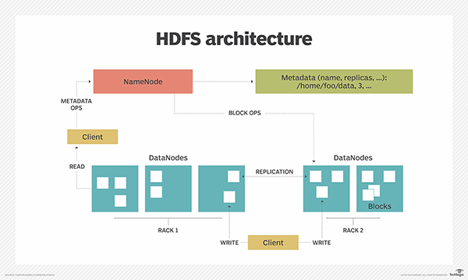

- HDFS is a storage layer for Hadoop.
- HDFS is suitable for distributed storage and processing, that is, while the data is being stored, it first gets distributed and then it is processed.
- HDFS provides Streaming access to file system data.
- HDFS provides file permission and authentication.
- HDFS uses a command line interface to interact with Hadoop.

So what stores data in HDFS? It is the HBase which stores data in HDFS.

HBase: NoSQL Database

- HBase is a column-oriented non-relational database management system that runs on top of Hadoop Distributed File System (HDFS).
- HBase provides a fault-tolerant way of storing sparse data sets, which are common in many big data use cases. It is well suited for real-time data processing or random read/write access to large volumes of data.

- HBase relies on ZooKeeper for high-performance coordination. ZooKeeper is built into HBase, but if you’re running a production cluster, it’s suggested that you have a dedicated ZooKeeper cluster that’s integrated with your HBase cluster.
- HBase works well with Hive, a query engine for batch processing of big data, to enable fault-tolerant big data applications.

MapReduce

- MapReduce is a processing technique and a program model for distributed computing based on java.
- The MapReduce algorithm contains two important tasks, namely Map and Reduce.
- Map takes a set of data and converts it into another set of data, where individual elements are broken down into tuples (key/value pairs).
- Secondly, reduce task, which takes the output from a map as an input and combines those data tuples into a smaller set of tuples.
- As the sequence of the name MapReduce implies, the reduce task is always performed after the map job.
- The major advantage of MapReduce is that it is easy to scale data processing over multiple computing nodes

YARN: Yet Another Resource Negotiator

Why YARN? (Over Map Reduce)
- In Hadoop version 1.0 which is also referred to as MRV1(MapReduce Version 1), MapReduce performed both processing and resource management functions.
- It consisted of a Job Tracker which was the single master.
- The Job Tracker allocated the resources, performed scheduling and monitored the processing jobs.
- It assigned map and reduce tasks on a number of subordinate processes called the Task Trackers. The Task Trackers periodically reported their progress to the Job Tracker.
- This design resulted in scalability bottleneck due to a single Job Tracker.
- IBM mentioned in its article that according to Yahoo!, the practical limits of such a design are reached with a cluster of 5000 nodes and 40,000 tasks running concurrently.
- Apart from this limitation, the utilization of computational resources is inefficient in MRV1. Also, the Hadoop framework became limited only to MapReduce processing paradigm.
- To overcome all these issues, YARN was introduced in Hadoop version 2.0 in the year 2012 by Yahoo and Hortonworks.
- The basic idea behind YARN is to relieve MapReduce by taking over the responsibility of Resource Management and Job Scheduling. YARN started to give Hadoop the ability to run non-MapReduce jobs within the Hadoop framework.

Spark

- Apache Spark is a fast, in-memory data processing engine with elegant and expressive development APIs to allow data workers to efficiently execute streaming, machine learning or SQL workloads that require fast iterative access to datasets.
- It adds in-Memory Compute for ETL, Machine Learning and Data Science Workloads to Hadoop.
- With Spark running on Apache Hadoop YARN, developers everywhere can now create applications to exploit Spark’s power, derive insights, and enrich their data science workloads within a single, shared dataset in Hadoop.
- Apache Spark consists of Spark Core and a set of libraries. The core is the distributed execution engine and the Java, Scala, and Python APIs offer a platform for distributed ETL application development.

Pig and Hive

- Pig and Hive are the two key components of the Hadoop ecosystem.
- What does pig hadoop or hive hadoop solve? Pig hadoop and Hive hadoop have a similar goal- they are tools that ease the complexity of writing complex java MapReduce programs.
- However, when to use Pig Latin and when to use HiveQL is the question most of the have developers have.
- Apache HIVE and Apache PIG components of the Hadoop ecosystem are briefed. If we take a look at diagrammatic representation of the Hadoop ecosystem, HIVE and PIG components cover the same verticals and this certainly raises the question, which one is better? It’s Pig vs Hive.

Pig vs Hive

Pig | Hive
Procedural Data Flow Language | Declarative SQLish Language
For Programming | For creating reports
Mainly used by Researchers and Programmers | Mainly used by Data Analysts
Operates on the client side of a cluster. | Operates on the server side of a cluster.
Does not have a dedicated metadata database. | Makes use of exact variation of dedicated SQL DDL language by defining tables beforehand.
Pig is SQL like but varies to a great extent. | Directly leverages SQL and is easy to learn for database experts.
Pig supports Avro file format. | Hive does not support it.

Zookeeper

- An open source server that reliably coordinates distributed processes.
- Apache ZooKeeper provides operational services for a Hadoop cluster.
- ZooKeeper provides a distributed configuration service, a synchronization service and a naming registry for distributed systems.
- Distributed applications use Zookeeper to store and mediate updates to important configuration information.

Oozie

- Apache Oozie is a scheduler system to manage & execute Hadoop jobs in a distributed environment.
- We can create a desired pipeline with combining a different kind of tasks. It can be your Hive, Pig, Sqoop or MapReduce task.
- Using Apache Oozie you can also schedule your jobs. Within a sequence of the task, two or more jobs can also be programmed to run parallel to each other.
- It is a scalable, reliable and extensible system.

REFERENCES :
- https://www.geeksforgeeks.org/hadoop-ecosystem/
- https://www.simplilearn.com/big-data-and-hadoop-ecosystem-tutorial
- https://www.ibm.com/analytics/hadoop/hbase
- https://searchdatamanagement.techtarget.com/definition/Hadoop-Distributed-File-System-HDFS
- https://www.edureka.co/blog/hadoop-yarn-tutorial/
- https://hortonworks.com/apache/spark/
- https://www.dezyre.com/article/difference-between-pig-and-hive-the-two-key-components-of-hadoop-ecosystem/79
- https://hortonworks.com/apache/zookeeper/
- https://www.edureka.co/blog/apache-oozie-tutorial

