- Investigating and calibrating the dynamics of vehicles
in traffic micro-simulations models.

- AIMSUN software allows to model transpotation network small and large from a single intersection to an entire region.
- This research paper investigated two main
- approaches in studying how car dynamics are represented in AIMSUN traffic micro-simulation model.
- First is to analyse traffic using AIMSUN and second is using Intrument vehicle(vi).

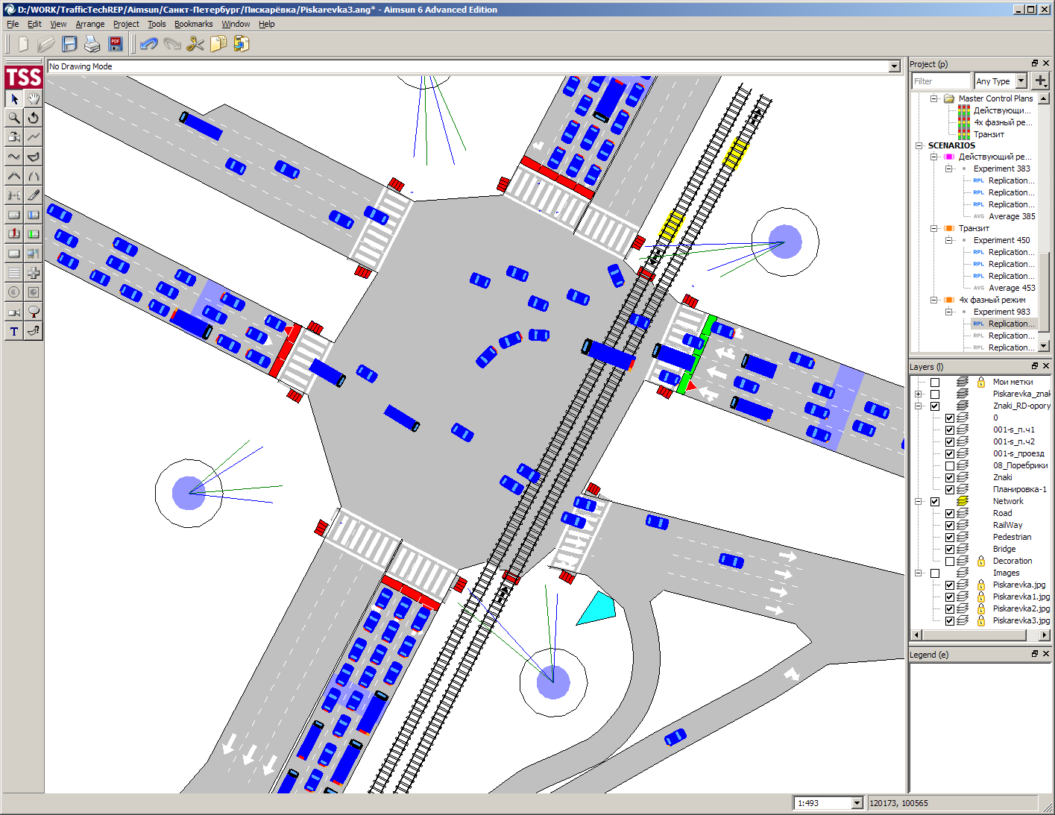
- Investigating the Transferability of Calibrated Microsimulation Parameters for Operational Performance Analysis in Roundabouts

- Microscopic simulation models are based on modelling of vehicle kinematics and interactions.
- Movements are governed by gap acceptance, car following, lane-changing, and other models and are typically calculated for each vehicle at every specified time-step.
- Two analytical models (aaSIDRA and RODEL)
- Three microsimulation tools (PARAMICS, Sim-Traffic, and VISSIM)
- Analysis done at Marconi Roundabout Cosenza, South Italy

- Modelling, Simulation Methods for Intelligent Transportation Systems

- Presents an overview of traffic flow modelling at the microscopic and macroscopic levels
- Review of current traffic simulation software, as well as several methods for managing and controlling the various transportation systems.
- Examines the field of traffic flow theory and the concept of macroscopic vs. microscopic ways of modelling transportation systems

- Short-term traffic forecasting: Where we are and where we’re going

- literature review of last decade(2001 to 2012)
- Findings support research interest towards:
  - responsive forecasting(capture situation as accurate as possible) schemes for non-recurrent conditions (unlikely to happen again)
  - developing prediction systems with increased algorithmic complexity
  - attempting to understand data coming from novel technologies and fuse multi-source traffic data to improve predictions
  - the applicability of AI methodologies to the short-term traffic prediction problem

- Speed and acceleration distributions at a traffic signal
analyzed from microscopic real and simulated data

- Modeling realistic driving behavior , determining the traffic signal performance, assessing the effect of different control strategies, estimating traffic emissions.
- This paper presents a method to collect real vehicle trajectories near traffic signals dataset using image processing techniques.
- measure individual vehicles speeds and accelerations at a microscopic level
- Phases:
  - Data requirements and choice of the study area : Rotterdam, the Netherlands
  - Data conversion process : To detect automatically vehicles as moving objects image processing technique implemented in matlab is used .
  - Data cleaning : cleaning the errors when detecting moving vehicle.
  - Simulation : using AIMSUN and VISSIM

- Traffic Simulation:Case for guidelines

- examine how existing guidelines are known and how much they are used in traffic simulation.
- The availability of guidelines was found to vary strongly from country to country.Eight countries have some guidance.(UK , US, Australia, Germany, Canada, New Zealand, Netherland, Japan).
- Discuss various issue to simulate traffic and some of them are as follows:
  - How to structure and manage a simulation project
  - How to handle model ‘warm up’/run duration/’cooling off’ period:
  - Warmup - time taken by initial empty network to fill with vehicles.
  - Run duration - time taken for actuall simulation
  - Cooling off - time taken by network filled with vehicle to empty
  - Number of runs to perform: Since traffic is stochastic and random so multiple runs of the simulation program are needed to obtain reliable results, problem is to find how much runs needed to complete the simulation
  - Calibration methodologies
  - Model specific issues
  - What to do in the absence of appropriate data
  - What data to use for validation

- Use of Mobile Data for Weather - Responsive Traffic Management Models

- Proposed weather responsive traffic managment (WRTM) model.
- Effect of weather on traffic has a direct impact on safety ,about 28% of all highway crashes, 19% of all fatalities and 25% of delays involve weather-related conditions as a factor
- Study predict effect of weather and traffic congession before it occurs.
- Real-time simulation of a traffic network can predict future conditions and thus help design and implement more effective traffic operations including various types of control measures.
- Live demo of project : https://mdotjboss.state.mi.us/MiDrive/map
- Youtube Vedio link :https://www.youtube.com/watch?v=pmmOCbn64p0

