Name : Ansari M.Saeem M.Saleem
Uid : 2019430001
Subject : AAC
Expt no : 4
Aim : Write a program to implement & Analysis Binomial Heap

Aim:
Write a program to implement & Analysis Binomial heap.
Objectives:
- To perform Binomial tree construction, insertion, deletion, finding min and extracting min.
- Calculate the optimal solution using linear programming problem.
Theory:
A binomial heap is a collection of binomial trees. The binomial tree B k is an ordered tree defined recursively. As shown in Figure (a), the binomial tree B0 consists of a single node. The binomial tree Bk consists of two binomial trees Bk-1 that are linked together: the root of one is the leftmost child of the root of the other. Figure (b) shows the binomial trees B0 through B4 .
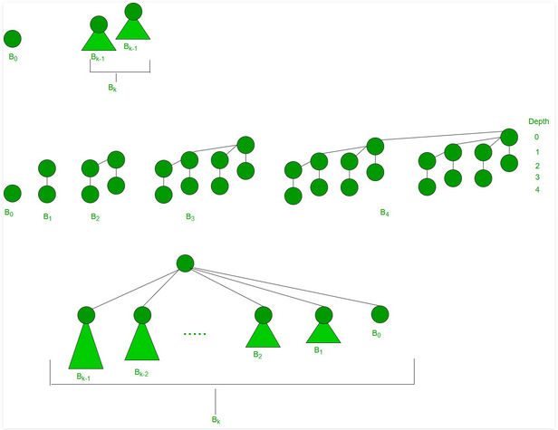

(a) The recursive definition of the binomial tree Bk.
(b) The binomial trees B0 through B4 . Node depths in B4 are shown.
(c) Another way of looking at the binomial tree Bk .

Properties:
- Each binomial tree in H obeys the min-heap property: the key of a node is greater than or equal to the key of its parent. We say that each such tree is min-heap-ordered.
- For any non negative integer k, there is at most one binomial tree in H whose root has degree k.
Time Complexity of operations:
Insertion: O(1) when heap is empty and O(log n) when heap is not empty.
Deletion: O(log n)
Searching: O(n)
Finding min: O(log n)
Delete minimum: O(log n)
Results:
Building:
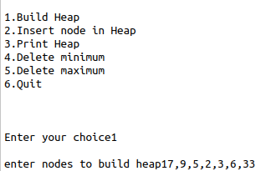
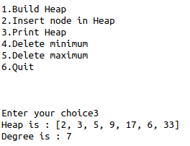

Insertion:
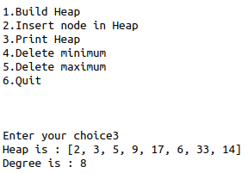
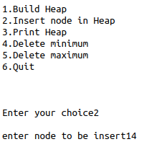

Min Deletion:
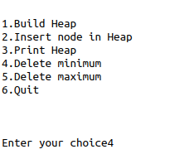
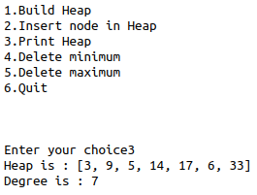

Max Deletion:
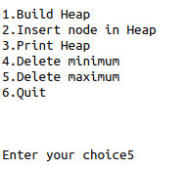
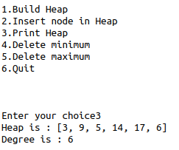

Conclusion:
The point of binomial heap is to provide cheap merging of stacks, while cost for the various operation is low. Binomial heap are fundamentally an arranged rundown of binomial trees. Because of the way that the binomial trees are organized, there will never be more than O(log n) of them, all in heap order with the minimum element at the root.

