Name : Ansari M.Saeem M.Saleem

Uid : 2019430001

Subject :BDA

Expt no :2

Aim : Basic Hadoop Commands.

1. Cat
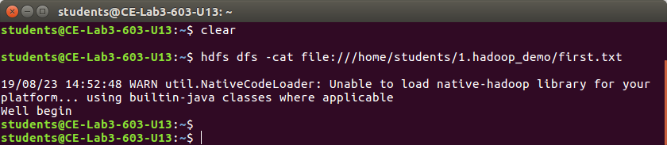
2.CopyFromLocal
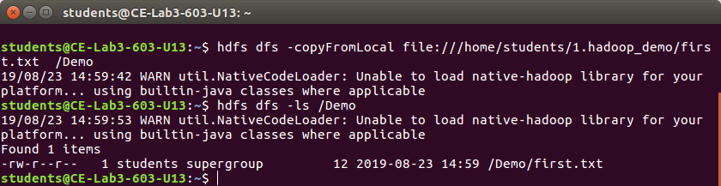
3.copyToLocal
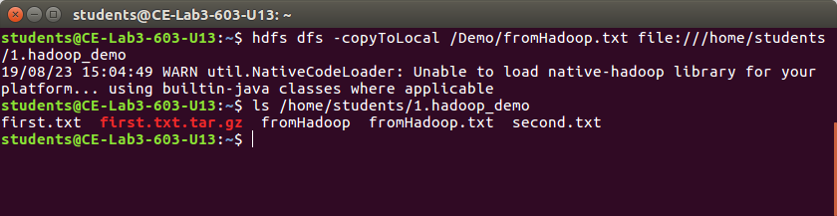

4.Mkdir & ls
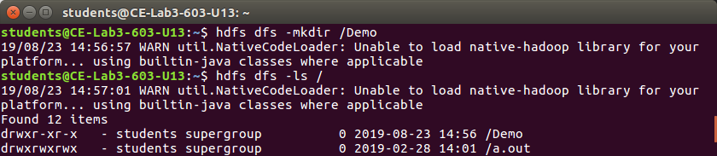
5.touchz
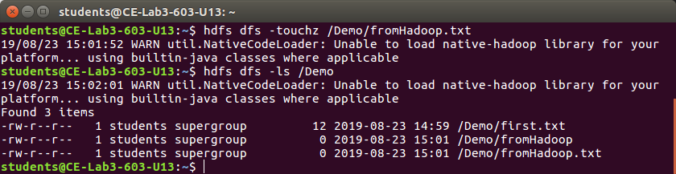

6.Count
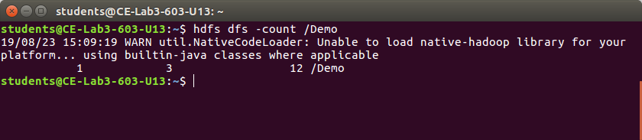
7.du
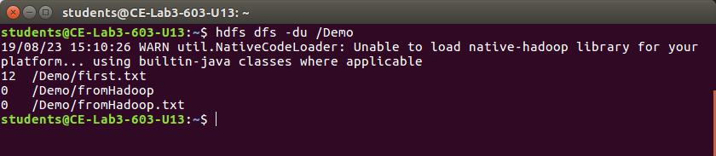
8.getmerge
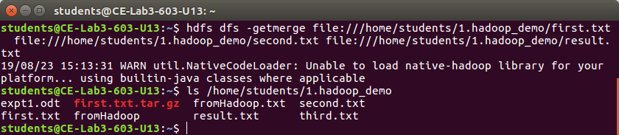
9.rm
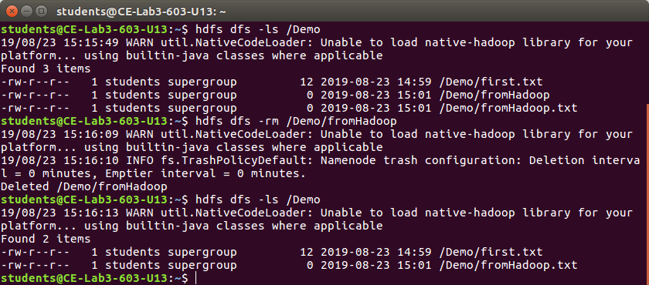

10.stat
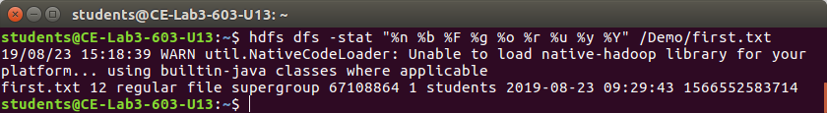

11.tail
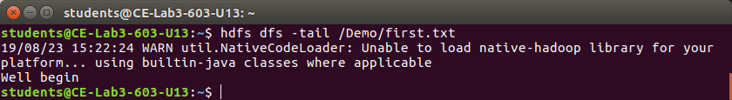
12.text
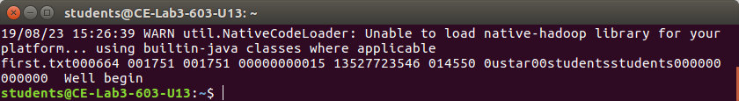
13.rmr
