Difference :
 | Bellman Ford Algorithm | Johnsons’s Algorithm
1 | Single Vertex Shortest Path | All Pair Shortest Path
2 | Effective on Dense Graph | Effective on Spears Graph
3 | Complexity is O(VE) | Complexity is O(V²log(V) + VE)
4 | It works alone | It combines Bellman Ford and Dijkstra's algorithm

Graph:
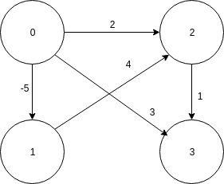
Results:
Bellman Ford
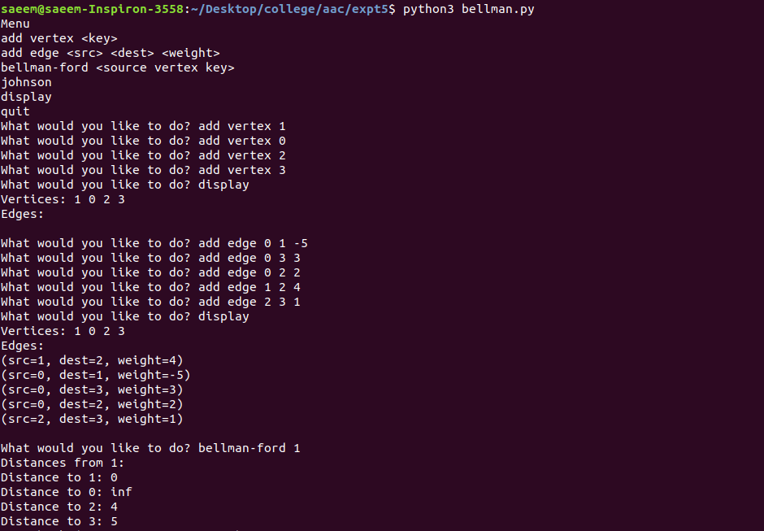

Johnsons Algorithm
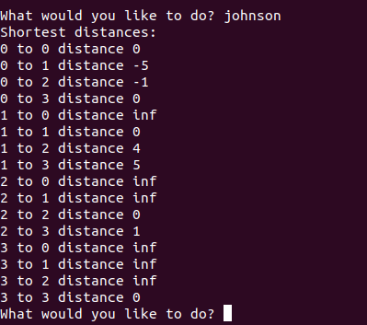

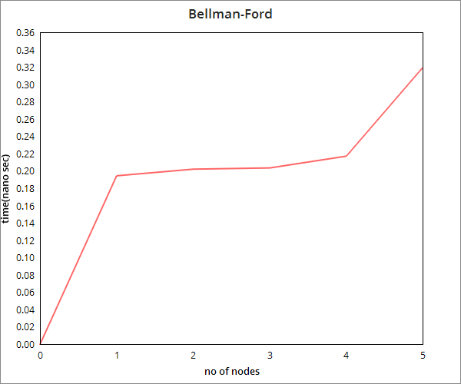
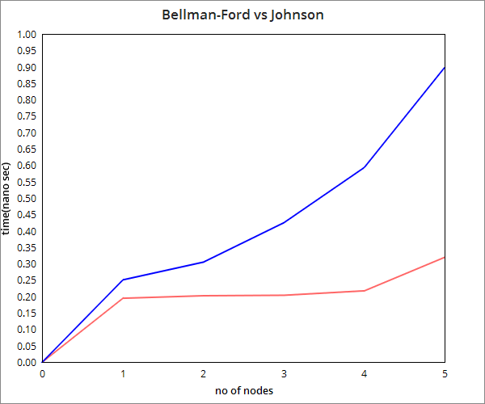
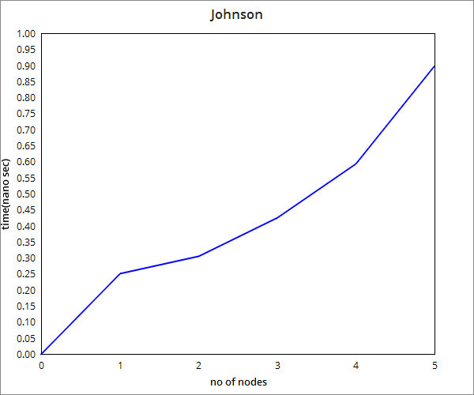
Conclusion:
It can be observed that Bellman Ford doesn’t follow a greedy approach like Dijkstra’s and it works on negative edge weights which is not the case with the latter. Johnson’s Algorithm works on integrating the Bellman Ford as well as the Dijkstra’s shortest path algorithm.

