Name : Ansari M.Saeem M.Saleem
Uid : 2019430001
Subject : AAC
Expt no : 6
Aim : Write a program to implement & Analysis Red Black Tree and to store the details of product (id,cost,qty)

Aim:
Write a program to implement & Analysis RBT and to store the details of product (id,cost,qty).
Objectives:
- Initialization Red Black Tree
- Perform primitive operations of RBT such as Insertion, Deletion and searching.
- Display the details of products (id,cost,qty) in RBT format.
Methodology:
A red–black tree is a kind of self-balancing binary search tree. Each node in RBT has an extra bit as compare to BST, and that bit is color (red or black) of the node.
Properties:
- Binary Search Tree : every RBT should be binary search tree
- Color Property : every node is either red or black
- Root Node : root node of RBT is always black
- Internal Node : If a node is Red then its both children are black
- Black Depth Property : for each node, all path from that node to descendants external nodes contains the same no of black tree.
Time Complexity of operations:
Insertion:
Deletion:
Searching:

Results:
Insertion:
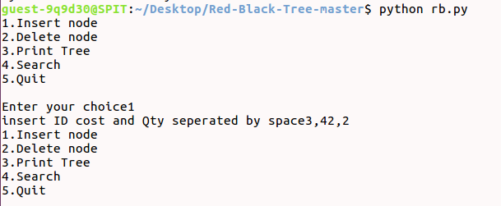

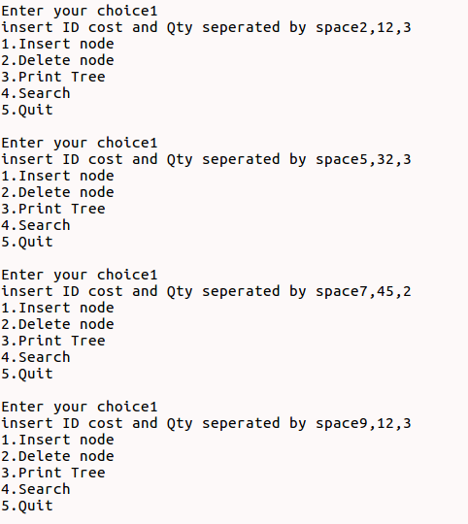

Deletion:
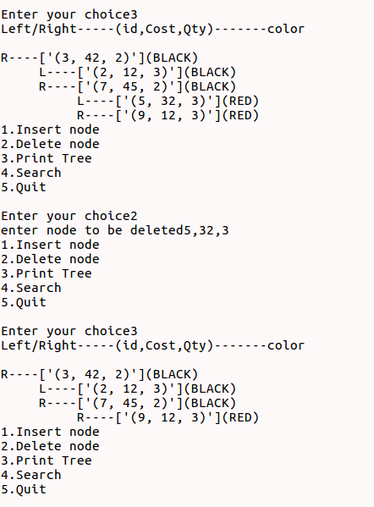

Search:
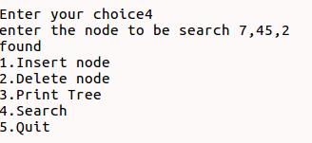

Conclusion:
Here we can conclude that Bellman-Ford works on negative edge weight which is the advantage of Dijkstra's algorithm. Johnson’s Algorithm is based on Bellman-Ford algorithm and Dijkstra's algorithm. Bellman-Ford required less time to find shortest path but on the other hand Johnson’s algorithm required more time as we increased the density of graph.

