Name : Ansari M.Saeem M.Saleem
Uid : 2019430001
Subject : NAD
Expt no : 1 B
Aim : Simulate a 3 node point to point network with duplex links between them. Set the Queue size and vary the bandwidth and find the number of packets dropped.

Aim:
Simulate a 3 node point to point network with duplex links between them. Set the Queue size and vary the bandwidth and find the number of packets dropped.
Objectives:
- To calculate the number of packets lost during transmission in a network.
- To observe the packet lost due to the effect of change in bandwidth.
Theory:
Packet loss occurs in networks when data packets are lost during transmission or individual data packets arrive late at their destination. Before being sent, data is packaged into several layers. These packets travel through a variety of different hubs (copper cables, fiber optics, wireless, etc.) to reach their destination. In these hubs, TCP packets get lost or become delayed. Once sent, each packet is marked with a timestamp.

Causes of Packet Loss - Packet loss can be caused by a number of issues, but the most common are:
- Network Congestion
Network congestion, as its name suggests, occurs when a network becomes congested with traffic and hits maximum capacity. Packets must wait their turn to be delivered, but if the connection falls so far behind that it cannot store any more packets, they will simply be discarded or ignored so that the network can catch up. The good news is that today's applications are able to gracefully handle discarded packets by re-sending data automatically or slowing down transfer speeds.
- Software Bugs
Software bugs are another common cause of packet loss. If rigorous testing has not been carried out or bugs have been introduced following software updates, this could result in unintended or unexpected network behavior. Sometimes rebooting can resolve this issues, but more often than not the software will need to be updated or patched.
- Problems with Network Hardware
Faulty or outdated network hardware such as firewalls, network switches and routers can slow down network traffic considerably. As a company grows and starts to experience lag, packet loss and total connectivity drops, this hardware needs to be revised and updated so that it can manage the growing throughput.
- Security Threats
In addition to problems with software and hardware, packet loss can also be caused by a security breach. One such attack that has become popular with cybercriminals in recent years is the packet drop attack. During an attack, a malicious user takes control of a router and sends commands that drop packets into a stream of data. If you suddenly notice high rates of packet loss across your network, it could be a cyber attack in progress.

Methodology :
Steps -
- Create a new simulation using following command
set ns [new Simulator]
- Use static routing because the duplex links are predefined using following command
$ns rtproto Static
- Set up trace files in write mode using following command
set traceFile [open 1.tr w]
$ns trace-all $traceFile
- Set up NAM files in write mode (for visualization) using following command
set nf [open 1.nam w]
$ns namtrace-all $nf
- Define the finish function to clear trace file and execute nam program to visualize the graph.
- Create 3 nodes – n1, n2, n3 using following commands
for {set i 1} {$i < 4} {incr i} {
set n($i) [$ns node]
}
- Establish links and set the bandwidth using following command (Case 1)
$ns duplex-link $n(1) $n(2) 0.5Mb 20ms DropTail
$ns duplex-link $n(2) $n(3) 0.5Mb 20ms DropTail
- Set the Queue length using following command
$ns queue-limit $n(1) $n(2) 10
- Create a UDP agent and attach it to node n(1)
- Create a CBR traffic source and attach it to udp0
- Create a Null agent (a traffic sink) and attach it to node n(3)
- Connect the traffic source with the traffic sink and assign flow id color
- Schedule Events
- Run the simulation

Experiment Setup :
The test cases to perform in this experiment :-
1. Link (n1-n2) and (n2-n3) have the same bandwidth of 1MB with queue size of 15.
2. Link (n1-n2) has 0.5MB and (n2-n3) has 1 MB bandwidth with queue size of 15.
3. Link (n1-n2) has 0.7MB and (n2-n3) has 0.4 MB bandwidth with queue size of 15.

Results :
Case 1:
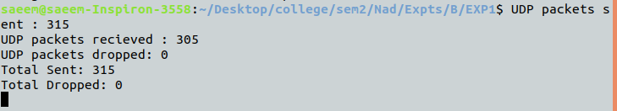
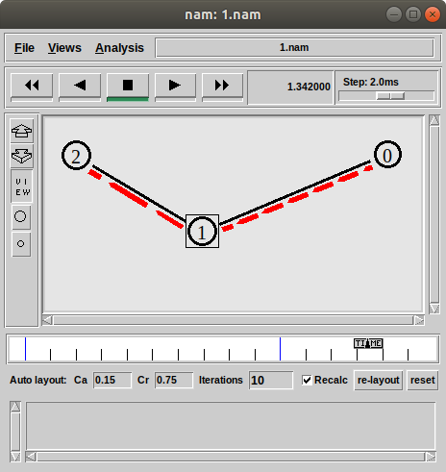

Case 2 :
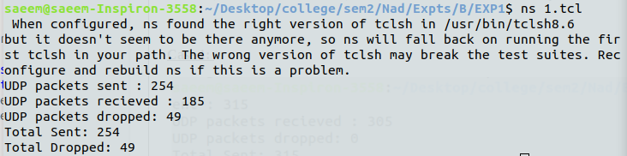
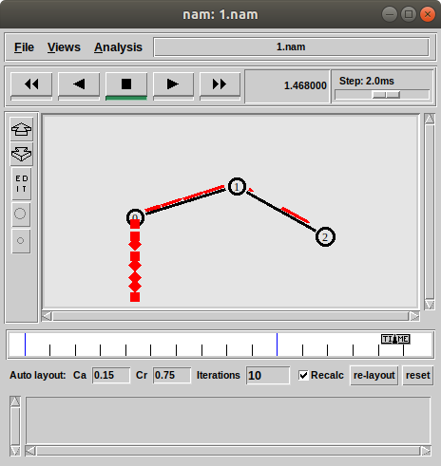

Case 3:
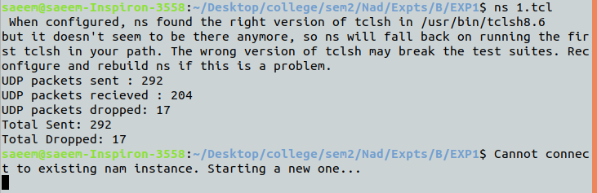
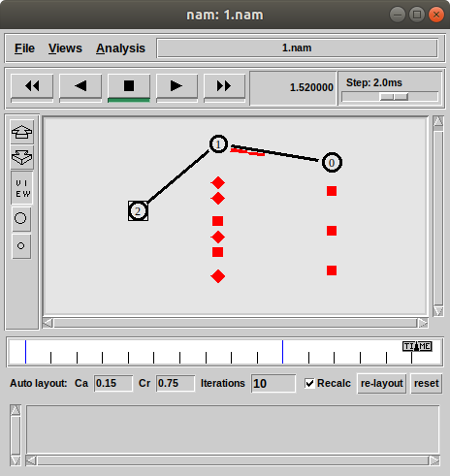

Conclusion:
Here we can conclude that there are many causes of packet lost and one of them is network congestion. We also conclude that Bandwidth is responsible for network congestion. If incoming packet link (here link between n1 – n2 ) and outgoing packet link (here link between n2 – n3 ) have same bandwidth then there is no packet lost but if bandwidth varies than network may face congestion and then packets will be lost.

