Name : Ansari M.Saeem M.Saleem
Uid : 2019430001
Subject : NAD
Expt no : 6
Aim : Simulate a 3 node point to point network with duplex links between them. Set the Queue size and vary the bandwidth and find the number of packets dropped.

Aim:
Simulate a 3 node point to point network with duplex links between them. Set the Queue size and vary the bandwidth and find the number of packets dropped.
Objectives:
- To calculate the number of packets lost during transmission in a network.
- To observe the packet lost due to the effect of change in bandwidth.
Theory:
Packet loss occurs in networks when data packets are lost during transmission or individual data packets arrive late at their destination. Before being sent, data is packaged into several layers. These packets travel through a variety of different hubs (copper cables, fiber optics, wireless, etc.) to reach their destination. In these hubs, TCP packets get lost or become delayed. Once sent, each packet is marked with a timestamp.

Methodology :
Steps -
- Create a new simulation using following command
set ns [new Simulator]
- Use static routing because the duplex links are predefined using following command
$ns rtproto Static
- Set up trace files in write mode using following command
set traceFile [open 1.tr w]
$ns trace-all $traceFile
- Set up NAM files in write mode (for visualization) using following command
set nf [open 1.nam w]
$ns namtrace-all $nf
- Define the finish function to clear trace file and execute nam program to visualize the graph.
- Create 3 nodes – n1, n2, n3 using following commands
for {set i 1} {$i < 4} {incr i} {
set n($i) [$ns node]
}
- Establish links and set the bandwidth using following command
$ns duplex-link $n(1) $n(2) 0.5Mb 20ms DropTail
$ns duplex-link $n(2) $n(3) 0.5Mb 20ms DropTail
- Set the Queue length using following command
$ns queue-limit $n(1) $n(2) 10
- Create a UDP agent and attach it to node n(1)
- Create a CBR traffic source and attach it to udp0
- Create a Null agent (a traffic sink) and attach it to node n(3)
- Connect the traffic source with the traffic sink and assign flow id color
- Simulate the events.
- Run the simulation

Results :
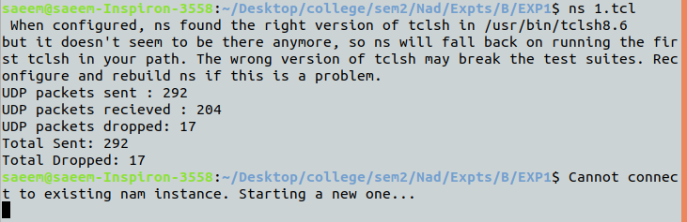
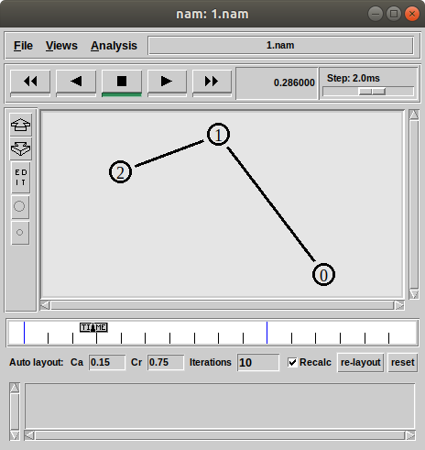

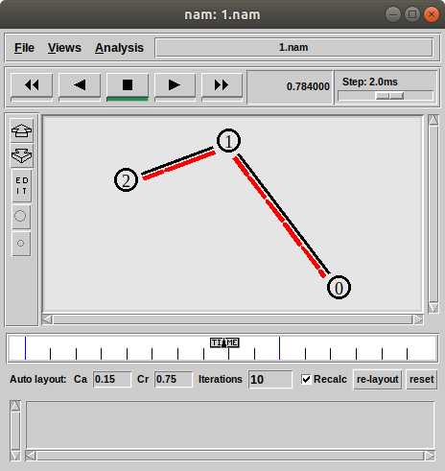

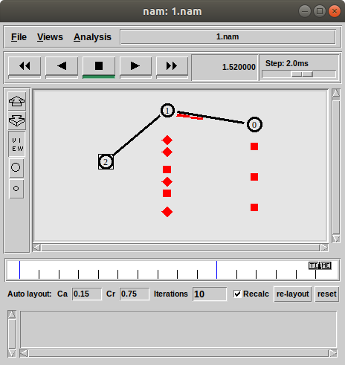

Conclusion:
Here we can conclude that Bellman-Ford works on negative edge weight which is the advantage of Dijkstra's algorithm. Johnson’s Algorithm is based on Bellman-Ford algorithm and Dijkstra's algorithm. Bellman-Ford required less time to find shortest path but on the other hand Johnson’s algorithm required more time as we increased the density of graph.

