Name : Ansari M.Saeem M.Saleem
Uid : 2019430001
Subject : NAD
Expt no : 2 B
Aim : Simulate a four-node point-to-point network, and connect the links as follows: n0->n2, n1->n2 and n2->n3. Apply TCP agent changing the parameters and determine the number of packets sent/received by TCP/UDP.

Aim:
Simulate a four-node point-to-point network, and connect the links as follows: n0->n2, n1->n2 and n2->n3. Apply TCP agent changing the parameters and determine the number of packets sent/received by TCP/UDP.

Objectives:
- To calculate the number of packets lost during transmission in a network.
- To Test the network in varies conditions
- To observe the effect of sending packets of relatively greater size
- To observe the effect of sending packets at a higher rate

Theory:
TCP (Transmission Control Protocol) is a standard that defines how to establish and maintain a network transmission through which application programs can exchange data.
UDP (User Datagram Protocol) is an alternative communications protocol to Transmission Control Protocol (TCP) used primarily for establishing low-latency and loss-tolerating connections between applications programs.

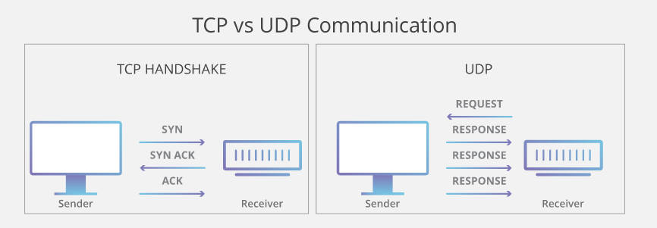

Methodology :
Steps -
- Create a new simulation
- Use static routing because the duplex links are predefined Set up trace files in write mode
- Set up NAM files in write mode (for visualization)
- Define the finish function to clear trace file and execute nam program to visualize the graph.
- Create 4 nodes – n1, n2, n3, n4
- Establish links and set the bandwidth
- Set the Queue length
- Set TCP connection between n(0) and n(3)
- Attach FTP application over TCP
- Set UDP connection between n(1) and n(3)
- Attach CBR traffic over UDP
- Schedule Events
- Connect the traffic source with the traffic sink and assign flow id color
- Run the simulation

Experiment Setup :
The test cases to perform in this experiment :-
- Link having a relatively low bandwidth with respect to other links
$ns duplex-link $n0 $n2 0.1Mb 20ms DropTail
$ns duplex-link $n1 $n2 0.9Mb 20ms DropTail
$ns duplex-link $n2 $n3 0.1Mb 20ms DropTail
- Node sending packets of relatively greater size
$cbr set packetSize_ 2000
- Node sending packets at a higher rate.
$cbr set interval_ 0.01

Result:
General Behavior of Network under Constant Bandwidth (0.7 MB):
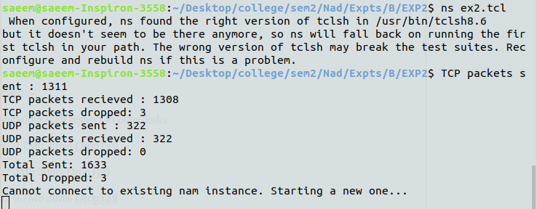
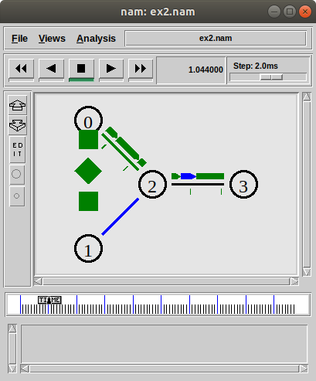

Case 1:
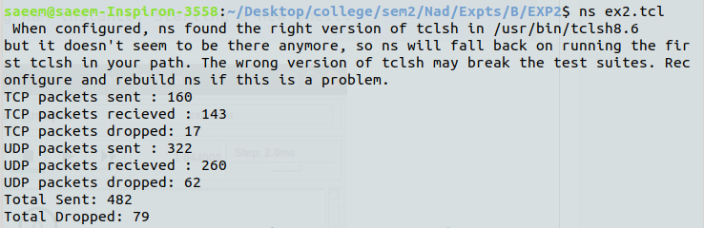
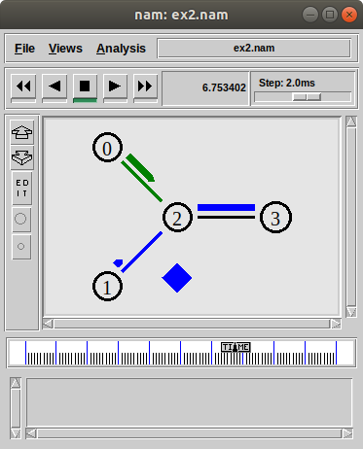

Case 2 :
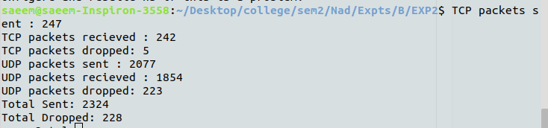
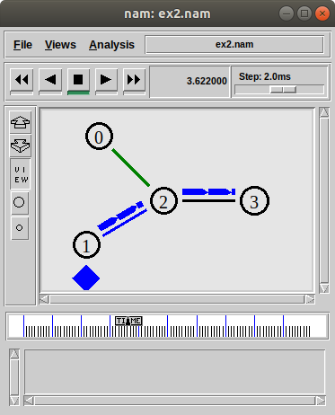
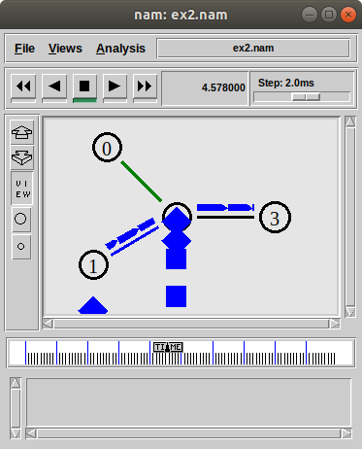

Case 3:
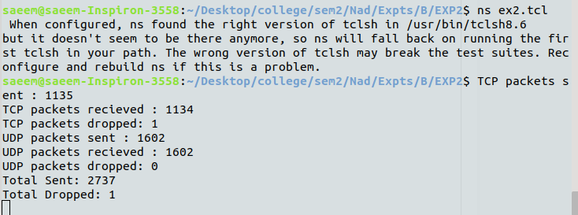
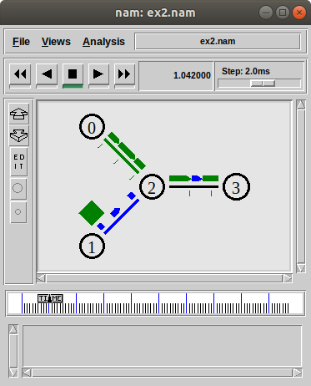

Conclusion: We observe that when the bandwidth link among all the nodes is equal ,maximum number packets is transmitted and drop rate is also low.
• In case1 when TCP link having a relatively low bandwidth with respect to other links, the transmission rate of TCP packet is reduced and drop rate is also increased for both TCP/UDP.
• In case 2 when Node sending packets of relatively greater size, we can observe slightly improved transmission rate due to that lesser drop rate.
• In case 3 when nodes are sending packets at a higher rate, the TCP transmission results in highest number of TCP packets transmitted among all the test cases and a negligible drop rate and also UDP transmission witnesses zero packet drops.

