Name : Ansari M.Saeem M.Saleem
Uid : 2019430001
Subject : NAD
Expt no : 3 B
Aim : Simulate the different types of internet traffic such as FTP and TELNET over network and analyze the throughput.

Aim:
Simulate the different types of internet traffic such as FTP and TELNET over network and analyze the throughput.
Objectives:
- To do comparative study and analysis of different type of internet traffic such as FTP and TELNET.
- To simulate FTP and TELNET over the network and analyze throughput.
Theory:
FTP :
FTP stands for File transfer protocol. FTP is a standard internet protocol provided by TCP/IP used for transmitting the files from one host to another. It is mainly used for transferring the web page files from their creator to the computer that acts as a server for other computers on the internet. It is also used for downloading the files to computer from other servers.
FTP the protocol for exchanging files over the Internet. FTP works in the same way as HTTP for transferring Web pages from a server to a user's browser and SMTP for transferring electronic mail across the Internet in that, like these technologies, FTP uses the Internet's TCP/IP protocols to enable data transfer. FTP is most commonly used to download a file from a server using the Internet or to upload a file to a server (e.g., uploading a Web page file to a server)
Objectives of FTP :
• It provides the sharing of files.
• It is used to encourage the use of remote computers.
• It transfers the data more reliably and efficiently.
Telnet :
The main task of the internet is to provide services to users. For example, users want to run different application programs at the remote site and transfers a result to the local site. This requires a client-server program such as FTP, SMTP. But this would not allow us to create a specific program for each demand.
The better solution is to provide a general client-server program that lets the user access any application program on a remote computer. Therefore, a program that allows a user to log on to a remote computer. A popular client-server program Telnet is used to meet such demands. Telnet is an abbreviation for Terminal Network.
Telnet provides a connection to the remote computer in such a way that a local terminal appears to be at the remote side. Telnet is a user command and an underlying TCP/IP protocol for accessing remote computers. Through Telnet, an administrator or another user can access someone else's computer remotely. On the Web, HTTP and FTP protocols allow you to request specific files from remote computers, but not to actually be logged on as a user of that computer. With Telnet, you log on as a regular user with whatever privileges you may have been granted to the specific application and data on that computer.

Methodology :
Steps -
- Create a new simulation
- Use static routing because the duplex links are predefined
- Set up trace files in write mode
- Set up NAM files in write mode (for visualization)
- Define the finish function to clear trace file and execute nam program to visualize the graph.
- Create 4 nodes – n0, n1, n2, n3
- Establish links and set the bandwidth
- Set the Queue length
- Set TCP TELNET Connection between n0 and n3
- Attach TELNET Application over TCP
- Set TCP FTP Connection between n1 and n3.
- Attach FTP Application over TCP
- Schedule Events.
- Run the simulation

Experiment Setup :
- TCP/ TELNET application will be established between the node
n0 →n2 →n3
- TCP / FTP application will be established between the node
n1 → n2→n3

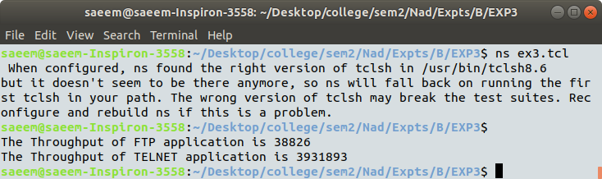
Results :
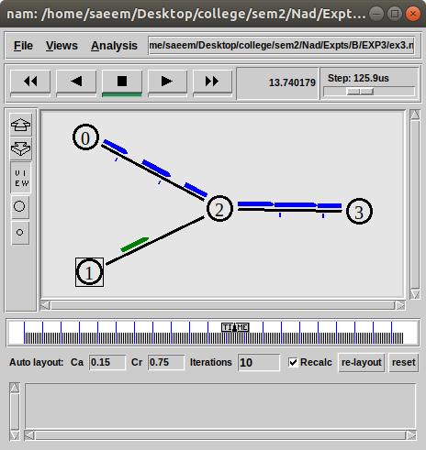

1.Instantaneous throughput for TELNET application (Graph is made by Automated Post Processing Tool by Wireless Information Network Group)
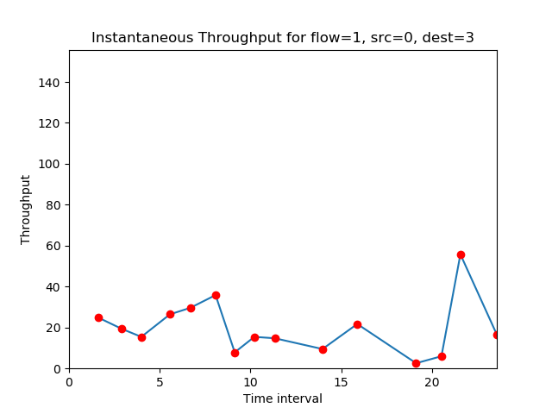

2. Instantaneous throughput for FTP application
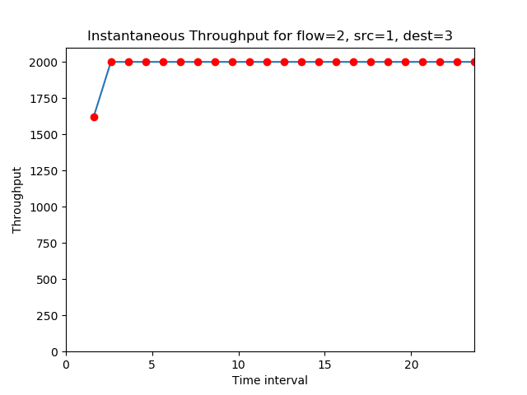

3.Instantaneous throughput Comparison
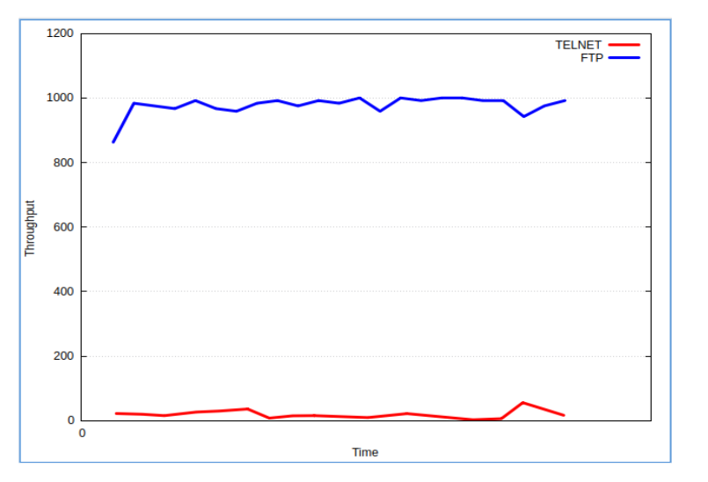

Conclusion:
Here we can conclude that we have observed that throughput of FTP application is very high and constant due to which it can transmits more packets as compare to TELNET application which tends to have a very low throughput leads to less packet transmissions.

