Name : Ansari M.Saeem M.Saleem
Uid : 2019430001
Subject : NAD
Expt no : 1
Aim : Introduction to OPENMP.

Aim:
Introduction to OPENMP.

Objectives:
- To Understand the OPENMP parallel computing approach and platform to achieve High Performance Computing.
- To learn how to design High Performance Computing System using MPI and OpenMP.

Theory:
The Open MPI Project is an open source Message Passing Interface implementation that is developed and maintained by a consortium of academic, research, and industry partners. Open MPI is therefore able to combine the expertise, technologies, and resources from all across the High Performance Computing community in order to build the best MPI library available. It comprises of three primary API
Components:
- Compiler Directives
- Run-time Library Routines
- Environment Variables
Features:
- Thread safety and concurrency
- Dynamic process spawning
- Network and process fault tolerance
- Support network heterogeneity
- Single library supports all networks
- Run-time instrumentation
- Many job schedulers supported
Sample Program:
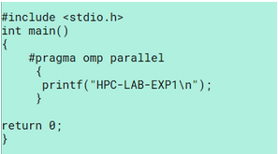

The OpenMP code Parallel executes following statement/block by multiple threads at the same time. So depending on the current CPU specifications (number of cores) and a few other things (process usage), a few threads will be generated to run the statement block in parallel, after the block, all threads are joined.

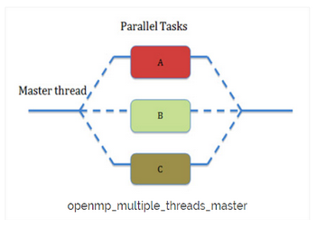

Results:


Conclusion: Hence, introduction to OPENMP was successfully studied.

