Name : Ansari M.Saeem M.Saleem
Uid : 2019430001
Subject : NAD
Expt no : 5
Aim : Implement floyd-warshall algorithm using openMP programming interface to find the lengths of the shortest paths between all pairs of vertices of the given directed graph.

Aim:
Implement floyd-warshall algorithm using openMP programming interface to find the lengths of the shortest paths between all pairs of vertices of the given directed graph.

Objectives:
- Understand floyd warshall algorithm.
- Find parallelism in the algorithm and implement using C++ and openMP.

Theory:
The Floyd Warshall Algorithm is for solving the All Pairs Shortest Path problem. The problem is to
find shortest distances between every pair of vertices in a given edge weighted directed Graph.
Problem Statement:
- (Your code may assume that the input has already been checked for loops, parallel edges and negative cycles.)
- Print the pairwise distances as output.
Input Graph :
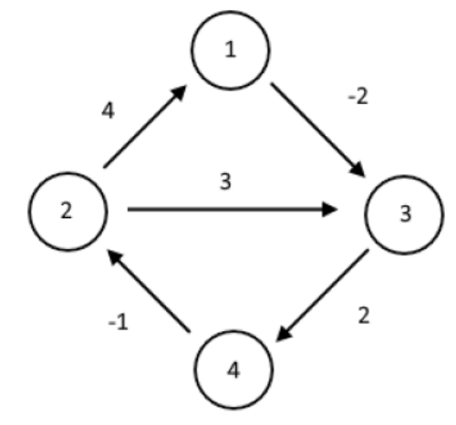

Methodology:
Parallelism in Flyod-warshall :
- Graph is represented in the form of cost adjacency matrix. (0 cost if no edge.)
- dist[ ][ ] is a 2D array representing graph. And dist[ i][j ] represents the length of an edge or a path.
- We can see that for every k where k is an intermediate node between node i and j we can achieve parallelism by independently computing distances.
- Hence for every k (for loop with k), we feed parallel i,j values to for loops i and j resp.by
- Using #pragma omp parallel for private(i,j)

Results:
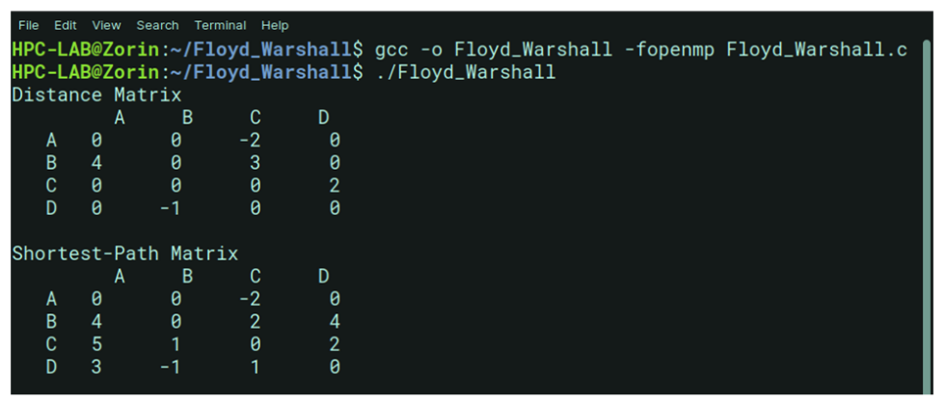
Conclusion:
Here we can conclude that, we have successfully study and analyzed serial floyd warshalls’ algorithm and achieved parallelism using openMP programming interface.

