Name:
UID:
Sub: HPC
Experiment 6

Aim: Matrix/Vector multiplication through parallel processing.

Objective:
- To distribute matrix element column and row wise to each processor.
- To calculate matrix product column wise at each processor.
- To aggregate the results from each processors.

Theory:
Problem with serial matrix multiplication :
Traditional serial matrix multiplication implements vector-matrix multiplication performing the addition of the partial mulitplication of the vector and the matrix rows due to which a huge amount of memory is accessed unessesarily to store partial result.

Here we can observe that calculation of each resultant element is indepenent. We can eassily make the multiplication parallel.
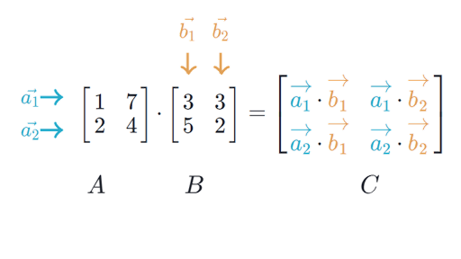

Parallel Matrix Multiplication :
In parallel matrix multiplication corresponding row and column data is distributed to each processor to calculate resultant matrix element.
Here, we assume both input matrix are in the order of 3X3 so the resultant matrix will be in the order of 3X3 and having 9 elements. Let the no of processors to be 9 each for each resultant element. In order to calculate first resultant element (C₀₀), first processir will have row of first input matrix (A) and column of seconf input matrix (B) and similarly for all rest 8 processor.

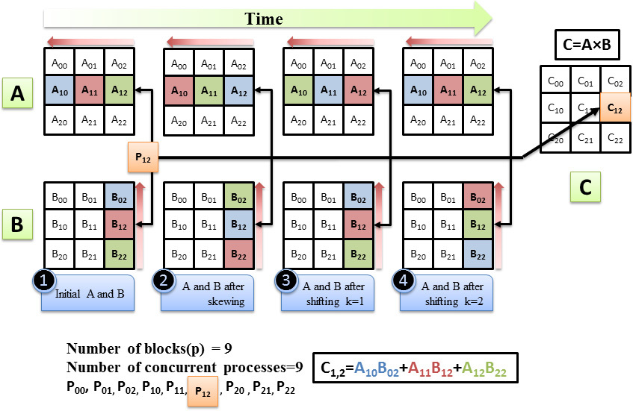

Experimental Result :

Executing the program with 4 threads :

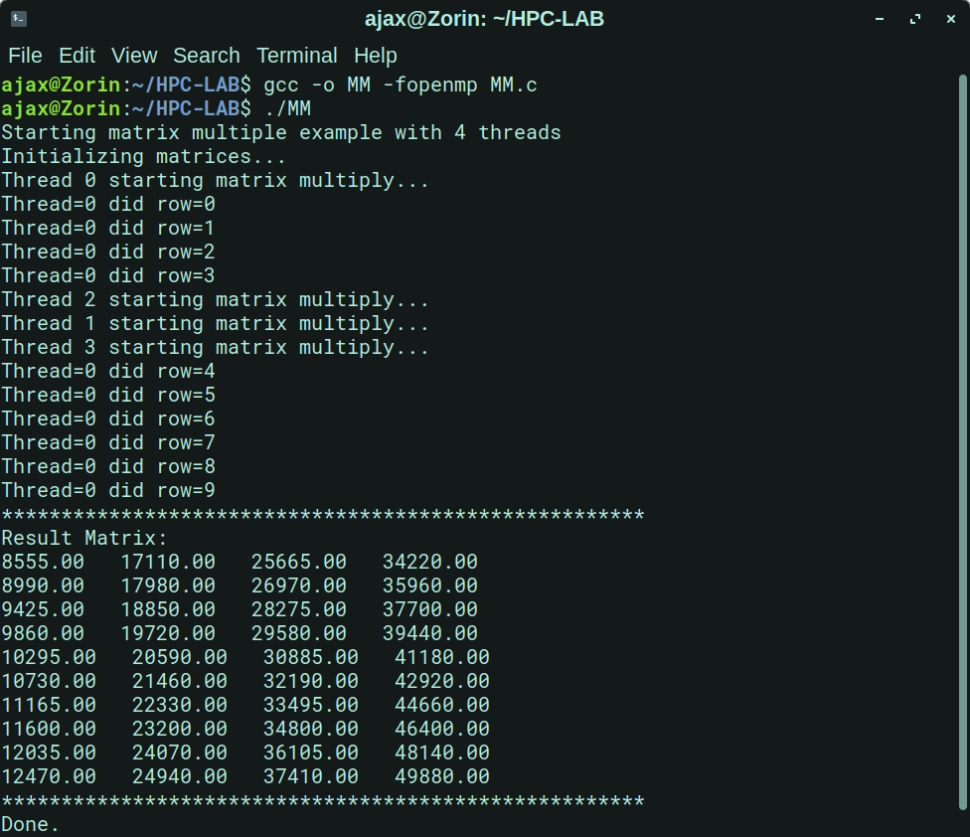

Executing the program with 10 threads :

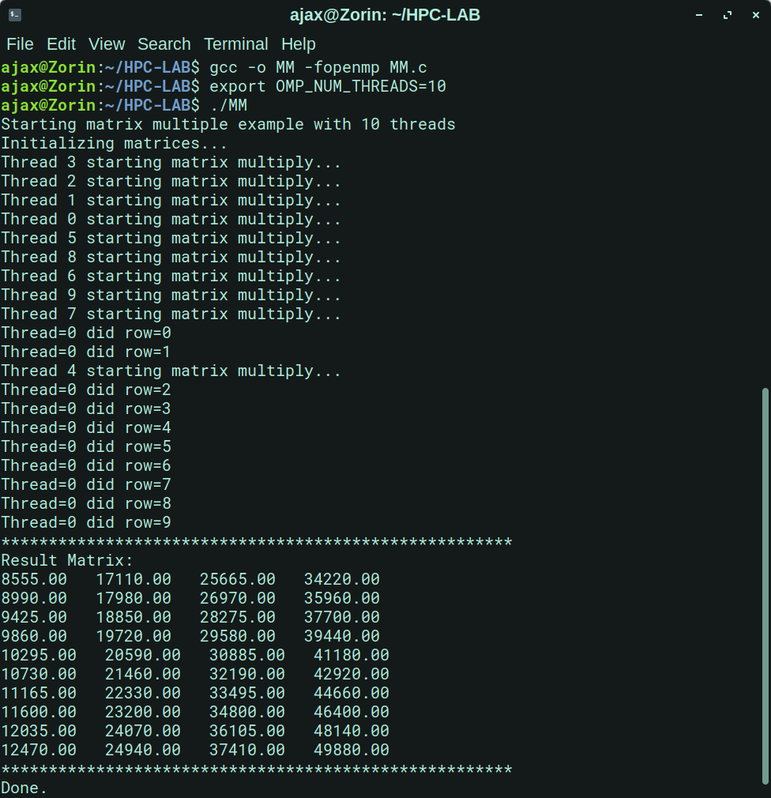

Once having the parallel code, we execute it and take time measurements for different square matrix sizes. We get expect a good performance from this code as we discussed in the previous sections of this experiment. All the measurements shown below were produced on the following machine using 8 threads:
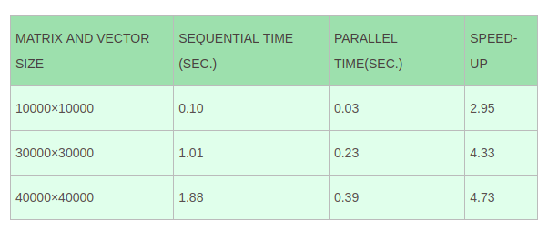
Conclusion: Here we can conclude that we successfully implemented, analyze and show the result of Matrix/Vector multiplication through parallel processing.

