Name : Ansari M.Saeem M.Saleem
Uid : 2019430001
Subject : NAD
Expt no : 4
Aim : Write a program to implement Link State Routing (Dijkstra Algorithm).

Aim:
Write a program to implement Link State Routing (Dijkstra Algorithm).
Objectives:
- To apply link state routing strategy to find optimal path for data transmission in a network.
- To find the shortest path from source node to every other node even using Dijkstra algorithm.
- To calculate routing table of a network.
Theory:
Link-State protocol is performed by every switching node in the network (i.e., nodes that are prepared to forward packets in the Internet, these are called routers). The basic concept of link-state routing is that every node constructs a map of the connectivity to the network, in the form of a graph, showing which nodes are connected to which other nodes. Each node then independently calculates the next best logical path from it to every possible destination in the network. Each collection of best paths will then form each node's routing table.
Dijkstra’s algorithm finds a shortest path from a single source node, by building a set of nodes that have minimum distance from the source. This algorithm works for both directed and undirected graphs. It works only for connected graphs. The graph should not contain negative edge weights.
Methodology :

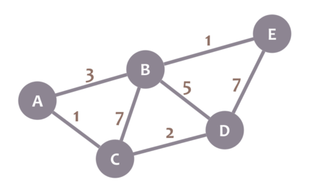
Step 1
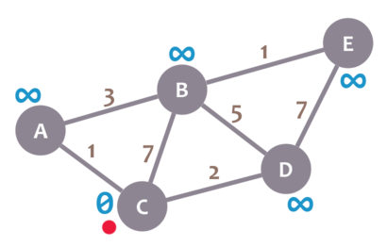
Step 2

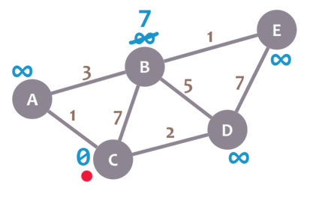
Step 3
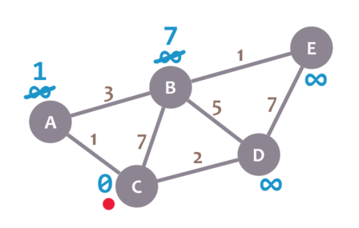
Step 4

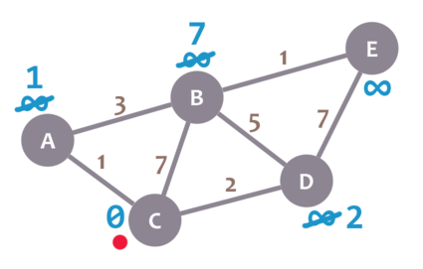
Step 5
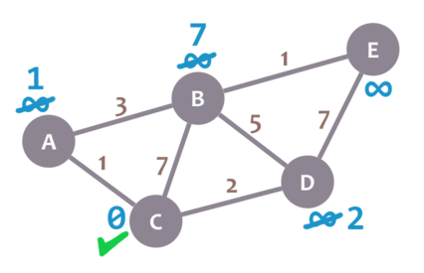
Step 6

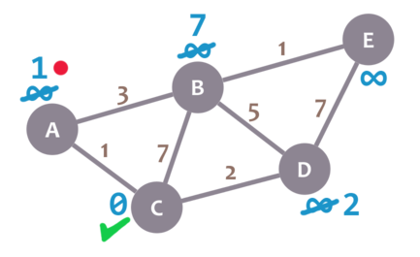
Step 7
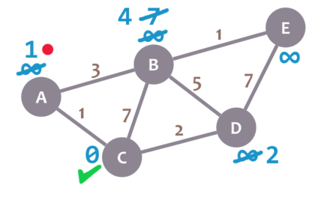
Step 8

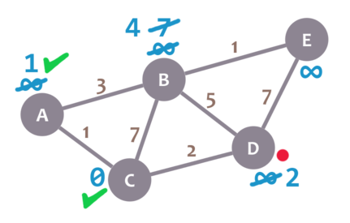
Step 9
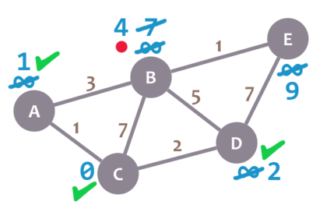
Step 9

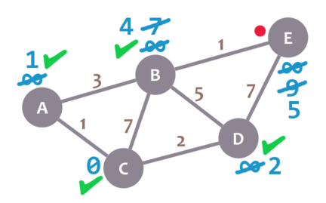
Step 10
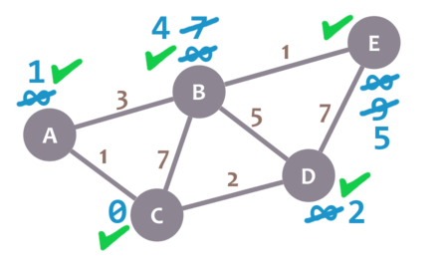
Step 11

Working-
Following are the steps used for finding the solution-
Step 1; Set dist[s]=0, S=ϕ // s is the source vertex and S is a 1-D array having all the visited vertices
Step 2: For all nodes v except s, set dist[v]= ∞
Step 3: find q not in S such that dist[q] is minimum // vertex q should not be visited
Step 4: add q to S // add vertex q to S since it has now been visited
Step 5: update dist[r] for all r adjacent to q such that r is not in S //vertex r should not be
visiteddist[r]=min(dist[r], dist[q]+cost[q][r])
Step 6: Repeat Steps 3 to 5 until all the nodes are in S // repeat till all the vertices have been visited
Step 7: Print array dist having shortest path from the source vertex u to all other vertices
Step 8: Exit
Results :
Input File :
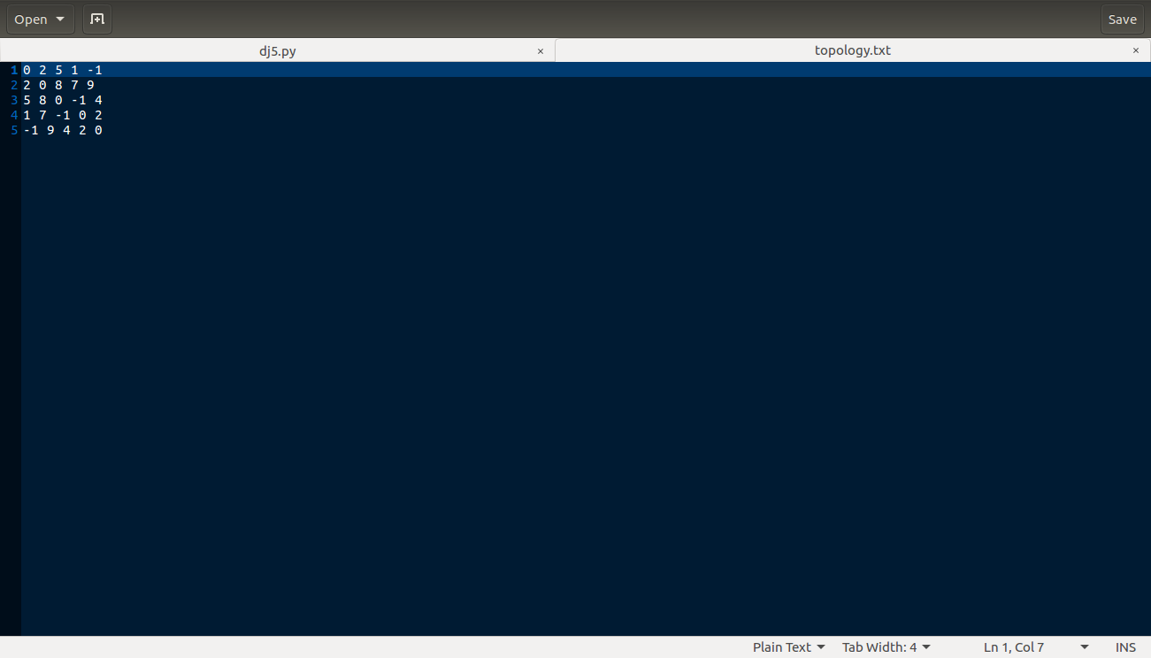
Output 1: Input File

Output :
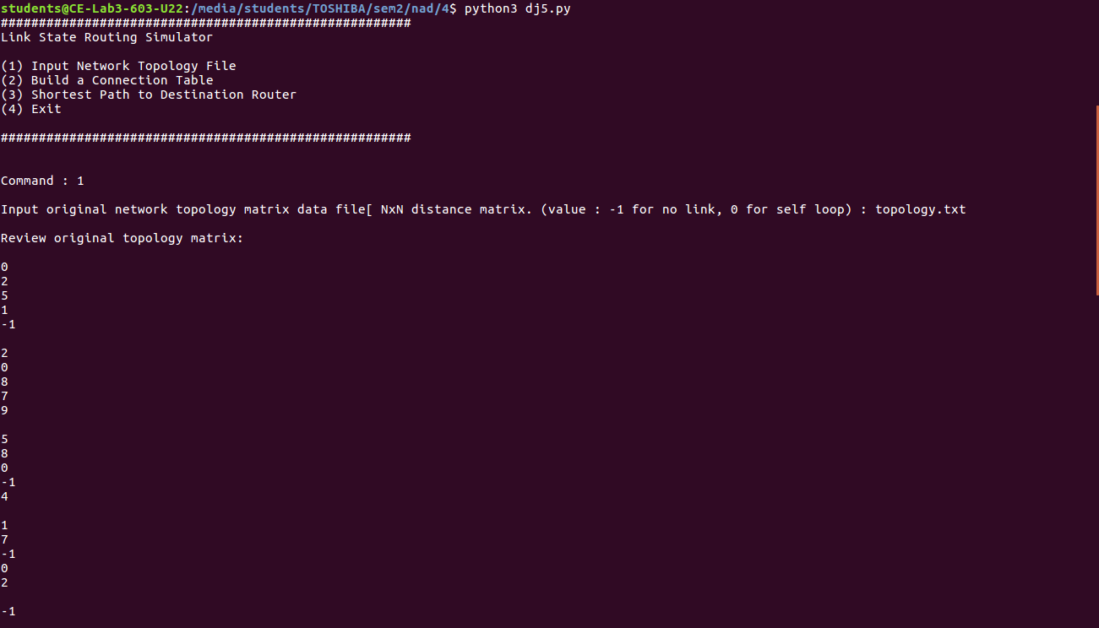
Output 2: Showing Adjacency Matix

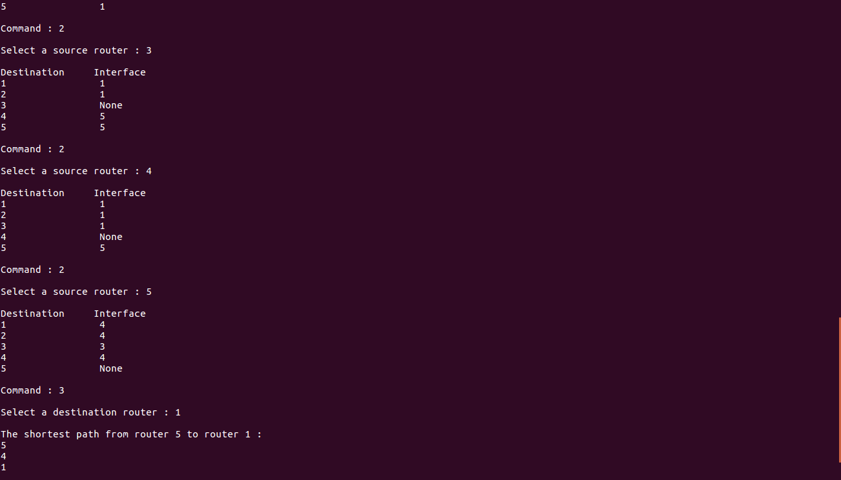
Output 3: Calculating Routing Table

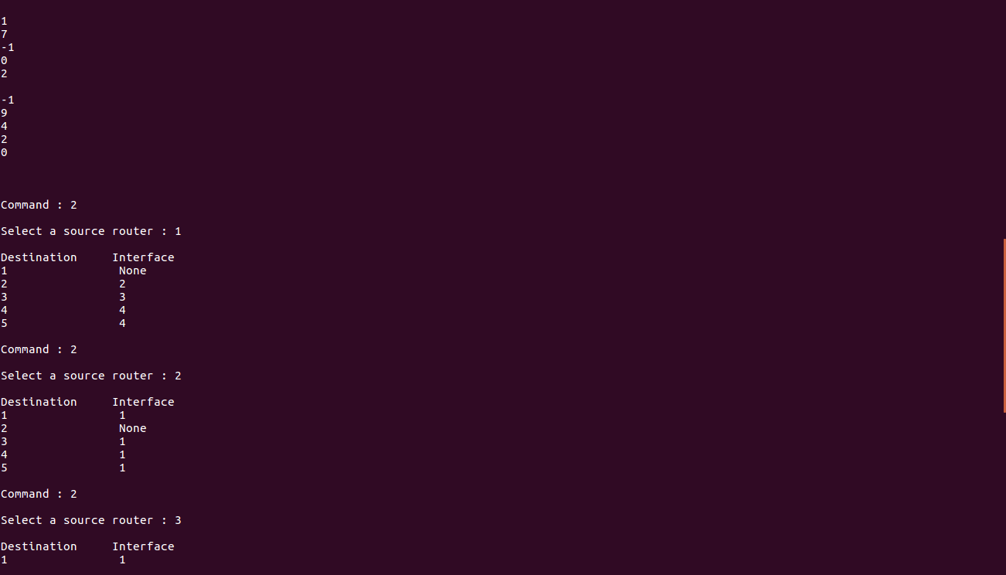
Output 4: Calculating Routing Table

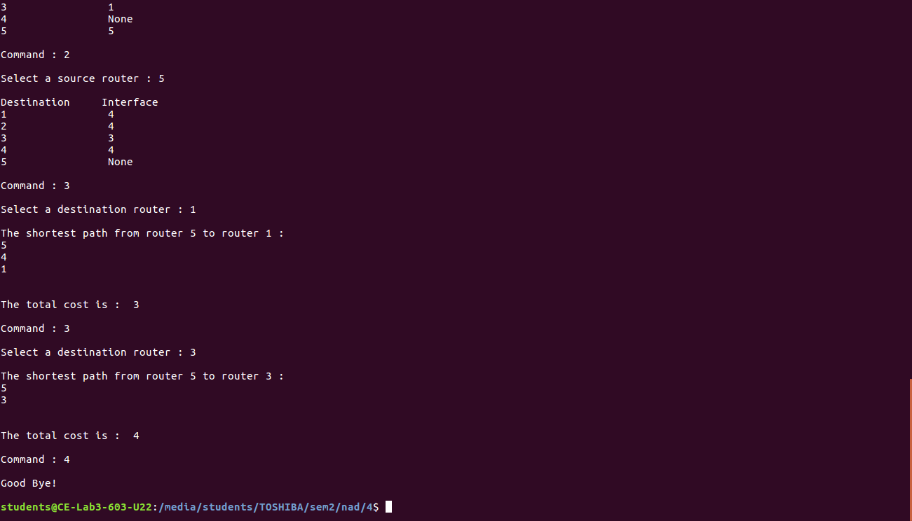
Output 5: Calculating Shortest Path

Conclusion: Here we can conclude that Dijkstra’s algorithm can be used to find the optimal path for data transmission in a network using link state routing strategy. We can also obtain the routing table showing cost from source node to destination node.

