Name : Ansari M.Saeem M.Saleem
Uid : 2019430001
Subject : NAD
Expt no : 1
Aim : Write a program to transfer the content of a requested file from server to client using TCP/IP sockets..

Aim:
Write a program to transfer the content of a requested file from server to client using TCP/IP sockets.

Objectives:
- Create and Bind sockets to transfer data from client to server.
- Implementation of File handling concepts in C programming language.

Theory:
The Internet protocol suite is the conceptual model and set of communications protocols used in the Internet and similar computer networks. It is commonly known as TCP/IP because the foundational protocols in the suite are the Transmission Control Protocol (TCP) and the Internet Protocol (IP). During its development, versions of it were known as the Department of Defense (DoD) model because the development of the networking method was funded by the United States Department of Defense through DARPA.
There are four layers in TCP/IP Protocol as follows :

1. Network Access Layer :
It looks out for hardware addressing and the protocols present in this layer allows for the physical transmission of data. This layer corresponds to the combination of Data Link Layer and Physical Layer of the OSI model.

2. Internet Layer :
It defines the protocols which are responsible for logical transmission of data over the entire network. The main protocols residing at this layer are :
- IP – stands for Internet Protocol and it is responsible for delivering packets from the source host to the destination host by looking at the IP addresses in the packet headers. IP has 2 versions:
IPv4 and IPv6. IPv4 is the one that most of the websites are using currently. But IPv6 is growing as the number of IPv4 addresses are limited in number when compared to the number of users.
- ICMP – stands for Internet Control Message Protocol. It is encapsulated within IP datagrams and is responsible for providing hosts with information about network problems.
- ARP – stands for Address Resolution Protocol. Its job is to find the hardware address of a host from a known IP address. ARP has several types: Reverse ARP, Proxy ARP, Gratuitous ARP and Inverse ARP.

3. Host-to-Host Layer :
It is responsible for end-to-end communication and error-free delivery of data. It shields the upper-layer applications from the complexities of data. This layer is analogous to the transport layer of the OSI model. The two main protocols present in this layer are :
- Transmission Control Protocol (TCP) – It is known to provide reliable and error-free communication between end systems. It performs sequencing and segmentation of data. It also has acknowledgment feature and controls the flow of the data through flow control mechanism. It is a very effective protocol but has a lot of overhead due to such features. Increased overhead leads to increased cost.
- User Datagram Protocol (UDP) – On the other hand does not provide any such features. It is the go-to protocol if your application does not require reliable transport as it is very cost-effective. Unlike TCP, which is connection-oriented protocol, UDP is connectionless.
4. Process Layer
It is responsible for node-to-node communication and controls user-interface specifications. Some of the protocols present in this layer are: HTTP, HTTPS, FTP, TFTP, Telnet, SSH, SMTP, SNMP, NTP, DNS, DHCP, NFS, X Window, LPD. Have a look at Protocols in Application Layer for some information about these protocols. This layer performs the functions of top three layers of the OSI model: Application, Presentation and Session Layer.
Methodology:

Results:
Server
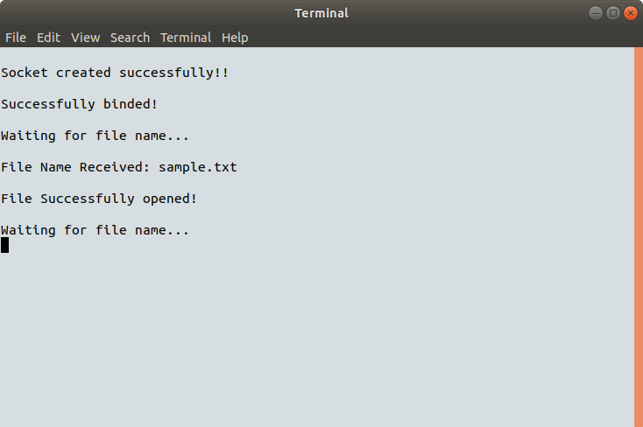

Client :
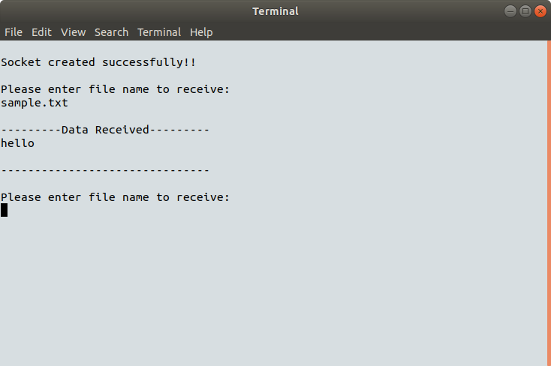

Conclusion:
Here we can conclude that TCP/IP used to communicate and send data between client and server.

