Name : Ansari M.Saeem M.Saleem
Uid : 2019430001
Subject : AAC
Expt no : 3
Aim : Write a program for implementing the error detection technique while data transfer in unreliable network code using CRC (16-bits) Technique.

Aim:
Write a program for implementing the error detection technique while data transfer in unreliable network code using CRC (16-bits) Technique.
Objectives:
- To detect error while transmitting packets from source to destination.
- To encode messages by adding a fixed-length check value, for the purpose of error detection in communication networks.
- To compute checksum when the data is transmitted or stored.
Theory:
- CRC or Cyclic Redundancy Check is a method of detecting accidental changes/errors in communication channel. It is one of the most powerful error detection technique based on the principle of binary division. In this, a sequence of bits append to the data unit is known as the CRC.
- A cyclic redundancy check (CRC) is an error-detecting code commonly used in digital networks and storage devices to detect accidental changes to raw data.
- Blocks of data entering these systems get a short check value attached, based on the remainder of a polynomial division of their contents.
- CRC are so called because the check (data verification) value is a redundancy (it expands the message without adding information) and the algorithm is based on cyclic codes.
- CRC are popular because they are simple to implement in binary hardware, easy to analyze mathematically, and particularly good at detecting common errors caused by noise in transmission channels.
- Because the check value has a fixed length, the function that generates it is occasionally used as a hash function.
Methodology :
There are two important steps of CRC technique :
1. CRC generator : It is the process of calculating the CRC bits at sender side using a generating function such that the data unit and generating function are operated using bit-wise XOR operation where generating function is of n+1 bits and CRC is of n bits. The data bits to be operated are appended with the n 0’s which together referred as data unit to be transmitted to receiver end.
2.CRC checker : It is the process of calculating the CRC bits at receiver side to check whether they are equivalent to 0 or not. It also uses the same bit-wise XOR operation on data unit received from sender side and generating function. If all the CRC bits are 0 then data unit is accepted otherwise it is discarded.
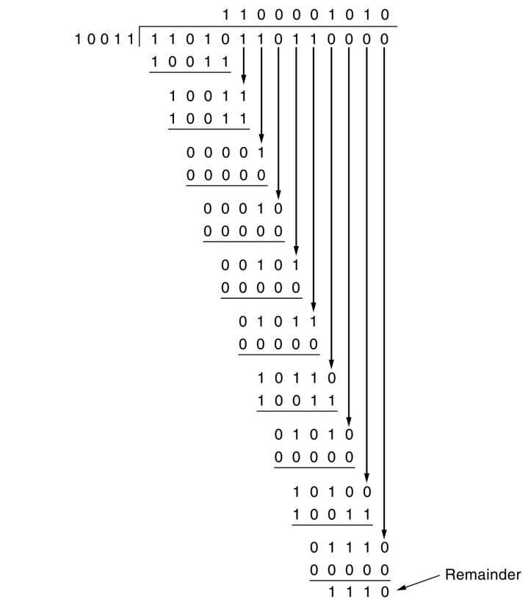
Example :

Algorithm for CRC :
1. Input the number of data unit bits (number of data bits + number of CRC bits) received from the sender.
2. Enter generating function bits, its value and data unit bits value.
3. Store generating function bits and data unit (data bits + CRC bits) received from sender in different arrays.
4. Repeat step-5 until each bit of data unit is processed.
5. Check data unit received from sender :
if(1st bit==0)
XOR the data unit with 0 and store the result in same array of data unit.
else
XOR the data unit with generating function and store the result in same array of data unit.
6. Display CRC bits, perform adder operation on them and store the result in an integer variable.
7. Check the value of integer variable (var)-
if (var ==0)
Data unit is correct and accepted after discarding the CRC bits.
else
Data unit received is corrupted and discarded.

Results :
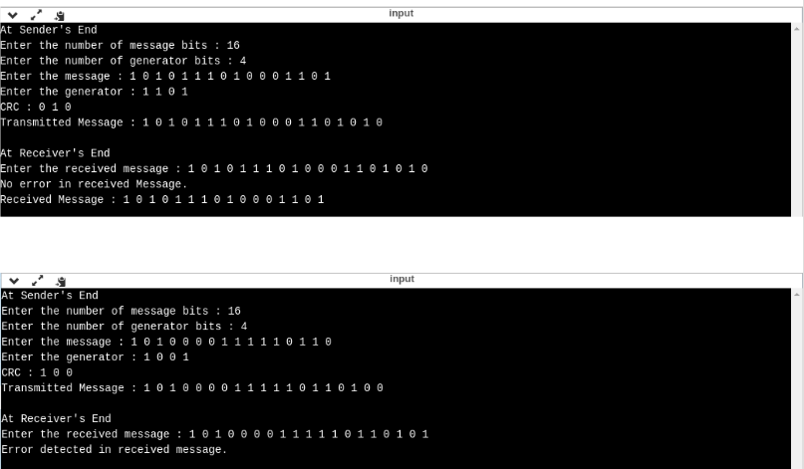

Conclusion:
Here we can conclude that 16-bit CRC can be used to detect transmitting errors and also used in polynomial division.

