M12 8-Pin Connector – Pin Assignment
Recommended industrial pin assignment for an optical sensor system with 24V supply, digital status outputs and one 4–20mA analog output.

Pin Assignment
Pin | Signal | Description
1 | +24V DC | Sensor power supply
2 | Sensor Active | Sensor ready output
3 | GND | Ground / 0V
4 | Glass In Sensor | Glass detected output
5 | Coating Front | Front coating detected
6 | Coating Back | Back coating detected
7 | 4–20mA Thickness (1-25mm) | Glass thickness analog output
8 | Reserved | Reserved for future use

Connector Front View (M12 A-coded, 8-pin)
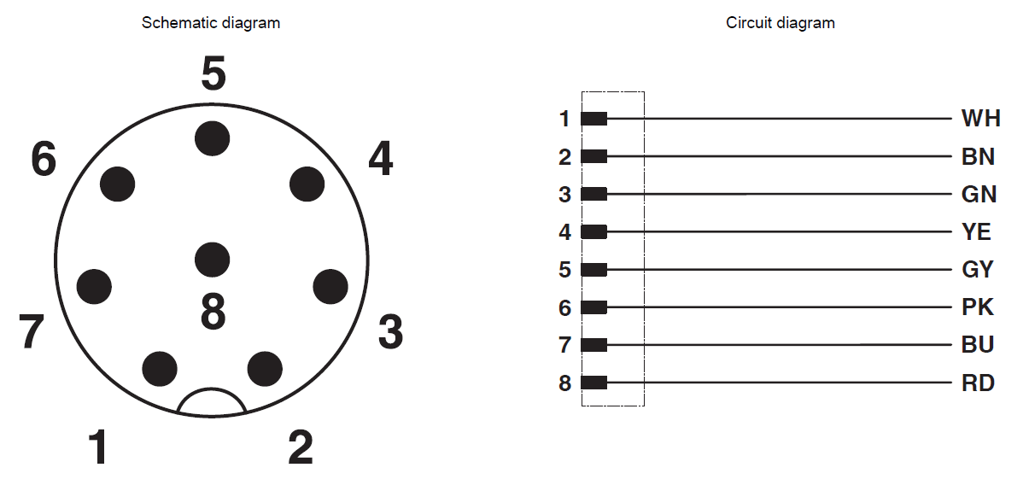

Signal Description
+24V DC: 24V supply voltage for the sensor system
Sensor Active: Digital output HIGH when sensor is operational
GND: Ground / reference potential
Glass In Sensor: Digital output HIGH when glass is detected
Coating Front: Digital output HIGH when front coating is detected
Coating Back: Digital output HIGH when back coating is detected
4–20mA Thickness: Analog output proportional to glass thickness
Reserved: Unused / reserved for future extensions

Recommendations
- Use a shielded 8-core cable
- Use a twisted pair for the 4–20mA signal if possible
- Connect cable shield 360° to the metal housing
- Use 24V PNP outputs for digital signals
- Keep the reserved pin available for future extensions

Technical Data
Connector | M12 A-coded, 8-pin
Supply Voltage | 24V DC ±10%
Digital Outputs | PNP 24V
Analog Output | 4–20mA (1-25mm)
Protection Class | IP54/IP65 depending on enclosure

