Creatine

SUPPLEMENT

Creatine is a supplement that can support the size, strength, and health of your muscles—as attested by countless scientific studies—creatine (monohydrate, the version that, despite many new revolutionary forms, still seems to work best in the long run) will, for most, boost lean muscle mass and amplify strength aid.

While this is a natural chemical that can be formed within the body by eating red meats and high omega-3 foods, it can also increase your stamina at the gym. Especially if your diet isn’t too far from your current goal set. There have also been studies done that show that creatine assists those that suffer from Parkinson’s Disease. Due to the molecular changes of cells within muscle tissues with taking creatine, individuals whom suffer combining creatine with weight training improved strength and daily function to a greater extent than just physically training alone.

Creatine helps increase muscle energy, allowing you to train harder and longer to reap more noticeable results. Also, it hydrates muscle tissue, which, over time, causes them to become bigger and stronger. Other cellular alterations from creatine can help the muscles recover faster after intense workouts.

Interested in trying some Creatine? Here’s some we recommend for beginners:

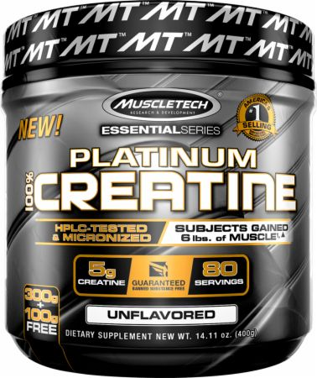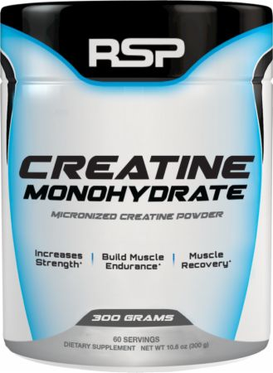

Most people can get enough protein from a healthy, varied diet. However, if you're having trouble meeting your daily protein needs due to a medical condition, ask your doctor if whey protein might be helpful. Don't use this protein if you have a dairy allergy. It's also important that you read the ingredients list, because some of them can have unhealthy additives like refined sugar.