CAFÉ System Specification

*Last Updated on December 8, 2015*

*By Roanna Lun*

CAFÉ is the College Administrative Faculty eManager program. It allows faculty member to review, edit, and manage their teaching schedule, research schedule, off-campus activities and compensation request. The department chair and college administrators can also manage the faculty schedules on-line.

# Introduction

The CAFÉ system is a Web application developed in Microsoft .Net 3.5 platform. The backend database engine is Microsoft SQL server 2012.

The user frond end system is developed in .Net system using HTML, ASPX and C#. The faculty can enter the request for compensation, teaching load and comments. They can also review or edit teaching schedule, research schedule, office hours and off-campus activities information. The schedule will be submitted to department Chair for approval once it is completed. The department chair can view the faculty’s submission and enter comments, but can’t make any changes to faculty submitted schedule. If chair is satisfied with faculty’s schedule, he or she can submit it to Dean for approval. If chair is not satisfied with schedule, it can be declined and sent back to faculty for remediation. Again the Dean can review faculty’s schedule and make decision on approval or rejection. The declined schedule will be sent back to faculty directly. Figure 1 shows the faculty form after log into CAFÉ system.

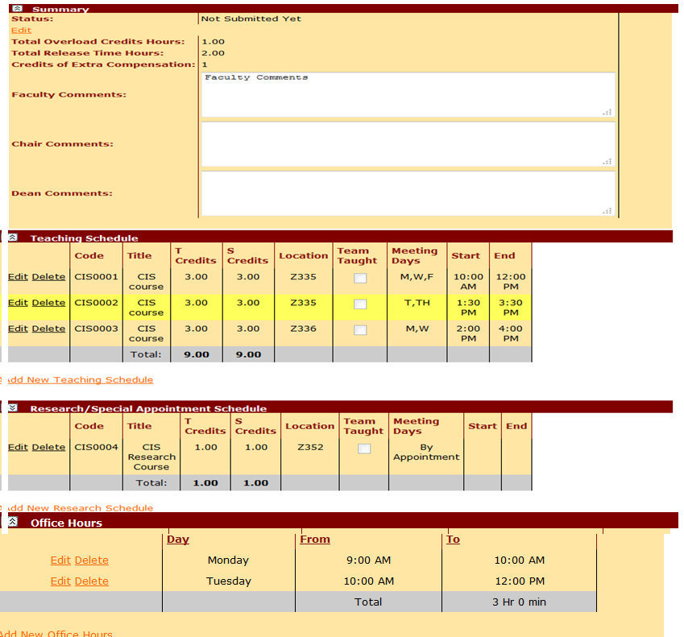

Figure 1: CAFÉ End User Screen

In addition to providing management for faculty’s schedule, CAFÉ also allows user to print door schedule.

# CAFÉ User Interface System

## User Groups

There are three user groups in CAFÉ system, faculty, chair and dean. The hierarchy of groups is illustrated below.

* Faculty’s role: Faculty can create, edit, and submit their own schedule.
* Chair’s role: View, enter/edit chair’s comment, approve, decline faculty’s schedule once they are submitted.
* Dean’s role: View, enter/edit chair’s comment, approve, decline faculty’s schedule once they are submitted to Dean by Chair

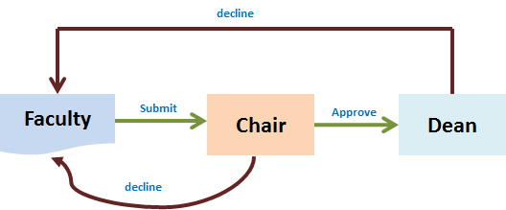

## Faculty Schedule

Functionality available in CAFÉ for a faculty includes entering a request for compensation in the schedule summary panel, editing or adding a teaching schedule or research schedule, entering or editing office hours entry and off-campus activities. A door schedule in the college format is also available to print. Upon the completion of schedule, faculty can submit it to department for approval.

* Schedule Summary Information

Click on Edit button on summary pane to start entering compensation request information.

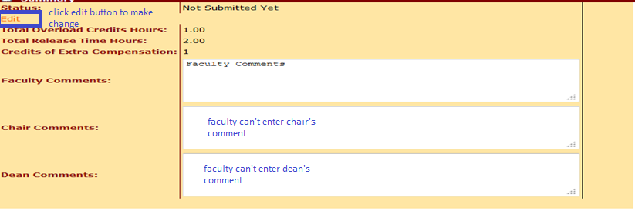

After Edit, click on Save button to save information.

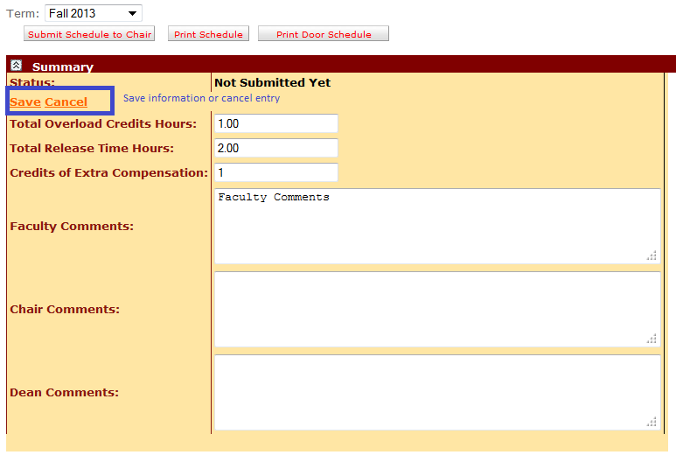

* Teaching and Research Schedules

The teaching and research schedules are download from Datatel at beginning of semester. The faculty allows making any changes to schedule. By click on <Edit> or <Delete> button to make changes to schedule or delete any schedules.

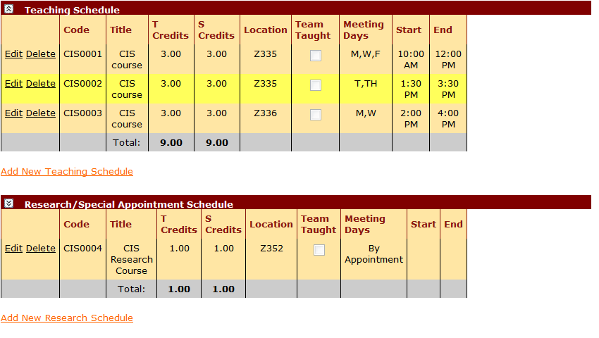

* Office Hours

The faculty can enter their office hours in CAFÉ system. The office hours from previous semester can also be imported into current semester for repeating use or editing.

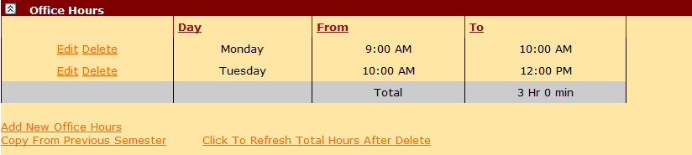

By clicking <copy from previous semester>, the below screen shown and user can select previous semester office hours copied into current semester.

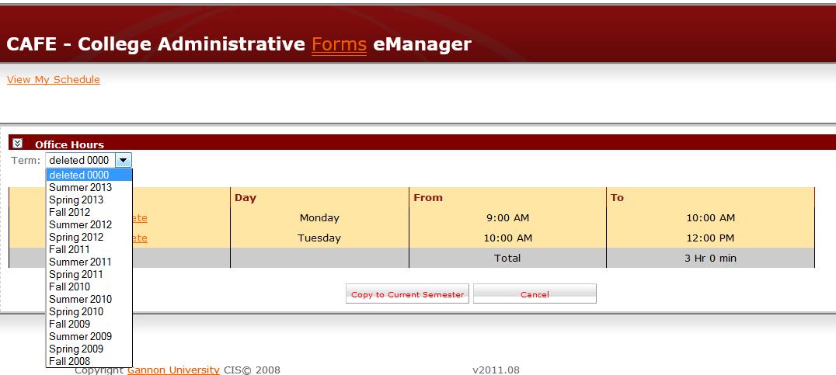

## Chair Schedule Form

The chair can access department faculty schedules and authorize to process schedules. The schedules submitted from faculty are saved in Inbox folder. The chair can approve or decline the schedule. The chair comment box is also available for entering text.

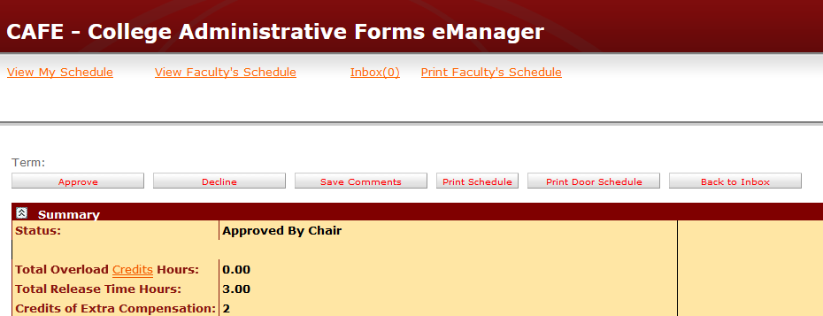

## Dean Schedule Form

The dean is able to view all schedules from college. The schedules are listed by departments.

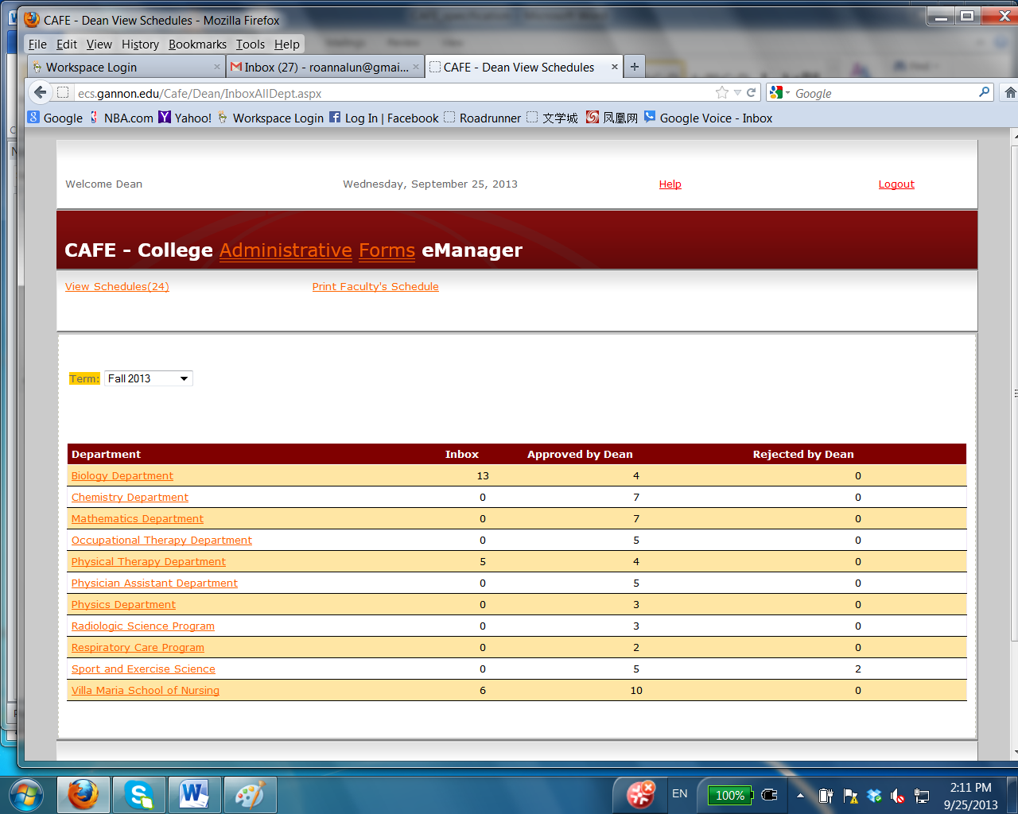

The dean can access college faculty schedules and authorize to process schedules. The schedules submitted from department chair are saved in Inbox folder. The dean can approve or decline the schedule. The dean comment box is also available for entering text.

By clicking on department name, all schedules in the department are listed for reviewing. The dean then can review faculty schedule and process them.

The declined schedule from dean will place to faculty.

# CAFÉ Database Scheme

The major data components in CAFÉ database are mainschedule, schedule, faculty, department, office hours and offcampus tables. The table schema and structure will be illustrated in following subsections.

## Main Schedule

The mainschedule table contains schedule status and summary information for a faculty in a specified semester. The table is joined with faculty table for faculty information, and with term table for semester information.

Only one term is active for a semester, and rest of terms is history report.



## Schedule

The schedule table contains teaching schedule and research schedule for a faculty in a specified semester. The table is joined with faculty table for faculty information, and with term table for semester information.

In each semester only schedules in one term are active, and rest of terms is history report.



## Office Hours

The OfficeHours table contains office hours for a faculty in a specified semester. The table is joined with faculty table for faculty information, and with term table for semester information.

Only one term is active for a semester, and rest of terms is history report.



## Off-campus Activates

The OffCampus table contains faculty hours for off-campus activities in a specified semester. The table is joined with faculty table for faculty information, and with term table



## Faculty Information

The faculty information includes faculty demographic data, department and ranking. The complete data set is joining by department and rank tables.



## Term

The term table is used to control the selection of current semester. By using status data, the current semester is marked as “c”, the previous semester as “p” and future semester as “f”, see below figure.

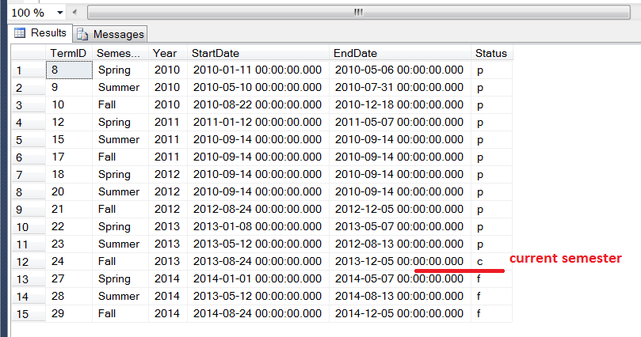

## Database Maintenance

The CAFÉ database is currently stored in Microsoft SQL 2012 server in CIS production server GALAHAD. The database is backed up weekly during schedule submission period, which is normally from a week prior to start of semester until 6 weeks after semester starts. The final backup is made after all schedules are approved by dean for semester. The backup media is located at GALAHAD.

# Data Import

The faculty teaching schedules are populated in CAFÉ from Gannon’s Datatel database through an Informer report called “CEB/MCHPS Course info.” The report is normally retrieved on demand, meaning it can be accessed anytime you want. The report data can be exported to an Excel file with .csv format. However the data in Informer report is not compatible with relational database design, so we have to run a function to convert report data into our SQL database.

## Informer Report to Retrieve Faculty Teaching Schedule from DataTel

* Open URL link: <https://informer4.gannon.edu/informer/?locale=en_US>
* Login to Informer report website:

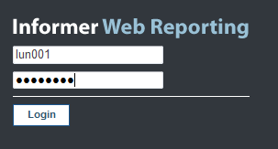

* Select Report Filter: CEB/MCHPS Course Import

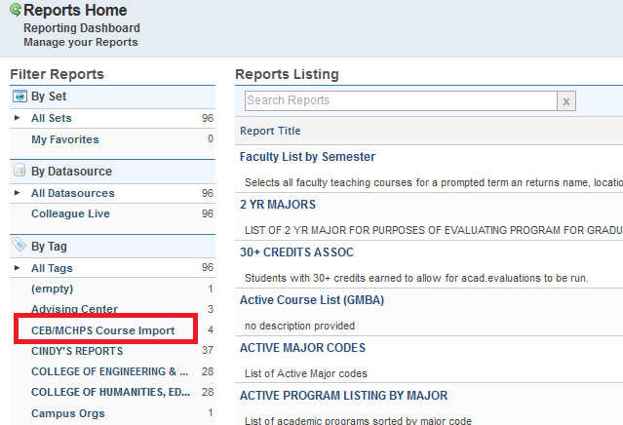

* Then select CEB/MCHES Course info report

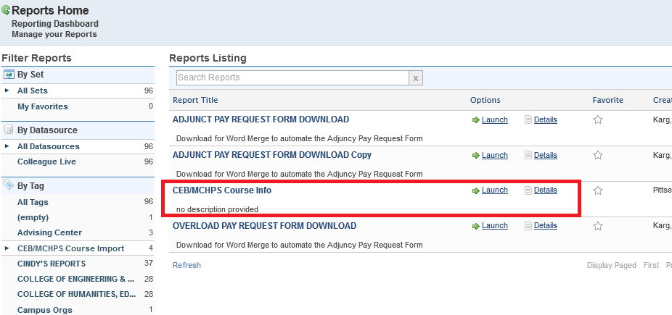

* The report is based on Academic Term, so the term is mandatory parameter.

For Fall 2013 semester, the parameter is “13/FA”.

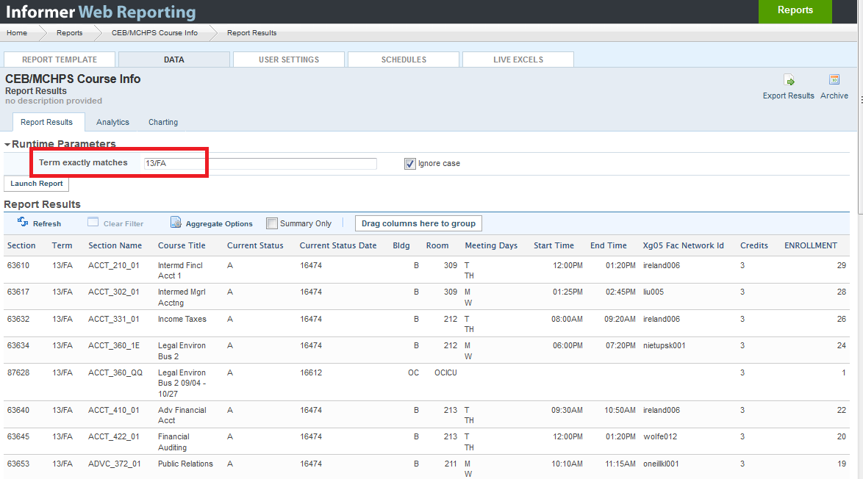

* Export this report to Excel file in .csv format

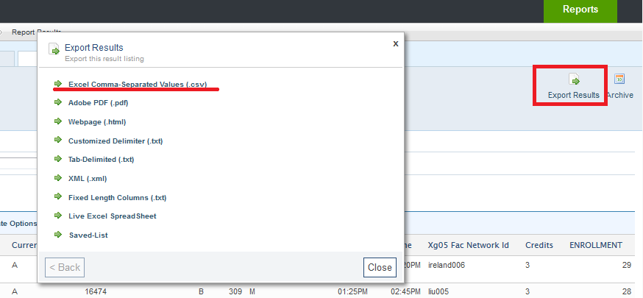

## Process Convert Data in Informer Report to SQL Server Database

A utility function is used to convert DataTel data to SQL database that is used by CAFÉ system. This program reads data from Excel file, and convert faculty teaching schedule into “schedule” table in CAFÉ database.

The Excel format is:

|  |  |  |  |  |  |  |  |  |  |  |  |  |  |  |
| --- | --- | --- | --- | --- | --- | --- | --- | --- | --- | --- | --- | --- | --- | --- |
| Section | Term | Section Name | Course Title | Current Status | Current Status Date | Bldg | Room | Meeting Days | Start Time | End Time | Xg05 Fac Network Id | Credits | ENROLLMENT | |
| 42424 | 12/FA | ACCT_210_01 | Intermd Fincl Acct 1 | A | 16110 | B | 213 | M | 01:25PM | 02:45PM | MILLER005 | 3 | 31 |  |
|  |  |  |  |  |  |  |  | W |  |  |  |  |  |  |
| 42426 | 12/FA | ACCT_302_01 | Intermed Mgrl Acctng | A | 16110 | B | 213 | M | 11:15AM | 12:10PM | ONEILL001 | 3 | 25 |  |
|  |  |  |  |  |  |  |  | W |  |  |  |  |  |  |
|  |  |  |  |  |  |  |  | F |  |  |  |  |  |  |
| 42427 | 12/FA | ACCT_331_01 | Income Taxes | A | 16110 | B | 212 | T | 12:00PM | 01:25PM | KIDD001 | 3 | 22 |  |
|  |  |  |  |  |  |  |  | TH |  |  |  |  |  |  |

The CAFÉ schedule table is:

|  |  |  |  |  |  |  |  |  |  |  |  |  |  |  |
| --- | --- | --- | --- | --- | --- | --- | --- | --- | --- | --- | --- | --- | --- | --- |
| ScheduleID | FacultyID | TermID | CourseCode | CourseTitle | Section | TeachingCredits | StudentCredits | Status | Location | MeetingDays | StartTime | EndTime | Enrollment | FacultyNetWorkID type |
| 10942 | 229 | 24 | ACCT_302_01 | Intermed Mgrl Acctng | 63617 | 3 | 3 | A | B 309 | M,W | 01:25PM | 02:45PM | 26 | liu005 |
| 10943 | 235 | 24 | ADVC_372_01 | Public Relations | 63653 | 3 | 3 | A | B 211 | M,W,F | 10:10AM | 11:15AM | 17 | oneillkl001 |
| 10944 | 235 | 24 | ADVC_400_01 | Int Mkt Campaign Dev | 63655 | 3 | 3 | A | B 211 | M,W | 01:25PM | 02:45PM | 7 | oneillkl001 |
| 10945 | 224 | 24 | BCOR_111_01 | Prin Microeconomics | 63664 | 3 | 3 | A | B 313 | M,W,F | 09:05AM | 10:00AM | 31 | brooker001 |
| 10946 | 224 | 24 | BCOR_111_02 | Prin Microeconomics | 63666 | 3 | 3 | A | B 313 | M,W | 03:00PM | 04:20PM | 33 | brooker001 |
| 10947 | 223 | 24 | BCOR_111_03 | Prin Microeconomics | 63668 | 3 | 3 | A | B 310 | M,W,F | 10:10AM | 11:05AM | 36 | bennett001 |
| 10948 | 223 | 24 | BCOR_111_04 | Prin Microeconomics | 63670 | 3 | 3 | A | B 310 | M,W,F | 11:15AM | 12:10PM | 30 | bennett001 |

## CAFÉ Import Process Program

The Import process program is developed by JAVA. The source code of this program is in Subversion, URL <http://206.180.209.64:8080/SVN/CISProjects/CAFE/CAFEDatabase/CAFE_ImportProgram>.

To start the program in Netbean,

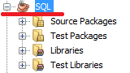

Below screen shot shows the import process program layout. It was developed using Netbean. It includes “select file”, “import data”, “export modified”, “update enrollment” and “other update” functions.

Select file – allow user to select DataTel exported file to convert to SQL server.

Import data – implement data conversion from DataTel data to SQL database

Export modified – save modified teaching schedule data in SQL server to another table before it’s overwritten by updating process

Update enrollment – only update enrollments after schedules were created in SQL server

Other Updates – implement an update based on data file from DataTel, could be a new faculty schedule, enrollment, time updates.

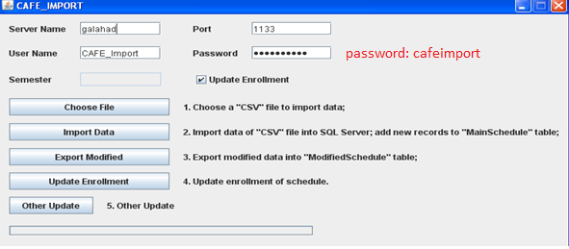

If the password doesn’t work in database, you can reset it to anything you like in SQL server.

## Data Update Constraints

As described above, the CAFÉ retrieves faculty teaching schedule information from DataTel through an Informer report. The schedule updates cannot be posted in CAFÉ system until the Import process is executed. Due to dependence of such inter-process, there are two constraints for CAFÉ data updates.

1. Timely Update

It is important to understand that the data updates in DataTel will not be implemented immediately in CAFÉ. Normally the CAFÉ data is populated or updated at very beginning (a week before semester starts) of a semester, which may have most accurate faculty schedules.

1. Data Content Update

Since the CAFÉ system allows faculty to change or edit schedule information, these schedule updates might not be same as the schedule updates in DataTel. Therefore once CAFÉ system is active (meaning faculty can change schedules for current semester), the DataTel might have different data content as CAFÉ. Normally the Import process will not implement schedule updates, such as course information, teaching credit hours, location, class time, and so on once CAFÉ is active. The only other update processes will execute after semester starts are enrollment update and new faculty updates.