**Office Hours System**

Vison, Scope and Requirement Baseline

**Stakeholders:**

Mr. Kurt

Dr. Frezza

**Version 2.1**

March 30/2016

**Prepared by:**

Ayman Alotaibi,

Mutaz Aldhuwayhi,

Wangel Tamang

& Ayoob Almotairi

**Table of Contents**

1.Introduction 3

1.1 Background 3

1.2 Business Opportunity 3

1.3 Business Objective 3

1.4 Success Metrics 3

1.5 Vision Statement 3

1.6 Business Risks 4

1.7 Business Assumptions and Dependencies 4

2.Scope and Limitations 4

2.1 Major Feature 4

2.2 Limitations and Exclusions 4

2.3 Business Rules 4

3. Requirements 5

3.1 System requirements 5

4. Model Diagrams 5

4.1 System Model 5

4.2 Use Case Diagram 6

4.2 Use case template 6

4.3 Context Diagram 8

4.4 Feature Diagram 8

5.Project Schedule 9

5.1 Next Sprint 2 Schedule 10

5.2 Sprint 2 Plan Review 11

6. Review Log 12

6.1 Issue Log 12

6.2 Issue Discussion 14

6.3 Additional note 14

7. Prototype 15

# 1.Introduction

## 1.1 Background

In present scenario on Gannon Campus, students are struggling of knowing each Department professors’ office hours. Students have just one way to know their professors’ office hours which is to go to professors’ office door and look at their schedule. Since we are CIS Dept. students we should not follow a traditional way in order to know our professors’ office hours, but rather make it online. As we have seen in CIS Department, students usually take a picture for each professors’ schedule on the starting of each semester making a crowd over the doors. Additionally, students waste their time by using this way which is going to professors’ office each semester when the schedule changes every time.

## 1.2 Business Opportunity

In recent days most students and facilities using the technology to achieve their needs, however the current status, which is the traditional approach, unfortunately does not go with professors and students’ desires as there is no other way to look at the professor’s work hours. On the contrary, the “**Office Hours System**” will satisfy their needs since we have another system that already exists which is “**CAFÉ**” system. The CAFÉ system gives us a huge chance to deliver our system successfully because CAFÉ has all professors’ office hours which means we do not have to collect the data and can sync professor schedule accordingly with the new proposed system.

## 1.3 Business Objective

**OB-1** View the professors schedule online.

**OB-2** Makes the appointment with the professors

**OB-3** Professors view the students’ appointment

## 1.4 Success Metrics

**SM-1:** at least100 students use the web application to make appointment where 80% of them find it useful to view hours and make an appointment.

**SM-2**: The first semester the web application helps to reduce the waiting time of student by 10%.

**SM-3:** 8 out 10 find helpful getting the schedule of professors online

## 1.5 Vision Statement

The Office Hours system is a website that will allow students to schedule an appointment online. Unlike the current way that instructor and students are doing to have a meeting.Our product will allow students to choose their appropriate time in an easy way and through the website and the respective professor will be notified via. Email.

## 1.6 Business Risks

**RI-1** Missing data from CAFÉ system will effect the development time on the project.

**RI-2** If the professors do not interact indirectly (via email), the process will be difficult to make schedule.

## 1.7 Business Assumptions and Dependencies

**AS-1:** The professor has already upload their schedule in the CAFE system.

**DE-1:** The user should be currently enrolled Gannon student.

**DE-2:** The student request for appointment should be accepted or rejected by the professor.

# 2.Scope and Limitations

## 2.1 Major Feature

**FE-1:** The system shall show the professor’s schedule.

**FE-2:** The student can be able to make appointment with any professor.

**FE-3:** The professor shall receive an email about the appointment made by the student.

**FE-4:** The student can cancel the appointment if required.

## 2.2 Limitations and Exclusions

**LI-1:** The system will only be limited to Gannon students.

**LI-2:** The café system DB is required in order to get professor’s schedule.

**LI-3:** The professors do not interact with the system directly

## 2.3 Business Rules

**BR-1:** Student must log in & register with their Gannon’s ID in order to use the system

**BR-2:** Student can only select the time for appointment only within the office hours of the professors.

**BR-3:** Student limitation for reservation is one appointment per day.

**BR-4:** Student will be allowed appointment time (MIN: 10 mins and MAX:30 mins )

**BR-5:** Professors must confirm appointment by verifying the email sent by the system to make sure schedule is on time.

**BR-6:** Students cannot make appointment if the hour is already occupied.

**BR-7:** Student can only make an appointment 2 days before the actual appointment time.

# 3. Requirements

## 3.1 System requirements

* Allow students to select department
* Allow students to select professors
* View professors’ office hours that are available
* Allow students to select their appropriate meeting time with their professors
* Notify students if professors cancel the appointment and vice versa

# 4. Model Diagrams

## 4.1 System Model

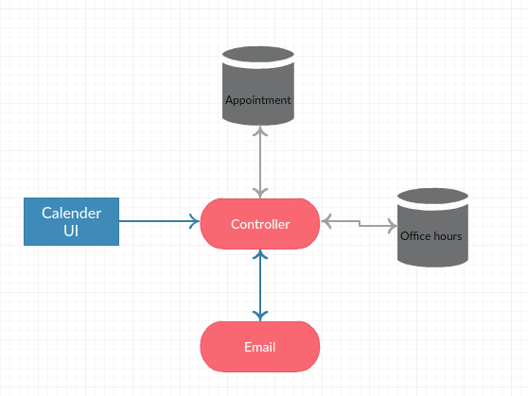

## 4.2 Use Case Diagram

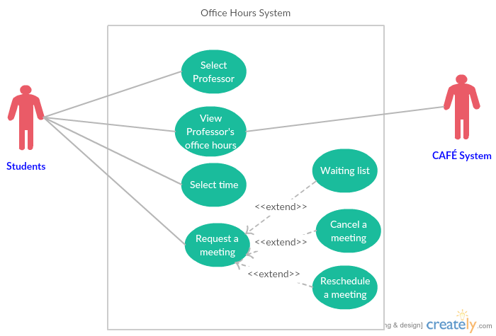

## 4.2 Use case template

|  |  |  |  |
| --- | --- | --- | --- |
| ID and Name: | **UC-1** view professors’ office hours | | |
| Created By: | Wangel,Ayman,Mutaz | Date Created: | 30/3/2016 |
| Primary Actor: | Students | Secondary Actors: |  |
| Description: | Students can view professors’ office hours online through the Office Hour System. | | |
| Trigger: | To see the available time for each professors | | |
| Preconditions: | 1. Students register to the Office Hour website | | |
| Postconditions: | 1. Students see the office hours of the professor | | |
| Normal Flow: | 1. Student Login 2. Student select View Schedule 3. Student select schedule by professor 4. Student submit the query 5. Student get the result | | |
| Alternative Flows: |  | | |
| Exceptions: |  | | |
| Priority: | High | | |
| Frequency of Use: | Approximately | | |
| Business Rules: |  | | |
| Other Information: |  | | |
| Assumptions: | AS1,DE1 | | |

|  |  |  |  |
| --- | --- | --- | --- |
| ID and Name: | **US-2 Make an appointment** | | |
| Created By: | Wangel,Ayman,Mutaz | Date Created: | 30 /03/2016 |
| Primary Actor: | Student | Secondary Actors: | Professor |
| Description: | The student can make appointment to the professor office hours online | | |
| Trigger: | Student want to meet professor for personal reasons | | |
| Preconditions: | The student is logged in | | |
| Postconditions: | The email request is sent to the professor | | |
| Normal Flow: | 1. Student open Make schedule form 2. Student select the professor 3. Student select time for appointment 4. Student submit the query 5. Student get confirmation. | | |
| Alternative Flows: |  | | |
| Exceptions: | 1. Time slot already reserved , the process will go back to step3. | | |
| Priority: | High | | |
| Frequency of Use: | Approximately | | |
| Business Rules: | BR-1,BR-2, BR-3, BR-4, BR-6, BR -7 | | |
| Other Information: | The student will get information of acceptance/reject | | |
| Assumptions: | AS-1 | | |

## 4.3 Context Diagram

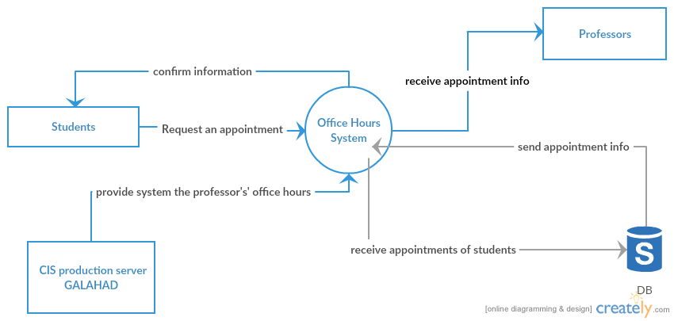

## 4.4 Feature Diagram

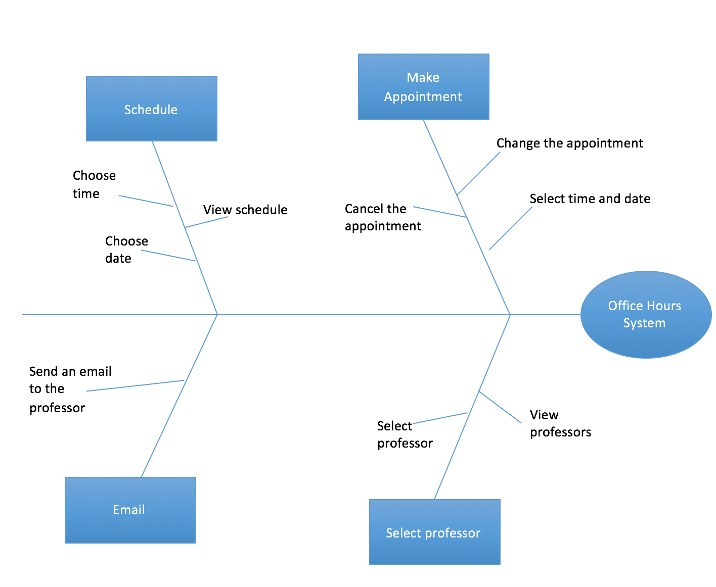

# 5.Project Schedule

|  |  |  |  |  |
| --- | --- | --- | --- | --- |
| Commitment | Made By | Made To | Due Date | Comments |
| First release of the application. | Requirement Team | Mr. Kurt | May 06 | The P. team will be responsible to conduct requirements, meetings and manage the project throughout the whole project phase . |
| Update Sprint Progress and development cycle. | Wangel | The Development Team & Stakeholder | May-6 | I will be responsible for handling Sprint and burn down chart updates from the development team to track progress and report to the whole team. |
| Maintain WBS and review the project reports | Ayman | The development team & Stakeholder | May-6 | I will be responsible for reviewing the project report with the team and making changes accordingly, |
| Project Planning and Documentation | Mutaz | The development team and stakeholder | May-6 | I will be responsible for documenting all project plans and cover any logs that are made or recorded from meeting review. |
| Meeting Organization | Ayoob | The development team and Stakeholder | May-6 | I will be responsible for organizing any meetings when required for each project plan set. I will make sure meeting for reviews, are done in time. |

## 5.1 Next Sprint 2 Schedule

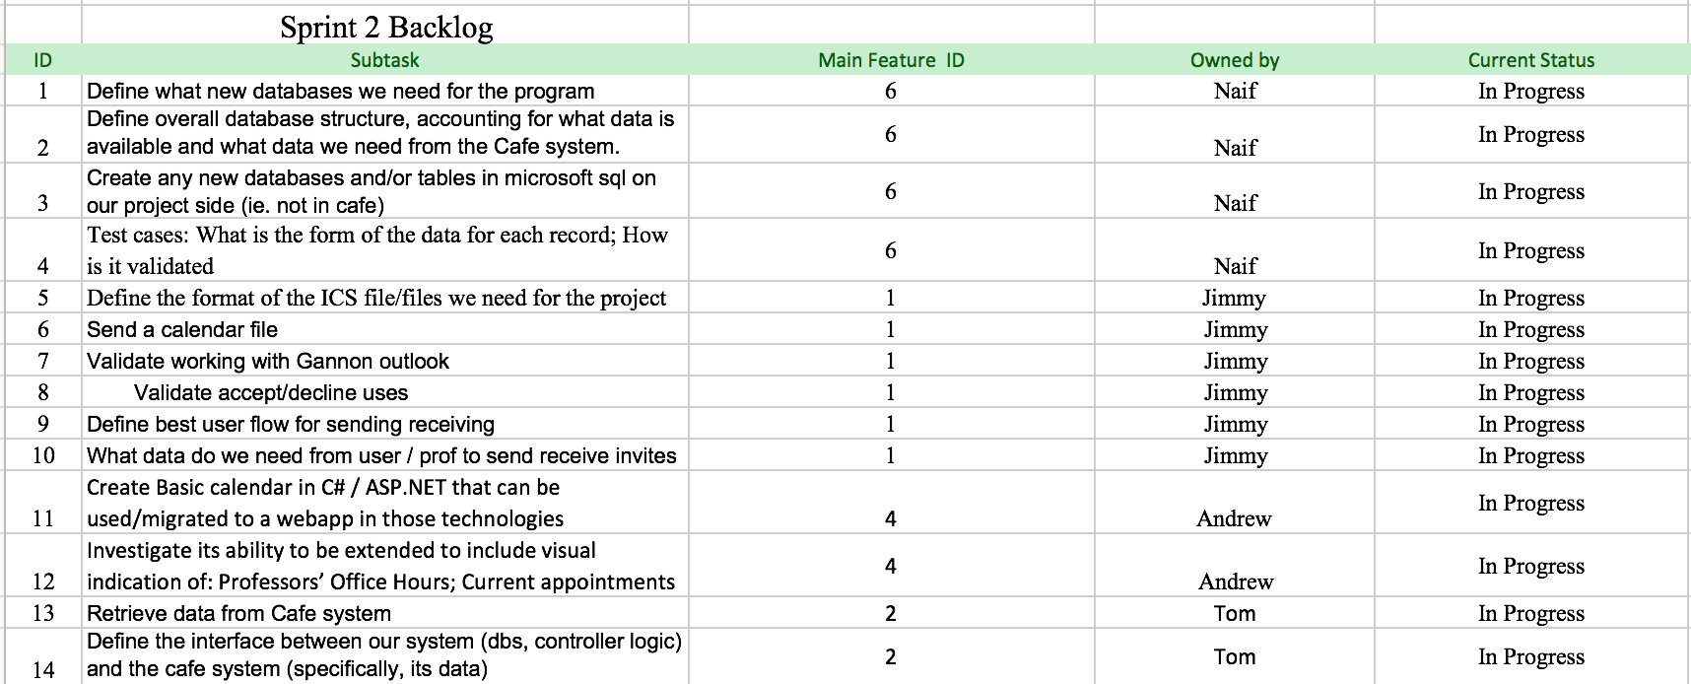

Table 1 - Activities for next Sprint by Development Team

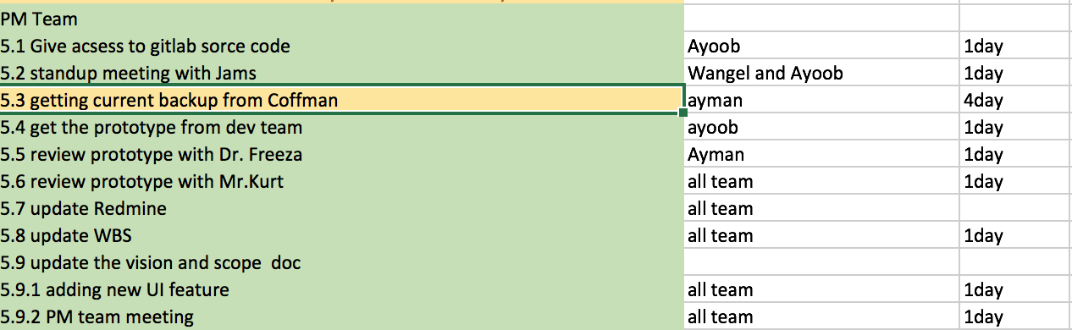

Table 2 – Activities for next Sprint by PM team.

## 5.2 Sprint 2 Plan Review

The development team have set their Schedule for the next sprint where Naif will be working on the database schema and making tables and making test cases on what data are required for each table. Jimmy will be working on the generation of .ics file for setting up appointment with the professor. Andrew will be working on the UI interface of the application where he is working on the early prototype of the application. Tom will be working n the logic of the café system and how to retrieve the schedule data from the CAFÉ system. The project Activities are listed in Table 1.

The project management team will be working on reviewing the prototype with Stakeholders and getting feedback so that the development team can make changes to the early prototype. Also, along with that, the team will be responsible for maintaining the Work Breakdown Structure of the activities that the development team and Project Management team will be working on. Also, new version of the Scope and Vision will be updated with change on the requirements feedback from the Development which is stated on Issue Log from table 6.1. The team will also will be responsible for organizing meeting with all the teams and stakeholder twice or more in a week for review of the progress. The project activities are listed in Table 2.

# 6. Review Log

**Date**: 31/3/16

**Team**: All PM team & Dev team

**Time**: 1:30pm – 2:15pm

**Place**: 4th floor ZURN Building.

## 6.1 Issue Log

|  |  |  |  |  |
| --- | --- | --- | --- | --- |
| **Issue #** | **Issue description** | **Ranking** | **Who found** | **Date** |
| 1 | Use Case Template | Major | James | 31/03/2016 |
| 2 | Change requirement | Normal | James | 31/03/2016 |
| 3 | Who does the email is sent to the professor? | Major | James | 31/03/2016 |
| 4 | Teacher won’t use the website to check appointment | Major | Req. Team | 31/03/2016 |
| 5 | How will the professor approve email | Major | Req. Team | 31/03/2016 |
| 6 | Is appointment cancellation a high priority? | Normal | James | 31/03/2016 |
| 7 | Who enters a faculty member’s office hour each semester? | Normal | James | 31/03/2016 |
| 8 | Can faculty change their office hours? | Normal | James | 31/03/2016 |
| 9 | Are all faculty data stored in the café system? | Major | James | 31/03/2016 |
| 10 | From use case review with Stakeholder, Reschedule meeting and cancel reservation should be in next release of the app. | Major | Mr. Kurt | 21/03/2016 |

## 6.2 Issue Discussion

James had questions from the development team that he accumulated from all the Development team. All questions were answered while Dev. Team was working in Sprint 1.

Below is the brief explanation for all issues encountered.

* For Issue 1
* we had a discussion with the development team and they required specific use case template for understanding the features of certain high priority tasks in version 2.0.
* For Issue 2 there were changes in requirement document with updated
* We added business rules from BR-1 to BR-7 and business risks RI-1 and R-2
* We also added major feature.
* For Issue 3
* we had discussion how does the email sent to the professors, and what is the process, after the student selected the time and date the professor will receive an email that shows all the details for the appointment
* For issue 4

- The professors will not interact with the system, it only thing that professors will get is the email that notify them about the appointment

* For issue 5
* The professor will receive an email that will let them to accept and decline the appointment
* For issue 6
* The appointment cancellation and waiting list are not important for the first release
* For issue 8
* Professors will not enter their office hours to the café
* Professors will not update their office hours
* If their office hours change they will be updated into the café
* For issue 9
* The faculty information and their office hours in stored on the café system

## 6.3 Additional note

* The student and faculty have the Gannon user ID.
* Dev team need the use case high priority templates.
* Req. Team needs work breakdown Structure.
* Dev. Team needs use cases and finished formal requirement template.
* Mr. Kurt’s review, we reviewed all the requirement with him and he likes our work but he mentioned to “Cancel appointment” it should be in the second version.

# 7. Prototype

