**Vison, scope and Baseline**

For

**Office Hours System**

Version 2.0

Prepared by Ayman Alotaibi, Mutaz Aldhuwayhi, Wangel Tamang and Ayoob Almotairi

March 30/2016

**Table of Contents**

Table of Contents…………………………….……………………………………………ii

1. Business Requirements…………………………………………………………….1

1.1. Background……………...…………………………………………………………1

1.2. Business Opportunity……...……………………………………………………….1

1.3. Business Objectives………….…………………………………………………….1

1.4. Success Metrics……………………...………………………………………….….1

1.5. Vision Statement……………………..…………………………………….………1

1.6. Business Risks…………………………………………………………….………..1

1.7. Business Assumptions and Dependencies…………………………………….……2

2. Scope and Limitations ……………………………..……………………….………2

2.1. Major Features…………………………………………...…………………………2

2.2. Limitations and Exclusions……………………………………………..…………..2

3. Business Rules…………………………………………….………………………..2

4. Use case template……………………………………………………………….….3

1. **Business requirement** 
   1. **Background**

Gannon students are suffering of knowing each Department professors’ office hours. Students have just one way to know their professors’ office hours which is to go to professors’ office and look at their schedule. Since we are computer science students we should not follow a traditional way in order to know our professors’ office hours. As we have seen in CIS Department, students usually take a picture for each professors’ schedule on the starting of each semester making a crowd over the doors. Additionally, students waste their time by using this way which is going to professors’ office each semester when the schedule changes every time.

* 1. **Business Opportunity**

In recent days most students and facilities using the technology to achieve their needs, however the current status, which is the traditional approach, unfortunately does not go with professors and students’ desires as there is no other way to look at the professor’s work hours. On the contrary, the “**Office Hours**” System will satisfy their needs since we have another system that already exists which is “**CAFÉ**” system. The CAFÉ system gives us a huge chance to deliver our system successfully because CAFÉ has all professors’ office hours which means we do not have to collect the data and can sync accordingly with the new proposed system.

* 1. **Business Objective**

**OB-1** view the professors schedule without going the office

**OB-2** makes the appointment with the professors

**OB-3** Professors view the students’ appointment

* 1. **Success metrics**

**SM-1:** at least100 students use the web application to make appointment

**SM-**2: The first semester the web application helps to reduce the waiting time of student by 10%.

**SM-**3: 8 out 10 find helpful getting the schedule of professors online

**1.5 Vision Statement**

For professors, students who need to see the professors’ office hours to request a meeting. The Office Hours system is a website that will allow students to schedule an appointment online. Unlike the current way that instructor and students are doing to have a meeting.Our product will allow both instructors and students to choose their appropriate time in an easy way and through the website.

**1.6 Business Risks**

**RI-1** missing the data will be effected on developing the project

**RI-2** if the professors do not interact indirectly with the system, the process will be difficult

**1.7 Business Assumptions and Dependencies**

**AS-1:** The professor has already upload their schedule in the café system

**DE-1:** The user should be currently enrolled Gannon student

**DE-2:** the student request for appointment should be accepted or rejected by the professor.

1. **Scope and Limitations** 
   1. **Major Feature**

**FE-1:** The system shall show the professor’s schedule

**FE-2:** The student can be able to make appointment with any professor

**FE-3:** The professor shall receive an email about the appointment made by the student.

**FE-4:** The student can cancel the appointment

* 1. **Limitations and Exclusions**

**LI-1:** The system will be only used by Gannon’s students

**LI-2:** The café system DB is required in order to get professor’s schedule.

**LI-3:** The professors do not interact with the system directly

1. **Business Rules**

**BR-1:** student must log in with their Gannon’s ID in order to use the system

**BR-2:** student can only select the time for appointment only within the office hours of the professors.

**BR-3:** student limitation for reservation is one appointment per day.

**BR-4:** student will be allowed appointment time (MIN: 10 mins and MAX:30 mins )

**BR-5:** professors must confirm appointment by verifying the email sent by the system to make a schedule appointment time.

**BR-6:** students can not make appointment at the same time or in between others student appointment schedule.

**BR-7:** student can only make an appointment tow day before the appointment time.

**Requirements**

System shall

* Allow students to select professors
* View professors’ office hours that are available
* Allow students to select their appropriate meeting time with their professors
* Notify students if professors cancel the appointment and vice versa

**Use case template**

|  |  |  |  |
| --- | --- | --- | --- |
| ID and Name: | **UC-1** view professors’ office hours | | |
| Created By: | Wangel,Ayman,Mutaz | Date Created: | 30/3/2016 |
| Primary Actor: | Students | Secondary Actors: |  |
| Description: | Students can view professors’ office hours online through the Office Hour System. | | |
| Trigger: | To see the available time for each professors | | |
| Preconditions: | 1. Students register to the Office Hour website | | |
| Postconditions: | 1. Students see the office hours of the professor | | |
| Normal Flow: | 1. Student Login 2. Student select View Schedule 3. Student select schedule by professor 4. Student submit the query 5. Student get the result | | |
| Alternative Flows: |  | | |
| Exceptions: |  | | |
| Priority: | High | | |
| Frequency of Use: | Approximately | | |
| Business Rules: |  | | |
| Other Information: |  | | |
| Assumptions: | AS1,DE1 | | |

|  |  |  |  |
| --- | --- | --- | --- |
| ID and Name: | **US-2 Make an appointment** | | |
| Created By: | Wangel,Ayman,Mutaz | Date Created: | 30 /03/2016 |
| Primary Actor: | Student | Secondary Actors: | Professor |
| Description: | The student can make appointment to the professor office hours online | | |
| Trigger: | Student want to meet professor for personal reasons | | |
| Preconditions: | The student is logged in | | |
| Postconditions: | The email request is sent to the professor | | |
| Normal Flow: | 1. Student open Make schedule form 2. Student select the professor 3. Student select time for appointment 4. Student submit the query 5. Student get confirmation. | | |
| Alternative Flows: |  | | |
| Exceptions: | 1. Time slot already reserved , the process will go back to step3. | | |
| Priority: | High | | |
| Frequency of Use: | Approximately | | |
| Business Rules: | BR-1,BR-2, BR-3, BR-4, BR-6, BR -7 | | |
| Other Information: | The student will get information of acceptance/reject | | |
| Assumptions: | AS-1 | | |

**Use Case Diagram**

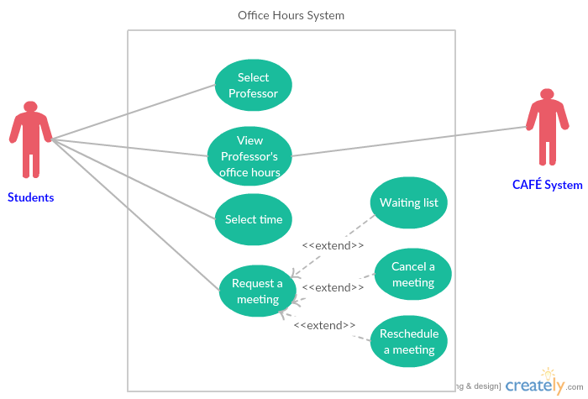

**Context Diagram**

