Sprint 2 planning meeting

4/7/16

* + Define DB Schema
    - Define what new databases we need for the program
      * For appointments, etc.

We need to create new database for appointments, which will be storing all appointments in office hours system. It works beside cafe database. We need new database called Appointment to store all appointments.

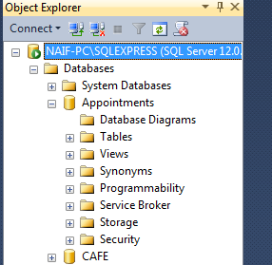

* + - Create any new databases and/or tables in microsoft sql on our project side (ie. not in cafe).

created table called appointment which include first column appointmentID, that is primary key. Second column FacultyID, third column FromTime (appointment start time and date), and last column ToTime ( appointment end time and date).

