Fun-O-Rama click-a-prize
By Ansel Lee and Phan Trung Kiet

Included in this folder
- clickaprize.html *
- styles.css *
- script.js
- FOR-smiley-pic.jpg *
- sample-entering-items.csv
- extremetestcase.csv
- sample-output.csv
- README.docx
- README.pdf (same as docx file)
Files marked with * are necessary

Format of input spreadsheet
You may use excel to create the CSV file. After inserting the data, in the top ribbon, click “File” > “Save As” > “Browse”. Name your file accordingly and set “Save as Type” as “CSV”. All 4 options work (CSV UTF-8 works). Here are the headings:
item name | qty | probability
pen | 100 | 0.191571
pencil | 79 | 0.151341
bag | 49 | 0.09387
clip | 20 | 0.038314
water bottle | 80 | 0.153257
jacket | 50 | 0.095785

Please do not add any other information in this CSV file. If needed, you may create another excel sheet and copy over only necessary information. Probability does not need to sum to 1 and may be calculated by qty divided by total items (i.e. “B2/sum(B$2:B$x)” where x is the last item). This helps if we have many high-value items but would like to clear low value items first.
All these details will be shown after you have uploaded the CSV file.
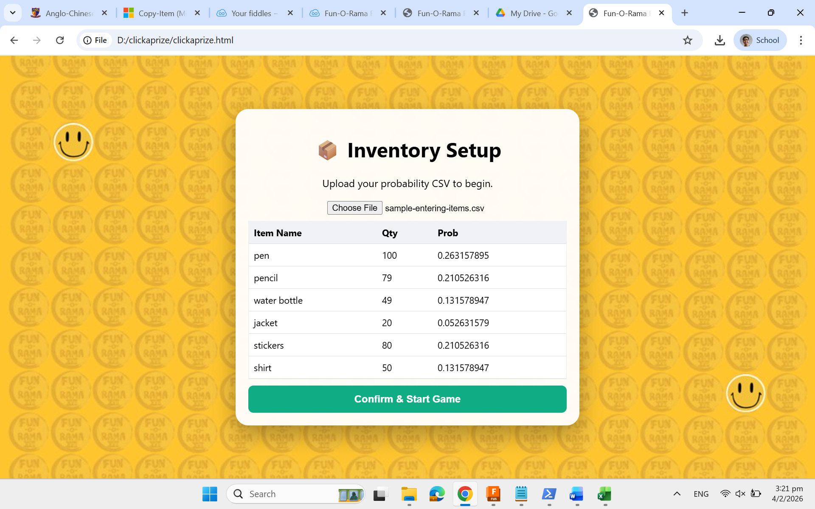
If these are not correct, please alert me.
Please note that the format of this spreadsheet DOES NOT match the export output spreadsheet. You will need to delete the first few rows until and excluding “Item Name”.

Scratching
Click while scratching the grid. Students need to open 3 of the same items to claim that prize. The colours do not follow the item name but is intended as a distraction so students don’t notice when there are less than 3 items in the grid. After the prize has been displayed, a side panel will show, with the prize and “Start Next Game”. Students can, however, continue scratching the card for fun.
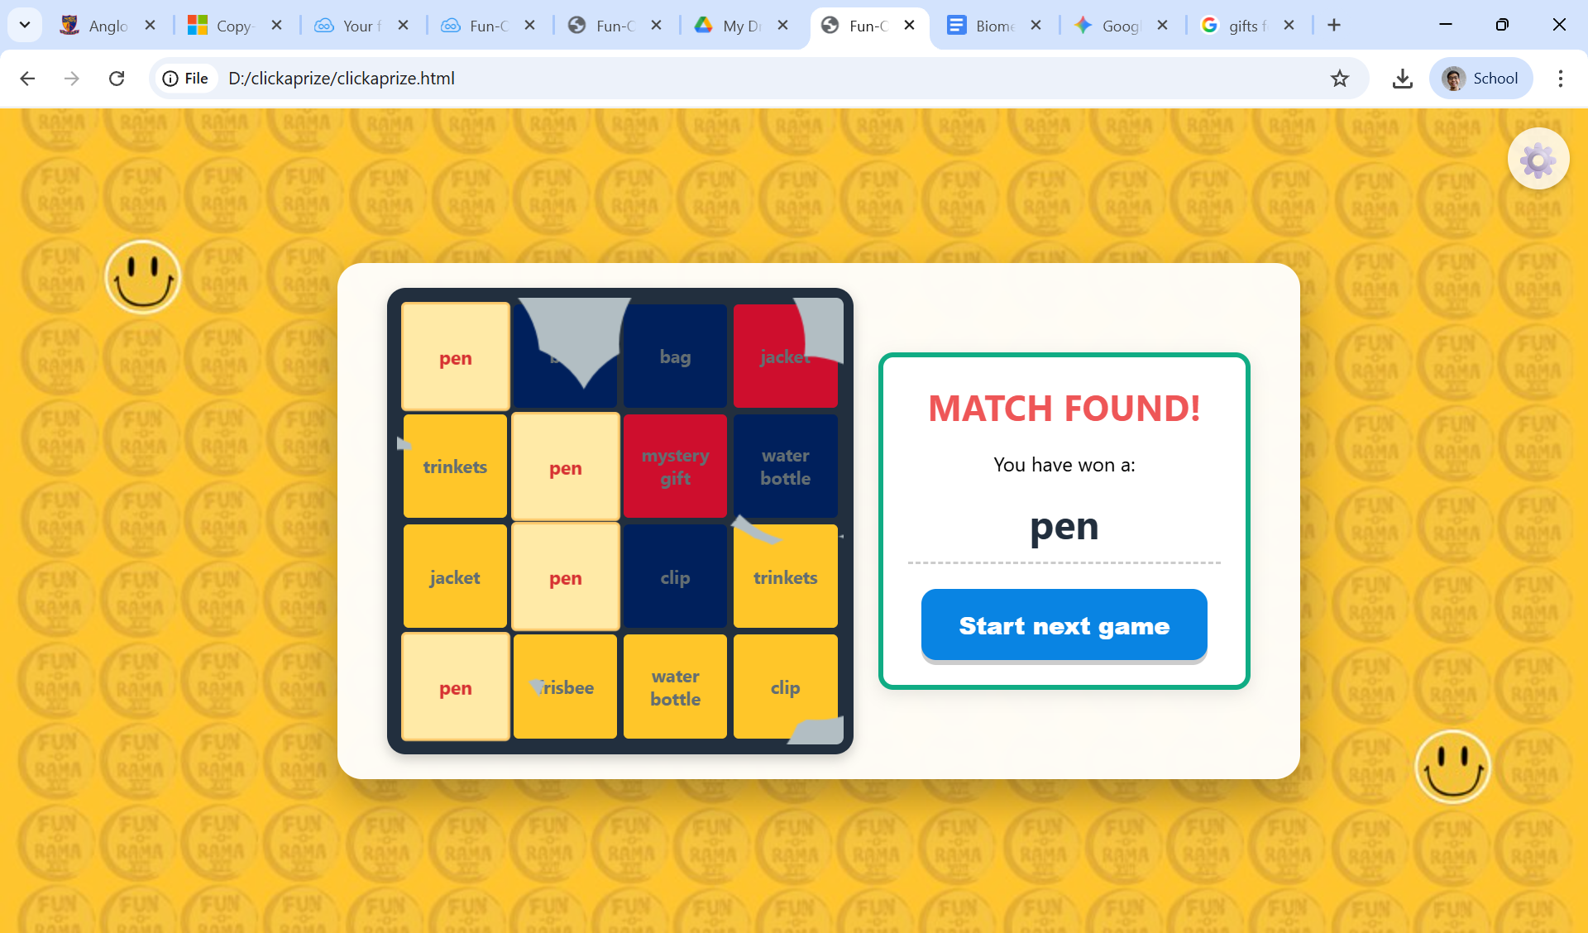

Game mechanics deep-dive
You need to open 3 of the same items to claim that prize. A prize is decided before the game starts. A minimum of 4 of these items will show on the board. The rest of the items are randomised.

Admin Controls
Hidden behind the gear cog, you may “view history”, “End and export” or “Clear Saved Data”. After clicking “End and export”, the list of items given and the ending inventory will be shown. Please note that to feed this into a new session, you must delete the rows until and excluding the “item name” header row.
If Column A shows ####s, please expand the column.
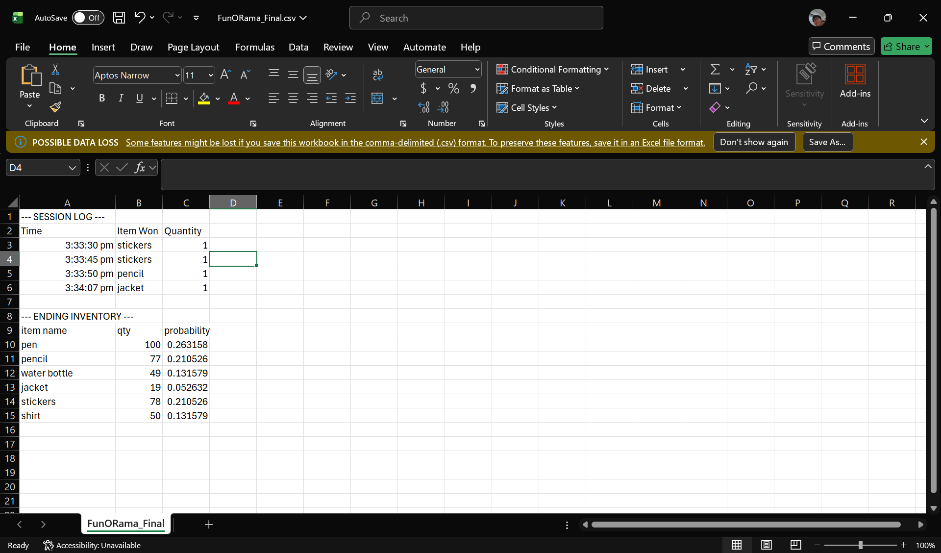

If the page was reloaded unintentionally, you may download the previous manifest, delete the first few rows in excel, and restart the game with the relevant data.
Thank you!

